The following pages preserve the complete technical before/after evidence package without modification.

- Preflight and smoke validation were executed before final document publication.
- All image cards remain clickable and resolve to commit-precise GitHub source permalinks.
- Core deltas cover prompt/replay behavior, tool metadata, RCA controls, persistence, workflow gates, and judging logic.
- Each before/after snapshot is tied to exact commit SHAs, files, and line-focused code regions.
- Comparison is fully aligned to current repository history; no synthetic v1-v7 labeling is used.
Executive Highlights

Scope: Oldest repository baseline vs latest repository commit with commit-precise source traceability
Executive Summary for Client Delivery
RLAIF Before vs After
RLAIF Harness Before vs After - What Changed and Why
Before/After code snapshots captured from your repository and mapped to commit-precise GitHub source links
Validation rule: clicking each image opens the exact source commit, file, and line-range used for that snapshot

A. Trace History Narrative
The problem. At baseline (trace-v), this section reflects earlier logic in TRACE_HISTORY.md before the current control refinements.
The change. The latest commit (trace-v) applies 1 focused patch hunk(s), with +42 and -0 line changes in this file.
The effect. Comparison now has commit-pinned before/after evidence and a structured delta table with 2 key setting/value changes.
Code-change table
Setting | Before (baseline) | After (latest)
taxonomy | (empty) | sharpen agent descriptions for routing
sequencing | (empty) | phase-gate tool selection

Before (v1)  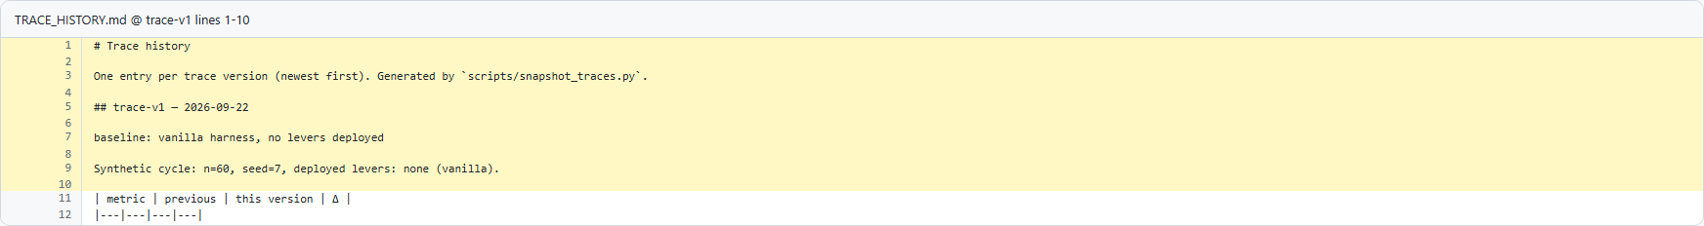  Baseline trace-history narrative at v1.  Narrative and governance delta  Open source on GitHub | After (v3)  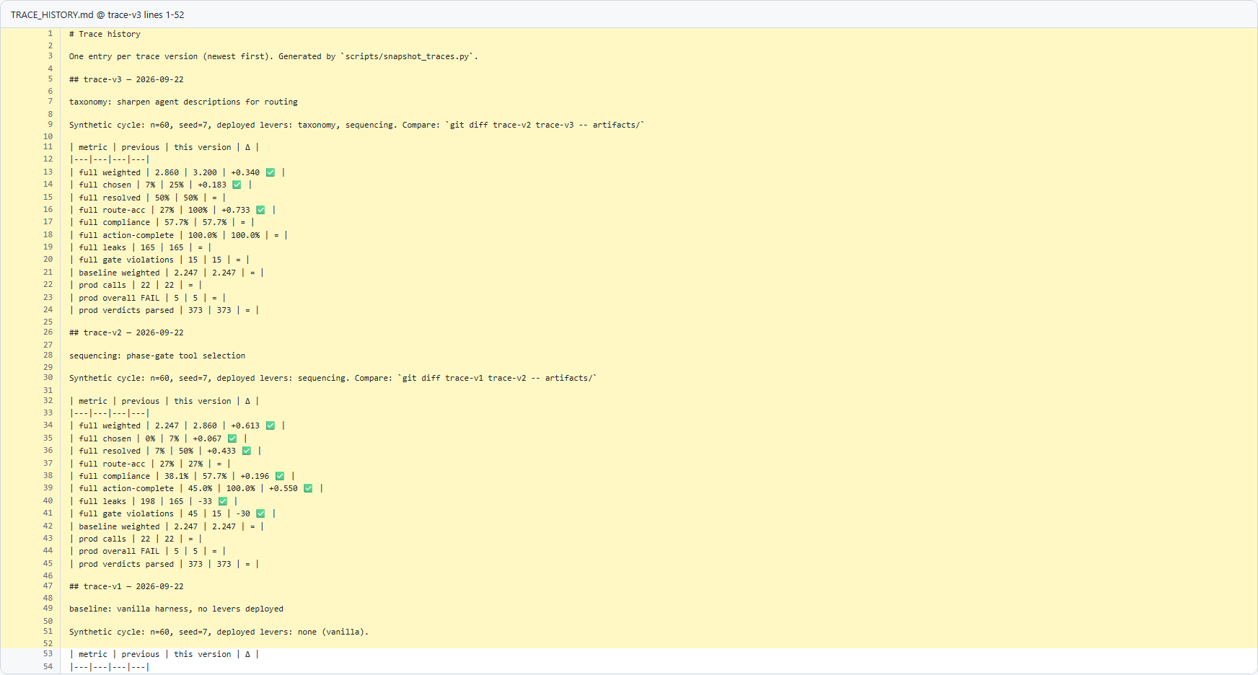  Updated trace-history narrative at v3.  Narrative and governance delta  Open source on GitHub

B. Cycle Summary Output
The problem. At baseline (trace-v), this section reflects earlier logic in artifacts/cycle_summary.json before the current control refinements.
The change. The latest commit (trace-v) applies 21 focused patch hunk(s), with +42 and -45 line changes in this file.
The effect. Comparison now has commit-pinned before/after evidence and a structured delta table with 8 key setting/value changes.
Code-change table
Setting | Before (baseline) | After (latest)
deployed_levers | [] | [
avg_compliance_rate | 0.381 | 0.577
action_completion_rate | 0.45 | 1.0
REPETITIVE_LOOP | 33 | (empty)
LIVE_AGENT_HANDOFF | 23 | 30
RESOLVED | 4 | 30
GEN-02 | "33 -> 33 fails" | "33 -> 30 fails"
GEN-04 | "11 -> 11 fails" | "11 -> 0 fails"

Before (v1)  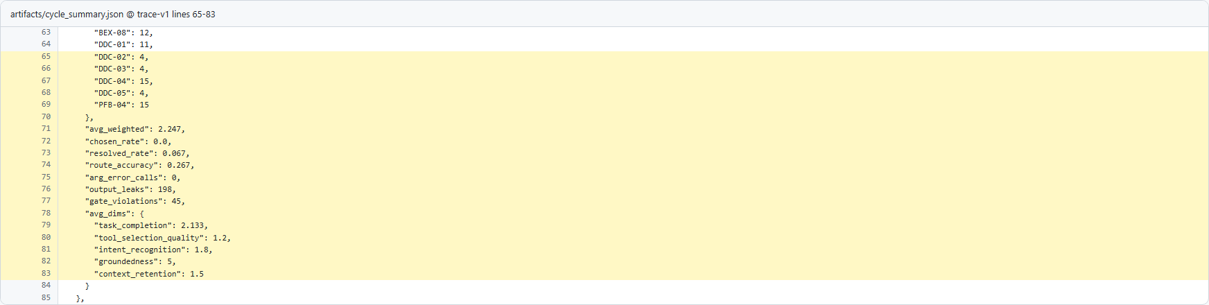  Baseline cycle summary output at v1.  Cycle summary delta  Open source on GitHub | After (v3)  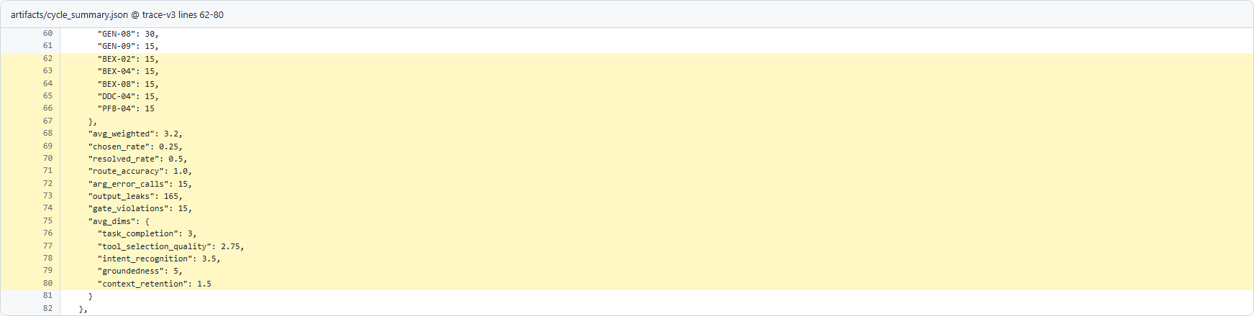  Updated cycle summary output at v3.  Cycle summary delta  Open source on GitHub

C. Preference Pairs Dataset
The problem. At baseline (trace-v), this section reflects earlier logic in artifacts/preference_pairs.json before the current control refinements.
The change. The latest commit (trace-v) applies 1 focused patch hunk(s), with +1759 and -1 line changes in this file.
The effect. Comparison now has commit-pinned before/after evidence and a structured delta table with 8 key setting/value changes.
Code-change table
Setting | Before (baseline) | After (latest)
pair_id | (empty) | "pp-ep-0059"
episode | (empty) | "ep-0059"
journey | (empty) | "gen"
utterance | (empty) | "I want to talk to a person. Also what is this $9.99 charge, and I need a new phone."
rejected | (empty) | {
levers | (empty) | [
weighted | (empty) | 2.35
verdict | (empty) | "Rejected"

Before (v1)  Baseline preference-pair records at v1.  Preference data delta  Open source on GitHub | After (v3)  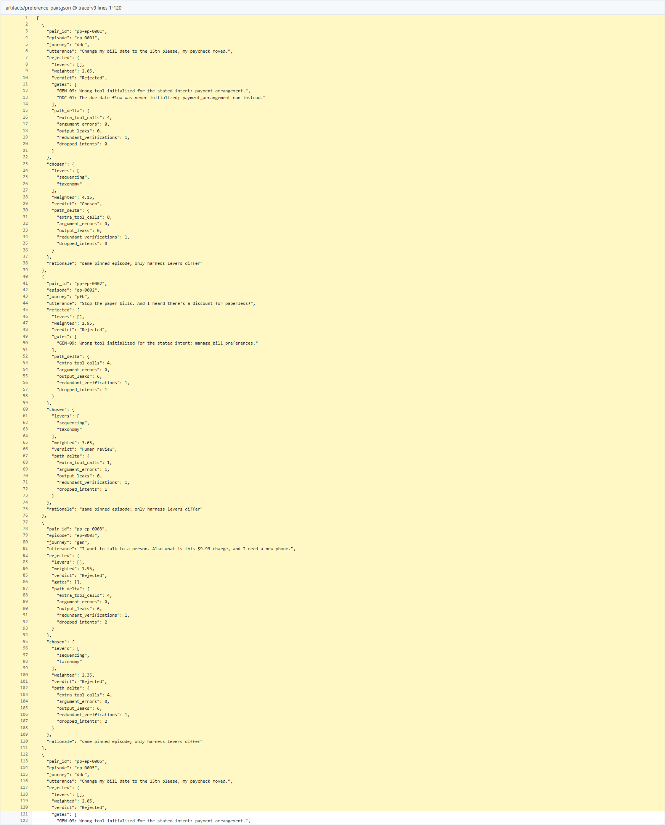  Updated preference-pair records at v3.  Preference data delta  Open source on GitHub

D. Recommendation Output
The problem. At baseline (trace-v), this section reflects earlier logic in artifacts/recommendations.json before the current control refinements.
The change. The latest commit (trace-v) applies 11 focused patch hunk(s), with +19 and -19 line changes in this file.
The effect. Comparison now has commit-pinned before/after evidence and a structured delta table with 8 key setting/value changes.
Code-change table
Setting | Before (baseline) | After (latest)
route_accuracy | "0.267 -> 0.267" | "0.267 -> 1.0"
GEN-09 | "41 -> 41 fails" | "41 -> 15 fails"
DDC-01 | "11 -> 11 fails" | "11 -> 0 fails"
leaks_full | 198 | 165
GEN-02 | "33 -> 33 fails" | "33 -> 30 fails"
GEN-08 | "33 -> 33 fails" | "33 -> 30 fails"
GEN-04 | "11 -> 11 fails" | "11 -> 0 fails"
BEX-08 | "12 -> 12 fails" | "12 -> 15 fails"

Before (v1)  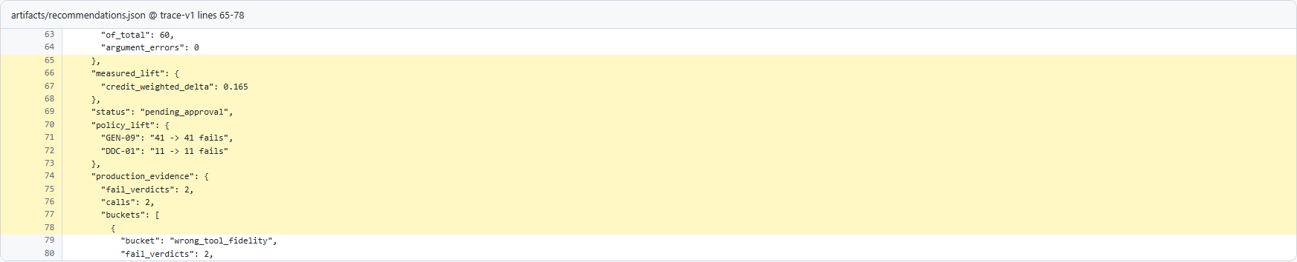  Baseline recommendation output at v1.  Recommendation delta  Open source on GitHub | After (v3)  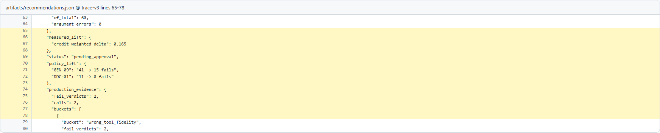  Updated recommendation output at v3.  Recommendation delta  Open source on GitHub

E. Full Verdicts Output
The problem. At baseline (trace-v), this section reflects earlier logic in artifacts/verdicts_full.json before the current control refinements.
The change. The latest commit (trace-v) applies 844 focused patch hunk(s), with +1999 and -1992 line changes in this file.
The effect. Comparison now has commit-pinned before/after evidence and a structured delta table with 8 key setting/value changes.
Code-change table
Setting | Before (baseline) | After (latest)
levers | [] | [
verdict | "NA" | "PASS"
evidence | "Turn 5: Agent says 'Is there anything else I can help you with today?'" | "Turn 9: Agent says 'Is there anything else I can help you with today?'"
reason | "Enrollment was never attempted." | "Eligibility -> full T&C -> explicit acceptance -> enroll, in order."
call | transfer_to_agent" | enroll_paper_free_billing"
leak | transfer_to_agent" | transfer_to_agent"
output_leaks | 6 | 0
overall_compliance_rate | 0.1667 | 0.7143

Before (v1)  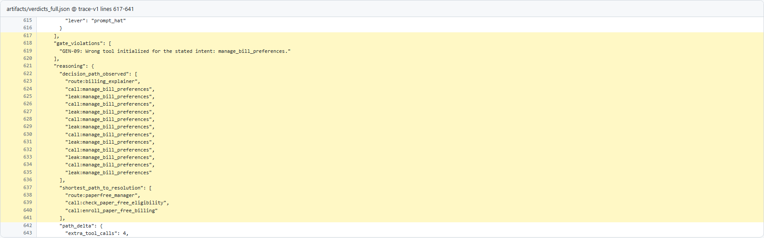  Baseline verdict output at v1.  Verdict delta  Open source on GitHub | After (v3)  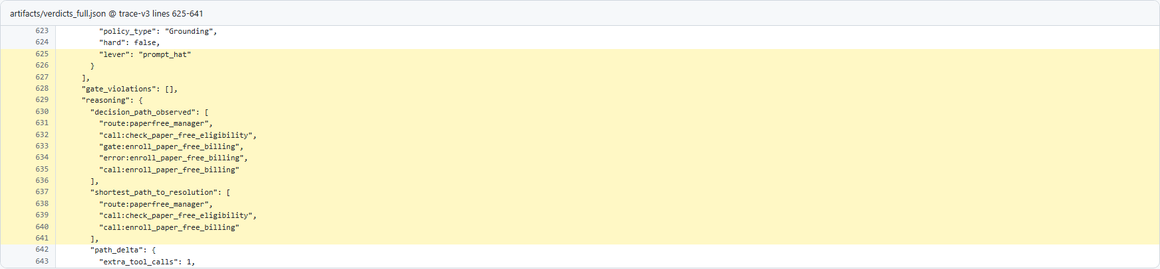  Updated verdict output at v3.  Verdict delta  Open source on GitHub

