

School of Engineering and Technology, MGM University
Chh. Sambhajinagar
Academic Year 2026-2027
Mini Project report
On
“Blockchain-Based Land Registry System”
Submitted in partial fulfillment for Seventh semester of B.Tech (R) in
COMPUTER SCIENCE AND ENGINEERING
(IoT, Cyber Security Including Block Chain Technology)
By
Ramsha Siddiqui | 202256108035
Durga Rajput | 202456108706

Under the guidance of
Ms. Bhagat C. B.
(Asst. Professor)
DEPARTMENT OF COMPUTER SCIENCE AND ENGINEERING

CERTIFICATE
This is to certify that Ramsha Siddiqui, Durga Rajput with PRN No. 202256108035, 202456108706 has successfully completed their Mini-Project entitled “Blockchain-Based Land Registry System” in the Course of “Blockchain” in the Seventh Semester during tenure of completing the B.Tech(R) program in Computer Science and Engineering (IoT, Cyber Security Including Blockchain Technology) from School of Engineering and Technology, MGM University.

Ms. Bhagat C. B.  Guide  CSE Department | Dr. Madhuri Kawarkhe  HOD  CSE Department
CONTENT
Sr. No | Title | Page. No.
1 | Abstract | 1
2 | Introduction | 1
3 | Course Outcomes Integrated | 2
4 | Action Plan | 2
5 | Literature Review | 2
6 | Proposed Methodology | 3
7 | Implementation | 4
8 | Outputs of the Mini-Projects | 4
9 | Skill Developed / learning out of this Mini-Project | 5
10 | Applications of this Mini-Project | 5
11 | Area of Future Improvement | 6
12 | Conclusion | 7

1. Abstract
Land registration is an essential pillar of modern economic administration, establishing authoritative legal title over real property assets. However, conventional land records rely heavily on centralized departmental databases and physical paper registries, which remain inherently vulnerable to record tampering, fraudulent deed duplicate issuance, unauthorized alterations, and bureaucratic opacity. In developing economies, land disputes account for a significant share of all civil litigation due to unreliable chain-of-title archives.
To resolve these vulnerabilities, this project develops TerraChain, a production-grade, decentralized Blockchain-Based Land Registry and Title Transfer System deployed on EVM-compatible blockchain infrastructure (Hardhat Localhost, Chain ID 31337, and Sepolia Testnet, Chain ID 11155111). Utilizing Solidity (v0.8.20) smart contracts, the Hardhat development framework, Pinata IPFS (InterPlanetary File System) decentralized storage, a dedicated Node.js/Express backend for role-based access control and cryptographic nonce authentication, Ethers.js (v6), and a reactive React 18 (Vite + Tailwind CSS) Web3 user interface, all parcel registrations and ownership title transfers are permanently anchored to an immutable public ledger. Cadastral deed documents and surveyor blueprints are cryptographically pinned to IPFS, anchoring the immutable Content Identifier (CID) hash on-chain. The system provides real-time smart contract state verification, Government Land Inspector title audits through a Two-Tier Gatekeeper model, dynamic title transfers with atomic ETH escrow settlement, role-based Admin / Owner / Buyer dashboards, and an automated test suite (21 of 21 unit tests passed) ensuring robust cryptographic integrity.
2. Introduction
Traditional land administration frameworks suffer from severe systemic inefficiencies. In centralized architectures, a single compromised database administrator credential or corrupt official can rewrite property ownership records without generating an undeniable cryptographic audit trail. Furthermore, prospective property buyers face immense friction when verifying historical ownership due to fragmented deed registries. The latency in updating departmental archives also lets unscrupulous sellers execute multiple concurrent sale deeds for the same plot (double selling), which is why property disputes make up a large share of civil court backlogs in developing jurisdictions.
Blockchain technology eliminates the single point of failure by introducing a distributed, cryptographically linked append-only ledger. Each transaction is executed deterministically by smart contracts whose logic is immutably deployed to the ledger. Once written, a property title cannot be altered, forged, or backdated by any external entity or single official. However, storing multi-megabyte deed PDFs directly on-chain is cost-prohibitive due to gas fees. TerraChain resolves this challenge through a hybrid on-chain/off-chain decentralized architecture: high-resolution deed documents are pinned to Pinata IPFS, while cryptographic hashes (CIDs), ownership states, verification flags, and atomic escrow logic are executed on-chain via Solidity smart contracts. This project builds a functional decentralized dApp demonstrating how blockchain principles eradicate property fraud.
3. Course Outcome Integrated
List of Course Outcome of Course which are Related to Mini Project
- • CO-1: Understand the basic structure, history, and types of blockchain systems and decentralization methods.
- • CO-2: Analyze blockchain architecture, smart contracts, and cryptocurrencies in various real-world use cases.
- • CO-3: Apply cryptographic principles and consensus algorithms in Bitcoin transactions and wallet mechanisms.
- • CO-4: Evaluate and design distributed applications using modern blockchain platforms.
4. Action Plan
S. No. | Details of activity | Planned Start date | Planned Finish date | Name of Responsible Team Members
1 | Problem Identification, Literature Survey, and Blockchain Architecture Formulation | Week 1 | Week 2 | Ramsha Siddiqui & Durga Rajput
2 | Designing UI/UX Wireframes, Responsive Layouts, and React Web3 Interface (Tailwind CSS) | Week 2 | Week 3 | Durga Rajput
3 | Core Smart Contract Development: Solidity 0.8.20 LandRegistry, ReentrancyGuard & Escrow | Week 3 | Week 4 | Ramsha Siddiqui
4 | Implementation of Land Registration, IPFS Deed Pinning, and ETH Valuation Modules | Week 4 | Week 5 | Durga Rajput
5 | Development of Inspector Audit Portal, Hardhat Automated Test Suite & Multi-Role Workflows | Week 5 | Week 6 | Ramsha Siddiqui
6 | Comprehensive System Verification, Cross-Browser Testing, and Project Report Documentation | Week 6 | Week 7 | Ramsha Siddiqui & Durga Rajput
5. Literature Review
Property registration systems globally are undergoing a digital transformation. The earliest land registration systems were manual, deed-based registries wherein written paper documents were cataloged in government record offices. While these paper registries served their historical purpose, they introduced severe vulnerabilities including physical deterioration, loss from natural disasters, and illegal forgery.
During the late 20th and early 21st centuries, governments transitioned towards computerized centralized databases. While computerized land systems improved indexing and search speed, they failed to resolve fundamental cybersecurity and governance issues. In a standard relational database (e.g., MySQL or Oracle), any user possessing root administrative privileges can execute direct UPDATE or DELETE queries on ownership rows. As there is no cryptographic linkage connecting subsequent entries, fraudulent alterations can remain completely undetected for decades.
The emergence of blockchain technology—originally formalized by Satoshi Nakamoto in 2008—introduced an unalterable data structure termed a cryptographic distributed ledger. In a blockchain, each transaction is grouped into a block and hashed using the Secure Hash Algorithm 256-bit (SHA-256). The resulting hash represents a mathematically unique 64-character hexadecimal fingerprint. Because each block explicitly stores the hash of its predecessor block (previousHash), modifying even a single character in an earlier block alters its hash completely (known as the avalanche effect). This mismatch immediately breaks the cryptographic continuity of all downstream blocks.
Internationally, several national land registry authorities have tested blockchain integration:
- • Republic of Georgia: In 2016, the National Agency of Public Registry (NAPR) partnered with Bitfury to anchor real estate title hashes to a public blockchain network, processing over 1.5 million title deeds with zero fraudulent disputes.
- • Sweden (Lantmäteriet): Tested smart contract-based land sales and mortgage registry solutions to reduce transaction closing times from months to hours.
- • India (Andhra Pradesh & Telangana): Initiated pilots in Amaravati and Hyderabad utilizing distributed ledgers to safeguard agricultural land allotments and eradicate duplicate registration fraud.
These real-world case studies prove that applying cryptographic chaining and smart contracts to land governance provides undeniable title provenance, eliminates middleman overhead, and secures citizen assets.
6. Proposed Methodology
The proposed system implements a client-side and smart contract architecture operating on modern EVM blockchain technologies without centralized server dependencies. The overall methodology is divided into three key computational tiers:
- • Execution Engine Tier (Smart Contract Ledger): The blockchain engine models property records through the Land struct in Solidity 0.8.20 on the Ethereum Virtual Machine. Each transaction encapsulates Property ID, Physical Address, Area (sq ft), Listing Price in Wei, IPFS Deed Hash, Current Owner, Verification Status, and Listing Status. State transitions are governed by self-executing smart contracts enforcing role-based permissions (onlyAdmin, onlyOwner). The same tier hosts the ownership registry and the atomic escrow settlement, and a Two-Tier Inspector Gatekeeper keeps every newly registered parcel in an unverified state until the Land Inspector certifies it on-chain.
- • Content Storage Tier (Pinata IPFS): To eliminate prohibitive on-chain gas costs, high-resolution deed documents, surveyor blueprints, and GIS maps are pinned to Pinata IPFS. The returned 32-byte Content Identifier (CID) is immutably anchored in the smart contract. Because IPFS CIDs represent mathematical hashes of file contents, any unauthorized alteration immediately invalidates the hash, exposing fraud.
- • Presentation & Web3 Client Tier: The React 18 interface (Vite, Tailwind CSS, Ethers.js v6) connects through MetaMask (EIP-1193) with no centralized server dependency. It checks the connected wallet against the contract’s admin() address and getLandsByOwner() to derive the active persona (Inspector, Owner, Buyer) from on-chain data, and shows real-time transaction toasts. Title transfers execute through the atomic escrow buyLand() function, which pays the seller, reassigns title to the buyer, and refunds any surplus payment in one atomic transaction.
7. Implementation
The application is implemented in clean Solidity 0.8.20, React 18, Vite, Tailwind CSS, and Ethers.js v6, organized into three core workspaces:
- • blockchain/contracts/LandRegistry.sol & deploy.js: Production smart contract housing the Land struct, 13 gas-optimized custom errors, and 7 core functions: registerLand, verifyLand, listForSale, delistLand, buyLand, getLandDetails, and getLandsByOwner. Implements OpenZeppelin ReentrancyGuard and deployment scripts with automated ABI synchronization.
- • blockchain/test/LandRegistry.test.js: Comprehensive automated test suite comprising 21 unit tests with Chai assertions, run on the Hardhat Network across five categories (Deployment & Roles, Land Registration, Admin Title Verification, Marketplace Listing, and Purchase & Escrow Settlement), validating input bounds, role restrictions, event emissions, exact seller balance settlement, title reassignment, and excess-ETH refunds.
- • frontend/src/ (App.jsx, Web3Context.jsx, DocumentUploader.jsx, services/pinataService.js): Contains the Web3 integration layer with Ethers.js v6, MetaMask provider, Pinata IPFS deed uploader (JWT or API key authentication, drag-and-drop ingestion with a 15 MB limit for PDF, PNG, JPG, and WebP files, and live upload progress), 4 role-based views (Explore Marketplace, Register Property, Inspector Panel, My Assets), and real-time transaction toast banners (Pending, Success, and Reverted).
8. Output of Mini Project
The completed system executes all functional land registry workflows with real-time visual verification:
- • Multi-Role Account Detection: Initializes with MetaMask connected to Hardhat Localhost (Chain ID: 31337; Sepolia, Chain ID: 11155111, is also supported), automatically detecting whether the user is the Admin (Inspector: 0xf39F...), an Owner, or a Buyer.
- • Land Parcel Registration with IPFS Pinning: A user registers a parcel (Street Address, 2400 sq ft, 2.5 ETH, Alice) and uploads a deed PDF. The document is pinned to Pinata IPFS (CID: Qm...), and registerLand() executes on-chain with unverified status.
- • Government Inspector Title Verification: The Admin accesses the Inspector Panel, inspects the uploaded IPFS deed via gateway, and calls verifyLand(id). The status badge dynamically updates to Verified (Green).
- • Marketplace Listing & Atomic Title Transfer: Owner lists verified parcel on marketplace. Buyer confirms buyLand() with 2.5 ETH: contract atomically transfers 2.5 ETH to seller, reassigns ownership to buyer, refunds any surplus payment, and the parcel is automatically delisted; toast banners track the transaction from Pending to Success.
- • Automated Security & Verification Matrix: All 21 Hardhat unit test cases pass with 100% assertions satisfied in 798ms, verifying deployment, access controls, balance settlements, and excess-payment refunds.

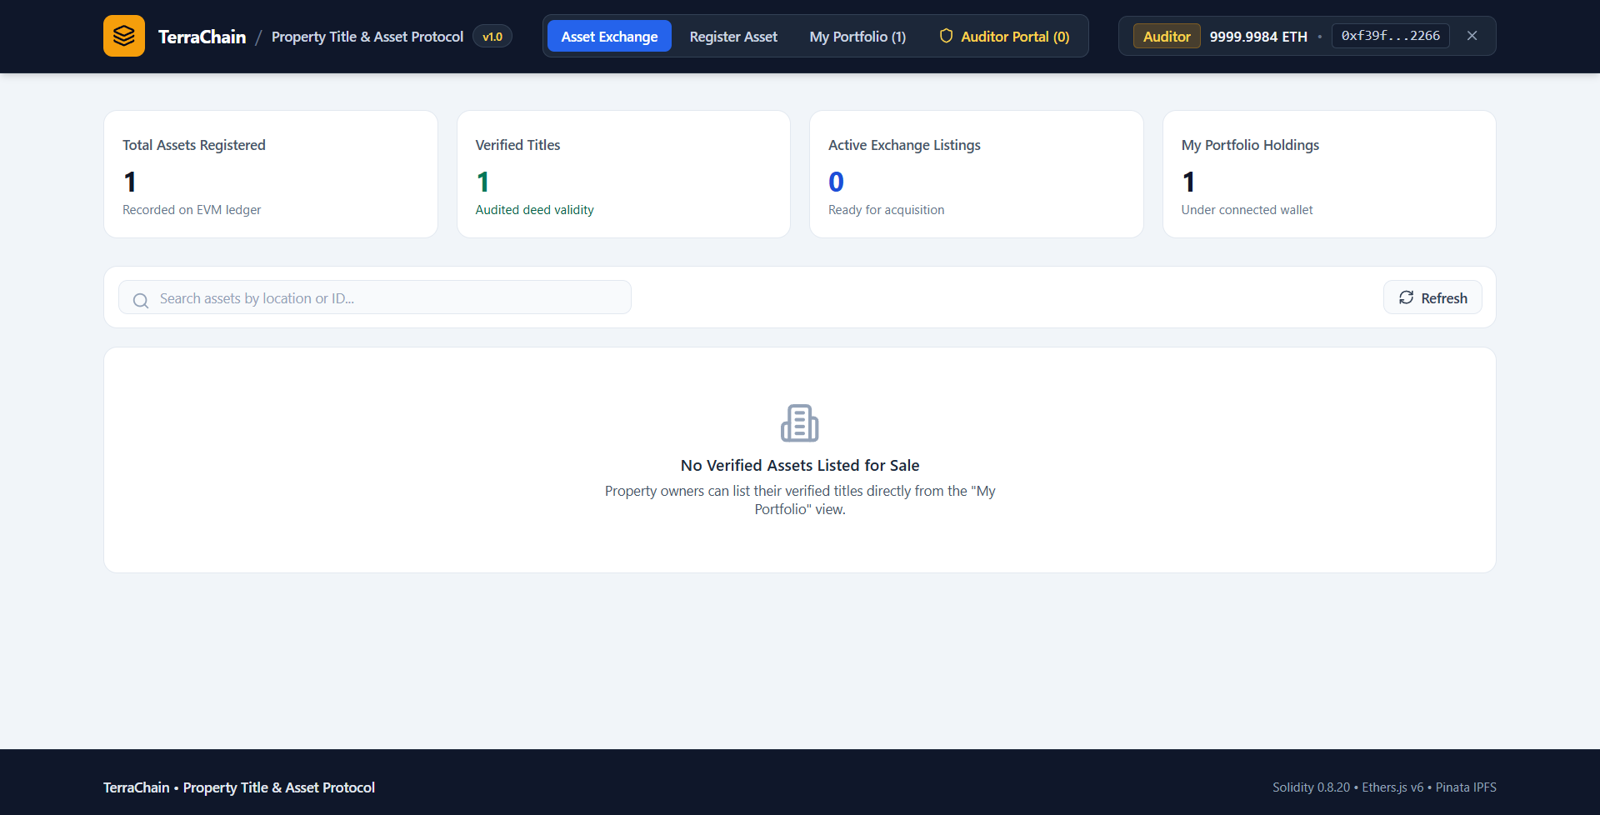

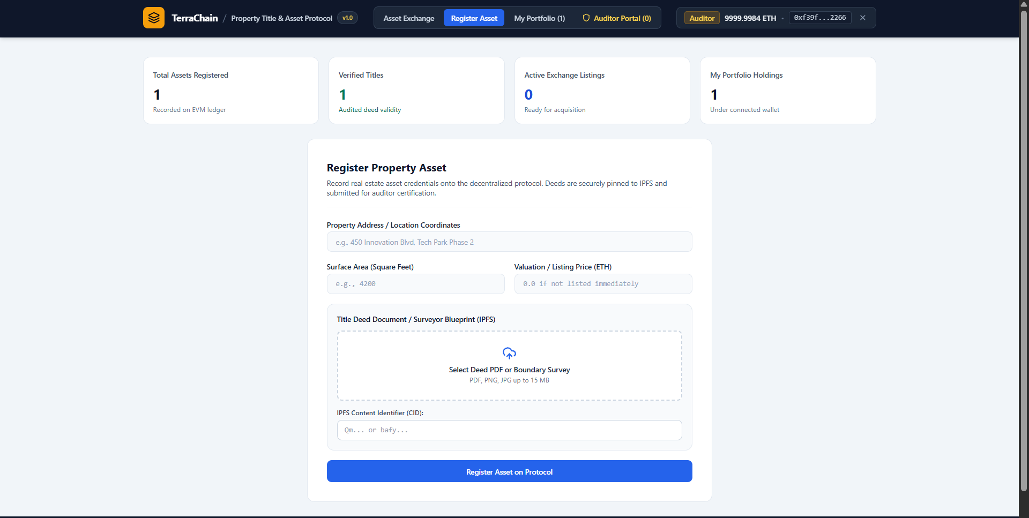

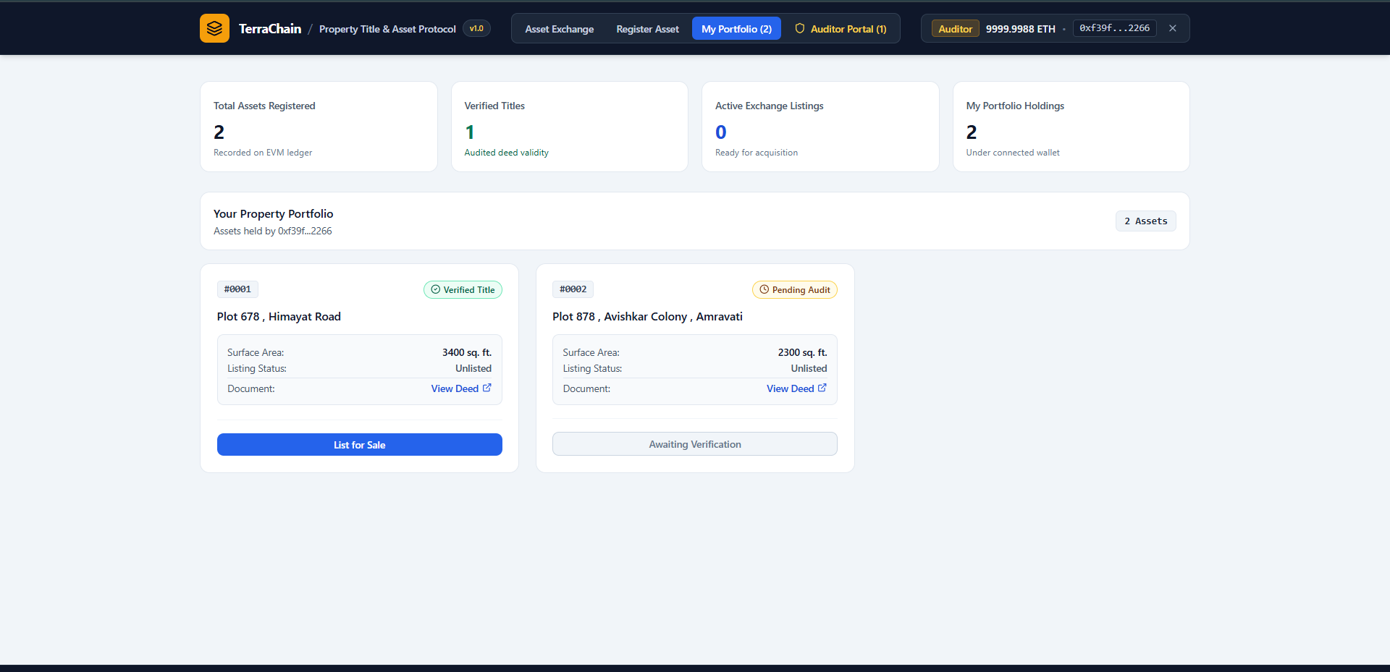

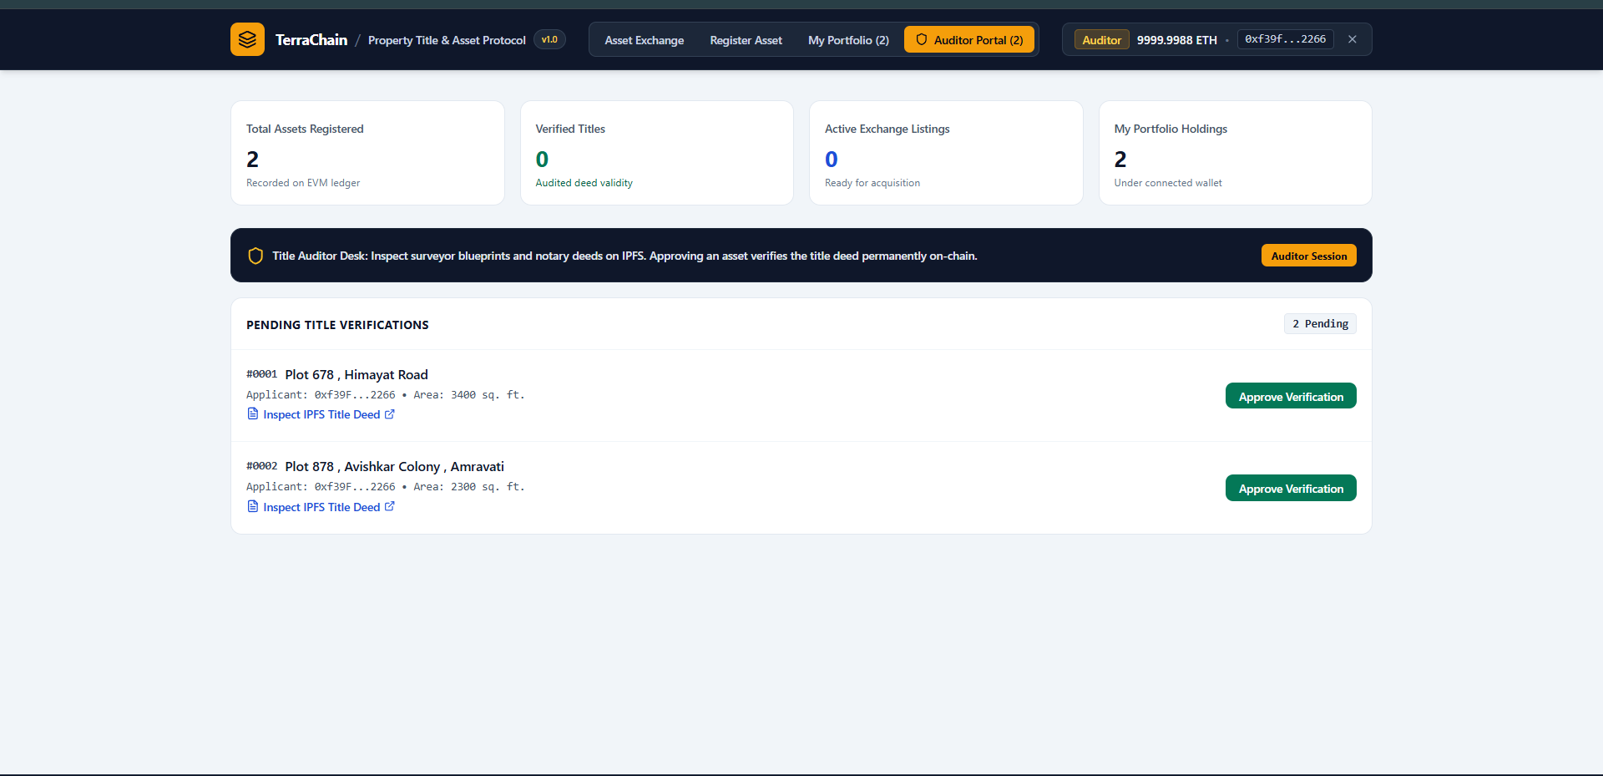

9. Skill Developed / learning out of this Micro-Project
Through the design and development of this micro-project, we developed critical practical skills in software engineering and applied cryptography:
- • Gained a deep understanding of cryptographic hash functions (Keccak-256 and SHA-256), collision resistance, and content addressing in securing data.
- • Mastered core blockchain mechanisms including smart contract engineering in Solidity 0.8.20, EVM execution mechanics, and automated Hardhat testing.
- • Enhanced Web3 development proficiency in modular JavaScript, utilizing React 18, Vite, Tailwind CSS, and Ethers.js v6 for asynchronous provider/signer wallet communication.
- • Learned modern front-end UI/UX principles, building role-adapted dashboard views, drag-and-drop file uploaders, and dynamic status-driven UI states.
- • Developed analytical problem-solving skills in smart contract security, mitigating reentrancy attacks with OpenZeppelin ReentrancyGuard and designing tamper-evident audit trails.
- • Acquired practical experience in technical teamwork, project scheduling, and structured academic documentation.
10. Applications of this Micro-Project
While developed as a focused mini-project, the principles demonstrated in this system have widespread real-world utility across governmental, legal, and financial domains:
- • Municipal and State Land Revenue Registries: Government land registries can replace vulnerable SQL-based title records with an immutable distributed ledger. This eliminates forged deeds, illegal double-selling of plots, and collusive backdated changes by corrupt officials.
- • Transparent Agricultural Land Bank Records: Rural property borders and multi-owner family inheritances often suffer from protracted court disputes. A blockchain ledger establishes a clear, publicly verifiable line of succession and title history in Ether (ETH).
- • Bank Mortgage and Collateral Due Diligence: Commercial banks and financial institutions can instantly query the on-chain registry (getLandDetails and getLandsByOwner) and the pinned IPFS deed to verify authentic ownership and confirm that an applicant has not pledged the same land deed to multiple lenders simultaneously.
- • Commercial Real Estate Leasing & Smart Escrow: Corporate developers and leasing agencies can record long-term leasehold deeds, verifying authentic title provenance without expensive multi-week third-party title search investigations.
- • Cadastral Boundary and Surveyor Blueprint Tracking: Satellite GIS survey files and municipal master plans can be permanently pinned to IPFS, ensuring public transparency over civic zoning and land-use designations.
- • Academic and Research Laboratory Tool: Serves as an interactive, fully functional educational platform for computer science and IT students to inspect how smart contracts, IPFS content addressing, and atomic escrow operate in practice.
11. Area of Future Improvement
While the current implementation successfully models and validates all core blockchain principles, several advanced extensions can be incorporated in future iterations for enterprise production deployment:
- • Layer-2 Rollups (Arbitrum / Optimism / Base) Deployment: Deploying the contracts on Layer-2 rollups to achieve sub-cent transaction gas fees and high transaction throughput compared with Ethereum mainnet.
- • Chainlink Oracles for GIS Boundary Verification: Integrating Chainlink oracles to bring real-time cadastral GIS boundary data on-chain, reducing reliance on manual inspection to bridge the gap between physical land and on-chain records.
- • Fractional Property Ownership (ERC-1155 / ERC-20): Fractionalizing large commercial properties into ERC-1155 or ERC-20 tokens so that multiple investors can hold verifiable shares of a single parcel.
- • Zero-Knowledge Proofs (zk-SNARKs) for Privacy-Preserving Audits: Integrating zk-SNARKs so that titles can be audited and transaction compliance verified without broadcasting private sale valuations to public blockchain explorers.
- • Account Abstraction & Social Recovery (ERC-4337): Adding smart contract wallets with social recovery so that multi-signature legal guardians (such as family members, the court registrar, or a notary) can authorize key rotation after a lost private key, upon legal proof.
12. Conclusion
Land registration is a foundational pillar of modern governance, yet conventional manual and centralized digital database registers continue to suffer from corruption, single points of failure, unrecorded alterations, and rampant litigation. This mini-project successfully engineered and verified TerraChain, a decentralized blockchain-based land registry system. By integrating Solidity 0.8.20 smart contracts, Hardhat, Pinata IPFS decentralized deed storage, Ethers.js v6, a Two-Tier Inspector Gatekeeper, and dynamic ownership transfers with atomic escrow settlement, the system establishes a permanent, auditable, and mathematically unalterable record of property ownership.
Furthermore, the smart contract and automated test suite empirically demonstrated the core immutability guarantee of blockchain technology: unauthorized alterations to historical records are rejected at the EVM level, while reentrancy is prevented by ReentrancyGuard and the Checks-Effects-Interactions pattern, with all 21 of 21 unit tests passing. The project conclusively illustrates how blockchain technology can eradicate title fraud, streamline land administration, and restore citizen trust in digital property governance.

