**Name:Ramsha Tariq**

**Class:BESE5B**

**Reg#111191**

**Section:B**

**Introduction:**

In this lab, we installed and configured a single node Hadoop instance capable to executing and retrieving a Map Reduce Job to count the frequency of words in any given file. I configured Single Node Cluster. I executed a Map Reduce Job to count word frequency in any given file.

**Approach:**

I have used Java language. The compiler is Net Beans IDE 1.8.I have taken help from internet.

**Design:**

I have made different classes with specific different functions. There are unit tests. There are different classes.I downloaded and successfully installed Cygwin on my laptop as seen from following screenshot:



Following is the screenshot of Cygwin terminal

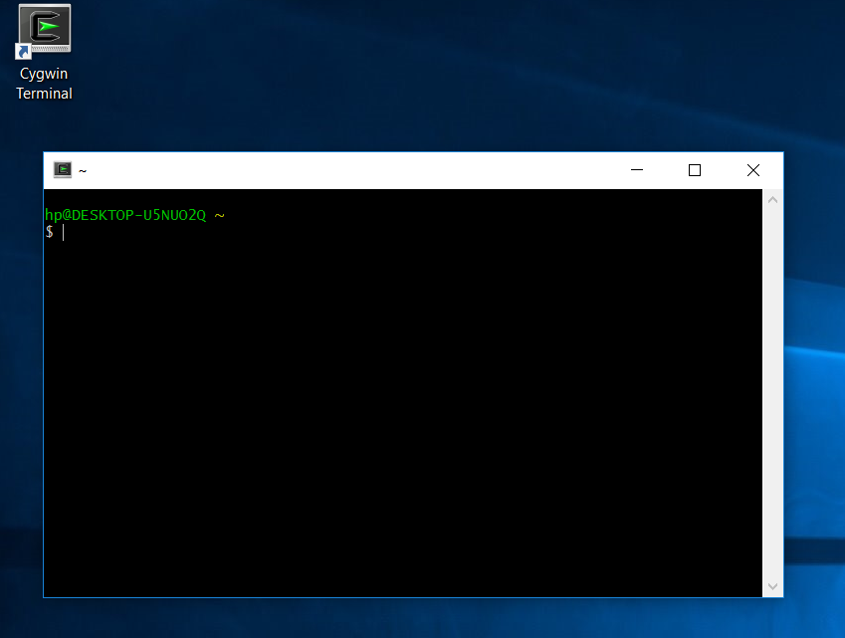

I also downloaded hadoop folder as seen from following screenshot:

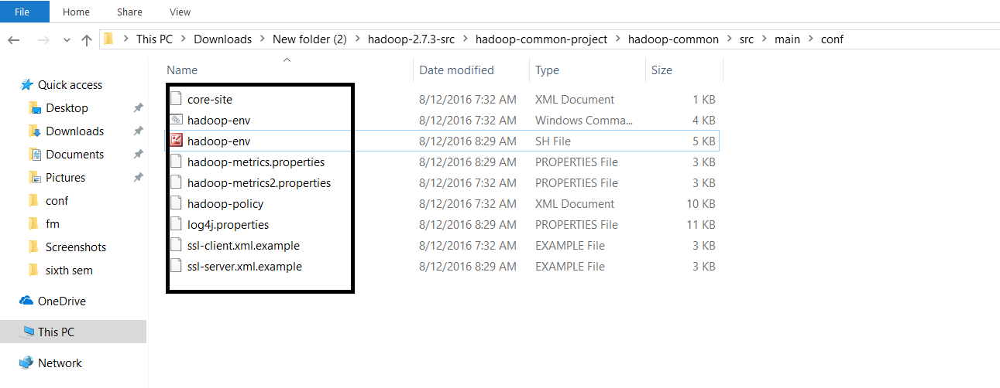

**How to Run and Analysis:**

I have used Java language. It is run on Net Beans IDE 1.8.I installed Cygwin and Hadoop.

**Link to the public repo on GitHub:**

https://github.com/ramshatariq