Android Application Framework for quickly developing DB backed applications

Submitted by

SHRIRAM D
Roll No.: 1201FOSS0019
Reg. No.: 75813150002

A PROJECT REPORT

Submitted to the

FACULTY OF SCIENCE AND HUMANITIES

in partial fulfilment for the requirement of award of the degree
of

MASTER OF SCIENCE
IN
FREE / OPEN SOURCE SOFTWARE (CS-FOSS)



CENTRE FOR DISTANCE EDUCATION
ANNA UNIVERSITY CHENNAI 600 025
FEBRUARY 2014

CENTRE FOR DISTANCE EDUCATION
ANNA UNIVERSITY CHENNAI 600 025

BONA FIDE CERTIFICATE

Certified that this Project report titled “Android Application Framework for quickly developing DB backed applications” is the bonafide work of Mr. Shriram D who carried out the research under my supervision. Certified further, that to the best of my knowledge the work reported herein does not form part of any other Project report or dissertation, on the basis of which a degree or award was conferred on an earlier occasion on this or any other candidate.

D.Shriram Dr. Sanjeev Kumar Saini
Student Guide

Project in-charge

CERTIFICATE OF VIVA-VOCE-EXAMINATION

This is to certify that Thiru/Ms./Tmt. ..........................................(Roll No. ........................; Register No. .............................) has been subjected to Viva-voce-Examination on ........................(Date) at ..............(Time) at the Study centre .................................................................(Name and Address of the Study centre)
Internal Examiner External Examiner
Name : Name :
(in capital letters) (in capital letters)
Designation : Designation :
Address : Address :
Coordinator centre
Name : (in capital letters)
Designation :
Address :

Date :

ACKNOWLEDGEMENT
I take this opportunity to express my profound gratitude and deep regards to my guide Dr. Sanjeev Kumar Saini for his exemplary guidance, monitoring and constant encouragement throughout the course of this project.
I also take this opportunity to express a deep sense of gratitude to AUKBC Staffs involved in M.Sc (CS-FOSS) Course for their cordial support, valuable information and guidance, which helped me in completing this task through various stages.
Lastly, I thank Anna University’s Centre for Distance Education (CDE) for providing M.Sc (CS-FOSS) course, without which this assignment would not be possible.

Shriram D

ABSTRACT
The main objective of the thesis was to provide a framework to generate android applications easily and quickly. The desired screen related requirements will be captured through PHP web page and it generates dynamic_fields_admin.xml. Also the php web page is provided with a feature for capturing style related informations(styles.xml) as well as a admin user and password for providing enhanced UI features and data abstraction to the Android Application. The Android Application Framework project will read the dynamic_fields_admin.xml and styles.xml and render the screen dynamically (with Sqlite database binding).
The following controls are covered in the current version of framework:
- Normal Edit Text Box
- Number Text Box
- Radio Button
- Date Picker
- Drop Down
- Checkbox
- Phone Text Box
- Multiline Text Box [Similar to rich text box]
- Password Text Box
- Email Text Box
- Web URL Text Box
The design and implementation of android application framework is described in this document. Android application framework is developed by using Eclipse IDE, Android SDK, ADT plugin for Eclipse.

திட்ட பணிசுருக்கம்

ஆய்வறிக்கை முக்கிய நோக்கம், எளிதாக மற்றும் விரைவில் அண்ட்ராய்டு பயன்பாடுகள் உருவாக்க ஒரு கட்டமைப்பை உருவாக்குதல். விரும்பிய திரை தொடர்பான தேவைகளைooa PHP வெப் பக்கம் மூலம் தகவல்களை கைப்பற்றப்பட்டு, அதை dynamic_fields_admin.xml மற்றும்
styles.xmlஆக உருவாக்குகிறது. அண்ட்ராய்டு கட்டமைப்பு திட்டம் dynamic_fields_admin.xml மற்றும் styles.xml படித்து, பின்னர் தானாக விரும்பிய திரை உருவாக்குகிறது.

தற்போதைய பதிப்பு, பின்வரும் உள்ளீடு வகைகளை விவாதிக்கப்படுகின்றன:
1. இயல்பான உரை வகை
2. எண்கள் வகை
3. ரேடியோ பட்டன் வகை
4. தேதி தேர்வாளர் வகை
5. கீழே இறக்கி வகை
6. டிக் வகை
7. தொலைபேசி எண் வகை
8. பலவரி உரை வகை
9. கடவுச்சொல் உரை வகை
10. மின்னஞ்சல் உரை வகை
11. மின்வலை URL உரை வகை
அண்ட்ராய்டு பயன்பாடு கட்டமைப்பை வடிவமைப்பு மற்றும் செயல்படுத்தல் இந்த ஆவணத்தில் விவரிக்கப்பட்டுள்ளது. அண்ட்ராய்டு பயன்பாடு கட்டமைப்பை எக்லிப்ஸ், அண்ட்ராய்டு SDK, எக்லிப்ஸ் ஏடிடீகளை பயன்படுத்தி உருவாக்கப்பட்டது.

TABLE OF CONTENTS

CHAPTER NO. | TITLE |  | PAGE NO.
 |  | ABSTRACT (ENGLISH) |  | iv
 |  | ABSTRACT (TAMIL) |  | v
 |  | ACKNOWLEDGEMENT |  | vi
 |  | LIST OF FIGURES |  | ix
 |  | LIST OF ABBREVATIONS |  | x
1 |  | INTRODUCTION |  | 1
 |  | 1.1 Objective |  | 1
 |  | 1.2 Sub Tasks |  | 1
 |  | 1.2.1 PHP Web Page |  | 1
 |  | 1.2.2 Android Application Framework to  generate dynamic UI |  | 1
 |  | 1.2.3 Generate and deploy the apk file |  | 2
 |  | 1.3 Current scope |  | 2
 |  | 1.4 Future Visions |  | 3
2 |  | REQUIREMENT ANALYSIS & DESIGN |  | 4
 |  | 2.1 Requirements |  | 4
 |  | 2.2 Use case diagram |  | 5
 |  | 2.3 Architecture |  | 6
 |  | 2.4 Class Diagram |  | 7
 |  | 2.4.1 Main Activity Class |  | 7
 |  | 2.4.2 Fields Class |  | 9
 |  | 2.4.3 MySQLiteOpenHelper Class |  | 9
3 |  | PHP |  | 10
 |  | 3.1 PHP Web Page |  | 10
 |  | 3.2 Generate XML |  | 11
 |  | 3.3 Apache Server |  | 14
CHAPTER NO. |  | TITLE |  | PAGE NO.
4 |  | ANDROID APPLICATION FRAMEWORK |  | 15
 |  | 4.1 Android |  | 15
 |  | 4.2 Android Application Framework |  | 16
 |  | 4.2.1 Read & Parse XML |  | 16
 |  | 4.2.2 Generate Dynamic Data Entry Screen |  | 17
 |  | 4.2.3 Sqlite Database Creation |  | 23
 |  | 4.2.4 Listing the stored data |  | 24
 |  | 4.2.5 Reset the stored data |  | 25
5 |  | GENERATE & DEPLOY APK FILE |  | 26
 |  | 5.1 Generate apk file |  | 26
 |  | 5.2 Deploy apk file in Android devices |  | 27
6 |  | TESTING |  | 28
 |  | 6.1 Issues & Status |  | 29
7 |  | CONCLUSIONS AND FUTURE WORKS |  | 30
 |  | APPENDIX I – SOURCE CODE |  | 31
 |  | REFERENCES |  | 59

LIST OF FIGURES

FIGURE NO. | TITLE | PAGE NO.
2.1 | Usecase Diagram | 5
2.2 | Architecture Diagram | 6
2.3 | Class Diagram | 7
3.1 | PHP Web Page to capture the field parameters | 10
3.2 | Check box – Field type | 12
3.3 | Dynamic_fields_Admin.xml for android application Framework | 13
3.4 | Styles.xml for customer information | 14
4.1 | Android Architecture | 15
4.2 | Dynamic controls creation – overview | 18
4.3 | Login Screen | 19
4.4 | Dynamic data entry screen | 20
4.5 | Dynamic list screen | 25
4.6 | Normal user | 26
5.1 | Apk file generation | 26

LIST OF ABBREVIATIONS

ADT | Android Development Tools
APK | Android application package file
DB | Database
XML | Extensible Markup Language
IDE | Integrated Development Environment
OS | Operating System
UML | Unified Modelling Language
PHP | Personal Home Page (Hypertext Preprocessor)
PDT | PHP Development Tools
CSV | Comma Separated Values
PDF | Portable Document Format

CHAPTER 1
INTRODUCTION

At present, Mobile Technology is an essential one to fulfil the customer’s day today needs. So a lot of research has been initiated in the field of mobile technology to address these various needs. Today almost every developers aim is to do project in mobile technology especially on the Android platform. This thought force initiated me to do a project in Android. The advantage of this framework is it enables Android users to create android application easy and quickly without any programming knowledge of Android or Java.

  - Objective
The main objective of the thesis is to design and implement a prototype of Android Application Framework. Here the Eclipse – ADT, Android Studio will be used for android application development. The Java programming language, Eclipse and the android Software Development Kit (SDK) will be used as the development tools and environment. Integrated development with the Eclipse IDE is selected for the development as it offers direct invoking of tools that are used for developing applications through the eclipse Android Development Tools (ADT) plug-in. Use case, architecture and class diagrams will be used to model activities and processes of the application in the requirements specification phase.
  - Sub Tasks
This project contain the following three sub tasks

PHP Web Page

PHP Web page is designed to get from users the following parameters:
- Application Name (mandatory)
- Admin User Name (mandatory)
- Admin Password (mandatory)
- Screen Name
- Field Name (mandatory)
- Field Type (mandatory)
- TypeFace
- TypeSize
- Color
- Field Values

After providing all the parameters, “Generate” button has been provided in the PHP Web page. Clicking this button will generate the dynamic_fields_admin.xml and styles.xml file used for generating the UI dynamically. The styles.xml file is generated using the values provided in Type face,Type size and color fields.

Android Application Framework to generate dynamic UI
Android Application framework will parse the dynamic_fields_admin.xml file and styles.xml and generate the UI screen based upon the field name, field type, field values,type face , type size and color values. The following are the sub tasks that needs to be done
- Parsing the XML.
- Generate the Screen for data entry for user specified fields.
- Create database, tables for the user specified fields & store the data into database.
- Providing the screen to list the user entered data as list view style.
- Rest option to delete the database, tables.

Generate and deploy the .apk file
Eclipse IDE provides facility to generate the apk file. After creating the apk file, it will be easy to deploy it in any of the Android Devices through android installer.
  - Current scope
The following controls are covered in the current version of the framework:
- Normal Edit Text Box

- Number Text Box

- Radio Button

- Date Picker

- Drop Down

- Checkbox

- Phone Text Box

- Multiline Text Box [Similar to rich text box]

- Password Text Box

- Email Text Box

- Web URL Text Box

  - Future Visions
To enhance the UI the Android Application Framework can be included with voice recognition feature. This way it could be still more apealing to the users for creating easy mobile applications.
Currently around 11 types of controls have been covered. In future, all the possible controls will be included in the android application framework.

CHAPTER 2
REQUIREMENT ANALYSIS & DESIGN

Requirements

Capture the parameters
To generate the Android application framework, the following points have been captured.

  - What is the title of application and screen name?

  - What are the fields have to create?

  - Each field data type?

  - How to get the admin User and password ?

  - What are the Type Face , Type Size and color of each field ?

  - How to enter the values for radio group controls, check boxes captions and drop down items.

If a user interface is provided, it will help in capturing all the user specific fields. So, the PHP web page is designed to address these user requirements.
PHP web page will also generate the dynamic_fields_admin.xml as well as styles.xml

Generating Dynamic Screen for data entry
Android Application Framework will read the dynamic_fields_admin.xml file and generate the dynamic screen which will be used to enter the values in each field. If successfull validation of user name and password for admin then it displays all the controls with edit and delete access to the user. If normal user it displays only the viewable screen for the entered data for the controls. Also it reads the styles.xml to bind the style properties to the controls while displaying in the screen.

Data Storage
Sqlite is used to create the database for storing the data.

Listing the entered data
All the entered data in each field will be displayed as a list view.

Reset Data
Reset option will delete the previous data.

Deploy the apk file in Android Devices
Finally, Android application framework will generate an apk file through eclipse ADT. It is directly deployed into the Android devices.

Use Case Diagram

The following use cases are captured in the use case diagram shown in Figure 2.1.
- Users access the PHP page and create the XML.

- Users generate dynamic android application by using android application framework project.

- Users deploy the apk file in android device.

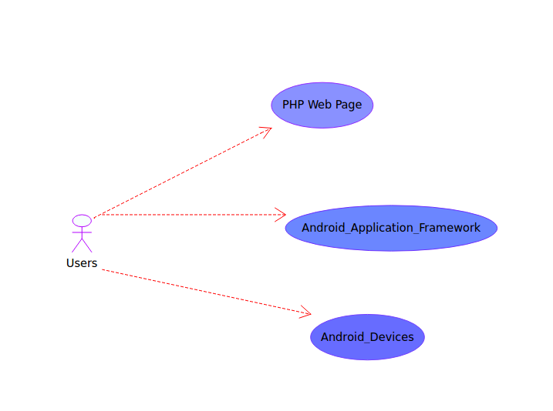

Figure 2.1. Use case diagram

Architecture

Overall architecture of Android Application Framework is as follows:

  - PHP Web Page generates xml file

  - Android Application Framework reads the xml file and generate dynamic screen

  - Sqlite database is used to store the data.

PHP Web Page
Users Enter the
Required fields
Data with admin
Credentials
Creation of
dynamic_fields_admin.xml
And styles.xml files
Android Application
Framework project
If not usccessfully validated,
The user is given access
Only to view the data for
The required controls.
If Successfully validated, the
User is given access to
Edit, view , delete the data
For the required controls.
Validation of
Admin
Credentials
Store data in SQLite database
Generation of Apk
file

Figure 2.2 Android Application Framework – Architecture Diagram

Class Diagram

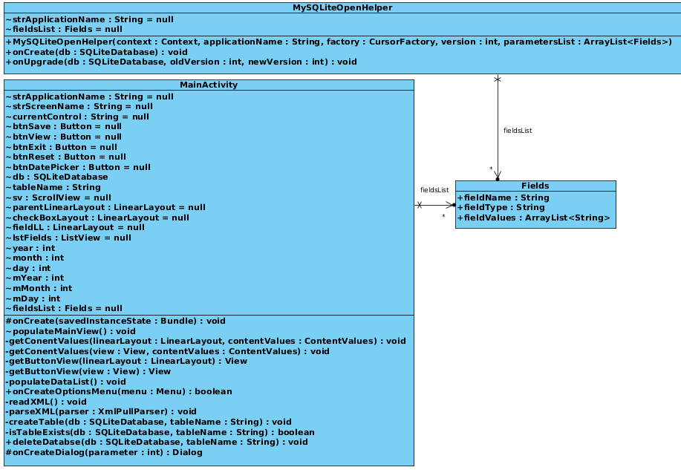

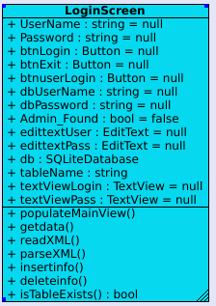

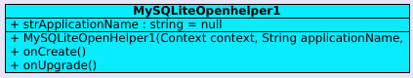

Figure 2.3. Android Application Framework – Class Diagram

Main Activity Class

PopulateMainView()
PopulateMainView() is the first and main method which calls the other sub methods. It initiates all the global variables.

ReadXML ()
This method is used to read the dynamic_fields.xml from the assets folder.

ParseXML()
In this method, dynamic_fields xml file is parsed and generate a list which hold the dynamic field details.

GetContentValues()
Two overloaded methods are used to construct dynamic controls structure list.

PopulateDataList()
Method used to create controls dynamically and added to parent linear layout control.
Creates database dynamic application based upon the application name if it was not created yet.
Generate dynamic list screen after storing data in sqlite database.
GetButtonView()
Two overloaded methods are used to generate Button for date picker control type.

DeleteDatabase()
Method used to delete the current database of the application.

Fields Class
The Field class is used to hold the dynamic field parameters like field name, field type and list of field values. In the MainActivity and MySQLiteOpenHelper classes, the fields class is used as a list.

MySQLiteOpenHelper Class

MySQLiteOpenHelper class is extended class of SQLiteOpenHelper. It is used to create database and table.

LoginScreen Class

PopulateMainView()
PopulateMainView() is the first and main method which calls the other sub methods. It initiates all the global variables.

ReadXML ()
This method is used to read the dynamic_fields.xml from the assets folder.

ParseXML()
In this method, dynamic_fields xml file is parsed and generate a list which hold the dynamic field details.
GetData()

Fetches the data from SQLite database and loads it into the String varialbes for validation.

IsTableExists()

The function checks if the table exists or not.

InsertInfo()

The function is called from PopulateMainView function to create the table for the android application.

Delete Info()

The function is called each time when the application framework is created to clear all the junk data from SQLite database.

MySqliteOpenHelper1 Class
MySQLiteOpenHelper class is extended class of SQLiteOpenHelper. It is used to create database and table.

CHAPTER 3
PHP

PHP is a server-side scripting language designed for web development but also used as a general-purpose programming language. PHP originally stood for Personal Home Page, it now stands for PHP: Hypertext Preprocessor.
PHP code is interpreted by a web server with a PHP processor module, which generates the resulting web page: PHP commands can be embedded directly into an HTML source document rather than calling an external file to process data. It has also evolved to include a command-line interface capability and can be used in standalone graphical applications.
PHP is free software released under the PHP License. PHP can be deployed on most web servers and also as a standalone shell on almost every operating system and platform, free of charge.

PHP Web Page
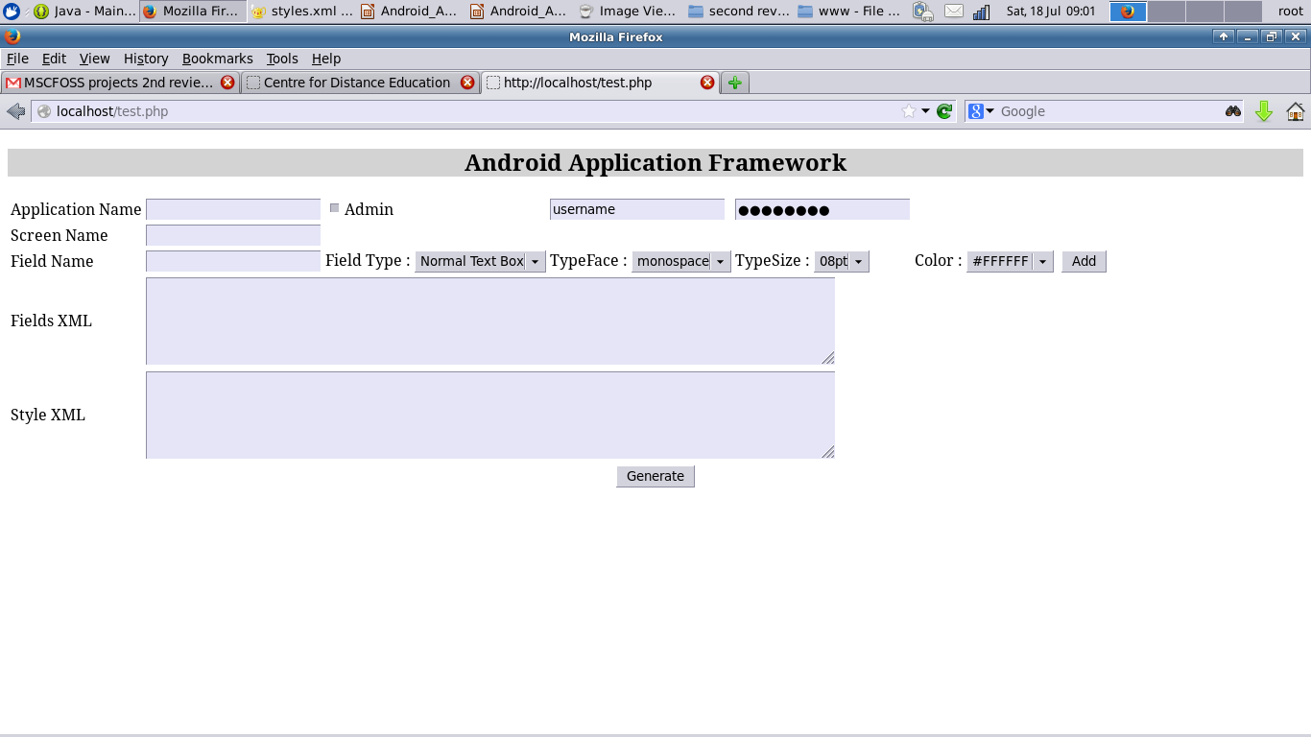

Figure 3.1. PHP Web Page to capture the field parameters
Application Name
Application name will represent the title of the screen in Android.
Admin
If this check box is enables two new text boxes appear to enter the admin user name and password.
Screen Name
Screen Name parameter represents functionality of the screen in Android.
Field Name
Field Name used to declare the unique field name.
Field Type
Field type represents the control type like normal text box, number text box, radio button, date picker, drop down, check box, phone text box, multiline text box, password text box,
Email text and web URL text box. If select on the following control type, then Field Value control will be visible.
- Radio Button

- Drop Down

- Checkbox

TypeFace

This is a drop down field for choosing the type face for the user defined control.
TypeSize
This is a drop down field for choosing the user defined control's size.

Type Color
This is a drop down field for choosing the user defined control's color.

Field Value
Field Value will be used to capture the values of radio button captions, drop down items or Check box captions.
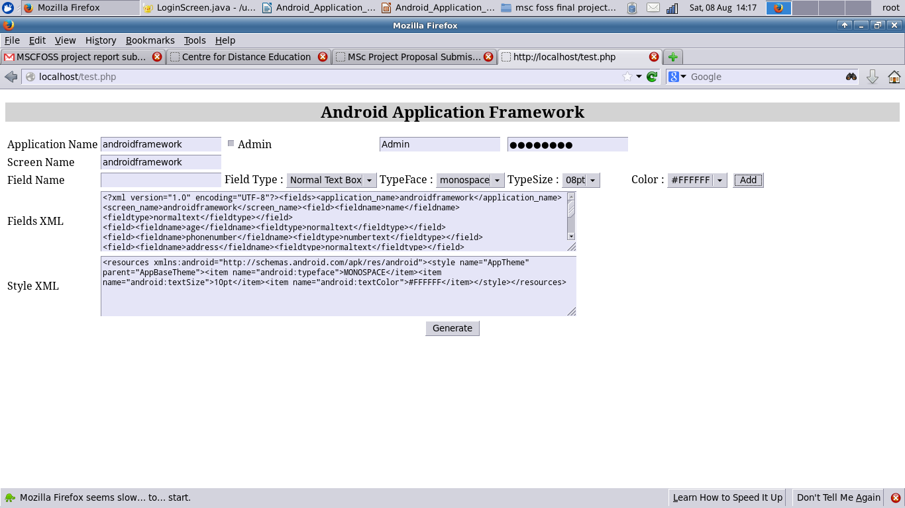

Figure 3.2. Check Box - Field Type

Generate XML
Whenever the user clicks on the “Add” button for the each field details, XML string will be populated in the XML textbox and is shown in Figure 5.
When the user clicks the “Generate” button, it will create the dynamic_fields_admin.xml file as well as styles.xml shown in Figure 3.3 and Figure 3.4
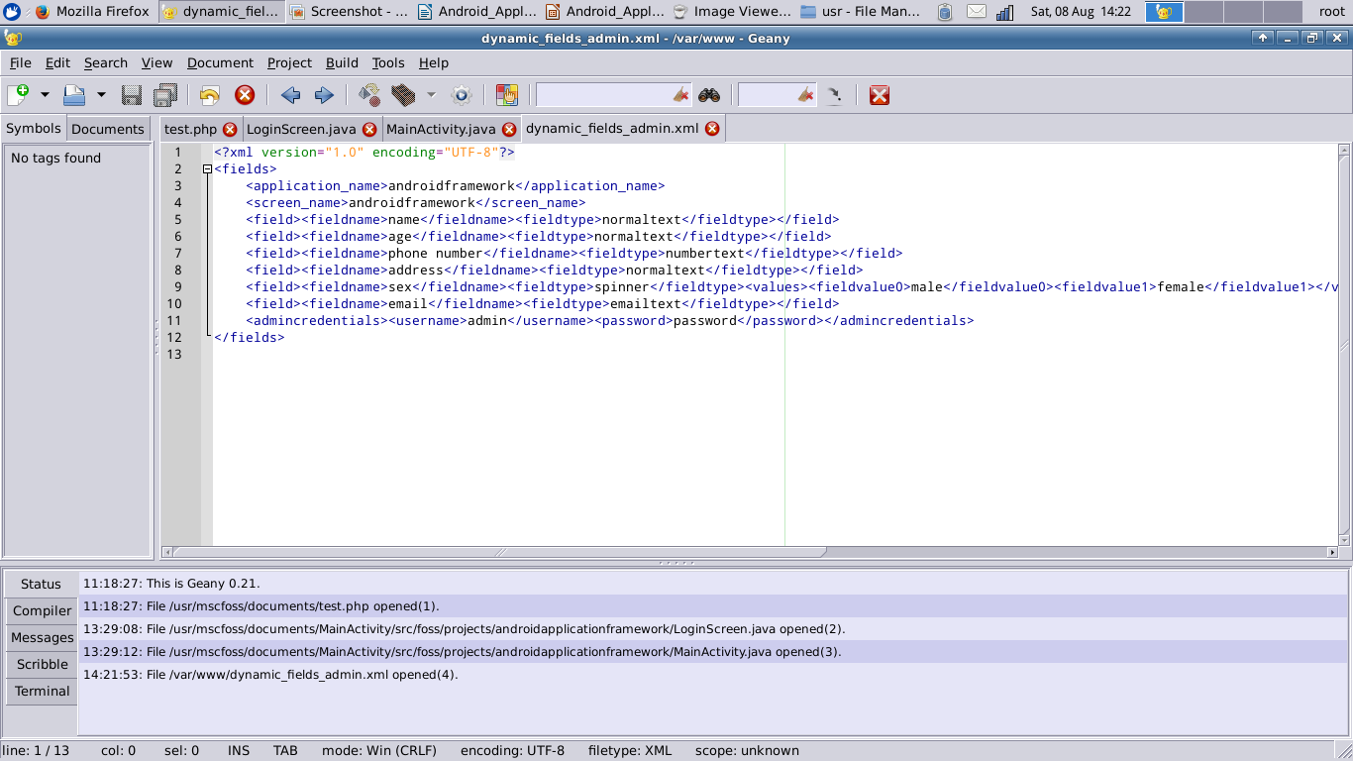

Figure 3.3. Dynamic_Fields_admin.xml for Android Framework

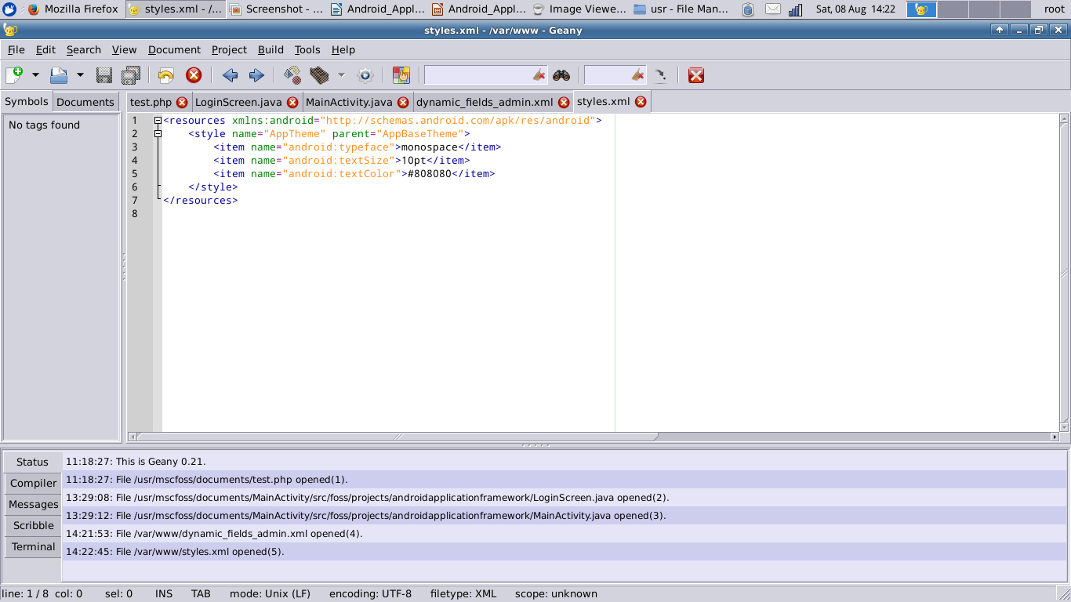
Figure 3.4. styles.xml for for Android Framework

Apache Server
Apache web server is widely used and is the most popular open source web server. PHP Web page - AndroidApplictionFramework.php is hosted in the Apache Web server.

CHAPTER 4
ANDROID APPLICATION FRAMEWORK

Android
Android is an operating system based on the Linux kernel, and designed primarily for touchscreen mobile devices such as smartphones and tablet computers.
The user interface of Android is based on direct manipulation, using touch inputs that loosely correspond to real-world actions, like swiping, tapping, pinching and reverse pinching to manipulate on-screen objects. Internal hardware such as accelerometers, gyroscopes and proximity sensors are used by some applications to respond to additional user actions, for example adjusting the screen from portrait to landscape depending on how the device is oriented. Android allows users to customize their home screens with shortcuts to applications and widgets, which allow users to display live content, such as emails and weather information, directly on the home screen. Applications can further send notifications to the user to inform them of relevant information, such as new emails and text messages.

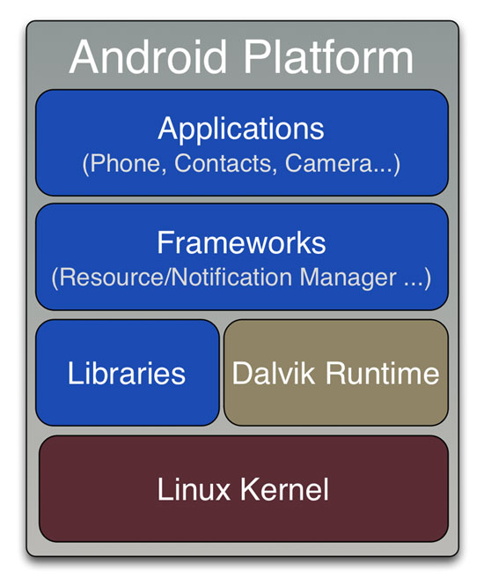
Figure 4.1. Android Architecture

Android Application Framework

The Android Application Framework is created based upon the default android project. After creating a new project in eclipse, it will generate one common template project with main activity.java.
Dynamic UI generation logic is based upon the xml, so all the logic has been moved into main activity.java. There are five main components i.e., Parse XML, Generate UI Screen, Sqlite Database creation, Rest Database and Listing the records.

Read & Parse XML

After generation of the dynamic_fields_admin.xml and styles.xml from php web page, it will be placed under /AndroidApplicationFramework/assets and /AndroidapplicationFramework/res/values/ folders respectively.
Android application framework readXML() method read the dynamic_fields_admin.xml (/AndroidApplicationFramework/assets) and styles.xml (/AndroidapplicationFramework/res/values/).
The parseXML() method will parse the dynamic_fields_admin.xml for the following elements:
- application_name
- screen_name
- field
  - fieldname
  - fieldtype
  - values
    - fieldvalue
At the time of parsing xml, one list will be created that holds the field details through fields class.
The Login Screen class also parses the dynamic_fields_admin.xml file to read the admin credentials with field name admincredentials and store it in the database. Once the data is validated successfully , through intent the MainActivity class is called.

Generate Dynamic Data Entry Screen

- Login Screen is the base view.
  - Once the admin credentials are successfully validated through an intent the MainActivity is called.
- MainActivity
  - Scroll View has been created and added with MainActivity.
    - Parent Layout has been created and add the following controls:
      - Text view with Application Name
      - Text view with Screen Name
      - Read the fields list recursively and create the linear control for each control
        - Create Text view for field name
        - Create dynamic control based upon the control type
For example, if control type is Normal Text box, then edit view is created. If control type is radio button, then radio buttons will be created and added with one radio group.

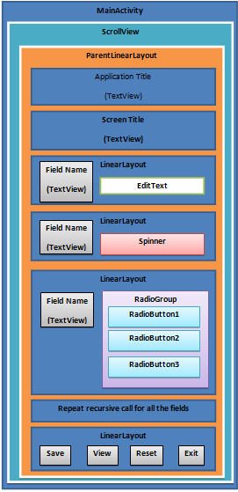
Figure 4.2. Dynamic controls creation - overview

The Login Screen will be displayed as given in the Figure 4.3.
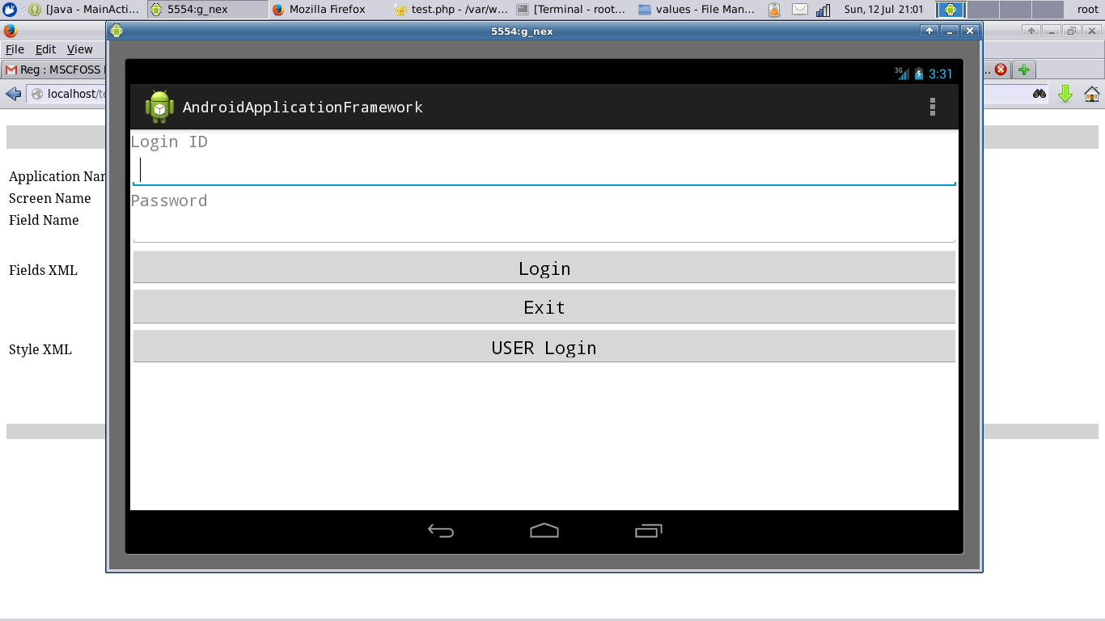

Figure 4.3. Login Screen

The dynamic screen will be generated after parsing the xml for admin user.
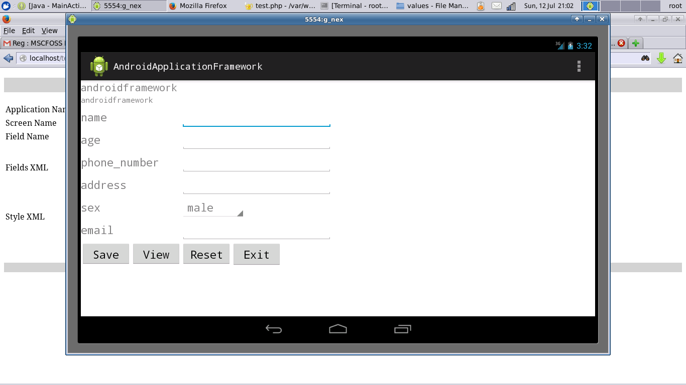

Figure 4.4. Dynamic data entry screen

Edit Text Control
Edit Text Control is common control and is used for various types. In Android there is option for Input Type, by using the input type various control type can be created based upon the user requirements.

Normal Edit Text

Control used to enter common text without restricting.
Number Text

Control used to enter only numbers.
InputType.TYPE_CLASS_NUMBER.

Email Text

Control used to enter email type fields.
InputType.TYPE_TEXT_VARIATION_EMAIL_ADDRESS

Phone Text

Control used to enter phone numbers
InputType.TYPE_CLASS_PHONE

URI Text
Control used to capture web site url details.
InputType.TYPE_TEXT_VARIATION_URI

Multiline Text

Control used to enter multiline text contents. The following Editor Info details have to provide at the time of setting the input type:
EditorInfo.TYPE_CLASS_TEXT | EditorInfo.TYPE_TEXT_FLAG_MULTI_LINE | EditorInfo.TYPE_TEXT_FLAG_IME_MULTI_LINE

Password Text
Control used to enter mask characters.
InputType.TYPE_MASK_VARIATION

Check Box Control

Check box control can be used for multiple option selection. Field Value list is holding the each check boxes caption. At the time of save, selected check box caption will be stored against the check box field name with comma separated values.
Radio Button Control

Radio Button control can be used to select at least one option among the various radio buttons. So while adding radio button controls, first of all, one radio group control created and then all the radio buttons have added into radio group control. So that user can able to select at least one radio button. Field Value list is holding the each radio button caption. At the time of save, selected radio button (0n) caption will be stored against the field name of radio button.

Drop Down Control (Spinner)

Drop down (Spinner) normally used to select one value from the list of values. Field Value list is holding all the list of values. At the time of save, the selected drop down value will be stored against the drop down field name.
Date Picker Control

Date Picker control is used to select the date from calendar. Button dynamically created with current date and added with parent linear layout. At the time of data entry, we can click on the button, so it will populate the calendar to select the required date. After date selection in the calendar, selected date value is assigned as button’s text.
At the time of save, button’s text (selected date value) will be stored against the date picker control field name.

Sqlite Database Creation

Android contains a set of C and C++ libraries that are responsible for performance optimization and efficiency. This includes SQLite that is a lightweight relational database engine.
At the time of controls creation, database has been created with the following name format:
dynamic_db_<application name>
Table has been created with <application name>. In this table, columns have been created with COL_<user specified field name>. If user specifies space between words, then space will be replaced by underscore (“_”) to avoid issues. For example of Android Framework, user specified application name as “androidframework” then the database will be created as below:
Database : dynamic_db_androidframework
Table : androidframework
Columns : COL_ID (Primary Key, Auto generated unique number)
: COL_Name (Text)
: COL_age (Text)
: COL_phone number (Text)
: COL_address (Text)
: COL_sex (Text)
: COL_email (Text)

Database : dynamic_db_androidframework
Table : Android_Admin
Columns : COL_ID (Primary Key, Auto generated unique number)
: COL_Username (Text)
: COL_Password (Text)

Listing the stored data

List the stored the data by creating the TextView controls for each field name and its value.
- MainActivity is the base view.
  - Scroll View has been created and added with MainActivity.
    - Parent Layout has been created and add the following controls:
- Text view with Application Name
- Text view with Screen Name
- Read the fields list recursively and create the linear control for each control
- Create Text view for field name : field value
- Back button
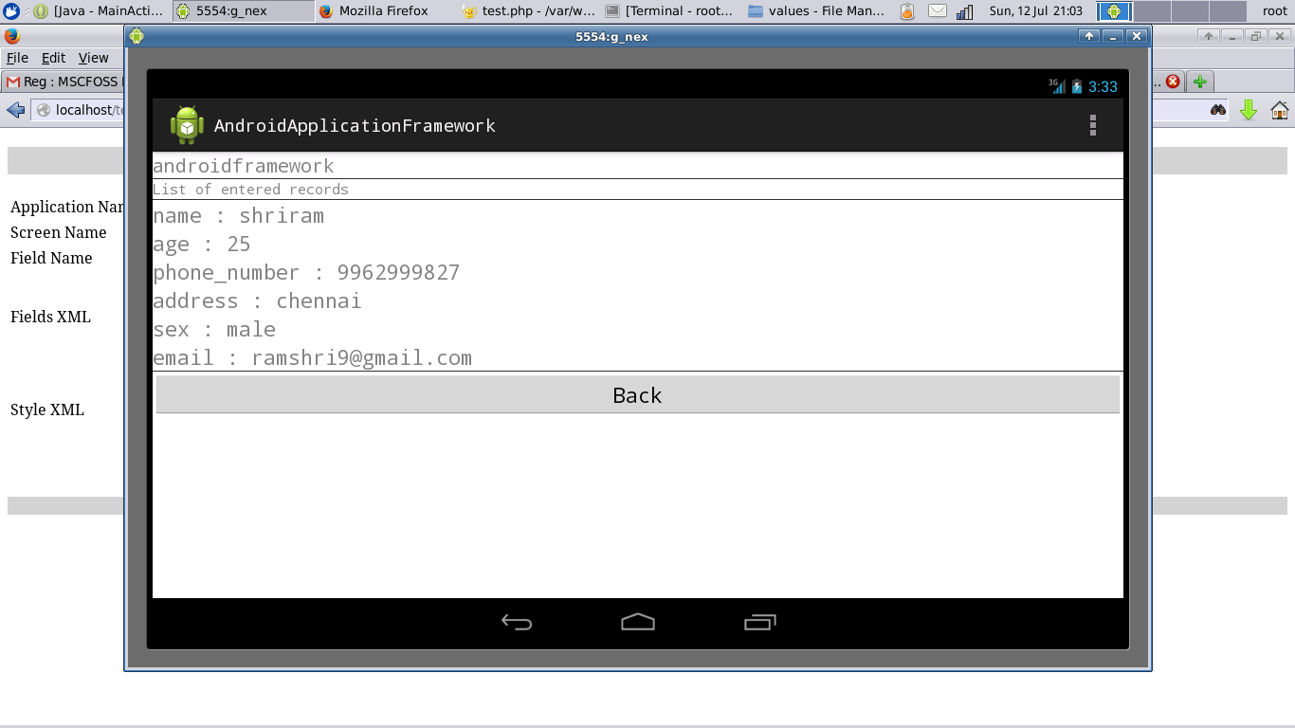

Figure 4.5. Dynamic List Screen

When press on Back Button, then home page will be shown for entering further data.

Reset the stored data

When press on the Reset Button, then Delete the dynamic database, tables for the application. Exit button used to quit from the application.
1.10.6 Dynamic Fields for Normal User
When the login credentials are not correct, the user can login as a normal user. The data for the created controls will be fetched from SQLite database and displayed to the user. Only the View option will be enabled for the normal users whereas for the Admin user Save and Reset Options will be enabled. After loggin as a normal user, the screen will be displayed as given in the figure 4.6 below. Figure 4.6 Normal user
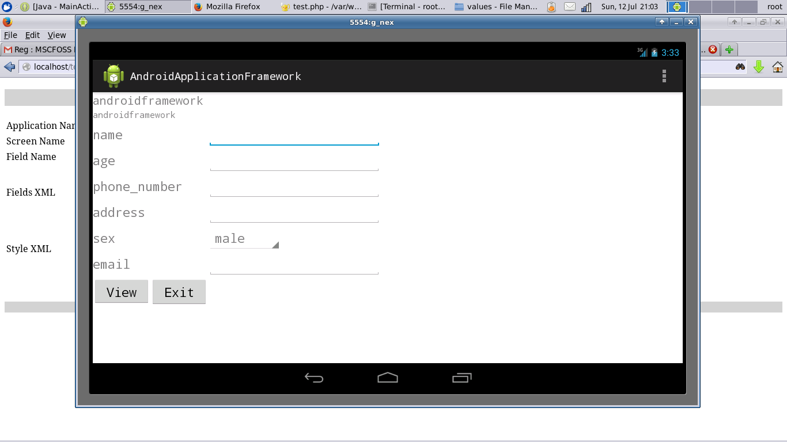

CHAPTER 5
GENERATE AND DEPLOYING APK FILE

Generate apk file

Android applications are written in the Java language, compiled into byte codes which will be converted to a .dex file (Dalvik executable file) using the dx converter. This will further be compiled in to android application package file (apk file), that can be installed on the android devices.
The following diagram depicts the components involved in building and running an application:

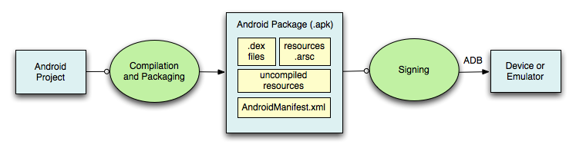
Figure 5.1. Apk file generation

In Eclipse, the ADT plugin incrementally builds your project as you make changes to the source code. Eclipse outputs an .apk file automatically to the bin folder of the project, so you do not have to do anything extra to generate the .apk.

Deploy apk file in Android device

Android Apps Installer is used to install the apk in devices.
The following steps have to follow to deploy the apk into android device:
- Copy the AndroidApplicationFramework.apk file into android’s device memory.
- Download and install the Apps Installer application from the Android Market
- Once installed, the Apps Installer will display the APK files on the memory card.
- Double Click on the AndroidApplicationFramework.apk file, it will be installed on the Android device.

CHAPTER 6
TESTING

Unit testing is very important at the time of development. All the unit test cases have been identified at the time of requirement analysis. So, it was easy to test the unit test cases and fix the issues quickly.
In Android application framework project, all the possible control type has been used and tested.
There are unique scenarios for Radio button, Date Picker, Check box and Drop down control type. But all the controls have been used in two kind of sample application.
Also the application were tested with different attributes for color, typeface and type size. Each scenario were tested with correct username password for admin credentials and wrong credentials.
To test Android application framework, there are two sample application has been created and tested.
- Patient Information System
  - Patient Name : Normal Text Edit control type
  - Patient Age : Number Text Edit control type
  - Sex : Radio button control type
  - Patient Phone : Phone Text Edit control type
  - Patient Email : Email Text Edit control type
  - Patient Diseases : Check box control type
  - Last Consultation Date : Date picker control type
  - Next Appointment Date : Date picker control type

- AndroidApplicationFramework
  - Name : Normal Text Edit control type
  - Age : Number Text Edit control type
  - Phone : Phone Text Edit control type
  - Address : Normal Text Edit Control type
  - Sex : Radio button control type
  - Email : Email Text Edit control type

- Next Appointment Date : Date picker control type

Issues & Status

Initially there was issue noticed at the time of saving the data. It was not stored in SQLite database.
When debugging, it was identified that creation of database has issues and it was resolved.
There were few issues while binding the controls with the layout in the android application. Debugged the same and corrected to correctly bind the contorls.
There were some issues when calling the main activity through intent. Later it was found out to be a syntactical error and identified and fixed the same.

CHAPTER 7
CONCLUSIONS AND FUTURE WORKS

The thesis project has covered Android application framework in the Android Platform. It explains briefly the need for the framework and its intended user. The requirement analysis and design and the tools and technologies used are explained. The Basic components of Android applications framework is described briefly. The generation and deployment of the apk file is explained followed by the testing. The goal of the project i.e. creation of an Android Application Framework is achieved. Even though the goal of the project is achieved there are a few more features and challenges that needs to be done in the future and these have been identified as below:
- Currently around 11 types of controls have been covered. In future, all the possible controls will be included in the android application framework.
- To enhance the UI the Android Application Framework can be included with voice recognition feature. This way it could be still more apealing to the users for creating easy mobile applications.

APPENDIX I
SOURCE CODE

Android_Application_Framework.php
<html>
<head>
<script type="text/javascript">

/*
* Function used to create XML for all the controls and populate in txtXML.
*/
var main_xml;
function addText()
{
//Variables decalaration
var applicationTitle, screenTitle, selectedControls,controlName,controlType,controlValue, xmlText,typeface,typesize,styleText,adminuser,adminspass;

//Assign values
applicationTitle = document.getElementById("txtApplicationName").value;
screenTitle = document.getElementById("txtScreenName").value;
selectedControls = document.getElementById("txtXml").value;
selectedStyle = document.getElementById("stylexml").value;
controlName = document.getElementById("controlName").value;
controlType = document.getElementById("controlType").value;
controlValue = document.getElementById("controlValue").value;
typeface = document.getElementById("FontFace").value;
typesize = document.getElementById("TypeSize").value;
color = document.getElementById("Color").value;

//Framing xml
xmlText = "\<\?xml version=\"1.0\" encoding=\"UTF-8\"\?\>\<fields\>";
styleText = "\<resources xmlns\:android=\"http://schemas.android.com/apk/res/android\">";

//Application Name
xmlText = xmlText + "<application_name>"+applicationTitle+"</application_name>";

//Screen Name
xmlText = xmlText + "<screen_name>"+applicationTitle+"</screen_name>";
styleText = styleText + "\<style name=\"AppTheme\" parent=\"AppBaseTheme\">";

if ( selectedControls.length > 0 )
{
xmlText = selectedControls.replace("</fields>","") + "\n" + getXml(controlName,controlType,controlValue);
}
else
{
xmlText = xmlText + getXml(controlName,controlType,controlValue);
}
xmlText = xmlText + "</fields>";
//if(document.getElementById("radadmin").checked)
//{
//adminuser = document.getElementById("adminuser").value;
//adminpass = document.getElementById("adminpass").value;
//xmlText = xmlText + "<admincredentials>";
//xmlText = xmlText + "<username>"+adminuser+"</username>";
//xmlText = xmlText + "<password>"+adminpass+"</password>";
//xmlText = xmlText + "</admincredentials>";
//}
//else
//{

//}

document.getElementById("txtXml").innerHTML = xmlText;
main_xml = xmlText;

styleText = styleText + "\<item name=\"android:typeface\">" + typeface + "</item>";
styleText = styleText + "\<item name=\"android:textSize\">" + typesize + "</item>";
styleText = styleText + "\<item name=\"android:textColor\">" + color + "</item>";
styleText = styleText + "</style>";
styleText = styleText + "</resources>";

document.getElementById("stylexml").innerHTML = styleText;

//Clear the content of the control
document.getElementById("controlName").value = "";
document.getElementById("controlType").selectedIndex = 0;
document.getElementById("controlValue").value = "";
}

/*
* Function used to show or hide the controlValue based upon the control type
* Usually control values parameter is required only for Drop down, Radio Button and Checkbox
*/
function visibleControl(sel)
{
var controlType = sel.options[sel.selectedIndex].value;
if ( controlType == "spinner" || controlType == "radiobutton" || controlType == "checkbox" )
{
document.getElementById("controlValue").style.display = "block";
}
else
{
document.getElementById("controlValue").style.display = "none";
}
}

function displaytext()
{
//var AdminValue = document.getElementById("radadmin").value;
if(document.getElementById("radadmin").checked)
{
document.getElementById("adminuser").disabled= false;
document.getElementById("adminpass").disabled= false;

document.getElementById("adminuser").style.visibility = "visible";
document.getElementById("adminpass").style.visibility = "visible";
}
else
{
//document.getElementById("adminuser").value= '';
//document.getElementById("adminpass").value= '';

document.getElementById("adminuser").disabled= true;
document.getElementById("adminpass").disabled= true;

document.getElementById("adminuser").style.visibility = "hidden";
document.getElementById("adminpass").style.visibility = "hidden";
}
}

/*
* Function used to ammend the | symbol when press enter key
*/
function fKeyDown(e)
{
var kc = window.event ? window.event.keyCode : e.which;
if (kc == 13)
{
document.getElementById('controlValue').value = document.getElementById('controlValue').value + "|";
}
}

/*
* Function used to get the XML based upon each control add
*/
function getXml(controlName, controlType, controlValue)
{
var xmlText = "<field><fieldname>" + controlName + "</fieldname>";
xmlText = xmlText + "<fieldtype>" + controlType +"</fieldtype>";
if (controlValue.length > 0 )
{
var controlValues = controlValue.split("|");
if (controlValues.length > 0 )
{
xmlText = xmlText + "<values>";
for (var index=0,len=controlValues.length; index<len; index++)
{

xmlText = xmlText + "<fieldvalue"+index+">"+ controlValues[index] +"</fieldvalue"+index+">";
}
xmlText = xmlText + "</values>";
}
}
xmlText=xmlText + "</field>";
return xmlText;
}

function loadcontrols()
{
document.getElementById("adminuser").style.visibility = "hidden";
document.getElementById("adminpass").style.visibility = "hidden";
}
function checkadmin()
{
var adminuser,adminpass;
if(document.getElementById("radadmin").checked)
{
adminuser = document.getElementById("adminuser").value;
adminpass = document.getElementById("adminpass").value;
main_xml = main_xml + "<admincredentials>";
main_xml = main_xml + "<username>"+adminuser+"</username>";
main_xml = main_xml + "<password>"+adminpass+"</password>";
main_xml = main_xml + "</admincredentials>";
document.getElementById("txtXml").innerHTML = main_xml;
}

}

</script>
</head>
<body onload="loadcontrols();">
<div style="background-color:lightgrey"><h2 align="center">Android Application Framework</h2></div>
<form method="post" action="<?php echo $_SERVER['PHP_SELF']; ?>">
<table>
<tr>
<td>Application Name</td>
<td><input type="text" name="txtApplicationName" id="txtApplicationName"/></td>
<td><input type="checkbox" name="adminval" id="radadmin" onchange="displaytext();"/>Admin </td>
<td><input type="text" name="username" id="adminuser" value="username"/> </td>
<td><input type="password" name="adminpassword" id="adminpass" value="password"/> </td>
</tr>
<tr>
<td>Screen Name</td><td><input type="text" name="txtScreenName" id="txtScreenName"/></td>
</tr>
<tr border><td>Field Name</td><td><input type="text" name="controlName" id="controlName"></td>
<td>
Field Type :
<select name="controlType" id="controlType" onchange="visibleControl(this);">
<option value="normaltext">Normal Text Box</option>
<option value="numbertext">Number</option>
<option value="radiobutton">Radio Button</option>
<option value="datepicker">Date Picker</option>
<option value="spinner">Drop Down</option>
<option value="checkbox">Check Box</option>
<option value="phonetext">Phone</option>
<option value="multilinetext">Multiline Text</option>
<option value="passwordtext">Password Text</option>
<option value="emailtext">Email</option>
<option value="uritext">Web URL</option>
</select>
</td>
<td>
TypeFace :
<select name="FontFace" id="FontFace" onchange="visibleControl(this);">
<option value="MONOSPACE">monospace</option>
<option value="SERIF">serif</option>
</select>
</td>
<td>
TypeSize :
<select name="TypeSize" id="TypeSize" onchange="visibleControl(this);">
<option value="10pt">08pt</option>
<option value="10pt">09pt</option>
<option value="10pt">10pt</option>
<option value="10pt">11pt</option>
<option value="12pt">12pt</option>
<option value="15pt">13pt</option>
<option value="15pt">14pt</option>
<option value="15pt">15pt</option>
</select>
</td>
<td>
Color :
<select name="Color" id="Color" onchange="visibleControl(this);">
<option value="#FFFFFF">#FFFFFF</option >
<option value="#FFFF00">#FFFF00</option >
<option value="#FF00FF">#FF00FF</option >
<option value="#FF0000">#FF0000</option >
<option value="#C0C0C0">#C0C0C0</option >
<option value="#808080">#808080</option >
<option value="#808000">#808000</option >
<option value="#800080">#800080</option >
<option value="#800000">#800000</option >
<option value="#00FFFF">#00FFFF</option >
<option value="#00FF00">#00FF00</option >
<option value="#008080">#008080</option >
<option value="#008000">#008000</option >
<option value="#0000FF">#0000FF</option >
<option value="#000080">#000080</option >
<option value="#000000">#000000</option >
</select>
</td>
<td>
<textarea name="controlValue" id="controlValue" rows="5" cols="30" style="display:none" onKeyDown=javascript:fKeyDown(event);></textarea>
</td>
<td><input type="button" onclick="addText();" name="btnAdd" value="Add" width="100"/></td>
</tr>
<tr>
<td>Fields XML </td><td colspan="6" align="left"><textarea name="txtXml" id="txtXml" rows="5" cols="100"></textarea>
</td>
</tr>
<tr>
<td>Style XML </td><td colspan="6" align="left"><textarea name="stylexml" id="stylexml" rows="5" cols="100"></textarea>
</td>
</tr>
<tr></tr>

</table>
<div align="center"><input type="submit" name="submit" value="Generate" align="center" onclick="checkadmin();"></div>
<p style="background-color:lightgrey" align="center">
<?php
if(isset($_POST['submit']))
{
$txtXml = $_POST['txtXml'];
$var = file_put_contents("/var/www/dynamic_fields_admin.xml",$txtXml);
$stylexml = $_POST['stylexml'];
$var1 = file_put_contents("/var/www/styles.xml",$stylexml);
echo $var;
echo "dynamic_fields.xml has been generated successfully";
}
?>
</p>
</form>
</body>
</html>

dynamic_fields_admin.xml

<?xml version="1.0" encoding="UTF-8"?>
<fields>
<application_name>androidframework</application_name>
<screen_name>androidframework</screen_name>
<field><fieldname>name</fieldname><fieldtype>normaltext</fieldtype></field>
<field><fieldname>age</fieldname><fieldtype>normaltext</fieldtype></field>
<field><fieldname>phone number</fieldname><fieldtype>numbertext</fieldtype></field>
<field><fieldname>address</fieldname><fieldtype>normaltext</fieldtype></field>
<field><fieldname>sex</fieldname><fieldtype>spinner</fieldtype><values><fieldvalue0>male</fieldvalue0><fieldvalue1>female</fieldvalue1></values></field>
<field><fieldname>email</fieldname><fieldtype>emailtext</fieldtype></field>
<admincredentials><username>admin</username><password>password</password></admincredentials>
</fields>

styles.xml

<resources xmlns:android="http://schemas.android.com/apk/res/android">
<style name="AppTheme" parent="AppBaseTheme">
<item name="android:typeface">monospace</item>
<item name="android:textSize">10pt</item>
<item name="android:textColor">#808080</item>
</style>
</resources>

MainActivity.java

private void readXML()
{
XmlPullParserFactory pullParserFactory;
try
{
pullParserFactory = XmlPullParserFactory.newInstance();
XmlPullParser parser = pullParserFactory.newPullParser();

AssetManager assetManager = getAssets();
InputStream inputStream = assetManager.open("dynamic_fields.xml");
//InputStream in_s = getApplicationContext().getAssets().open("dynamic_fields.xml");
parser.setFeature(XmlPullParser.FEATURE_PROCESS_NAMESPACES, false);
parser.setInput(inputStream, null);

parseXML(parser);

}
catch (XmlPullParserException e)
{
e.printStackTrace();
}
catch (IOException e)
{
e.printStackTrace();
}
}

private void parseXML(XmlPullParser parser) throws XmlPullParserException,IOException
{

int eventType = parser.getEventType();
Fields currentField = null;

while (eventType != XmlPullParser.END_DOCUMENT){
String name = null;
switch (eventType){
case XmlPullParser.START_DOCUMENT:
fieldsList = new ArrayList();
break;
case XmlPullParser.START_TAG:
name = parser.getName();
if (name.equalsIgnoreCase("application_name"))
{
this.strApplicationName = parser.nextText();
}
else if (name.equalsIgnoreCase("screen_name"))
{
this.strScreenName = parser.nextText();
}
else if (name.equalsIgnoreCase("field"))
{
currentField = new Fields();
}
else if (currentField != null)
{
if (name.equalsIgnoreCase("fieldname"))
{
currentField.fieldName = parser.nextText();
currentField.fieldName = currentField.fieldName.replace(' ', '_');
}
else if (name.equalsIgnoreCase("fieldtype"))
{
currentField.fieldType = parser.nextText();
}
else if (name.equalsIgnoreCase("values"))
{
currentField.fieldValues = new ArrayList<String>();
}
else if (name.startsWith("fieldvalue"))
{
currentField.fieldValues.add(parser.nextText());
}

}
break;
case XmlPullParser.END_TAG:
name = parser.getName();
if (name.equalsIgnoreCase("field") && currentField != null)
{
fieldsList.add(currentField);
}

}

eventType = parser.next();
}

}

void populateMainView()
{
sv = new ScrollView(this);
sv.setLeft(10);
parentLinearLayout = new LinearLayout(this);
parentLinearLayout.setGravity(parentLinearLayout.TEXT_ALIGNMENT_GRAVITY);
parentLinearLayout.setOrientation(LinearLayout.VERTICAL);
sv.addView(parentLinearLayout);

parentLinearLayout.setDividerPadding(5);

TextView textViewControl = null;
EditText editTextControl = null;
RadioGroup radioGroup = null;
RadioButton radioButtonControl = null;
Spinner spinnerControl = null;
CheckBox checkBox = null;

//Read the Fields xml file
readXML();

LinearLayout.LayoutParams params = new LinearLayout.LayoutParams(
ViewGroup.LayoutParams.FILL_PARENT, ViewGroup.LayoutParams.WRAP_CONTENT);
params.gravity = Gravity.CENTER;

//Set Application Title
textViewControl = new TextView(this);
textViewControl.setText(strApplicationName);
textViewControl.setLeft(10);
textViewControl.setGravity(View.TEXT_ALIGNMENT_CENTER);
textViewControl.setTextSize(20);
textViewControl.setLayoutParams(params);
parentLinearLayout.addView(textViewControl);

View line = new View(this);
line.setLayoutParams(new ViewGroup.LayoutParams(ViewGroup.LayoutParams.FILL_PARENT, 1));
line.setBackgroundColor(Color.rgb(51, 51, 51));
parentLinearLayout.addView(line);

//Set Table Name
tableName = strApplicationName.replace(' ','_');

//Set Screen heading
textViewControl = new TextView(this);
textViewControl.setText(strScreenName);
textViewControl.setLeft(10);
textViewControl.setTextSize(15);
textViewControl.setLayoutParams(params);
parentLinearLayout.addView(textViewControl);

line = new View(this);
line.setLayoutParams(new ViewGroup.LayoutParams(ViewGroup.LayoutParams.FILL_PARENT, 1));
line.setBackgroundColor(Color.rgb(51, 51, 51));
parentLinearLayout.addView(line);

//Create all the controls for fields dynamically
if ( fieldsList != null && fieldsList.size() > 0 )
{
for(Fields currentField : fieldsList)
{
fieldLL = new LinearLayout(this);
fieldLL.setOrientation(LinearLayout.HORIZONTAL);
fieldLL.setLeft(10);
if (currentField.fieldType.equalsIgnoreCase("normaltext"))
{
textViewControl = new TextView(this);
textViewControl.setText(currentField.fieldName);
textViewControl.setWidth(200);
fieldLL.addView(textViewControl);

editTextControl = new EditText(this);
editTextControl.setWidth(300);
editTextControl.setTag(currentField.fieldName);
fieldLL.addView(editTextControl);

}
else if (currentField.fieldType.equalsIgnoreCase("emailtext"))
{
textViewControl = new TextView(this);
textViewControl.setText(currentField.fieldName);
textViewControl.setWidth(200);
fieldLL.addView(textViewControl);

editTextControl = new EditText(this);
editTextControl.setWidth(300);
editTextControl.setTag(currentField.fieldName.replace(' ', '_'));
editTextControl.setInputType(InputType.TYPE_TEXT_VARIATION_EMAIL_ADDRESS);
fieldLL.addView(editTextControl);

}
else if (currentField.fieldType.equalsIgnoreCase("phonetext"))
{
textViewControl = new TextView(this);
textViewControl.setText(currentField.fieldName);
textViewControl.setWidth(200);
fieldLL.addView(textViewControl);

editTextControl = new EditText(this);
editTextControl.setWidth(300);
editTextControl.setTag(currentField.fieldName);
editTextControl.setInputType(InputType.TYPE_CLASS_PHONE);
fieldLL.addView(editTextControl);
}
else if (currentField.fieldType.equalsIgnoreCase("numbertext"))
{
textViewControl = new TextView(this);
textViewControl.setText(currentField.fieldName);
textViewControl.setWidth(200);
fieldLL.addView(textViewControl);

editTextControl = new EditText(this);
editTextControl.setWidth(300);
editTextControl.setTag(currentField.fieldName);
editTextControl.setInputType(InputType.TYPE_CLASS_NUMBER);
fieldLL.addView(editTextControl);
}
else if (currentField.fieldType.equalsIgnoreCase("uritext"))
{
textViewControl = new TextView(this);
textViewControl.setText(currentField.fieldName);
textViewControl.setWidth(200);
fieldLL.addView(textViewControl);

editTextControl = new EditText(this);
editTextControl.setWidth(300);
editTextControl.setTag(currentField.fieldName);
editTextControl.setInputType(InputType.TYPE_TEXT_VARIATION_URI);
fieldLL.addView(editTextControl);
}
else if (currentField.fieldType.equalsIgnoreCase("multilinetext"))
{
textViewControl = new TextView(this);
textViewControl.setText(currentField.fieldName);
textViewControl.setWidth(200);
fieldLL.addView(textViewControl);

editTextControl = new EditText(this);
editTextControl.setWidth(300);
editTextControl.setTag(currentField.fieldName);
editTextControl.setSingleLine(false);

editTextControl.setImeOptions(EditorInfo.IME_FLAG_NO_EXTRACT_UI);
editTextControl.setFocusableInTouchMode(true);
editTextControl.setInputType(EditorInfo.TYPE_CLASS_TEXT | EditorInfo.TYPE_TEXT_FLAG_MULTI_LINE | EditorInfo.TYPE_TEXT_FLAG_IME_MULTI_LINE);
editTextControl.setMaxLines(Integer.MAX_VALUE);
editTextControl.setHorizontallyScrolling(false);
editTextControl.setTransformationMethod(null);
fieldLL.addView(editTextControl);
}
else if (currentField.fieldType.equalsIgnoreCase("passwordtext"))
{
textViewControl = new TextView(this);
textViewControl.setText(currentField.fieldName);
textViewControl.setWidth(200);
fieldLL.addView(textViewControl);

editTextControl = new EditText(this);
editTextControl.setWidth(300);
editTextControl.setTag(currentField.fieldName);
editTextControl.setInputType(InputType.TYPE_MASK_VARIATION);
fieldLL.addView(editTextControl);
}
else if (currentField.fieldType.equalsIgnoreCase("datepicker"))
{
textViewControl = new TextView(this);
textViewControl.setText(currentField.fieldName);
textViewControl.setWidth(200);
fieldLL.addView(textViewControl);

btnDatePicker = new Button(this);

btnDatePicker.setTag(currentField.fieldName.replace(' ', '_'));
fieldLL.addView(btnDatePicker);

final Calendar c = Calendar.getInstance();
mYear = c.get(Calendar.YEAR);
mMonth = c.get(Calendar.MONTH) + 1;
mDay = c.get(Calendar.DAY_OF_MONTH);

btnDatePicker.setText(mDay+"/"+mMonth+"/"+mYear);

// Set ClickListener on btnDatePicker
btnDatePicker.setOnClickListener(new View.OnClickListener() {

public void onClick(View v)
{
currentControl = v.getTag().toString();
// Show the DatePickerDialog
showDialog(0);
}
});
}
else if (currentField.fieldType.equalsIgnoreCase("radiobutton"))
{
textViewControl = new TextView(this);
textViewControl.setText(currentField.fieldName);
textViewControl.setLeft(10);
textViewControl.setWidth(200);
fieldLL.addView(textViewControl);

radioGroup = new RadioGroup(this);
for(String fieldValue : currentField.fieldValues)
{
radioButtonControl = new RadioButton(this);
radioButtonControl.setText(fieldValue);
radioButtonControl.setTag(fieldValue.replace(' ','_'));
radioGroup.addView(radioButtonControl);
}
fieldLL.addView(radioGroup);
}
else if (currentField.fieldType.equalsIgnoreCase("spinner"))
{
textViewControl = new TextView(this);
textViewControl.setText(currentField.fieldName);
textViewControl.setLeft(10);
textViewControl.setWidth(200);
fieldLL.addView(textViewControl);

spinnerControl = new Spinner(this);
spinnerControl.setTag(currentField.fieldName);
ArrayAdapter<String> aa = new ArrayAdapter<String>( this, android.R.layout.simple_spinner_item,
currentField.fieldValues);
spinnerControl.setAdapter(aa);
fieldLL.addView(spinnerControl);
}
else if (currentField.fieldType.equalsIgnoreCase("checkbox"))
{

textViewControl = new TextView(this);
textViewControl.setText(currentField.fieldName);
textViewControl.setLeft(10);
textViewControl.setWidth(200);
fieldLL.addView(textViewControl);

checkBoxLayout = new LinearLayout(this);
checkBoxLayout.setOrientation(LinearLayout.VERTICAL);
checkBoxLayout.setTag("checkbox");

for(String fieldValue : currentField.fieldValues)
{
checkBox = new CheckBox(this);
checkBox.setTag(fieldValue);
checkBox.setText(fieldValue);
checkBoxLayout.addView(checkBox);
}

fieldLL.addView(checkBoxLayout);
}

parentLinearLayout.addView(fieldLL);
}
}

btnSave = new Button(this);
btnSave.setText("Save");
btnSave.setWidth(100);
btnSave.setHeight(30);
btnSave.setPadding(10, 10, 10, 10);

btnView = new Button(this);
btnView.setText("View");
btnView.setWidth(100);
btnView.setHeight(30);
btnView.setPadding(10, 10, 10, 10);

btnReset = new Button(this);
btnReset.setText("Reset");
btnReset.setWidth(100);
btnReset.setHeight(30);
btnReset.setPadding(10, 10, 10, 10);

btnExit = new Button(this);
btnExit.setText("Exit");
btnExit.setWidth(100);
btnExit.setHeight(50);
btnExit.setPadding(10, 10, 10, 10);

fieldLL = new LinearLayout(this);
fieldLL.setOrientation(LinearLayout.HORIZONTAL);

line = new View(this);
line.setLayoutParams(new ViewGroup.LayoutParams(ViewGroup.LayoutParams.FILL_PARENT, 1));
line.setBackgroundColor(Color.rgb(51, 51, 51));
parentLinearLayout.addView(line);

fieldLL.addView(btnSave);
fieldLL.addView(btnView);
fieldLL.addView(btnReset);
fieldLL.addView(btnExit);

fieldLL.setGravity(View.TEXT_ALIGNMENT_CENTER);

parentLinearLayout.addView(fieldLL);

line = new View(this);
line.setLayoutParams(new ViewGroup.LayoutParams(ViewGroup.LayoutParams.FILL_PARENT, 1));
line.setBackgroundColor(Color.rgb(51, 51, 51));
parentLinearLayout.addView(line);

this.setContentView(sv);

//Getting database instance
db = new MySQLiteOpenHelper(this,
"dynamic_db_"+tableName,null,1,fieldsList).getWritableDatabase();

btnSave.setOnClickListener(new View.OnClickListener()
{

@Override
public void onClick(View v)
{
//Creating a row to be inserted in database with the help of ContentValues.
ContentValues cv = new ContentValues();

//Fetching all data for user has entered before clicking save button
for (int i = 0; i < parentLinearLayout.getChildCount(); i++)
{
View view = parentLinearLayout.getChildAt(i);
if (view.getClass().equals(LinearLayout.class))
{
LinearLayout childLL = (LinearLayout)view;
getConentValues(childLL,cv);
}
else
{
getConentValues(view,cv);
}
}

try
{
//Check whether table exist or not
if (!isTableExists(db,tableName))
{
createTable(db,tableName);
}

//Inserting newly created row in table in database
//db.insert(strApplicationName.replace(' ','_'),null, cv);

StringBuilder sbInsertSql = new StringBuilder();
sbInsertSql.append("Insert into "+tableName );

StringBuilder sbKeys = new StringBuilder();
sbKeys.append(" (");
for(String keyItem : cv.keySet())
{
sbKeys.append(" "+ keyItem + ",");
}

sbInsertSql.append( sbKeys.substring(0, sbKeys.length() -1) + " ) values ( ");
for(String keyItem : cv.keySet())
{
sbInsertSql.append("'" + cv.get(keyItem) + "',");
}

String finalQuery = sbInsertSql.substring(0,sbInsertSql.length()-1) + " );";
db.execSQL(finalQuery);
}
catch (Exception ex)
{
ex.printStackTrace();
}
populateDataList();
}
});

btnView.setOnClickListener(new View.OnClickListener()
{
@Override
public void onClick(View v)
{
populateDataList();
}
});

btnReset.setOnClickListener(new View.OnClickListener()
{
@Override
public void onClick(View v)
{
deleteDatabse(db,tableName);
}
});

btnExit.setOnClickListener(new View.OnClickListener()
{
@Override
public void onClick(View v)
{
MainActivity.this.finish();
}
});
}

private void getConentValues(LinearLayout linearLayout, ContentValues contentValues)
{
for(int controlIndex=0; controlIndex < linearLayout.getChildCount(); controlIndex++)
{
View view = linearLayout.getChildAt(controlIndex);

getConentValues(view,contentValues);
}

}

private void getConentValues(View view, ContentValues contentValues)
{
Class viewClass = view.getClass();
if (viewClass == EditText.class)
{
for (Fields currentField : fieldsList)
{
if (currentField.fieldType.equals("normaltext") || currentField.fieldType.equals("emailtext")
|| currentField.fieldType.equals("phonetext") || currentField.fieldType.equals("numbertext")
|| currentField.fieldType.equals("uritext") || currentField.fieldType.equals("multilinetext")
|| currentField.fieldType.equals("passwordtext")
)
{
if (view.getTag() != null && view.getTag().equals(currentField.fieldName))
{
contentValues.put("COL_"+currentField.fieldName, ((EditText)view).getText().toString());
break;
}
}
}
}
else if (viewClass == Button.class)
{
for (Fields currentField : fieldsList)
{
if (currentField.fieldType.equals("datepicker"))
{
if (view.getTag() != null && view.getTag().equals(currentField.fieldName))
{
contentValues.put("COL_"+currentField.fieldName, ((Button)view).getText().toString());
break;
}
}
}
}
else if (viewClass == RadioGroup.class)
{
int radioGroupChildCount = ((RadioGroup)view).getChildCount();
for( int radioButtonIndex =0; radioButtonIndex < radioGroupChildCount; radioButtonIndex++)
{
RadioButton childRadioButton = (RadioButton) ((RadioGroup)view).getChildAt(radioButtonIndex);
for (Fields currentField : fieldsList)
{
if (currentField.fieldType.equals("radiobutton") && !contentValues.containsKey("COL_"+currentField.fieldName))
{
for(String radioButtonName : currentField.fieldValues)
{
if ( childRadioButton.getTag() != null )
{
if ( childRadioButton.getTag().equals(radioButtonName) && childRadioButton.isChecked())
{
contentValues.put("COL_"+currentField.fieldName, radioButtonName);
break;
}
}

}
}

}
}
}
else if (viewClass == Spinner.class)
{
for (Fields currentField : fieldsList)
{
if (currentField.fieldType.equals("spinner"))
{
if ( view.getTag() != null && view.getTag().equals(currentField.fieldName) )
{
int positionIndex = ((Spinner)view).getSelectedItemPosition();
contentValues.put("COL_"+currentField.fieldName,
currentField.fieldValues.get(positionIndex));
break;
}

}

}
}
else if (viewClass == LinearLayout.class && view.getTag() != null && view.getTag().equals("checkbox"))
{
for (Fields currentField : fieldsList)
{
if ( !contentValues.containsKey("COL_"+currentField.fieldName))
{
int checkBoxChildCount = checkBoxLayout.getChildCount();
StringBuilder sbCheckBoxValues = new StringBuilder();
for(int checkBoxIndex = 0; checkBoxIndex< checkBoxChildCount; checkBoxIndex++)
{
CheckBox currentCheckBox = (CheckBox)checkBoxLayout.getChildAt(checkBoxIndex);
if ( currentCheckBox.isChecked() )
{
sbCheckBoxValues.append(currentCheckBox.getTag());
sbCheckBoxValues.append(",");
}
}
contentValues.put("COL_"+currentField.fieldName,sbCheckBoxValues.substring(0,sbCheckBoxValues.length()-1));
break;

}

}
}
}

private void populateDataList()
{
try
{
sv = new ScrollView(this);
parentLinearLayout = new LinearLayout(this);
parentLinearLayout.setOrientation(LinearLayout.VERTICAL);
parentLinearLayout.setGravity(parentLinearLayout.TEXT_ALIGNMENT_GRAVITY);
sv.addView(parentLinearLayout);

LinearLayout.LayoutParams params = new LinearLayout.LayoutParams(
ViewGroup.LayoutParams.FILL_PARENT, ViewGroup.LayoutParams.WRAP_CONTENT);
params.gravity = Gravity.CENTER;

//Set Application Title
TextView textViewControl = new TextView(this);
textViewControl.setText(strApplicationName);
textViewControl.setLeft(10);
textViewControl.setGravity(View.TEXT_ALIGNMENT_CENTER);
textViewControl.setTextSize(20);
textViewControl.setLayoutParams(params);
parentLinearLayout.addView(textViewControl);

View line = new View(this);
line.setLayoutParams(new ViewGroup.LayoutParams(ViewGroup.LayoutParams.FILL_PARENT, 1));
line.setBackgroundColor(Color.rgb(51, 51, 51));
parentLinearLayout.addView(line);

//Set Screen heading
textViewControl = new TextView(this);
textViewControl.setText("List of entered records");
textViewControl.setLeft(10);
textViewControl.setTextSize(15);
textViewControl.setLayoutParams(params);
parentLinearLayout.addView(textViewControl);

line = new View(this);
line.setLayoutParams(new ViewGroup.LayoutParams(ViewGroup.LayoutParams.FILL_PARENT, 1));
line.setBackgroundColor(Color.rgb(51, 51, 51));
parentLinearLayout.addView(line);

//Getting an instance of database
db = new MySQLiteOpenHelper(this,
"dynamic_db_"+strApplicationName.replace(' ','_'),null,1,fieldsList).getWritableDatabase();

//Check whether table exist or not
if (isTableExists(db,tableName))
{
StringBuilder sbFieldNames = new StringBuilder();
for(Fields currentField : fieldsList)
{
sbFieldNames.append("COL_"+currentField.fieldName+",");
}
String fieldNames = sbFieldNames.substring(0,sbFieldNames.length()-1);

//Fetching data by executing query on our table.
Cursor cursor = db.query(tableName, new String[]{fieldNames}, null, null, null, null, null);

//Checking wether cursor pointing to first record or not ?
if(!cursor.isAfterLast())
{
cursor.moveToFirst();
int fieldsCount = fieldsList.size();
//Navigating through all records and storing each row in a new //candidate object and then adding it to ArrayList
do
{
for(int fieldIndex = 0; fieldIndex < fieldsCount; fieldIndex++)
{
textViewControl = new TextView(this);
textViewControl.setText(fieldsList.get(fieldIndex).fieldName + " : "+ cursor.getString(fieldIndex));
parentLinearLayout.addView(textViewControl);
}
line = new View(this);
line.setLayoutParams(new ViewGroup.LayoutParams(ViewGroup.LayoutParams.FILL_PARENT, 1));
line.setBackgroundColor(Color.rgb(51, 51, 51));
parentLinearLayout.addView(line);
cursor.moveToNext();
}
while(!cursor.isAfterLast());
}
else
{
textViewControl = new TextView(this);
textViewControl.setText("No records exist in database");
parentLinearLayout.addView(textViewControl);
}
cursor.close();
}
else
{
textViewControl = new TextView(this);
textViewControl.setText("Table is not created yet");
parentLinearLayout.addView(textViewControl);
}
Button btnBack = new Button(this);
btnBack.setText("Back");
parentLinearLayout.addView(btnBack);
btnBack.setOnClickListener(new View.OnClickListener() {

@Override
public void onClick(View v) {
populateMainView();

}
});
this.setContentView(sv);
}
catch (Exception ex)
{
ex.printStackTrace();
}
}

LoginScreen.java
public void populateMainView()
{
TextView textViewLogin = null;
TextView textViewPass = null;

parentLinearLayout = new LinearLayout(this);
//parentLinearLayout.setGravity(parentLinearLayout.TEXT_ALIGNMENT_GRAVITY);
parentLinearLayout.setOrientation(LinearLayout.VERTICAL);

parentLinearLayout.setDividerPadding(5);

//Read the Fields xml file
readXML();

LinearLayout.LayoutParams params = new LinearLayout.LayoutParams(
ViewGroup.LayoutParams.FILL_PARENT, ViewGroup.LayoutParams.WRAP_CONTENT);
params.gravity = Gravity.CENTER;

textViewLogin = new TextView(this);
textViewLogin.setText("Login ID");
textViewLogin.setLeft(10);
textViewLogin.setGravity(View.TEXT_ALIGNMENT_CENTER);
textViewLogin.setTextSize(20);
textViewLogin.setLayoutParams(params);
parentLinearLayout.addView(textViewLogin);

//Set Application Title
edittextUser = new EditText(this);
//edittextUser.setLeft(10);
edittextUser.setGravity(View.TEXT_ALIGNMENT_CENTER);
//edittextUser.setTextSize(20);
edittextUser.setLayoutParams(params);
parentLinearLayout.addView(edittextUser);

textViewPass = new TextView(this);
textViewPass.setText("Password");
textViewPass.setLeft(10);
textViewPass.setGravity(View.TEXT_ALIGNMENT_CENTER);
textViewPass.setTextSize(20);
textViewPass.setLayoutParams(params);
parentLinearLayout.addView(textViewPass);

edittextPass = new EditText(this);
//edittextPass.setLeft(10);
edittextPass.setGravity(View.TEXT_ALIGNMENT_CENTER);
edittextPass.setTextSize(20);
edittextPass.setLayoutParams(params);
parentLinearLayout.addView(edittextPass);

View line = new View(this);
line.setLayoutParams(new ViewGroup.LayoutParams(ViewGroup.LayoutParams.FILL_PARENT, 1));
parentLinearLayout.addView(line);

//Set Table Name
tableName = "Android_Admin";

btnLogin = new Button(this);
btnLogin.setText("Login");
btnLogin.setWidth(100);
btnLogin.setHeight(30);
btnLogin.setPadding(10, 10, 10, 10);

btnuserLogin = new Button(this);
btnuserLogin.setText("USER Login");
btnuserLogin.setWidth(100);
btnuserLogin.setHeight(30);
btnuserLogin.setPadding(10, 10, 10, 10);

btnExit = new Button(this);
btnExit.setText("Exit");
btnExit.setWidth(100);
btnExit.setHeight(50);
btnExit.setPadding(10, 10, 10, 10);

line = new View(this);
line.setLayoutParams(new ViewGroup.LayoutParams(ViewGroup.LayoutParams.FILL_PARENT, 1));
//line.setBackgroundColor(Color.rgb(51, 51, 51));
parentLinearLayout.addView(line);

parentLinearLayout.addView(btnLogin);
parentLinearLayout.addView(btnExit);
parentLinearLayout.addView(btnuserLogin);

line = new View(this);
line.setLayoutParams(new ViewGroup.LayoutParams(ViewGroup.LayoutParams.FILL_PARENT, 1));
//line.setBackgroundColor(Color.rgb(51, 51, 51));
parentLinearLayout.addView(line);

//setTheme(R.style.AppTheme);
this.setContentView(parentLinearLayout);

//Getting database instance
db = new MySQLiteOpenHelper1(this,
tableName,null,1).getWritableDatabase();

insertinfo(db,tableName);

btnLogin.setOnClickListener(new View.OnClickListener()
{
@Override
public void onClick(View v)
{
getdata();

//Toast.makeText(getApplicationContext(), "After get data", Toast.LENGTH_SHORT).show();
//Toast.makeText(getApplicationContext(), edittextUser.getText().toString(), Toast.LENGTH_SHORT).show();
//Toast.makeText(getApplicationContext(), edittextPass.getText().toString(), Toast.LENGTH_SHORT).show();
//Toast.makeText(getApplicationContext(), dbUserName, Toast.LENGTH_SHORT).show();
//Toast.makeText(getApplicationContext(), dbPassword, Toast.LENGTH_SHORT).show();

if(edittextUser.getText().toString().equals(dbUserName) && edittextPass.getText().toString().equals(dbPassword))
{
Admin_Found = true;
//Toast.makeText(getApplicationContext(), "Correct!!", Toast.LENGTH_SHORT).show();
Intent launchActivity2 = new Intent(LoginScreen.this, MainActivity.class);
launchActivity2.putExtra("Admin_Found", Admin_Found);
startActivity(launchActivity2);
}
else
{
Toast.makeText(getApplicationContext(), "Incorrect admin password!!", Toast.LENGTH_SHORT).show();
}

}
});

btnuserLogin.setOnClickListener(new View.OnClickListener()
{
@Override
public void onClick(View v)
{
Intent launchActivity2 = new Intent(LoginScreen.this, MainActivity.class);
startActivity(launchActivity2);

}
});

btnExit.setOnClickListener(new View.OnClickListener()
{
@Override
public void onClick(View v)
{
LoginScreen.this.finish();
}
});

}

@SuppressLint("NewApi")
private void getdata()
{
try
{
//Getting an instance of database
db = new MySQLiteOpenHelper1(this,
tableName.replace(' ','_'),null,1).getWritableDatabase();

//Check whether table exist or not
if (isTableExists(db,tableName))
{
//Toast.makeText(getApplicationContext(), "Inside table exists", Toast.LENGTH_SHORT).show();
String SelectQuery = "Select COL_Username,COL_Password from "+tableName;
Cursor cur = db.rawQuery(SelectQuery, null);
if (cur.moveToFirst()) {
do {
dbUserName = cur.getString(0);
dbPassword = cur.getString(1);
// Toast.makeText(getApplicationContext(), dbUserName, Toast.LENGTH_SHORT).show();
//Toast.makeText(getApplicationContext(), dbPassword, Toast.LENGTH_SHORT).show();
break;
} while (cur.moveToNext());
}
db.close();

return;
}
else
{
;
}

}
catch (Exception ex)
{
ex.printStackTrace();
}
}

@Override
public boolean onCreateOptionsMenu(Menu menu) {
// Inflate the menu; this adds items to the action bar if it is present.
getMenuInflater().inflate(R.menu.main, menu);
return true;
}

private void readXML()
{
XmlPullParserFactory pullParserFactory;
try
{
pullParserFactory = XmlPullParserFactory.newInstance();
XmlPullParser parser = pullParserFactory.newPullParser();

InputStream in_s = getApplicationContext().getAssets().open("dynamic_fields_admin.xml");
parser.setFeature(XmlPullParser.FEATURE_PROCESS_NAMESPACES, false);
parser.setInput(in_s, null);

parseXML(parser);

}
catch (XmlPullParserException e)
{
e.printStackTrace();
}
catch (IOException e)
{
e.printStackTrace();
}
}

private void parseXML(XmlPullParser parser) throws XmlPullParserException,IOException
{

int eventType = parser.getEventType();
Fields2 currentField = null;

while (eventType != XmlPullParser.END_DOCUMENT){
String name = null;
switch (eventType){
case XmlPullParser.START_DOCUMENT:
//fieldsList = new ArrayList();
break;
case XmlPullParser.START_TAG:
name = parser.getName();
// Toast.makeText(getApplicationContext(), name, Toast.LENGTH_SHORT).show();
//if (name.equalsIgnoreCase("admincredentials"))
//{
//parser.nextText();
if (name.equalsIgnoreCase("username"))
{
this.UserName = parser.nextText();
//Toast.makeText(getApplicationContext(), UserName, Toast.LENGTH_SHORT).show();
//this.UserName = "shriram";
}
if (name.equalsIgnoreCase("password"))
{
this.Password = parser.nextText();
//Toast.makeText(getApplicationContext(), Password, Toast.LENGTH_SHORT).show();
//this.Password = "Polaris08";
}
//}
}

eventType = parser.next();
}

}

private boolean isTableExists(SQLiteDatabase db, String tableName)
{
Cursor cursor = db.rawQuery("Select count(*) from sqlite_master where type = ? AND name = ?",
new String[] {"table", tableName});
if (!cursor.moveToFirst())
{
return false;
}
int count = cursor.getInt(0);
cursor.close();
return count > 0;
}

public void insertinfo(SQLiteDatabase db, String tableName)
{
deleteinfo(db,tableName);
ContentValues initialValues = new ContentValues();
initialValues.put("COL_UserName",UserName);
initialValues.put("COL_Password",Password);

db.insert(tableName, null, initialValues);
//Toast.makeText(getApplicationContext(), "Inserted", Toast.LENGTH_SHORT).show();

}
public void deleteinfo(SQLiteDatabase db, String tableName)
{
String whereClause = "1=1";
db.delete(tableName, whereClause, null);
}
}

class MySQLiteOpenHelper1 extends SQLiteOpenHelper
{
String strApplicationName = null;

public MySQLiteOpenHelper1(Context context, String applicationName,
CursorFactory factory, int version)
{

super(context, applicationName, null, version);
//fieldsList = parametersList;
strApplicationName = applicationName;

}

@Override
public void onCreate(SQLiteDatabase db)
{
StringBuilder sbSql = new StringBuilder();
sbSql.append("CREATE TABLE ");
sbSql.append(strApplicationName.replace(' ','_'));
sbSql.append("( COL_ID INTEGER PRIMARY KEY AUTOINCREMENT,");
sbSql.append("COL_");
sbSql.append("UserName");
sbSql.append(" TEXT,");
sbSql.append("COL_");
sbSql.append("Password");
sbSql.append(" TEXT");
db.execSQL(sbSql.substring(0,sbSql.length() - 1) +")");

}

@Override
public void onUpgrade(SQLiteDatabase db, int oldVersion, int newVersion) {
// TODO Auto-generated method stub

}

}

REFERENCES

    - Ed Burnette, “Hello Android: Introducing Google's Mobile Development Platform”, The Pragmatic Programmers, 3rd edition, 2010
    - Reto Meier, “Professional Android 4 Application Development”
    - http://developer.android.com

