|  |  |
| --- | --- |
| **Expt.No:** 1 | **CREATING A NEW GIT REPOSITORY, CLONING EXISTING REPOSITORY, CHECKING CHANGES INTO A** |
| **Date:** |
|  | **GIT REPOSITORY, PUSHING CHANGES TO A GIT** |
|  | **REMOTE, CREATING A GIT BRANCH** |

# AIM:

To creating a new Git repository, cloning existing repository, checkin changes into a Git repository, pushing changes to a Git remote, creating a Git branch.

# CREATING A NEW GIT REPOSITORY:

1. On GitHub.com, in the upper-right corner of any page, use the drop-down menu, and select New repository.

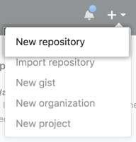

1. Type a short, memorable name for your repository. For example, "hello-world”.

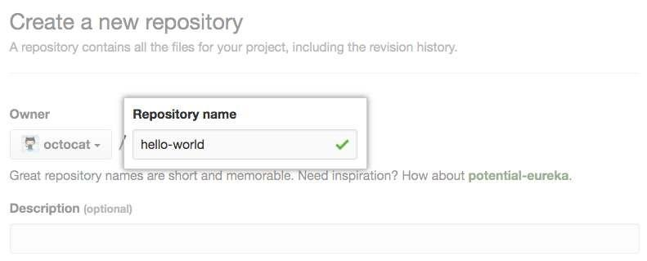

1. Optionally, add a description of your repository. For example, "My first repository on GitHub."

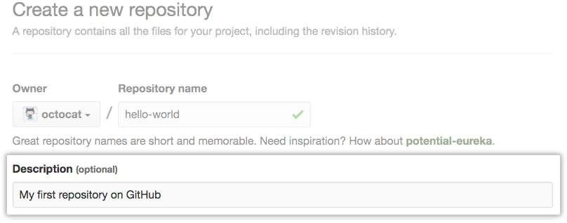

1

1. Choose a repository visibility.

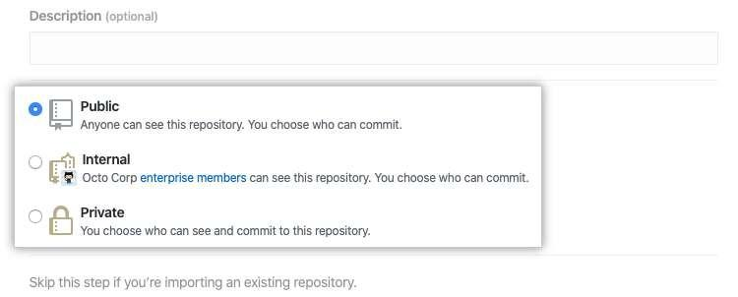

1. Select Initialize this repository with a README.

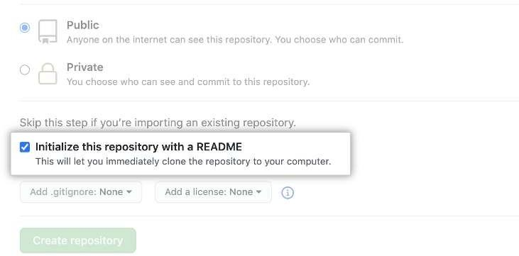

1. Click **Create repository**.

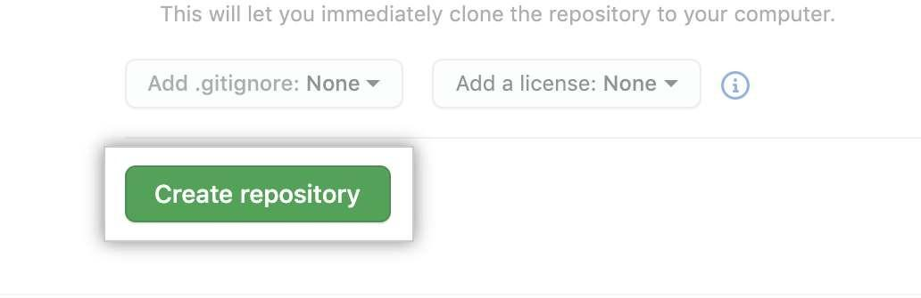

2

# CLONING EXISTING REPOSITORY

* 1. On GitHub.com, navigate to the main page of the repository.
  2. Above the list of files, click **Code**.

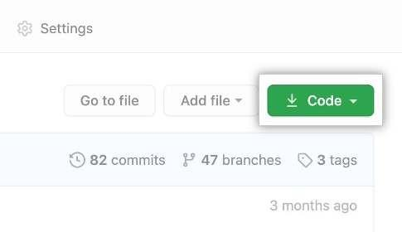

* 1. Copy the URL for the repository.
     + To clone the repository using HTTPS, under "HTTPS", click .
     + To clone the repository using an SSH key, including a certificate issued by your organization's SSH certificate authority, click **SSH**, then click .
     + To clone a repository using GitHub CLI, click **GitHub CLI**, then click .

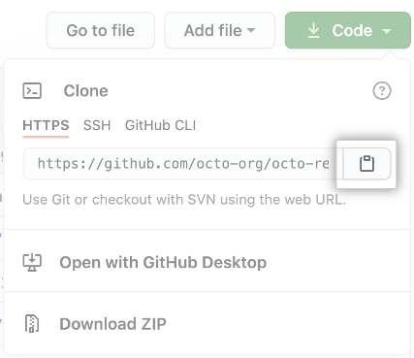

* 1. Open Git Bash.
  2. Change the current working directory to the location where you want the cloned directory.
  3. Type git clone, and then paste the URL you copied earlier.

$ git clone https://github.com/YOUR-USERNAME/YOUR-REPOSITORY

* 1. Press **Enter** to create your local clone.



3

# CHECKIN CHANGES INTO A GIT REPOSITORY

* 1. Fetching changes from a remote repository



* 1. Merging changes into your local branch



* 1. Pulling changes from a remote repository



# PUSHING CHANGES TO A GIT REMOTE

The git push command takes two arguments:

* A remote name, for example, origin
* A branch name, for example, main



# CREATING A GIT BRANCH

* 1. On GitHub.com, navigate to the main page of the repository.
  2. Above the list of files, click **Branches**.

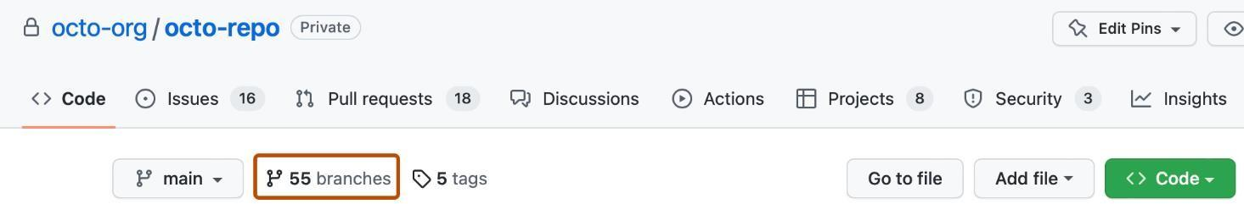

* 1. Click **New branch**.

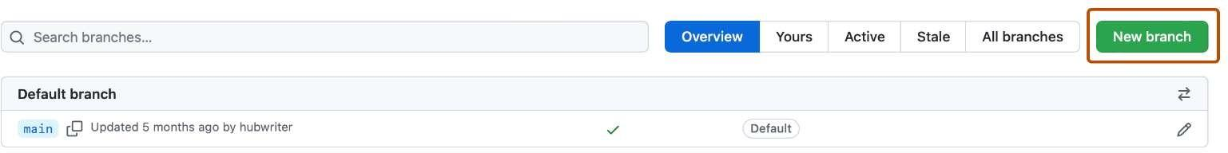

* 1. Under "Branch name", type a name for the branch.
  2. Under "Branch source", choose a source for your branch.
     + If your repository is a fork, select the repository dropdown menu and click your fork or the upstream repository.
     + Select the branch dropdown menu and click a branch.

4

* 1. Click **Create branch**.

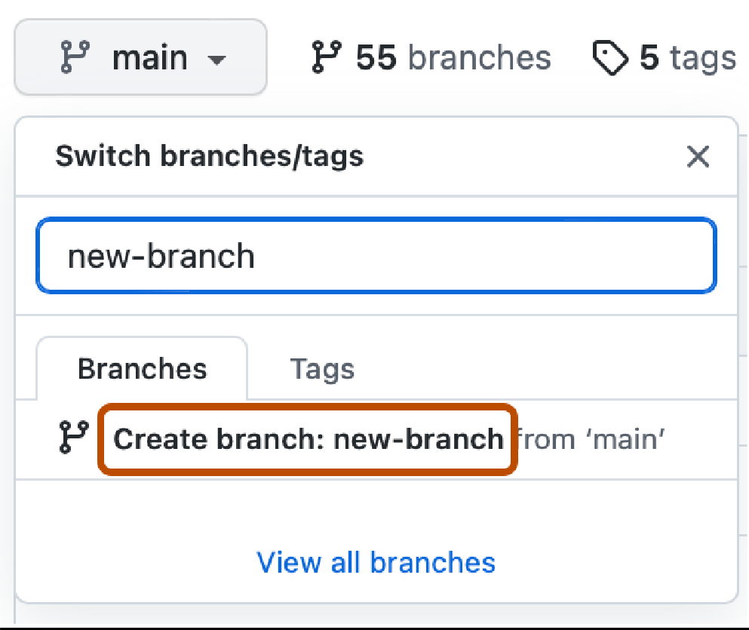

# CONCLUSION:

Successfully executed the above operations on local and remote Git Repositories and outputs were captured.

5

5