Expt.No: 1 | CREATING A NEW GIT REPOSITORY, CLONING EXISTING REPOSITORY, CHECKING CHANGES INTO A
Date:
 | GIT REPOSITORY, PUSHING CHANGES TO A GIT
 | REMOTE, CREATING A GIT BRANCH

AIM:
To creating a new Git repository, cloning existing repository, checkin changes into a Git repository, pushing changes to a Git remote, creating a Git branch.

CREATING A NEW GIT REPOSITORY:

- On GitHub.com, in the upper-right corner of any page, use the drop-down menu, and select New repository.
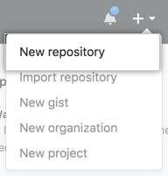
- Type a short, memorable name for your repository. For example, "hello-world”.
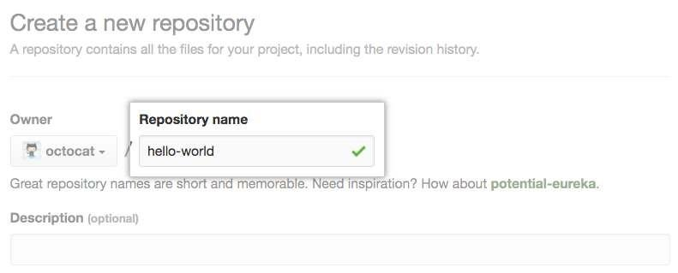
- Optionally, add a description of your repository. For example, "My first repository on GitHub."

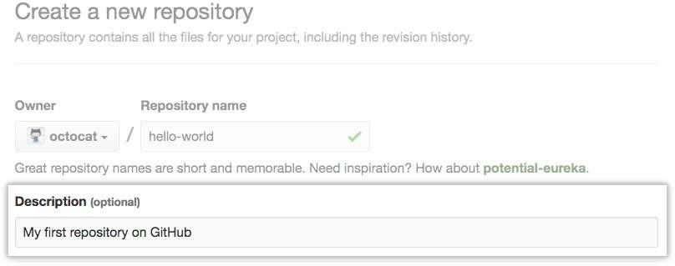
1

- Choose a repository visibility.
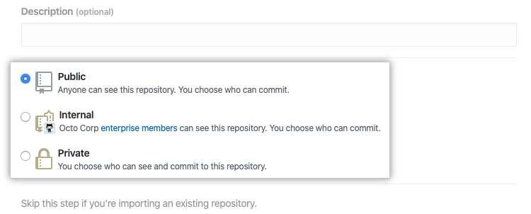
- Select Initialize this repository with a README.
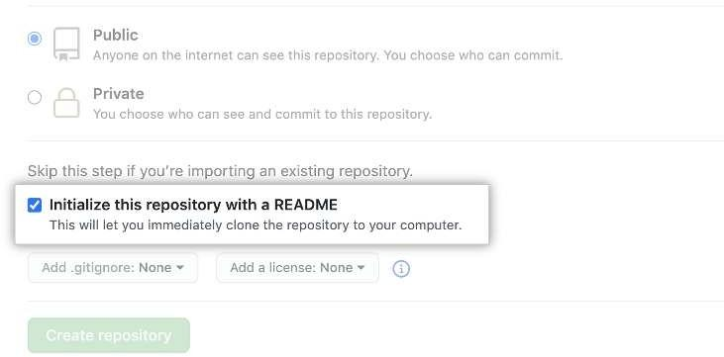

- Click Create repository.
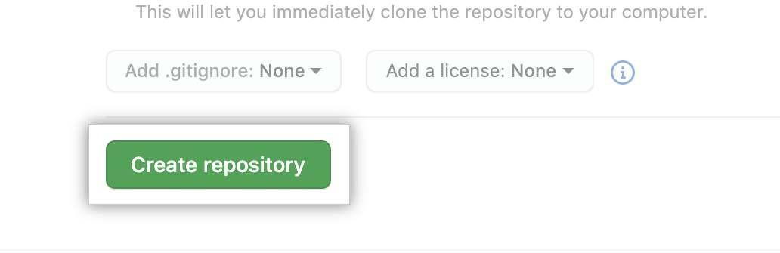

2

CLONING EXISTING REPOSITORY

  - On GitHub.com, navigate to the main page of the repository.
  - Above the list of files, click Code.
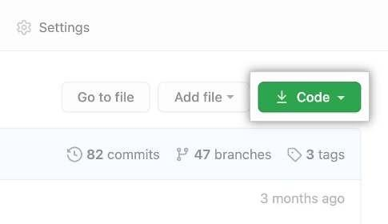
  - Copy the URL for the repository.
    - To clone the repository using HTTPS, under "HTTPS", click .
    - To clone the repository using an SSH key, including a certificate issued by your organization's SSH certificate authority, click SSH, then click .
    - To clone a repository using GitHub CLI, click GitHub CLI, then click .
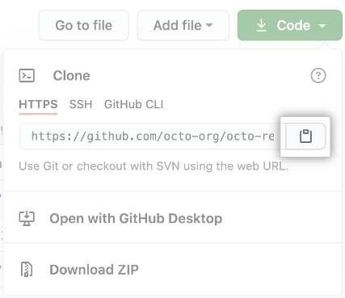

  - Open Git Bash.

  - Change the current working directory to the location where you want the cloned directory.

  - Type git clone, and then paste the URL you copied earlier.
$ git clone https://github.com/YOUR-USERNAME/YOUR-REPOSITORY

  - Press Enter to create your local clone.
$ git clone https://github.com/YOUR-USERNAME/YOUR-REPOSITORY
Cloning into `Spoon-Knife`...
remote: Counting objects: 10, done.
remote: Compressing objects: 100% (8/8), done.
remove: Total 10 (delta 1), reused 10 (delta 1)
Unpacking objects: 100% (10/10),
3

CHECKIN CHANGES INTO A GIT REPOSITORY

  - Fetching changes from a remote repository
$ git fetch REMOTE-NAME
# Fetches updates made to a remote repository

  - Merging changes into your local branch
$ git merge REMOTE-NAME/BRANCH-NAME
# Merges updates made online with your local work

  - Pulling changes from a remote repository
$ git pull REMOTE-NAME BRANCH-NAME
# Grabs online updates and merges them with your local work

PUSHING CHANGES TO A GIT REMOTE

The git push command takes two arguments:

- A remote name, for example, origin
- A branch name, for example, main
git push REMOTE-NAME BRANCH-NAME

CREATING A GIT BRANCH

  - On GitHub.com, navigate to the main page of the repository.
  - Above the list of files, click Branches.
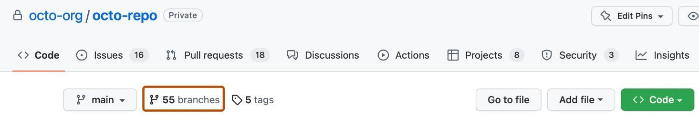

  - Click New branch.
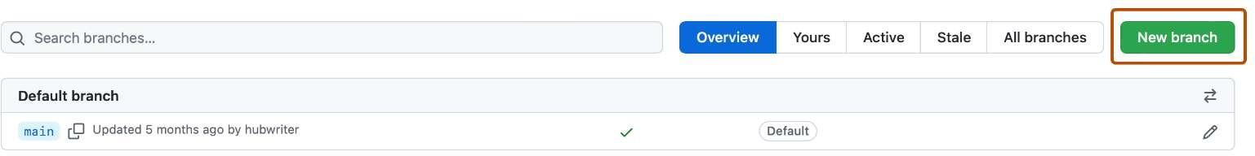

  - Under "Branch name", type a name for the branch.
  - Under "Branch source", choose a source for your branch.
    - If your repository is a fork, select the repository dropdown menu and click your fork or the upstream repository.
    - Select the branch dropdown menu and click a branch.
4

  - Click Create branch.
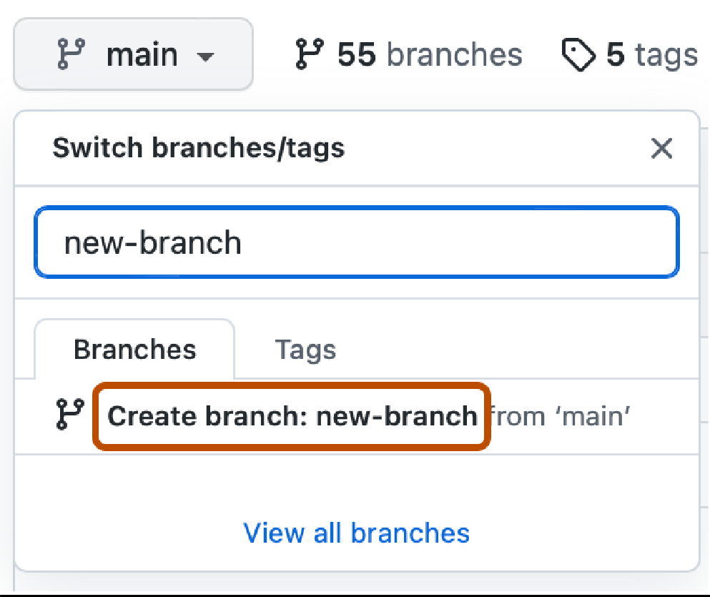

CONCLUSION:
Successfully executed the above operations on local and remote Git Repositories and outputs were captured.
5

5

