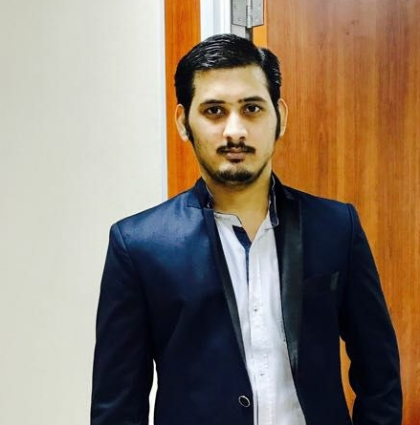**JIGNESH.K.MEHTA**

B-406, Poonam Aura Building,

Padmavati Nagar, Bolinj.

Virar (West), Mumbai.

**Mobile: - +91-8983123658.**

**Skype ID: mehta.jignesh1989.**

[E-Mail-mehta.jignesh1989@gmail.com](mailto:E-Mail-mehta.jignesh1989@gmail.com)

**VISION**

Looking forward to be associated with an organization where I can sharp my skills and talent and concentrating simultaneously on the growth of gaining knowledge.

**Skill**

1. Ability to complete work on time & work effectively under pressure.
2. Ms. Excel V- Look Up, Pivot Chart.
3. Customer Payment Follow up .
4. Account Receivable & Paybale.
5. Cash Flow Statement.
6. SAP SD – (SALE ORDER- INVOICING- DEBIT & CREDIT Note & Account Reconcilition)
7. SAP FI- END USER AND
8. **CONSULTANT.**
   1. GL MASTER CONFIGRUATION
   2. VENDOR & CUSTOMER MASTER.
9. **END USER**
10. GL ENTRIES
11. CUSTOMER & VENDOR THROUGH FI.
12. RECEIPT & PAYMENT ENTRIES
13. BANK RECONCILIATON.

**Software**

1. SAP ERP EHP 7 ( Finance and Sale & Distribution Module).
2. FOCUS SOFTWARE.
3. TALLY ERP 9.0.
4. Ms. Excel.
5. Outlook.

**Work EXPERIENCE:**

1. **Jana Marine Service.**

**Freight Forwarding Company Saudi Arabia-Dammam.**

**Senior Account Executive December,2015 – December,2019.**

* **Using Focus Software.**
* **Using SAP ERP EHP 7 (FI Module & SD Module).**

**Responsibilities:**

1. **Customer Billing.**
2. **Customer / Vendor Account Reconcilation.**
3. **Customer Payment Follow- Ups.**
4. **Revenue Accounting (Account Receivable, Cash Receipt,Reconciling Debtors Account Monthly, Credit Memo)**
5. **Account Payable.**
6. **Bank Reconcilation Statement.**
7. **Calculating Deprication and Maintining Fixed Assets.**
8. **Other Activities:**
9. **Monthly Closing Activities (Like Prepaid Expenses, Sales Report, Calculating Cost Of Good Sold Related to Sale, Preparing Work in Progress Report.**
10. **Commission Report Quaterly.**
11. **Cash Flow Statement.**
12. **Preparing VAT Report Quaterly.**
13. **Blanket Hospitality Venture Pvt.Ltd.-Hotel Mumbai.**

**Account Executive. January,2015-December-2015.**

**Responsibilities:**

**1. Purchase, Sales, Receipt, Payment and Contra Entries**

**2. Revenue Account (Account Receivable, Cash Receipt,Credit Memo)**

**2. Bank Reconciliation Statement.**

**3. Service Tax Payment & Return Filling.**

**4. TDS Payment and Return Filling.**

**5. Accounts Payable.**

**6. MIS Report.**

**3.) Linc Pen & Plastic Ltd.-Retail &Trading Co. Mumbai.**

**Account Officer. August,2013-December-2014.**

**Responsibilities**

**1. Worked on SAP (S & D) Module.**

**2. Non-Inventory Entries of vendors and customers.**

**3. Cash Entries on Daily Basis in (SAP-FI).**

**4. Debit Note and Credit Note.**

**5. Purchase Order/MIGO&MIRO in SAP.**

**6. Production Entries in SAP**.

**7. Handling Pretty cash on daily basis.**

**8. Expenses related entries on monthly basis.**

**4.) Soni Vipul (HUF)-Chartered Accountant Thane.**

**Account Assistant. June,2011-July-2013.**

**Responsibilities:**

**1. Purchase, Sales, Receipt, Payment and Contra Entries.**

**2. Bank Reconciliation.**

**3.TDS Online Return Filling.**

**Academic Overview.**

|  |  |  |  |  |
| --- | --- | --- | --- | --- |
| **Qualification** | **INSTITUTION** | **BOARD/UNIVERSITY** | **PERCENTAGE&**  **CLASS** | **YEAR** |
| Bachelor Of Commerce | Shree Shankar Narayan College of Arts, Commerce and Science. | Mumbai University | 70.42%  FIRST CLASS | 2009-2010 |
| HSC | Shree Shankar Narayan College of Arts, Commerce and Science. | Maharashtra Board | 59.13%  SECOND CLASS | 2006-2007 |
| SSC | ZB Zakaria English Medium School. | Maharashtra Board | 47.06%  SECOND CLASS | 2004-2005 |
|  | | | | | | |
|  | | | | | | |

**HOBBIES & INTERESTS**

* Cricket.
* Carrom.
* Listening Music.

**KEYS OF SUCCESS**

* Hard Worker
* Teamwork.
* Quick Learner of New Technologies.
* Continuous Improvement.

**LANGUAGES KNOWN**

|  |  |  |
| --- | --- | --- |
| **LANGUAGE** | **SPEAK** | **WRITE** |
| English | Good | Good |
| Hindi | Fluent | Good |
| Marathi | Good | Good |

**PERSONAL INFORMATION**

**Nationality:** Indian.

**Birth date:** 9th OCTOBER 1989.

**Gender:** Male.

**Marital Status:** Single.

Date: _____________

Place: _____________

Signature.

(JIGNESH MEHTA)