Resource group created
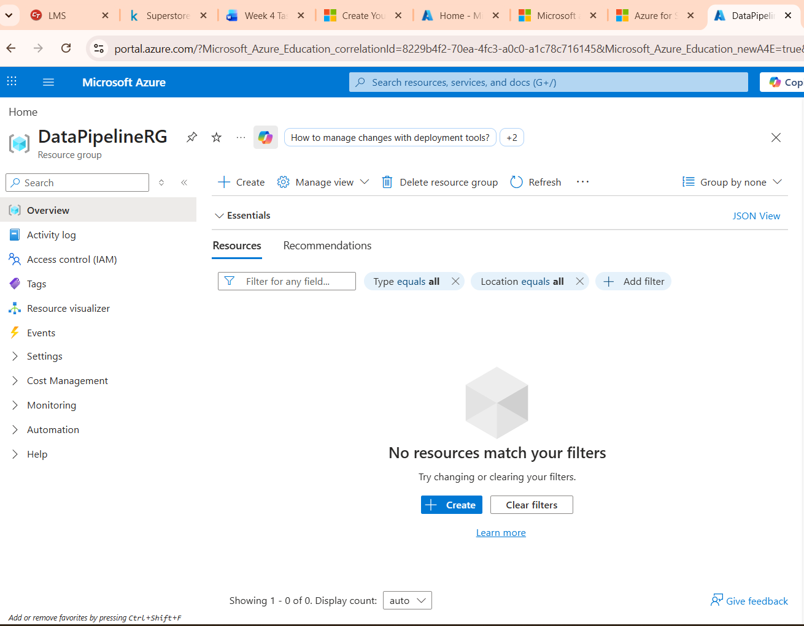
A Resource Group named DataPipeLineRG was created in the East Asia region. It acts as a logical container to organize and manage all Azure resources used in this pipeline project.

Storage account created
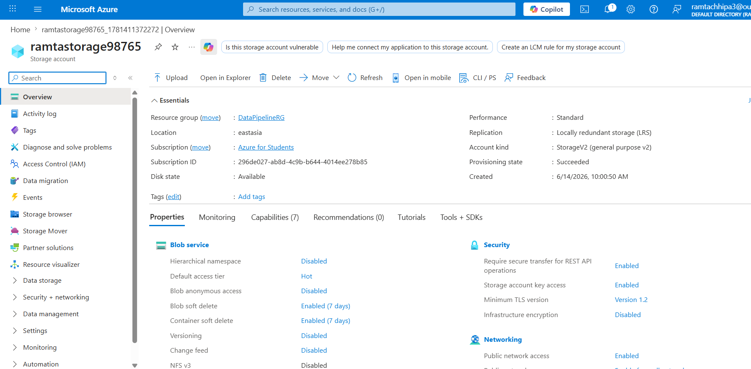
A Storage Account named”ramtastorage98765” was created inside the resource group in the East Asia region. This serves as the primary data store for both input and output files used in the pipeline.

Blob container created
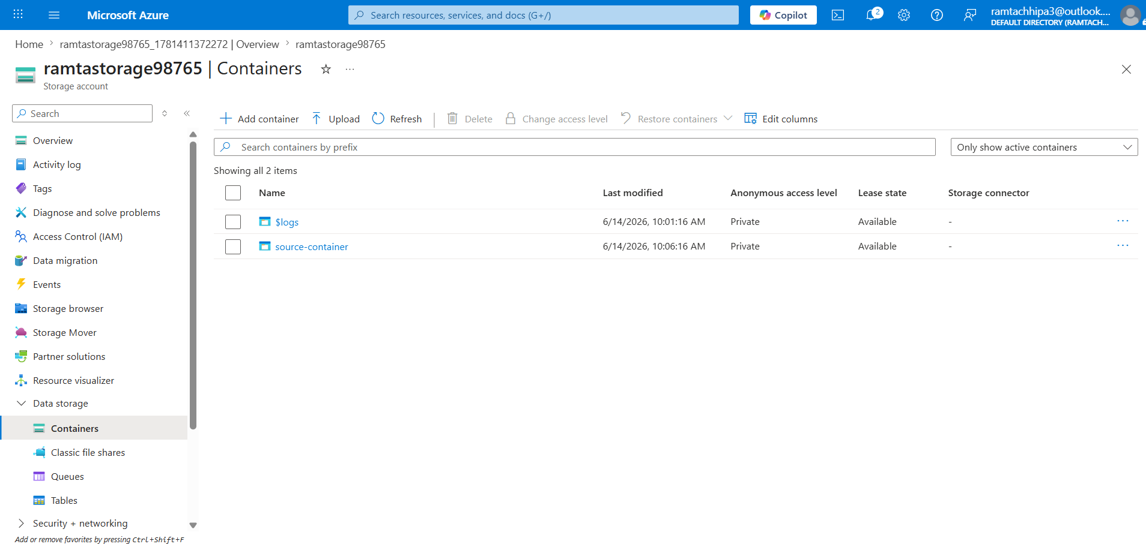

Source container
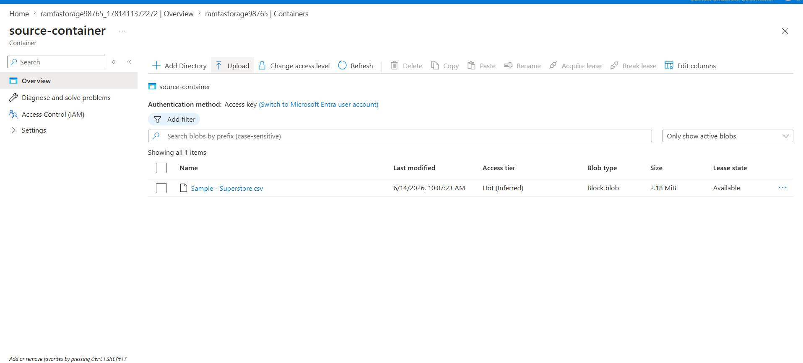
A Blob Container named source-container was created inside the Storage Account and a sample-superstore CSV file was uploaded. This CSV file acts as the input data source for the ADF pipeline.
Destination container(ouput-container)
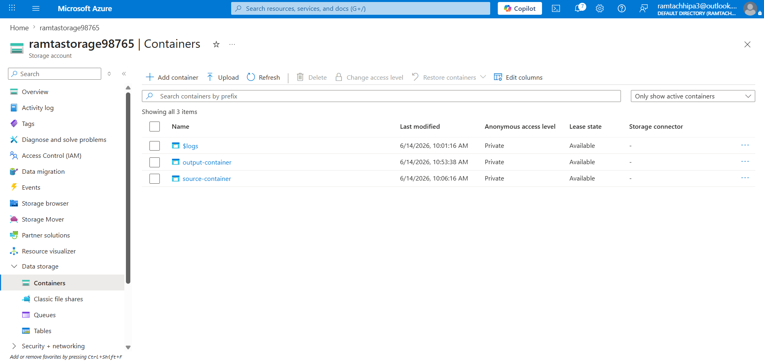
A second Blob Container named output-container was created to receive the output data. The ADF pipeline will copy the processed CSV file into this container as the final output.

ADF created UI explored
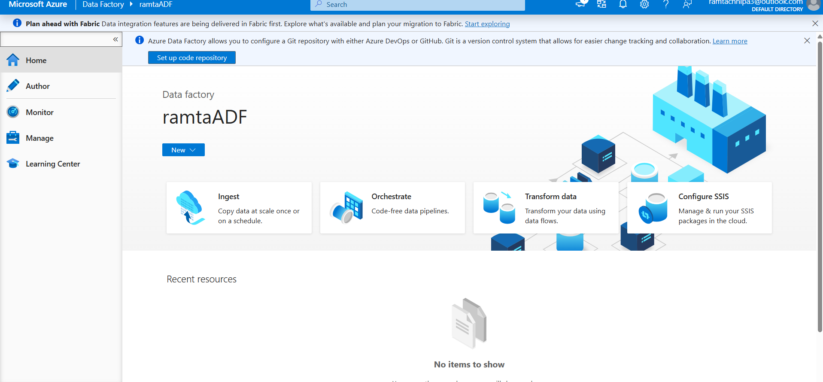
Azure Data Factory instance ramtaADF was successfully created and launched. The ADF Studio provides three key sections — Author, Monitor, and Manage — for building and managing data pipelines.

Source dataset created
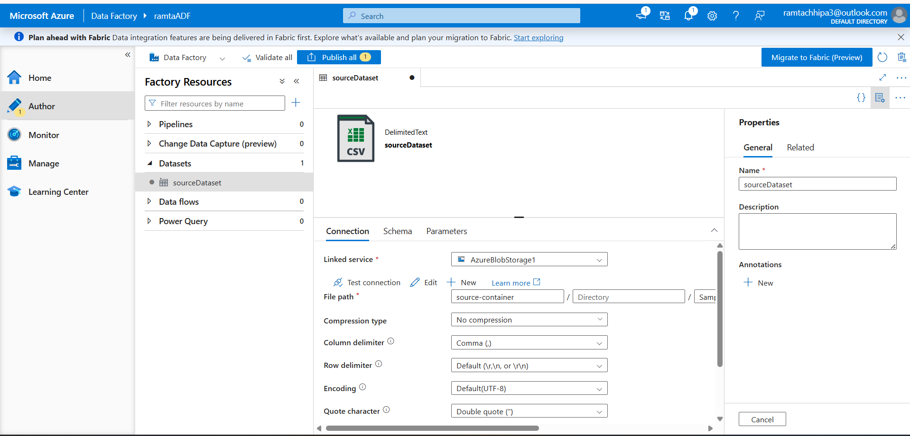
A dataset named sourceDataset was created in ADF pointing to the CSV file in the source container. This dataset defines the structure and location of the input data for the pipeline.

Destination dataset created
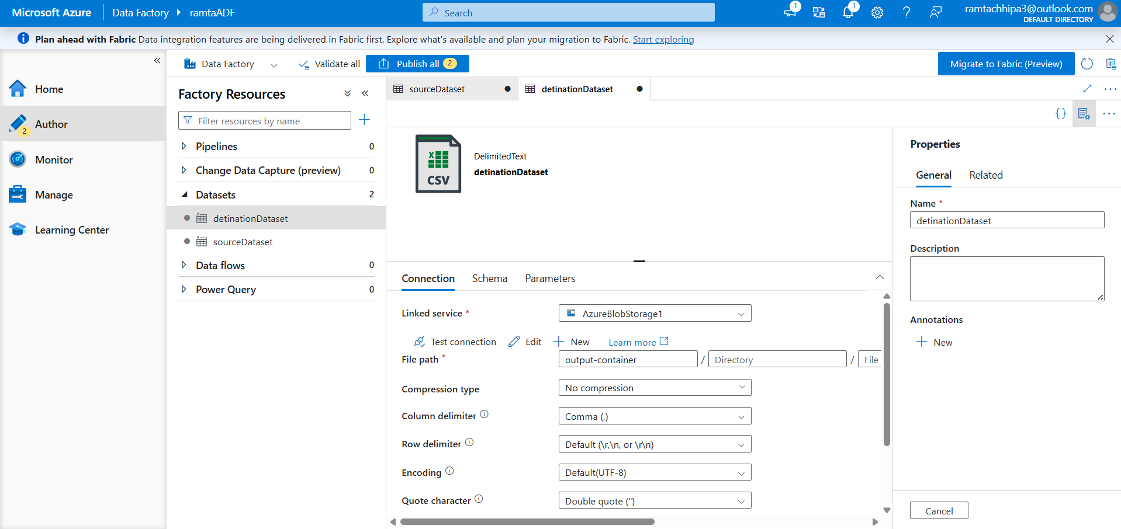
A dataset named detinationDataset was created pointing to the destination container. This dataset defines where the pipeline will write the copied output data.

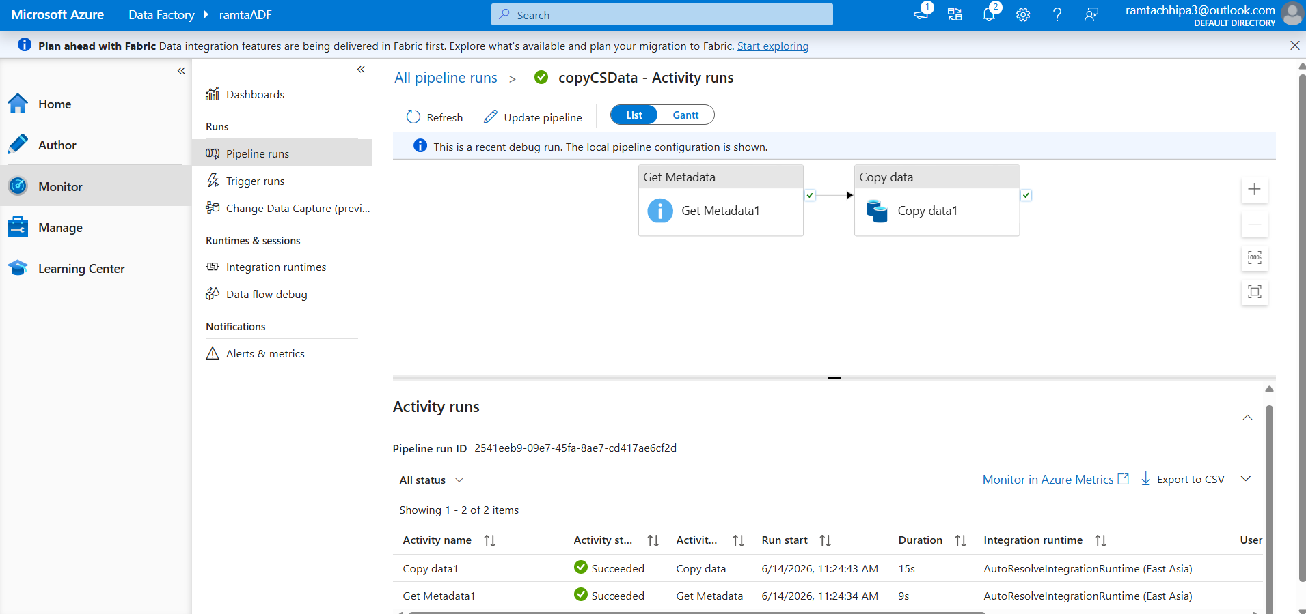
getMetaData and CopyData activity done
The pipeline copyCSData was built with two activities — Get Metadata and Copy Data — connected with a success dependency arrow. This ensures metadata is validated before the data copy operation begins
Get Metadata Activity Settings
The Get Metadata activity was configured to retrieve file properties such as item name, size, exists, and last modified date from the source dataset. This validates that the file exists before the copy activity runs.
Copy Data Activity Settings
The Copy Data activity was configured with sourceDataset as input and detinationDataset as output. This activity reads the CSV from the source container and writes it to the destination container.

Pipeline executed succesfully
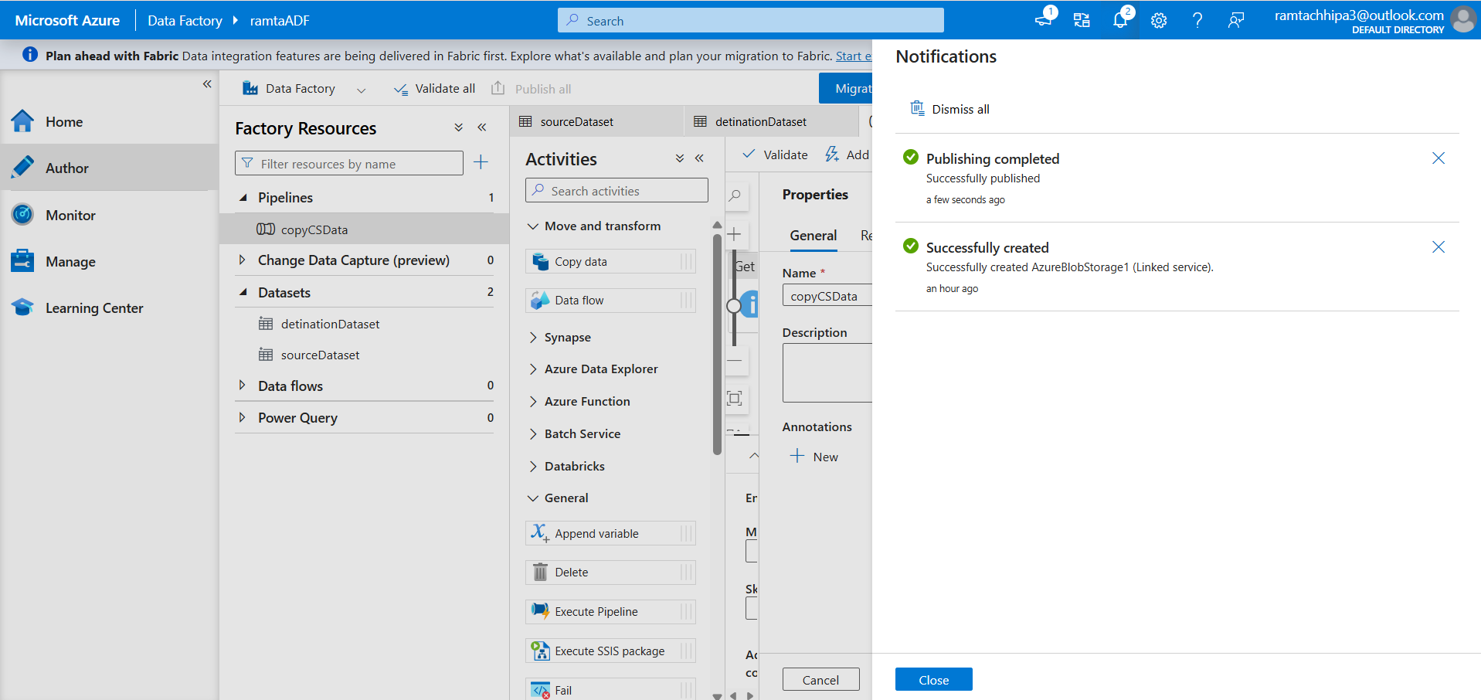
The pipeline was executed using the Debug option in ADF Studio. Both activities — Get Metadata and Copy Data — ran sequentially and completed successfully within 34 seconds.

Monitor execution
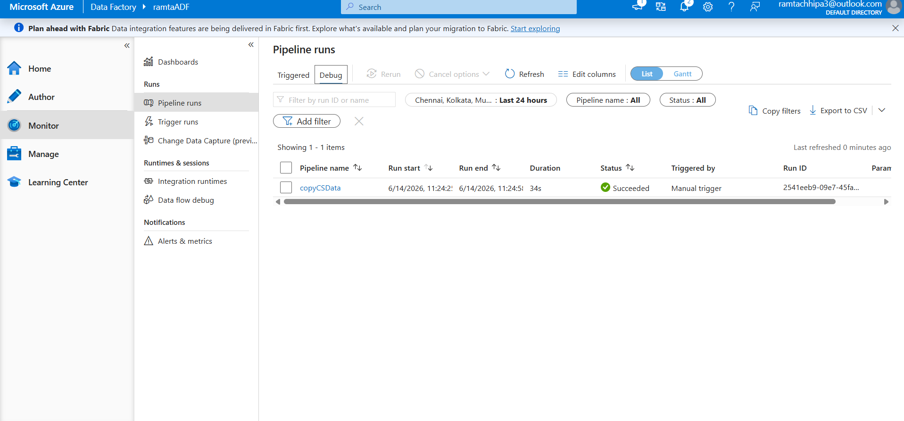
The Monitor tab shows the pipeline run copyCSData with a Succeeded status under the Debug tab. The run completed in 34 seconds confirming the end-to-end pipeline executed without any errors.

Verified output in destination container(output-container)
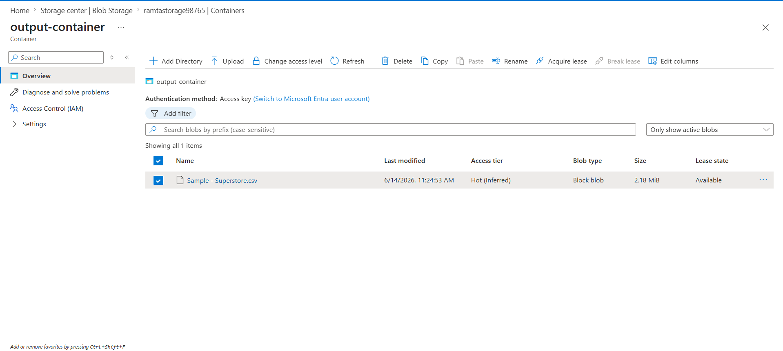
The destination container now contains the output CSV file copied by the ADF pipeline. This confirms that data was successfully transferred from the source container to the destination container.

Assigning reader role
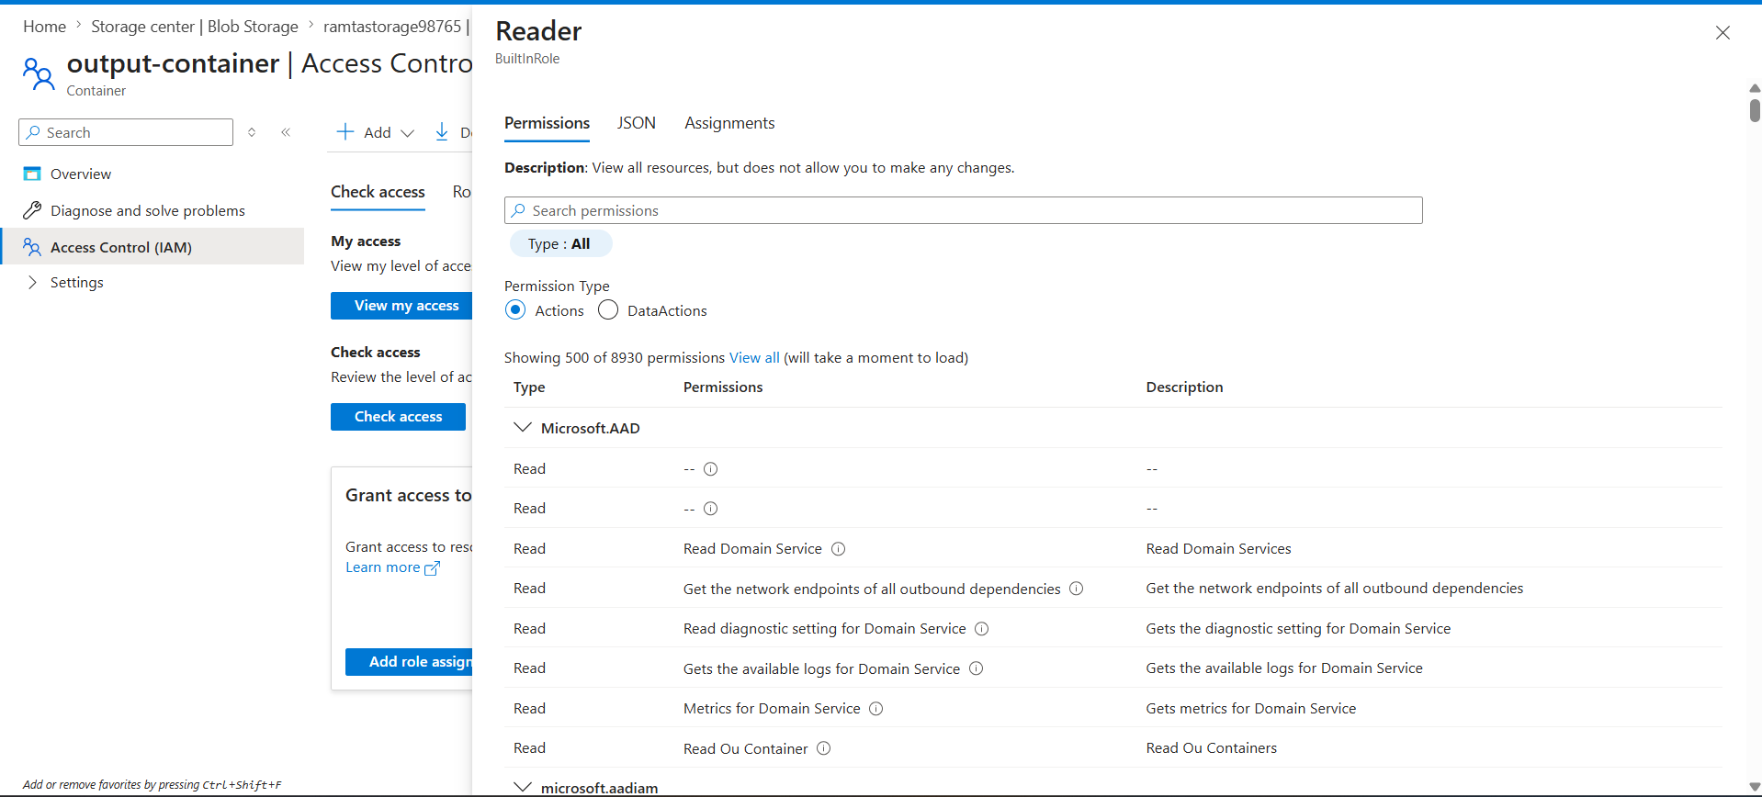
Reader and Contributor roles were assigned to the user account under the Storage Account's Access Control (IAM) section. This ensures Azure Data Factory has the necessary permissions to read from and write to the Blob Storage.

Assigning contributor role
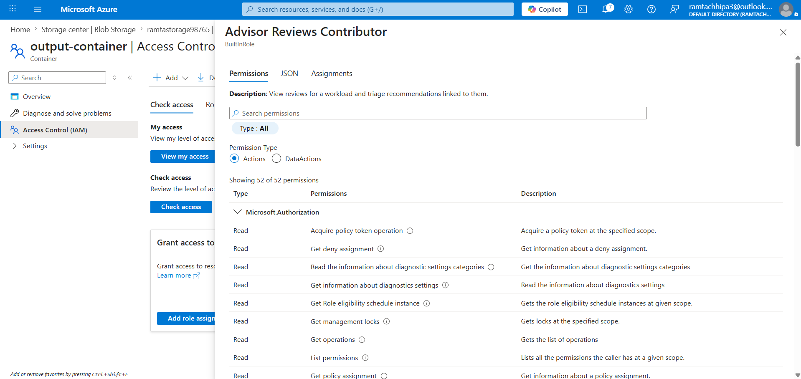

Pipeline published
