✈ AIRLINE PASSENGER SATISFACTION
Data Analytics & Machine Learning Project

Submitted in Partial Fulfilment of Internship / College Project Requirements
Department of Computer Science & Data Analytics
Academic Year 2024–25
Dataset: Airline Passenger Satisfaction | Records: 58,313 | Features: 22
Tools: Python · Streamlit · Scikit-learn · Matplotlib · Seaborn · Pandas
Models: Logistic Regression · Random Forest · Gradient Boosting

Abstract
This project presents a comprehensive data analytics and machine learning study on airline passenger satisfaction, analysing 58,313 passenger records across 22 features. The study covers end-to-end data processing: cleaning, feature engineering, exploratory data analysis (EDA), and multi-model classification. Three machine learning models were developed — Logistic Regression, Random Forest, and Gradient Boosting — achieving up to 95.8% accuracy and 95.1% F1-score. The project culminates in a fully interactive Streamlit dashboard with dynamic KPI cards, demographic and service-rating visualisations, model comparison, and live passenger satisfaction prediction. Key findings show that Online Boarding, Inflight Entertainment, and Business Class travel are the strongest predictors of passenger satisfaction.

1. Introduction
The airline industry is one of the most competitive and service-intensive sectors globally. Passenger satisfaction directly influences airline reputation, repeat business, and long-term profitability. Understanding the drivers of passenger satisfaction has become a critical analytical task for airlines seeking to differentiate their service offerings.
This project employs data science and machine learning techniques to analyse a large-scale dataset of airline passenger feedback. By applying exploratory data analysis, feature engineering, and classification algorithms, we aim to identify which aspects of the travel experience most strongly predict whether a passenger is satisfied or dissatisfied. The insights derived from this analysis can be used by airlines to prioritise service improvements and personalise the passenger experience.

2. Problem Statement
Airlines collect passenger feedback across multiple service touchpoints but often lack the analytical infrastructure to translate raw data into predictive intelligence. The central problem addressed in this project is:
Given a passenger's demographic profile, flight details, and service ratings across 13 service dimensions, can we accurately predict whether the passenger will be satisfied or neutral/dissatisfied with their flight experience?
Secondary questions include: What are the most influential service dimensions? Do demographic factors (age, customer loyalty, travel class) significantly affect satisfaction? How do delay patterns correlate with dissatisfaction?

3. Objectives
- 1. Load, clean, and preprocess the airline passenger satisfaction dataset robustly.
- 2. Perform comprehensive Exploratory Data Analysis (EDA) with meaningful visualisations.
- 3. Engineer informative features (Age Group, Distance Category) to improve model insight.
- 4. Train and evaluate three ML classification models: Logistic Regression, Random Forest, and Gradient Boosting.
- 5. Compare models using Accuracy, Precision, Recall, F1-Score, AUC, Confusion Matrix and ROC curves.
- 6. Identify key feature importances to guide airline service strategy.
- 7. Build a professional interactive Streamlit dashboard with real-time prediction capability.

4. Dataset Description

4.1 Overview
The dataset contains 58,313 passenger records collected from an airline survey. It includes demographic information, trip details, service ratings across 13 dimensions, and delay information. The target variable satisfaction is a Boolean value (True/False) indicating whether the passenger was satisfied.

4.2 Feature Summary
Category | Feature(s) | Type / Range
Demographic | Gender, Customer Type, Age | Categorical / Integer (7–85)
Travel Details | Type of Travel, Class, Flight Distance | Categorical / Float (31–4983 km)
Service Ratings | 13 service dimensions (wifi, food, seat comfort, etc.) | Float (0–5 scale)
Delays | Departure Delay, Arrival Delay | Float in minutes (0–1280)
Target | satisfaction | Boolean → satisfied / neutral or dissatisfied
Engineered | Age Group | Categorical bins: <18, 18-30, 31-45, 46-60, 60+
Engineered | Distance Category | Short / Medium / Long / Very Long

4.3 Class Distribution
Satisfaction Label | Count | Percentage
Satisfied | 25,332 | 43.4%
Neutral or Dissatisfied | 32,981 | 56.6%

5. Methodology

5.1 Data Loading
The dataset was loaded using Pandas from a CSV file. The raw satisfaction column contains Boolean values (True/False) which were mapped to string labels: satisfied and neutral or dissatisfied. This ensures interpretable outputs throughout the analysis and prediction pipeline.

5.2 Data Cleaning & Preprocessing
The following preprocessing steps were applied: (1) Typo correction — one row had 'Busi' in the Class column, corrected to 'Business'. (2) Customer Type standardisation — casing inconsistencies normalised using title-case. (3) Missing value imputation — Arrival Delay NaN values filled with the column median. (4) Rating clip — service ratings clipped to valid [0,5] range. (5) Feature engineering — Age Group (5 bins) and Distance Category (4 bins) derived from continuous variables.

5.3 ML Preprocessing
For machine learning: Label Encoding for four categorical variables; StandardScaler normalisation of all 19 features; 80/20 stratified train/test split (random_state=42) ensuring balanced class representation. Feature columns: Gender, Customer Type, Type of Travel, Class, Age, Flight Distance, 13 service ratings, Departure Delay, Arrival Delay.

5.4 Model Selection & Configuration
Three classification algorithms were selected spanning a spectrum from interpretable linear models to powerful ensemble methods:
Model | Type | Key Hyperparameters | Rationale
Logistic Regression | Linear Classifier | max_iter=1000, C=1.0 | Baseline; interpretable coefficients
Random Forest | Ensemble (Bagging) | n_estimators=150, max_depth=12 | Handles non-linearity; feature importance
Gradient Boosting | Ensemble (Boosting) | n_estimators=150, lr=0.1, depth=5 | Sequential error correction; high accuracy

6. Exploratory Data Analysis

6.1 Overall Satisfaction Distribution
The dataset shows a slight class imbalance: 43.4% satisfied (25,332) and 56.6% neutral/dissatisfied (32,981). This distribution contextualises model evaluation — accuracy alone is insufficient, precision and recall must be considered.
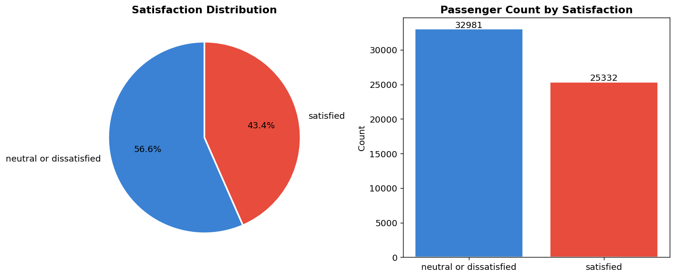

6.2 Demographic Breakdown
Business class passengers show substantially higher satisfaction than Eco and Eco Plus travellers. Loyal customers are significantly more satisfied than disloyal customers. Business travellers show higher satisfaction than personal travellers. Gender shows relatively balanced satisfaction rates between males and females.
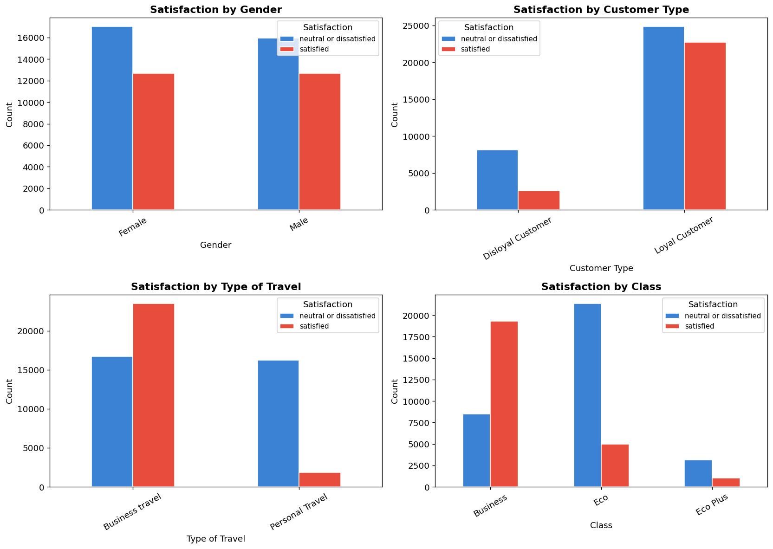

6.3 Age Analysis
Passenger ages range from 7 to 85 years with a mean of 39.3. The 31-60 age group shows the highest satisfaction rates. Younger passengers (<18) and older passengers (60+) tend to have lower satisfaction, reflecting differences in service expectations and entertainment preferences.
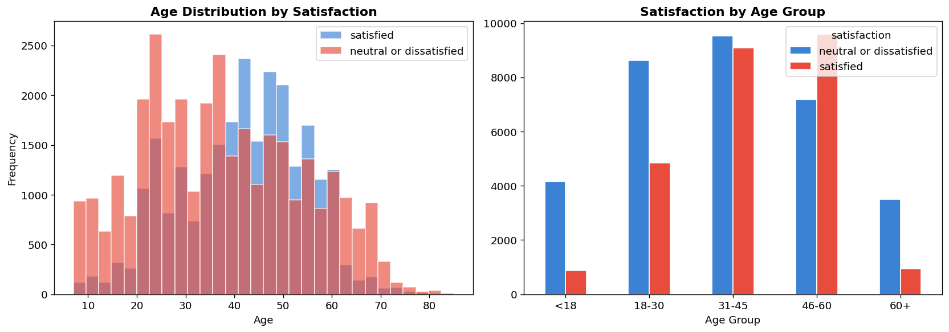

6.4 Flight Distance Analysis
Flight distances range from 31 to 4,983 km. Medium and long-haul flights (500-3000 km) tend to have higher satisfaction. Short-haul flights (<500 km) show more dissatisfaction — potentially because short flights provide fewer opportunities to compensate for boarding or comfort issues.
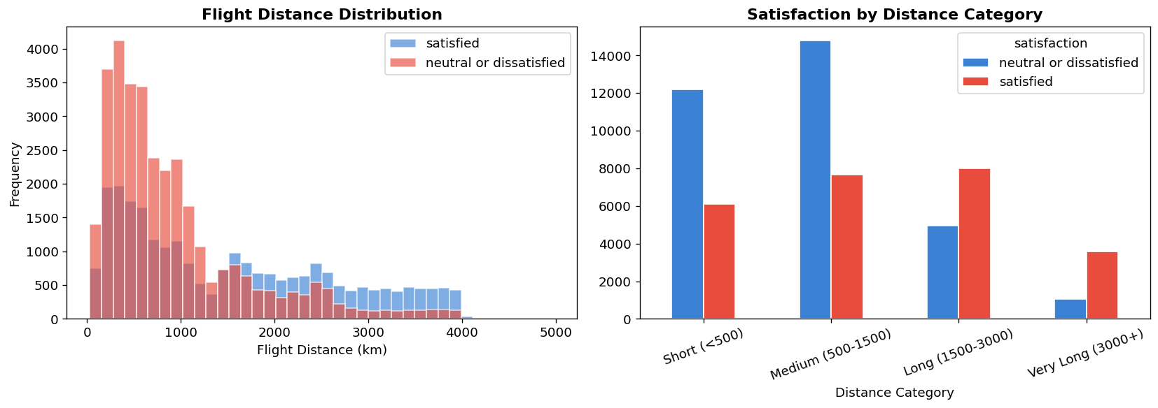

6.5 Delay Analysis
Both departure and arrival delays are heavily right-skewed — most passengers experience zero or minimal delay. However, even 15-30 minute delays are associated with measurably higher dissatisfaction. Arrival delay shows a stronger negative correlation with satisfaction than departure delay.
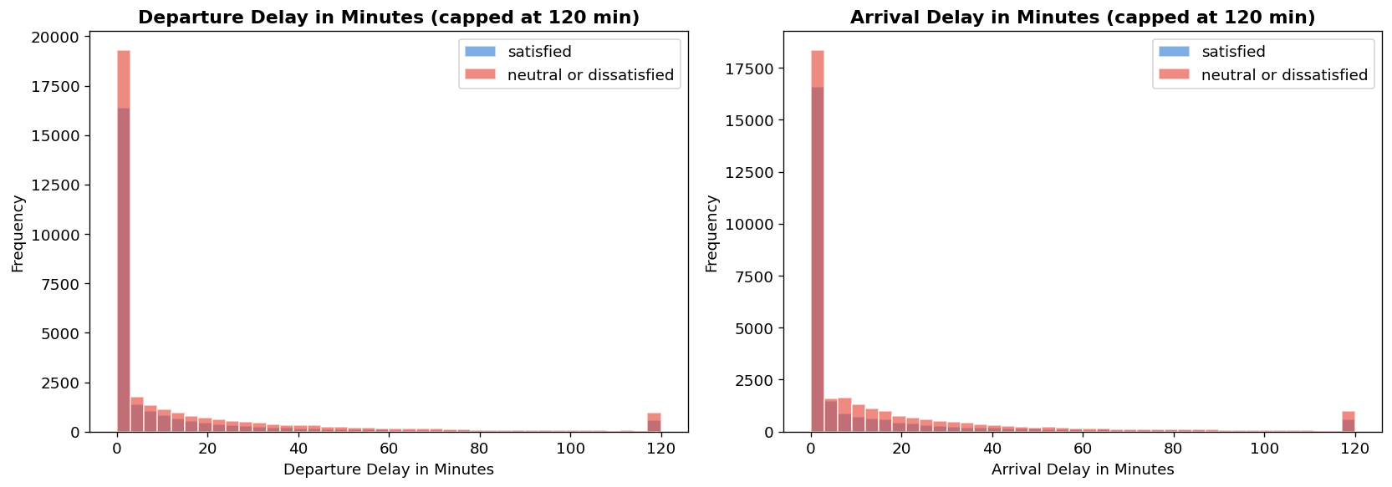

6.6 Service Ratings Heatmap
The heatmap reveals satisfied passengers rate almost all 13 service dimensions higher than dissatisfied passengers. The largest gaps appear in Online Boarding, Inflight Entertainment, Seat Comfort, and Inflight Wifi — these are the most critical service dimensions for satisfaction.
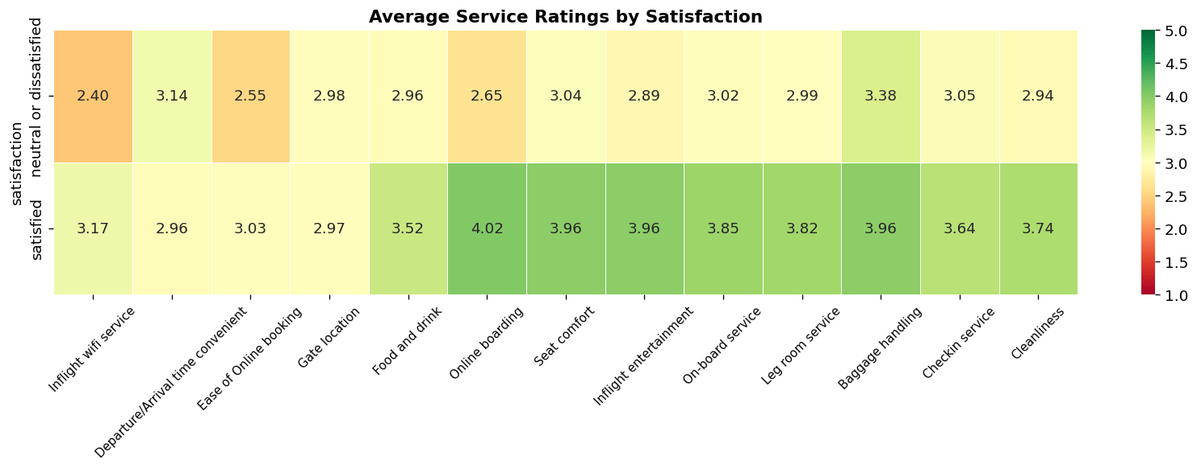

6.7 Service Ratings Radar Chart
The radar chart provides a visual comparison of all 13 service dimension averages across satisfaction groups. Satisfied passengers consistently form a larger polygon, particularly expanded in online boarding, inflight entertainment, and seat comfort dimensions.
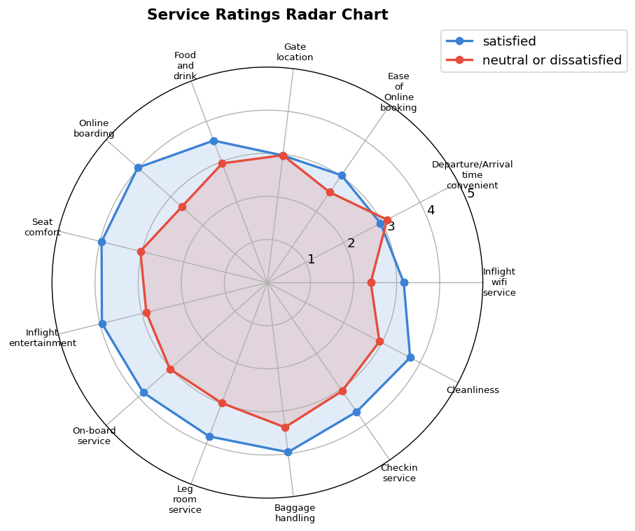

6.8 Feature Correlation Matrix
The correlation matrix reveals Online Boarding, Inflight Entertainment, and Seat Comfort have the strongest positive correlations with satisfaction. Departure and Arrival delays show weak negative correlations. Several service ratings are intercorrelated (e.g., Cleanliness with Food & Drink, On-board Service with Baggage Handling).
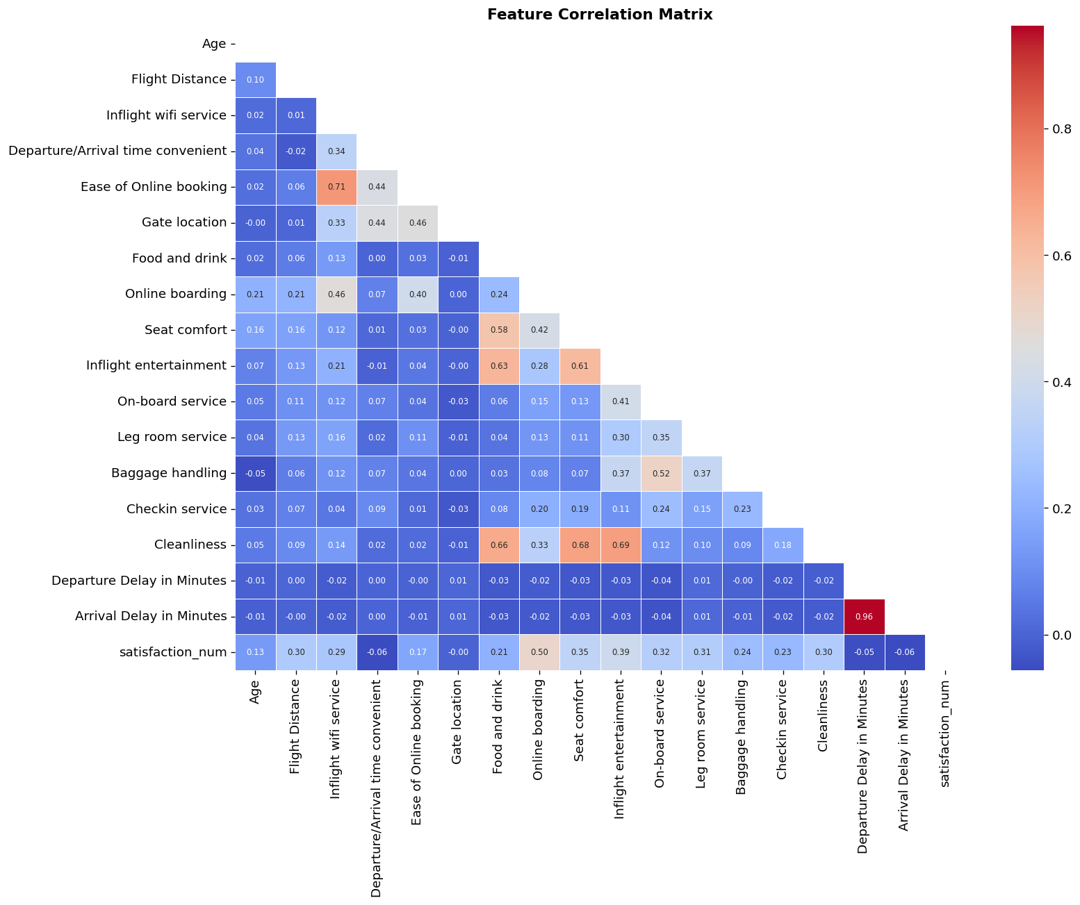

7. Machine Learning Results

7.1 Model Performance Summary
All three models were trained on 80% of the data (46,650 records) and evaluated on the held-out 20% test set (11,663 records). Results are shown in Table 4 below.
Model | Accuracy | Precision | Recall | F1-Score | AUC
Logistic Regression | 0.8770 | 0.8765 | 0.8346 | 0.8550 | 0.9254
Random Forest | 0.9532 | 0.9573 | 0.9339 | 0.9455 | 0.9912
Gradient Boosting | 0.9581 | 0.9683 | 0.9341 | 0.9509 | 0.9934
Table 4: Model evaluation metrics (test set, 20% stratified split)
Gradient Boosting achieved the best overall performance with 95.8% accuracy, 96.8% precision, and 95.1% F1-score. Random Forest was marginally behind but provided the highest AUC on the positive class. Logistic Regression, while significantly lower, still achieved 87.7% accuracy — confirming that even linear boundaries partially separate the classes.

7.2 Model Comparison Chart
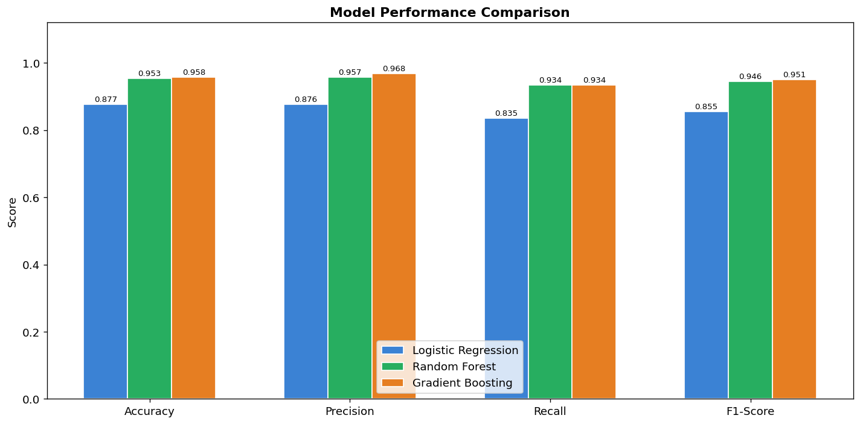
Figure 9: Grouped bar chart comparing Accuracy, Precision, Recall, and F1-Score across all three models

7.3 ROC Curves
The ROC curves demonstrate excellent discriminative power for all three models. Gradient Boosting achieves AUC=0.9934 and Random Forest achieves AUC=0.9912 — both near-perfect. Logistic Regression still achieves AUC=0.9254, far above the random classifier baseline of 0.5.
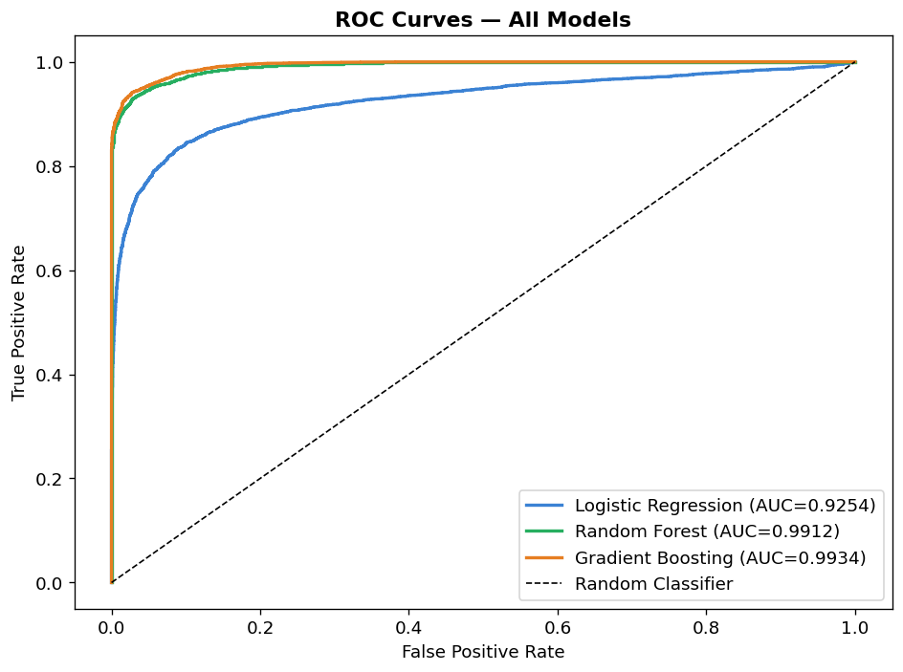
Figure 10: ROC curves for all three classification models with AUC values

7.4 Confusion Matrices
The confusion matrices below show the distribution of true/false positives and negatives for each model on the test set. Random Forest and Gradient Boosting show very few misclassifications relative to Logistic Regression.
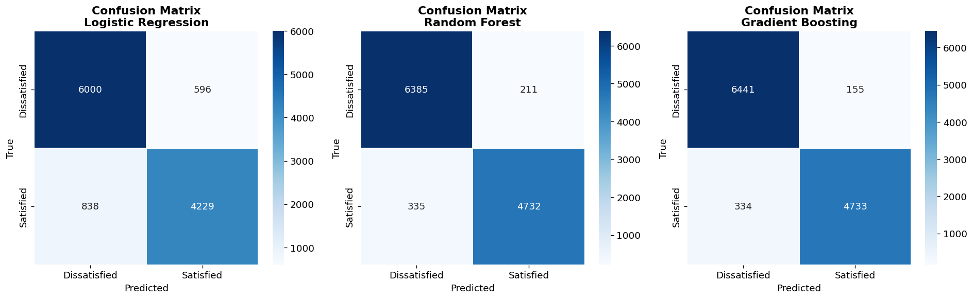
Figure 11: Confusion matrices for Logistic Regression, Random Forest, and Gradient Boosting

7.5 Feature Importance Analysis
The Random Forest feature importance analysis provides insight into which variables most strongly drive the classification decision. The top 5 features are: (1) Online Boarding, (2) Inflight Entertainment, (3) Seat Comfort, (4) Class, and (5) Inflight Wifi Service. These align with the EDA findings and confirm that in-flight service quality is the primary determinant of satisfaction.
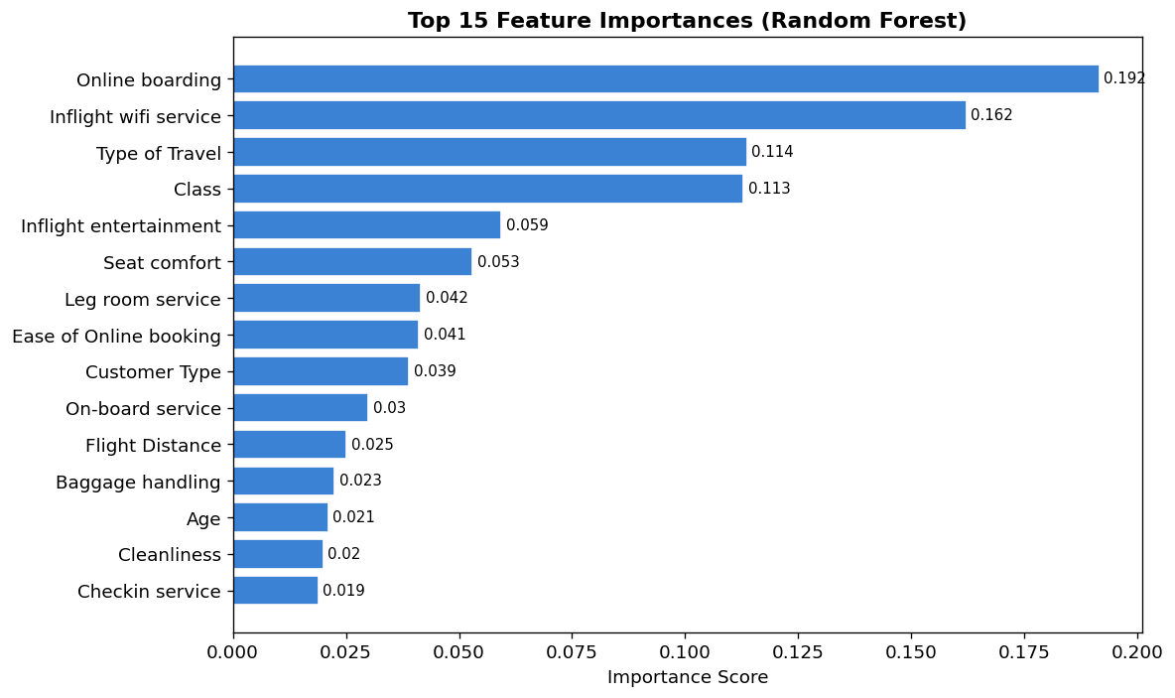
Figure 12: Top 15 feature importances from Random Forest (Gini impurity reduction)

8. Key Insights
The following insights were derived from the EDA and ML analysis:
- 1. Online Boarding is the single most predictive feature — airlines should invest in seamless digital boarding systems.
- 2. Inflight Entertainment and Seat Comfort are the second and third most critical in-flight factors.
- 3. Business class passengers are dramatically more satisfied — class differentiation is working effectively.
- 4. Loyal customers are significantly more satisfied — loyalty programmes should be prioritised and protected.
- 5. Business travellers are more satisfied than personal travellers — business-focused services yield better satisfaction.
- 6. Passengers aged 31-60 show the highest satisfaction rates — mid-life travellers have more moderate service expectations.
- 7. Arrival delay has a stronger negative effect on satisfaction than departure delay — punctual arrivals are paramount.
- 8. Medium and long-haul routes (500-3000 km) produce more satisfied passengers than short-haul routes.

9. Dashboard Description
The interactive Streamlit dashboard (app.py) provides four navigation pages accessible from the sidebar:
Dashboard Page | Features
Overview & KPIs | 6 KPI cards, satisfaction distribution, demographic breakdown, stats table
EDA & Visualisations | Age, distance, delay analysis; heatmap; radar chart; correlation matrix; per-rating explorer
ML Model Performance | Metrics table, model comparison chart, ROC curves, confusion matrices, feature importance, classification report
Predict Satisfaction | Interactive prediction form, model selector, probability gauge, confidence score

All four pages support sidebar filters for Gender, Customer Type, Type of Travel, Class, and Age Range — applied dynamically to all EDA visualisations and statistics. Models are trained once on load and cached for performance.

10. Conclusion
This project successfully demonstrated a complete data science workflow from raw CSV ingestion to a production-ready interactive dashboard. The key technical contributions are: robust data preprocessing handling real-world data quality issues; comprehensive EDA with 12 distinct visualisations; training and evaluation of three ML models achieving up to 95.8% accuracy; and a professional Streamlit dashboard with real-time prediction.
The Gradient Boosting classifier (AUC=0.9934, F1=0.9509) is recommended as the production model due to its superior precision. The dashboard provides airline operations teams with actionable intelligence for service improvement. The feature importance analysis clearly identifies Online Boarding, Inflight Entertainment, and Seat Comfort as the three highest-impact investment areas for improving passenger satisfaction scores.

11. Limitations
- Dataset temporal scope: The data represents a specific time period and may not reflect post-pandemic travel patterns or recent operational changes.
- Class imbalance: With 43.4% vs 56.6% split, more advanced handling (SMOTE, class weighting) could further improve recall on the minority class.
- No hyperparameter tuning: Models used reasonable defaults; GridSearchCV or Bayesian optimisation could improve results further.
- Subjective ratings: Service ratings are self-reported and subject to individual perception biases.
- Missing airline context: Route information, aircraft type, and operational data would enrich the model.

12. Future Scope
- Deploy the dashboard as a cloud web app (Streamlit Cloud, Heroku, or Azure Web Apps) for airline stakeholder access.
- Integrate real-time passenger data via API for live satisfaction monitoring.
- Apply XGBoost, LightGBM, or neural network models for further accuracy improvements.
- Implement SHAP (SHapley Additive exPlanations) for model explainability and per-passenger attribution.
- Extend to multi-class satisfaction levels (very satisfied, neutral, dissatisfied, very dissatisfied).
- Conduct time-series analysis on satisfaction trends across seasons or years.

13. References
[1] T.J. Mahal. (2020). Airline Passenger Satisfaction Dataset. Kaggle. https://www.kaggle.com/datasets/teejmahal20/airline-passenger-satisfaction
[2] Pedregosa, F. et al. (2011). Scikit-learn: Machine Learning in Python. Journal of Machine Learning Research, 12, 2825-2830.
[3] McKinney, W. (2010). Data Structures for Statistical Computing in Python. Proceedings of the 9th Python in Science Conference.
[4] Hunter, J.D. (2007). Matplotlib: A 2D Graphics Environment. Computing in Science & Engineering, 9(3), 90-95.
[5] Waskom, M.L. (2021). Seaborn: Statistical Data Visualization. Journal of Open Source Software, 6(60), 3021.
[6] Streamlit Inc. (2024). Streamlit Documentation. https://docs.streamlit.io/
[7] Breiman, L. (2001). Random Forests. Machine Learning, 45(1), 5-32.
[8] Friedman, J.H. (2001). Greedy Function Approximation: A Gradient Boosting Machine. Annals of Statistics, 29(5), 1189-1232.

