Centum Configuration Tool

# Centum Configuration Tool A desktop solution for converting fonts and images to C source arrays for embedded and display projects, including features for zone configuration to optimize display management. This document presents an overview of key screens and functionalities with hand-drawn style diagrams.

# App Icon on Desktop

The “Centum Configuration Tool” appears as a desktop shortcut for convenient access.

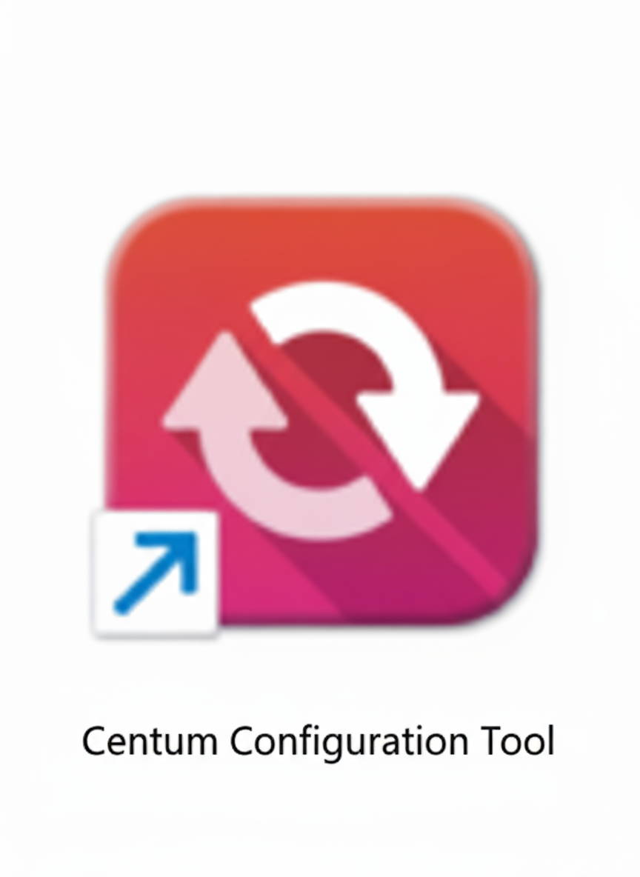

# Main Application Window

* Choose display type – Monochrome or color
* At launch, the tool presents three main options:  
  - Font converter to C  
  - Image converter to C  
  - Zone Configuration
* This entry screen allows users to select which option they would like to perform.
* Each option screen includes a **Back button** that returns the user to the main entry screen.

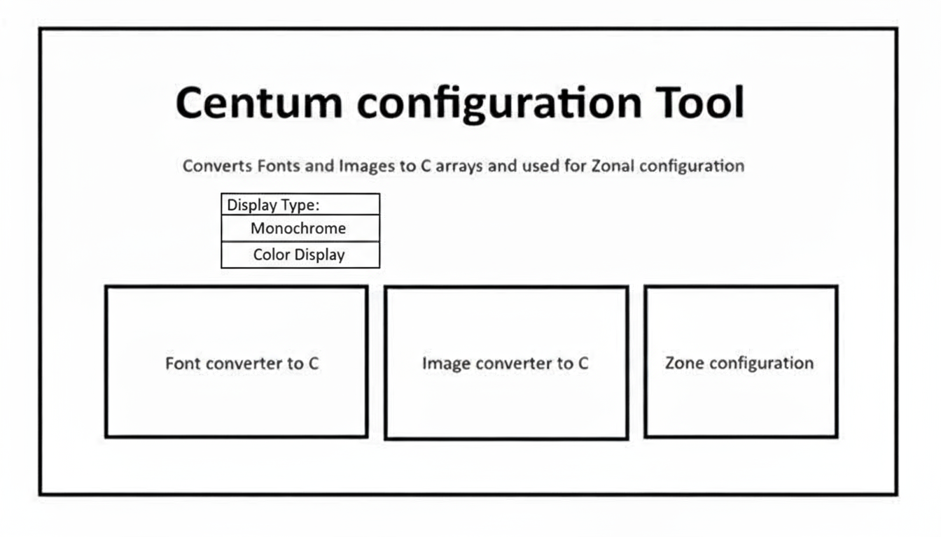

# Font to C Converter Module

Users can generate C arrays from TTF font files by specifying File name, font size and language.  
  
**Workflow:**

1. Select TTF font file and set font parameters (size, Unicode ranges).
2. Optionally include another font with separate parameters.
3. Each font conversion generates one .c file.
4. If multiple fonts are included, clicking submit generates multiple .c files, one per font, simultaneously.
5. Save output files with automatic renaming if needed

**Additional points:**

* Output is generated only if all fonts meet valid input criteria.
* Errors like missing files or unsupported ranges block output generation.
* The app includes a dropdown with 10 languages (English, Hindi, Marathi, Kannada, Malayalam, Tamil, Telugu, Gujarati, Punjabi, Bengali, Oriya, and Urdu) .
* Users can manually edit or enter additional ranges if needed and For detailed Unicode ranges, visit:  
  <https://jrgraphix.net/research/unicode.php>
* Selecting a language automatically fills the Unicode ranges field with the standard Unicode range(s) for that language.

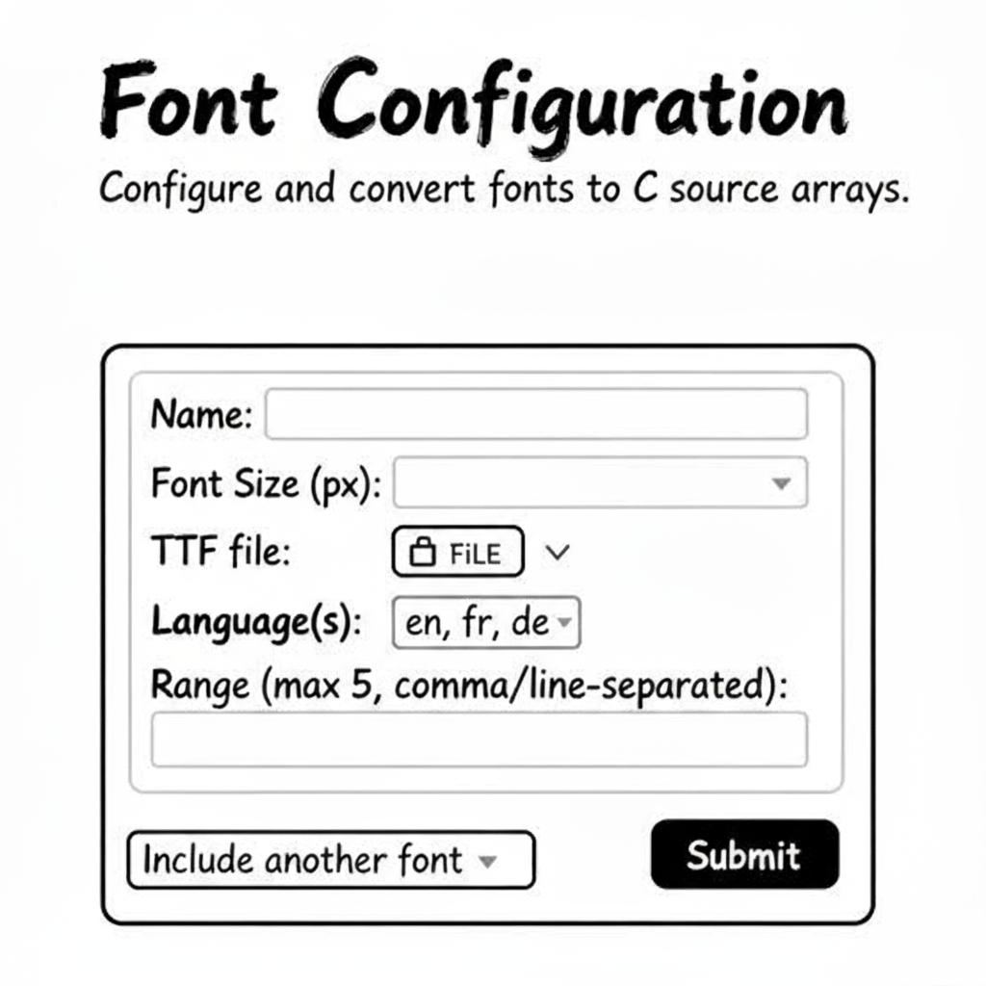

# Image to C Converter Module

Convert image files (BMP/JPG/JPEG/PNG/GIF/ICO) into RGB888 C arrays.  
  
**Workflow:**

* Select image file(s) in supported formats (BMP, JPG, JPEG, PNG, GIF, ICO) and Color Format is RGB888
* Selecting the image will display image, name, and size along with option [x] to remove if not needed
* Click convert to start processing.
* Each image conversion generates one .c source file.
* If multiple images are selected, clicking convert generates multiple .c files simultaneously.
* Save output file(s) with automatic renaming to avoid overwrites.

**Additional points:**

* Conversion only proceeds if image files pass validation checks (unsupported formats or corrupted files prevent output).

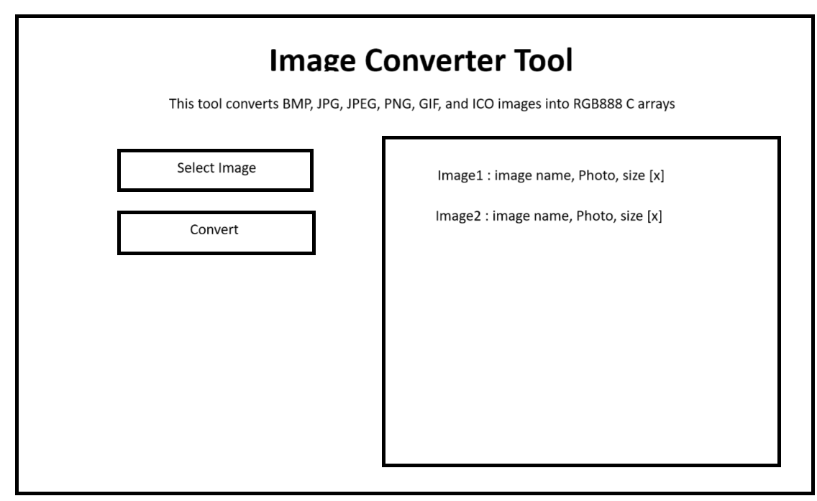

**Zone Configuration**

This interface is designed for grid-based zone creation and configuration.

**Workflow :**

* Set Grid Dimensions: Input your desired number of rows and columns in the respective fields labelled "Number of rows" and "Number of columns" and this will be common for all pages
* Create the Grid: Click the "Create page" button to dynamically generate a visual grid based on your specified dimensions.​
* Define Zones: In the displayed grid view, create up to five distinct zones by selecting or drawing rectangular areas; each zone will appear with a unique coloured border for easy identification.​
* Page Management: Each created page (up to a maximum of 12) will be listed, displaying its page number, no of rows and columns, and no of zones associated. A dropdown menu enables quick zone selection for further edits.​
* Zone Management: When a specific zone is selected from the dropdown, a detailed window opens to display all properties for that zone. Users can adjust configuration parameters for the selected zone and must click "Save" to store any changes.​
* Generate Output:  Click the "Generate JSON" button. This exports a file containing details of all pages and for each page it will have details like page number, grid dimensions, zone definitions, each zone’s coordinates, and their assigned properties.

**Additional Points :**

* The dimensions [No of rows and columns] mentioned on top for creating pages will be common for all pages
* Each page can contain a maximum of 5 zones, and a maximum of 12 pages can be defined in one session.
* The zone creation via the grid visual ensures accuracy in region selection and helps prevent overlapping or invalid zone definitions.
* Each zone properties will be in dropdown format and user selects it based on requirement
* Include another page option creates pages by displaying a new grid and provide new page details

**Zone Configuration Tool**

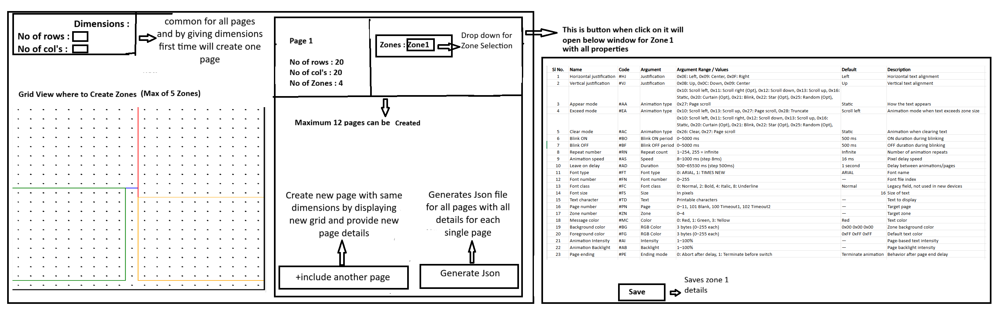

**Zone Properties List**

