**LED Display Rendering & Zone Configuration proposal**

**Document Control**

Document Information

|  |  |
| --- | --- |
|  | **Information** |
| Document Id | *EmdSW_Proposal_LEDDisplay_002* |
| Document Owner | *Vijay Mukilan S* |
| Issue Date | *23th Sep 2025* |
| Last Saved Date | *23th Sep 2025* |
| File Name | *LED_DisplayDriver-DigicommProposal* |

Document History

|  |  |  |
| --- | --- | --- |
| **Version** | **Issue Date** | **Changes** |
| *[1.0]* | *22rd Sep 2025* | *Initial version* |
| *[1.0]* | *23rd Sep 2025* | *Review and updated* |
|  |  |  |
|  |  |  |

**Table of Contents**

1 Executive Summary 1

2 Background 1

2.1 Digicomm Semiconductor Overview 1

2.2 Understanding on the scope 1

2.3 Solution 2

2.3.1 Software Tool 2

2.3.2 LVGL Rendering Engine 2

2.3.3 Zone configuration 4

2.3.4 Test 4

3 Proposal 5

3.1 Deliverables 5

3.2 Dependencies 5

3.3 Timeframe 6

3.4 Budget 6

3.5 Reporting 6

3.6 Implications 6

3.7 Success Criteria 6

# Executive Summary

Centum T&S has issued a Statement of Work (SoW) to Digicomm Semiconductor for the development of LED Display rendering software. In response, Digicomm Semiconductor also had a discussion with Centum team to understand the SOW. Below document outlines the understanding based on SoW and discussion at Centum’s office. This proposal will outline the project budget, schedule, and demonstrate a clear understanding on the scope of the development.

# Background

## Digicomm Semiconductor Overview

Founded in 2012, Digicomm Semiconductor is a trusted technology partner to over 20+ global clients, with a robust team of 500+ professionals spread across India (Bangalore, Pune, Noida), the US, and Taiwan. We specialise in semiconductor IC design, embedded solutions, and system-level services across industries including semiconductor, automotive, networking, IoT, telecom, aerospace, and defence.

We support our partners from fabrication to production. We have both in-house and customer supporting team across VLSI and Embedded areas.

## Understanding on the scope

The project aims to develop a software which can render the fonts, bitmaps, Icons to display in an LED device using the NXP i.MX RT1064 MCU(Microcontroller). The rendering will be carried out using the LVGL framework and the LVGL need to be ported in the NXP MCU controller. Expectation is the MCU should be able to support the rendering of the mentioned indic languages along with the English.

The software development will be in bare metal (c language) without OS. Below is the architecture of the planned development software.

Software Tool

.bin file

Display configuration

**Microcontroller**

**NXP i.MX RT1064**

Webserver

(I SERVER)

Primary Ethernet

Secondary Ethernet

Display driver

SPI/ split SPI

Digicomm implementation scope

LED1

LLED22

## Solution

The scope of development for Digicomm team involves multiple components and it is listed below

1. Software Tool
2. Firmware - NXP microcontroller -Rendering engine,
3. Language rendering – English, Hindi, Marathi, Kannada, Malayalam, Tamil, Telugu, Gujarati, Punjabi, Bengali, Oriya and Urdu.
4. Configuring the zone properties.
5. Testing – Rendering engine & Zone configuration.

## Software Tool

The tool runs on PC. It is used to configure the LED font including bitmaps, icons and zones. It utilizes the icons, fonts that are stored in the PC. The generated file will be a C-Array file(binary).

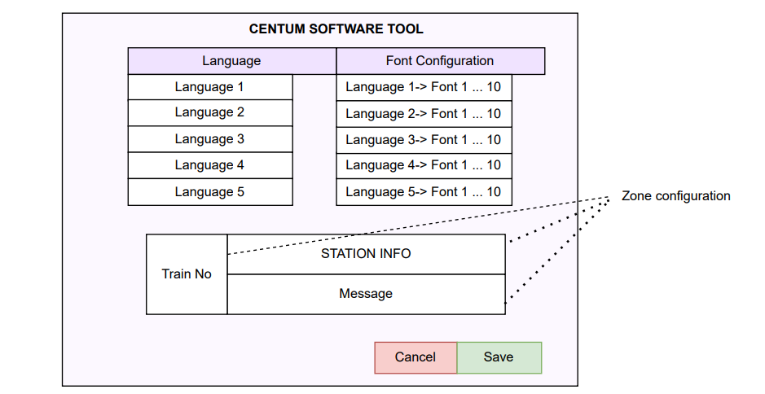

The C array file will be an input for the font handling in the rendering engine.

It will support up to 10 configurations of each of the mentioned languages.

* English, Hindi, Marathi, Kannada, Malayalam, Tamil, Telugu, Gujarati, Punjabi, Bengali, Oriya and Urdu.
* LED display can be configured to support up to 5 languages, it’s based on the memory constraint of the NXP controller.

## LVGL Rendering Engine

Both Indic and English languages rendering is handled using the LVGL library, The library will be ported in the NXP microcontroller.

The LVGL stack is configured on the MCU. The configuration file of LVGL contains details of colour depth of the display to be used. The frame buffer is configured for LVGL in RAM. The application code on the MCU fetches the data from the configuration file from the web page based on the tag/header and sends to the display controller.

#define BUFFER_SIZE (MY_DISP_HOR_RES * MY_DISP_VER_RES * sizeof(lv_color_t))

lv_color_t bufferA[BUFFER_SIZE];

* LVGL takes the input string (UTF‑8), decodes Unicode code points.
* For each code point it looks up the glyph (if present). If missing, fallback or blank.
* It retrieves the glyph’s bitmap and metrics (width, height, baseline, etc.).
* It draws the bitmap into the display buffer (or directly to display) honouring alignment, colour, possibly anti‑aliasing etc.
* After drawing all characters, the display gets updated (via LVGL display driver / flush callback).

**Case A: Monochrome (1 bit per pixel)**

* Resolution = 128 × 16 = 2048 pixels
* 1 bit per pixel ⇒ total bits = 2048 bits ⇒ bytes = 2048 / 8 = **256 bytes** per full frame
* With double buffering, you need two such buffers: 2 × 256 bytes = **512 bytes** total for frame buffers.

**Case B: 16×128 RGB LED matrix:**

* Resolution: 128 × 16 pixels = 2,048 pixels
* Colour Depth: RGB (3 channels)
* 16 bpp: 2 bytes (16-bit colour depth)
* Double Buffering: 2frame × 2bytes x 4,096 bytes = **8,192 bytes**

Total Buffer Size: **8,192 bytes** (~8 KB)

## Zone configuration

LED display can be configured with different properties to share information to the passenger. The following commands will determine the display properties.

|  |  |  |
| --- | --- | --- |
| SL No. | Command | Description |
| 1 | Zone Page Configuration | This command is for selecting a particular page, whose zone configuration must be done |
| 2 | Zone Configuration in a Page | This command is for selecting a particular zone, whose configuration must be done and here maximum there can be 4 zones |
| 3 | Set Zone Properties | This command is to configure different zone properties |
| 4 | Erase Page | This command is to erase a zone and page |
| 5 | Erase Zone in Page |
| 6 | Display Page | This command is to do the configuration of display of its properties like animation and colour |
| 7 | Display Text in Specified Zone | This command is to send text that must be displayed |

Using these commands pages can be added to the display and if required zones can be created to display specific information.

The properties like justification, animation, blinking, font style and size, Display colour, etc, can be configured to display the information. In total the 23 properties mentioned ASOP160000IDD-F in section 4.9 will be implemented.

Using the command text to be displayed is sent which will be displayed.

## Test

All the implemented functionality to be tested and validated for the correctness.

Test Specification and Test report will be delivered as part of the deliverables.

# Proposal

The proposal is to execute the project at a fixed price from the Digicomm office. Both Digicomm and Centum will regularly meet in the centum office on a need basis to showcase the progress, clarify and discuss the next steps.

Below will be the modules & Time requirement for the Digicomm to execute the project.

|  |  |  |  |
| --- | --- | --- | --- |
| Sl. NO. | Task Description | Duration (days) | Remark |
| 1 | Requirement engineering +Porting of the rendering engine- NXP microcontroller + Environment setting to start the development. | 20 |  |
| 2 | LVGL rendering - Indic & English, along with bitmaps and Icons | 30 |  |
| 3 | Software tool to convert TTF to C Array/Unicode file | 30 |  |
| 4 | Display Page/Zone Properties | 15 |  |
|  | (Page Configuration, Zone Configuration, Zone Properties, Erase Page/Zone, Display Page, Display Text) |  |  |
| 5 | LED Screen Configuration - 23 Properties | 20 |  |
| 6 | Test - Validation of the implemented functionality | 35 | S/W Tool, Rendering Language, Zone |
| 7 | Integration to the display driver & Support | 18 |  |

## Deliverables

Below are the deliverables and the timeline required for the completion of the activity.

|  |  |
| --- | --- |
| Sl. NO. | Task Description |
| 1 | Requirement Engineering |
| 2 | Porting of the rendering engine- NXP microcontroller |
| 3 | LVGL rendering - Indic & English, along with bitmaps and Icons |
| 4 | Software took to convert TTF to C array/Unicode file |
| 5 | Display Page/Zone Properties |
| 6 | LED Screen Configuration - 23 Properties |
| 7 | Test - Validation of the implemented functionality |
| 8 | Integration to the display driver & Support |

## Dependencies

To meet the timeline of each deliverable, considering the project starts on 3rd of October below dependencies has to be met.

|  |  |  |
| --- | --- | --- |
| Dependencies | | |
| SL No. | Description | Date |
| 1 | EVK Board | 06-10-2025 |
| 2 | LED Display | 16-10-2025 |
| 3 | Debugger | 06-10-2025 |
| 4 | License for IAR Workbench | 06-10-2025 |
| 5 | Font Files | 03-11-2025 |
| 6 | Display driver code (SPI) | 16-10-2025 |
| 7 | Software Support |  |

## Timeframe

The timeframe considers the development complexity and the need to test all the functionality before releasing to the end user. To support a quick prototype of the module for the centum to test parallel execution of the activity is planned.

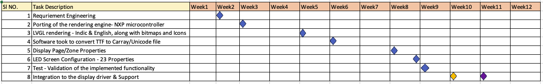

## Budget

## Reporting

To keep the transparency between Centum and Digicomm, Digicomm will conduct alternate week status call to give the status of the project. Meanwhile a status report will be shared on each week to explain the status of each module.

## Implications

The project is planned considering the start on 1st Oct 2025. If the approval to start is delayed all activity will also get delayed accordingly.

## Success Criteria

On completion of each milestone the Digicomm sends an approval mail for the milestone completion. Centum is requested to approve the milestone in 7 working days accepting the milestone.