**ASSIGNMENT-1**

1. **CREATE THREE INSTANCE**

**Step 1: Sign in to the AWS Management Console**

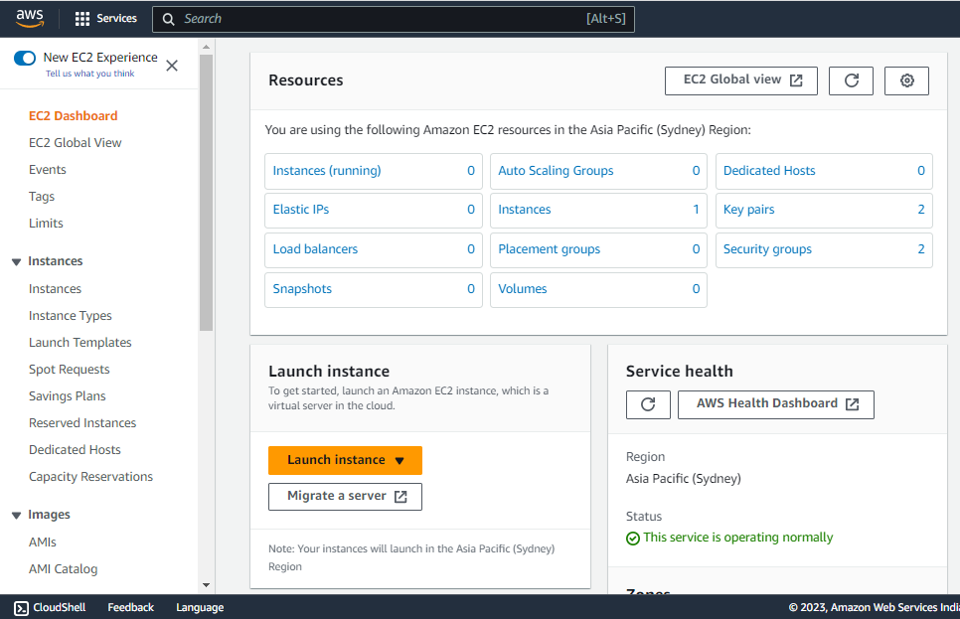

EC2 dashboard

To create an EC2 instance, you first need to sign in to the AWS Management Console. If you don't already have an AWS account, you'll need to create one. Once you're signed in, navigate to the EC2 dashboard and Launch an instance.

**Step 2: Choose a name of your instance**

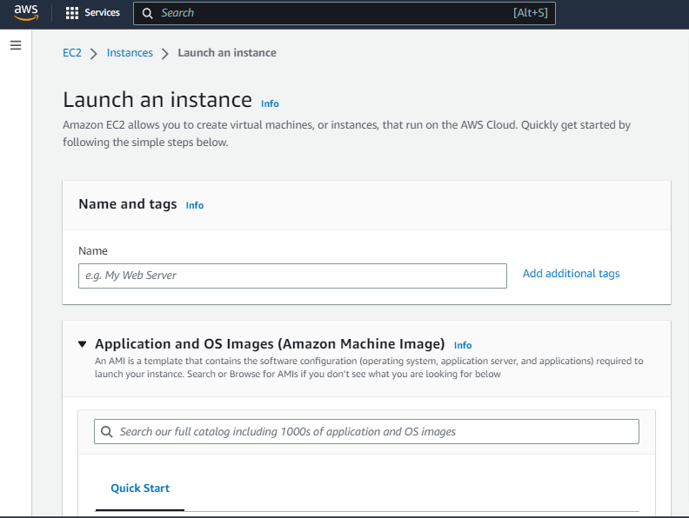

Select a name of your instance as per your likability

**Step 3: Choose an Amazon Machine Image (AMI)**

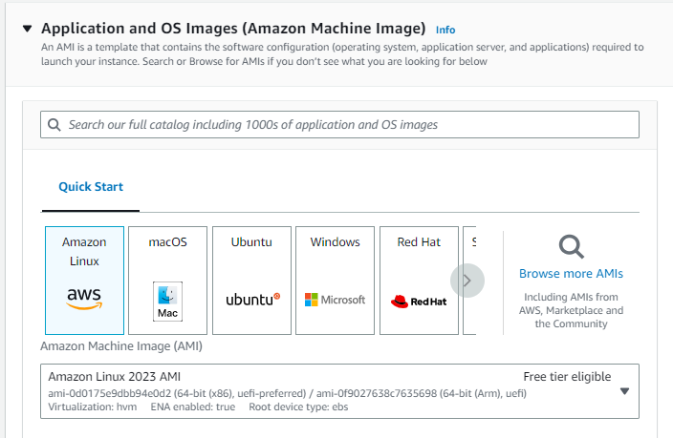

Selecting AMI for your instance

An Amazon Machine Image (AMI) is a pre-configured virtual machine that serves as a template for your EC2 instance. You'll be prompted to choose an AMI from a list of available options. You can choose from Amazon Linux, Ubuntu, Windows, and many other options.

**Step 4: Choose an Instance Type**

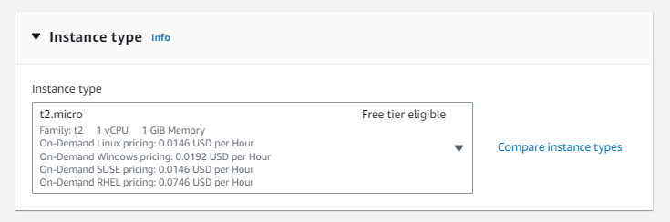

An instance type determines the computing resources (CPU, RAM, storage, etc.) available to your EC2 instance. There are a variety of instance types to choose from, ranging from small and low-cost to large and high-performance. Select the instance type that best fits your needs and budget.

**Step 5: Create a key pair**

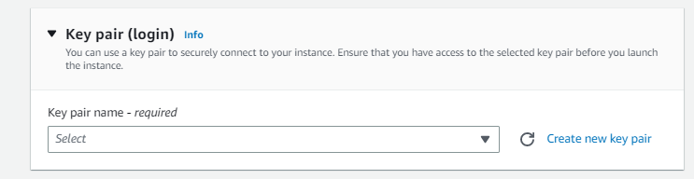

Create a key pair if you have never created one and store it in a safe place because it will act as a key to log in to your instance.

**Step 6: Configure Security Group**

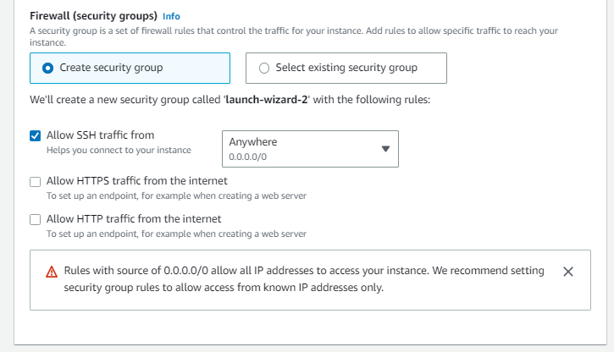

Security groups act as virtual firewalls for your EC2 instance, controlling inbound and outbound traffic. You can configure security groups to allow or deny traffic from specific IP addresses, protocols, and ports. In this step, you'll need to create a new security group or select an existing one.

**Step 7: Add Storage**

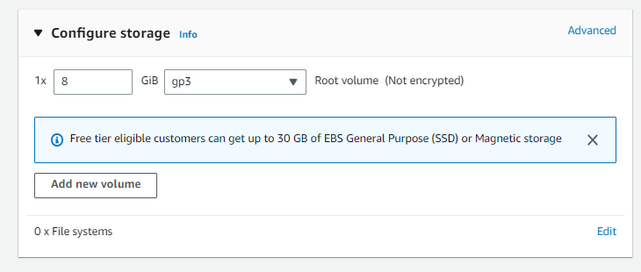

EC2 instances require storage for the operating system, applications, and data. In this step, you can add and configure storage volumes for your instance. You can choose from different types of storage, including Amazon Elastic Block Store (EBS) volumes and instance store volumes.

**Step 8: Review and Launch**

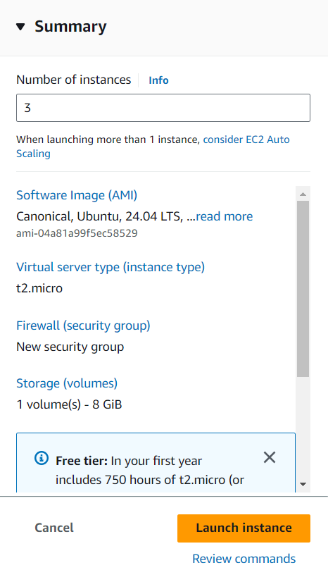

Before launching your instance, review all the details to make sure everything is correct. You can also modify any settings that need to be changed. Once you're ready, click the "Launch" button to start your EC2 instance.

**Attach one EBS to two instances**

After creating EC2 instance, we can connect to the instance

**Connect to the Instance**

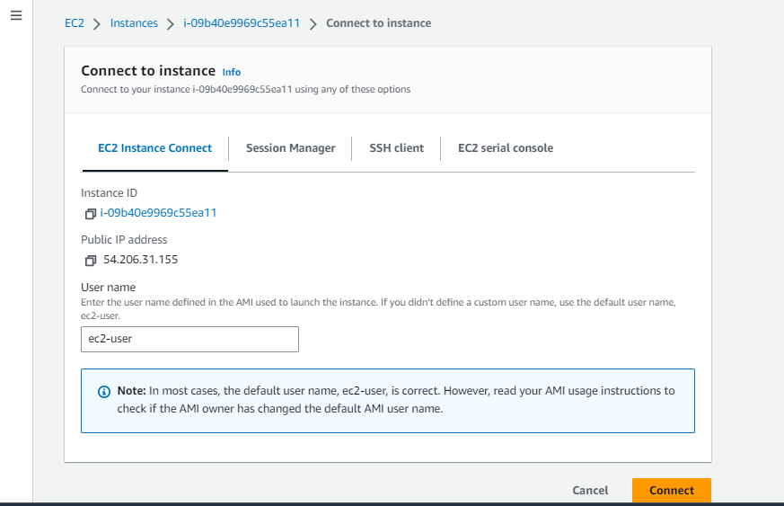

After launching your instance, you can connect to it using various methods, such as SSH or Remote Desktop Protocol (RDP). You can also use the AWS Systems Manager Session Manager to connect to your instance securely without the need for a public IP address.

**Connect to the server**

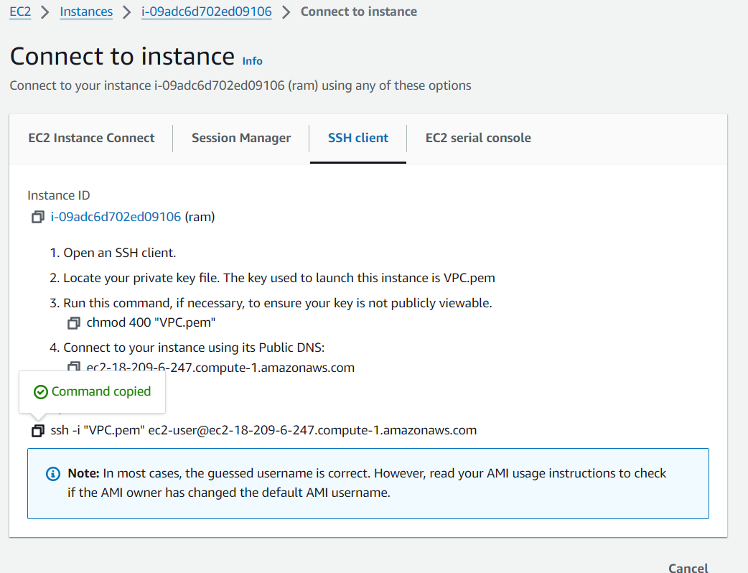

After copy the command, open the Gitbash and paste the command in the git bash and press enter.

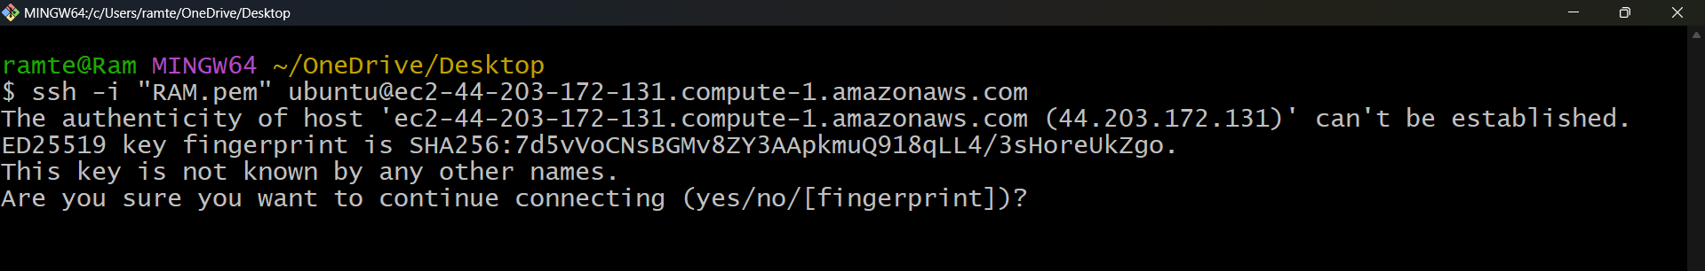

Then type YES and press enter.

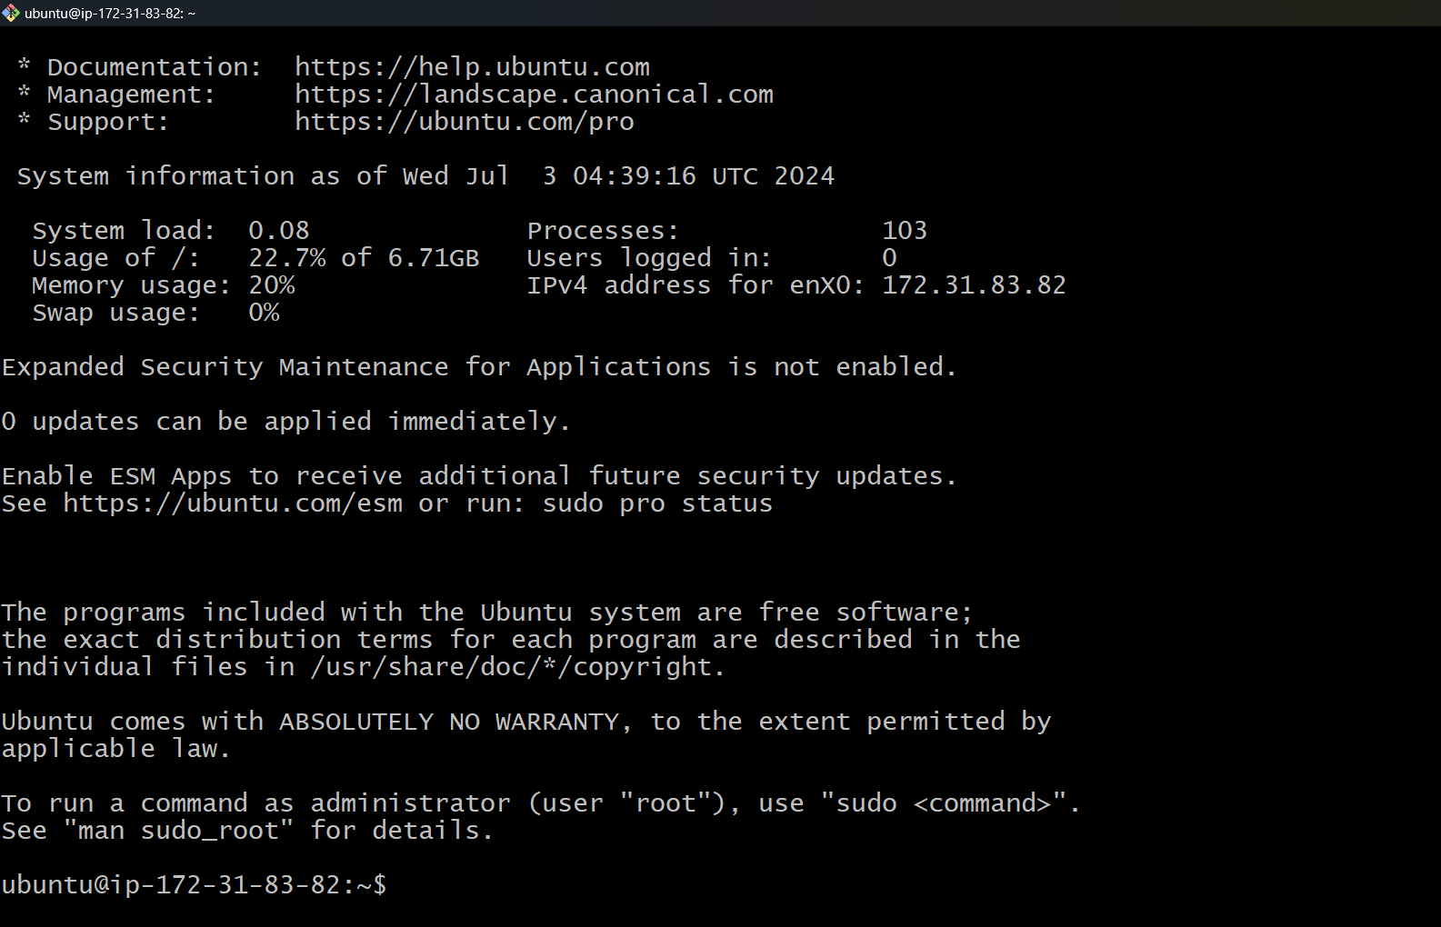

To become a root user, type

# sud0 –i

# clear

Then type

# df –h

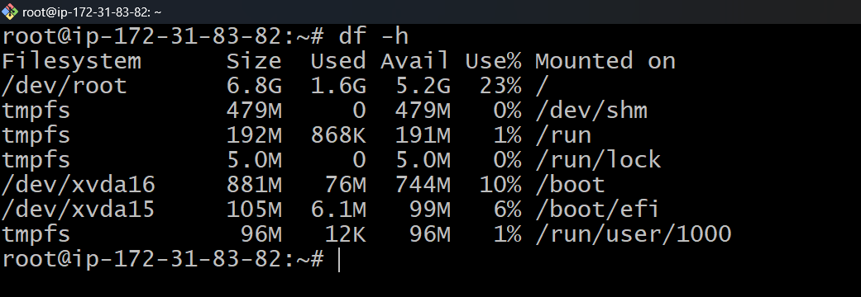

We can see the disc storage, if we want to increase the size volume

* Go to volumes and select the volume and go to actions and select modify volume

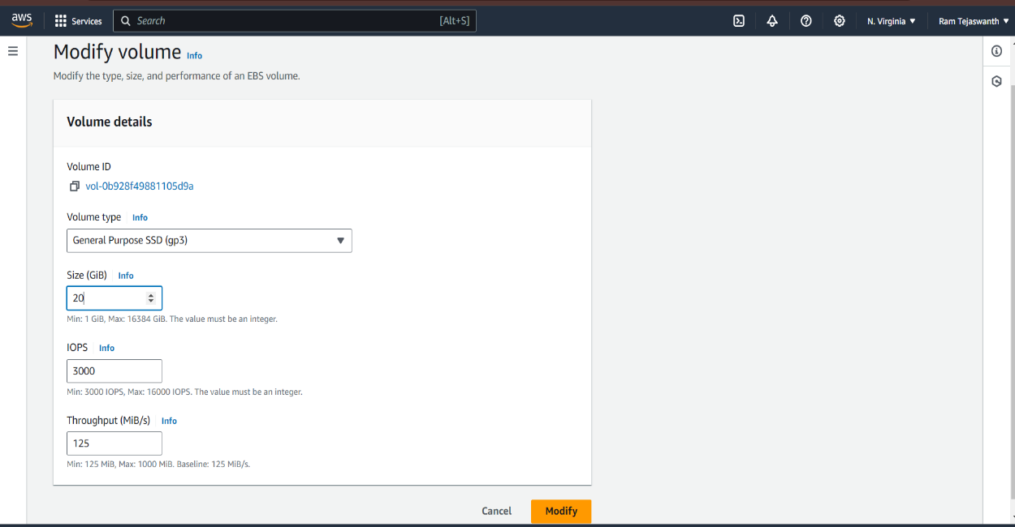

* After modify the volume reboot the instance. After reboot the innstance go to git bash connect the server.
* Paste the SSH command and type the command

# sudo –i

# df –h

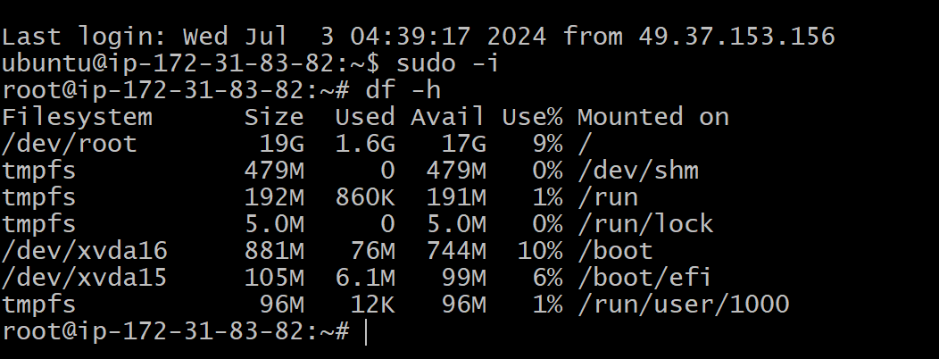

Now the size of the volume is increased.

**Mount the volumes**

* Go to volumes
* Click on create volumes
* Select the volume type and size and click on create volume.
* Select the volume and click on attach volume.
* Select the instance and device name and click on attach volume.

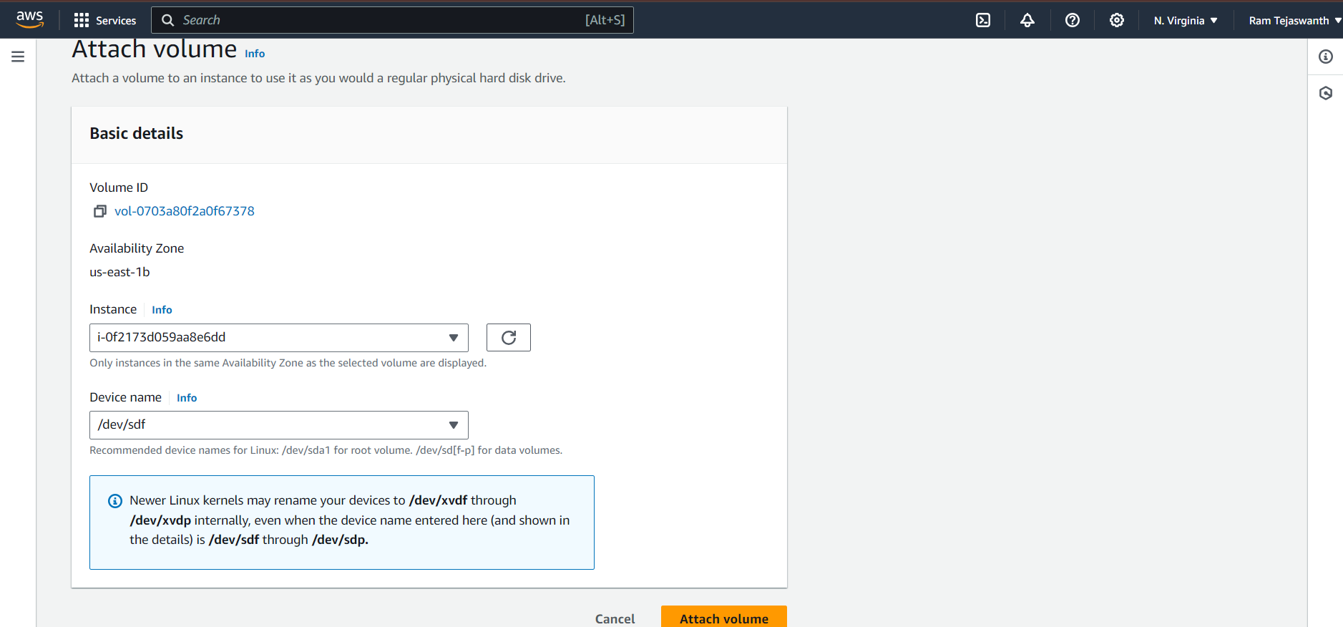

To see the size of the volume, connect to the instance and become root user type

# ls

# lsblk

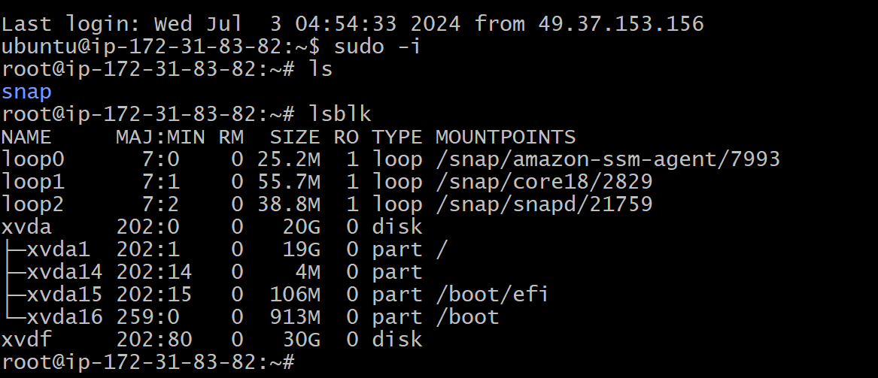

To check the weather the file system is available in volume

# file –s /dev/xvdf

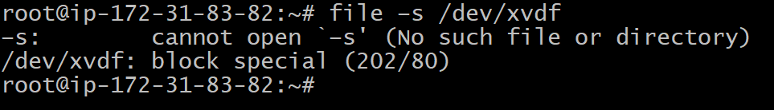

There is no file system in device. To create file system

# mkfs –t xfs /dev/xvdf

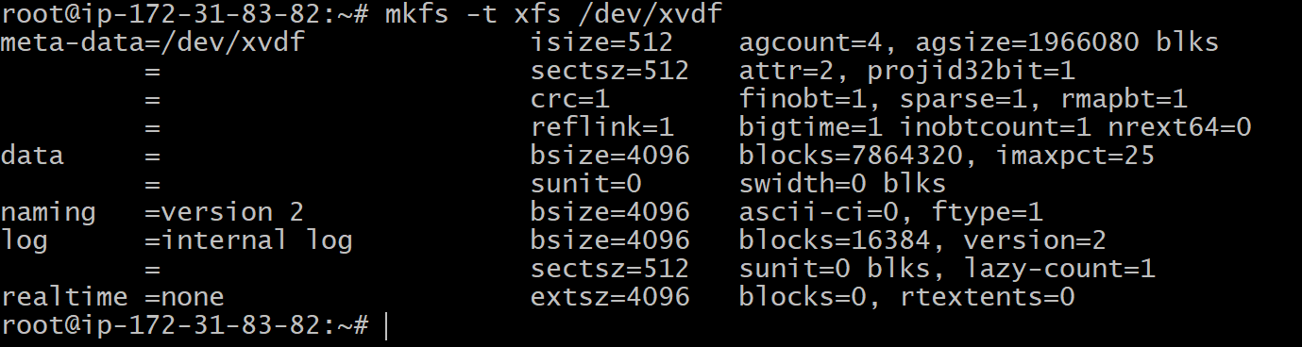

To check weather the file system is there

# file –s /dev/xvdf



Create a directory

# mkdir –p vcube/ram

To mount

# mount /dev/xvdf vcube/ram

# df –h

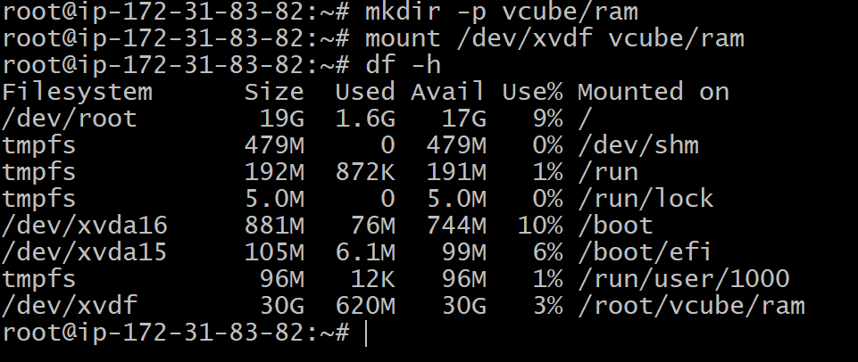

**Attach one EFS to two instances**

**Step 1:Create a security group**

* Click on security group

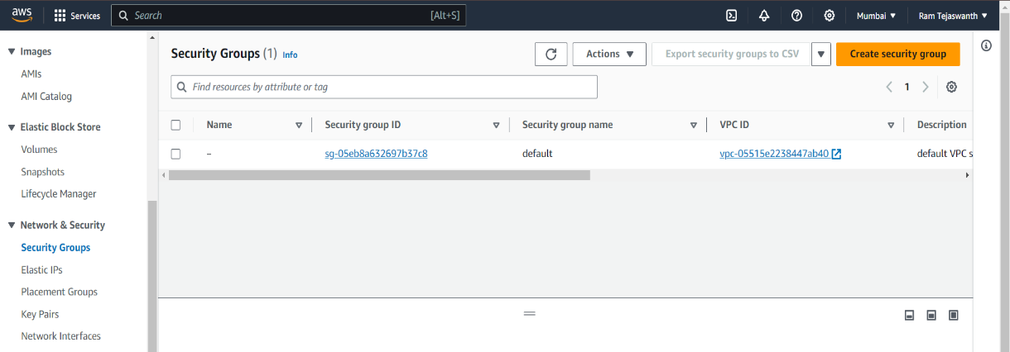

* Type security group name

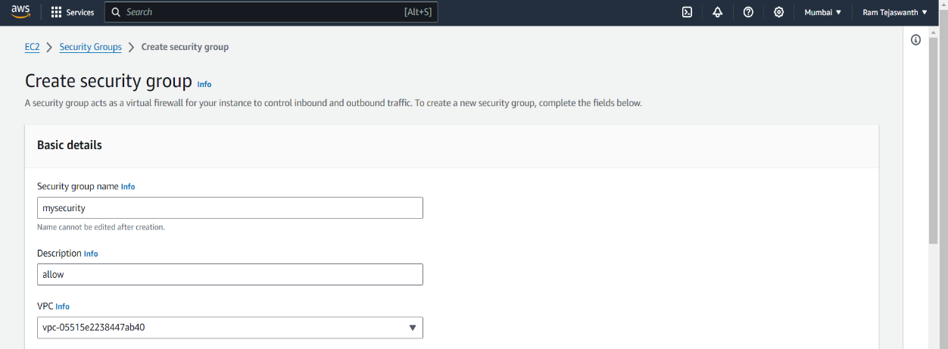

* In Inbound rules
  + Click on add rule
  + Select **SSH**

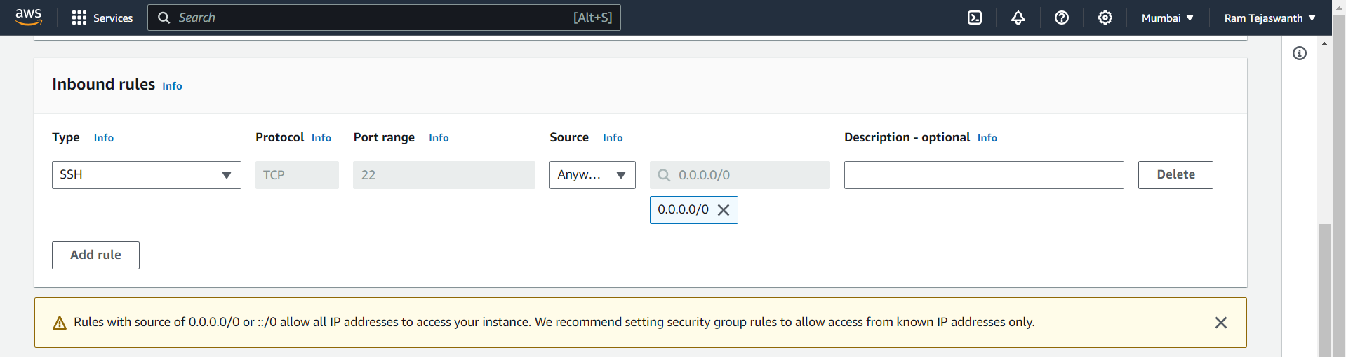

* Click on ‘Create security group’

**Step 2:Create an EFS**

* In EFS go to file system and click on Create file system

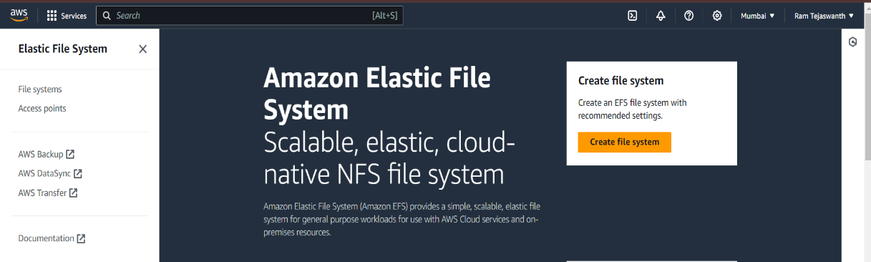

* Type the name for file system and click on customize

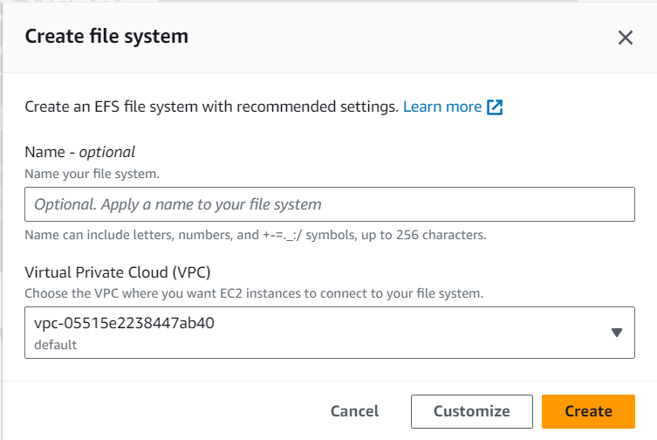

* Choose Regional and
* Click on next
* On Mount tragets choose the security group that created in step 1

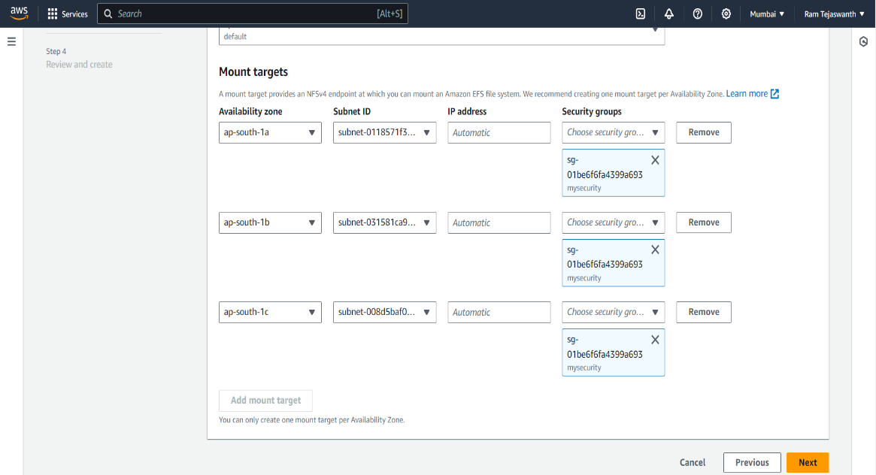

* And click on next and click on Create

**Step 3:Create EC2 Instance**

* Click on Launch Instance
* Type name and select Amazon Linux(AMI)
* Create a new key pair
* Click on Select existing security group and select security group

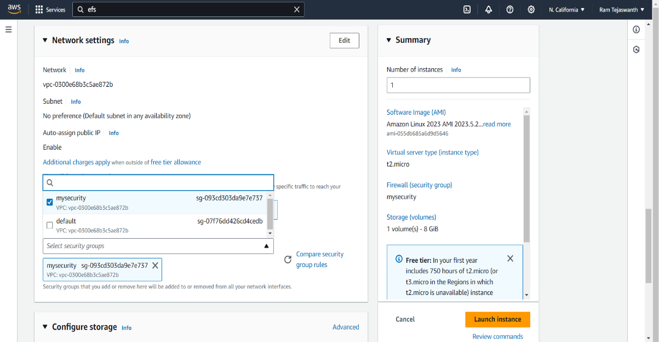

* Click on Edit and select file system
* And uncheck the “Automatically create and attach security groups”
* Click on Launch Instance

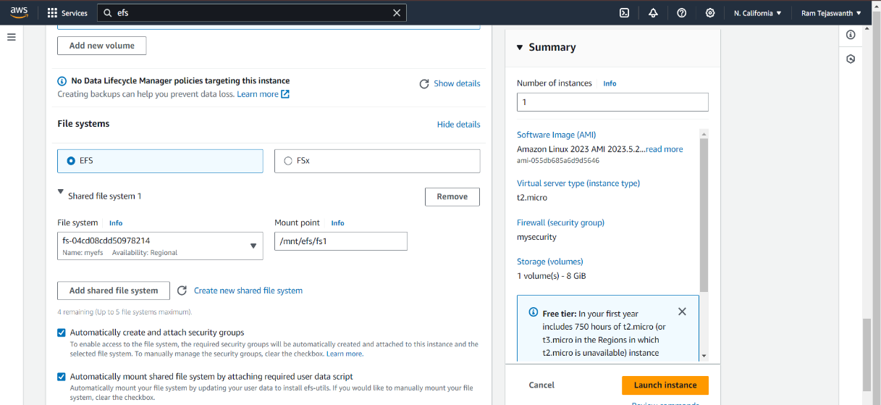

* Click on Instance ID and click on security
* Click on Connect and copy the SSH command

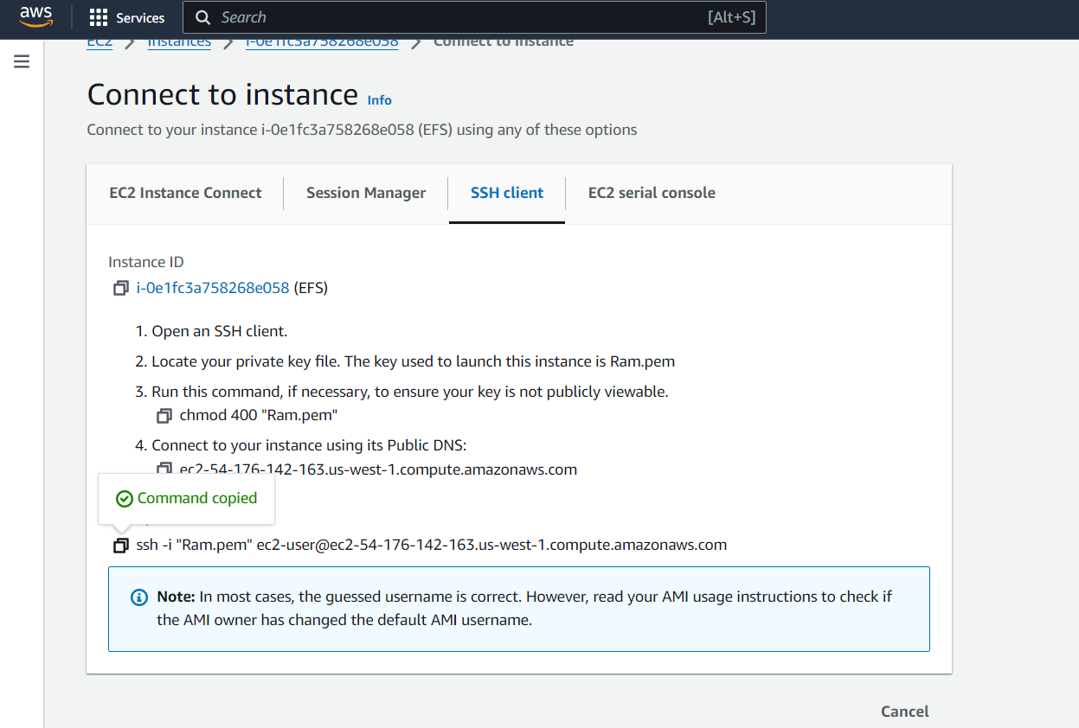

* Open Git bash and paste the command and press enter and type Yes

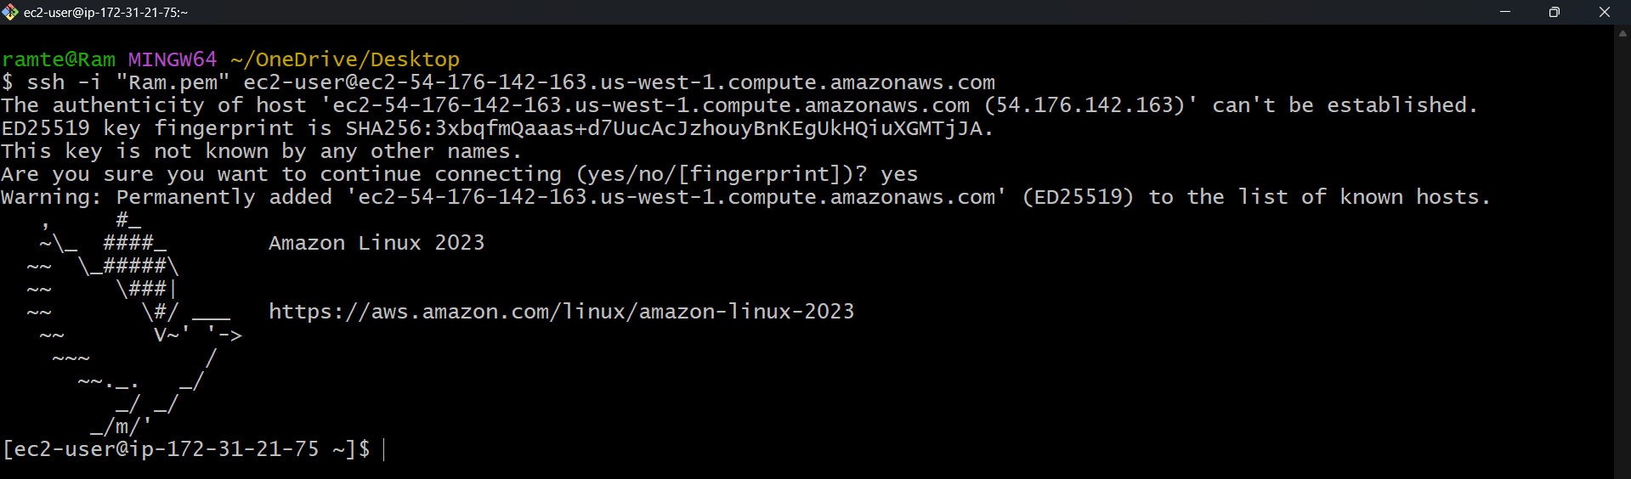

* After connecting to the server type

# sudo –i

# cd /mnt

# cd efs

# ls

# cd fs1

# vi file1(create a file in fs1)

* Type the content and press “Esc+Shift+;” and type “wq”

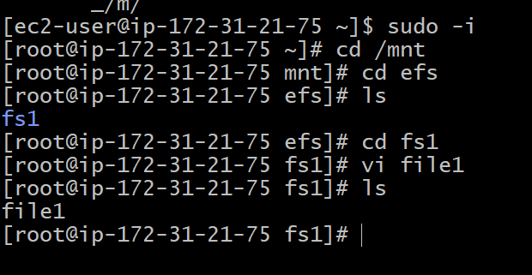

* Create a another Instance and select another subnet in Network Settings

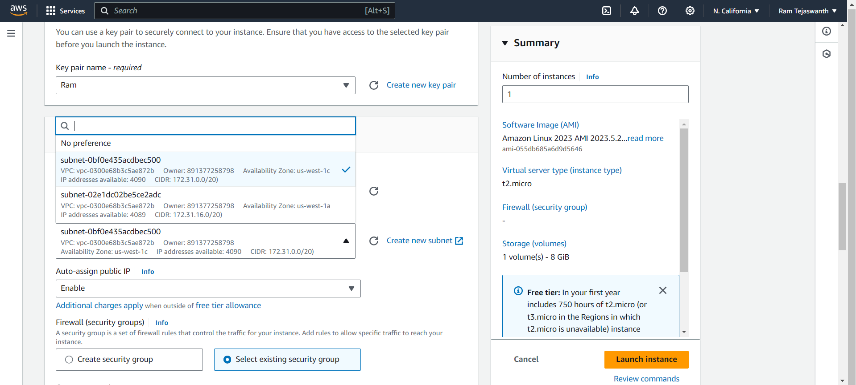

* Connect to the Instance and copy the SSH command
* Paste it in Git bash and press enter, type Yes and press enter

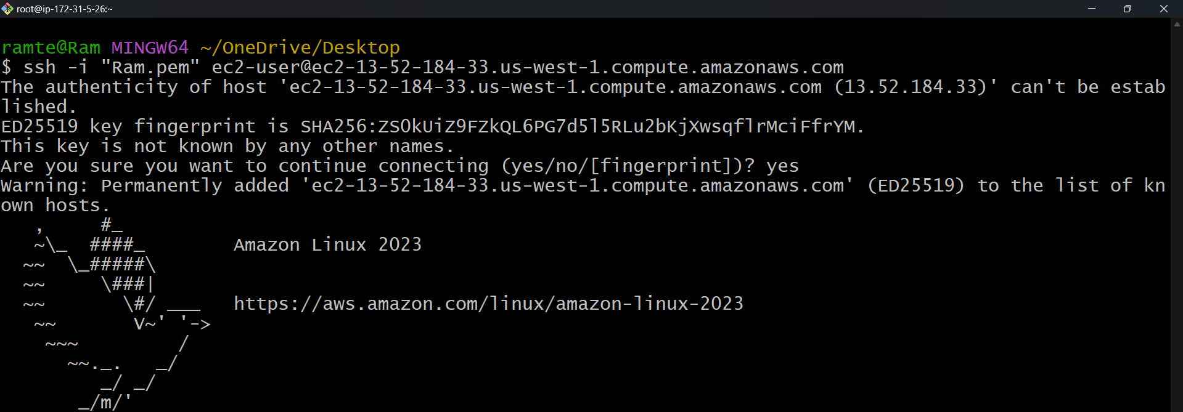

* After connecting to the server

# sudo –i

# cd /mnt

# ls

#cd efs

# ls

# cd fs1

# vi file2

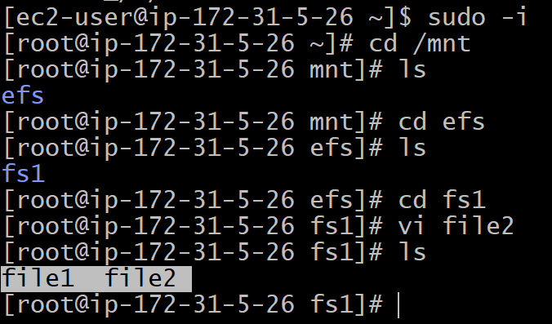

To access the file from one server to another server through EFS.