**ASSIGNMENT-2**

**CREATE THREE INSTANCES AND INSTALL NGNIX AND APPLY ALB**

**Step 1:Create a security group**

* Click on security group

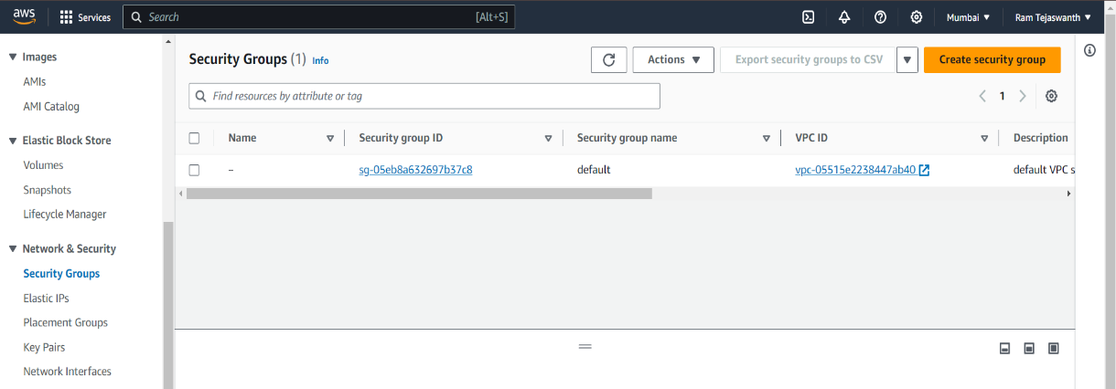

* Type security group name

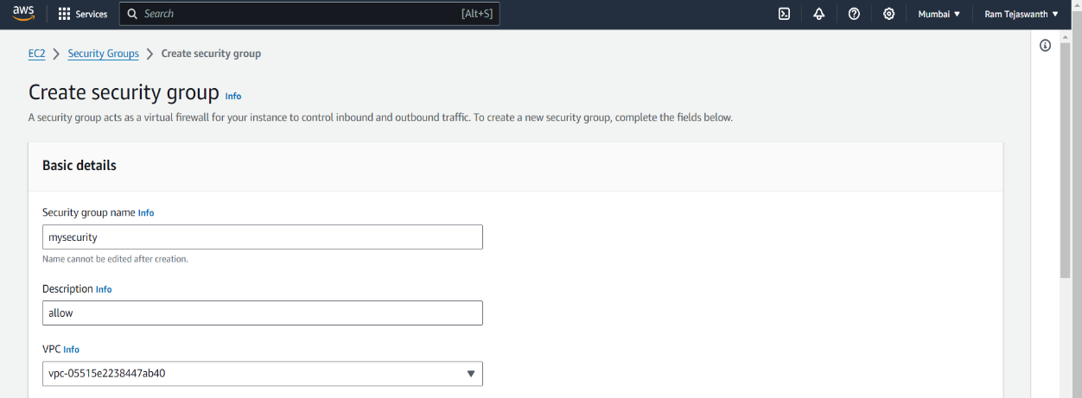

* In Inbound rules
  + Click on add rule
  + Select **HTTP**
  + Select All traffic

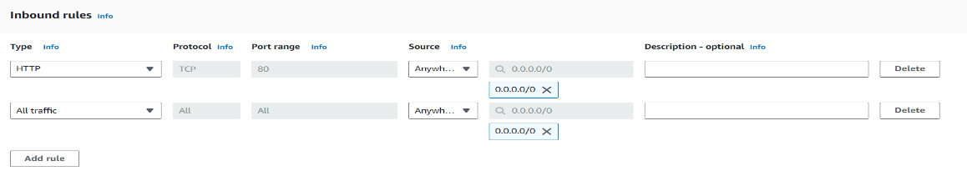

* Click on ‘Create security group’

**Step 2:Create EC2 Instance**

* Click on Launch Instance
* Type name and select Amazon Linux(AMI) and Instance type
* Create a new key pair
* Click on Select existing security group and select security group

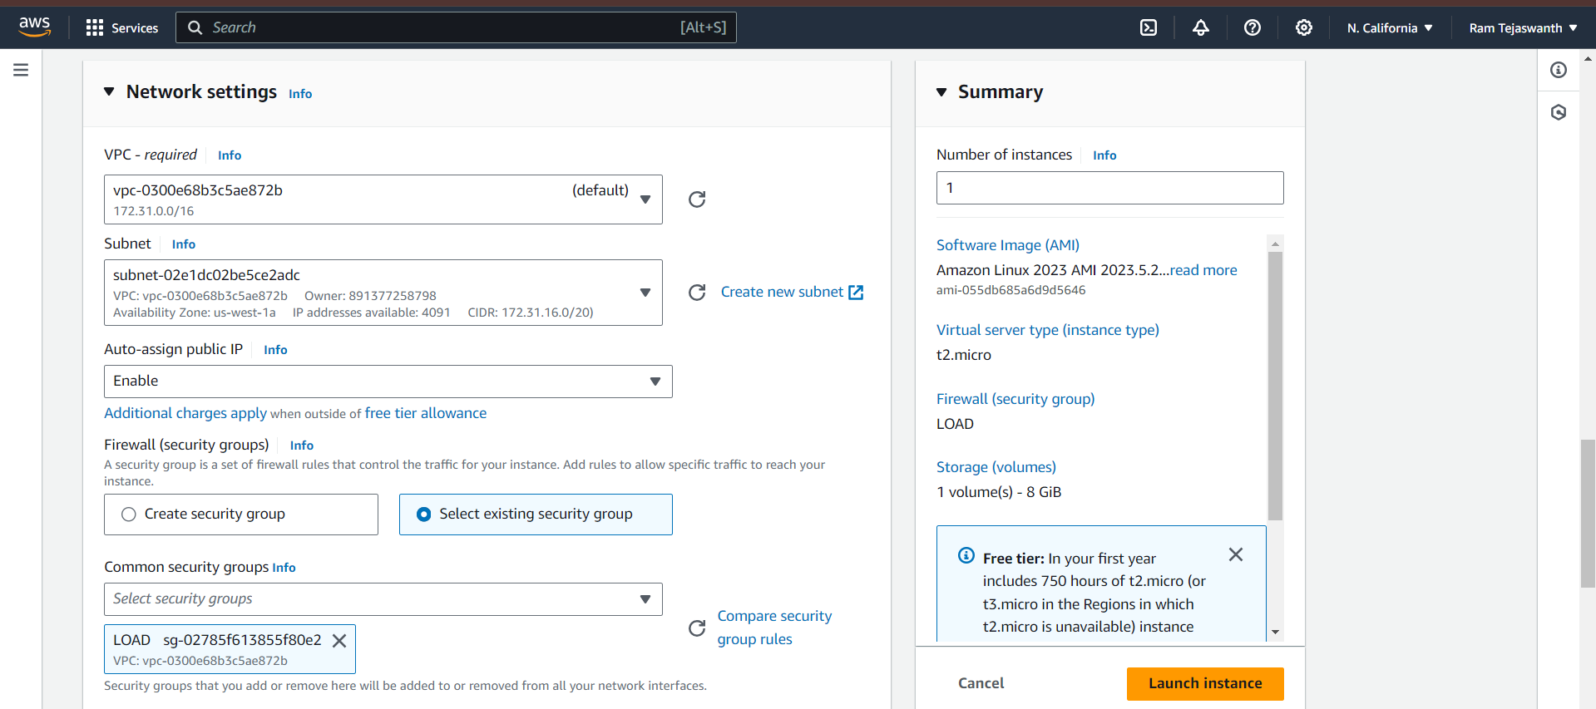

* Click on Launch Instance.
* Again create another Instance with change in availability zone and select security group

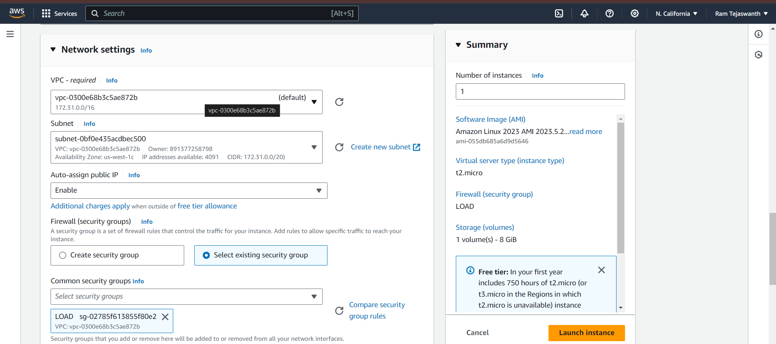

* Click on Launch Instance
* Connect to the Instance
* Click on Instance ID

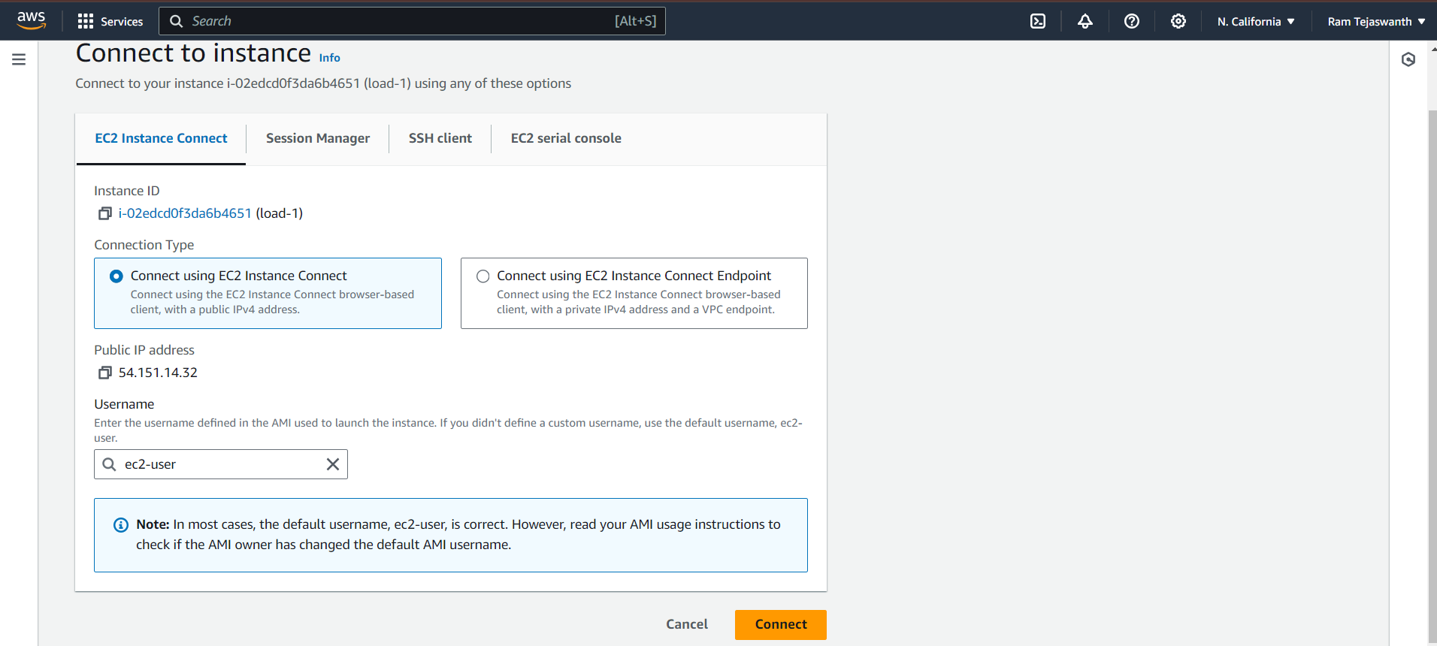

* Click on connect

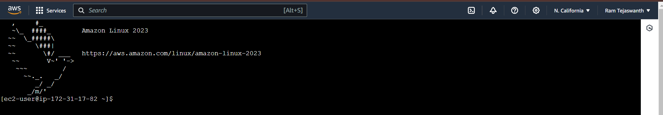

* Type the commands to install nginx

# sudo –i

# yum update –y

# yum install nginx –y

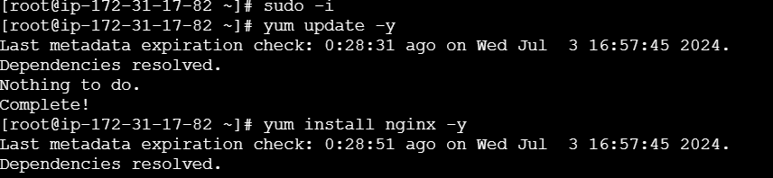

# ls

# cd/usr/share/nginx/html

# rm –rf index.html

# ls

# vi index.html

* Insert the content and press **“Esc+shift+:”** and press **“wq”**

# systemctl restart nginx

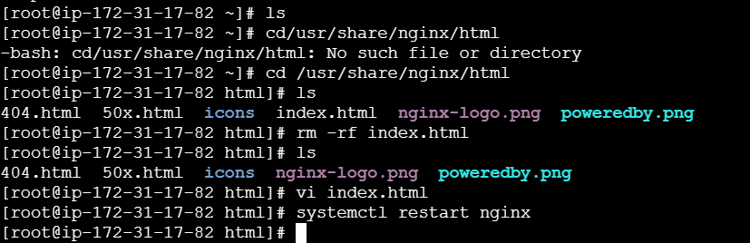

* Copy the PublicIPs and paste in the browser



* Repeat the same process to the load 2

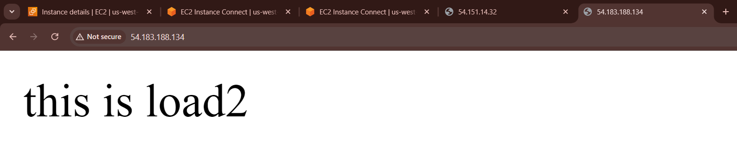

* Repeat the same process to the load 3

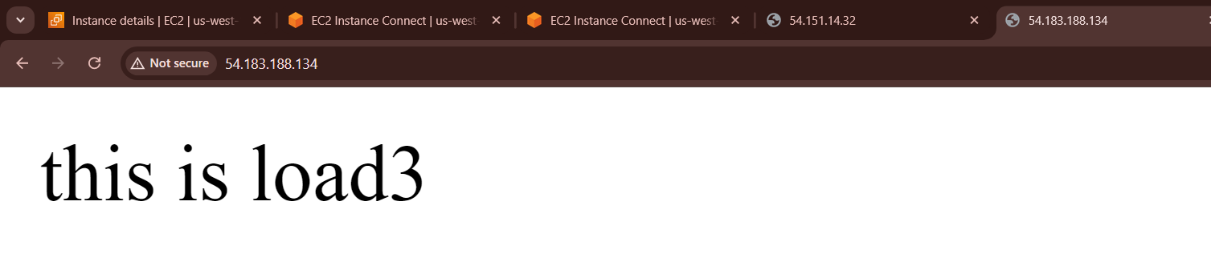

After installing nginx go to the load balancing

* Go to Traget Groups and click on Create traget group
* Choose target type

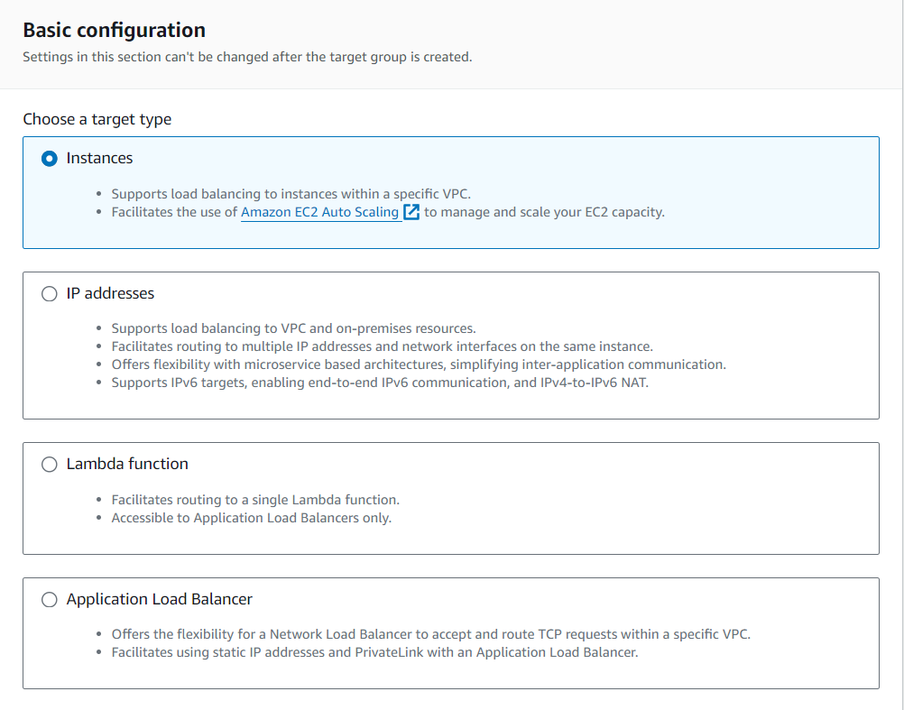

* Type Traget group name

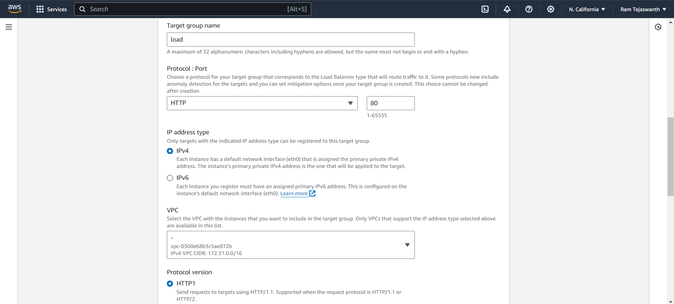

* Click on next
* Select all available Instances and click on include as pending below

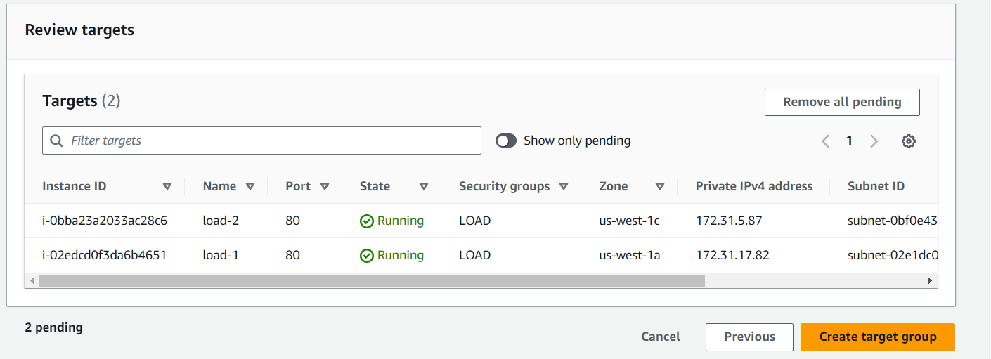

* Click on Create target group
* After Create target group go to the Load balancer
* Click on Create load balancer

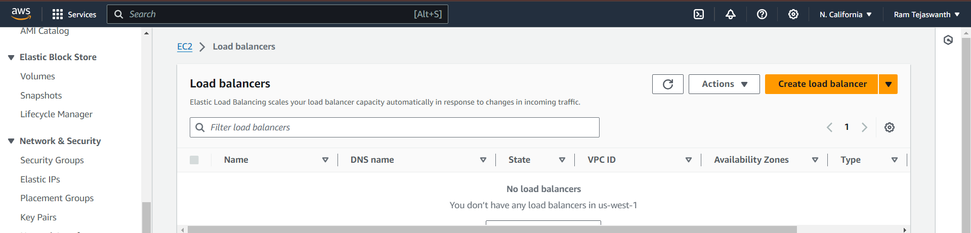

* Select the Load balancer type
* Click on Application load balancer
* Type load balancer name
* Select the availability zones
* Select the security group

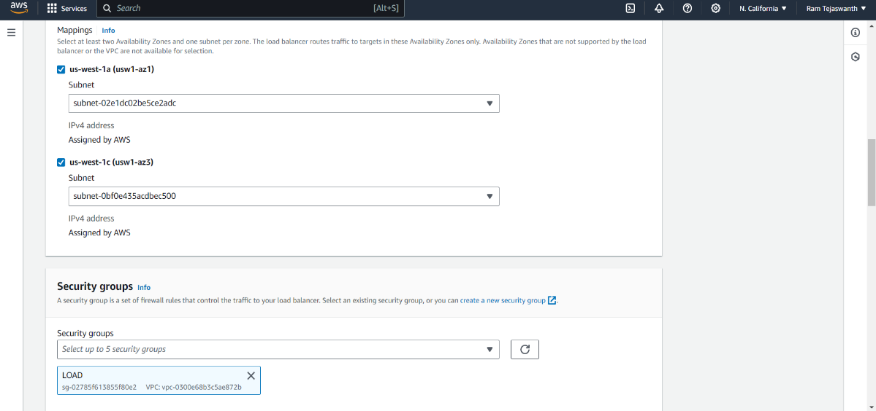

* Select target group

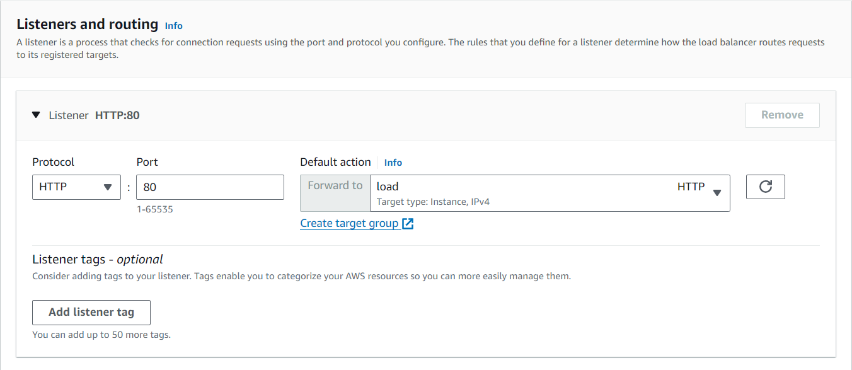

* Click on Create load balancer

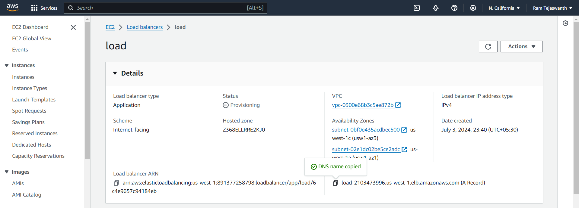

* After creating load balancer copy the DNS name and paste it in browser

