STUDENT PERFORMANCE ANALYSIS
USING POWER BI
Analysis Report
Python | Pandas | CSV | Microsoft Power BI

1. INTRODUCTION
In this project, we have developed a Student Performance Analysis dashboard to study the academic performance of 200 students. The project uses student information such as gender, branch, semester, attendance percentage, daily study hours, final marks, grade, and result. Instead of checking these records manually, we process the dataset and present the important information in a visual form.
We use Python and Pandas to read and prepare the CSV dataset, and then import the cleaned data into Microsoft Power BI. In Power BI, we create cards and charts to compare student performance across branches and semesters and to observe attendance, marks, results, gender, and study habits. The final dashboard makes the dataset easier to understand and helps us identify performance patterns quickly.

2. OBJECTIVE OF THE PROJECT
The objective of our project is to convert raw student records into a clear and useful performance analysis dashboard. We use the available academic data to understand how students are performing and to compare different groups of students.
- To import and work with student performance data stored in CSV format.
- To clean and prepare the dataset using Python and Pandas before visualization.
- To calculate the total number of students and the average values of final marks and attendance.
- To compare average final marks of Computer Science, Information Technology, and Electronics students.
- To compare average performance across Semesters 3, 4, 5, and 6.
- To visualize the distribution of student records and analyze performance using Power BI charts.
- To study student information according to gender, study hours, attendance, branch, semester, and final marks.
- To present the complete analysis in a single Power BI dashboard that is easy to read.

3. THEORETICAL BACKGROUND
Our project is based on data analysis and data visualization. We start with raw student records in a CSV file. Each row represents one student and the columns contain the student's academic and related information. The main fields used in our project are Student_ID, Gender, Branch, Semester, Attendance_Percent, Study_Hours_Per_Day, Final_Marks, Grade, and Result.
We use Python because it allows us to handle the CSV data easily. The Pandas library is used to load the file into a DataFrame, inspect the records, check missing and duplicate values, calculate basic statistics, and save a cleaned version of the dataset. This cleaned dataset is then used for our Power BI analysis.
In Power BI, we use cards to display important summary values and charts to compare different parts of the dataset. A column chart is used for branch-wise average final marks, a line chart is used for semester-wise average marks, and a donut chart is used to show the distribution of records. These visualizations make the numerical data easier to compare than reading the complete CSV file manually.

4. PROPOSED SYSTEM
In our proposed system, the student performance CSV file is first loaded using Python. We inspect the dataset and clean unnecessary, duplicate, or missing records if required. After cleaning, the processed dataset is saved as a new CSV file named student_performance_cleaned.csv.
The cleaned CSV file is then imported into Power BI. We create summary cards for the total number of students, average final marks, and average attendance. We also create branch-wise, semester-wise, result-distribution, gender, and study-hours visualizations. The complete workflow used in our project is shown below.
Student Performance CSV Dataset
↓
Python and Pandas
↓
Data Checking and Cleaning
↓
Cleaned CSV Dataset
↓
Import into Power BI
↓
Create Cards and Charts
↓
Student Performance Dashboard
↓
Analyze the Results

5. CSV VIEW
For this project, we use a CSV dataset containing 200 student records. The CSV file acts as the main input of our system. Every record contains the student's ID and academic information that is later used in Python and Power BI.
The important columns used from the CSV file are Student_ID, Gender, Branch, Semester, Attendance_Percent, Study_Hours_Per_Day, Final_Marks, Grade, and Result. A sample of the data used in our project is shown below.
Student_ID | Gender | Branch | Semester | Attendance % | Study Hours | Final Marks | Grade | Result
STU001 | Female | Computer Science | 6 | 84.7 | 2.3 | 74.7 | B+ | Pass
STU002 | Male | Electronics | 6 | 97.0 | 3.2 | 72.0 | B+ | Pass
STU003 | Male | Information Technology | 5 | 89.6 | 4.2 | 74.6 | B+ | Pass

6. PYTHON CODING
We use the following Python code to load the student CSV file, inspect the data, clean it, calculate useful values, and create the cleaned CSV file that is imported into Power BI.
import pandas as pd
df = pd.read_csv("student_performance.csv")
print(df.head())
print(df.info())
print(df.isnull().sum())
print(df.duplicated().sum())
df = df.drop_duplicates()
df = df.dropna()
print(df.describe())
average_marks = df["Final_Marks"].mean()
average_attendance = df["Attendance_Percent"].mean()
print("Average Final Marks:", average_marks)
print("Average Attendance:", average_attendance)
branch_performance = df.groupby("Branch")["Final_Marks"].mean()
semester_performance = df.groupby("Semester")["Final_Marks"].mean()
print(branch_performance)
print(semester_performance)
df.to_csv("student_performance_cleaned.csv", index=False)
print("Dataset cleaned successfully.")
After running the code, student_performance_cleaned.csv is used as the data source for the Power BI report. This keeps the visualization stage separate from the data-preparation stage and ensures that the dashboard is created from the prepared dataset.

7. OUTPUT
The final output of our project is the Power BI dashboard shown below. We use this dashboard to summarize and compare the student performance data.
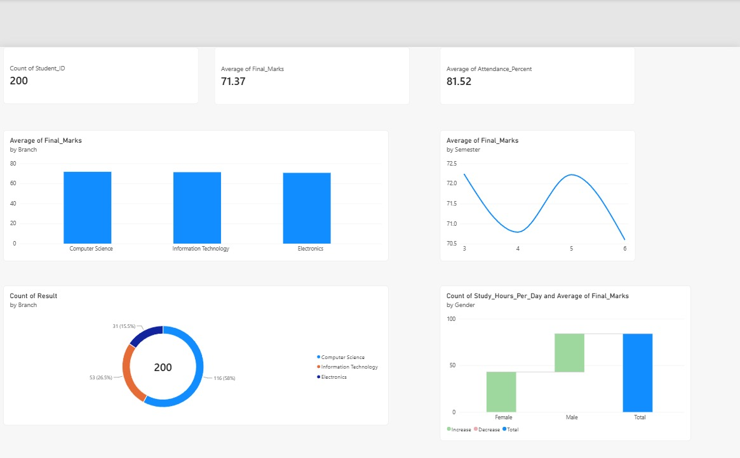
Student Performance Analysis Dashboard - Project Output
In our dashboard, the Count of Student_ID card shows that the dataset contains 200 students. The Average of Final_Marks card shows an overall average of 71.37, while the Average of Attendance_Percent card shows an overall average attendance of 81.52.
The Average of Final_Marks by Branch column chart is used to compare the academic performance of Computer Science, Information Technology, and Electronics students. The values are close to each other, which shows that the three branches have similar average final marks in this dataset.
The Average of Final_Marks by Semester line chart is used to observe how the average marks change from Semester 3 to Semester 6. In the displayed output, the average decreases from Semester 3 to Semester 4, increases in Semester 5, and then decreases again in Semester 6.
The donut chart displays the distribution of the 200 records across the branches. In the current dashboard output, Computer Science contains 116 records (58%), Information Technology contains 53 records (26.5%), and Electronics contains 31 records (15.5%).
The gender-based visual is used in the project to compare study-hours and final-marks information for female and male students. Together, these visuals allow us to view the dataset from multiple perspectives without manually checking all 200 rows.

8. LIMITATIONS
While developing this project, our analysis is limited to the columns available in the student performance CSV file. The dashboard can only show patterns that are represented by these fields.
- Our dataset contains 200 records, so the findings represent only the students included in this dataset.
- The dashboard depends on the correctness of the values entered in the CSV file.
- Our current project focuses on analysis and visualization; it does not predict future student marks.
- Factors such as teaching method, health, family background, classroom participation, and assignment performance are not available in the current dataset.
- The current dashboard uses a static CSV file, so new records must be added or refreshed before they appear in Power BI.
- The system helps identify patterns, but it does not automatically explain the exact reason behind a student's high or low performance.

9. CONCLUSION
In this project, we successfully use Python, Pandas, CSV data, and Microsoft Power BI to create a Student Performance Analysis dashboard. We prepare the student dataset using Python and then use the cleaned data in Power BI to generate meaningful cards and visualizations.
The final dashboard allows us to see that the dataset contains 200 students, with average final marks of 71.37 and average attendance of 81.52. It also allows us to compare branch-wise and semester-wise performance and view the distribution and gender-related information visually.
Therefore, the project provides a simple and effective way to analyze student academic records. In future work, we can extend the same system by adding more student records, additional academic factors, interactive filters, and machine-learning techniques for performance prediction.

