**INVESTIGATION REPORT**

According to the claim of Mrs.Kalavathi, W/o Mr.Kalman the Case numbered Ind323(F) was given for the investigation. The FIR report states that Mr.Kalman have committed suicide. But his wife Mrs.Kalavathi, tells that his husband cannot commit suicide. This is not possible. Becaue there are no reasons for him to commit suicide. They are not bankrupt, they lead a very happy life.

This case was given for CBI investigation to Mr. Sherlock Holmes as the chief investigator officer.

Firstly, Mr. SSherlock Holmes went through the FIR report. He found certain information suspicious. Like, the post mortem report timing for his death and maid statements are not synchronous. Before, starting his investigation Mr.Sherlock Holmes have performed ground work research on Mr.Kalman’s Life

Mr. Kalman is a Hollywood Director. He is an Anglo Indian settled in South Africa. He started his career as an Assistant Director in 2000. Later, in 2010 he did his Debut movie “Eternal Life”. From then onwards he has directed many movies and his every movie was a suspense thriller. He married Mrs.Kalavathi in the year 2003. Due to some biological reasons they could not have their own child. So, They have adopted a child from an orphanage in 2010. Mr.Kalman used to live with his small nuclear family in South Africa. For shootings he used to go to America. So, the time he spent with his family was less. He has won many prestigious awards in a short span. In the film industry he had set up bench marks for suspense thrillers.

Firstly, MrSherlock started his investigation from Mrs.Xera, the Maid of Kalman’s Family. The maid has given the same statements that were registered in FIR. She additionally added that Mr.Kalman did not take his diabetic medicines as it was out of shock. And moreover he was tense after talking to someone on the telephone. By these two statements of Maid Mr. Sherlock Homles confirmed that it was not suicide rather Murder. Later, he went to Mr.Kalman home for investigation. Mr.Kalman home was seized by police after the suicide. So, all the things in Mr.Kalmans home were undisturbed after his death. Mr.Sherlock Holmes searches for clues. In the entrance Mr.Sherlock Holmes notices scratch on the Car and the broken rear view window. In the house he finds the half bitten apple on the hall’s cushion. He goes to Mr.Kalman’s bed room where the dead body was found. He searched for Diabetics medicines in his room but he didn't find it. But he found a letter in the Jacket that was placed on the reading desk. He also found the mobile of Mr.Kalman which was broken at the top left edge. There were dust stains on the Jacket. This made him more suspicious. There were four words written on the letter.

Mr.Sherlock Holmes tried to relate the words. Sia means success in Swedish language. Toronto India????.... Dam???... These two words were not that easy to crack. L+2006 was the Diary name. Mr.Sherlock related this because when he was searching in the bed room, he found that Mr.Kalman kept his diary named “League-2006” separately in a desk. Then the word @Monday, made him search all the Monday pages in the Diary. Then, Mr.Kalman has not completely written the diary but he has stopped writing the diary after 13-March-2006. At that time he was in India, at his grandparents village, Maheshwaram, Telangana. He went there to resolve the land disputes of his parents. He met with a lady named Ms.Indira on that day at the FoxSagar Lake near the Dam side…. These were the last words in that Diary. After reading the diary, Mr.Sherlock Holmes has got into the other direction of investigating this case. Mr.Sherlock has also found the notepad at the telephone table, with a phone number written on it. But he noticed that the pen at the telephone table was missing. This was other evidence for him. MrSherlock has sent the number for tracing.

The number traced was an Indian number. And this is the number of Ms. Indira. Later, Mr.Sherlock Holmes have interrogated Ms. Indira on Skype. From there he understood that Ms. Indira wanted to take revenge on Mr.Kalman as she feels that he has done in-justice in land distribution. So, she has sent Mr.Ife Moore to work as Correspondent for Mr.Kalman. The correspondent was the person who planned the adoption of child Mr.Finch, who is none other than the son of Ms.Indira. So, that Ms.Indira could get the property of Mr.Kalman she has sent her son with Mr.Ife Moore. The biological reasons for not having their own child, is the result of the medicines given to Mr.Kalman in his food by Mr.Ife Moore. But since, the will of the property was not in favour of her plan. So, Ms.Indira have planned his death as suicide and changed his will completely.

Mr.Ife Moore has called in telephone and spoke to Mr.Kalman as a stranger, stating that “If Mr.Kalman does not get Rad 50Cr to **Tugela waterfall** then he will reveal his affair with Ms.Indira in the media.” Mr.Kalman was on the way to the waterfall, he placed the money in the place told by Mr.Kalman. But due to hurry he fell at the waterfall, where he broke his mobile and while on his way back to him, he saw Mr.Ife Moore taking the money from the rear view mirror. In shock and since he had not taken his diabetic medicine, he subconsciously hit his car to the tree, where his window broke. Once, he reached home, he called Mr.Ife Moore and asked him to meet immediately. When Mr.Ife Moore came, they had a great fight and Mr.Ife is the culprit of his death with Ms.Indira playing the key role in it.

**Evidences :-**



Mr.Kalman Death Picture

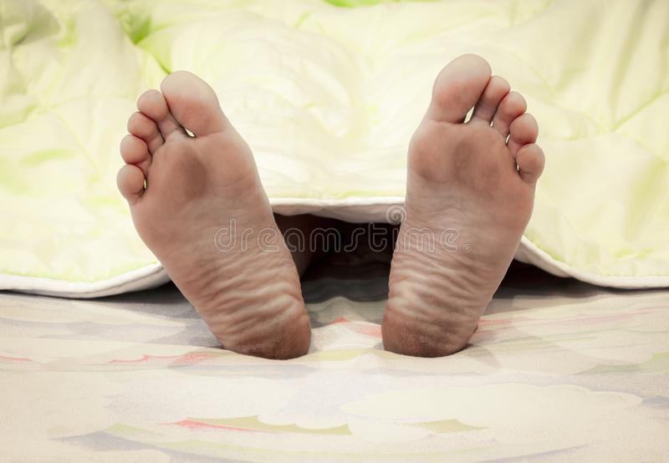

The dust on his foot



Mr. Kalman HOUSE PICTURE (H.No- 200750 Cape-Town, South Africa)

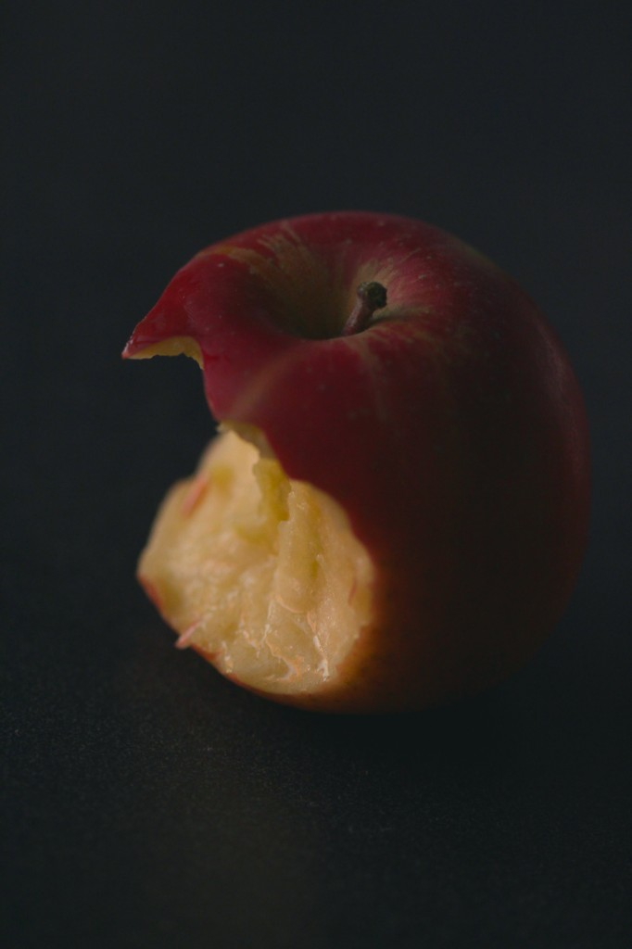

Half bit apple on the cushion

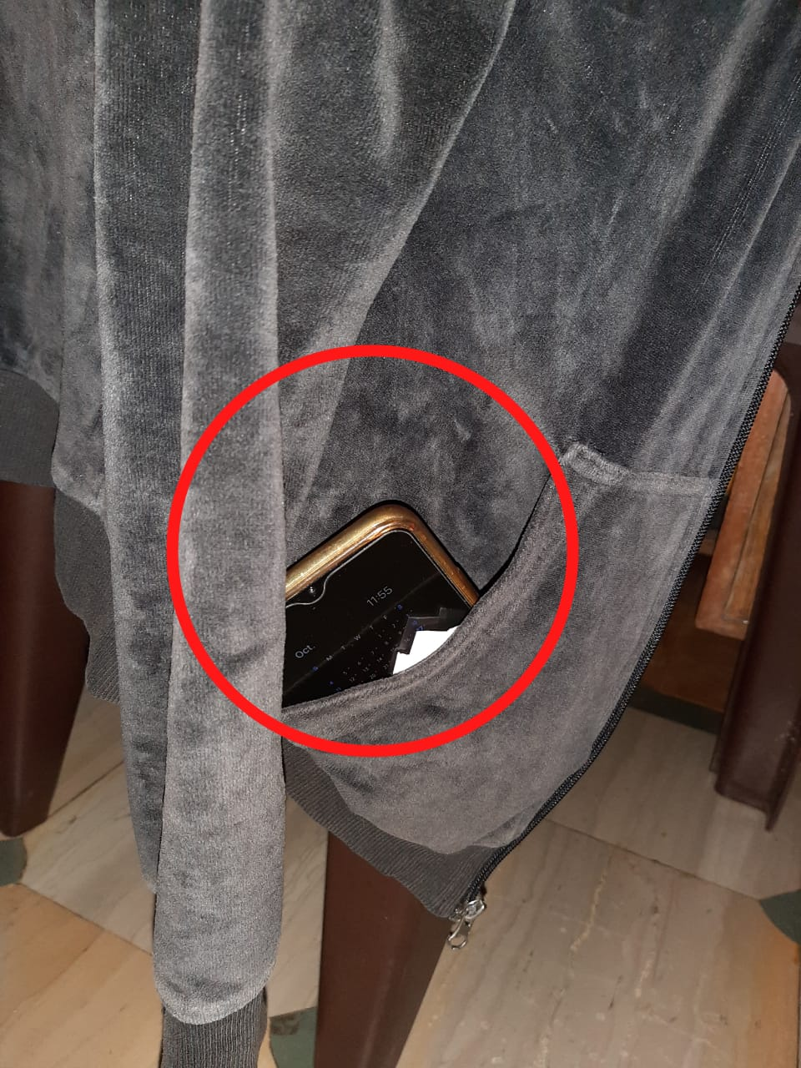

The hanging jacket on the reading desk with dust on it, and with the letter and broken phone

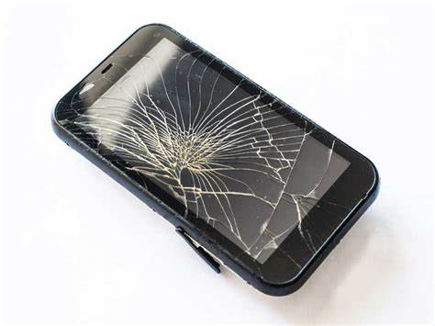

Broken Mobile Phone in the Jacket

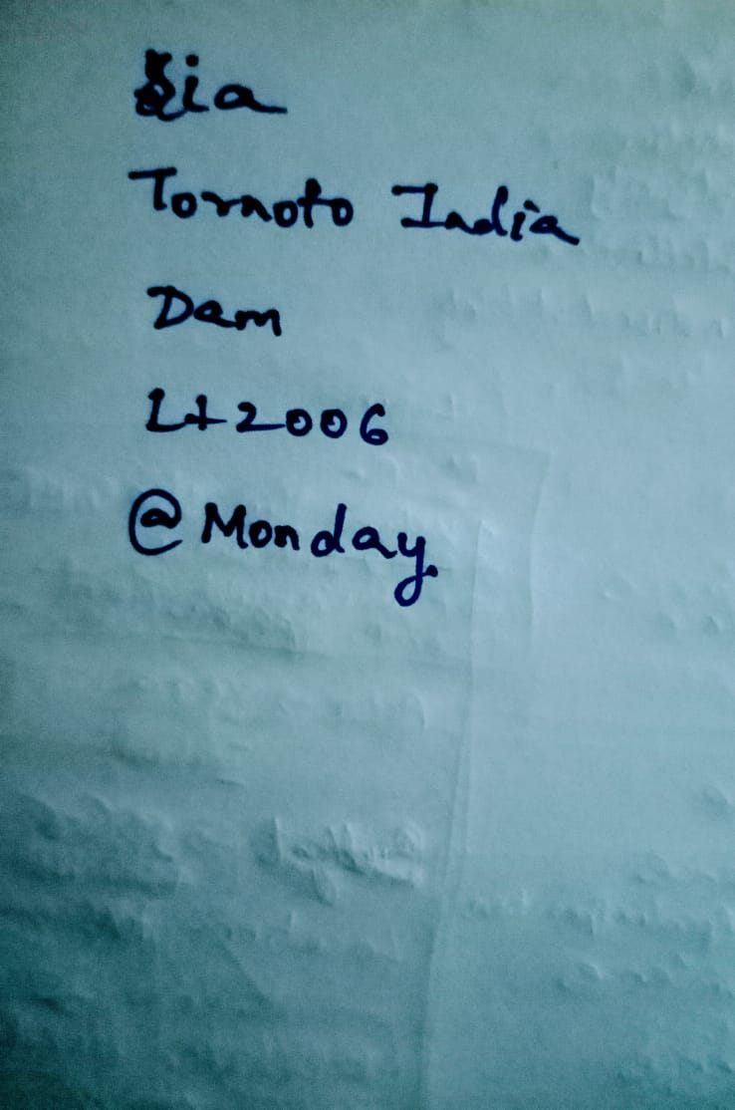

Letter written by Mr.Kalman

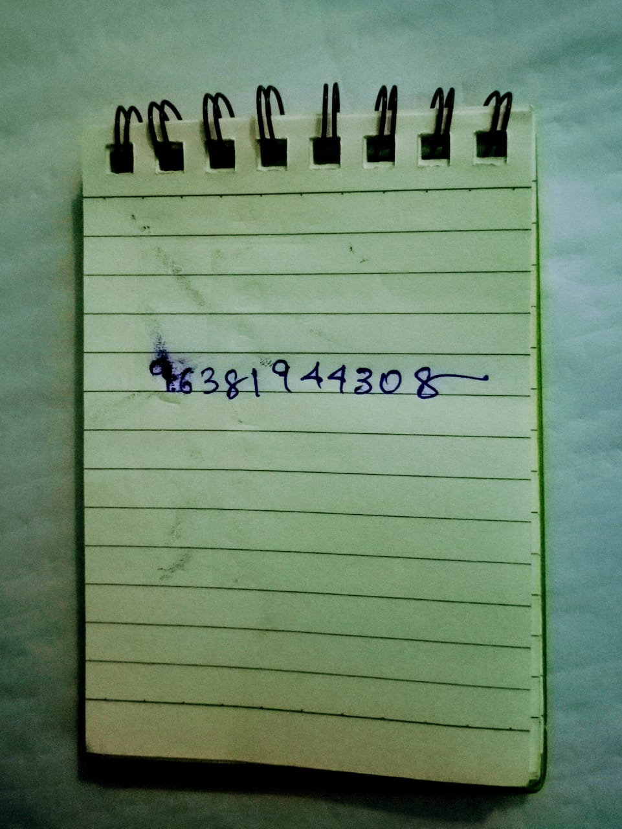

Notepad at telephone desk

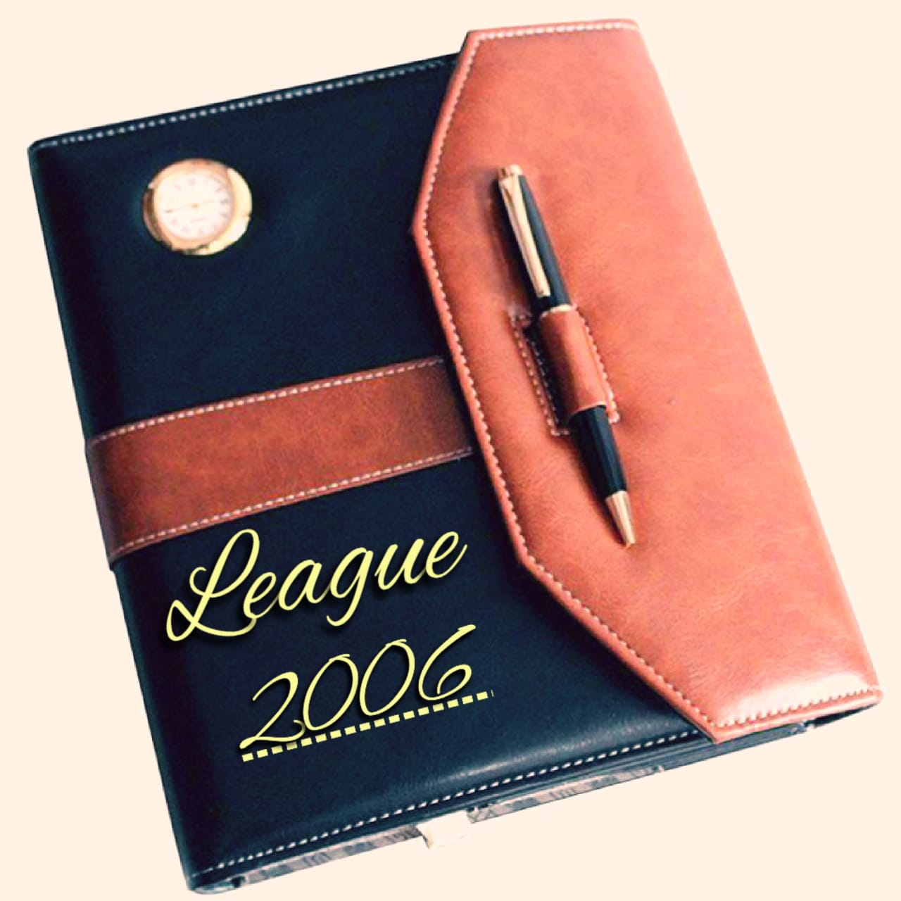

The diary which is the main evidence which was found at the reading desk



The Broken rear view mirror of his car.

**Culprit :** Mr. Ife Moore, Ms. Indira

**Evidences :** Letter, Notepad, Broken Car Window, Jacket, Mobile, Half bit Apple

**Reason :** Revenge on land dispute and affair Issue