**REPORT**

The Case numbered Ind323(F) of Mr.Kalman is declared to be as the Suicide [REPORT]. On 26-10-2018 Mr.Kalman, the Director of many Hollywood Films have committed suicide in stress. Mr.Kalman lives in H.No- 200750 Cape-Town, South Africa with his wife and son. His wife Mrs.Kalavathi and son Mr.Finch went to Canada to admit Mr.Karthik in University of Toronto.

The works done by him before he committed suicide are:

1. He asked his maid to cook his favourite food Naan and Paneer Masala for dinner.
2. He used to be very particular about his Appetite, as he is a diabetic patient..
3. Then,he spoke to his Correspondent Mr.Ife Moore to update his endeavour.Kalman.org website with the future funding details.
4. He slept late at 1:40 am.
5. Next day morning he took a call at 8:15 am by telephone..
6. And the Maid Mrs.Xera found him dead at around 4:30 pm.

(These were statements given by his maid)

According to a post mortem report given by UGS Hospital, near Opera Gardens, CapeTown he had his last breath at around 10:10am. The residuals of over dosage of Saxagliptin (Onglyza). It is his diabetic medicine.

**The following are the Pictures of the Location Scenes:**



DEAD PICTURE (LYING ON BEAD)

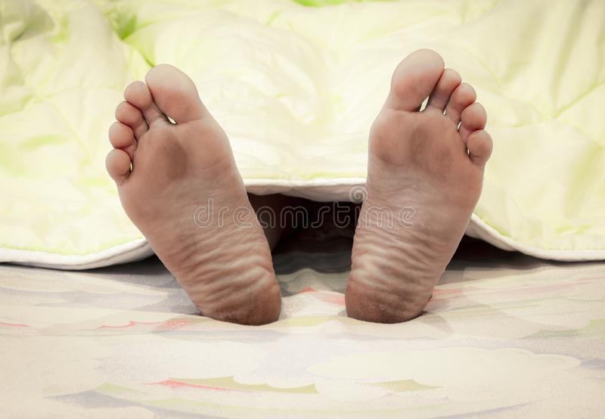

LEGS PICTURE AFTER DEAD (LYING ON BED)



Mr. Kalman HOUSE PICTURE (H.No- 200750 Cape-Town, South Africa)

**Claim:-**

Mrs.Kalavathi claims that,his husband cannot commit suicide. He is very strong. He does not have stress problems. We don't even have any loans to be repaid. There, is no reason for him to commit suicide. So, she wanted the case to be investigated again.