

ATM MACHINE SYSTEM

**A Project Submitted during 1st Year 1st Semester in Oct’2018 using C at :**

**Vidya Jyothi Institute of Technology**



**Submitted by :**

1. **AKSHAT AGRAWAL – 18911A0505**
2. **S. KISHORE KUMAR – 18911A0556 3. B.RAMU – 18911A0509**

**4. CH.VIVEK – 18911A0512**

**Subject : Programming and Problem Solving – I (PPS – I)**

**Developed under the guidance of : Dr. Siddhartha Ghosh**

|  |  |  |
| --- | --- | --- |
|  | **Content** |  |
|  | **Page no** |
| 1. Introduction |  | - 3 |
| 2. Functions Used |  | - 4 |
| 3. Use Case Diagram |  | - 5 |
| 4. The Code |  | - 6 |
| 5. Output Screens |  | - 11 |
| 6. Conclusion |  | - 15 |

# Introduction :

This project is prototype of ATM ( Automated Teller Machine) system. It has many options like withdraw money, check balance, deposit money and fast cash. This project is made by using c language. We have used simple printf and scanf statements, switch cases and functions. Our program is short and effective. We have designed our program in such a way that it is very easy to handle by every common citizen of our nation.

Automated Teller Machine enables the clients of a bank to have access to their account without going to the bank. This is achieved only by development the application using online concepts. When the product is implemented, the user who uses this product will be able to see all the information and services provided by the ATM, when he enters the necessary option and arguments.

The product also provides services like request for deposit cash, cash withdraw, fast cash and other requirement of the user. The data is stored in the database and is retrieved whenever necessary. The implementation needs ATM machine hardware to operate or similar simulated conditions can also be used to successfully use the developed product. To develop this ATM system the entire operation has been divided into the following steps.

1.verification process. 2.cheek Balance.

3.deposite money. 4.fast cash.

5.Special services

**The functions used :**

**b_alance():** This function allows the user to check the account balance.

**d_eposit():** This function allows the user to deposit money in the account.

**fast_cash():** This function allows the user to withdraw fixed cash from the given options account.

**with_draw():** This function allows the user to withdraw cash from account.

**receipt():** This function is used to ask whether user want to print recipt or not.

# The use case diagram for ATM:-

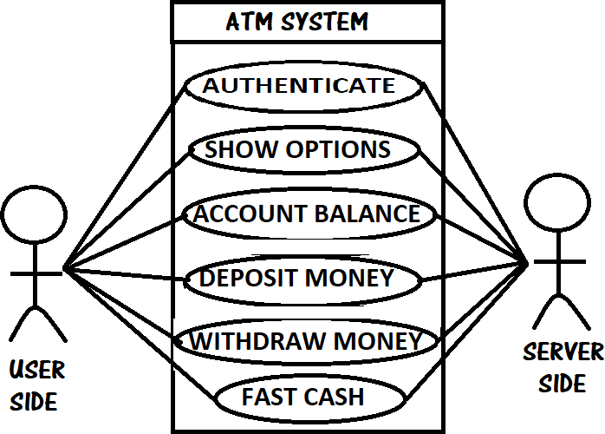

## The Code :

#include<stdio.h> #include<conio.h> #include<math.h> #include<time.h> void receipt(); void b_alance(); void d_eposit(); void fast_cash(); void with_draw(); void main()

{

int pin=9999,temppin,k; char transction='y';

printf("\n\n\n\n***********************************\n"); printf("* *\n");

printf("* WELCOME TO SBI ATM *\n");

printf("* BRANCH:AZIZNAGAR *\n");

printf("* *\n");

printf("*******************************************\n"); printf("* PLEASE INSERT THE CARD *\n");

printf("\n\n\nplease enter your pin:\n"); scanf("%d",&temppin);

if (pin!=temppin)

{

printf("invalid pin \n");

printf("\n please enter a valid pin..");

}

else if (pin=temppin)

{

int option;

printf("to check your account balance ....press : 1 \n"); printf("to deposit money .................press : 2 \n");

printf("to withdraw money ................press : 3 \n");

printf(" fast cash........................press : 4 \n"); scanf("%d",&option);

switch(option)

{

case 1:

b_alance(); receipt(); break;

case 2:

d_eposit(); receipt(); break ;

case 3:

break ; case 4:

with_draw(); receipt();

fast_cash(); receipt(); break;

default:

printf("\n entered option is wrong \n ");

}

}

}

/* ------------------------------------------recipt-----------------------------------------------------------------*/

void receipt()

{

int recipt;

printf("would you like to print receipt? \n if yes....press:1 \n if no..... press:2 \n"); scanf("%d",&recipt);

if(recipt==1)

{

printf("your recipt has been successfully printed. \n please collect it..\n thank you. \n visit again.\n");

}

else if(recipt==2)

{

printf("thank you. \n visit again.");

}

else

printf("entrred option is wrong"); main ();

}

/*-------------------------------------------------balance--------------------------------------------------------*/

void b_alance()

{

int balance=100000;

printf("your account balance = %d \n ",balance);

}

/*---------------------------------------------deposit--------------------------------------------------------------*/

void d_eposit()

{

int deposit,balance=100000; printf("enter the money to be deposited : \n"); scanf("%d",&deposit);

balance+=deposit;

printf("total balance after depositing =%d \n",balance);

}

/*-----------------------------------------------------with draw---------------------------------------------*/

void with_draw()

{

int withdraw,balance=100000; printf("enter the amount to withdrawn :\n"); scanf("%d",&withdraw);

printf("thank you \n"); balance-=withdraw;

if (balance>0)

{

printf("\n your total blance after withdrawal = %d",balance);

}

else

{

printf("\n you dont have enough balance in your account");

}

}

/*-------------------------------------------------------fast cash-----------------------------------------------*/

void fast_cash()

{

int fastcash,balance=100000;

printf("enter the denomination of amount you want to withdraw \n 100 \t\t 200 \n 500 \t\t 1000 \n 2000 \t\t 3000 \n 5000 \t\t 10000 \n");

scanf("%d",&fastcash); balance-=fastcash;

printf("\n your transction is successful. \n please collect your cash from cash reciever\n thank you..\n");

printf("\n your total balance after the withdrawal of money = %d \n",balance);

}

* * * * * * * * * * *

## Output Screens :

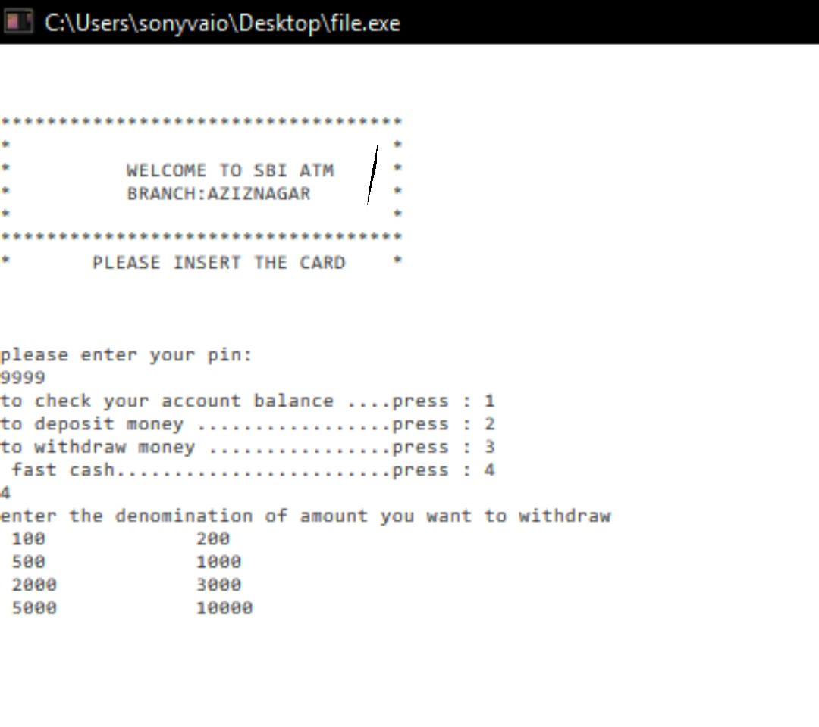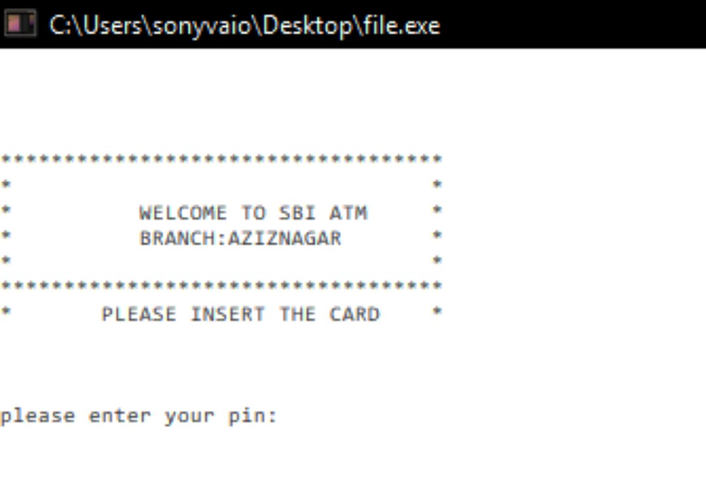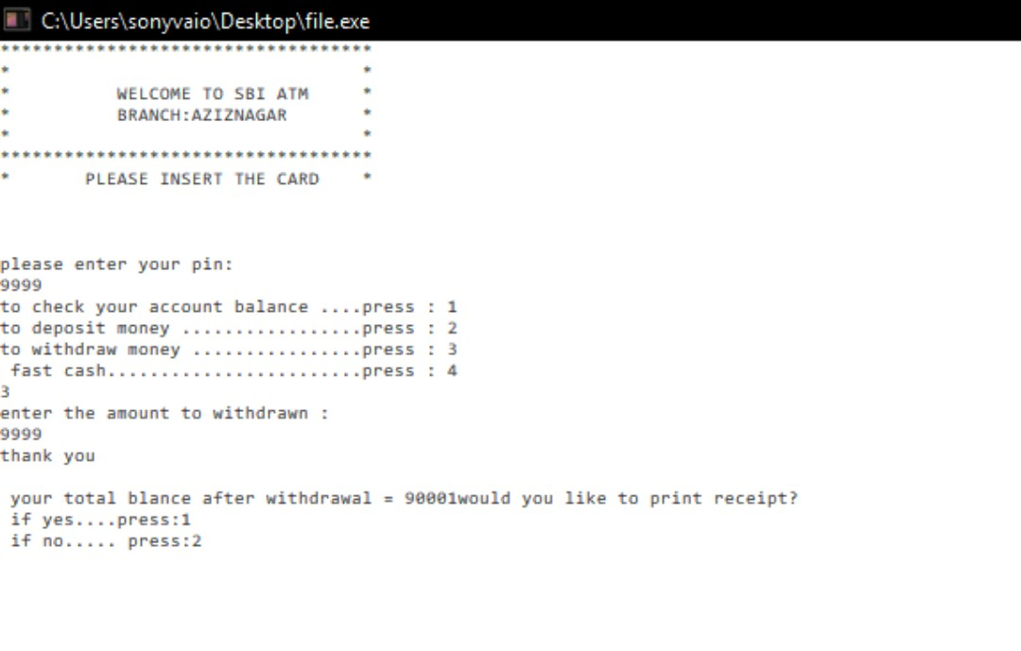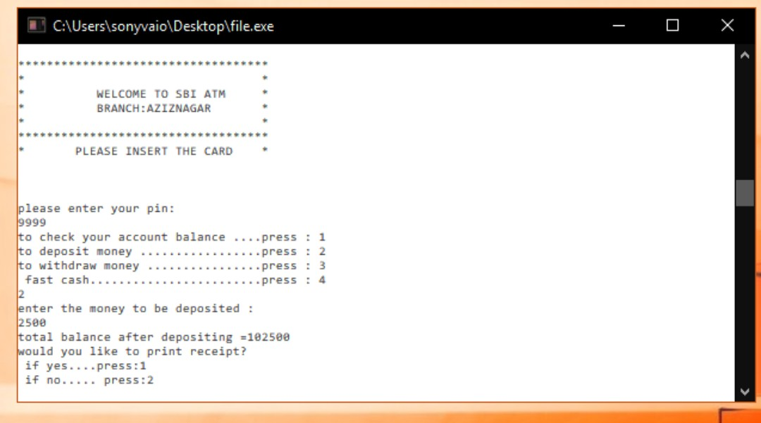

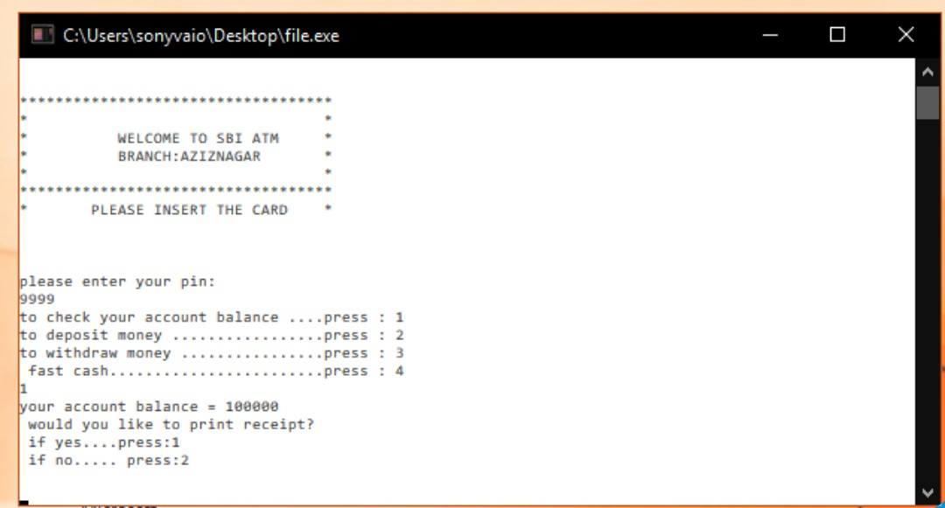

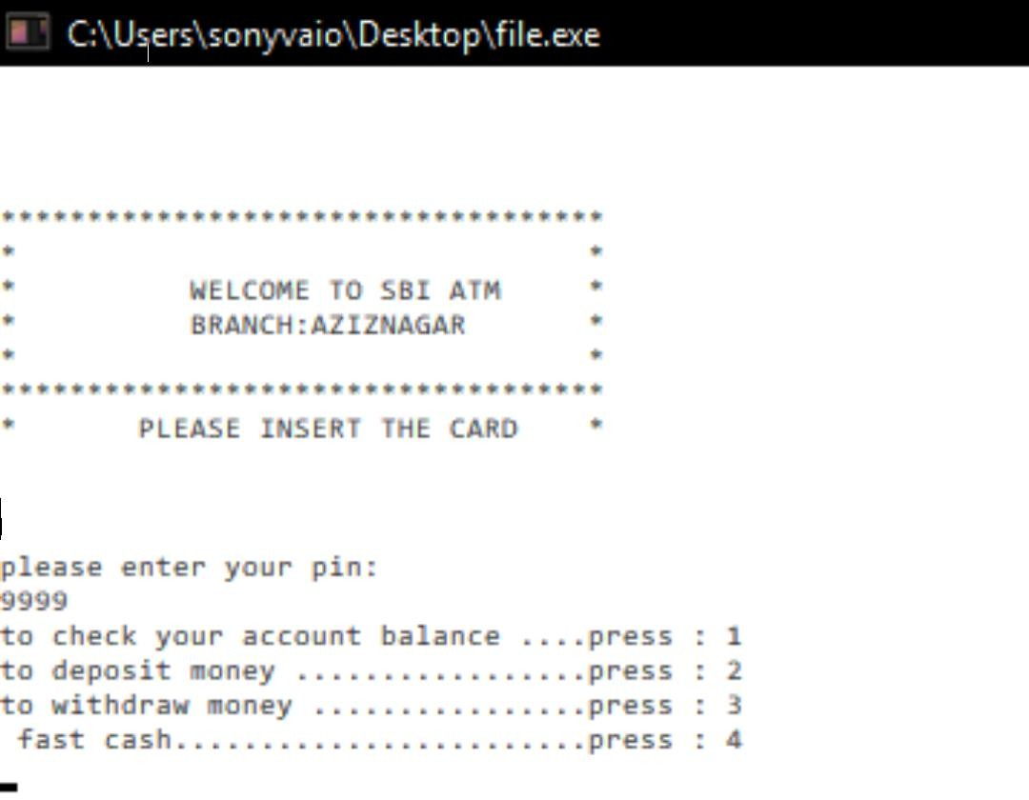

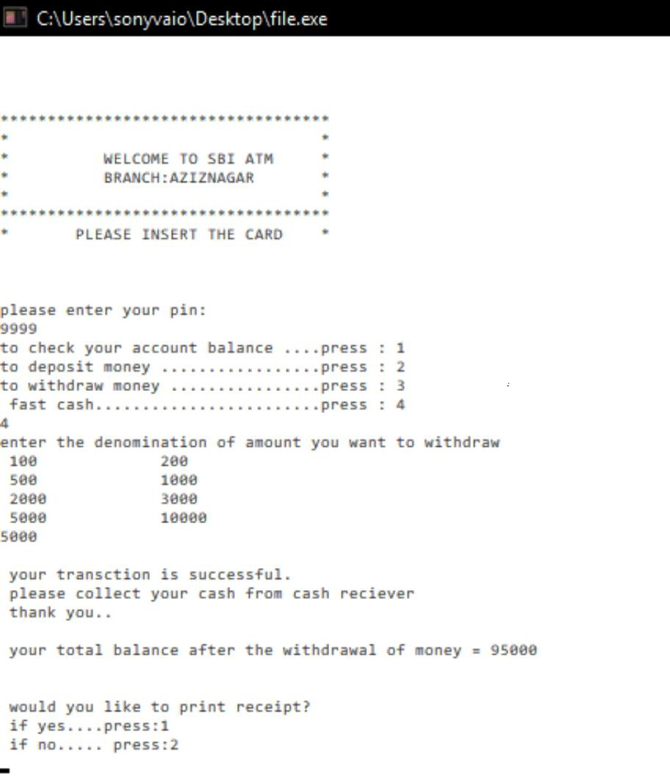

**Conclusion :**

By doing this project our team learned a lot about programming, solving a real life problems. It was a great opportunity for our team do this project. It extend our skills of programming and logical thinking. We also learnt how to organize things in a project so that it is ready for presentation. The project outcome was better than we expected and it is almost completed. We are only left with some more options that user can have for better handling of our program .