……………………………………………………………………………………………………………………………………….

How many ways we can add css?

1. Inline

<h1 style="color:blue;text-align:center;">This is a heading</h1>  
<p style="color:red;">This is a paragraph.</p>

1. Internal

<head>  
<style>  
body {  
  background-color: linen;  
}  
  
h1 {  
  color: maroon;  
  margin-left: 40px;  
}  
</style>  
</head>

1. External

<head>  
<link rel="stylesheet" href="mystyle.css">  
</head>

### "mystyle.css"

body {  
  background-color: lightblue;  
}  
  
h1 {  
  color: navy;  
  margin-left: 20px;  
}

…………………………………………………………………………………………………………………………………………………

CSS Selector

h1{

}

Class Selector

.conatainer {

}

Id Selector

#main {

}

ID can be applied to only element but class can be used for many

Id are unique

**Attribute Selector**

**<p draggable=”true”>Drag me </p>**

**P[draggable]{**

**Color= red;**

**}**

**<p draggable=”true”>Drag me </p>**

**<p draggable=”false”>Drag me </p>**

**<p draggable=” false”>Drag me </p>**

**P[draggable=false]{**

**Color=green**

**}**

**Font Size**

**1px=1/96 inch**

**1pt=1/72 inch**

**1em =100% of parent—next parent**

**1rem=100% root---always points to html**

**Box model:**

**Border: 10px solid black**

**Thickness ,style, color**

**Border-width: 0px 10px 20px 30px**

**Padding: Distance between element and border**

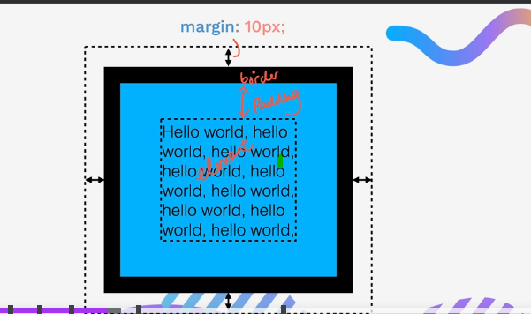

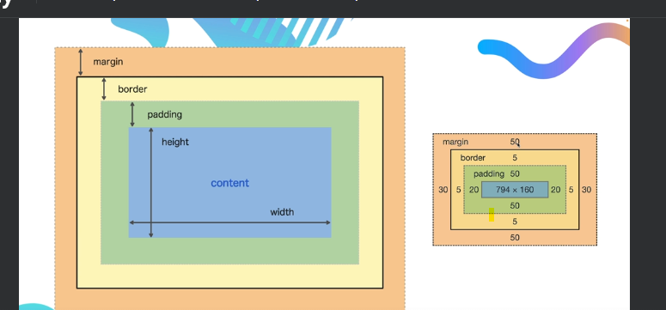

**Angela-yu Box model.**

[**https://appbrewery.github.io/box-model/**](https://appbrewery.github.io/box-model/)

[**https://github.com/appbrewery/box-model**](https://github.com/appbrewery/box-model)

**Pesticide Chrome**

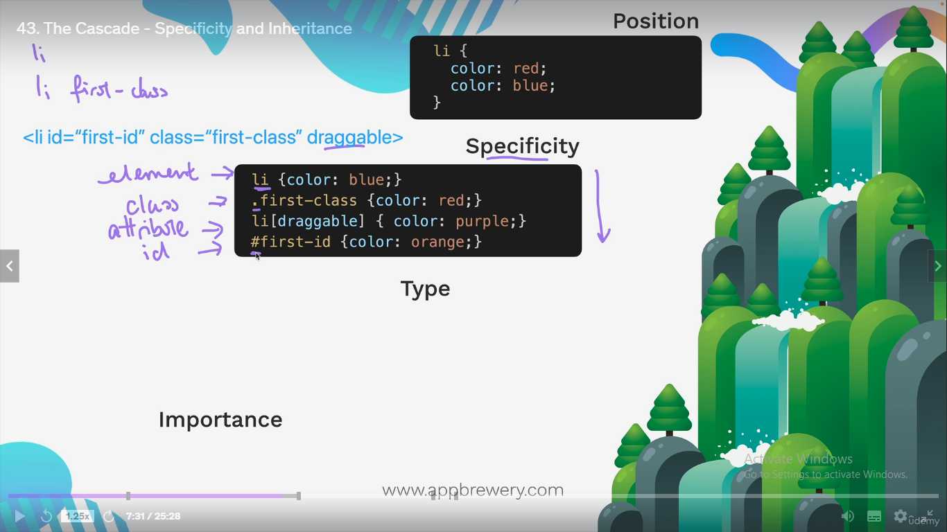

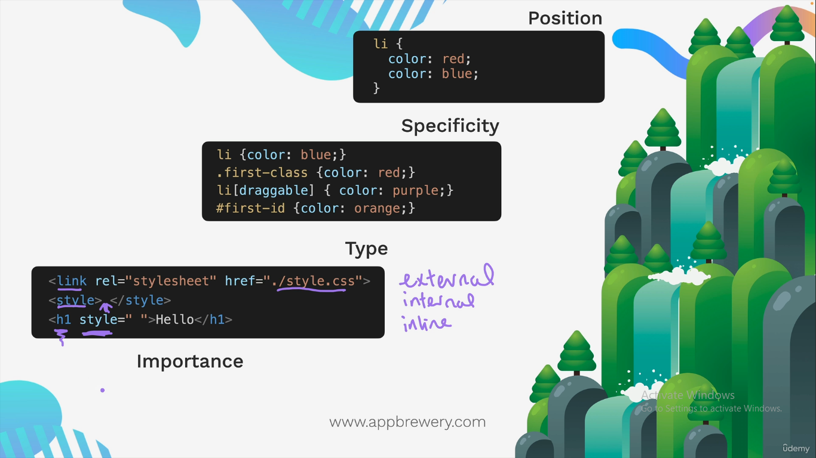

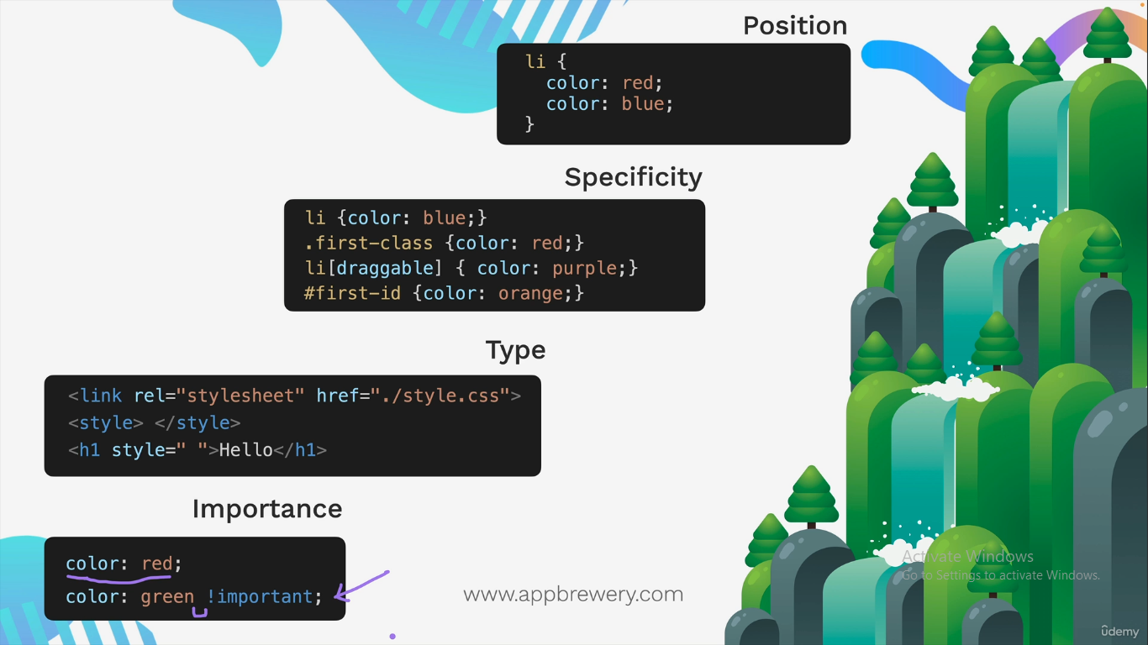

<!DOCTYPE html>

<html>

<head>

<style>

body {

background-color: lightblue;

}

h1 {

color: red;

text-align: center;

}

p {

font-family: verdana;

font-size: 20px;

text-align: ;

}

</style>

</head>

<body>

<h1>My First CSS Example</h1>

<p>This is a paragraph.</p>

</body>

</html>

2.

In this example we have grouped the selectors from the code above:

<!DOCTYPE html>

<html>

<head>

<style>

h1, h2, p {

text-align: center;

color: red;

}

</style>

</head>

<body>

<h1>Hello World!</h1>

<h2>Smaller heading!</h2>

<p>This is a paragraph.</p>

</body>

</html>

Left margin is a CSS property that defines the space between the left edge of an element and its surroundings,

How to add back ground color to p or h1 elemements?

h1 {

color: white;

text-align: center;

background-color:Tomato;

}

p {

font-family: verdana;

font-size: 20px;

background-color:Orange;

}

Backgroung tags:

* background-color
* background-image
* background-repeat
* background-attachment
* background-position
* background

body {

background-image: url("img_tree.png");

background-repeat: no-repeat;

background-position: right top;

margin-right: 200px;

background-attachment: fixed;

}

body {

background-image: url("img_tree.png");

background-repeat: no-repeat;

background-position: right top;

margin-right: 200px;

background-attachment: scroll;

}

Border Styles.

<style>

p.dotted {border-style: dotted;}

p.dashed {border-style: dashed;}

p.solid {border-style: solid;}

p.double {border-style: double;}

p.groove {border-style: groove;}

p.ridge {border-style: ridge;}

p.inset {border-style: inset;}

p.outset {border-style: outset;}

p.none {border-style: none;}

p.hidden {border-style: hidden;}

p.mix {border-style: dotted dashed solid double;}

</style>

</head>

<body>

Border with different colors:

.one {

border-style: solid;

border-color: red green blue yellow; /* red top, green right, blue bottom and yellow left */

}

p {

border-style: dotted solid;

}

</style>

p {

border: 4px solid red;

}

p {

border-left: 6px solid red;

background-color: lightgrey;

}

Border round

.round2 {

border: 2px solid red;

border-radius: 8px;

padding: 5px;

}

**Margins:**

p {  
  margin-top: 100px;  
  margin-bottom: 100px;  
  margin-right: 150px;  
  margin-left: 80px;  
}

**Perfect Example to learn Margin with line: by using <hr> tag**

<!DOCTYPE html>

<html>

<head>

<style>

div {

border: 1px solid black;

margin: 30px 25px 25px 100px;

background-color: lightblue;

}

</style>

</head>

<body>

<h2>The margin shorthand property - 4 values</h2>

<hr>

<div>This div element has a top margin of 25px, a right margin of 50px, a bottom margin of 75px, and a left margin of 100px.</div>

<hr>

</body>

</html>

The CSS box model is essentially a box that wraps around every HTML element. It consists of: content, padding, borders and margins. The image below illustrates the box model:

Table in css

<style>

table, th, td {

border: 1px solid;

}

table {

width: 100%;

}

</style>

table, td, th {

border: 1px solid black;

}

table {

border-collapse: collapse;

width: 100%;

}

th {

height: 20px;

}

th, td {

padding: 8px;

text-align: left;

border-bottom: 1px solid #ddd;

}

table {

border-collapse: collapse;

width: 100%;

}

th, td {

padding: 8px;

text-align: left;

border-bottom: 1px solid #ddd;

}

tr:hover {background-color: coral;}

tr:nth-child(even) {background-color: #f2f2f2;}

<div style="overflow-x: auto;">

**CSS Display:**

**li {**

**display: inline;**

**}**

**<ul>**

**<li><a href="/html/default.asp" target="_blank">HTML</a></li>**

**<li><a href="/css/default.asp" target="_blank">CSS</a></li>**

**<li><a href="/js/default.asp" target="_blank">JavaScript</a></li>**

**</ul>**

**Output:**

* HTML CSS [JavaScript](https://www.w3schools.com/js/default.asp)

Inline, block, none

……………………………………………………………………………………

The position Property

The position property specifies the type of positioning method used for an element.

There are five different position values:

* static
* relative
* fixed
* absolute
* sticky

<p>An element with position: static; is not positioned in any special way; it is always positioned according to the normal flow of the page:</p>

selector, selector {

}

h1, h2{

color:red;

}

Parent selector >Direct child selector {

color :red

}

Immediate child not grand child

. box >p {

color :red;..

}

selector selector{ Desendant selector

}

. box li{? N?

?

??

.?

Color:red;

}

<h1 id="title" class="big heading" >Hello World <\h1>

h1#titlebig heading

Selectorselector {

}

Combining Combines

Selector selectorsselector {

font-size;0.5 rem

}

Ul p. Done{

font size :5rem;

}

Position

Static

Relative

Absolute

Fixed

Static defaut

App brewery.github.io/css-positioning/

Relative to its original position

Absolute position

Position relative to nearest positioned ancestor or top left corner of web page

Zindex it will float

Zindex :-1

Zindex :2

Fixed position

position relative to top left corner of browser window

Even if you scroll down it won't move

In Absolute position scroll down it moves but in fixed one it won't move

.

,