Creating react app in VS code

Install vs code, node, node –v, npm –v

Install prettier, install react snippet dead simple react snippet, Sublime Babel, VScode icons

Install ES7+React/Redux/React-Native snippets and live server

Search for React docs

npm install npm –g

short cut rfc

Entire Course docs

<https://www.appbrewery.co/p/web-development-course-resources/>

npx create-react-app my-app

npm start



go to codesandbox and fork anjel yu

index.js

import { StrictMode } from "react";

import ReactDOM from "react-dom";

import App from "./App";

const rootElement = document.getElementById("root");

ReactDOM.render(

  <StrictMode>

    <App />

  </StrictMode>,

  rootElement

);

Modified index.js

Var REACT=require("react");

Var REACTDOM=require("react-dom");

ReactDOM.render(<h1>Hello World!</h1>,document.getElementById("root"));.

Babel –java script compiler

Var REACTDOM=require("react-dom"); Var REACTDOM=require("react-dom");

Can be replaced like **import ReactDOM from “react-dom”**

**Final code**

import React from "react";

import ReactDOM from "react-dom";

ReactDOM.render(<h1>Hello World Ramu!</h1>,document.getElementById("root"));

ReactDOM.render**(**

**<h1>Hello World Ramu!</h1>**

**<p>hello world2</p>**

**,**document.getElementById("root"));-- Adding two html elements like don’t works.

But it can be done by using **div**

ReactDOM.render**(**

**<div>**

**<h1>Hello World Ramu!</h1>**

**<p>hello world2</p>,**

</div>

document.getElementById("root"));

Final code is like below

import React from "react";

import ReactDOM from "react-dom";

ReactDOM.render(

    <div>

    <h1>Hello World Ramu!</h1>

    <p>hello world2</p>

    </div>,

    document.getElementById("root")

    );

Assignment

import React from "react";

import ReactDOM from "react-dom";

ReactDOM.render(

    <div>

    <h1>Hello World Ramu!</h1>

    <ul>

    <li>hello world1</li>

    <li>hello world2</li>

    <li>hello world3</li>

    </ul>

    </div>,

    document.getElementById("root")

    );

**How to use constants**

const name="Bandela"

ReactDOM.render(

    <div>

    <h1>Hello World Ramu {name}!</h1>

    <ul>

    <li>hello world1</li>

    <li>hello world2</li>

    <li>hello world3</li>

    </ul>

    </div>,

    document.getElementById("root")

    );

<h1>My Lucky number is {Math.Random()*10}!</h1>

<h1>My Name is {firstName +” ”+secondName }!</h1>

<h1>My Lucky number is {4+7}}!</h1>

How to add color

Add className=”heading”, but don’t use class like in css.

import React from "react";

import ReactDOM from "react-dom";

const name="Bandela"

var sname="hell"

ReactDOM.render(

    <div>

    <h1 className="heading">Hello World Ramu {name} {sname}!</h1>

    <ul>

    <li>hello world1</li>

    <li>hello world2</li>

    <li>hello world3</li>

    </ul>

    </div>,

    document.getElementById("root")

    );

Style.css

.heading{

Color: red;

}

Ul{

Color: blue

}

.food-image{  
height: 100px;

Width: 100px

}

HTML Global attributes

Inline styling for react elements

import React from "react";

import ReactDOM from "react-dom";

const name="Bandela"

var sname="hell"

ReactDOM.render(

    <h1 style={{color:”red”}}>Hello World </h1>

    document.getElementById("root")

    );

How to add custom styles

import React from "react";

import ReactDOM from "react-dom";

const customStyle={

color:”red”,

fontSize:”20px”.

Border: 1px solid block

}

ReactDOM.render(

    <h1 style={customStyle} Hello World </h1>

    document.getElementById("root")

    );

Again how to change custom style property values

import React from "react";

import ReactDOM from "react-dom";

const customStyle = {

  color: "red",

  fontSize: "20px",

  border: "1px solid purple"

};

customStyle.color = "green";

ReactDOM.render(

  <h1 style={customStyle}>Neha Khan!</h1>,

  document.getElementById("root")

);

**EXercie:**

**If time is before 12 AM color should be red, evening color green, night color purple.**

**All should be in same h1 element saying Good Moring, Good evening, Good night.**

**Const date= new Date();**

**#Const date= new Date(2023,12,23,20);**

**Const currentTime=date.getHours();**

**Let greeting;**

**Const** customStyle{

Color:””;

}

**If(currentTime<12){**

**Greeting=”Good morning”;**

customStyle.Color=”red”;

**}else if(currentTime<18){**

**Greeting=”Good Afternoon”;**

customStyle.Color=”green”;

**}else{**

**Greeting=”Good night”;**

customStyle.Color=”blue”;

**}**

ReactDOM.render(

  <h1 className=”heading” style={customStyle}>{greeting}</ h1>,

  document.getElementById("root")

);

import React from "react";

import ReactDOM from "react-dom";

const name="Bandela"

var sname="hell"

ReactDOM.render(

    <div>

    <h1 className="heading">Hello World Ramu {name} {sname}!</h1>

    <ul>

    <li>hello world1</li>

    <li>hello world2</li>

    <li>hello world3</li>

    </ul>

    </div>,

    document.getElementById("root")

    );

**For the above code separate headings and list of items.**

**For this we need to create header.jsx and ListItems.jsx**

**Header.jsx**

import React from "react";

function Header(){

return <h1>My favourite food</h1>;

}

Export default Header;

ListItems.jsx

Function ListItems(){

Return (

<ul>

    <li>hello world1</li>

    <li>hello world2</li>

    <li>hello world3</li>

    </ul>

);

}

Export default ListItems;

import React from "react";

import ReactDOM from "react-dom";

import Header from “./Header”;

import ListItems from “./ListItems”;

ReactDOM.render(

    <div>

   <Header/>

<ListItems/>

    </ul>

    </div>,

    document.getElementById("root")

    );

**Still we can separate div elements**

**App.js**

import React from "react";

**import Header from “./Header”;**

**import ListItems from “./ListItems”;**

**function App(){**

**return <div>**

**</Heading>**

**</ListItems>**

**</div>**

**}**

**Export default App;**

**Finally Index.js**

import React from "react";

import ReactDOM from "react-dom";

ReactDOM.render(</App>, document.getElementById("root"));

**Same can be applied to above code exercise. Need to write javascript and header content into Headeing.jsx as shown in the below code snippet**

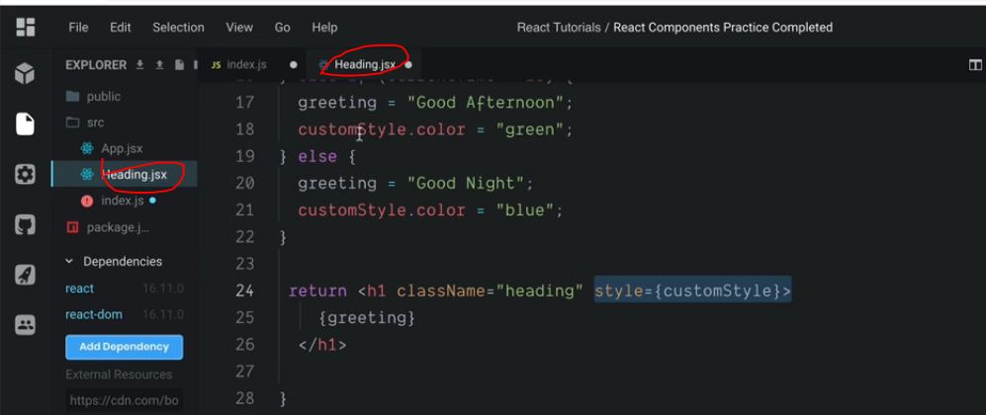

**Import and export**

**We can export functions or constants**

**Maths.jsx**

**Pi=3.43212445;**

**Export default pi;**

**In index.js we need to import entire file**

**Index.js**

**Import React from “react”;**

**Import pi from “./maths.jsx”**

**We can export multiple values like below**

**Maths.jsx**

**Pi=3.43212445;**

**Function DoublePi(){**

**Return pi*2;**

**}**

**Function ThriplePi(){**

**Return pi*3;**

**}**

**Export default pi;**

**Export { DoublePi , ThriplePi };**

**Index.js**

**Import React from “react”;**

**Import pi, { doublePi,thriplePi } from “./maths.jsx”**

**Calculator Example**

**How to do below example code:**

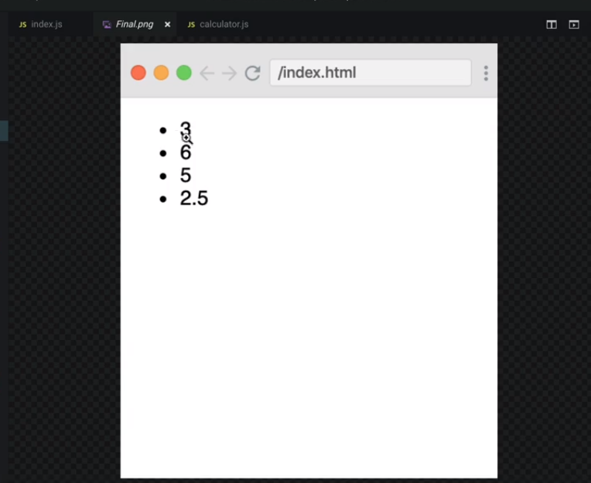

**Calculator.js**

function add(n1, n2) {

  return n1 + n2;

}

function multiply(n1, n2) {

  return n1 * n2;

}

function subtract(n1, n2) {

  return n1 - n2;

}

function divide(n1, n2) {

  return n1 / n2;

}

export { add, multiply, subtract, divide };

**Index.js**

import React from "react";

import ReactDOM from "react-dom";

import * as Calculator from "./calculator.js";

ReactDOM.render(

  <ul>

    <li>{Calculator.add(1, 2)}</li>

    <li>{Calculator.multiply(2, 3)}</li>

    <li>{Calculator.subtract(7, 2)}</li>

    <li>{Calculator.divide(5, 2)}</li>

  </ul>,

  document.getElementById("root")

);

**React properties**

**React Props completed.**

import React from "react";

import ReactDOM from "react-dom";

function Card(props) {

  return (

    <div>

      <h2>{props.name}</h2>

      <img src={props.img} alt="avatar_img" />

      <p>{props.tel}</p>

      <p>{props.email}</p>

    </div>

  );

}

ReactDOM.render(

  <div>

    <h1>My Contacts</h1>

    <Card

      name="Beyonce"

      img="https://blackhistorywall.files.wordpress.com/2010/02/picture-device-independent-bitmap-119.jpg"

      tel="+123 456 789"

      email="b@beyonce.com"

    />

    <Card

      name="Jack Bauer"

      img="https://pbs.twimg.com/profile_images/625247595825246208/X3XLea04_400x400.jpg"

      tel="+7387384587"

      email="jack@nowhere.com"

    />

    <Card

      name="Chuck Norris"

      img="https://i.pinimg.com/originals/e3/94/47/e39447de921955826b1e498ccf9a39af.png"

      tel="+918 372 574"

      email="gmail@chucknorris.com"

    />

  </div>,

  document.getElementById("root")

);

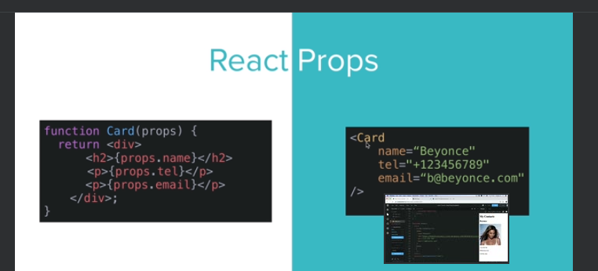

**React Props Practice completed.**

[**https://codesandbox.io/p/sandbox/nostalgic-shape-jcf6c9?file=%2Fpublic%2Fstyles.css%3A8%2C22**](https://codesandbox.io/p/sandbox/nostalgic-shape-jcf6c9?file=%2Fpublic%2Fstyles.css%3A8%2C22)

**react devtools extension**

**Mapping data to components**

**Contacts.jsx**

const emojipedia = [

  {

    id: 1,

    emoji: "💪",

    name: "Tense Biceps",

    meaning:

      "“You can do that!” or “I feel strong!” Arm with tense biceps. Also used in connection with doing sports, e.g. at the gym."

  },

  {

    id: 2,

    emoji: "🙏",

    name: "Person With Folded Hands",

    meaning:

      "Two hands pressed together. Is currently very introverted, saying a prayer, or hoping for enlightenment. Is also used as a “high five” or to say thank you."

  },

  {

    id: 3,

    emoji: "🤣",

    name: "Rolling On The Floor, Laughing",

    meaning:

      "This is funny! A smiley face, rolling on the floor, laughing. The face is laughing boundlessly. The emoji version of “rofl“. Stands for „rolling on the floor, laughing“."

  }

];

export default emojipedia;

**Entry.jsx**

import React from "react";

function Entry(props) {

  return (

    <div className="term">

      <dt>

        <span className="emoji" role="img" aria-label={props.name}>

          {props.emoji}

        </span>

        <span>{props.name}</span>

      </dt>

      <dd>{props.meaning}</dd>

    </div>

  );

}

export default Entry;

**App.jsx**

import React from "react";

import emojis from "../emojipedia";

import Entry from "../components/Entry";

function CreateEntry(emoji) {

  return (

    <Entry

      key={emoji.id}

      emoji={emoji.emoji}

      name={emoji.name}

      meaning={emoji.meaning}

    />

  );

}

function App() {

  return (

    <div>

      <h1>

        <span>emojipedia</span>

      </h1>

      <dl className="dictionary">{emojis.map(CreateEntry)}</dl>

    </div>

  );

}

export default App;

**React map function**

**Map/Filter/Reduce Completed.**

// var numbers = [3, 56, 2, 48, 5];

//Map -Create a new array by doing something with each item in an array.

// function double(x) {

//   return x * 2;

// }

// const newNumbers = numbers.map(double);

// var newNumbers = [];

// numbers.forEach(function (x) {

//   newNumbers.push(x * 2);

// });

// const newNumbers = numbers.map(function (x) {

//   return x * 2;

// });

// console.log(newNumbers);

//Filter - Create a new array by keeping the items that return true.

// const newNumbers = numbers.filter(function(num) {

//   return num < 10;

// });

// var newNumbers = [];

// numbers.forEach(function(num) {

//   if (num < 10) {

//     newNumbers.push(num);

//   }

// })

//Reduce - Accumulate a value by doing something to each item in an array.

// var newNumber = numbers.reduce(function (accumulator, currentNumber) {

//   console.log("accumulator = " + accumulator);

//   console.log("currentNumber = " + currentNumber);

//     return accumulator + currentNumber;

// })

// var newNumber = 0;

// numbers.forEach(function (currentNumber) {

//   newNumber += currentNumber

// })

//Find - find the first item that matches from an array.

// const newNumber = numbers.find(function (num) {

//   return num > 10;

// })

// console.log(newNumber);

//FindIndex - find the index of the first item that matches.

// const newNumber = numbers.findIndex(function (num) {

//   return num > 10;

// })

// console.log(newNumber);

//Challenge Solution

import emojipedia from "./emojipedia";

const newEmojipedia = emojipedia.map(function(emojiEntry) {

  return emojiEntry.meaning.substring(0, 100);

});

console.log(newEmojipedia);

**306: Javascript arrow functions**

**307: Keeper app part2**

**App.jsx**

import React from "react";

import Header from "./Header";

import Footer from "./Footer";

import Note from "./Note";

import notes from "../notes.js";

function App() {

  return (

    <div>

      <Header />

      {notes.map((noteItem) => (

        <Note

          key={noteItem.key}

          title={noteItem.title}

          Content={noteItem.content}

        />

      ))}

      <Footer />

    </div>

  );

}

export default App;

**notes.jsx**

const notes = [

  {

    key: 1,

    title: "Delegation",

    content:

      "Q. How many programmers does it take to change a light bulb? A. None – It’s a hardware problem"

  },

  {

    key: 2,

    title: "Loops",

    content:

      "How to keep a programmer in the shower forever. Show him the shampoo bottle instructions: Lather. Rinse. Repeat."

  },

  {

    key: 3,

    title: "Arrays",

    content:

      "Q. Why did the programmer quit his job? A. Because he didn't get arrays."

  },

  {

    key: 4,

    title: "Hardware vs. Software",

    content:

      "What's the difference between hardware and software? You can hit your hardware with a hammer, but you can only curse at your software."

  }

];

export default notes;

**Conditional rendering completed.**

**App.jsx**

import React from "react";

import Login from "./Login";

var isLoggedIn = true;

// Condition ? do it when true : false

// const currentTime = new Date(2022, 11, 1, 9).getHours();

// console.log(currentTime);

function App() {

  return (

    <div className="container">

      {/*Ternary Operator*/}

      {isLoggedIn ? <h1>Hello</h1> : <Login />}

      {/*AND Operator*/}

      {/* {currentTime > 12 && <h1>Why are you still working?</h1>} */}

    </div>

  );

}

export default App;

**Login.jsx**

import React from "react";

import Input from "./Input";

function Login() {

  return (

    <form className="form">

      <Input type="text" placeholder="Username" />

      <Input type="password" placeholder="Password" />

      <button type="submit">Login</button>

    </form>

  );

}

export default Login;

**Input.jsx**

import React from "react";

function Input(props) {

  return <input type={props.type} placeholder={props.placeholder} />;

}

export default Input;

**310: state in React declarative vs imperative programming**

**311: React hooks—usestate**

**App.jsx**

**Import React from “react”;**

**Import ReactDOM from “react-dom”**

**Var count=0;**

**Function increase(){**

**Console.log(count);**

**Count++;**

**}**

**ReactDOM.render(**

**<div>**

**<h1>{count}</h1>**

**<button onClick=”increase”>+</>**

**</div>,**

**Document.getElementById(“root”);**

**)**

**If you execute the above code <h1> count value won’t increases, but console log value will be increased.**

**The above problem can be solved by using hooks.**

**useStateHook completed**

import React, { useState } from "react";

function App() {

  var [count, setNewCount] = useState(0);

  var [y, setY] = useState(1);

  function increase() {

    setNewCount(count + 1);

  }

  function decrease() {

    setNewCount(count - 1);

  }

  function double() {

    y = y + y;

    setY(y);

  }

  return (

    <div className="container">

      <h1>{count}</h1>

      <h1>{y}</h1>

      <button onClick={increase}>+</button>

      <button onClick={decrease}>-</button>

      <button onClick={double}>double</button>

    </div>

  );

}

export default App;

**useState Hook Practise completed**

import React, { useState } from "react";

import Heading from "./Heading";

function App() {

  setInterval(updateTime, 1000);

  const now = new Date().toLocaleTimeString();

  const [time, setTime] = useState(now);

  function updateTime() {

    const newTime = new Date().toLocaleTimeString();

    setTime(newTime);

  }

  function facebook() {

    window.open("https://www.facebook.com", "_blank");

  }

  function rahs() {

    window.open(" https://rasd.us/", "_blank");

  }

  function amazon() {

    window.open(" https://www.amazon.com", "_blank");

  }

  function workcheck() {

    window.open(

      " https://www.paycomonline.net/v4/ee/web.php/app/login",

      "_blank"

    );

  }

  return (

    <div className="container">

      <Heading />

      <h1>{time}</h1>

      <button onClick={facebook}>Facebook</button>

      <button onClick={rahs}>Ridgway High</button>

      <button onClick={amazon}>Amazon</button>

      <button onClick={workcheck}>Nancy's Work</button>

      <h3>What did you need today?</h3>

    </div>

  );

}

export default App;

**313: Javascript ES6 Object && Array Destructuring**

**Data.js**

const animals = [

  {

    name: "cat",

    sound: "meow",

    feedingRequirements: {

      food: 2,

      water: 3

    }

  },

  { name: "dog", sound: "woof" }

];

function useAnimals(animal) {

  return [

    animal.name,

    function() {

      console.log(animal.sound);

    }

  ];

}

export default animals;

export { useAnimals };

**Index.js**

// import animals, { useAnimals } from "./data";

// //Destructuring Arrays

// // console.log(animals);

// const [cat, dog] = animals;

// // console.log(cat);

// const [animal, makeSound] = useAnimals(cat);

// console.log(animal);

// makeSound();

// //Destructuring Objects

// // const { name, sound} = cat;

// // const { name: catName, sound: catSound } = cat;

// // const { name = "Fluffy", sound = "Purr" } = cat;

// // const {feedingRequirements: {food, water} } = cat;

// // console.log(food);

// CHALLENGE: uncomment the code below and see the car stats rendered

import React from "react";

import ReactDOM from "react-dom";

import cars from "./practice";

const [honda, tesla] = cars;

const {

  speedStats: { topSpeed: hondaTopSpeed }

} = honda;

const {

  speedStats: { topSpeed: teslaTopSpeed }

} = tesla;

const {

  coloursByPopularity: [hondaTopColour]

} = honda;

const {

  coloursByPopularity: [teslaTopColour]

} = tesla;

ReactDOM.render(

  <table>

    <tr>

      <th>Brand</th>

      <th>Top Speed</th>

      <th>Top Colour</th>

    </tr>

    <tr>

      <td>{tesla.model}</td>

      <td>{teslaTopSpeed}</td>

      <td>{teslaTopColour}</td>

    </tr>

    <tr>

      <td>{honda.model}</td>

      <td>{hondaTopSpeed}</td>

      <td>{hondaTopColour}</td>

    </tr>

  </table>,

  document.getElementById("root")

);

**How to Debug a react application**

**In inspect 🡪**

**Pages🡪**

**Add Debugger🡪**