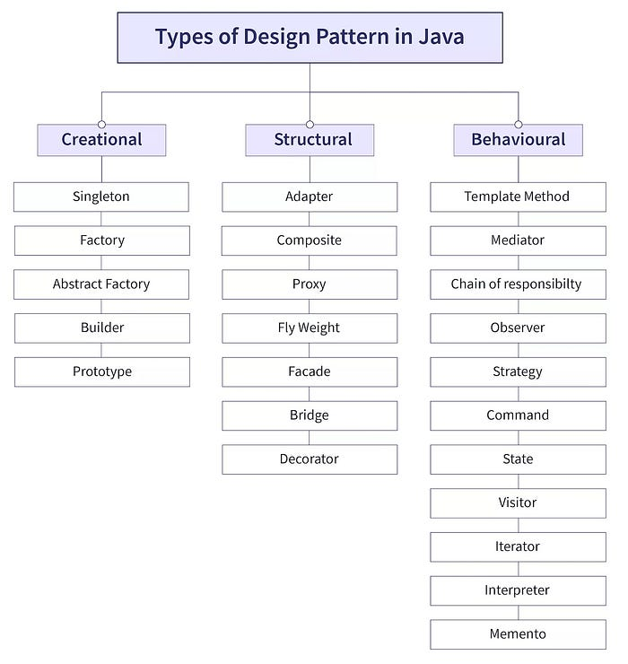

……………………………………………………………………………………………………………………………………………………..

BD🡪Budedu , PFAC-🡪PF acoount

BD 🡪(Bridge, Decorator)Budedu, PFFAC🡪 (Proxy, Flyweight, Façade, Adapter, Composite)PF account

1. Creational
2. Singleton

public class Singleton {

// 1. volatile ensures visibility and prevents instruction reordering

private static volatile Singleton instance;

// 2. Private constructor prevents external instantiation

private Singleton() {

// Optionally: guard against reflection

if (instance != null) {

throw new RuntimeException("Use getInstance() method to create");

}

}

// 3. Public method to provide access to the instance

public static Singleton getInstance() {

if (instance == null) { // First check (no locking)

synchronized (Singleton.class) {

if (instance == null) { // Second check (with locking)

instance = new Singleton();

}

}

}

return instance;

}

// 4. Optional: Prevent cloning (violates singleton)

@Override

protected Object clone() throws CloneNotSupportedException {

throw new CloneNotSupportedException("Cloning not allowed");

}

// 5. Optional: Prevent deserialization from creating new instance

protected Object readResolve() {

return getInstance();

}

}

1. Factory

### Simple Java Example

#### Step 1: Product Interface

public interface Notification {

void notifyUser();

}

#### Step 2: Concrete Products

public class EmailNotification implements Notification {

public void notifyUser() {

System.out.println("Sending Email Notification");

}

}

public class SMSNotification implements Notification {

public void notifyUser() {

System.out.println("Sending SMS Notification");

}

}

#### Step 3: Factory Class

public class NotificationFactory {

public Notification createNotification(String type) {

if (type == null || type.isEmpty())

return null;

if ("EMAIL".equalsIgnoreCase(type))

return new EmailNotification();

if ("SMS".equalsIgnoreCase(type))

return new SMSNotification();

return null;

}

}

#### Step 4: Usage

public class Main {

public static void main(String[] args) {

NotificationFactory factory = new NotificationFactory();

Notification notification = factory.createNotification("EMAIL");

notification.notifyUser();

Notification sms = factory.createNotification("SMS");

sms.notifyUser();

}

}

1. Abstract design factory

**Scenario: Notification System (Email & SMS)**

Imagine you are building a system that can send notifications via:

* **Email**
* **SMS**

You want your system to support different **families of notifications** (e.g., "Urgent", "Normal") and each family may use a different channel (email or SMS). This is perfect for Abstract Factory.

**🏗️ Step-by-Step Code**

**🔹 Step 1: Abstract Product Interfaces**

interface Message {

void send(String to, String message);

}

**🔹 Step 2: Concrete Products**

class EmailMessage implements Message {

public void send(String to, String message) {

System.out.println("Sending EMAIL to " + to + ": " + message);

}

}

class SmsMessage implements Message {

public void send(String to, String message) {

System.out.println("Sending SMS to " + to + ": " + message);

}

}

**🔹 Step 3: Abstract Factory**

interface NotificationFactory {

Message createMessage();

}

**🔹 Step 4: Concrete Factories**

class EmailNotificationFactory implements NotificationFactory {

public Message createMessage() {

return new EmailMessage();

}

}

class SmsNotificationFactory implements NotificationFactory {

public Message createMessage() {

return new SmsMessage();

}

}

**🔹 Step 5: Client Code**

public class NotificationService {

private Message message;

public NotificationService(NotificationFactory factory) {

this.message = factory.createMessage();

}

public void notifyUser(String to, String messageText) {

message.send(to, messageText);

}

}

**🔹 Main Method (to run the program)**

public class Main {

public static void main(String[] args) {

NotificationFactory factory = new EmailNotificationFactory();

NotificationService service = new NotificationService(factory);

service.notifyUser("ramu@example.com", "Welcome to our service!");

// Change to SMS

NotificationFactory smsFactory = new SmsNotificationFactory();

NotificationService smsService = new NotificationService(smsFactory);

smsService.notifyUser("9876543210", "Your OTP is 123456.");

}

}

4.Builder

public class User {

private String name;

private int age;

// Private constructor

private User(Builder builder) {

this.name = builder.name;

this.age = builder.age;

}

// Static nested Builder class

public static class Builder {

private String name;

private int age;

public Builder setName(String name) {

this.name = name;

return this;

}

public Builder setAge(int age) {

this.age = age;

return this;

}

public User build() {

return new User(this);

}

}

@Override

public String toString() {

return name + " - " + age;

}

}

With out static class also we can create but object is required.

## ❌ 2. Builder Pattern ****without**** static (⚠️ ****Not recommended**** – rarely useful)

public class User {

private String name;

private int age;

private User(Builder builder) {

this.name = builder.name;

this.age = builder.age;

}

// Inner (non-static) Builder class

public class Builder {

private String name;

private int age;

public Builder setName(String name) {

this.name = name;

return this;

}

public Builder setAge(int age) {

this.age = age;

return this;

}

public User build() {

return new User(this);

}

}

// Factory method to get Builder

public Builder getBuilder() {

return new Builder();

}

@Override

public String toString() {

return name + " - " + age;

}

}

### Usage (awkward):

User outer = new User(null); // Not possible if constructor is private!

User.Builder builder = outer.new Builder(); // ❌ Needs outer class instance

**How to remember Structural Design patterns:**

BD🡪Budedu , PFAC-🡪PF acoount

BD 🡪(Bridge, Decorator)Budedu, PFFAC🡪 (Proxy, Flyweight, Façade, Adapter, Composite)PF account

1. **Façade design pattern**

## Real-World Analogy

* 🏨 **Hotel Front Desk** = Facade
* They internally talk to:
  + Housekeeping
  + Kitchen
  + Billing

But you (the customer) only deal with the **front desk**.

**public class TravelFacade {**

**private HotelBooking hotel;**

**private FlightBooking flight;**

**private CarRental car;**

**public TravelFacade() {**

**this.hotel = new HotelBooking();**

**this.flight = new FlightBooking();**

**this.car = new CarRental();**

**}**

**public void bookTrip() {**

**hotel.bookRoom();**

**flight.bookFlight();**

**car.rentCar();**

**System.out.println("Trip booking completed.");**

**}**

**public static void main(String[] args) {**

**TravelFacade facade = new TravelFacade();**

**facade.bookTrip(); // Client doesn't know how the internals work**

**}**

**}**

1. **Adapter**

**🧩 Real-World Analogy: Charger Plug Adapter**

**Scenario:**

* You have a **Laptop** that only accepts **Type-C** chargers.
* You have an **old USB-A charger**.
* You need an **Adapter** that converts the USB-A output to fit into the Type-C port.

**🎯 Goal in Code**

* Laptop expects a TypeCCharger interface
* You only have a USBACharger (legacy)
* You use USBAtoTypeCAdapter to convert the interface

**💻 Java Code**

**✅ Step 1: Target Interface (Type-C)**

// The expected interface by the laptop

public interface TypeCCharger {

void chargeViaTypeC();

}

**✅ Step 2: Adaptee Class (USB-A charger)**

// The incompatible legacy class

public class USBACharger {

public void chargeViaUSBA() {

System.out.println("Charging with USB-A charger.");

}

}

**✅ Step 3: Adapter Class**

// The adapter that makes USBA work with Type-C interface

public class USBAtoTypeCAdapter implements TypeCCharger {

private USBACharger usbaCharger;

public USBAtoTypeCAdapter(USBACharger usbaCharger) {

this.usbaCharger = usbaCharger;

}

@Override

public void chargeViaTypeC() {

System.out.println("Adapter converting USB-A to Type-C...");

usbaCharger.chargeViaUSBA();

}

}

1. **Proxy design pattern.**

Great question again! The **Proxy Design Pattern** may *look similar* to Adapter and Facade (since it also wraps another object), but it has a **very different purpose**.

Let’s explain it fully with:

* ✅ Concept
* ✅ Real-world analogy
* ✅ Java code example
* ✅ Comparison with Adapter and Facade

**🧱 What is the Proxy Design Pattern?**

The **Proxy Pattern** provides a **placeholder or surrogate** for another object to **control access** to it.

Instead of directly calling the real object, clients go through a **proxy object** that can add **extra behavior** like:

* Security checks 🔐
* Lazy loading 💤
* Caching 🗃️
* Access control 🚧
* Logging 📝

**💡 Real-World Analogy**

🕵️ **Credit card = Proxy for your bank account**

* You don’t give your **bank account directly** to the merchant.
* You give your **credit card**, which acts as a **proxy**.
* It controls:
  + ✅ Who can charge you
  + ✅ How much
  + ✅ When

public interface Payment {

void pay(double amount) throws Exception;

}

public class BankAccount implements Payment {

private double balance;

public BankAccount(double balance) {

this.balance = balance;

}

@Override

public void pay(double amount) throws Exception {

if (amount > balance) {

throw new Exception("Insufficient funds in bank account.");

}

balance -= amount;

System.out.println("Paid ₹" + amount + " using bank account. Remaining: ₹" + balance);

}

}

public class CreditCardProxy implements Payment {

private BankAccount bankAccount;

public CreditCardProxy(BankAccount bankAccount) {

this.bankAccount = bankAccount;

}

@Override

public void pay(double amount) throws Exception {

System.out.println("Attempting payment via credit card proxy...");

// Add logging, fraud checks, limits etc.

bankAccount.pay(amount); // delegate to real subject

System.out.println("Transaction logged successfully.\n");

}

}

**Saga Orchestration Pattern**

**🎯 What is it?**

A **central coordinator** (orchestrator) manages the entire saga by telling each service **what to do next**.

Example

**OrchestratorService is the orchestrator ✅**

java

CopyEdit

@Service

public class OrchestratorService {

@Autowired OrderService orderService;

@Autowired PaymentService paymentService;

@Autowired InventoryService inventoryService;

public String placeOrder(OrderRequest request) {

boolean orderCreated = orderService.createOrder(request);

if (!orderCreated) return "Order Failed";

boolean paid = paymentService.deductPayment(request);

if (!paid) {

orderService.cancelOrder(request);

return "Payment Failed";

}

boolean stock = inventoryService.reduceStock(request);

if (!stock) {

paymentService.refund(request);

orderService.cancelOrder(request);

return "Inventory Failed";

}

return "Order Successful!";

}

}

## 💃 Choreography Pattern

### 🎯 What is it?

There is **no central coordinator** — each service **reacts to events** from the previous service and decides what to do next.

## 🧩 Scenario: Order Placement Flow (Choreography Style)

**Services:**

1. OrderService → emits OrderCreatedEvent
2. PaymentService → listens to OrderCreatedEvent, emits PaymentCompletedEvent
3. InventoryService → listens to PaymentCompletedEvent, emits InventoryUpdatedEvent
4. ShippingService → listens to InventoryUpdatedEvent

## Shared Model (Used across services)

java

CopyEdit

// OrderEvent.java

public class OrderEvent {

private String orderId;

private String status; // CREATED, PAID, FAILED, etc.

private String source; // ORDER, PAYMENT, INVENTORY

// + Getters/Setters

}

## ✅ 1. Order Service

java

CopyEdit

@RestController

@RequestMapping("/order")

public class OrderController {

@Autowired KafkaTemplate<String, OrderEvent> kafkaTemplate;

@PostMapping

public ResponseEntity<String> placeOrder(@RequestBody OrderEvent event) {

event.setStatus("CREATED");

event.setSource("ORDER");

kafkaTemplate.send("order-events", event);

return ResponseEntity.ok("Order created and event published.");

}

}

## ✅ 2. Payment Service

java

CopyEdit

@Component

public class PaymentListener {

@Autowired KafkaTemplate<String, OrderEvent> kafkaTemplate;

@KafkaListener(topics = "order-events", groupId = "payment-group")

public void listen(OrderEvent event) {

if ("CREATED".equals(event.getStatus())) {

System.out.println("Processing payment for order: " + event.getOrderId());

// Simulate payment success

event.setStatus("PAID");

event.setSource("PAYMENT");

kafkaTemplate.send("order-events", event);

}

}

}

## ✅ 3. Inventory Service

java

CopyEdit

@Component

public class InventoryListener {

@Autowired KafkaTemplate<String, OrderEvent> kafkaTemplate;

@KafkaListener(topics = "order-events", groupId = "inventory-group")

public void listen(OrderEvent event) {

if ("PAID".equals(event.getStatus())) {

System.out.println("Reducing stock for order: " + event.getOrderId());

// Simulate stock update

event.setStatus("INVENTORY_UPDATED");

event.setSource("INVENTORY");

kafkaTemplate.send("order-events", event);

}

}

}

## ✅ 4. Shipping Service

java

CopyEdit

@Component

public class ShippingListener {

@KafkaListener(topics = "order-events", groupId = "shipping-group")

public void listen(OrderEvent event) {

if ("INVENTORY_UPDATED".equals(event.getStatus())) {

System.out.println("Shipping order: " + event.getOrderId());

// Final service, no new event needed

}

}

}