**Online voting system**



NAME : S. Archana

ROLL NO : 1325-19-862-034

GUIDE NAME : CH.VINOD

COLLEGE NAME : AURORA PG COLLEGE MCA

**DESIGN**

**INPUT DESIGN**

* The input design is the link between the information system and the user. It comprises the developing specification and procedures for data preparation and those steps are necessary to put transaction data in to a usable form for processing can be achieved by inspecting the computer to read data from a written or printed document or it can occur by having people keying the data directly into the system. The design of input focuses on controlling the amount of input required, controlling the errors, avoiding delay, avoiding extra steps and keeping the process simple. The input is designed in such a way so that it provides security and ease of use with retaining the privacy. Input Design considered the following things:
* What data should be given as input?
* How the data should be arranged or coded?
* The dialog to guide the operating personnel in providing input.
* Methods for preparing input validations and steps to follow when error occur.

**USE CASE DIAGRAM**

* An utilization case outline in the UML is a sort of conduct graph characterized by and made from a Use-case examination. Its motivation is to introduce a graphical diagram of the usefulness given by a framework regarding on-screen characters, their objectives (spoke to as use cases), and any conditions between those utilization cases. The fundamental motivation behind an utilization case outline is to indicate what framework capacities are performed for which on-screen character. Jobs of the on-screen characters in the framework can be delineated”.

**Use case diagram :**

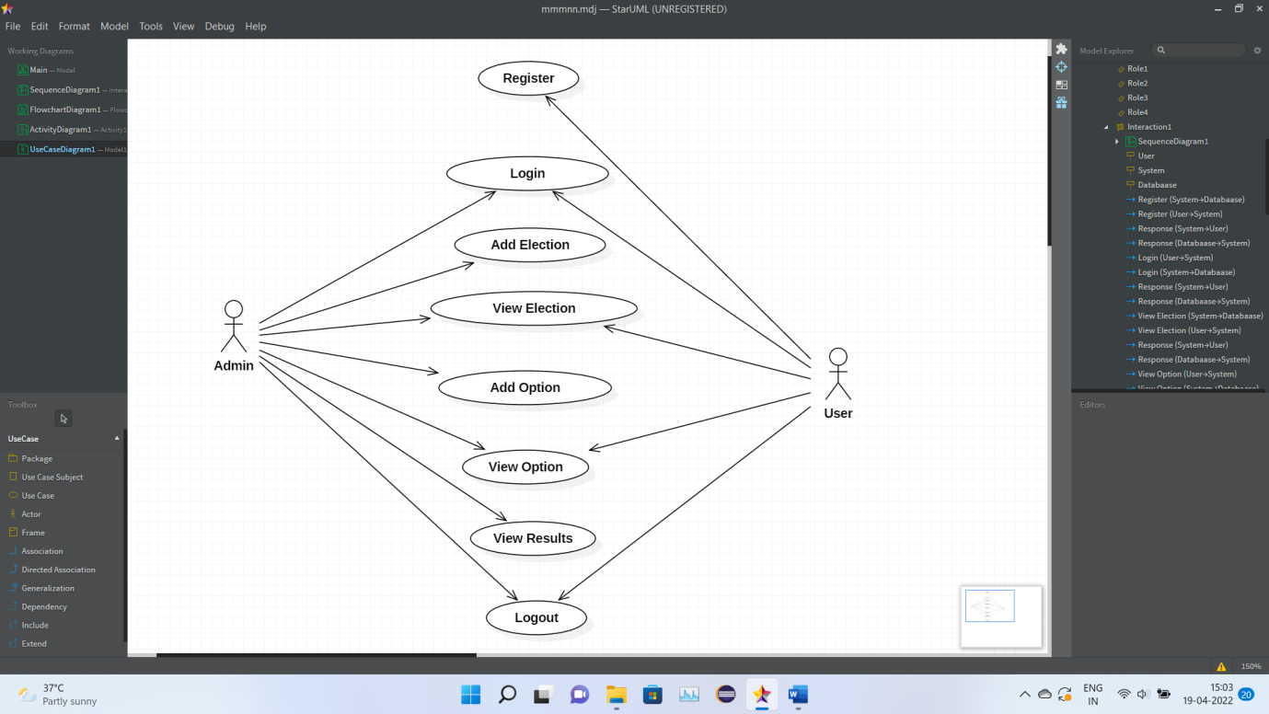

Sequence diagram:

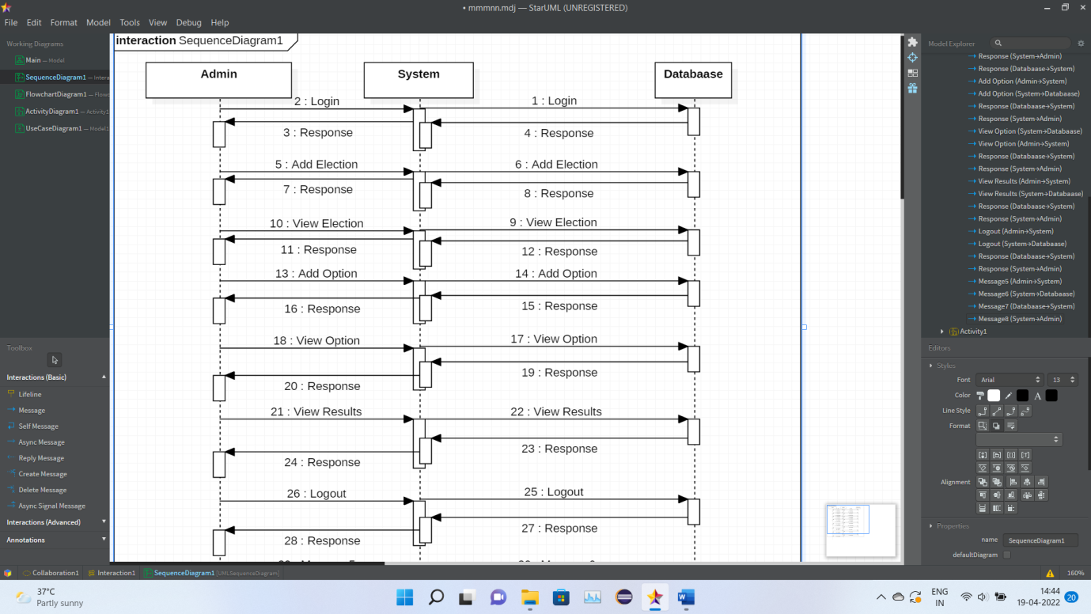

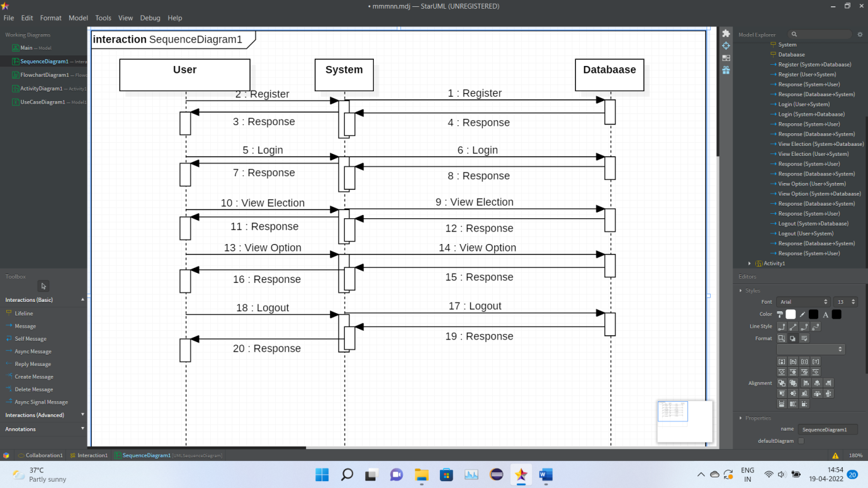

Activity diagram

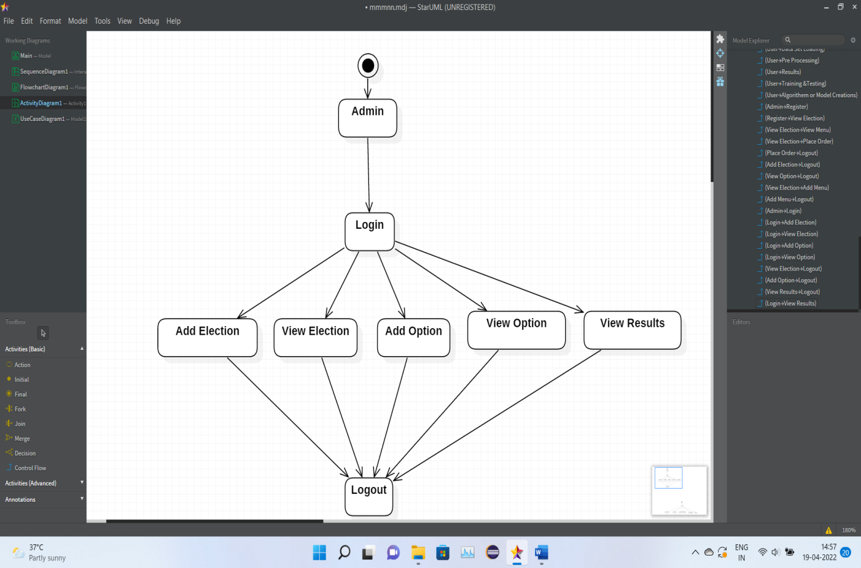

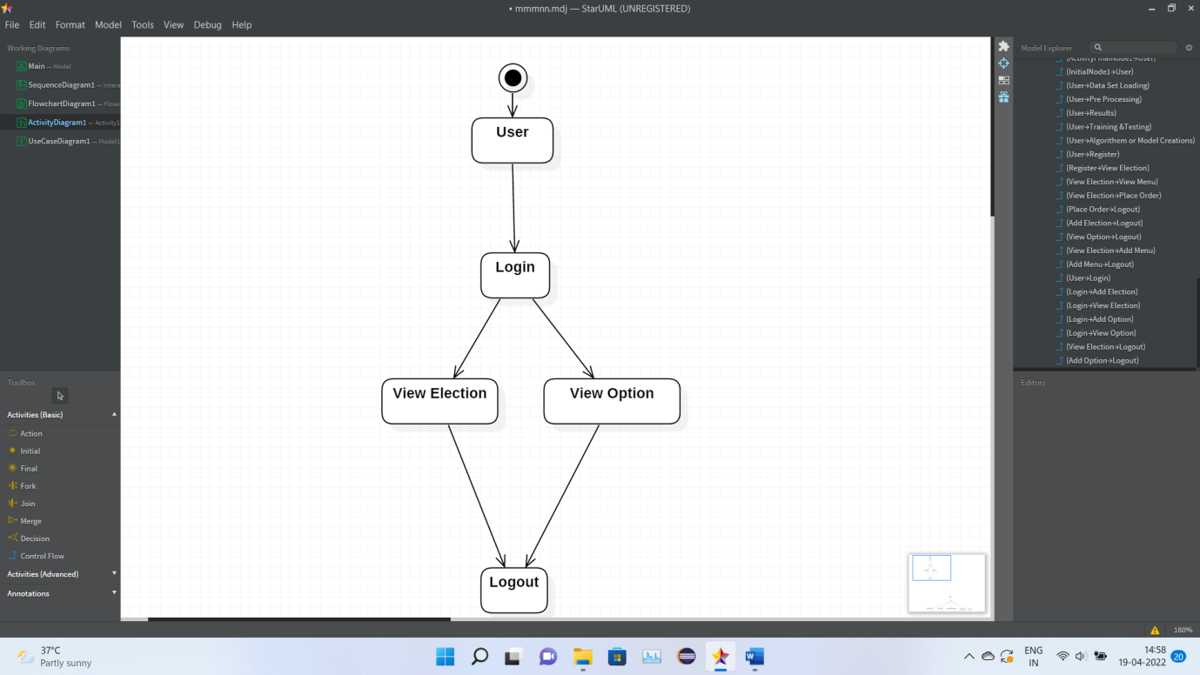

CLASS DIAGRAM

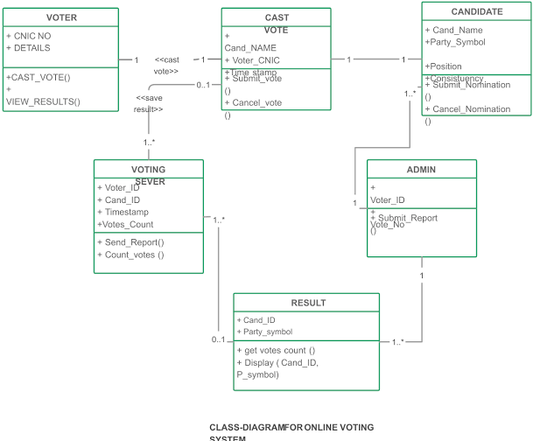

**IMPLEMENTATION**

**Component Diagram**

* The component diagram is a special purpose diagram, which is used to visualize the static implementation view of a system. It represents the physical components of a system, or we can say it portrays the organization of the components inside a system. The components, such as libraries, files, executables, etc.

**Deployment Diagram**

* A deployment diagram is a UML diagram type that shows the execution architecture of a system, including nodes such as hardware or software execution environments, and the middleware connecting them. Deployment diagrams are typically used to visualize the physical hardware and software of a system

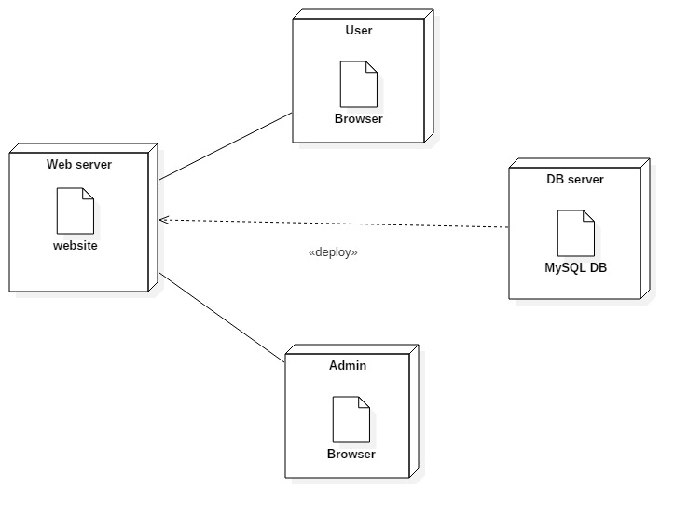

**SAMPLE SOURCE CODE**

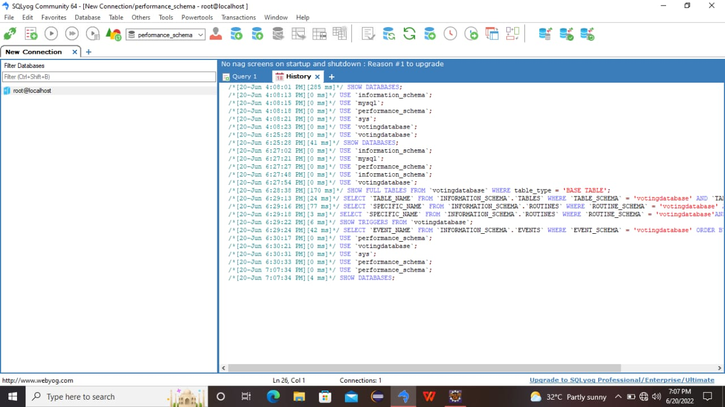

**TEST CASES**

* Testcase Id
* Objective
* Description
* Expected Result
* log001
* To test the URL
* 1)Enter URL 2)Open the webpage 3)Check for GUI
* Login validation page should open
* log002
* To test the GUI
* 1)open the webpage 2) check the GUI components
* It should display webpage with label,email,password,submit…etc
* log003
* To validate the Login page
* 1)Open the login page 2)keep empty the input elements 3)click on login button
* It should display error message as "Please enter email and password".
* log004
* To validate the login page
* 1)Open the login page 2)Enter valid credentials 3)click on login button
* It should display message as "Login successfully ".
* mv005
* To validate the mobile number
* 1)Open the login page 2)Enter mobile with less than 10 digits 3)click on login button
* It should display error message as "Please enter mobile number with10 digits".
* mv006
* To validate the mobile number
* 1)Open the login page 2)Enter mobile with greater than 10 digits 3)click on login button
* It should display error message as "Please enter mobile number with 10 digits".
* mv007
* To validate the mobile number
* 1)Open the login page 2)Enter mobile number starts with 6,7,8,9 digits 3)click on login button
* It should sent OTP to the respective mobile number
* mv008
* To validate the mobile number
* 1)Open the login page 2)Enter mobile number doesnot starts with 6,7,8,9 digits 3)click on login button
* It should display error message as "Please enter mobile number strats with 6,7,8,9 digits".
* mv009
* To validate the mobile number
* 1)Open the login page 2)Enter mobile number with special characters 3)click on login button
* It should display error message as "Please enter mobile number with valid digits
* mv010
* To validate the mobile number
* 1)Open the login page 2)Enter mobile number with valid inputs 3)click on login button
* It should sent OTP to the respective mobile number

**SCREEN SHOTS**

