**Vending Machine Application**

**By Lekkala Ramanjaneyulu Reddy**

I am submitting two projects.

1. Vending machine assignment
2. WCAG Project (this I did in past while learning to implement WCAG). This is implemented using JavaScript and jQuery.

**All details provided here-onwards are for Vending Machine assignment.**

**To execute the application:** As per the compression on the code, we have removed **node_modules** folder. Whenever code has been compiled the dependent libraries will be hosted on the node_modules folder.

Command to execute for creating node_modules folder and downloading the dependent libraries:-

1. npm install
2. ng serve --open
3. **Technical Considerations:**
4. We have implemented basic Angular 8 framework based soda vending machine application.
5. We have also used HTML5, SCSS (CSS pre-processor), Typescript, Node JS, Webpack and Bootstrap 4.
6. We have used JSON file to retrieve data for displaying items.
7. The application will support in all the screens (mobile, iPad, iPad Pro, tablets and desktops)
8. There is no need of error messages as we are enabling and disabling the items and buttons. But I have implemented both error message and disabling controls.
9. **Design Considerations:**

**Maintainability, Scalability & Responsiveness:**

1. We have used CSS Preprocessor for maintainable CSS code.
2. Created Constant file for error and success message.
3. Using JSON, we can change item list, Quantity or price.
4. Bootstrap 4 provides responsiveness.
5. **Application Work Flow for Vending Machine System:**

We get below screen using <http://localhost:4200/>. For making responsive application to work on all devices, application has been developed using Bootstrap 4. We get list of items from local JSON data. We are displaying list of items in vending machine GUI with Item Name, Quantity and Cost.

There are three states for the soda items.

1. Out of stock (color: red)
2. In stock (color: blue)
3. Not available for the inserted coins (color: grey)
4. **Initial Desktop screens**: except coin entry input, all other controls (Soda items, Insert Coin and Return Coin Button) are disabled.

Return coins input box will always be read-only and disabled.

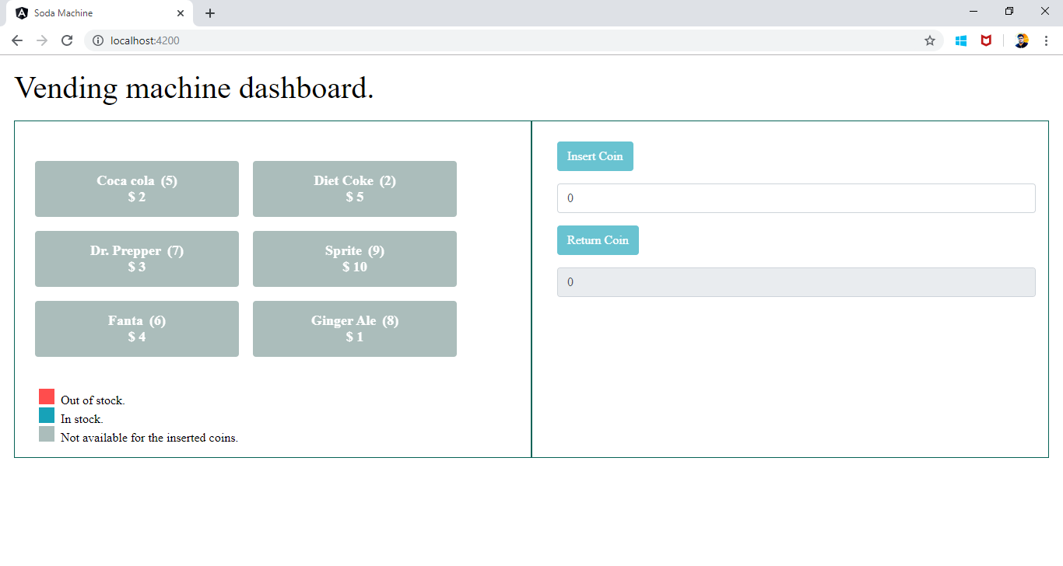

1. **After inserting coins**, controls are enabled. Items with price more than deposited amount will remain disable.

In example be. Coin inserted is $4. Items with price more than $4 (Diet Coke and Sprite) are disabled.

A success message “Successfully inserted $12coins. Select a soda item to dispense.” will be shown.

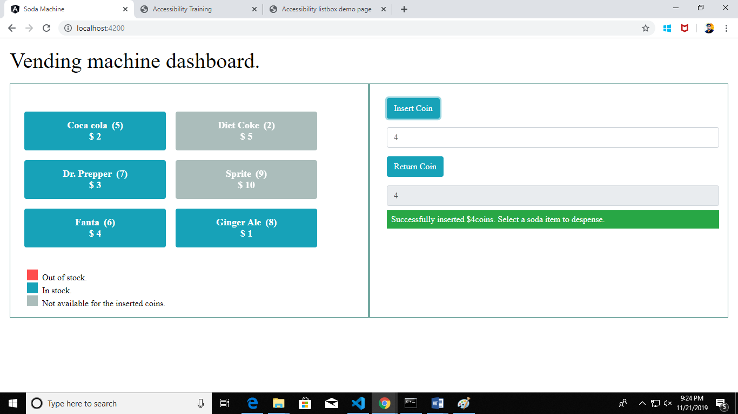

1. **Item dispensed**: On selecting item, Insert coin and Return Coin will get reduced by the price. Updated purchase history will be displayed.

Success Message: Enjoy your soda drink. You can still avail some more drinks with the remaining $4 coins.

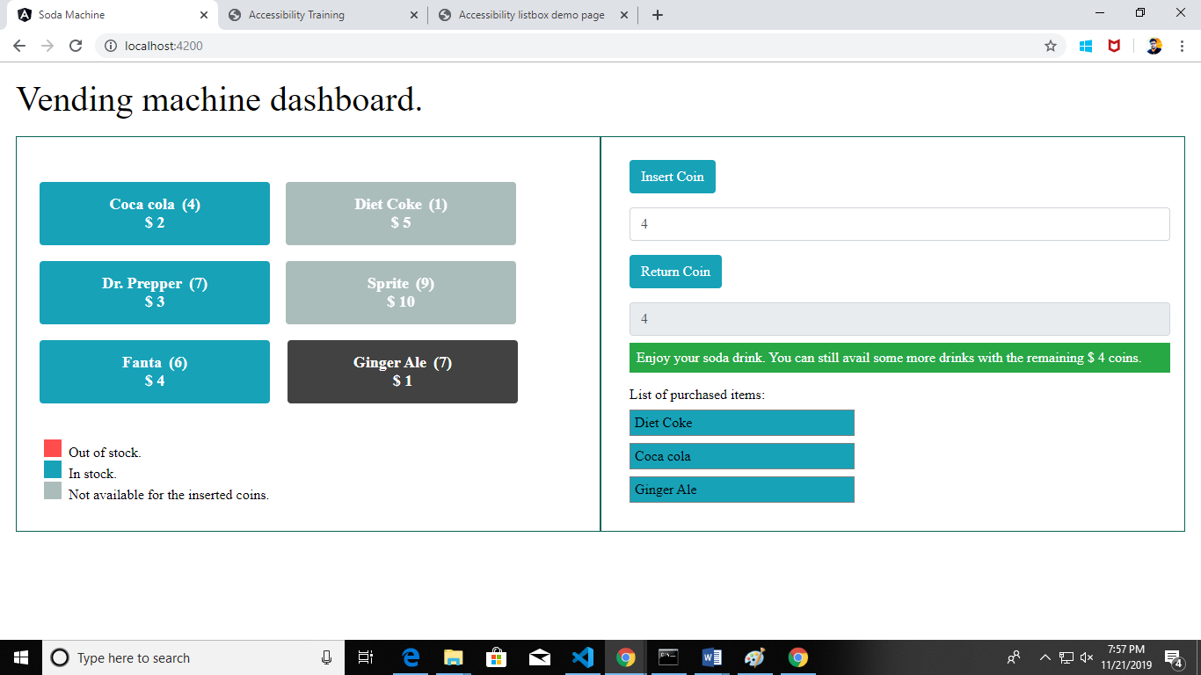

1. **Return Coin :** On clicking return coin, remaining money will be dispensed back. All controls will get disabled.

Success Message: We are returning $4 coins. Please take it before you leave from the vending machine. Thank you visit again.

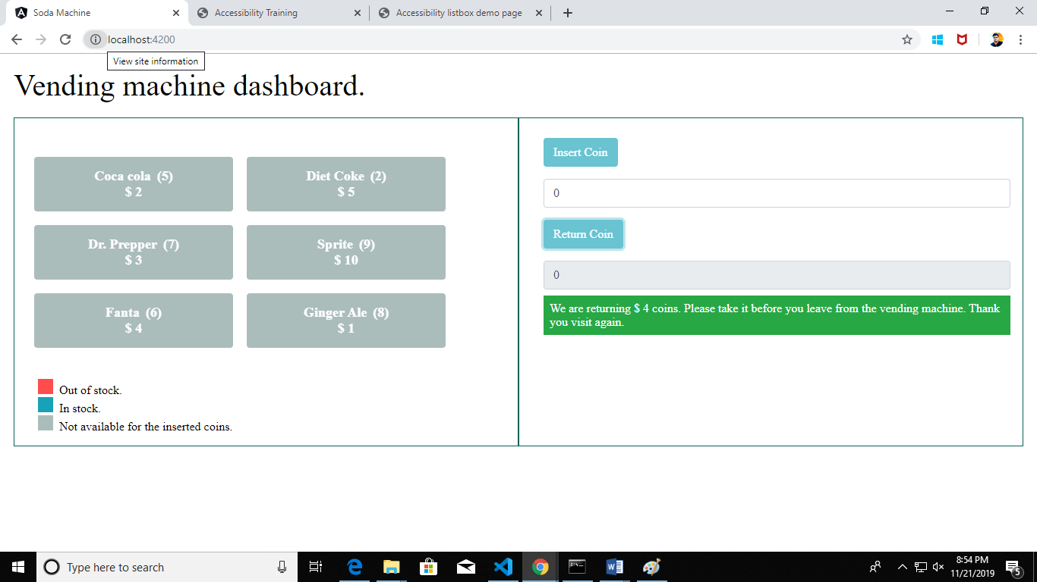

1. **Out of Stock:** If we keep on buying item so that its quantity becomes 0, it becomes out of Stock and displayed in Red. In example below, we inserted $12. We purchased 1 Coca Cola ($2) and 2 Diet Cokes ($5 each) as per “List of Items Purchased”. Original available Diet Coke quantity was 2. So it became out of Stock.

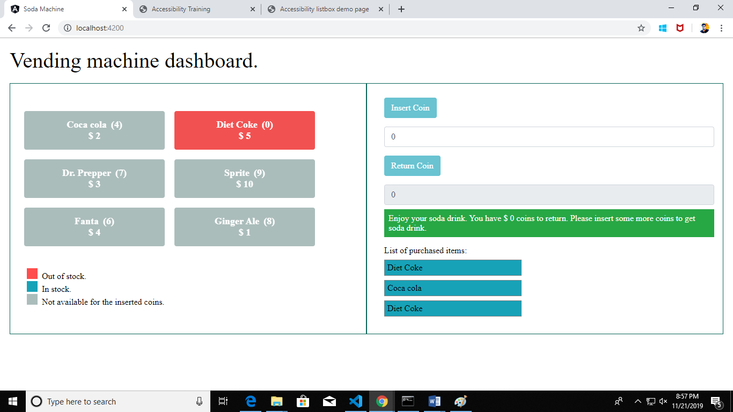

1. **Responsive design:** Due to responsive design using Bootstrap 4, application will work on all devices like laptop, Mobile, tablet etc. Some examples are shown below
2. **Mobile Device Screen**

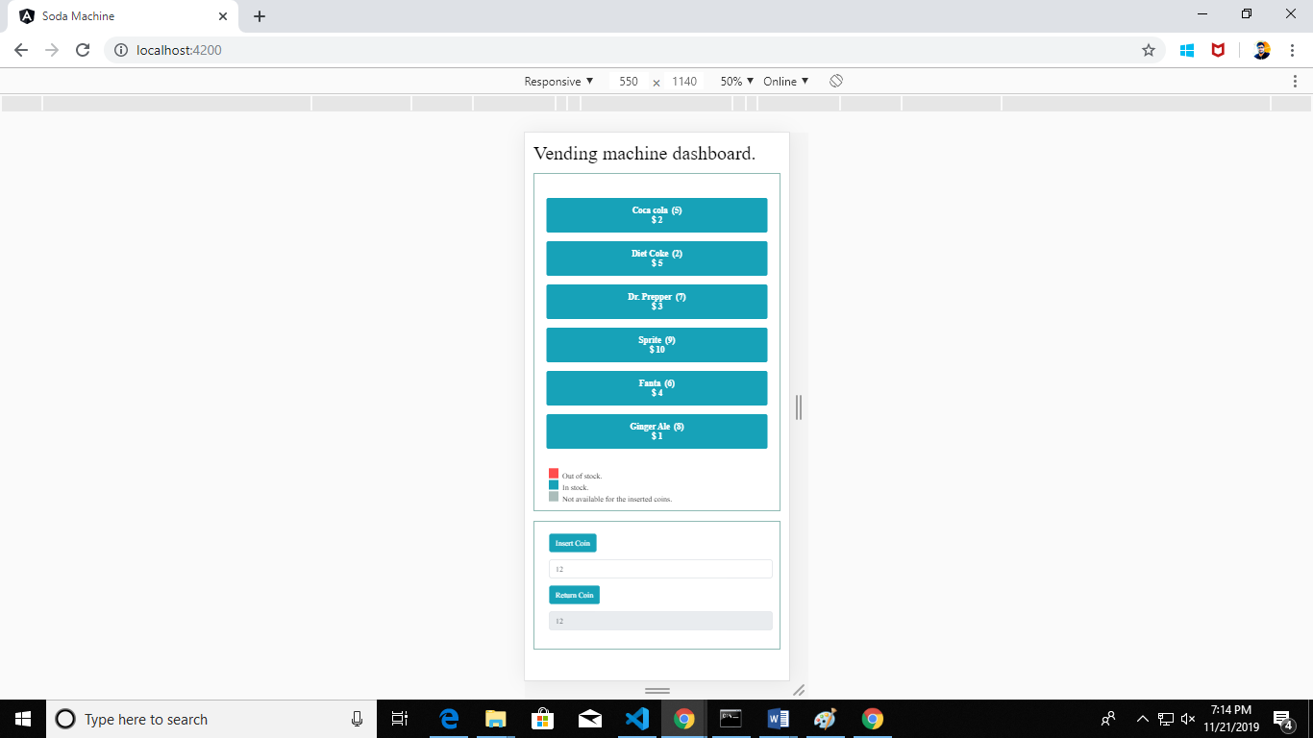

1. **iPad Pro Screen**

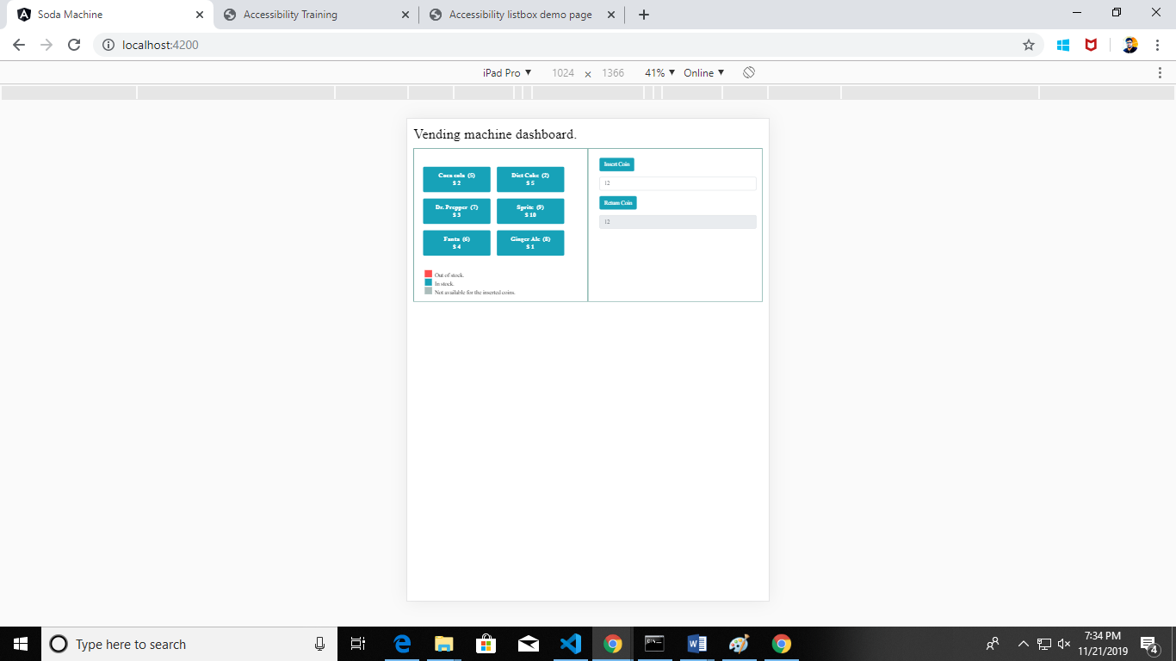

1. **IPad screen**

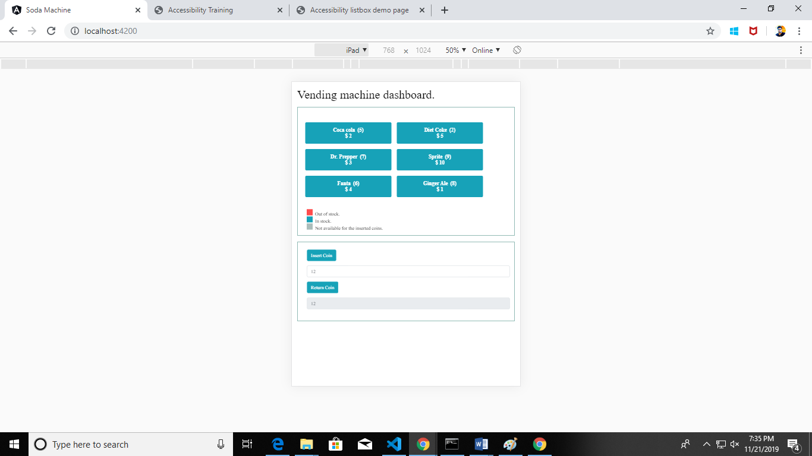

1. **IPhone X screen**

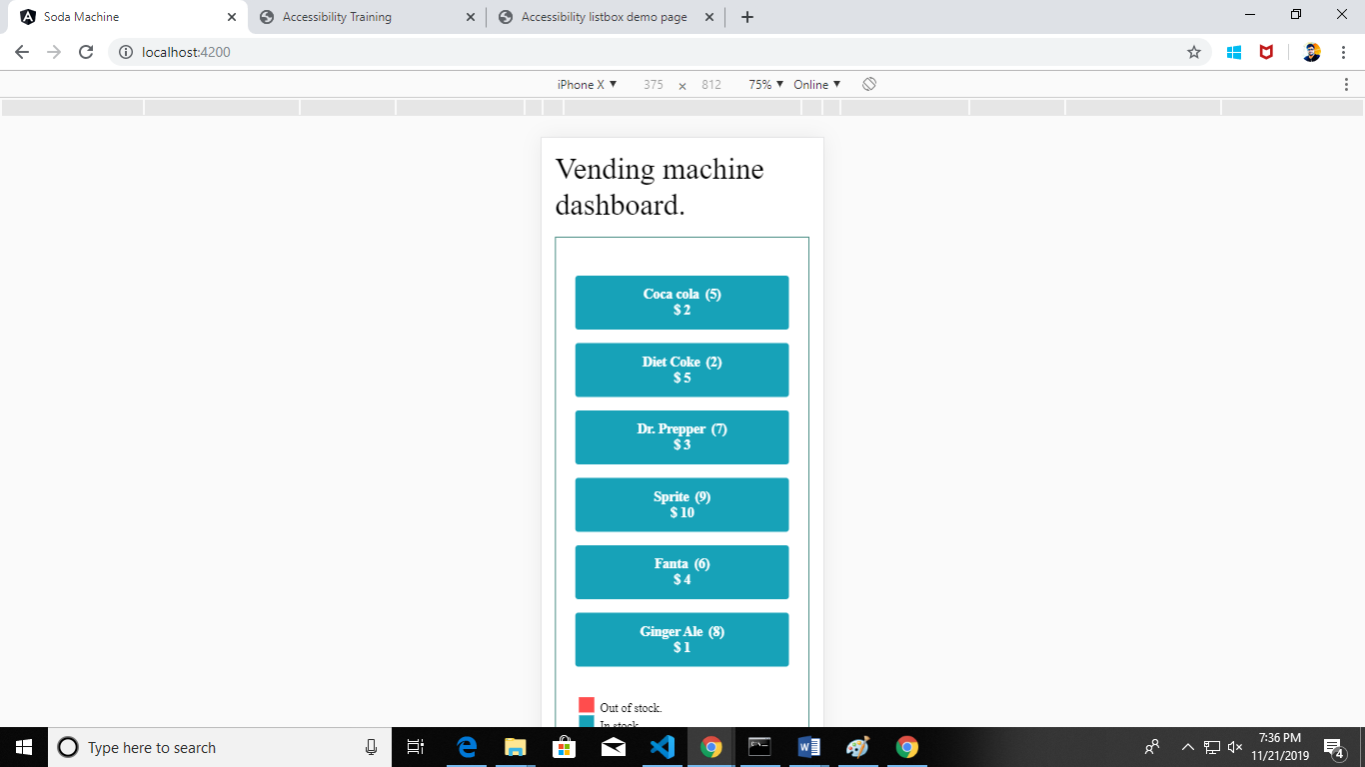

**End of the Document**