SAGE-Credit: Adaptive Expert Gating for Credit Default Prediction Under Variable External-Score Availability
Abstract: Credit-default models may lose predictive performance when highly informative external-score variables are unavailable. This study developed SAGE-Credit, an adaptive gated-expert framework designed to improve robustness under changing external-score availability. Data from 307,511 applicants in the Home Credit Default Risk dataset were transformed into a 929-feature tabular representation. Preliminary comparisons of five tabular models and a Long Short-Term Memory network identified CatBoost as the strongest modeling foundation. SAGE-Credit combined a full expert trained on all 929 features with a score-free expert trained on 922 features. A neural gate trained on three-fold out-of-fold predictions assigned applicant-specific weights to the experts. Evaluation on a held-out test set of 30,752 applicants included natural availability and three increasingly restrictive score conditions. Under natural availability, SAGE-Credit achieved a ROC-AUC of 0.793104 and an average precision of 0.299780. Under complete score removal, its ROC-AUC of 0.772607 remained close to the score-free expert's 0.772787 and exceeded the degraded full expert's 0.750769. Across the four equally weighted conditions, SAGE-Credit achieved the highest mean ROC-AUC and average precision and the lowest mean Brier score and log loss. Paired bootstrap comparison supported improvements over the selected individual expert under both partial-score conditions, but not under natural availability or complete removal. The gate progressively shifted toward the score-free expert as scores disappeared. These findings show that adaptive expert weighting can improve credit-risk prediction robustness when important inputs become unavailable.
Keywords: credit risk, default prediction, missing data, CatBoost, expert gating, model robustness
Introduction
Credit Default Prediction
Credit default prediction estimates the likelihood that an applicant will fail to meet future credit obligations within a specified period^{1,2}. Lenders use these estimates in deciding whether to approve credit and managing active accounts. Inaccurate assessment can lead to financial losses from defaults or rejections of applicants who may be creditworthy.
Credit-scoring systems traditionally use structured information from the current application and the applicant's prior credit record^{1,2}. Application data describe the applicant's financial circumstances when credit is requested. Historical records show how the applicant has managed earlier accounts and payments. Machine-learning methods can identify nonlinear relationships across these sources, and comparative studies have performed strongly in consumer credit-risk comparisons^{3,4}. The value of any model still depends on whether the information available during training is also available when the prediction is made.
External-Score Availability
Credit-scoring systems may incorporate information obtained beyond the immediate application, including prior credit records and assessments produced by outside data providers. These inputs can substantially improve risk estimation by capturing financial behaviors that are not observable from a single application record^{1,2}. However, this predictive value can also become a source of vulnerability. When a small group of external variables carries substantial predictive signal, a model trained under one pattern of information may become highly dependent on those inputs. Its performance may consequently deteriorate if the same information is only partially available when a prediction is required.
The absence of external score information does not represent a single uniform statistical condition. Missing-data mechanisms differ according to how the probability of a missing value relates to observed or unobserved information, with important consequences for statistical analysis and interpretation⁵. External source coverage may also vary among applicants, and access to that information may change between model development and model deployment. The Home Credit dataset does not disclose why individual external source values are absent. Accordingly, this study does not assign the observed gaps to a particular missing-data mechanism or assume that the controlled score-removal group produces a process that generates the original missing values.
External-score information was operationally defined in this study as three anonymized external-source variables - EXT_SOURCE_1, EXT_SOURCE_2, and EXT_SOURCE_3 - and four summary features derived from them. The underlying origin and interpretation of these variables are not disclosed in the public dataset, so they are not treated as a specific commercial credit score. The study instead asks whether application and historical information that remains available can compensate as access to these variables declines.
Research Gap and Contribution
A model trained with external-score information may perform strongly when those inputs are present, while a model trained without them may provide a more stable fallback. The second model gives up useful information when the scores are available. A fixed blend of the two models offers a simple alternative, although one unchanged mixture weight cannot account for differences in information availability across applicants.
Mixture-of-experts methods provide a general framework for this type of adaptation by using a learned gating function that determines how much each expert contributes to an individual prediction⁶. The relevant question is whether a gate can use the external-score signal when it exists and shift toward information that remains available when it does not.
This study introduces the Score-Availability Gated Ensemble for Credit Risk, or SAGE-Credit. It combines a full expert with a score-free expert through an applicant-specific weight. The contribution is an availability-aware prediction system evaluated against the individual experts and fixed combinations of their predictions.
Objective and Research Questions
The objective of this study was to develop and evaluate SAGE-Credit for credit default prediction when external-score availability changes. The study aimed to address the following research questions:
- Which data representation and predictive model provide the strongest baseline for credit-default prediction?
- How effectively can SAGE-Credit predict credit default compared with other models when external-score information is partially or completely unavailable?
Methods
Dataset and Applicant Partitions
This study used the publicly available Home Credit Default Risk competition dataset, which contains application information and linked historical financial records for consumer-loan applicants⁷. The primary application_train dataframe contained 307,511 current loan applications. The binary TARGET variable was assigned a value of 1 when an applicant experienced payment difficulties on the current loan and 0 otherwise. Of the 307,511 applications, 24,825 had a positive TARGET label, giving a default rate of 8.073%. Six relational tables supplied the linked records summarized in Table 1.
Table 1 | Home Credit Raw Data Sources. The table summarizes the application data and six linked relational tables used in the study, including each table's role, number of rows, and number of variables. Source: Home Credit Default Risk data⁷; row and variable counts calculated by the author.
Dataset table | Description | Rows | Variables
application_train | Applicant demographic, financial, and loan information, including the target variable | 307,511 | 122
bureau | Historical credit-bureau records associated with applicants' previous loans | 1,716,428 | 17
bureau_balance | Monthly status histories for loans represented in the credit-bureau records | 27,299,925 | 3
previous_application | Previous Home Credit loan applications associated with each applicant | 1,670,214 | 37
POS_CASH_balance | Monthly balance and repayment records for point-of-sale and cash loans | 10,001,358 | 8
installments_payments | Scheduled and completed installment-payment records for previous loans | 13,605,401 | 8
credit_card_balance | Monthly credit card balance, payment, drawing, and delinquency records | 3,840,312 | 23
The applicants were divided using a fixed, stratified 80:10:10 split (80% training, 10% validation, 10% test) with a random seed of 42. The training partition contained 246,011 applications, the validation partition contained 30,748 applications, and the test partition contained 30,752 applications. Their corresponding positive-class rates were 8.073%, 8.072%, and 8.074%, respectively. All records associated with a given SK_ID_CURR remained within the same partition.
Overall Study Design
This study consisted of two connected stages, as summarized in Figure 1. The preliminary stage constructed two representations of the Home Credit data. The two representations were then used to screen five tabular models and one recurrent model. Figure 1 displays how this screening stage led into the final SAGE-Credit experiment.
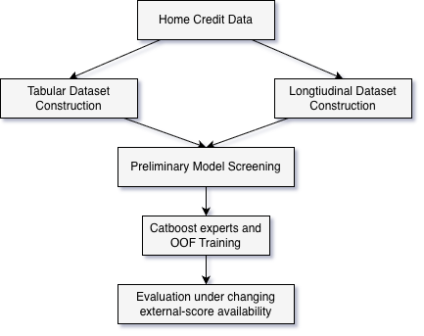
Figure 1 | Overall SAGE-Credit Study Workflow. The study first constructed tabular and longitudinal representations and screened five tabular models and one recurrent model. The final stage trained full and score-free CatBoost experts, combined their predictions through a learned gate, and evaluated the resulting system under four external-score availability conditions. Source: Author's study design.
The second stage trained specialized CatBoost experts and used OOF predictions from the training partition to fit the SAGE-Credit gate. Once the model configuration was fixed, the experts and gate were compared under changing external-score availability.
Tabular Data Construction
The relational tables followed different paths to the labeled application data⁷. Sources containing the applicant identifier were joined directly. Bureau-balance records were first connected through the main bureau table, while records tied to earlier Home Credit loans were aligned through the previous-credit identifiers. The value 365243 was treated as missing in the affected employment and application-day fields, and invalid ratios were converted to missing values before the feature blocks were merged.
Credit card and POS records were summarized over their full histories and over the previous 1, 3, 6, 12, and 24 months. Installment-payment windows extended from 30 to 365 days, while previous applications used windows stretching from 30 to 730 days. Bureau records were summarized through 1,095 days, and their monthly status histories used windows through 24 months. The resulting variables described account activity and balance. Separate aggregates represented repayment behavior, delinquency, and changes between recent and overall activity.
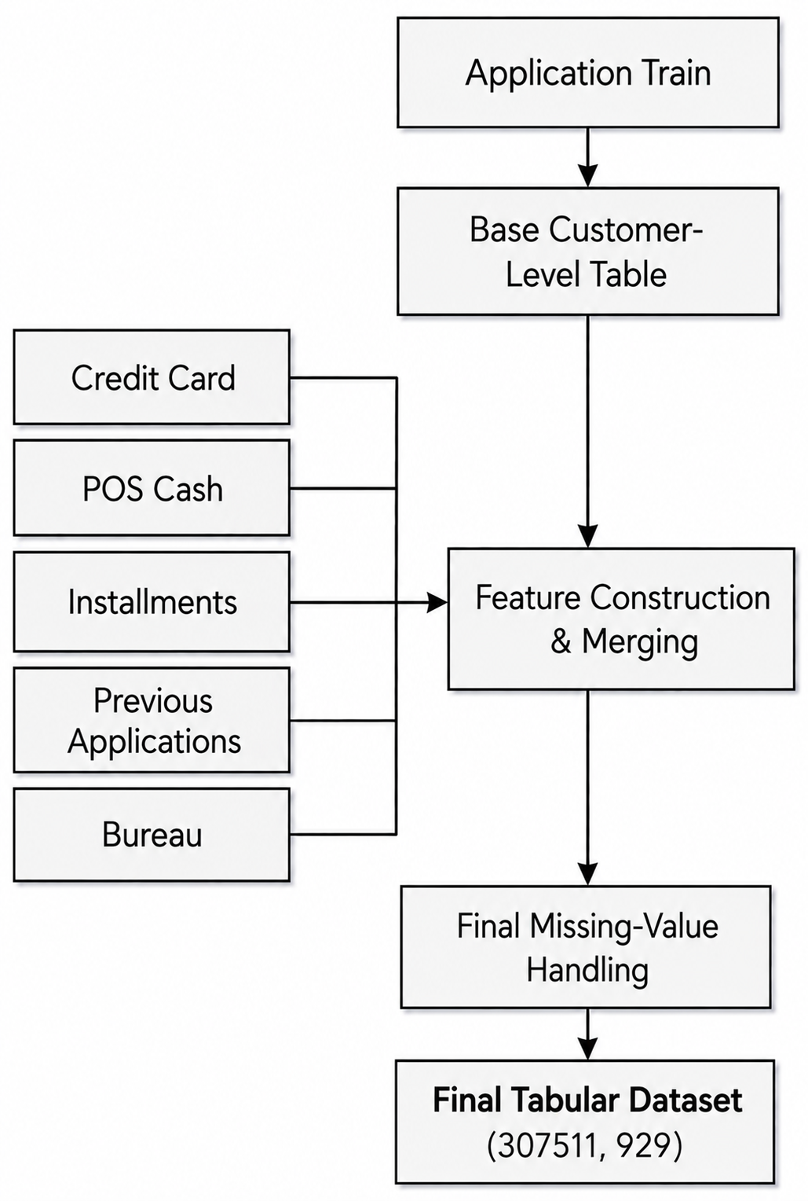
Figure 2 | Customer-Level Tabular Dataset Construction. Application data were combined with applicant-level aggregates derived from previous applications, installment payments, POS and cash loans, credit-card records, bureau records, and bureau-balance histories. The completed representation contained one row and 929 model inputs for each of the 307,511 applicants. Source: Author's data-processing workflow using Home Credit data⁷.
Each feature block was reduced to one row per applicant and left joined to the processed application data. Missing numerical application data were filled with column medians. After the linked-record features were merged, unavailable engineered values were set to zero. The applicant identifier and target variable were excluded from the model inputs, leaving a 307,511 x 929 tabular representation. Scikit-learn supported the stratified split and the model-specific transformations used later in training⁸.
Longitudinal Data Construction
In contrast to the tabular representation, the longitudinal data preserved the monthly order of linked records rather than reducing it to one row per applicant. Each applicant received 60 rows covering months -60 to -1, representing the number of months before the current application. Applying this grid to 307,511 customers resulted in 18,450,660 applicant-month pairs. Selected information (such as income, annuity amount, and requested credit) from the current application was repeated across the 60 rows belonging to the same applicant⁷.
Monthly credit card information produced 20 variables for each applicant-month. Most were totals, while the number of accounts was counted and delinquency was represented by monthly maximums. POS loan records added 14 variables. Bureau-balance statuses were connected to applicants through the main bureau table and converted into 8 monthly status counts.
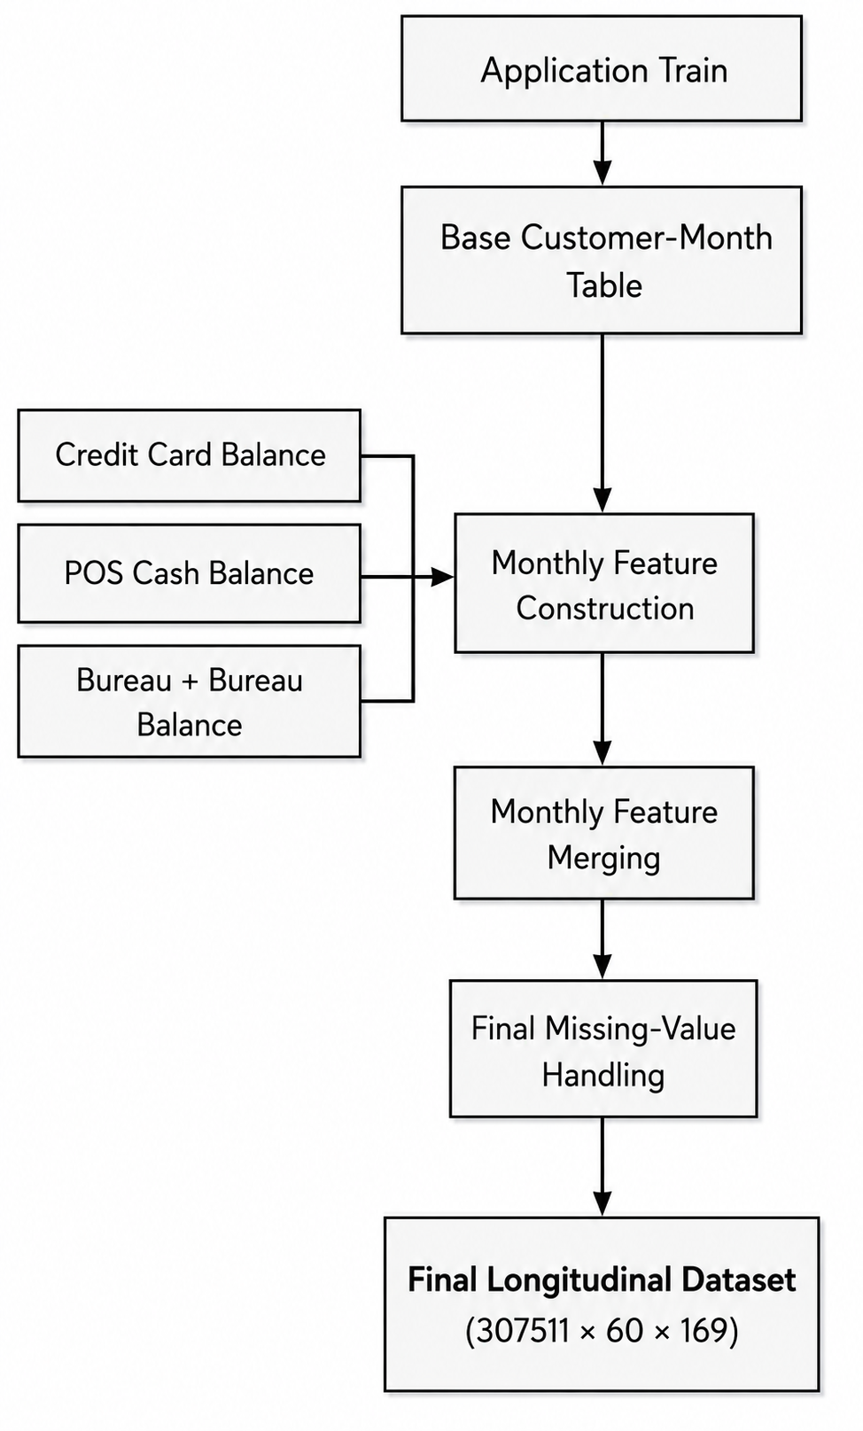
Figure 3 | Longitudinal Dataset Construction. Selected application variables were repeated across 60 monthly rows per applicant and combined with monthly credit-card, POS and cash-loan, and bureau-balance information. The completed 307,511 x 60 x 169 tensor was used only by the preliminary LSTM model. Source: Author's longitudinal data-processing workflow using Home Credit data⁷.
Preliminary Model Screening
The preliminary screening used the two representations to train six total models. Logistic regression, random forest, LightGBM, XGBoost, and CatBoost were all trained on the tabular representation, and the LSTM was trained separately on the 60-month longitudinal representation. All six models followed the applicant split described above. The validation partition guided model tuning. Performance on the test partition was recorded for the screening stage. These experiments were used to select the model family used for the SAGE-Credit experts.
Logistic regression served as the linear baseline. Missing values were replaced with medians, then standardized using parameters fitted on the training partition. The model used balanced class weights and allowed up to 1,000 iterations. The random forest contained 500 trees with a maximum depth of 20. Each leaf required at least 50 observations, and each split considered 5% of the available features. Class weights were recalculated from the bootstrap sample used for each tree^{8,10}.
LightGBM allowed up to 800 boosting rounds with a learning rate of 0.03, a maximum depth of 6, and 31 leaves per tree. Each round sampled 80% of the observations and features, and training stopped after 10 rounds without improvement in validation ROC-AUC¹¹. XGBoost allowed up to 1,000 iterations with depth 5 and the same learning rate. Observation and feature sampling were set at 0.8, and a positive-class weight of 11.35 (the ratio of non-defaults to defaults) addressed class imbalance¹². CatBoost used depth 4, a learning rate of 0.03, 80% feature sampling at each level, and a limit of 4,000 iterations. Its overfitting detector allowed 50 iterations without improvement and retained the best validation iteration, leaving 2,660 trees in the fitted screening model¹³. A random seed of 42 was used for every tabular model.
Before LSTM training, each input was standardized across the monthly rows in the training partition, and the fitted transformation was applied unchanged to the other partitions. The network contained one LSTM layer with 128 units, followed by dropout of 0.3 and a sigmoid output. It used Adam with binary cross-entropy loss and batches of 2,048 applicants. Training allowed up to 50 epochs but stopped after 7 because validation loss had not improved for three consecutive epochs. The weights from the epoch with the lowest validation loss were restored⁹.
SAGE-Credit Architecture and Model Inputs
The final experiment trained three CatBoost models separately on different columns of the tabular representation¹³. The full expert received all 929 inputs. The score-free expert received 922 inputs after removal of the 3 external-score variables (EXT_SOURCE_1, EXT_SOURCE_2, EXT_SOURCE_3) and the 4 features derived from them (APP_EXT_SOURCE_MEAN, APP_EXT_SOURCE_MIN, APP_EXT_SOURCE_MAX, APP_EXT_SOURCE_STD). The application-only expert received 247 inputs after removal of the same 7 score-related variables and the 675 engineered features identified by the CC_, POS_, BUR_, BB_, INST_, and PREV_ prefixes. This third model was used only as an ablation study to quantify the contribution of the engineered features.
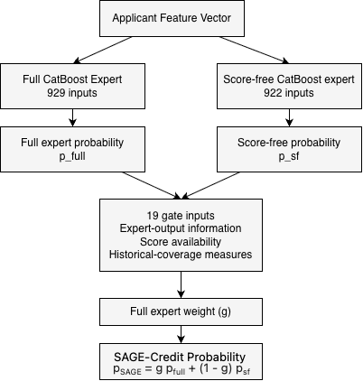
Figure 4 | SAGE-Credit Availability-Aware Gated-Expert Architecture. The full and score-free CatBoost experts generate separate default-probability estimates. A neural gate uses 19 applicant-specific inputs to assign the full-expert weight g, and SAGE-Credit combines the two expert predictions using g for the full expert and 1 - g for the score-free expert. Source: Author's model design.
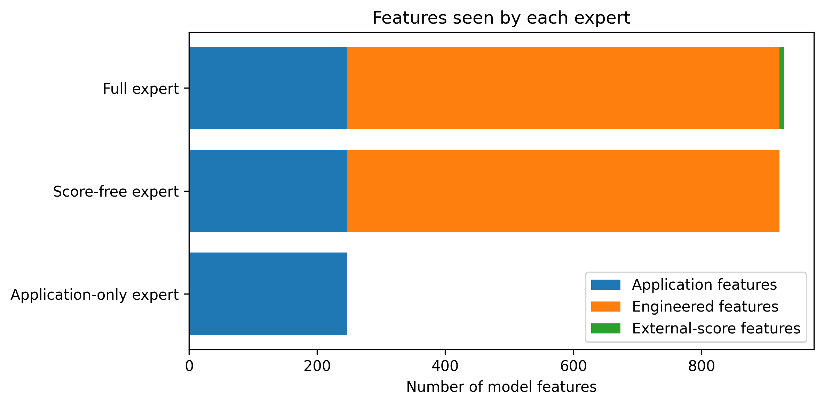
Figure 5 | Feature Composition of the SAGE-Credit Experts. The full expert contains 247 application features, 675 engineered features, and seven external-score-related features, for 929 inputs. The score-free expert excludes the seven external-score-related features and contains 922 inputs. The 247-input application-only expert excludes both the external-score-related and engineered features and is used only for the ablation analysis. Source: Author's feature grouping from the final experiment.
The gate used 19 inputs from three groups. Five described the expert outputs: the logit of each probability, the absolute difference in the probabilities, and each expert's distance from 0.5. Four described external-score availability through the number of observed raw scores and three availability indicators. The remaining ten measured historical coverage through a presence indicator and a fraction of nonzero engineered features for each of the five sources.
The standardized 19-input vector entered a PyTorch network with one 16-unit hidden layer, a ReLU activation, and dropout of 0.05¹⁴. A final one-unit sigmoid layer produced the applicant-specific full-expert weight g. For applicant i, SAGE-Credit combined the two expert probabilities as
p_{SAGE,i} = g_{i} p_{full,i} + (1 - g_{i}) p_{score-free,i}
A value of g near 1 gives greater weight to the full expert, while a value near 0 gives greater weight to the score-free expert. Table 2 summarizes the processed representations and the inputs used by the final models.
Table 2 | Processed Representations and Model Inputs. The table summarizes the dimensions, included information, and experimental roles of the tabular and longitudinal representations, the three CatBoost experts, and the SAGE-Credit gate. Final feature-group counts are 247 application features, 675 engineered features, and seven external-score-related features. Source: Author's processed data and final experiment configuration.
Component | Input structure | Included information | Role
Tabular representation | 307,511 x 929 | Application and linked-record features | Five tabular screening models
Longitudinal representation | 307,511 x 60 x 169 | Repeated application and monthly-linked record inputs | LSTM screening model only
Full expert | 929 inputs | 247 application, 675 engineered, 7 external-score | Primary SAGE-Credit expert
Score-free expert | 922 inputs | 247 application, 675 engineered | Score-free SAGE-Credit expert
Application-only expert | 247 inputs | Application features only | Ablation study
Gate | 19 inputs | 5 expert-output, 4 score-availability, 10 historical-coverage | Applicant-specific full-expert weight
OOF Gate Training
Three-fold stratified out-of-fold (OOF) predictions were generated for the full and score-free experts across all 246,011 training applicants^{8,16}. Within each fold, the experts were fitted on two folds and applied to the remaining fold, ensuring that no applicant's gate inputs included predictions from an expert trained on that applicant. The full expert produced a separate OOF prediction under each of the four planned availability conditions. The score-free prediction remained unchanged because its inputs did not include the removed score variables. Together, these predictions produced four gate-training rows per applicant, giving 984,044 rows. The gate-input scaler was fitted on all 984,044 OOF training rows and then applied unchanged to the held-out validation and test gate features. The three final experts were then fitted on the complete training partition.
Gate-training duration was selected using the permanent validation partition. The final experts, which had been fitted exclusively on the training partition, generated predictions for the 30,748 validation applicants under all four score-availability conditions. During gate training, these rows were used only to calculate validation loss after each epoch and were not supplied to the optimizer. The gate was optimized with binary cross-entropy loss and AdamW using a learning rate of 0.003, weight decay of 0.0001, and a batch size of 8,192. Training continued for up to 60 epochs and stopped after 10 epochs without a validation-loss improvement of at least 10⁻⁶. The selected criterion identified epoch 38, after which the gate was reinitialized and fitted for 38 epochs on all 984,044 OOF training rows. No validation or test applicants were included in this fit.
The global fixed blend was selected using the OOF predictions from the training partition. Full-expert weights from 0.00 to 1.00 were evaluated in increments of 0.01, with the remaining weight assigned to the score-free expert. Each weight was evaluated using the mean ROC-AUC across the four score-availability conditions. This procedure selected a full-expert weight of 0.48, which was then held fixed during validation and test evaluation.
Table 3 | Final SAGE-Credit Training Configuration. The table summarizes the CatBoost expert settings, three-fold OOF construction, 984,044 gate-training rows, gate-input scaling, AdamW optimization, validation-based selection of 38 training epochs, final gate refitting, and the OOF-selected global fixed-blend weight of 0.48. Source: Author's final training configuration.
Component | Configuration
CatBoost experts | 2,200 iterations; learning rate 0.03; depth 4; 80% feature sampling per level; L2 leaf regularization 3.0; random strength 1.0
OOF construction | 3 folds; each applicant was predicted by experts trained on the other two folds
Gate-training data | 246,011 applicants under four availability conditions; 984,044 rows
Gate-input scaling | Standardization fitted on the 984,044 gate-fitting rows
Gate optimizer | AdamW; learning rate 0.003; weight decay 0.0001; binary cross-entropy loss
Epoch selection | Maximum of 60 epochs; patience of 10 epochs; minimum improvement of 10⁻⁶; 38 epochs selected
Final gate training | All 984,044 OOF gate-training rows, 38 epochs
Global fixed blend | Full-expert weights tested from 0.00 to 1.00 in increments of 0.01; selected weight 0.48
Evaluation Design
The final evaluation used four external-score availability conditions. Natural availability preserved the raw external scores originally observed for each applicant. The at-most-two-score condition limited each applicant to no more than two scores, while the at-most-one-score condition retained no more than one. The no-score condition removed all three scores. Scores that were already missing remained missing.
A fixed seed of 4200 created a deterministic score order for each applicant. The at-most-one-score condition was nested within the at-most-two-score condition, meaning that a score retained under the first condition was also retained under the second. After scores were removed, the four score-summary features were recalculated from the remaining values, and the gate's availability indicators were updated to match. These conditions provided a controlled test of decreasing score availability. They do not represent every process that may cause external scores to be missing in real lending data⁵. The same deterministic score ranking defined both partial-score conditions, and the models and gate were evaluated without retraining under these conditions.
Six prediction methods were evaluated: the full expert, score-free expert, application-only expert, fixed 50/50 mixture, OOF-tuned global fixed blend, and SAGE-Credit. The global fixed blend used the 0.48 full-expert weight, selected through the process described above, for every applicant and availability condition. The application-only expert was used in the no-score condition to measure the predictive contribution of the engineered features.
ROC-AUC was the primary metric and measured how well each method ranked applicants by default risk across classification thresholds. Average precision summarized precision and recall across thresholds and provided a second measure suited to imbalanced classification. The Brier score measured the mean square difference between the predicted probabilities and actual outcomes. Log loss was used to place a larger penalty on confident incorrect predictions. Better performance was indicated by ROC-AUC and average precision scores being higher, while log loss and Brier scores were lower. The metrics were calculated using scikit-learn⁸.
Each metric was first calculated separately under the four availability conditions. A macro ROC-AUC and macro average precision were then calculated by giving each condition equal weight. The validation partition provided development-stage comparisons, while the test partition provided the final reported performance.
Differences between models were examined with 5,000 paired applicant bootstrap resamples¹⁷. Within each resample, the same applicant positions were used for both models. For macro ROC-AUC comparisons, the same sampled applicants were also used across all four conditions before the results were averaged. The observed difference was reported with a percentile-based 95% confidence interval. If the interval contained zero, neither model could be considered superior to the other.
Results
Preliminary Model Screening
CatBoost achieved the highest test ROC-AUC and F1 score among the six screened models, reaching 0.792287 and 0.351371, respectively (Table 4). It also produced the highest recall, while LightGBM produced the highest precision. Logistic regression and random forest produced lower values, and the longitudinal LSTM had the lowest performance on both metrics.
Table 4 | Model Screening Performance. The table reports test-partition performance for logistic regression, random forest, LightGBM, XGBoost, CatBoost, and the LSTM. Higher ROC-AUC, precision, recall, and F1 values indicate stronger performance; precision, recall, and F1 are reported at the displayed model-specific thresholds. Source: Author's preliminary model-screening analysis.
Model | ROC-AUC | Precision | Recall | F1 | Threshold
CatBoost | 0.792287 | 0.274603 | 0.487716 | 0.351371 | 0.15
XGBoost | 0.791393 | 0.283620 | 0.444221 | 0.346202 | 0.66
LightGBM | 0.790246 | 0.287044 | 0.434555 | 0.345723 | 0.68
Logistic regression | 0.774456 | 0.258223 | 0.445832 | 0.327031 | 0.68
Random forest | 0.773381 | 0.250345 | 0.437777 | 0.318535 | 0.54
LSTM | 0.750804 | 0.234347 | 0.422070 | 0.301365 | 0.14
The ROC curves in Figure 6 further illustrate the similar performance of the three boosted-tree models. CatBoost was selected as the foundation for the SAGE-Credit experts because it achieved the highest ROC-AUC and F1 while also producing the highest recall. Its advantage over XGBoost and LightGBM was small, but its overall performance across the reported metrics supported its selection.
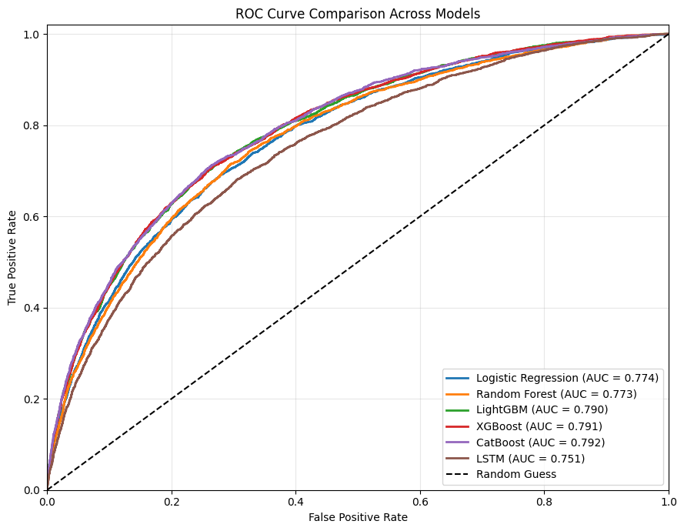
Figure 6 | Preliminary ROC Curves Across Screened Models. Test-partition receiver operating characteristic curves are shown for logistic regression, random forest, LightGBM, XGBoost, CatBoost, and the LSTM. The diagonal reference line represents random classification, and each legend entry reports the corresponding ROC-AUC. Source: Author's preliminary model-screening analysis.
Predictive Performance Across Score Availability
SAGE-Credit maintained the strongest overall performance as external-score availability declined (Table 5). It achieved the strongest average discrimination and probability-based accuracy across conditions, while the full expert deteriorated substantially as scores were removed. The score-free expert remained stable because its inputs were unaffected by score removal, and SAGE-Credit converged toward its performance under the no-score condition. The fixed mixtures reduced the full expert's deterioration but could not adapt their weights to individual applicants or changing score availability.
Table 5 | Test Performance Across External-Score Availability Conditions. Panels A through D report ROC-AUC, average precision, Brier score, and log loss, respectively, under the four external-score availability conditions. Mean across conditions values are unweighted averages across the four conditions. Higher ROC-AUC and average precision values indicate stronger performance, while lower Brier scores and log losses indicate stronger probability-based performance. Source: Author's final test-partition analysis.
Method | Natural availability | <= 2 scores | <= 1 score | No scores | Mean across conditions
Panel A. ROC-AUC
Full expert | 0.792093 | 0.787653 | 0.773087 | 0.750769 | 0.775900
Score-free expert | 0.772787 | 0.772787 | 0.772787 | 0.772787 | 0.772787
Fixed 50/50 mixture | 0.790877 | 0.788780 | 0.782123 | 0.764901 | 0.781670
OOF-tuned blend | 0.790532 | 0.788536 | 0.782187 | 0.765390 | 0.781661
SAGE-Credit | 0.793104 | 0.789273 | 0.781043 | 0.772607 | 0.784007
Panel B. Average precision
Full expert | 0.297611 | 0.290752 | 0.270383 | 0.239063 | 0.274452
Score-free expert | 0.270862 | 0.270862 | 0.270862 | 0.270862 | 0.270862
Fixed 50/50 mixture | 0.296333 | 0.292796 | 0.283019 | 0.262615 | 0.283691
OOF-tuned blend | 0.295743 | 0.292423 | 0.283064 | 0.263250 | 0.283619
SAGE-Credit | 0.299780 | 0.293180 | 0.282904 | 0.269691 | 0.286389
Panel C. Brier score
Full expert | 0.065171 | 0.065531 | 0.066807 | 0.072500 | 0.067502
Score-free expert | 0.066640 | 0.066640 | 0.066640 | 0.066640 | 0.066640
Fixed 50/50 mixture | 0.065399 | 0.065547 | 0.066049 | 0.068043 | 0.066260
OOF-tuned blend | 0.065429 | 0.065570 | 0.066047 | 0.067928 | 0.066244
SAGE-Credit | 0.065063 | 0.065402 | 0.066006 | 0.066663 | 0.065784
Panel D. Log loss
Full expert | 0.234777 | 0.236355 | 0.241763 | 0.267438 | 0.245083
Score-free expert | 0.241509 | 0.241509 | 0.241509 | 0.241509 | 0.241509
Fixed 50/50 mixture | 0.235892 | 0.236596 | 0.238962 | 0.250058 | 0.240377
OOF-tuned blend | 0.236025 | 0.236696 | 0.238952 | 0.249514 | 0.240297
SAGE-Credit | 0.234374 | 0.235811 | 0.238629 | 0.241576 | 0.237598
The ordering of the methods changed as score availability became more limited. As shown in Figure 7, Panel A, the full expert's ROC-AUC decreased by 0.041324 between natural availability and complete score removal, while SAGE-Credit decreased by 0.020497. Under the at-most-one-score condition, the OOF-tuned global fixed blend produced the highest ROC-AUC and average precision, although SAGE-Credit produced the lowest Brier score and log loss. When no scores remained, the score-free expert slightly outperformed SAGE-Credit across all four metrics. These differences were small, indicating that SAGE-Credit converged closely toward the score-free expert after external-score information disappeared.
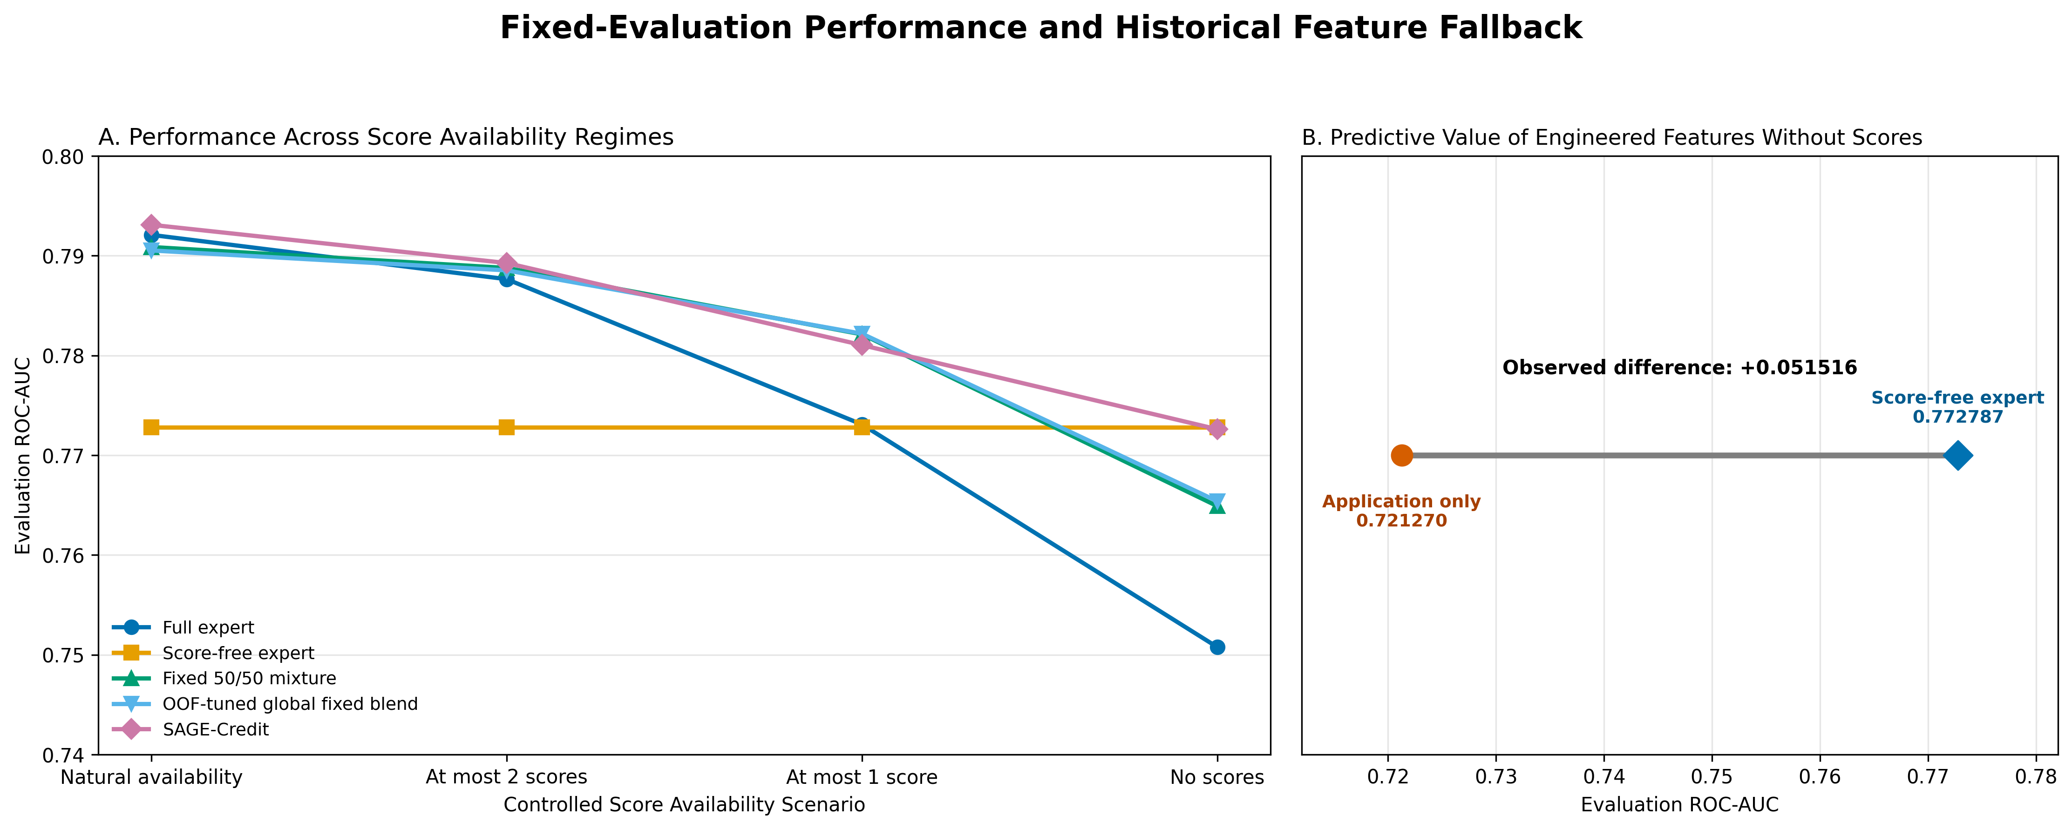
Figure 7 | Performance Across External-Score Availability Conditions and Engineered-Feature Ablation. Panel A shows test-partition ROC-AUC across natural availability, at most two scores, at most one score, and no scores for the full expert, score-free expert, fixed 50/50 mixture, OOF-tuned global fixed blend, and SAGE-Credit. Panel B compares the score-free and application-only experts under complete score removal to show the predictive contribution of the engineered features. Source: Author's final test-partition and ablation analyses.
When the four conditions were weighted equally, SAGE-Credit achieved the highest mean ROC-AUC at 0.784007 and the highest mean average precision at 0.286389. It also achieved the lowest mean Brier score at 0.065784 and the lowest mean log loss at 0.237598. The fixed 50/50 mixture ranked second in mean ROC-AUC and mean average precision, while the OOF-tuned global fixed blend ranked second in mean Brier score and mean log loss. SAGE-Credit therefore produced the strongest average performance across the evaluated availability conditions, although it was not the highest-performing method under every individual condition. Because the conditions were weighted equally, these means summarize performance across the predefined availability conditions rather than expected performance under real-world availability frequencies.
The application-only ablation further demonstrated the predictive contribution of the engineered features. Under complete score removal, the score-free expert achieved a ROC-AUC of 0.772787, compared with 0.721270 for the application-only expert. Their average precision values were 0.270862 and 0.198383, respectively. As shown in Figure 7, Panel B, the ROC-AUC difference of 0.051517 indicated that the engineered features provided substantial predictive information beyond the current application when external scores were unavailable. The score-free expert also produced a lower Brier score and log loss than the application-only expert.
The validation partition selected the full expert as the individual-expert comparator under the first three conditions and the score-free expert under the no-score condition. The paired ROC-AUC bootstrap comparison in Figure 8 shows that SAGE-Credit exceeded the selected expert by 0.001011 under natural availability, 0.001620 with at most two scores, and 0.007956 with at most one score. The confidence intervals excluded zero under both partial-score conditions, supporting a performance difference in favor of SAGE-Credit. The interval contained zero under natural availability. Under complete score removal, SAGE-Credit was 0.000179 below the score-free expert, and the interval also contained zero. The results therefore did not provide evidence of a ROC-AUC difference under natural availability or complete score removal.
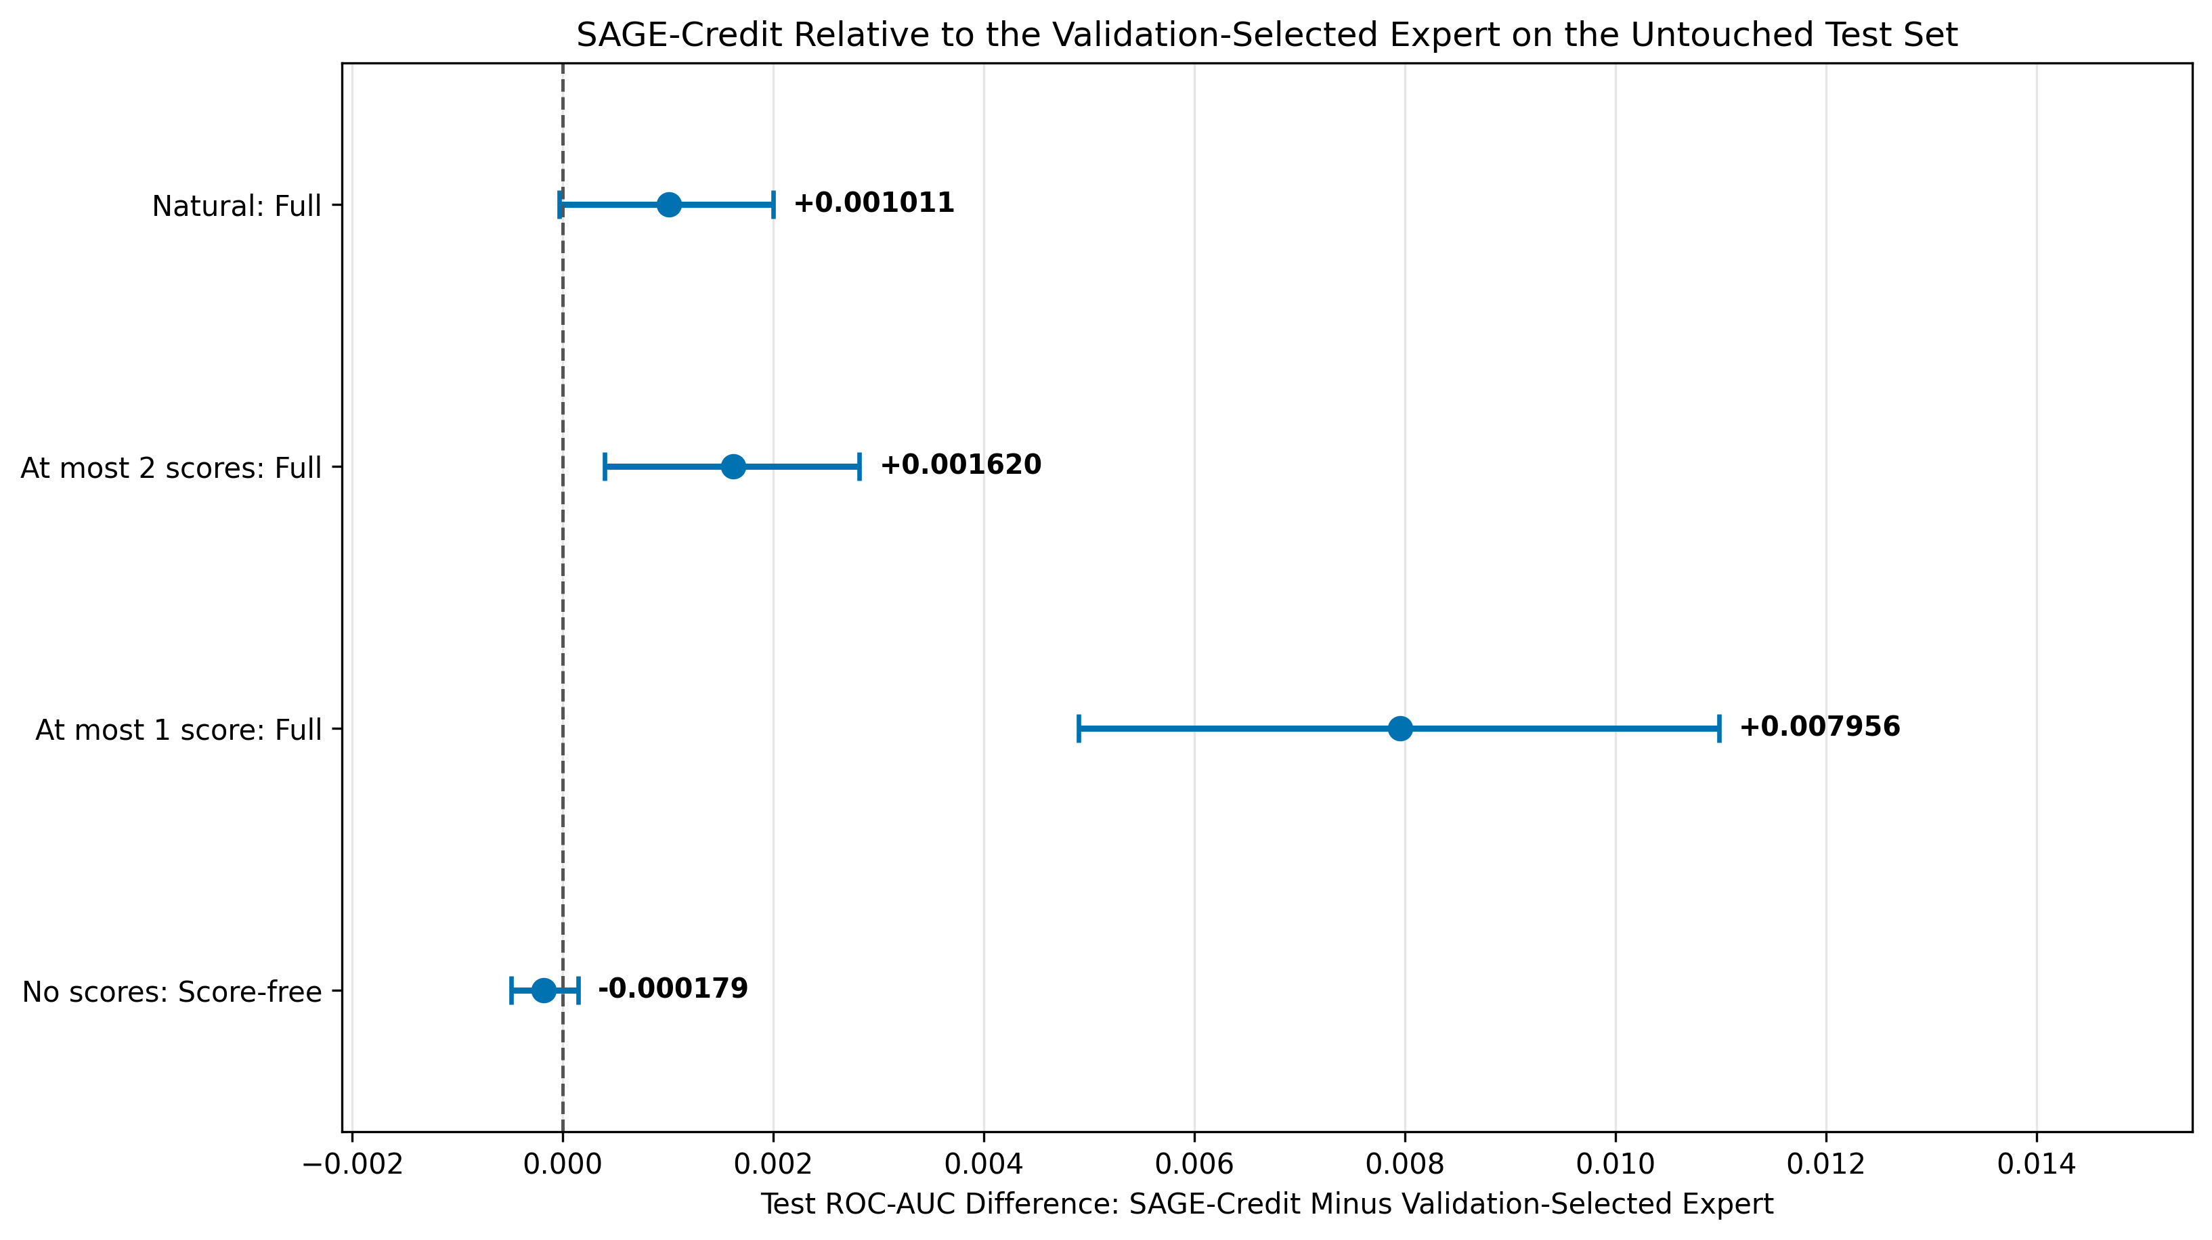
Figure 8 | Paired ROC-AUC Differences Between SAGE-Credit and the Selected Individual Expert. Points show the observed test-partition ROC-AUC difference between SAGE-Credit and the individual expert selected using validation performance for each availability condition. Horizontal bars show percentile-based 95% confidence intervals from 5,000 paired applicant-bootstrap resamples. Positive values favor SAGE-Credit, and the vertical reference line at zero represents no difference. The comparator is the full expert under the first three conditions and the score-free expert under the no-score condition. Source: Author's paired applicant-bootstrap analysis.
Model Behavior Under Reduced Score Availability
The feature-importance comparison showed that removing the external-score variables changed which information the model emphasized (Figure 9). External-score variables and their derived summaries occupied several leading positions in the full expert. After these seven features were excluded, engineered features and other application features occupied the leading positions in the score-free expert. The presence of engineered features among its leading predictors showed that the score-free expert used information derived from applicants' prior credit records when external-score information was unavailable. Because feature importance was calculated separately for each expert, the values should be interpreted as within-model descriptions of predictor use rather than directly comparable measures of absolute importance across the two models. These importances are also descriptive and do not establish causal relationships between the predictors and default.
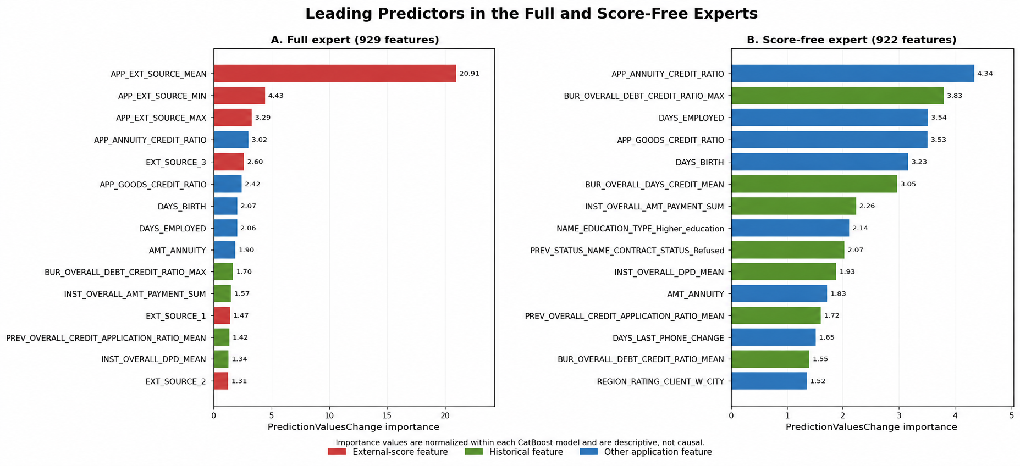
Figure 9 | Leading Predictors in the Full and Score-Free Experts. The leading CatBoost feature importances are shown separately for the full and score-free experts and classified as external-score-related, engineered, or other application features. Importances were calculated and normalized within each model, so they describe predictor use within an expert and are not directly comparable as absolute values across experts. The importances are descriptive and do not establish causal relationships with default. Source: Author's CatBoost feature-importance analysis.
The learned gate shifted its predictions toward the score-free expert as external-score availability declined (Figure 10). The mean weight assigned to the full expert decreased from 0.901 under natural availability to 0.860 with at most two scores, 0.550 with at most one score, and 0.033 when no scores remained. The corresponding mean weights assigned to the score-free expert were 0.099, 0.140, 0.450, and 0.967. This monotonic progression showed that the gate relied primarily on the full expert when external-score information was available, divided its reliance more evenly as availability became limited, and shifted almost entirely toward the score-free expert after the scores were removed. Although Figure 10 shows the average weight for each condition, the gate determined the weight separately for each applicant based on the available information and the experts' outputs.
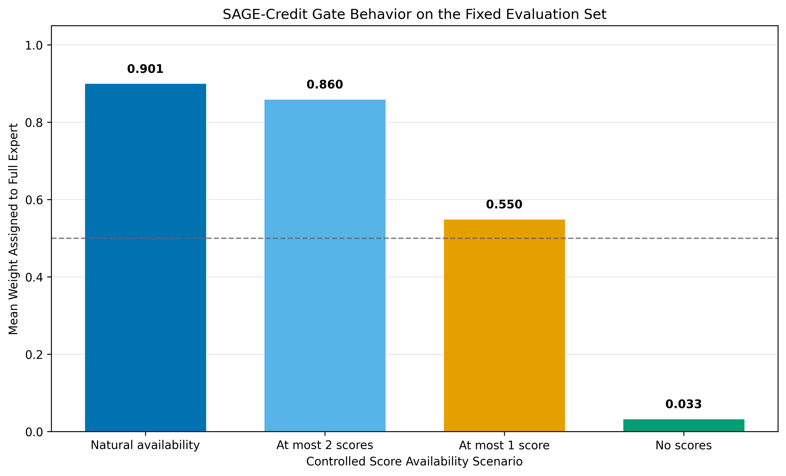
Figure 10 | Mean SAGE-Credit Gate Weights Across External-Score Availability Conditions. The figure shows the condition-level mean weights assigned to the full and score-free experts under natural availability, at most two scores, at most one score, and no scores. The gate produced applicant-specific weights, while the displayed means summarize how its reliance on the two experts changed as external-score availability declined. Source: Author's learned-gate analysis on the test partition.
Together, Figures 9 and 10 show two complementary forms of adaptation. The score-free expert redistributed its predictor importance toward the remaining application and engineered features, while the gate redistributed the ensemble prediction toward that expert as external scores disappeared. The gate weights are descriptive diagnostics and do not independently establish predictive improvement. Evidence about whether this behavior preserved performance therefore comes from the test metrics and paired bootstrap comparisons reported above.
Discussion
Interpretations and Implications
The preliminary model comparison supported the use of CatBoost with the engineered tabular representation as the foundation for SAGE-Credit. In the primary experiment, SAGE-Credit achieved the strongest mean performance across the four predefined score-availability conditions for ROC-AUC, average precision, Brier score, and log loss. Its advantage was not uniform, however. The improvement over the selected individual expert was small and not statistically supported under natural availability. SAGE-Credit improved significantly over the selected expert in both partial-score conditions, although the OOF-tuned global fixed blend produced slightly higher ROC-AUC and average precision when applicants retained at most one score. Under complete score removal, the score-free expert slightly outperformed SAGE-Credit. These results indicate that the main value of adaptive gating arose when external-score information was limited rather than fully present or entirely absent.
The gate's behavior helps explain this pattern. When external scores were generally available, the gate assigned most of the prediction weight to the full expert because that model retained access to the most informative feature set. As availability declined, the gate progressively increased its reliance on the score-free expert. This adjustment was most useful under partial availability, where neither expert consistently matched the information available for every applicant. When no scores remained, the gate assigned almost all weight to the score-free expert, causing SAGE-Credit to converge closely toward that model rather than continue relying on the degraded full expert. The role of the gate was therefore not to create new predictive information, but to direct each prediction toward the expert whose training inputs more closely matched the information available for that applicant.
The comparison between the score-free and application-only experts further showed that the remaining engineered features provided a meaningful fallback. The score-free expert's substantially stronger performance indicated that information derived from prior credit records contributed predictive value beyond the current application variables alone. Its feature-importance pattern also showed that the model shifted its emphasis toward the application and engineered features that remained after the external-score variables were excluded. In practice, this type of architecture could allow a credit-risk system to degrade more gradually when an important information source is missing, delayed, or excluded. The findings support availability-aware model design as a strategy for improving robustness under changing input conditions, although they do not establish that SAGE-Credit is ready for use in real lending decisions.
Limitations and Future Research
Several limitations define the scope of these findings. First, all models were developed and evaluated using a single public, anonymized dataset and one fixed training, validation, and test split. The held-out test evaluation and paired bootstrap analysis support the internal comparisons, but they do not establish that the results would transfer to applicants from another lender, time period, loan product, or economic environment. Second, score availability was changed through controlled removal of seven predefined variables. This design provided a consistent robustness test, but real missingness may arise for nonrandom reasons and may be associated with applicant characteristics, data-provider coverage, or operational failures. Because the external-score variables were anonymized, their exact sources and the real-world circumstances that could make them unavailable could not be examined. In addition, the means across conditions weighted the four experimental conditions equally and therefore do not represent expected performance under actual score-availability frequencies. Finally, the study evaluated predictive performance rather than lending decisions. It did not examine subgroup fairness, decision thresholds, the costs of false approvals and denials, or the operational monitoring required for deployment.
Future research should first test SAGE-Credit on external datasets and through temporal validation in which models are trained on earlier applications and evaluated on later ones. Evaluations should also reproduce naturally occurring patterns of score absence or simulate missingness associated with applicant and system characteristics, rather than limiting removal to the same predefined conditions for every applicant. Repeating training across additional splits and random seeds would help determine whether the learned gate behavior remains stable. Further work should evaluate calibration within each availability condition, compare performance across relevant applicant subgroups, and examine whether adaptive gating affects fairness when score access differs across those groups. Deployment-oriented research would also need to select decision thresholds using the financial and social costs of different errors, generate suitable explanations for model outputs, and monitor performance as applicant populations and data availability change. These steps are necessary before SAGE-Credit could be considered for operational lending decisions, but they extend rather than diminish the present finding that adaptive expert gating improved robustness across the controlled score-availability conditions evaluated in this study.
Conclusion
This study examined whether credit-default prediction could remain reliable as external-score information became less available. The results show that SAGE-Credit's adaptive gate successfully changed its reliance on the full and score-free experts as applicant information changed. This approach produced the strongest average performance across the four evaluated availability conditions and significantly outperformed the selected individual expert under both partial-score conditions. When external scores were completely removed, SAGE-Credit converged closely toward the score-free expert, which benefited from predictive information retained in the engineered features. SAGE-Credit did not outperform every comparator under every condition, so its contribution is not universal superiority. Rather, the findings demonstrate that applicant-specific expert weighting can provide a more robust alternative to relying on one model or an unchanged mixture when important inputs may be unavailable. Further validation is needed to determine how well this approach generalizes beyond the dataset and controlled conditions examined here.
References
- L. C. Thomas. A survey of credit and behavioural scoring: forecasting financial risk of lending to consumers. International Journal of Forecasting. Vol. 16, pg. 149-172, 2000, https://doi.org/10.1016/S0169-2070(00)00034-0.
- D. J. Hand, W. E. Henley. Statistical classification methods in consumer credit scoring: a review. Journal of the Royal Statistical Society: Series A (Statistics in Society). Vol. 160, pg. 523-541, 1997, https://www.jstor.org/stable/2983268.
- A. E. Khandani, A. J. Kim, A. W. Lo. Consumer credit-risk models via machine-learning algorithms. Journal of Banking & Finance. Vol. 34, pg. 2767-2787, 2010, https://doi.org/10.1016/j.jbankfin.2010.06.001.
- S. Lessmann, B. Baesens, H.-V. Seow, L. C. Thomas. Benchmarking state-of-the-art classification algorithms for credit scoring: an update of research. European Journal of Operational Research. Vol. 247, pg. 124-136, 2015, https://doi.org/10.1016/j.ejor.2015.05.030.
- R. J. A. Little, D. B. Rubin. Statistical Analysis with Missing Data. Wiley, 2019, https://doi.org/10.1002/9781119482260.
- R. A. Jacobs, M. I. Jordan, S. J. Nowlan, G. E. Hinton. Adaptive mixtures of local experts. Neural Computation. Vol. 3, pg. 79-87, 1991, https://doi.org/10.1162/neco.1991.3.1.79.
- Home Credit. Home Credit Default Risk. https://www.kaggle.com/competitions/home-credit-default-risk, 2018.
- F. Pedregosa, G. Varoquaux, A. Gramfort, V. Michel, B. Thirion, O. Grisel, M. Blondel, P. Prettenhofer, R. Weiss, V. Dubourg, J. Vanderplas, A. Passos, D. Cournapeau, M. Brucher, M. Perrot, E. Duchesnay. Scikit-learn: machine learning in Python. Journal of Machine Learning Research. Vol. 12, pg. 2825-2830, 2011.
- S. Hochreiter, J. Schmidhuber. Long short-term memory. Neural Computation. Vol. 9, pg. 1735-1780, 1997, https://doi.org/10.1162/neco.1997.9.8.1735.
- L. Breiman. Random forests. Machine Learning. Vol. 45, pg. 5-32, 2001, https://doi.org/10.1023/A:1010933404324.
- G. Ke, Q. Meng, T. Finley, T. Wang, W. Chen, W. Ma, Q. Ye, T.-Y. Liu. LightGBM: a highly efficient gradient boosting decision tree. Advances in Neural Information Processing Systems. Vol. 30, 2017, https://proceedings.neurips.cc/paper_files/paper/2017/file/6449f44a102fde848669bdd9eb6b76fa-Paper.pdf.
- T. Chen, C. Guestrin. XGBoost: a scalable tree boosting system. Proceedings of the 22nd ACM SIGKDD International Conference on Knowledge Discovery and Data Mining. Pg. 785-794, 2016, https://doi.org/10.1145/2939672.2939785.
- L. Prokhorenkova, G. Gusev, A. Vorobev, A. V. Dorogush, A. Gulin. CatBoost: unbiased boosting with categorical features. Advances in Neural Information Processing Systems. Vol. 31, 2018, https://arxiv.org/abs/1706.09516.
- A. Paszke, S. Gross, F. Massa, A. Lerer, J. Bradbury, G. Chanan, T. Killeen, Z. Lin, N. Gimelshein, L. Antiga, A. Desmaison, A. Kopf, E. Yang, Z. DeVito, M. Raison, A. Tejani, S. Chilamkurthy, B. Steiner, L. Fang, J. Bai, S. Chintala. PyTorch: an imperative style, high-performance deep learning library. Advances in Neural Information Processing Systems. Vol. 32, 2019.
- I. Loshchilov, F. Hutter. Decoupled weight decay regularization. International Conference on Learning Representations, 2019, https://arxiv.org/abs/1711.05101.
- D. H. Wolpert. Stacked generalization. Neural Networks. Vol. 5, pg. 241-259, 1992, https://doi.org/10.1016/S0893-6080(05)80023-1.
- B. Efron, R. J. Tibshirani. An Introduction to the Bootstrap. Chapman & Hall/CRC, 1993.

