CSPO

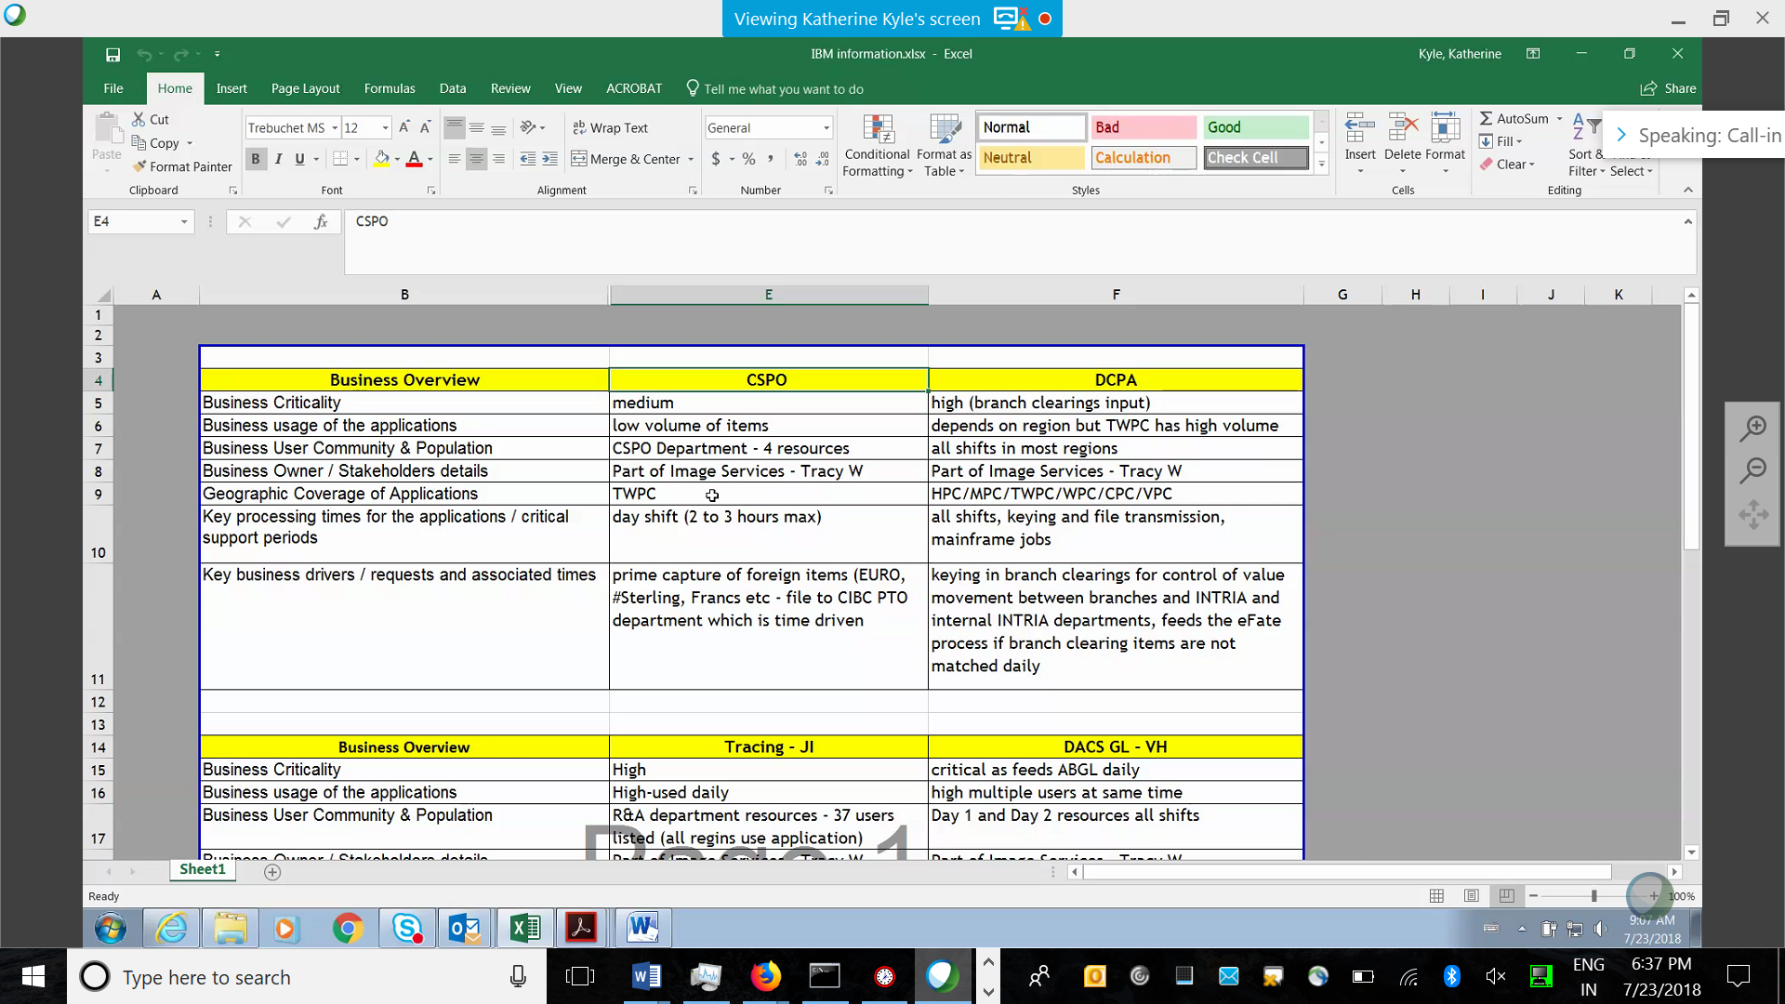

NCR product

Standard procedure

These application is stable no prospective of L2 and L3

DCPA

Data center processing application is tool

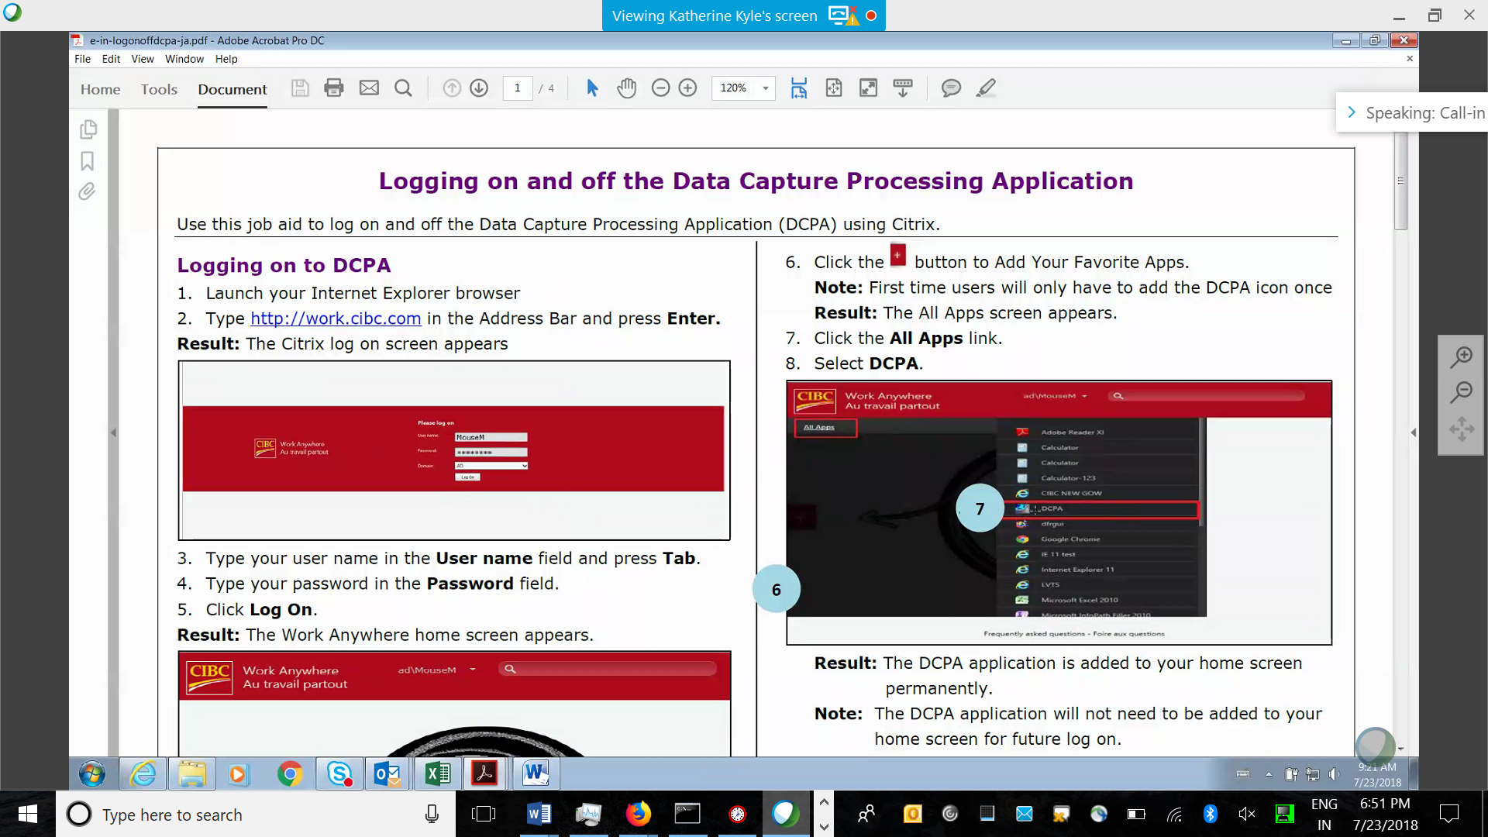

Service desk

Dcpa is a tool

Tracingji:

Taking the input Control of debit and credit

L1

25/07/2018.

High level overview of tracing ji:

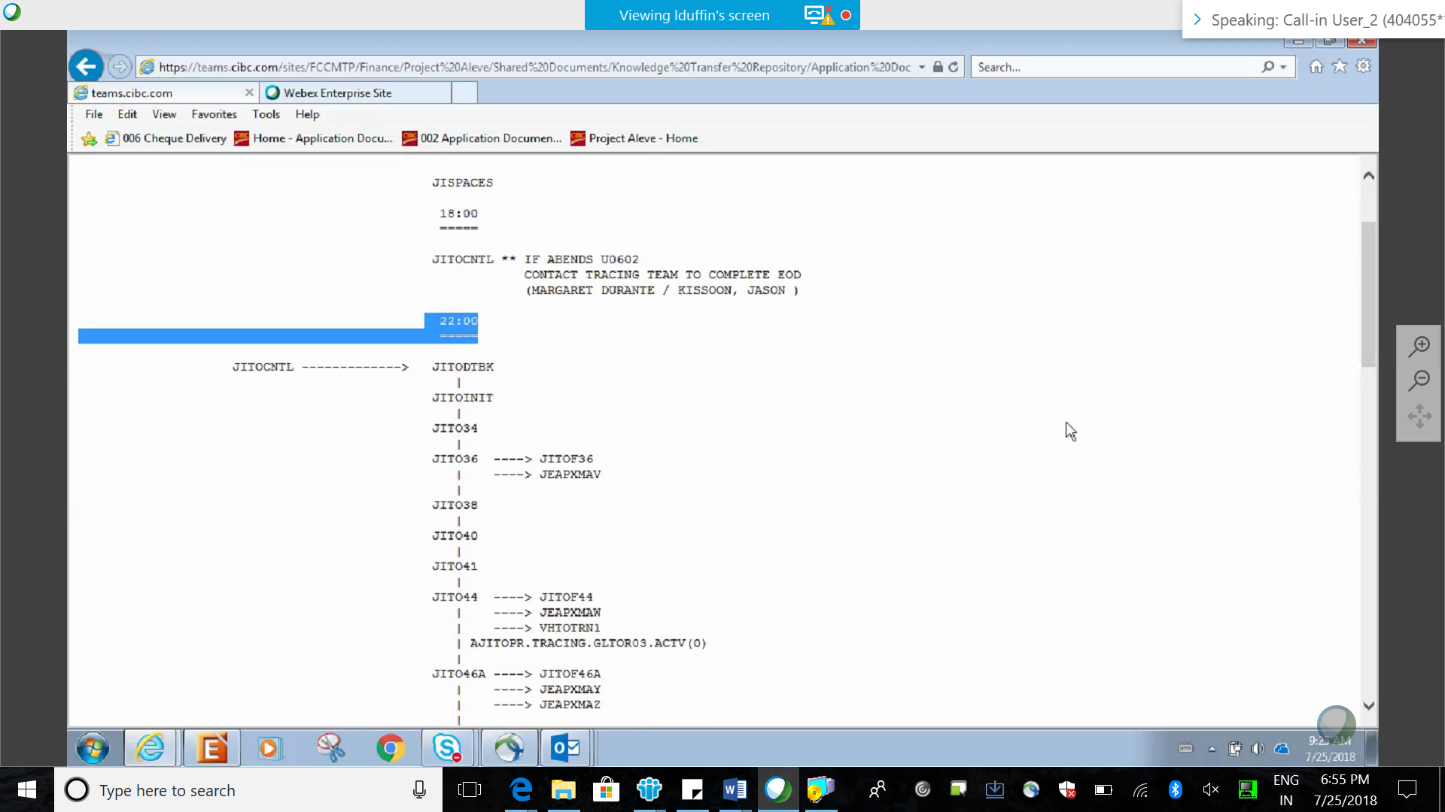

Where we ae getting the input files? Which system?

We process 50 general files to trace.

Corresponeded services processing operations(CSPO)

DACS

abjl