##### Resume

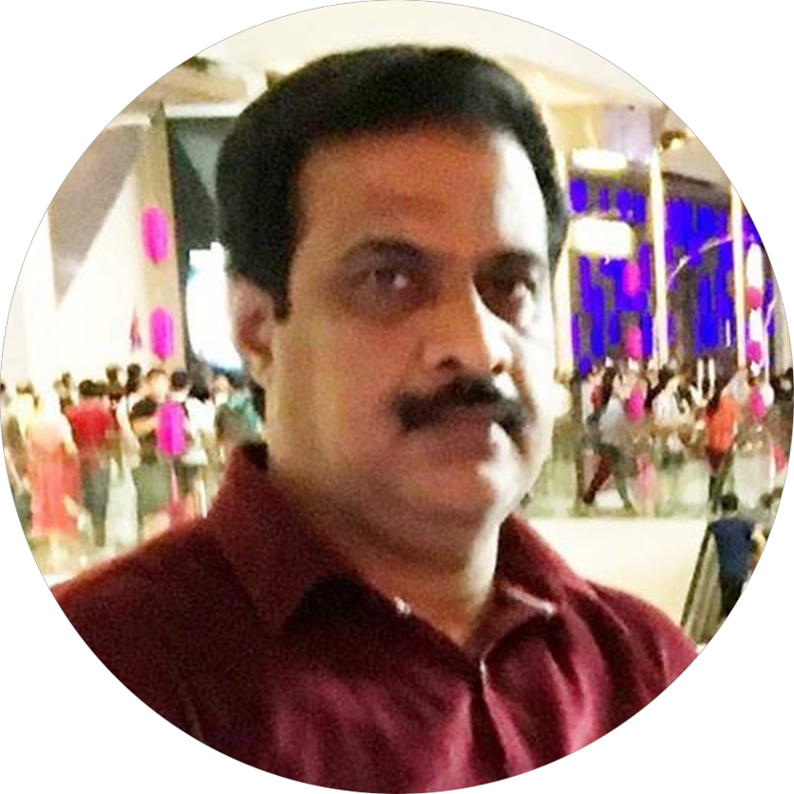

**V.Ramachandran**

**Email:** [ram_vvram@yahoo.com](mailto:ram_vvram@yahoo.com)

**Web: http://ramvvram.design/**

#### HP: 8233 6251

An emerging **Graphic and Web Design and developing** professional specialising in designs**, Image retouching and Illustration** with extensive experience in full life cycle of **Printing process** including requirements definition, design interface implementation **Web and Multi-Media Animation Designing .**

# Workflows

**• Strategic thinker**

**• Excellent leadership and planning skills**

**• Adaptable and efficient**

**• Exceptional attention to detail**

**• Team player and team builder**

**• Love for growth and learning**

**• Ability to relate to cultures**

**• Thorough and meticulous**

**• Fast and able to work under pressure**

**• Capable of doing a massive range of styles rather than just my own**

**• Excellent knowledge of design, typography**

**and Web standard**

**• Mobile-First, Responsive Design**

**• Cross Browser Testing & Debugging**

# Experiences

# TNB Wave pte ltd *Apr 2017 to till*

## Senior Creative Manager

* Managing and guide to Design and development (Graphic and Web) team and my personal doing design and developing web and all other design materials.
* Art Direction and Design for add Hooks, Brochures, Web
* Wireframe for websites and full mock-ups
* Coding and supervising for websites

# Iceberg media works *Sep 2014 to Mar 2017*

## Creative Manager

* Managing and guide to Design and development (Graphic and Web) team and my personal doing design and developing web and all other design materials.

# What to Eat Delivery pte ltd *Sep 2013 to Mar 2014*

## Senior Graphic / Web Designer

* Create company website project ,ads, banners and all advertising

# Colourcast Bureau Pte Ltd, Singapore *Sep 2007 to Aug 2013*

## Senior Graphic / Web Designer

* Designer for the marketing department and consistently met tight deadlines by prioritizing and organizing tasks..
* Established streamlined electronic on-demand forms printing system using a high-speed Xerox printer/copier connected to multiple computers using different operating systems including Mac, PC
* Played a key role in establishing of print design such as brochures, Newsletters, Magazines and other print materials, web and interactive presentations as part of our services

### National Photo Engravers Pte Ltd, Singapore *Sep 2006 to Aug 2007*

## Graphic Designer

* Worked as in-house graphic designer. Designed and produced a variety of ads, brochures, stationary, and other creative projects for local distribution.

### Trend Frames Art Gallery Pte Ltd, Singapore *Dec 2005 to Aug 2006*

## Graphic Designer

* Worked as a graphic designer. Designed and produced a variety of ads, brochures, stationary, and other creative projects for local distribution.

### Mediatron Advertising Pte Ltd, Singapore *Sep2004 to Dec 2005*

## Graphic Designer

* Designed and produced a variety of ads for newspapers

### SriRam7Graphics, India *Jan 2001 to Aug2004*

## Senior Graphic Designer/FA artist

* Designed and produced a all printing items and checking printing items

### Supreme Scanners, India *Aug 1999 to Dec 2000*

## Graphic Designer

* Designed and produced a all printing items and checking printing quality advice to colour correction

### Indian Army, India

## *Jan 1988 to June 1998*

## Artist

* Worked as draftsman and Artist

## EDUCATIONAL QUALIFICATIONS

### Diploma in Fine Arts

Institution **:** Santhanu's Citira Vidyalayam,Chennai

Year **:** 1985

**Post Graduate Diploma in Computer Applications**

Institution **:** Wizard Soft Tech, Mannargudi

Year **:** 2001

**Master of Arts (Economics)**

University **:** Annamalai University

Class **:** Second

Year **:** 1996-1998

## TECHNICAL QUALIFICATIONS

**Freehand outline and Model Drawing**

Class **:** Second

Year **:** 1993

**Technical Teacher Certificate**

Class **:** First

Year **:** 2003

SOFTWARE SKILLS

▪ Operating Systems **: Mac OS, Windows**

▪ Packages **:** **Adobe CC**

###### 

#### PHP,MySQL,HTML5, jQuery,Bootstrap,JavaScript,AJAX.

For Web

Coding: **HTML5, CSS3 and Bootstrap**

CMS: **Wordpress (custom theme, HTML - WP, PSD - WP)**

Scripting Languages **:** **Javascript, jQuery, AJAX**

Back-end **: PHP, MySqli**

## Nature of work familiar with

▪ **Creative Design, mockup website and Animation**

▪ **Web page designing and development (front end)**

▪ **Paintings** Oil, Water color art works.

▪ **Drawing** Pen& Ink Illustrates.

PERSONEL DETAILS

Name **: V.Ramachandrans**

Father’s Name **: S.Varatharajan**

Date of Birth **:** 26th May 1968

Gender **:** Male

Marital Status **:** Married

Languages Known **:** Tamil, Hindi, English (Speak and Write)

Religion **:** Hindu

Nationality **:** Indian

Passport No. **:** K 7999340

Date of Issue **:** 29-11-2012

Date of Expiry **:** 28-11-2022

Place of Issue **:** Singapore

ECNR Status **:** Yes

**Address for communication**

**Block 53, # 12-3599**

**Geylang Bharu**

Singapore-330053

Yours faithfully, V. Ramachandran.