Project Phase-1 (18CS703) Report

on

**Ecommerce Website - Grocery Store**

#### *Submitted to*

**NMAM INSTITUTE OF TECHNOLOGY, NITTE**

(An Autonomous Institution under VTU, Belagavi)

*In partial fulfillment of the requirements for the award of the*

Degree of Bachelor of Engineering

in

Computer Science and Engineering

#### *by*

**Arvind G Kamath 4nm18cs024**

**Adithya Poojary 4nm19cs401**

**Ramya 4nm19cs414**

Under the guidance of

**Mr. PRADEEP KANCHAN**

**Assistant. Professor**

Dept. of CSE, NMAMIT, NITTE



CERTIFICATE

Certified that the project work entitled **Ecommerce Website** is a bonafide work carried out by Arvind g Kamath(4nm18cs024),Adithya Poojary(4nm19cs401), Ramya(4nm19cs414) in partial fulfillment for the award of Degree of Bachelor of Engineering in Computer Science and Engineering of the Visvesvaraya Technological University, Belagavi during the year 2021-2022.It is certified that all corrections/suggestions indicated for Internal Assessment have been incorporated in the report deposited in the departmental library. The project report has been approved as it satisfies the academic requirements in respect of Project Phase- 1 (18CS703) prescribed for the said Degree.

**Name & Signature of Guide Signature of HOD** **Signature of the Principal**

Mr. Pradeep Kanchan,

Assistant professor

**External Viva**

**Name of the Examiners** **Signature with Date**

*1. _______________________________ ________________________________*

*2. _______________________________ ________________________________*

**ACKNOWLEDGEMENT**

The satisfaction that accompanies the completion of any task would be incomplete without the mention of all the people, without whom this endeavour would have been a difficult one to achieve. Their constant blessings, encouragement, guidance and suggestions have been a constant source of inspiration

First and foremost, my gratitude to my project guide, Mr. Pradeep Kanchan,***.*** for his constant guidance throughout the course of this project Phase-1 and for the valuable suggestions.

I also take this opportunity to express a deep sense of gratitude to the project coordinators for their valuable guidance and support.

I acknowledge the support and valuable inputs given by **Dr. Jyothi Shetty** the Head of the Department, Computer Science and Engineering, NMAMIT, Nitte.

My sincere thanks to our beloved principal, **Dr. Niranjan N Chiplunkar** for permitting us to carry out this project at our college and providing us with all needed facilities.

Finally, thanks to staff members of the Department of Computer Science and Engineering and our friends for their honest opinions and suggestions throughout the course of our project Phase-1.

Arvind G Kamath(4nm18cs024)

Adithya Poojary(4nm19cs401)

Ramya(4nm19cs414)

ABSTRACT



**E-commerce (Electronic Commerce or EC) is the buying and selling of goods and services on the Internet, especially the World Wide Web. For online retail selling, the term e-tailing sometimes used. E-Commerce, formerly referred to as Electronic Commerce, is the**

**trading of several of goods & services over a wide area of electronic means; such as the Internet or any other Computer Networks. E-Commerce allows the exchange of data over electronic means in order to facilitate the financing & payment aspects of business transaction**

**In this era of internet, e-commerce is growing by leaps and bounds keeping the growth of brick-and-mortar businesses in the dust. In many cases, brick-and-mortar businesses are resorting to having a counterpart which is internet or e-commerce driven. People in the developed world and a growing number of people in the developing world now use e-commerce websites on a daily basis to make their everyday purchases. Still the proliferation of e-commerce in the under-developed world is not that great and there is a lot to desire for. This paper outlines different aspects of developing an e-commerce website and the optimum solution to the challenges involved in developing one. It consists of the planning process, which starts with determining the use case, domain modeling and architectural pattern of the web application. The entire development process is primarily divided into two parts: the front-end development and the back end development. The database design is also discussed with an emphasis on its relational connectivity. This no-nonsense method of developing an e-commerce website can be easily replicated and followed in developing e-commerce websites in the developing and under-developed countries where computing resources are scarce and expensive because of their socio-economic condition.**

III

**TABLE OF CONTENTS**

|  |  |  |
| --- | --- | --- |
| **CHAPTER NO.** | **CHAPTER NAME** | **PAGE NO.** |
| 1 | INTRODUCTION | 7 |
| 2 | LITERATURE SURVEY | 8-9 |
| 3 | PROBLEM STATEMENT | 10 |
| 4 | SYSTEM REQUIREMENTS SPECIFICATION | 11 |
| 5 | SYSTEM CONFIGURATION AND SETUP | 11-12 |
| 6 | EXECUTION | 13-17 |
| 7 | RESULTS AND FUTURE WORK | 18 |
| 8 | CONCLUSIONS | 19 |
| 9 | REFERENCES | 20 |

**LIST OF FIGURES**

|  |  |  |
| --- | --- | --- |
| **Figure no.** | **Description** | **Page No.** |
| 1 |  | 3 |
| 2 |  | 11 |

**LIST OF TABLES**

|  |  |  |
| --- | --- | --- |
| **Table no.** | **Description** | **Page No.** |
| 1 |  | 12 |

**INTRODUCTION**

The term e-commerce was coined back in the 1960s, with the rise of electronic commerce – the buying and selling of goods through the transmission of data – which was made possible by the introduction of the electronic data interchange. Fast forward fifty years and **ecommerce has changed the way in which society sells goods and services.**

E-commerce has become one of the **most popular methods of making money online** and an attractive opportunity for investors

‘E-commerce’ and ‘online shopping’ are often used interchangeably but at its core e-commerce is much broader than this – it **embodies a concept for doing business online**, incorporating a multitude of different services e.g. **making online payments, booking flights etc.**

E-commerce has **experienced rapid growth since its humble beginnings** with e-commerce sales projected to [grow to 599.2 billion USD by 2024](http://www.statista.com/statistics/272391/us-retail-e-commerce-sales-forecast/). The COVID-19 outbreak saw e-commerce sales spike 25% in March 2020 alone. The power of e-commerce should not be underestimated as it continues to pervade everyday life and present significant **opportunities** for small, medium, and large businesses and online investors. You don’t need to look far to see the potential of e-commerce businesses. [Amazon](https://feinternational.com/blog/how-to-increase-your-amazon-associates-revenue/), for example, which set the standard for customer-orientated websites as well as a lean supply chain, is selling [over 4000 items a minute](https://www.oberlo.co.uk/blog/amazon-statistics) from SMBs alone.

Ecommerce has erased the limitation of time and distance to buy or sell the goods without facing any part of problem permanently, in short, it has emerged as a saviour of business, it has given a cool and wonderful platform to the business with which you as a business person can list your company’s product over internet and can grow your business non-uniformly and with this it has also blessed the consumers to find their needed product in an easy way without roaming sweating here and there, your product is just a single click away. The traditional way of buying and selling has changed completely after the arrival of e-commerce in the field of Internet.

Those online portals on which the selling and purchase of goods are done and also the transactions of amount corresponding to them occurs too are E-commerce website, but, the E-commerce is not bounded by the selling and buying, it also includes the web portals regarding the trading, counselling, tutorial, music, auction, movies, retailing, and so on. A wide platform is an e-commerce which welcomes every individual to sell their product and buy your product.

**LITERATURE SURVEY ON E-COMMERCE**

Global ecommerce is the selling products or services across geopolitical borders from a company’s country of origin, normally defined as its founding or incorporating location. Products or services are sold into non-native markets via online sales and marketing.

As [*Harvard Business Review*](https://hbr.org/2017/07/globalization-in-the-age-of-trump) wrote: “Business leaders are scrambling to adjust to a world few imagined possible just a year ago. The myth of a borderless world has come crashing down. Traditional pillars of open markets—the United States and the UK—are wobbling, and China is positioning itself as globalization’s staunchest defender.

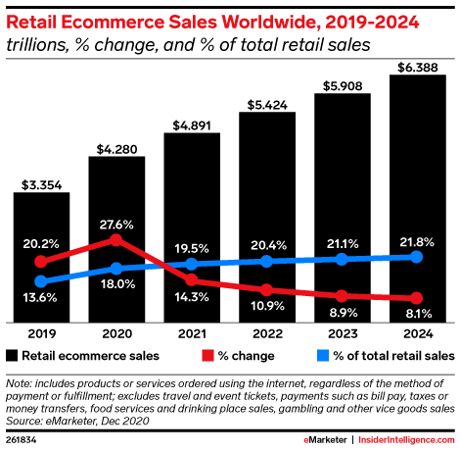

The global ecommerce market is expected to total [**$4.89 trillion**](https://www.emarketer.com/content/worldwide-ecommerce-will-approach-5-trillion-this-year) in 2021. That figure is estimated to grow over the next few years, showing that borderless ecommerce is becoming a profitable option for online retailers.

Of course, even the best-informed speculation pales in comparison to the insights contained within the geography of current customers and visitors. You can uncover this **by** [**analyzing traffic and sales-by-country data**](https://www.shopify.com/enterprise/international-ecommerce-issues)**.**

With Google Analytics’ locations report (Audience > Geo > Location), set up segments to examine international traffic by continent, country, region, or city. Take special note of the areas where traffic and conversion rates are highest—these may represent where you’ve unknowingly gone global already.

The India’s e-commerce market is expected to reach **US$ 350 billion** by 2030. By 2021, total e-commerce sales are expected to reach **US$ 67-84 billion** from the **US$ 52.57 billion** recorded in 2020.

According to **NASSCOM**, despite COVID-19 challenges/disruptions, India's e-commerce market continues to grow at 5%, with expected sales of US$ 56.6 billion in 2021.

The Indian e-commerce sector is ranked 9th in cross-border growth in the world, according to **Payoneer report**. Indian e-commerce is projected to increase from 4% of the total food and grocery, apparel and consumer electronics retail trade in 2020 to 8% by 2025. India's e-commerce orders volume increased by 36% in the last quarter of 2020, with the personal care, beauty and wellness (PCB&W) segment being the largest beneficiary. E-commerce sales in India were estimated to increase by only 7-8% in 2020, compared with 20% in China and the US. The e-commerce market is expected to touch the US$ 84-billion mark in 2021 on the back of healthy growth in the Indian organised retail sector.

As most Indians have started shopping online rather than stepping outside their houses, the Indian e-commerce sector witnessed an increase. India's e-commerce festive sale season from October 15 to November 15 in 2020 recorded Rs. 58,000 crore (US$ 8.3 billion) worth of gross sales for brands and sellers, up 65% from Rs. 35,000 crore (US$ 5 billion) last year.

According to **Bain & Company** report, India’s social commerce gross merchandise value (GMV) stood at ~US$ 2 billion in 2020. By 2025, it is expected to reach US$ 20 billion, with a potentially monumental jump to US$ 70 billion by 2030, owing to high mobile usage. India's e-commerce order volume increased by 36% in the last quarter of 2020, with the personal care, beauty & wellness (PCB&W) segment being the largest beneficiary. Driven by beauty and personal care (BPC), India's live commerce market is expected to reach a gross merchandise value (GMV) of US$ 4-5 billion by 2025.

Huge investments from global players—such as Facebook, which is investing in Reliance Jio—are being recorded in the e-commerce market. Google also reported its first investment worth US$ 4.5 billion in Jio Platforms. This deal was followed by the purchase of Future Group by Reliance Retail, expanding the presence of the Ambani Group in the e-commerce space.

**PROBLEM STATEMENT**

E-commerce provides an easy way to sell products to a large customer base. However, there is a lot of competition among multiple e-commerce sites. When users land on an e-commerce site, they expect to find what they are looking for quickly and easily. Also, users are not sure about the brands or the actual products they want to purchase. They have a very broad idea about what they want to buy. Many customers nowadays search for their products on Google rather than visiting specific e-commerce sites. They believe that Google will take them to the e-commerce sites that have their product.

The purpose of any e-commerce website is to help customers narrow down their broad ideas and enable them to finalize the products they want to purchase. For example, suppose a customer is interested in purchasing a mobile. His or her search for a mobile should list mobile brands, operating systems on mobiles, screen size of mobiles, and all other features as facets. As the customer selects more and more features or options from the facets provided, the search narrows down to a small list of mobiles that suit his or her choice. If the list is small enough and the customer likes one of the mobiles listed, he or she will make the purchase.

The challenge is also that each category will have a different set of facets to be displayed. For example, searching for books should display their format, as in paperback or hardcover, author name, book series, language, and other facets related to books. These facets were different for mobiles that we discussed earlier. Similarly, each category will have different facets and it needs to be designed properly so that customers can narrow down to their preferred products, irrespective of the category they are looking into.

The takeaway from this is that categorization and feature listing of products should be taken care of. Misrepresentation of features can lead to incorrect search results. Another takeaway is that we need to provide multiple facets in the search results. For example, while displaying the list of all mobiles, we need to provide facets for a brand. Once a brand is selected, another set of facets for operating systems, network, and mobile phone features has to be provided. As more and more facets are selected, we still need to show facets within the remaining products.

**SYSTEM REQUIREMENTS AND DESIGN**

Online Grocery Store is an eCommerce based web application for our Web Programming project. We had developed a sample in which user can search and find necessary information about any grocery item, can proceed to checkout to buy products. User can create an account, update personal information, can check its past activities, orders and transaction.

**Frontend Languages:** HTML, CSS, and Client-Side JavaScript Backend: PHP7 & MySQL Database: MYSQL Tools: MS Visual Cod.

**SYSTEM CONFIGURATION AND SETUP**

MySQL has been used to create and host the database for the internet banking website.

Other than the languages/tools mentioned above no other/external libraries and/or web-page templates have been used, everything has been coded from ground-up straight from scratch.

How to build/use Setup an environment which supports web development like LAMP on Linux systems OR install WampServer/XAMPP or anything similar on Windows.

Copy the folder net-banking or the files in it to the location of the localhost. For example "/var/www/html", the loaction of localhost in Ubuntu.

# Import the online_grocery.sql database into your MySQL setup.

Edit the file connect.php and give proper username and password of your MySQL setup.

Open a browser and test wether the setup works or not by visiting the home page. Type "localhost/index.php" as the URL in the browser to visit the home page.

However some important usernames and passwords are provided below :

Username of admin is "[admin@gmail.com](mailto:admin@gmail.com)" & password is "password". Username of the user is their "[shashankkumar269@gmail.com](mailto:shashankkumar269@gmail.com)" & password is "password".

# Installing XAMPP

Xampp Server 3.4 Importing database in MySQL Details about the project An exhaustive list of features, documentation, design hierarchy, details about the web pages, database, design characterstics/features and a lot more can be found here.

The ER Diagram can also be found on the link given above or can be viewed here.

# Description of the various folders

/online_grocery_shopping : Contains the source code of the website /online_grocery_shopping/images : Contains various images and icon vectors used as resources in the website /online_grocery_shopping/css : Contains various fonts(.css files) used in the website

**EXECUTION**

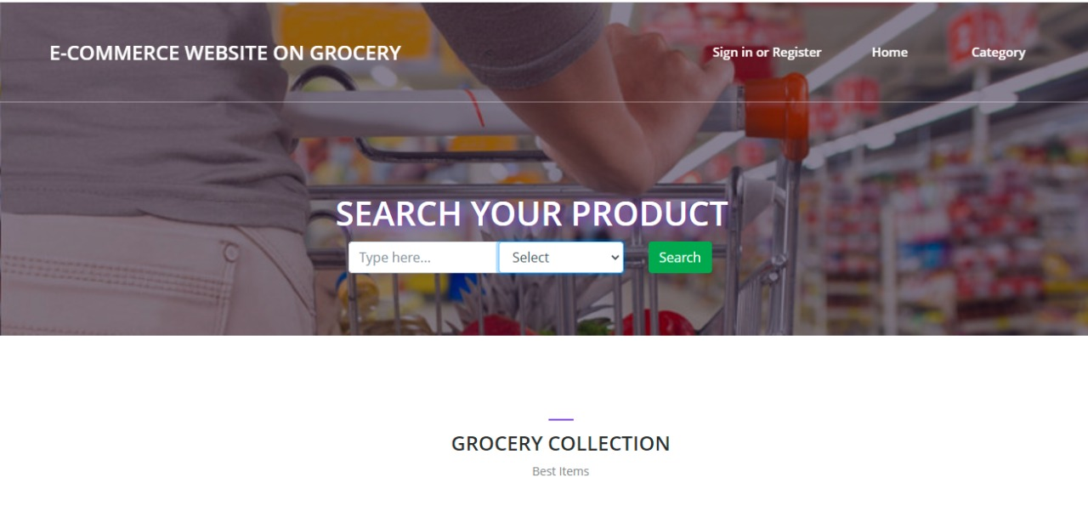

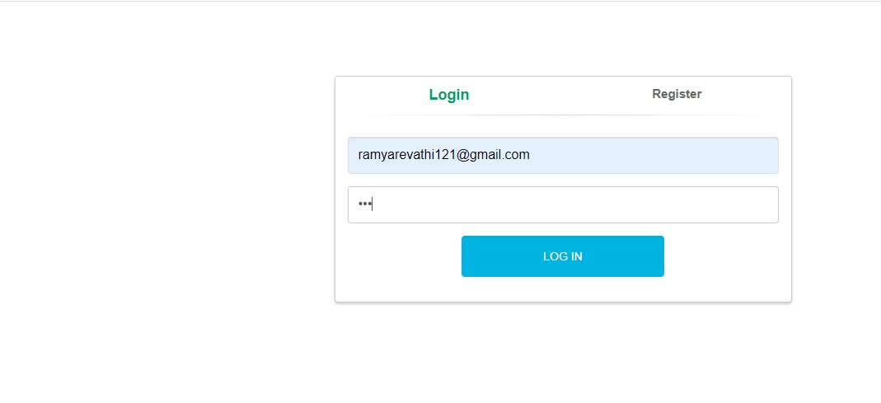

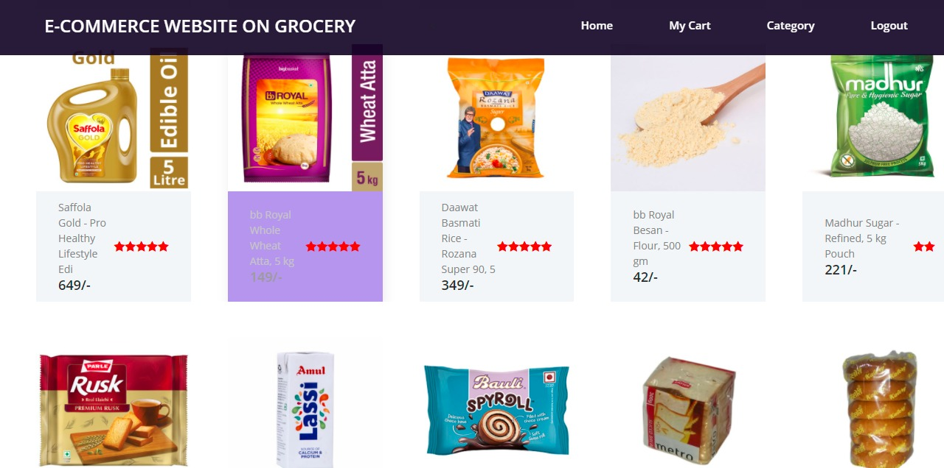

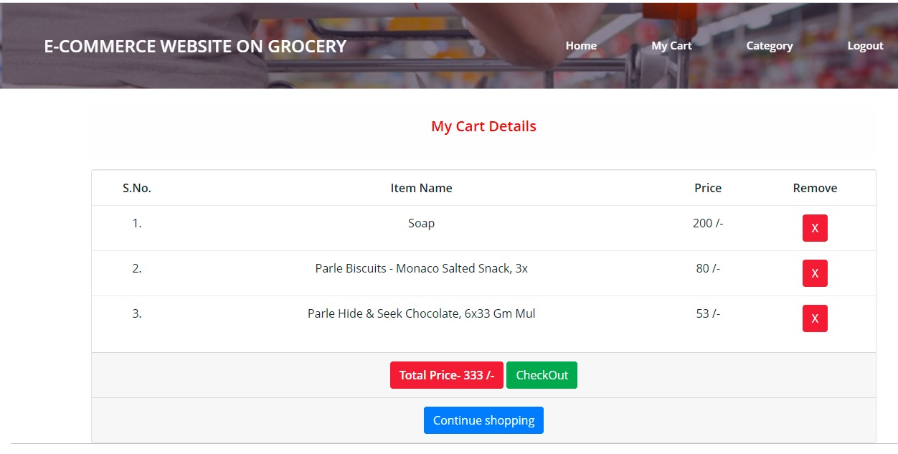

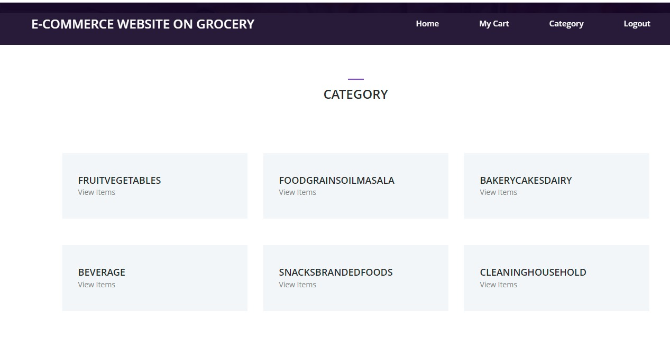

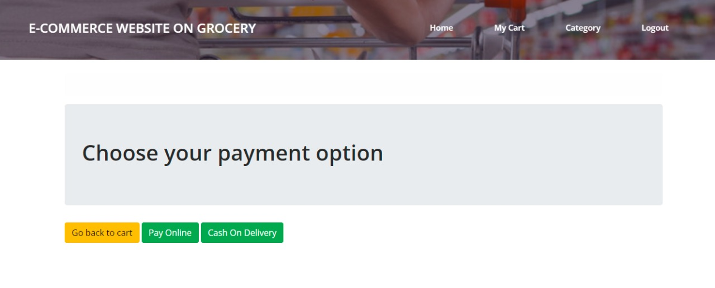

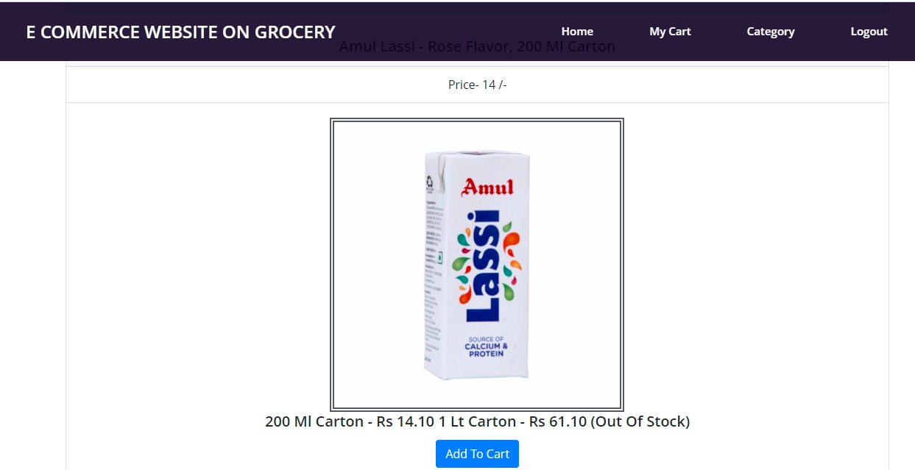

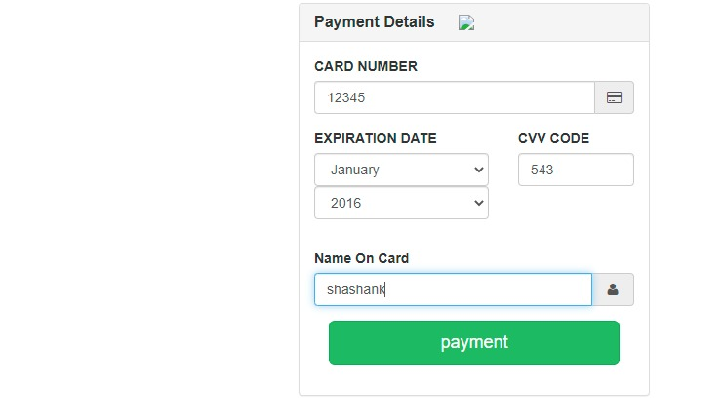

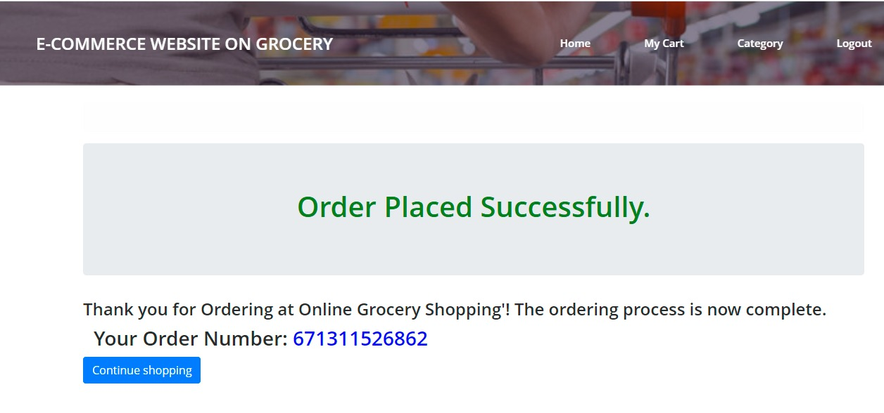

**RESULT AND FUTURE WORK**

The ever-changing landscape of eCommerce is both scary and exciting. Every year, there are changes that may help us grow our businesses or new challenges that we may not be able to keep up. Whatever ups and downs you may have encountered this year, the eCommerce market is still expanding bigger and brighter as ever. As we approach a new year, we’re here to give you an exclusive sneak peek of the eCommerce growth trends in 2022 and beyond. We have curated the following list of the hottest 10 international growth trends to spark new ideas, overcome the hurdles, and get you ready to win and maintain a successful eCommerce business for the years to come.

**FUTURE WORK AND LINEUP**

1. Use Google trends to follow trends and products
2. Utilize and add new payment methods
3. Automate manual processes using a chatbot.
4. Use social media marketing
5. Use the website for commercial purpose.

Online shoppers want to access sites that have a fast loading time and a simple and easy-to-navigate design. Potential ecommerce customers [will definitely lean towards minimalistic designs](https://cxl.com/blog/why-simple-websites-are-scientifically-better/) that are efficient as opposed to overly complicated layouts that take a lot of time to navigate. So the focus shifts from aesthetics to functionality. If there was a time to optimize the load time of your site, along with its design and layout, then this is definitely it.

**CONCLUSION**

In general, today’s businesses must always strive to create the next best thing that consumers will want because consumers continue to desire their products, services etc. to continuously be better, faster, and cheaper.  In this world of new technology, businesses need to accommodate to the new types of consumer needs and trends because it will prove to be vital to their business’ success and survival.  E-commerce is continuously progressing and is becoming more and more important to businesses as technology continues to advance and is something that should be taken advantage of and implemented.

REFERENCES

• [***"For the first time, India has more rural net users than urban"***](https://timesofindia.indiatimes.com/business/india-business/for-the-first-time-india-has-more-rural-net-users-than-urban/articleshow/75566025.cms)**.** timesofindia*. Retrieved 23 February 2021*.

• [*"Online shoppers in India"*](http://m.timesofindia.com/tech/tech-news/Online-shoppers-in-India-to-cross-100-million-by-2016-Study/articleshow/45217773.cms). timesofindia.indiatimes/tech. 20 November 2014*. Retrieved 25 March 2015*.

• [*"Indian e-commerce at inflection point?"*](http://www.vccircle.com/500/news/e-commerce-in-india-are-we-at-an-inflection-point/). Vccircle.com. 19 August 2010*. Retrieved 4 July 2013*.

• [*"In COD we trust"*](http://www.translatemedia.com/translation-blog/cod-trust/). translatemedia.com. 6 February 2015*. Retrieved 24 March 2015*.

• Hayes, Adam. [*"Understanding Long Tails"*](https://www.investopedia.com/terms/l/long-tail.asp). Investopedia*. Retrieved 2 June 2020*.

• Variyar, Mugdha. [*"Amazon India reportedly closing in on Flipkart"*](https://economictimes.indiatimes.com/small-biz/startups/newsbuzz/amazon-india-reportedly-closing-in-on-flipkart/articleshow/63407725.cms). The Economic Times*. Retrieved 22 March 2018*.

• [*"Amazon beats Flipkart to become India's largest ecommerce company by gross sales"*](https://www.timesnownews.com/business-economy/companies/article/amazon-beats-flipkart-to-become-indias-largest-ecommerce-company-by-gross-sales/322166). www.timesnownews.com*. Retrieved 9 September 2019*.

• [*"Flipkart beats Amazon in India's record 8.3bn USD festive sales"*](https://asia.nikkei.com/Business/Retail/Flipkart-beats-Amazon-in-India-s-record-8.3bn-festive-sales). asia.nikkei.com*. Retrieved 12 July 2021*.

• [*"Archived copy"*](https://web.archive.org/web/20150412092703/http:/www.avendus.com/Files/India_goes_Digital.pdf) *(PDF)*. Archived from [*the original*](http://www.avendus.com/Files/India_goes_Digital.pdf) *(PDF)* on 12 April 2015*. Retrieved 4 May 2016*.

• [Evolution of e-commerce in India](http://www.pwc.in/assets/pdfs/publications/2014/evolution-of-e-commerce-in-india.pdf), [PwC](https://en.wikipedia.org/wiki/PwC), 2014.

• [*"Online shoppers in India to cross 100 million by 2016: Study"*](http://m.timesofindia.com/tech/tech-news/Online-shoppers-in-India-to-cross-100-million-by-2016-Study/articleshow/45217773.cms). The Times of India*. Retrieved 4 May 2016*.

• [*"Freecharge Aims to Achieve 7 Million Transactions Per Day"*](https://telecomtalk.info/freecharge-transactions-per-day/149707/). Telecom Talk. 17 February 2016.

• [*"CaratLane in talks with US-based online stores for acquisition"*](http://articles.economictimes.indiatimes.com/2016-03-25/news/71808492_1_carat-lane-caratlane-mithun-sacheti). Economic Times*. Retrieved 5 April 2016*.

• PTI (19 March 2015). [*"India's fashion e-retail market to touch $35 bn by 2020: Google"*](http://www.livemint.com/Industry/N9i3R5ExZpSBIhtuS0CCQJ/Indias-fashion-eretail-market-to-touch-35-bn-by-2020-Goo.html). [*Mint*](https://en.wikipedia.org/wiki/Mint_(newspaper))*. Retrieved 13 March 2016*.

• [*"Indian e-commerce market to touch USD 84 billion in 2021: Report"*](https://economictimes.indiatimes.com/industry/services/retail/indian-e-commerce-market-to-touch-usd-84-billion-in-2021-report/articleshow/68169239.cms?from=mdr). The Economic Times. 26 February 2019*. Retrieved 29 August 2019*.

• Market, Capital (17 December 2018). [*"E-Commerce Market growing at a rate of about 17% in 2018-19"*](https://www.business-standard.com/article/news-cm/e-commerce-market-growing-at-a-rate-of-about-17-in-2018-19-118121700794_1.html). Business Standard India*. Retrieved 29 August 2019*.

• "Indian Ecommerce Industry Analysis | IBEF". www.ibef.org*. Retrieved 22 April 2020*.

• Network, The Statesman/Asia News (23 July 2020). [*"India e-commerce to grow 27%; Reliance to capture half of online grocery sales—Goldman"*](https://business.inquirer.net/303336/india-e-commerce-to-grow-27-reliance-to-capture-half-of-online-grocery-sales-goldman). INQUIRER.net*. Retrieved 8 August 2020*.

• [*"India's e-commerce industry to be $99 billion in size by 2024; RIL to dominate online grocery space"*](https://www.businesstoday.in/current/corporate/indias-ecommerce-industry-goldman-sachs-survey-online-shopping-grocery-ril/story/411139.html). www.businesstoday.in*. Retrieved 8 August 2020*.

• [*"In-city warehousing demand may rise as e-commerce firms target same-day delivery"*](https://www.moneycontrol.com/news/business/in-city-warehousing-demand-may-rise-as-e-commerce-firms-target-same-day-delivery-5665521.html). Moneycontrol*. Retrieved 8 August 2020*.

• [*"Walmart's Flipkart to offer 90-minute deliveries in India"*](https://www.reuters.com/article/us-india-flipkart-idUSKCN24T0TL). Reuters. 28 July 2020*. Retrieved 8 August 2020*.