
Applied Software Project Report

By

RAMYA K

A Master’s Project Report submitted to Scaler Neovarsity - Woolf in partial fulfillment of the requirements for the degree of Master of Science in Computer Science

<November, 2025>

Scaler Mentee Email ID : ramyak1197@gamil.com
Thesis Supervisor : Naman Bhalla
Date of Submission : DD/MM/YYYY <Date of Submission>

Certification

I confirm that I have overseen / reviewed this applied project and, in my judgment, it adheres to the appropriate standards of academic presentation. I believe it satisfactorily meets the criteria, in terms of both quality and breadth, to serve as an applied project report for the attainment of Master of Science in Computer Science degree. This applied project report has been submitted to Woolf and is deemed sufficient to fulfill the prerequisites for the Master of Science in Computer Science degree.

Naman Bhalla
…………………
Project Guide / Supervisor

DECLARATION

I confirm that this project report, submitted to fulfill the requirements for the Master of Science in Computer Science degree, completed by me from < Project Module start date > to < Module end date >, is the result of my own individual endeavor. The Project has been made on my own under the guidance of my supervisor with proper acknowledgement and without plagiarism. Any contributions from external sources or individuals, including the use of AI tools, are appropriately acknowledged through citation. By making this declaration, I acknowledge that any violation of this statement constitutes academic misconduct. I understand that such misconduct may lead to expulsion from the program and/or disqualification from receiving the degree.

<Ramya K>

<Signature of the Candidate> Date: XX Month 20XX

ACKNOWLEDGMENT

<Insert a Paragraph within this Page to express gratitude to your family, Scaler instructors and everyone who helped, inspired or motivated you to complete the program and earn the Master’s degree>
I would like to express my heartfelt gratitude to my family for their unwavering support, patience, and encouragement throughout this journey. A sincere thank you to the incredible instructors and mentors at Scaler who not only guided me technically but also inspired me to push beyond my limits. I’m also deeply grateful to my friends and peers who shared their knowledge and motivation along the way. Special mention to AI tools like ChatGPT, Copilot and others, which played a crucial role in helping me understand complex concepts, debug code efficiently, and stay productive during challenging times. This achievement is a reflection of everyone who stood by me and contributed to my learning in meaningful ways.

Table of Contents

List of Tables 6
List of Figures 7
Applied Software Project 8
Abstract 8
Project Description 8
Requirement Gathering 9
Payments Integration 9
Security 9
Deployment Flow 10
Technologies Used 10
Conclusion 10
References 11

List of Tables
(To be written sequentially as they appear in the text)

Table No. | Title | Page No.
1
2

List of Figures
(List of Images, Graphs, Charts sequentially as they appear in the text)

Figure No. | Title | Page No.
1
2

Applied Software Project

Abstract
This project involves the development of a BookMyShow clone — an online ticket booking system designed to streamline the reservation of tickets for movies, events, concerts, and live shows. The main objective is to replicate and enhance the core functionalities of the original platform, demonstrating how such systems can be adapted to meet diverse needs across industries such as entertainment, sports, and event management.
The system is built using a modern, scalable tech stack: React.js for the frontend, Node.js with Express for the backend, and MongoDB as the database. The platform supports essential features including event browsing, real-time seat selection, secure user authentication, and integration with payment gateways. The user interface is designed to be intuitive and responsive across devices, ensuring accessibility and ease of use. Additionally, an administrative dashboard enables event organizers to manage listings.
This clone project illustrates the increasing need for digital solutions in today's service-driven economy. By automating and digitizing the ticketing process, it eliminates the inefficiencies of manual booking systems, reduces operational costs, and provides customers with a seamless experience. From a societal perspective, such systems contribute to enhanced public convenience, reduced queuing times, and better crowd management at events.
Furthermore, the architecture of the application is modular and extensible, allowing for easy customization for other domains such as seminars, sports tournaments, theater productions, or amusement parks. This project not only serves as a proof of concept but also as a foundation for building real-world SaaS platforms in the event-ticketing domain.
In conclusion, this BookMyShow clone highlights the practical application of software engineering principles in solving real-world problems and improving service delivery across multiple industries.

Requirement Gathering

- Describe the requirements - Functional, Non-Functional Requirements
- Describe the Users and Use Cases
  - Include detailed Use Case Diagram / Images to illustrate
- List and detail out the Feature set -
  - Use Tables to list out the feature set

Use the below format as reference when including a table

CHAPTER 1
INTRODUCTION

  - Purpose of the Project
The purpose of this project is to design and develop a BookMyShow clone, an online ticket booking platform that enables users to browse events, select seats, and make secure payments for movies, concerts, and live shows. The project aims to replicate and enhance the core functionalities of existing ticketing systems while demonstrating the application of modern web technologies in building scalable, user-friendly solutions.

  - Problem Statement
Traditional ticket booking methods often involve long queues, manual processes, and limited accessibility, leading to inefficiency and poor user experience. Existing platforms, while effective, may lack customization for niche events or smaller organizers. This project addresses these challenges by creating a digital solution that:
- Automates ticket booking and payment processes.
- Provides real-time seat availability.
- Ensure secure transactions and user data protection.
- Offers an intuitive interface accessible across devices.

  - Scope and Objectives
Scope:
- Develop a full-stack web application using the MERN stack (MongoDB, Express.js, React.js, Node.js).
- Integrate a secure payment gateway (Stripe) for online transactions.
- Implement role-based access for customers, partners, and admins.
- Deploy the application on cloud platforms for public access.
Objectives:
- Build a responsive and user-friendly interface for event browsing and booking.
- Implement authentication and authorization for secure user management.
- Enable real-time seat selection and ticket generation.
- Provide an administrative dashboard for event and partner management.

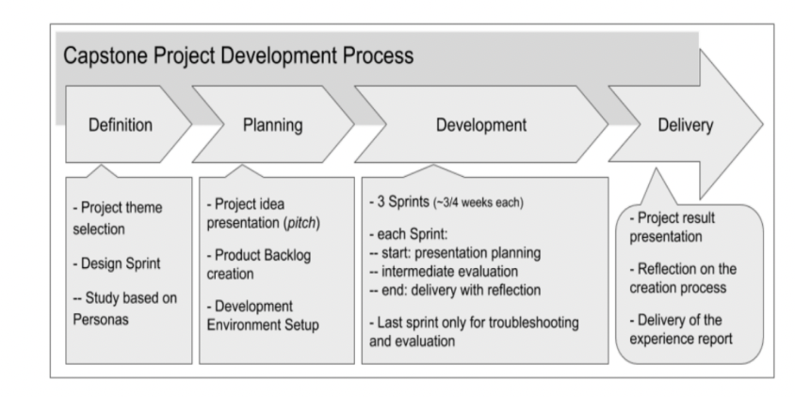
Figure 1.1: Project Development Process (Figure captions go below figures.)

CHAPTER 2
Requirement Gathering

  - Functional Requirements
- User Authentication & Authorization: Secure login, signup, password reset
- Role-Based Access: Separate routes for users and admins.
- Protected Routes: Access control for booking and admin actions.
- Movie & Theatre Management: APIs for listing movies, theaters, and schedules.
- Partner Management: Admin approval for partners adding shows.
- Live Show & Seating: Real-time seat selection and availability.
- Payment Integration: Secure payment gateway and ticket generation.
- Email Notifications: Send tickets and password reset links via email.
- Security & Deployment: Implement bcrypt, helmet, rate limiting, and deploy on Render/Netlify

  - Non-Functional Requirements
- Security: Data encryption, secure payment (PCI DSS compliance).
- Usability: Responsive UI for mobile and desktop.

  - Users and Use Cases
• Customer: Browse events, select seats, make payments, receive tickets.
- Admin: Approve partners, manage movies, theaters, and bookings.
- Partner: Add shows, manage seating and pricing.

Feature Set Table
Table 2.1: Feature Set Table

Feature | Description
Authentication | Login, Signup, Password Reset
Role-Based Access | User/Admin routes
Movie & Theatre API | CRUD operations for movies and theaters
Seat Selection | Real-time seat availability
Payment Gateway | Razorpay/Stripe integration
Ticket Generation | PDF/Email ticket delivery
Security | bcrypt, helmet, rate limiting
Deployment | Render (backend), Netlify (frontend)

CHAPTER 3
System Architecture

The BookMyShow clone uses a three-tier architecture integrated with a payment gateway and cloud deployment services. This architecture ensures scalability, security, and real-time updates for ticket booking.
Components
- Frontend (React.js)
  - Handles UI rendering and user interactions.
  - Features: Event browsing, seat selection, payment interface.
  - Communicates with backend via REST APIs.
- Backend (Node.js + Express)
  - Implements business logic and API endpoints.
  - Handles authentication, booking, and payment processing.
  - Integrates with Stripe for secure transactions.
- Database (MongoDB)
  - Stores user profiles, event details, seat availability, and transaction records.
  - NoSQL structure for flexibility and scalability.
- Payment Gateway (Stripe)
  - Processes payments securely.
  - Supports PCI DSS compliance and tokenization.
  - Uses webhooks for payment status updates.
- Deployment
  - Frontend: Netlify for hosting React app.
  - Backend: Render for Node.js APIs.
  - Database: MongoDB Atlas for cloud storage.
- Security Layers
  - bcrypt for password hashing.
  - Helmet and express-rate-limit for API protection.
  - CORS configuration for secure cross-origin requests.

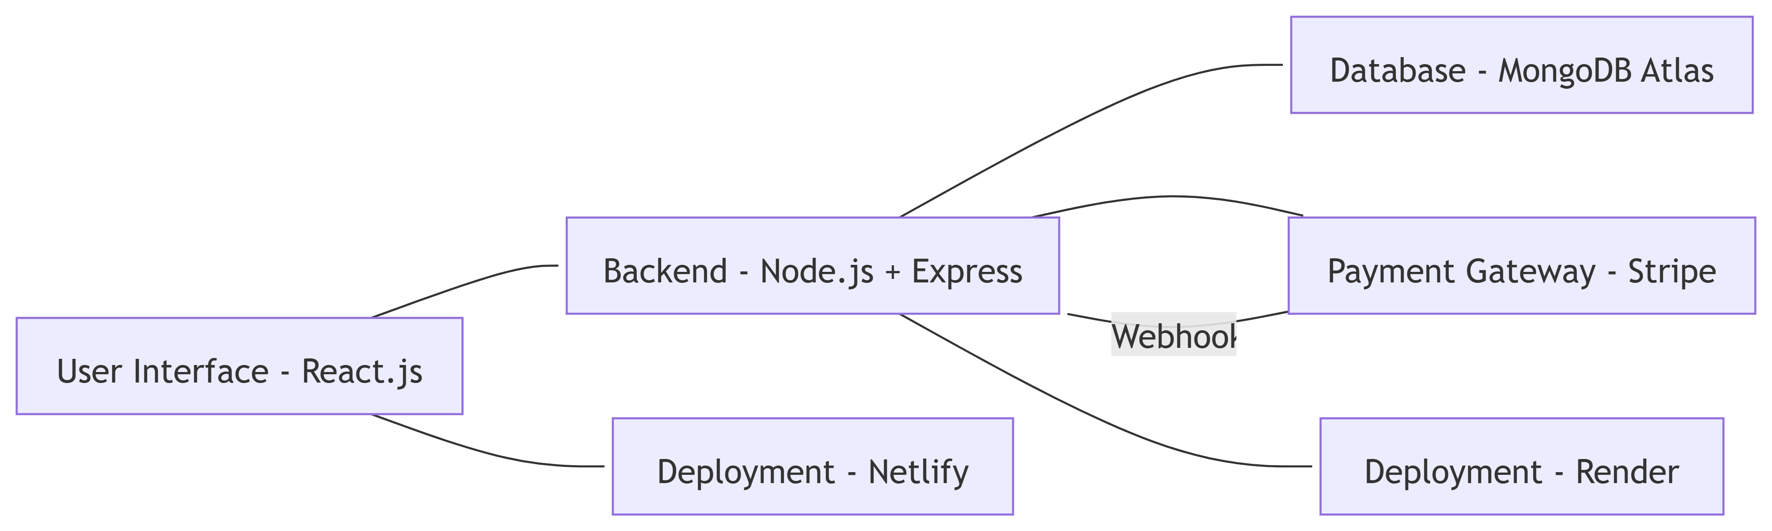

CHAPTER 4
Low Level Design

The Low-Level Design focuses on the internal structure of the system, detailing modules, classes, API endpoints, and database schema. It ensures clarity for developers during implementation.

  - Module Breakdown
- Authentication Module
  - Handles user signup, login, password reset.
  - Uses bcrypt for password hashing.
  - JWT for session management.
- Authorization Module
  - Role-based access control (User, Admin, Partner).
  - Middleware for protected routes.
- Event Management Module
  - CRUD operations for movies, theaters, and shows.
  - Admin approval for partner-added events.
- Booking Module
  - Real-time seat selection using WebSockets.
  - Ticket generation and email delivery.
- Payment Module
  - Stripe integration for secure payments.
  - Webhook handling for payment confirmation.

CHAPTER 5
Use Case Analysis
Use case analysis helps identify the interactions between users (actors) and the system. It defines the functional requirements and ensures clarity in system behavior.
Actors
- Customer: Browses events, selects seats, makes payments, and receives tickets.
- Admin: Approves partners, manages movies, theaters, and bookings.
- Partner: Adds shows, manages seating and pricing.

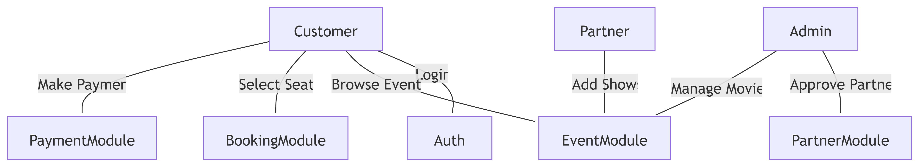

  - Customer Use Cases
    - Login/Signup
Description: Customer registers or logs in using email and password.
Precondition: User account exists for login.
Postcondition: JWT token issued for session.
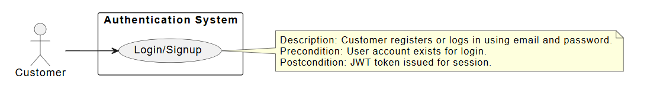
    - Browse Events
Description: Customer views available movies and shows.
Precondition: Events exist in the database.
Postcondition: List displayed with details.
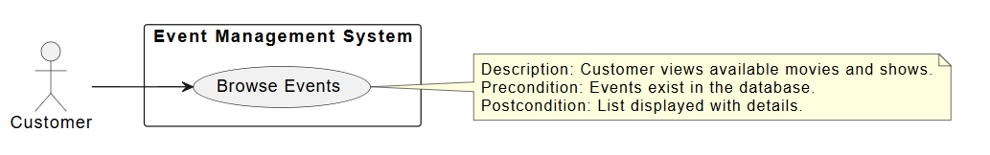

    - Select Seats
Description: Customer selects seats in real-time using WebSocket updates.
Precondition: Show is active and seats are available.
Postcondition: Seats locked for booking.
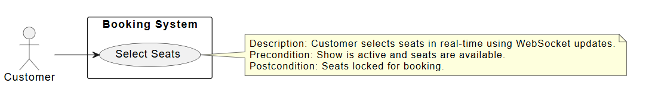
    - Make Payment
Description: Customer pays via Stripe.
Precondition: Booking initiated.
Postcondition: Payment confirmed, ticket generated.
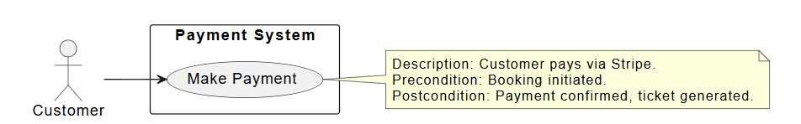
  - Admin Use Cases
- Approve Partner
Description: Admin verifies and approves partner requests.
Precondition: Partner registration request exists.
Postcondition: Partner can add shows.
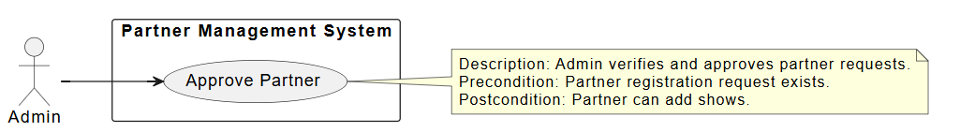
- Manage Movies/Theaters
Description: Admin adds or updates movie and theater details.
Precondition: Admin logged in.
Postcondition: Updated data reflected in listings.
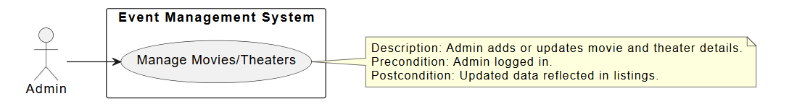

Partner Use Cases

Add Shows
Description: Partner adds show details including timing and pricing.
Precondition: Partner approved by admin.
Postcondition: Show available for booking.

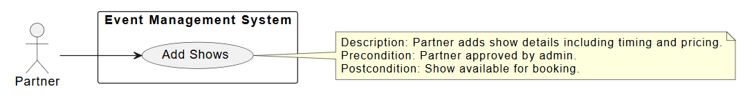

  - Sequence Diagram for User/Customer
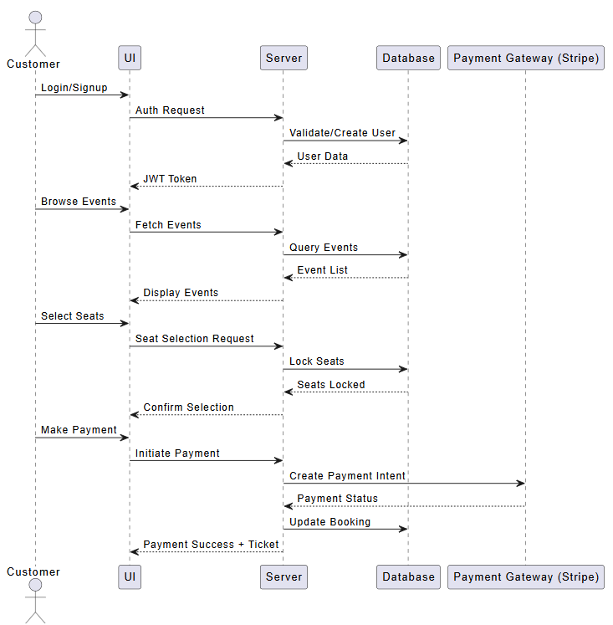

  - Sequence Diagram for Admin
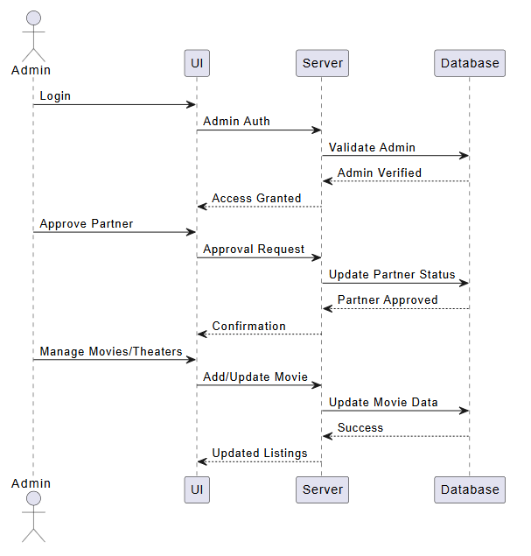

  - Sequence diagram for Partner
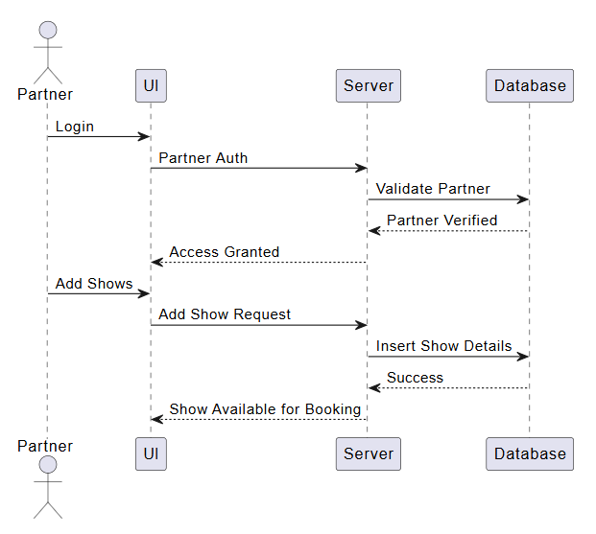

CHAPTER 6
UI/UX

The UI/UX design of the BookMyShow clone focuses on creating an intuitive, responsive, and visually appealing interface that enhances user experience across devices. The design principles followed include:
Key Principles
- Simplicity and Clarity
  - Minimalistic layout with clear navigation menus.
  - Prominent call-to-action buttons for booking and payment.
- Responsive Design
  - Optimized for mobile, tablet, and desktop using CSS Flexbox and Grid.
  - Adaptive components for different screen sizes.
- Accessibility
  - High-contrast color schemes for readability.
  - ARIA roles and semantic HTML for screen readers.
- Consistency
  - Uniform color palette and typography across all pages.
  - Reusable React components for headers, footers, and cards.

UX Flow
- Browse Events → View Details → Select Seats → Make Payment → Receive Ticket
- Error Handling: Clear messages for failed payments or unavailable seats.
- Notifications: Email confirmations and reminders for upcoming events.

Payments Integration

Payment Flow with Stripe
- Customer Initiates Payment: After selecting seats, the user clicks “Pay”.
- Frontend (React): Stripe Checkout or Stripe Elements is used to collect payment details securely.
- Backend (Node.js/Express):
  - Create a Payment Intent using Stripe API.
  - Confirm the payment and handle success/failure responses.
- Stripe Server: Processes the payment and returns the status.
- Webhook Handling:
  - Webhooks notify your backend about payment events (e.g., success, refund).

Security
- Discuss bcrypt. discuss salt and encryption . using bcrypt for password hashing
- Different node packages for added security measures like express-rate-limiter ( api rate limiting ), express-mongo-sanitize ( for no-sql injection ) , helmet ( hiding server details in response), etc

Deployment Flow

- Maintain code in github
- Can use aws or for simple deployment process, can use Render
- For frontend deployment many use Netlify. If you do so, then can use Render for backend apis and then connect to it through URL in Netlify
- Remember to handle CORS issue

Technologies Used
MERN Stack Overview
The MERN stack is a popular JavaScript-based technology stack used for building full-stack web applications. It consists of:
1. MongoDB
- Description: A NoSQL database that stores data in flexible, JSON-like documents.
- Why Used: Ideal for applications requiring dynamic schemas and scalability.
- Real-Life Applications:
  - E-commerce platforms for storing product catalogs.
  - Event booking systems for managing user profiles and ticket data.
- In This Project: Stores user details, event listings, seat availability, and transaction records.

2. Express.js
- Description: A lightweight Node.js framework for building server-side applications and APIs.
- Why Used: Simplifies routing, middleware integration, and RESTful API development.
- Real-Life Applications:
  - Backend for social media apps.
  - APIs for payment gateways and authentication.
- In This Project: Handles routes for user authentication, booking, and payment processing.

3. React.js
- Description: A front-end library for building dynamic and responsive user interfaces.
- Why Used: Component-based architecture, virtual DOM for fast rendering.
- Real-Life Applications:
  - Streaming platforms like Netflix.
  - Ticket booking portals for interactive seat selection.
- In This Project: Implements event browsing, seat selection, and payment UI.

4. Node.js
- Description: A JavaScript runtime environment for executing server-side code.
- Why Used: Non-blocking, event-driven architecture for high-performance applications.
- Real-Life Applications:
  - Real-time chat applications.
  - APIs for large-scale SaaS platforms.
- In This Project: Powers backend logic, integrates with MongoDB, and communicates with Stripe for payments.

Other Technologies
- Stripe: Secure payment gateway integration.
- bcrypt: Password hashing for authentication.
- Helmet & express-rate-limit: Security enhancements.
- Render & Netlify: Deployment platforms for backend and frontend respectively.

Conclusion

This project provided hands-on experience with modern web development technologies including React.js for building dynamic user interfaces, Node.js and Express for creating a robust backend, and MongoDB for flexible data management. Key concepts such as RESTful API design, state management, user authentication, and secure payment integration were thoroughly explored and implemented.
The BookMyShow clone demonstrates how digital ticketing platforms streamline and enhance user convenience in booking entertainment events, reducing reliance on physical counters and minimizing human errors. The technologies used have broad applicability across industries such as event management, sports ticketing, travel bookings, and conference registrations, where real-time seat availability and secure transactions are critical.
Despite its functionality, the project has certain limitations. The payment integration currently supports only a limited set of gateways, which could affect user accessibility in different regions. Scalability concerns may arise with an increasing number of users, requiring optimized database indexing and server load balancing. Additionally, implementing advanced features like AI-based recommendation systems or multi-language support would improve user experience but require more development time and resources. Future improvements could focus on enhancing security protocols, expanding payment options, and integrating analytics for personalized recommendations.

References

Include the websites or works or the list of works referred to in a text or consulted by you for writing this report

- Name of the Website, Date and time of referring to the Website, Name of the Author, Title/Topic
- Author Name, Title / Topic, Research Paper Name / Book Name, Year of Publication

Format Guidelines

- Detailed and Elaborate report of 40 pages at least is expected
- Margins - Every page of your document must meet the margin requirements of 1.25 inches on the left and right, and 1 inch on the top and bottom.
- Font:
  - Style: Times New Roman,
  - Font Size:14 (For Headings), 12 (For body text) in black colored text.
  - All text must be the same justification, like left justified or fully justified.
- Line Spacing:
  - Body of the text: 1.5
  - List of Tables/graphs/charts/bibliography: single line.
- Alignment:
  - Title page: Centre
  - Chapter Heading: Centre
  - Subheading: Left
  - Body of the text: Justify
- Titles: All titles and subtitles should be in bold. All tables/graphs/charts/figures should have appropriate titles.
- Numbering of the tables, charts, graphs should be in the following fashion: Second table/graph/chart in the second chapter should be numbered as Table/graph/chart no. 2.02; where the first digit stands for chapter no. and digits after (.) stands for number of table/graph/charts in that chapter. Same numbering should be followed for all other chapters.

Here are some additional chapter suggestions to make your report more comprehensive and aligned with academic standards:

✅ Suggested Chapters
- Introduction
  - Purpose of the project
  - Problem statement
  - Scope and objectives
- Literature Review
  - Existing ticket booking systems
  - Comparative analysis of similar platforms (e.g., BookMyShow, Eventbrite)
- System Architecture
  - High-level architecture diagram (Frontend, Backend, Database, Payment Gateway)
  - Explanation of components and data flow
- Low-Level Design (LLD)
  - Detailed module design
  - API endpoints and their specifications
  - Database schema diagrams
- Use Case Analysis
  - Use Case Diagram
  - Detailed description of each use case
- UI/UX Design
  - Wireframes and mockups
  - Design principles followed (responsive design, accessibility)
- Implementation Details
  - MERN stack explanation
  - Key modules (Authentication, Payment, Seat Selection)
  - Code snippets for critical features
- Payment Integration
  - Stripe integration flow diagram
  - Security standards (PCI DSS)
  - Role of webhooks and HTTP tunneling
- Security Measures
  - Password hashing (bcrypt)
  - Middleware for security (helmet, express-rate-limit)
  - Data sanitization techniques
- Testing
  - Unit testing and integration testing
  - Tools used (e.g., Jest, Postman)
  - Test cases and results
- Deployment
  - Platforms used (Render for backend, Netlify for frontend)
  - Steps for deployment
  - Handling CORS and environment variables
- Challenges and Solutions
  - Technical challenges faced
  - How they were resolved
- Future Enhancements
  - AI-based recommendations
  - Multi-language support
  - Scalability improvements
- Conclusion
  - Key learnings
  - Practical applications
  - Limitations and suggestions
- References
  - Websites, articles, and documentation used
  - Proper citation format

