Weapon Detection

As per your request we have added FRCNN algorithm from scratch and added weapon detection from both images and videos and we are using below screen images to train FRCNN model

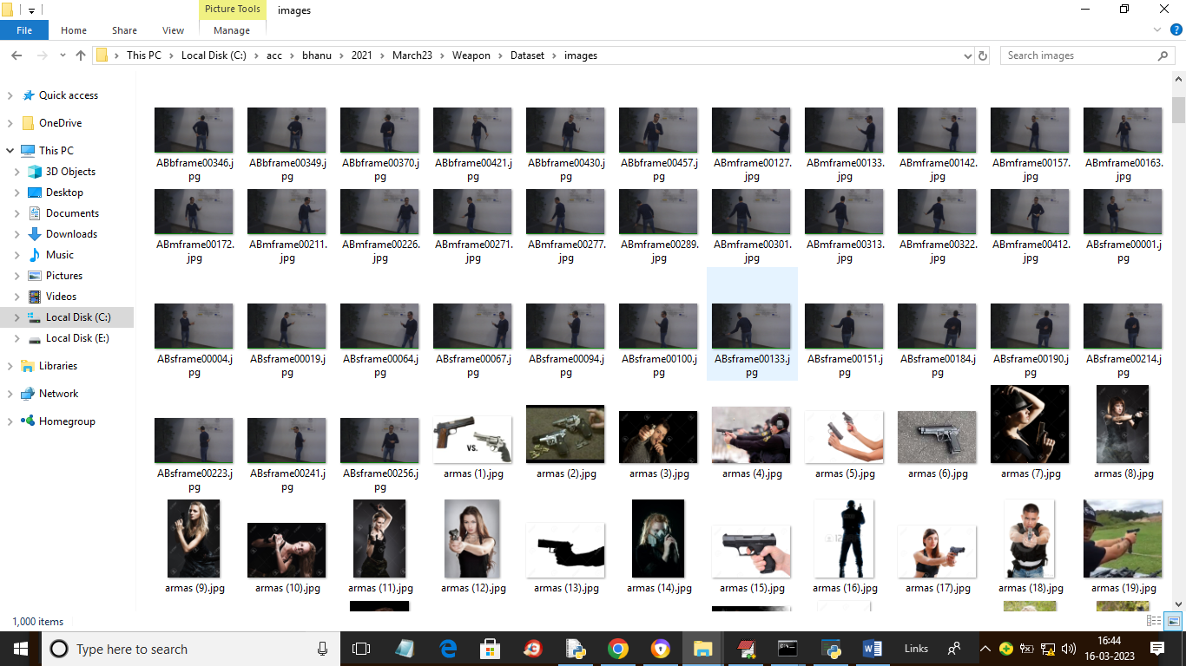

In above screen we are having all weapon images and for each image we have bounding boxes as XML file and in below screen you can see those file example and this is in XML folder

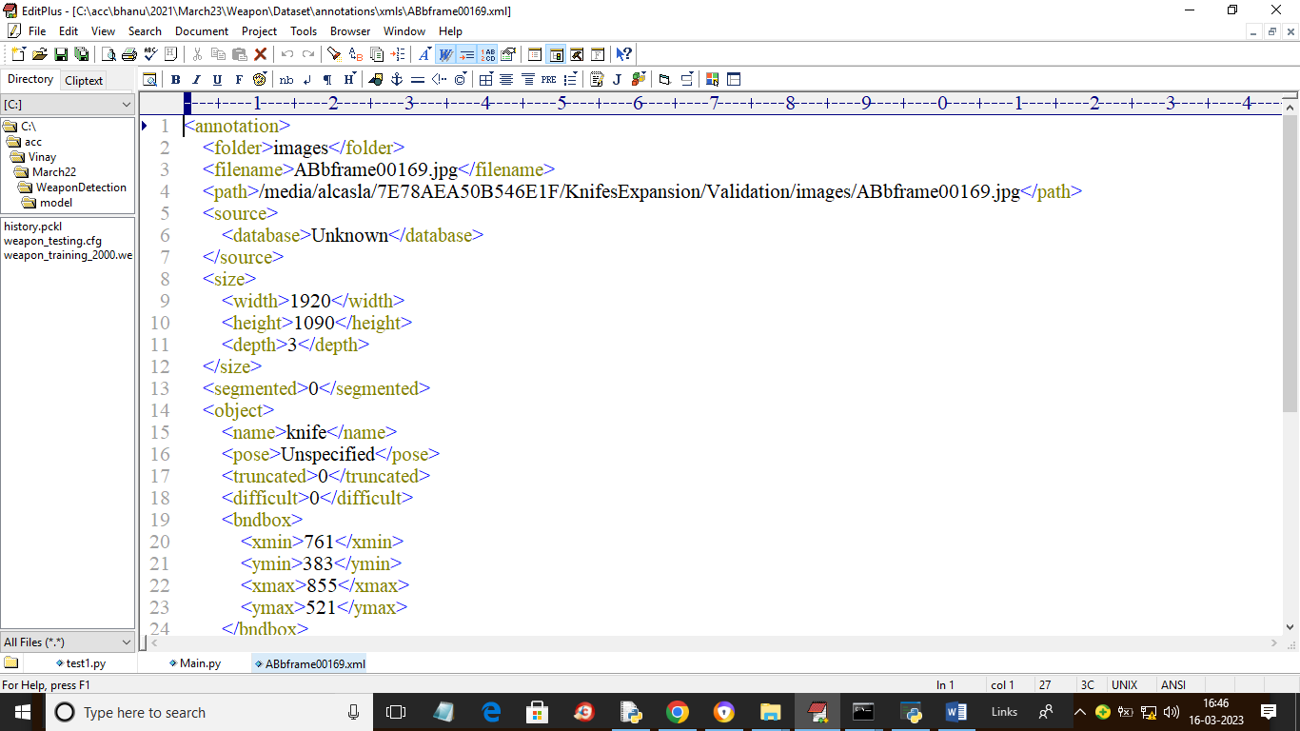

From above XML file we will read all bounding boxes and then train with FRCNN. In below screen we are showing code for dataset reading process

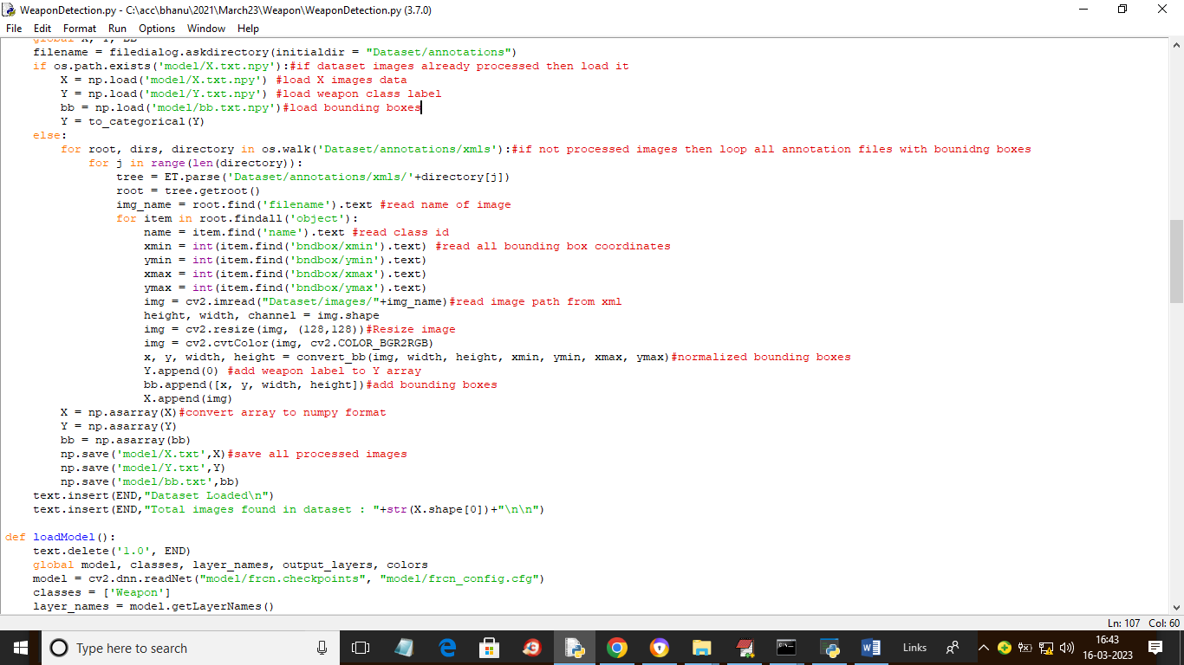

In above screen read red colour comments to know about dataset images loading and processing

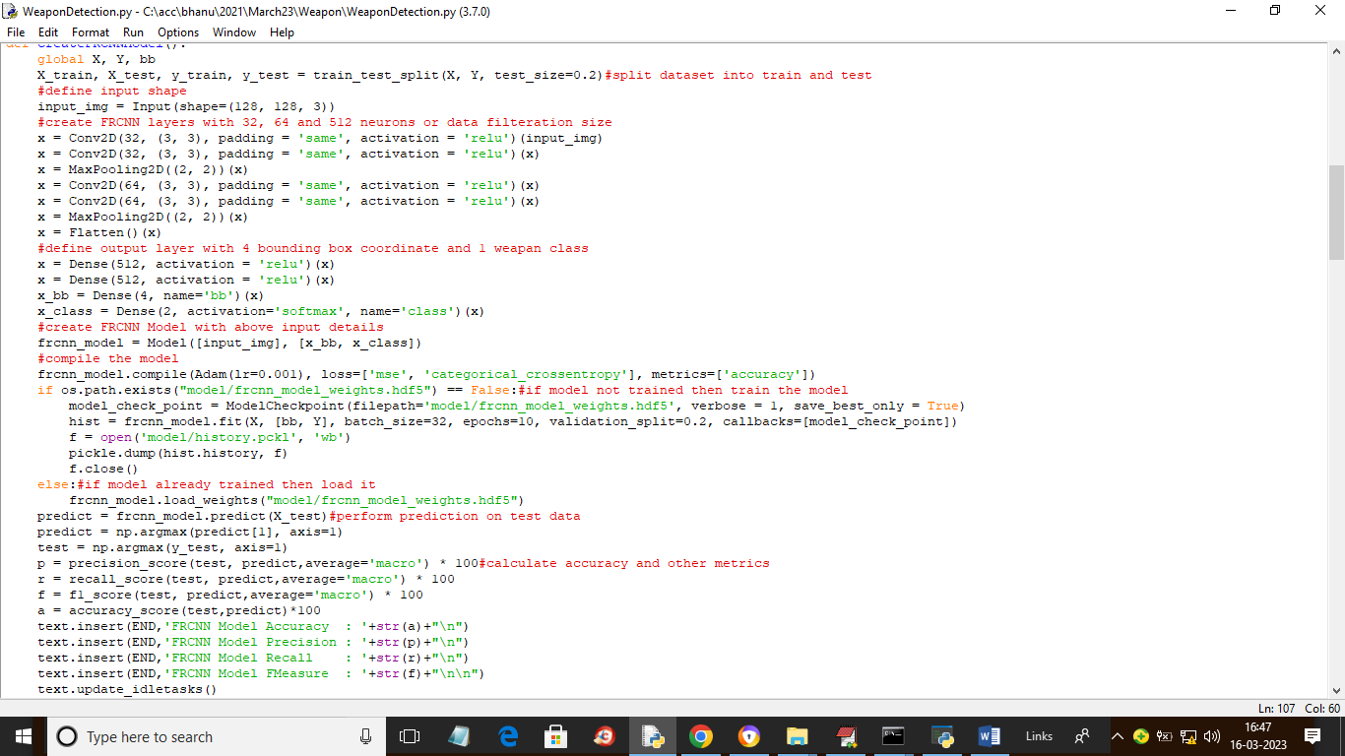

In above screen defining FRCNN model with bounding box detection and then calculating accuracy and other metrics

SCREEN SHOTS

To run project double click on ‘run.bat’ file to get below screen

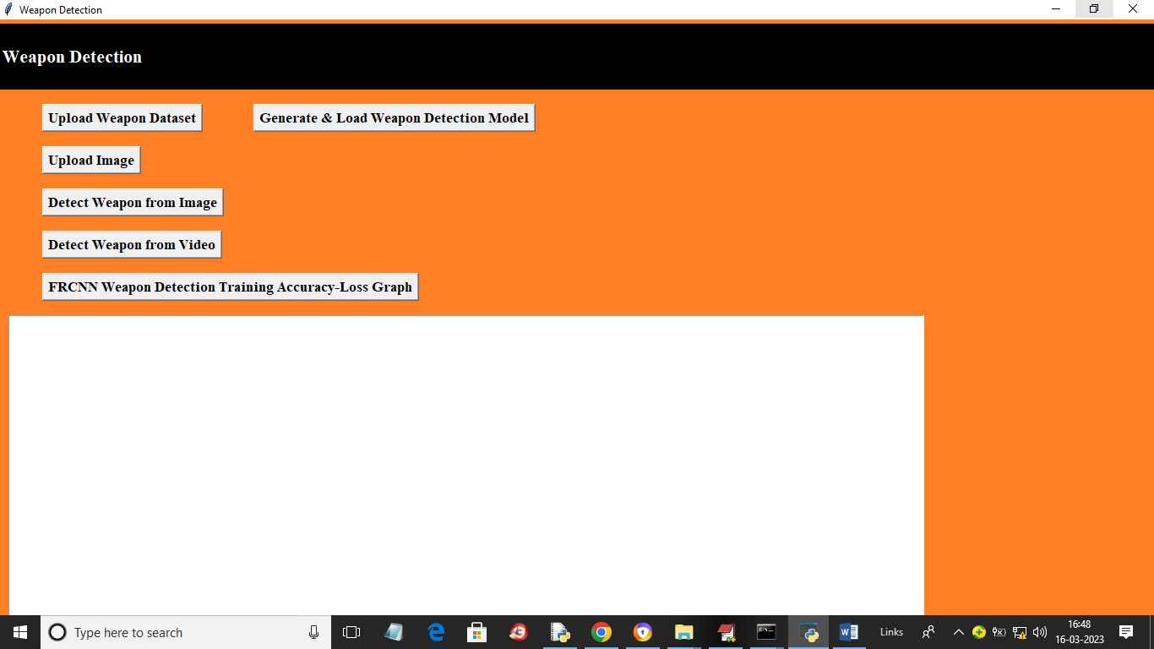

In above screen click on ‘Upload Weapon Dataset’ button to upload dataset and get below output

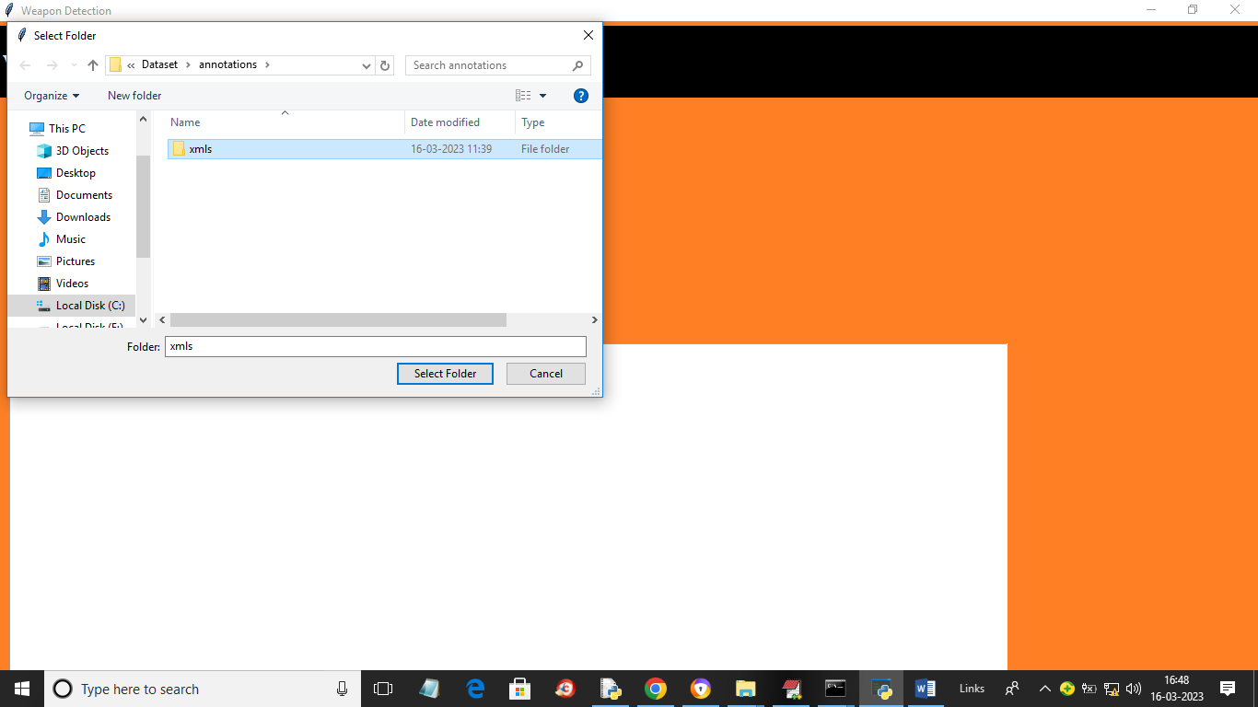

In above screen selecting and uploading entire XML folder with annotating bounding boxes and images path and then click on ‘Select Folder’ button to load dataset and get below output

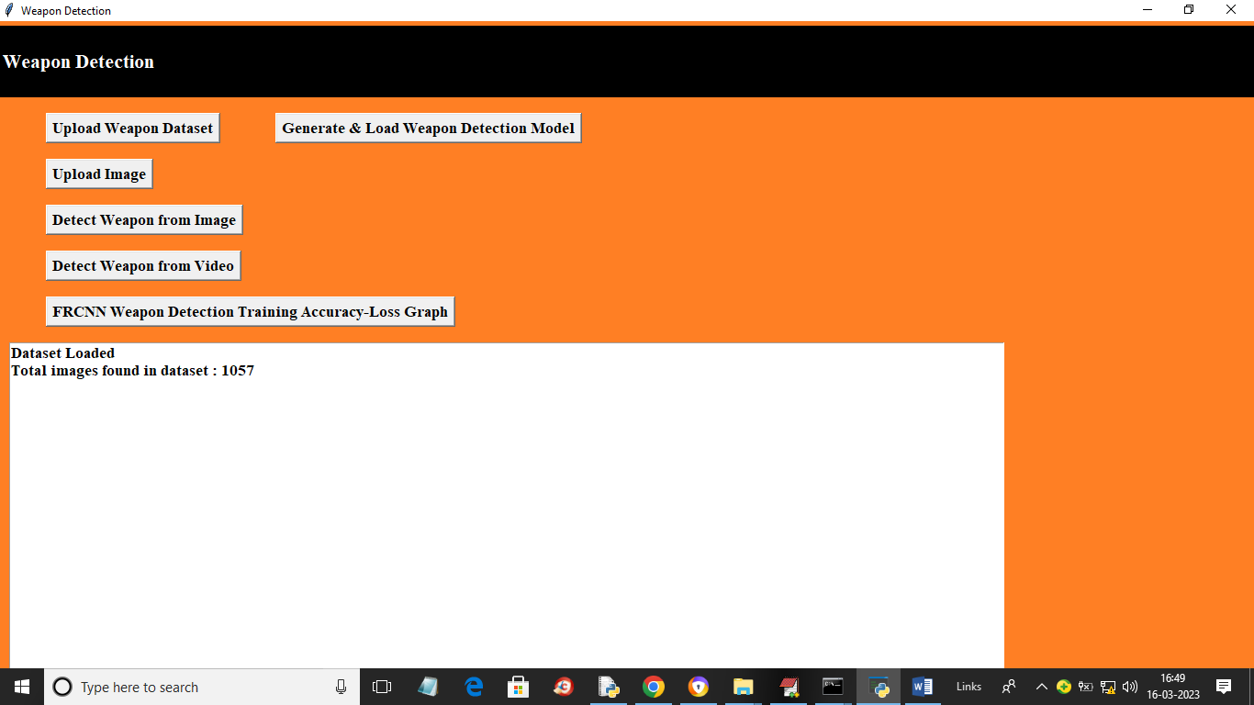

In above screen we can see 1057 weapon images loaded from dataset and now click on ‘Generate & Load Weapon Detection Model’ button to train FRCNN model and get below output

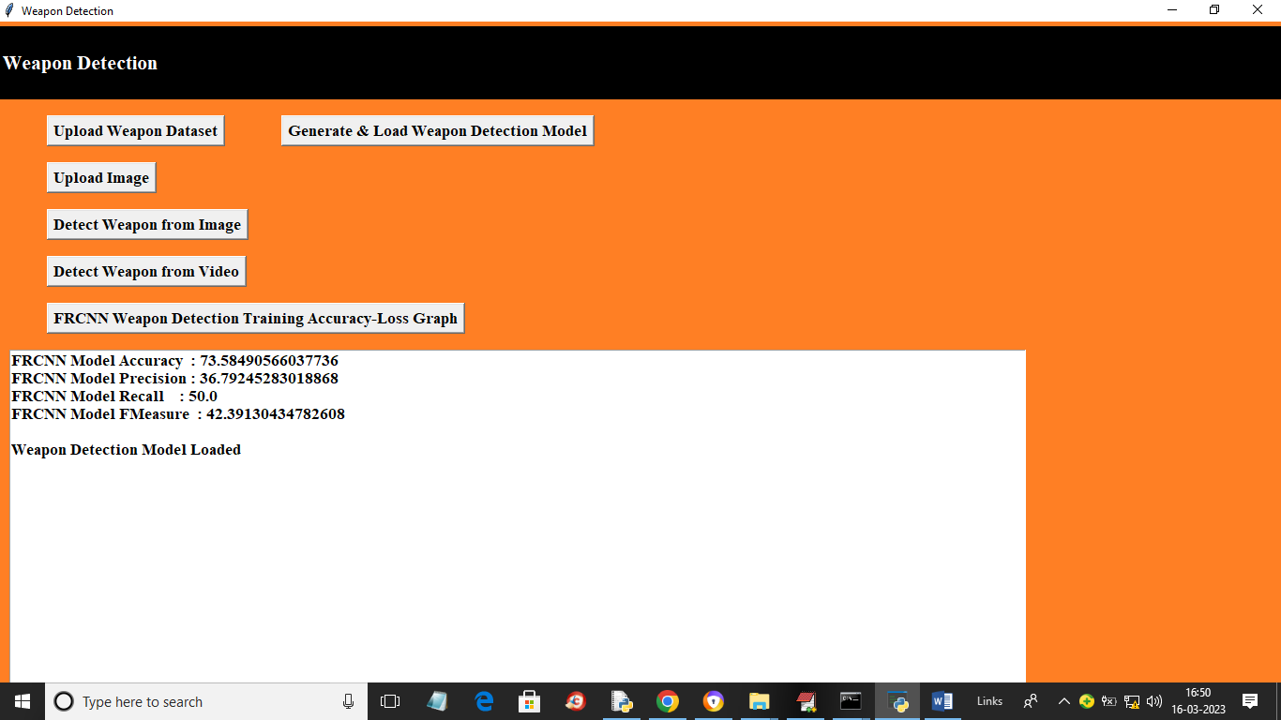

In above screen FRCNN model loaded and we got it accuracy as 73% and we can see other metrics also and now click on ‘Upload Image’ button to upload image and get below output

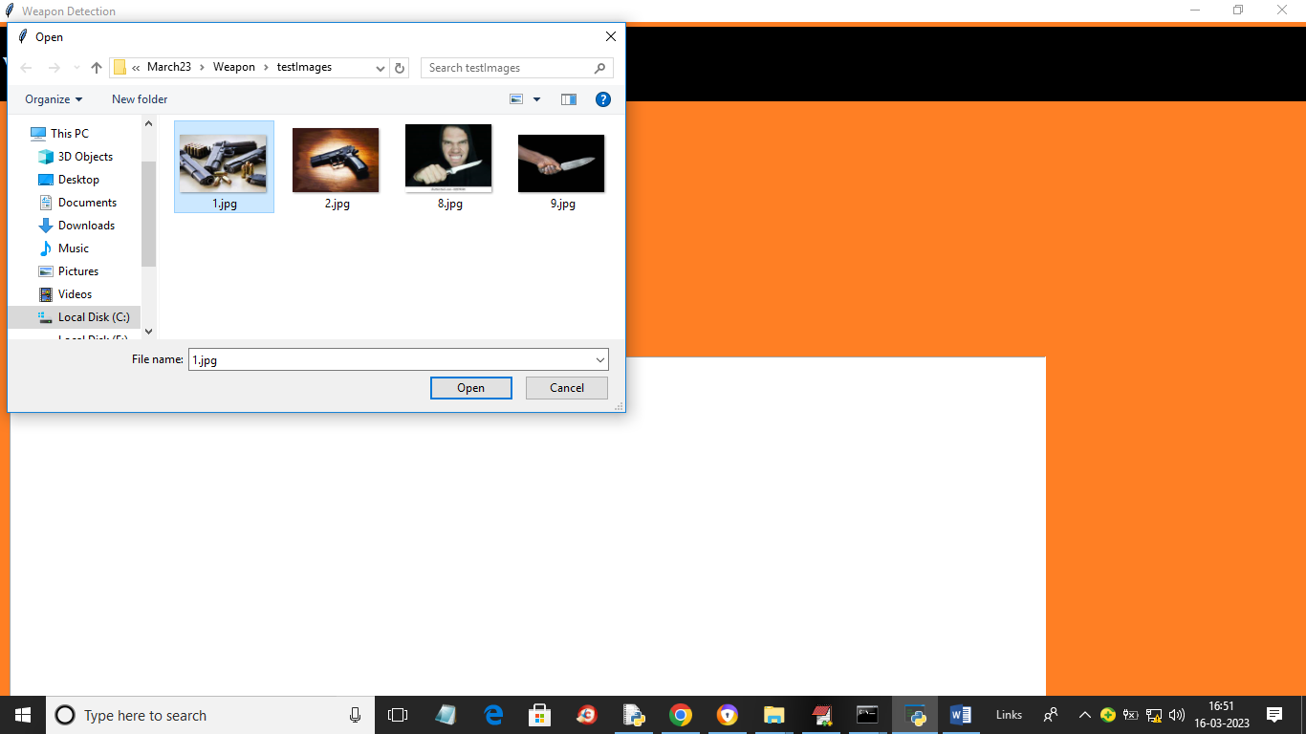

In above screen selecting and uploading image and then click on ‘Open’ button and ‘Detect Weapon from Image’ button to get below output

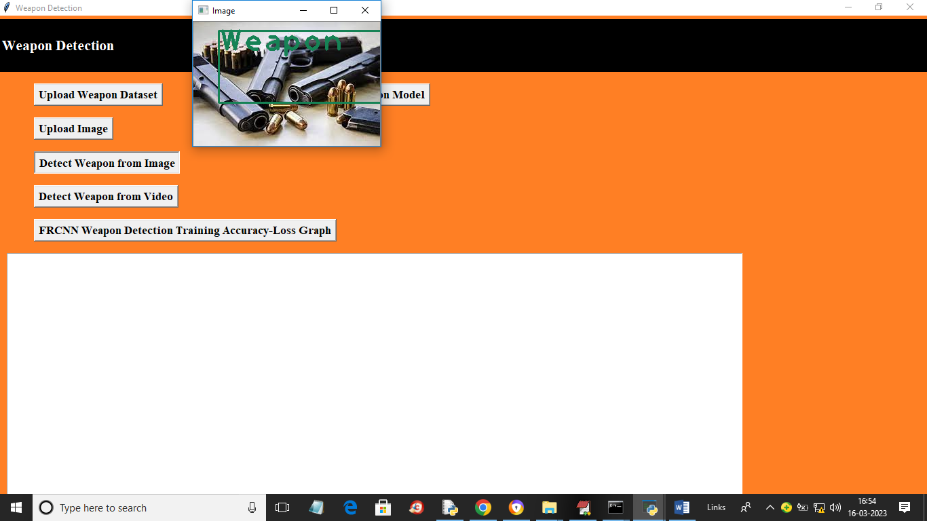

In above screen in image weapon is detected and now similarly click on ‘Detect Weapon from Video’ button to upload video file and get below output

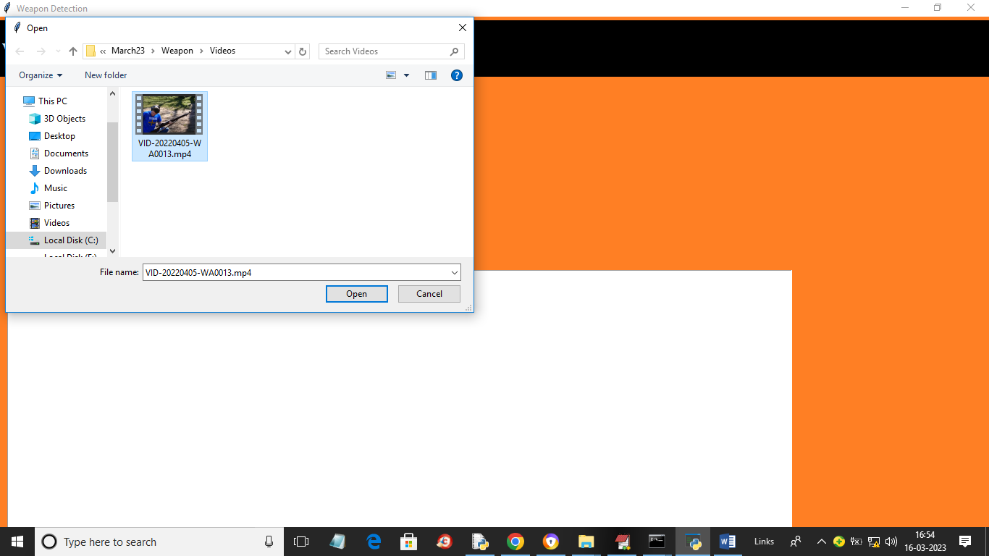

In above screen selecting and uploading MP4 video file and then click on ‘Open’ button to start video playing and if your system fast then video will play faster otherwise slow

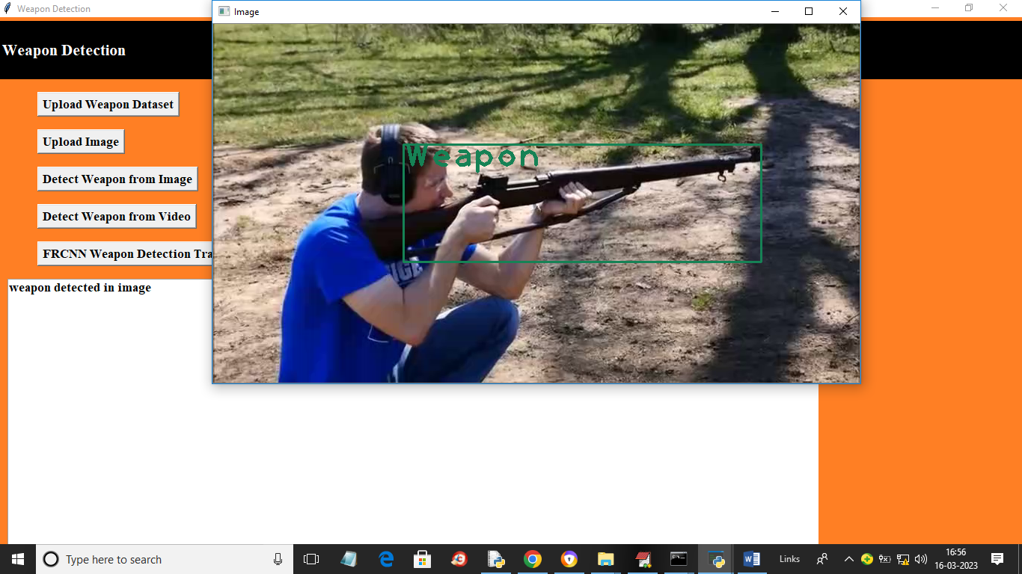

In above screen you can see video start playing and we can see detection output also and now click on ‘FRCNN Weapon Detection Training Accuracy-Loss Graph’ button to get below output

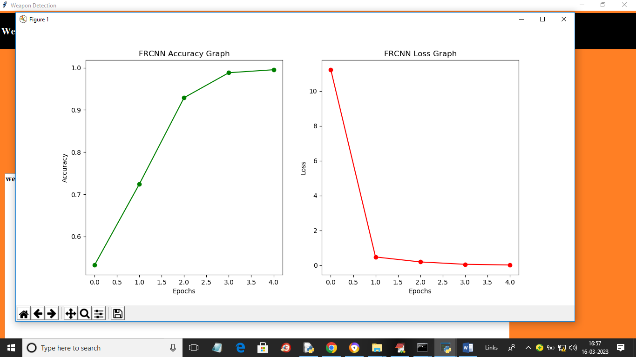

In above training graphs x-axis represents training EPOCH and y-axis represents accuracy and loss values and green line represents accuracy and red line represents LOSS and with each increasing epoch accuracy got increase and loss got decrease. Similarly you can upload and test other images