CHAPTER 1
INTRODUCTION
1.1 OPENGL
OpenGL is the abbreviation for Open Graphics Library. It is a software interface for graphics hardware. This interface consists of several hundred functions that allow you, a graphics programmer, to specify the objects and operations needed to produce high-quality color images of two-dimensional and three-dimensional objects. Many of these functions are actually simple variations of each other, so in reality there are about 120 substantially different functions .The main purpose of OpenGL is to render two-dimensional and three-dimensional objects into the frame buffer. These objects are defined as sequences of vertices (that define geometric objects) or pixels (that define images).OpenGL performs several processes on this data to convert it to pixels to form the final desired image in the frame buffer.
1.2 HISTORY
As a result, SGI released the OpenGL standard In the 1980s, developing software that could function with a wide range of graphics hardware was a real challenge. Software developers wrote custom interfaces and drivers for each piece of hardware. This was expensive and resulted in much duplication of effort.
By the early 1990s, Silicon Graphics (SGI) was a leader in 3D graphics for workstations. Their IRIS GL API was considered the state of the art and became the de facto industry standard, overshadowing the open standards-based PHIGS. This was because IRIS GL was considered easier to use, and because it supported immediate mode rendering. By contrast, PHIGS was considered difficult to use and outdated in terms of functionality.
SGI's competitors (including Sun Microsystems, Hewlett-Packard and IBM) were also able to bring to market 3D hardware, supported by extensions made to the PHIGS standard. This in turn caused SGI market share to weaken as more 3D graphics hardware suppliers entered the market. In an effort to influence the market, SGI decided to turn the Iris GL API into an open standard.

SGI considered that the Iris GL API itself wasn't suitable for opening due to licensing and patent issues. Also, the Iris GL had API functions that were not relevant to 3D graphics. For example, it included a windowing, keyboard and mouse API, in part because it was developed before the X Window System and Sun's NEWSsystems were developed.
In addition, SGI had a large number of software customers; by changing to the OpenGL API they planned to keep their customers locked onto SGI (and IBM) hardware for a few years while market support for OpenGL matured. Meanwhile, SGI would continue to try to maintain their customers tied to SGI hardware by developing the advanced and proprietary Iris Inventor and Iris Performer programming APIs.
1.3 FEATURES OF OPENGL
- Industry standard
An independent consortium, the OpenGL Architecture Review Board, guides the OpenGL specification. With broad industry support, OpenGL is the only truly open, vendor-neutral, multiplatform graphics standard.

- Stable
OpenGL implementations have been available for more than seven years on a wide variety of platforms. Additions to the specification are well controlled, and proposed updates are announced in time for developers to adopt changes. Backward compatibility requirements ensure that existing applications do not become obsolete.
- Reliable and portable
All OpenGL applications produce consistent visual display results on any OpenGL API-compliant hardware, regardless of operating system or windowing system.

- Evolving
Because of its thorough and forward-looking design, OpenGL allows new hardware innovations to be accessible through the API via the OpenGL extension mechanism. In
this way, innovations appear in the API in a timely fashion, letting application developers
and hardware vendors incorporate new features into their normal product release cycles.

- Scalable
OpenGL API-based applications can run on systems ranging from consumer electronics to PCs, workstations, and supercomputers. As a result, applications can scale to any class of machine that the developer chooses to target.

- Easy to use
OpenGL is well structured with an intuitive design and logical commands. Efficient OpenGL routines typically result in applications with fewer lines of code than those that make up programs generated using other graphics libraries or packages. In addition, OpenGL drivers encapsulate information about the underlying hardware, freeing the application developer from having to design for specific hardware features.
- Well-documented
Numerous books have been published about OpenGL, and a great deal of sample code is readily available, making information about OpenGL inexpensive and easy to obtain.
1.4 BASIC OPENGL OPERATION
The following diagram illustrates how OpenGL processes data. As shown, commands enter from the left and proceed through a processing pipeline. Some commands specify geometric objects to be drawn, and others control how the objects are handled during various processing stages.
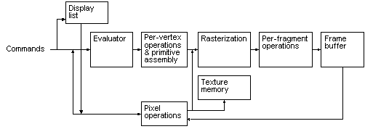
Fig: 1.4 OpenGL Block Diagram
The processing stages in basic OpenGL operation are as follows:
- Display list
Rather than having all commands proceed immediately through the pipeline, you can choose to accumulate some of them in a display list for processing later.
- Evaluator
The evaluator stage of processing provides an efficient way to approximate curve and surface geometry by evaluating polynomial commands of input values.
- Pre-vertex operations and primitive assembly
OpenGL processes geometric primitives - points, line segments, and polygons all of which are described by vertices. Vertices are transformed, and primitives are clipped to the viewport in preparation for rasterization.
- Rasterization
The rasterization stage produces a series of frame-buffer addresses and associated values using a two-dimensional description of a point, line segment, or polygon. Each so produced is fed into the last stage, per-fragment operations.
- Per-fragment operations

These are the final operations performed on the data before it is stored as pixels in the frame buffer Per-fragment operations include conditional updates to the frame buffer based on incoming and previously stored z values (for z buffering) and blending of incoming pixel colors with stored colors, as well as masking and other logical operations on pixel values.

- Pixel operation
Input data can be in the form of pixels rather than vertices. Such data which might describe an image for texture mapping skips the first stage of processing and instead processed as pixels in the pixel operation stage.
- Texture memory
The result of pixel operation stage is either stored as texture memory for use in rasterization stage or rasterised and resulting fragment merged into the frame buffer just as they were generated from the geometric data.
  - THE OPENGL INTERFACE
Most of our applications will be designed to access OpenGL directly through functions in three libraries. They are
GL – Graphics Library
Functions in the main GL (or OpenGL in Windows) library have names that begin with the letters gl and are stored in a library usually referred to as GL (or OpenGL in Windows).
- GLU – Graphics Utility Library
This library uses only GL functions but contain code for creating common objects and simplifying viewing. All functions in GLU can be created from the core GL library but application programmers prefer not to write the code repeatedly. The GLU library is available in all OpenGL implementations; functions in the GLU library begins with the letters glu.
- GLUT – OpenGL Utility Toolkit
To interface with the window system and to get input from external devices into our programs we need at least one more library. For the X window System, this library is called GLX, for Windows, it is wgl, and for the Macintosh, it is agl. Rather than using a different library for each system, we use a readily available library called the OpenGL Utility Toolkit (GLUT) , which provides minimum functionality that should be expected in any modern windowing system.
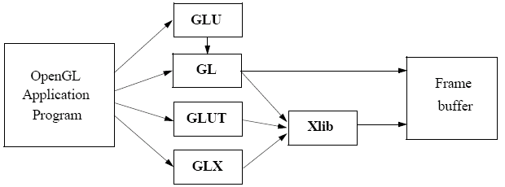
Fig: 1.5 Library Organization
The above figure shows the organization of the libraries for an X Window System environment.
In most implementations, one of the include lines
#include<GL/glut.h>
or
#include<GLUT/glut.h>
is sufficient to read in glut.h, gl.h and glu.h.

1.6 Graphics Functions
Our basic model of a graphics package is a black box, a term that engineers use to denote a system whose properties are described only by its inputs and outputs; we may know nothing about its internal workings.
OpenGL functions can be classified into seven major groups:
- Primitive function: The primitive functions define the low-level objects or atomic entities that our system can display. Depending on the API, the primitives can include points, lines, polygons , pixels, text, and various types of curves and surfaces.

- Attribute functions
If primitives are the what of an API – the primitive objects that can be displayed- then attributes are the how. That is, the attributes govern the way the primitive appears on the display. Attribute functions allow us to perform operations ranging from choosing the color with which we display a line segment, to picking a pattern with which to fill inside of a polygon.

- Viewing functions
The viewing functions allow us to specify various views, although APIs differ in the degree of flexibility they provide in choosing a view.

- Transformation functions
One of the characteristics of a good API is that it provides the user with a set of transformations functions such as rotation, translation and scaling.

- Input functions
For interactive applications, an API must provide a set of input functions, to allow users to deal with the diverse forms of input that characterize modern graphics systems. We need functions to deal with devices such as keyboards, mice and data tablets.

- Control functions
These functions enable us to communicate with the window system, to initialize our programs, and to deal with any errors that take place during the execution of our programs.

- Query functions
If we are to write device independent programs, we should expect the implementation of the API to take care of the differences between devices, such as how many colors are supported or the size of the display. Such information of the particular implementation should be provides through a set of query functions.
1.7 DATA TYPES:
OpenGL supports different data types. A list of data types supported by OpenGL is given in the following table.

Sl no. | Suffix | Data type | C type | OpenGL type
1. | B | 8 bit int | signed int | GLbyte
2. | S | 1 bit int | Short | GLshort
3. | I | 32 bit int | Long | GLint , GLsizei
4. | F | 32 bit float | Float | GLfloat ,GLclampf
5. | D | 64 bit float | Double | GLdouble,  GLclampd
6. | Ub | 8 bit unsigned | unsigned char | GLubyte, GLboolean
7. | Us | 16 bit unsigned | unsigned short | GLushort
8. | Ui | 32 bit unsigned | unsigned int | GLuint, GLenum, GLbitfield

CHAPTER 2
SYSTEM REQUIREMENTS
2.1 Software Requirements
1. Operating System : Microsoft Windows XP,Microsoft Windows 7
2. Compiler used: VC++ 6.0 compiler
3. Language used: C
2.2 Hardware Requirements
1. Main Processor: PENTIUM III
2. Processor Speed: 800 MHz
3. RAM Size: 128MB DDR
CHAPTER 3

SYSTEM DESIGN

3.1 Initialization:
- Initialize to interact with the Windows.
- Initialize the display mode that is double buffer and RGB color system.
- Initialize window position and window size.
- Initialize and create the window to display the output.

3.2 Display:
- Menus are created and depending on the value returned by menus.
- Suitable operations are performed.
- The operations performed are:
  - Displaying a resort scenario.
  - Changing the direction of boat, saucer plane.
Clockwise rotation.
Anticlockwise rotation.
  - Resume.
  - Stop.
  - Quit.

3.3 FLOW CHART
START
INTRO

PRESS ANY KEY

yes
MAIN WINDOW

CLICKRIGHT BUTTON

yes
OBJECTS ACW

RESUME
OBJECTS CW
EXIT

STOP

Fig: 3.3 Flow Chart

CHAPTER 4
IMPLEMENTATION
4.1 OVERVIEW
In this project scenario of the resort is demonstrated. We have taken the help of built in functions present in the header file. To provide functionality to our project we have written sub functions. These functions provide us the efficient way to design the project. In this chapter we are describing the functionality of our project using these functions.
Mouse interactions are provided where when a right mouse button is pressed, menu displays and we can select options from menu displayed.

4.2 USER INTERFACE
The Project which we have done uses OpenGL functions and is implemented using C. Our Project is to illustrate SCENARIO OF THE RESORT. User can control the rotation speed of both flying saucer and boat.

Mouse interaction:
When we right click the mouse button on the display window several options are available:
- Exit: It is used to exit the program.
- Stop: It stops the rotation of objects.
- Objects CW: Clockwise rotation of flying saucer and boat.
- Objects ACW: Anticlockwise rotation of flying saucer and boat.
- Resume: Continues the rotation of objects after a pause or interruption.

4.3 STRUCTURE:
- void front()
{
//To display Introduction page
}
- void drawHouse(p2D pos,const GLfloat size)
{
//To draw house
}
- void DrawBeach()
{
//To display beach
}
- void DrawPier()
{
//To draw pier image
}
- void DrawTree(p2D coord)
{
//To draw tree
}
- void DrawWaves()
{
//Shows effect of waves in beach
}

- void DrawBoat()
{
//To draw boat
}
- void DrawSun()
{
//To draw sun
}
- void DrawPlane()
{
//To draw flying saucer
}
- void help()
{
//Displays Instructions
}
- void myKey(unsigned char k, int x, int y)
{
//Mouse interactions
}
- void aClockWise()
{
//Anticlockwise rotation of objects
}

- void ClockWise()
{
//Clockwise rotation of objects
}

4.4 ANALYSIS:
Purpose:
- Function to draw house.
- Function to draw beach.
- Function to draw pier.
- Function to draw tree.
- Function to draw waves.
- Function to draw boat.
- Function to draw sun.
- Function to draw plane.
- Display function.
- Function for Anticlockwise Rotation.
- Function for Clockwise Rotation
- Function for mouse_menu.

4.4.1 FUNCTION TO DRAW HOUSE:

void drawHouse(p2D pos,const GLfloat size)
{
const GLfloat xzSize = (0.5*size) + (0.075*size);
const GLfloat yHeight = (0.5*size);
.
.
.
glPopMatrix();
glPopMatrix();
}

4.4.2 FUNCTION TO DRAW BEACH:

void DrawBeach()
{
glBegin(GL_POLYGON);
glColor3f(1.0,1.0,0.0);
glNormal3f(0, 1, 0);
.
.
.
glVertex3f(-50.0, -0.1, 6.0);
glVertex3f(50.0, -0.1, 6.0);
glEnd();
}

4.4.3 FUNCTION TO DRAW PIER:

void DrawPier()
{
glScalef(1.0, 0.2, 2.0);
glTranslatef(-3.25, 0.5, 0.5);
glColor3f(1.0, 1.0, 1.0);
.
.
.
glPopMatrix();
glutSolidCube(1.0);
glPopMatrix();
}

4.4.4 FUNCTION TO DRAW TREE:

void DrawTree(p2D coord)
{
pushMatrix();
glTranslatef(coord[0], 0.9, coord[1]);
.
.
.
glutSolidCone(0.75, 2.0, 100,20);
glPopMatrix();
}

4.4.5 FUNCTION TO DRAW WAVES:

void DrawWaves()
{
const GLfloat waveHeight = -0.0099;
waveDistance = waveDistance-0.01;
if (waveDistance<= 0.25)
.
.
.
glEnd();
glPopMatrix();
}

4.4.6 FUNCTION TO DRAW BOAT:

void DrawBoat()
{
glPushMatrix();
glTranslatef(0.0, 0.0, 1.9);
.
.
.
glVertex3f(0.0, 0.125, -0.5);
glEnd();
glPopMatrix();
}

4.4.7 FUNCTION TO DRAW SUN:

void DrawSun()
{
int i = 0;
glPushMatrix();
glEnd();
.
.
.
glRotatef(60.0, 0.0,0.0,1.0);
glPopMatrix();
}

4.4.8 FUNCTION TO DRAW PLANE:

void DrawPlane()
{
glPushMatrix();
glColor3f(0.0, 0.0, 0.0);
.
.
.
glutSolidSphere(0.5, 20, 20);
glPopMatrix();
}

4.4.9 DISPLAY FUNCTION:

void Display(void)
{
p2D house1 = {0.9/*x*/, 1.5/*z*/};
.
.
.
p2D house2 = {-1.75/*x*/, 0.5/*z*/};
DrawWaves();
}

4.4.10 FUNCTION FOR ANTICLOCKWISE ROTATION:

void aClockWise()
{
sunAngle += 1%360;
boatAngle += 1%360;
planeAngle += 1%360;
boatFlip = 0.0;
glutPostRedisplay();
}

4.4.11 FUNCTION FOR ANTICLOCKWISE ROTATION:

void clockWise()
{
sunAngle -= 1%360;
boatAngle -= 1%360;
planeAngle -= 1%360;
boatFlip = 180.0;
glutPostRedisplay();
}

4.4.10 FUNCTION FOR MOUSE_MENU:

void main_menu_select(int value)
{
switch(value)
.
.
.
glutIdleFunc(clockWise);
glutPostRedisplay();
}

CHAPTER 5
SNAPSHOTS

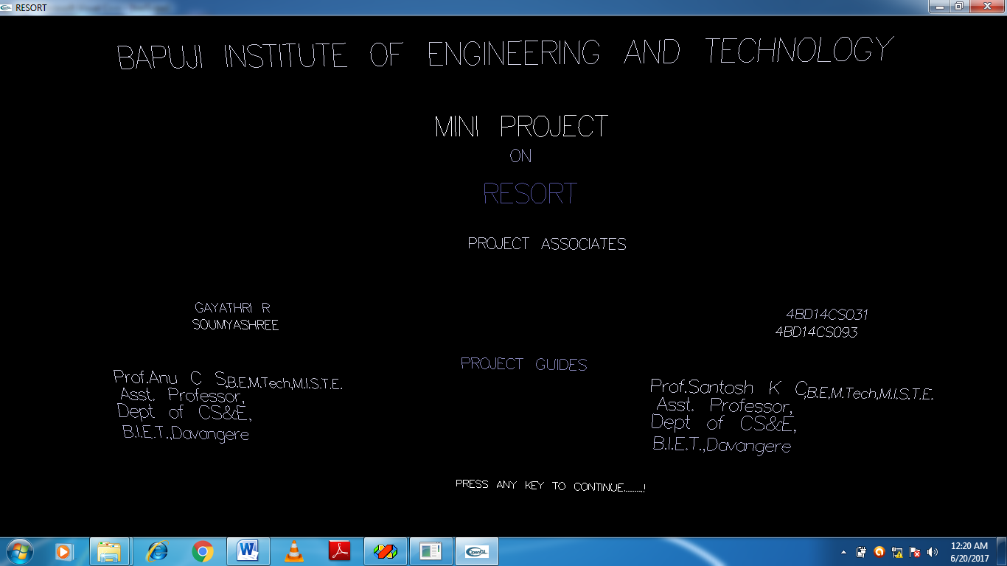
Fig 5.1:Introduction
The above snapshot shows the introduction page.

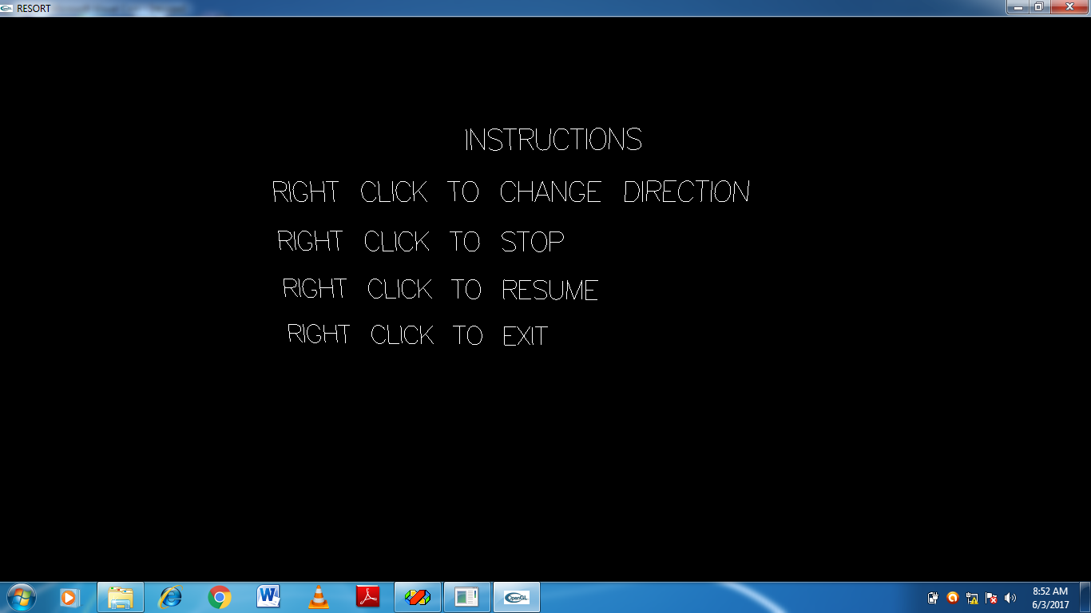
Fig 5.1:Instructions
The above snapshot shows various instructions that are needed.

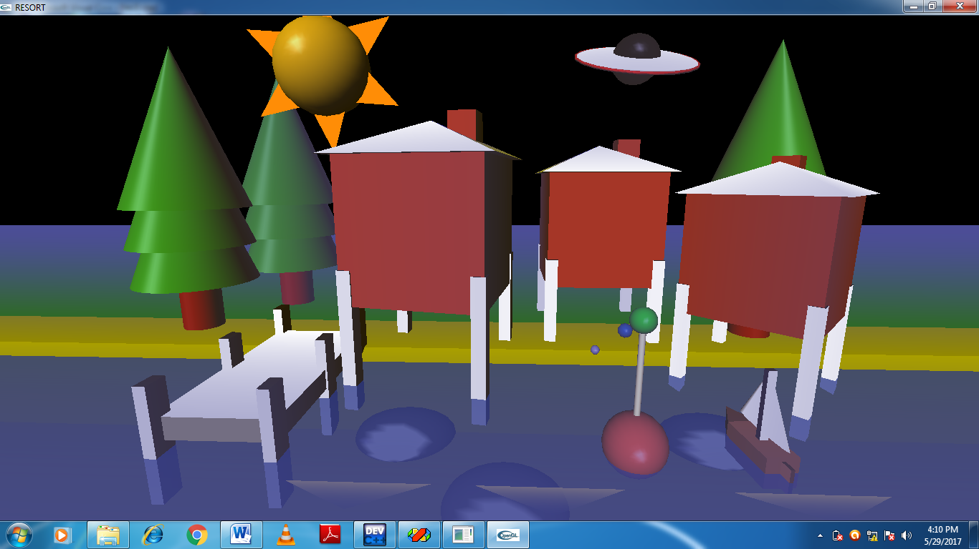
Fig 5.3:Initial view
The above snapshot shows the resort scenario with various elements like sun,trees,pier, buoy,boat,flying saucer.

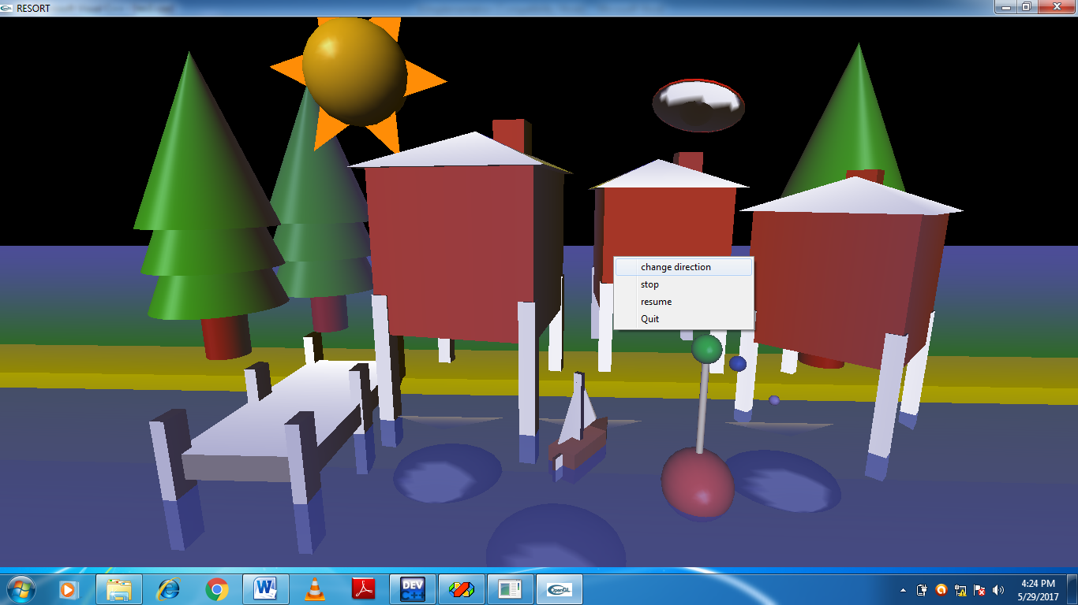
Fig:5.4: Initial rotation is in Anticlockwise Direction
The flying saucer and the boat are rotating in anticlockwise direction initially.

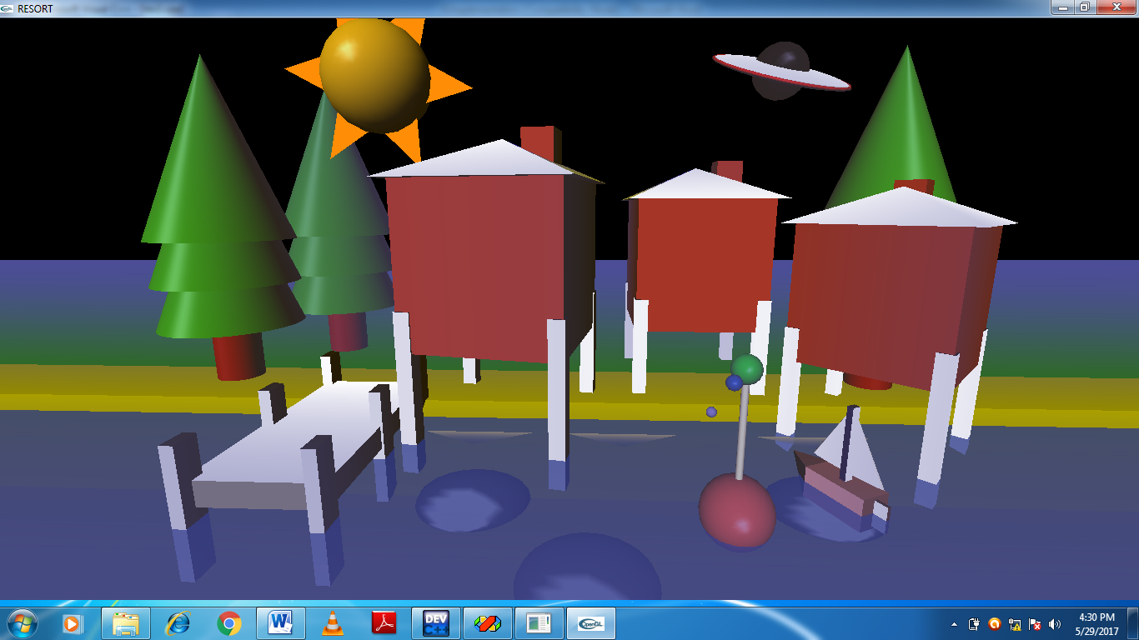

Fig:5.5: Clockwise rotation
The flying saucer and the boat starts rotating in clockwise direction when “change
direction” menu is chosen.

CONCLUSION
Resort Scenario is designed and implemented using a graphics software system called OpenGL which has become a widely accepted standard for developing graphic application. In our project the overview of the resort is displayed which includes sun, trees, pier, beach. Using OpenGL functions user can create all these objects and can use translation, rotation, scaling with respect to the co-ordinate system. With these functions we can change the direction of rotation of boat and flying saucer. Interactions through the mouse are provided via menus. The development of the Simulation of Resort project has given us a good exposure to OpenGL by which we have learnt some of the technique which help in development of animated pictures, gaming.

