CHAPTER 1
INTRODUCTION
1.1 OPENGL
OpenGL is the abbreviation for Open Graphics Library. It is a software interface for graphics hardware. This interface consists of several hundred functions that allow you, a graphics programmer, to specify the objects and operations needed to produce high-quality color images of two-dimensional and three-dimensional objects. Many of these functions are actually simple variations of each other, so in reality there are about 120 substantially different functions.The main purpose of OpenGL is to render two-dimensional and three-dimensional objects into the frame buffer. These objects are defined as sequences of vertices (that define geometric objects) or pixels (that define images).OpenGL performs several processes on this data to convert it to pixels to form the final desired image in the frame buffer.
1.2 HISTORY
As a result, SGI released the OpenGL standard In the 1980s, developing software that could function with a wide range of graphics hardware was a real challenge. Software developers wrote custom interfaces and drivers for each piece of hardware. This was expensive and resulted in much duplication of effort.
By the early 1990s, Silicon Graphics (SGI) was a leader in 3D graphics for workstations. Their IRIS GL API was considered the state of the art and became the de facto industry standard, overshadowing the open standards-based PHIGS. This was because IRIS GL was considered easier to use, and because it supported immediate mode rendering. By contrast, PHIGS was considered difficult to use and outdated in terms of functionality.
SGI's competitors (including Sun Microsystems, Hewlett-Packard and IBM) were also able to bring to market 3D hardware, supported by extensions made to the PHIGS standard. This in turn caused SGI market share to weaken as more 3D graphics hardware suppliers entered the market. In an effort to influence the market, SGI decided to turn the Iris GL API into an open standard.
SGI considered that the Iris GL API itself wasn't suitable for opening due to licensing and patent issues. Also, the Iris GL had API functions that were not relevant to 3D graphics. For example, it included a windowing, keyboard and mouse API, in part because it was developed before the X Window System and Sun's NEWSsystems were developed.
In addition, SGI had a large number of software customers; by changing to the OpenGL API they planned to keep their customers locked onto SGI (and IBM) hardware for a few years while market support for OpenGL matured. Meanwhile, SGI would continue to try to maintain their customers tied to SGI hardware by developing the advanced and proprietary Iris Inventor and Iris Performer programming APIs.
1.3 FEATURES OF OPENGL
- Industry standard
An independent consortium, the OpenGL Architecture Review Board, guides the OpenGL specification. With broad industry support, OpenGL is the only truly open, vendor-neutral, multiplatform graphics standard.

- Stable
OpenGL implementations have been available for more than seven years on a wide variety of platforms. Additions to the specification are well controlled, and proposed updates are announced in time for developers to adopt changes. Backward compatibility requirements ensure that existing applications do not become obsolete.
- Reliable and portable
All OpenGL applications produce consistent visual display results on any OpenGL API-compliant hardware, regardless of operating system or windowing system.

- Evolving
Because of its thorough and forward-looking design, OpenGL allows new hardware innovations to be accessible through the API via the OpenGL extension mechanism. In this way, innovations appear in the API in a timely fashion, letting application developers and hardware vendors incorporate new features into their normal product release cycles.
- Scalable
OpenGL API-based applications can run on systems ranging from consumer electronics to PCs, workstations, and supercomputers. As a result, applications can scale to any class of machine that the developer chooses to target.

- Easy to use
OpenGL is well structured with an intuitive design and logical commands. Efficient OpenGL routines typically result in applications with fewer lines of code than those that make up programs generated using other graphics libraries or packages. In addition, OpenGL drivers encapsulate information about the underlying hardware, freeing the application developer from having to design for specific hardware features.

- Well-documented
Numerous books have been published about OpenGL, and a great deal of sample code is readily available, making information about OpenGL inexpensive and easy to obtain.

1.4 BASIC OPENGL OPERATION
The following diagram illustrates how OpenGL processes data. As shown, commands enter from the left and proceed through a processing pipeline. Some commands specify geometric objects to be drawn, and others control how the objects are handled during various processing stages.

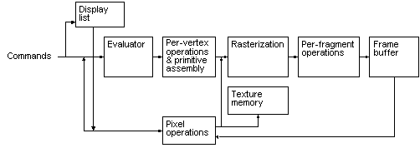
Fig1.0: OpenGL Block Diagram
The processing stages in basic OpenGL operation are as follows:
- Display list
Rather than having all commands proceed immediately through the pipeline, you can choose to accumulate some of them in a display list for processing later.
- Evaluator
The evaluator stage of processing provides an efficient way to approximate curve and surface geometry by evaluating polynomial commands of input values.

- Per-vertex operations and primitive assembly
OpenGL processes geometric primitives - points, line segments, and polygons all of which are described by vertices. Vertices are transformed, and primitives are clipped to the viewport in preparation for rasterization.
- Rasterization
The rasterization stage produces a series of frame-buffer addresses and associated values using a two-dimensional description of a point, line segment, or polygon. Each so produced is fed into the last stage, per-fragment operations.
- Per-fragment operations

These are the final operations performed on the data before it is stored as pixels in the frame buffer Per-fragment operations include conditional updates to the frame buffer based on incoming and previously stored z values (for z buffering) and blending of incoming pixel colors with stored colors, as well as masking and other logical operations on pixel values.
- Pixel operation
Input data can be in the form of pixels rather than vertices. Such data which might describe an image for texture mapping skips the first stage of processing and instead processed as pixels in the pixel operation stage.
- Texture memory
The result of pixel operation stage is either stored as texture memory for use in rasterization stage or rasterised and resulting fragment merged into the frame buffer just as they were generated from the geometric data.

  - THE OPENGL INTERFACE
Most of our applications will be designed to access OpenGL directly through functions in three libraries. They are
- GL – Graphics Library
Functions in the main GL (or OpenGL in Windows) library have names that begin with the letters gl and are stored in a library usually referred to as GL (or OpenGL in Windows).
- GLU – Graphics Utility Library
This library uses only GL functions but contain code for creating common objects and simplifying viewing. All functions in GLU can be created from the core GL library but application programmers prefer not to write the code repeatedly. The GLU library is available in all OpenGL implementations; functions in the GLU library begins with the letters glu.
- GLUT – OpenGL Utility Toolkit
To interface with the window system and to get input from external devices into our programs we need at least one more library. For the X window System, this library is called GLX, for Windows, it is wgl, and for the Macintosh, it is agl. Rather than using a different library for each system, we use a readily available library called the OpenGL Utility Toolkit (GLUT) , which provides minimum functionality that should be expected in any modern windowing system.
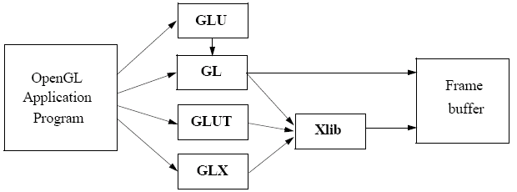
Fig 1.1: Library Organization
The above figure shows the organization of the libraries for an X Window System environment.
In most implementations, one of the include lines
#include<GL/glut.h>
or
#include<GLUT/glut.h>
is sufficient to read in glut.h, gl.h and glu.h.

  - Graphics Functions
Our basic model of a graphics package is a black box, a term that engineers use to denote a system whose properties are described only by its inputs and outputs; we may know nothing about its internal workings.
OpenGL functions can be classified into seven major groups:
- Primitive function: The primitive functions define the low-level objects or atomic entities that our system can display. Depending on the API, the primitives can include points, lines, polygons , pixels, text, and various types of curves and surfaces.

- Attribute functions
If primitives are the what of an API – the primitive objects that can be displayed- then attributes are the how. That is, the attributes govern the way the primitive appears on the display. Attribute functions allow us to perform operations ranging from choosing the color with which we display a line segment, to picking a pattern with which to fill inside of a polygon.

- Viewing functions
The viewing functions allow us to specify various views, although APIs differ in the degree of flexibility they provide in choosing a view.

- Transformation functions
One of the characteristics of a good API is that it provides the user with a set of transformations functions such as rotation, translation and scaling.

- Input functions
For interactive applications, an API must provide a set of input functions, to allow users to deal with the diverse forms of input that characterize modern graphics systems. We need functions to deal with devices such as keyboards, mice and data tablets.

- Control functions
These functions enable us to communicate with the window system, to initialize our programs, and to deal with any errors that take place during the execution of our programs.

- Query functions
If we are to write device independent programs, we should expect the implementation of the API to take care of the differences between devices, such as how many colors are supported or the size of the display. Such information of the particular implementation should be provides through a set of query functions.
1.7 DATA TYPES:
OpenGL supports different data types. A list of data types supported by OpenGL is given in the following table.
Fig 1.3:Data types supported by OpenGL
Sl no. | Suffix | Data type | C type | OpenGL type
1. | B | 8 bit int | signed int | GLbyte
2. | S | 1 bit int | Short | GLshort
3. | I | 32 bit int | Long | GLint , GLsizei
4. | F | 32 bit float | Float | GLfloat ,GLclampf
5. | D | 64 bit float | Double | GLdouble,  GLclampd
6. | Ub | 8 bit unsigned | unsigned char | GLubyte, GLboolean
7. | Us | 16 bit unsigned | unsigned short | GLushort
8. | Ui | 32 bit unsigned | unsigned int | GLuint, GLenum, GLbitfield
CHAPTER 2
SYSTEM REQUIREMENTS
2.1 Software Requirements
1. Operating System : Microsoft Windows XP,Microsoft Windows 7
2. Compiler used: VC++ 6.0 compiler
3. Language used: Visual C++
2.2 Hardware Requirements
1. Main Processor: PENTIUM III
2. Processor Speed: 800 MHz
3. RAM Size: 128MB DDR
4. Keyboard: Standard qwerty serial or PS/2 keyboard
5. Mouse: Standard serial or PS/2 mouse
6. Compatibility: AT/T compatible
7. Cache Memory: 256 KB
CHAPTER 3
DESIGN
3.1: INITIALIZATION
- Initialize to interact with the windows.
- Initialize the display mode that is double buffer and RGB color system.
- Initialize window position and window size.
- Initialize and create the window to display the output.

3.2: DISPLAY
- Initially a window is displayed.
- You will observe
- Cricket field
- Pitch
- Wickets
- Ball
- The operations performed are
- Initially you will find a red ball at the non striker end.
- You can move the ball and pitch on the desired position.
- Pressing the left mouse button moves the ball towards the striker end.
- Pressing the right mouse button at the desired position on the pitch , pitches the ball.
- If the ball is pitched on the LBW reference, you get the output as 'PITCHED INSIDE' else the output is 'PITCHED OUTSIDE'.

3.3: CONTROL FLOW DIAGRAM
START

OUTPUT SCREEN

HAWK-EYE

IF LMB

BALL STARTS MOVING

IF RMB

NO
BALL MOVES WITHOUT PITCHING

YES
BALL PITCHES

IF IN LBW REFERENCE LINE
RESTART

NO

X
X

X
X
YES
RESTART
PITCHED INSIDE
PITCHED OUTSIDE
BAILS DISSAPEAR

- LMB - Left Mouse Button
- RMB - Right Mouse Button

Fig 1.4: Indicates flow of control

CHAPTER 4
IMPLEMENTATION
4.1: OVERVIEW
The project implements a virtual Hawk-Eye system used in modern day cricket to determine whether a batsman is out or not for a LBW appeal and it provides user interface options i.e., mouse keys. This outcome makes use of OpenGL user defined functions, allowing the programmer a great deal of control and flexibility. This project also make use of the prominent library of OpenGL (i.e.,) GLUT.
The main operations of this project are:
- Ball movement
- Ball pitching
- Decision making

1. Ball movement:
This operation allows the ball to move in a desired direction.
2. Ball pitching:
This operation allows the ball to pitch on a desired position.
3. Decision making:
This operation specifies that if the ball hits the wickets, the batsman is considered out else not out.

4.2: USER INTERFACE
The user interface implemented in demonstration of "Hawk-Eye" is as mentioned below:
User Interactions through mouse:
As soon as the program is executed, the user has to press buttons from the mouse for the movement of ball and pitching.
- Left Mouse Button: Makes the ball to move.
- Right Mouse Button: Makes the ball to pitch.

4.3: STRUCTURE
The following functions are used in the demonstration of this model:
- void Sprint(int x,int y,char *st)
{
//This function is used to print a character string from the point x to point y.
}
- void display()
{
//It renders the output on the screen.
}
- void spindispay()
{
//This function defines the code for movement of the ball before pitching.
}

- void spindisplayy()
{
//This function defines the code for movement of the ball after pitching.
}
- void mouse(int button, int state, int x, int y)
{
//This function defines the code for mouse interaction.
}
- int main(int argc, char **argv)
{
//This is where the program begins its execution.
}

4.4: ANALYSIS
Purpose:
- Demonstrates the drawing of solid primitives.
- Demonstrates the mouse interactions.
- Demonstrates the multiplication of buffer matrices.
Functions:
- Demonstration of drawing of solid primitives
void display()
{
glClear(GL_COLOR_BUFFER_BIT|GL_DEPTH_BUFFER_BIT);
.
.
.
glSwapBuffers();
}
- Demonstration of mouse interactions
void mouse(int button, int state, int x, int y)
{
.
.
.
.
case GLUT_LEFT_BUTTON:
if(state==GLUT_DOWN)
glutIdleFunc(spindisplay);
.
case GLUT_RIGHT_BUTTON:
if(state==GLUT_DOWN)
glutIdleFunc(spindisplayy);
.
}

CHAPTER 5:
SNAP SHOTS

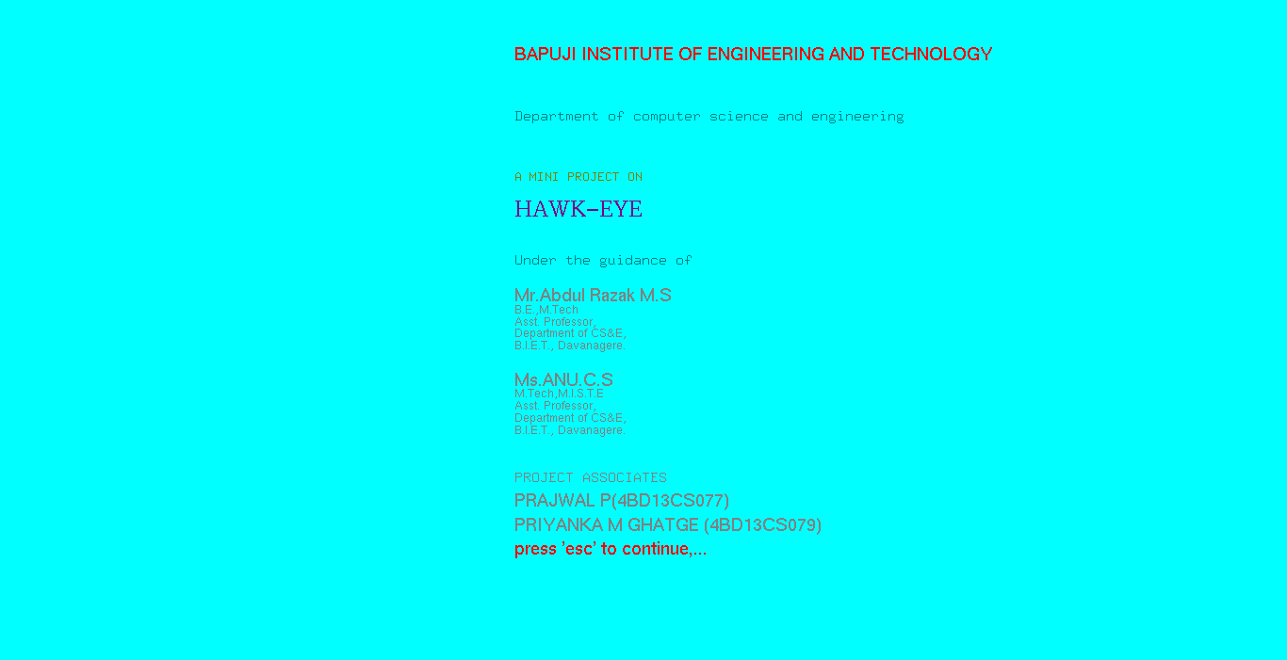
Fig. 5.1: Welcome Screen

The above snapshot shows information about the college, project name, project associates, project guides.

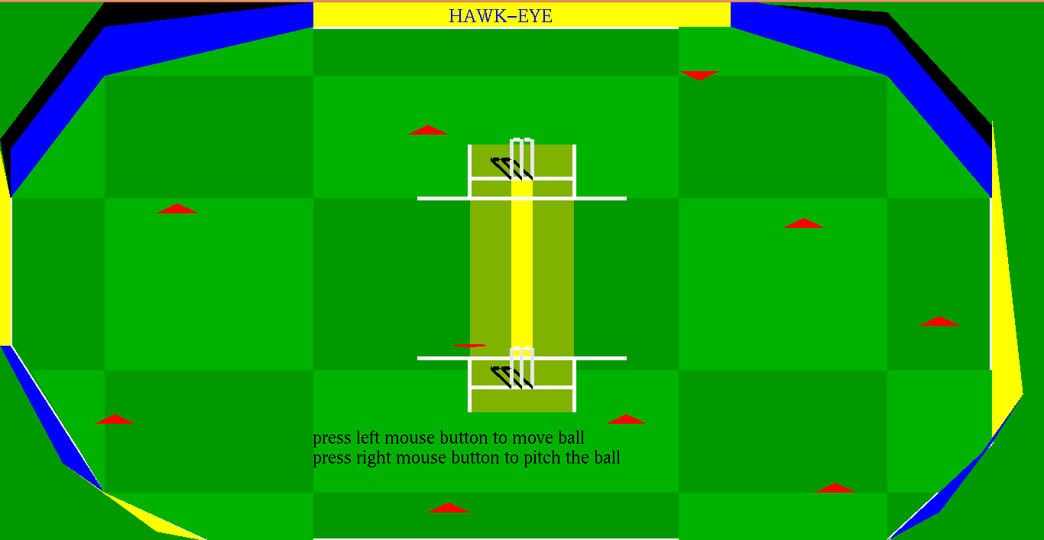

Fig. 5.2 Initial display

The above snapshot shows the display of pitch, wickets, ball and the fielders.

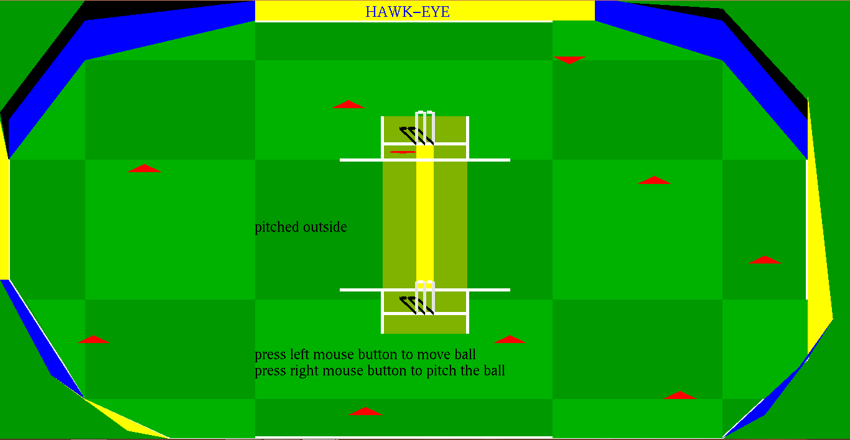

Fig. 5.3: Ball pitching outside

The above snapshot shows the ball pitching outside the LBW reference line.

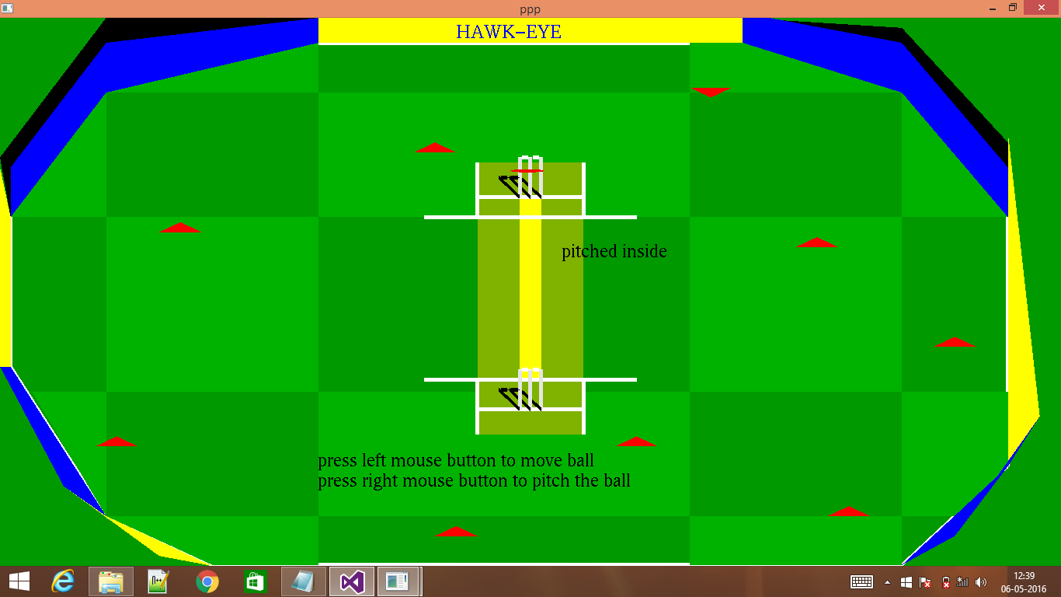

Fig. 5.4: Ball pitching inside

The above snap shot shows the ball pitching inside the LBW reference line.

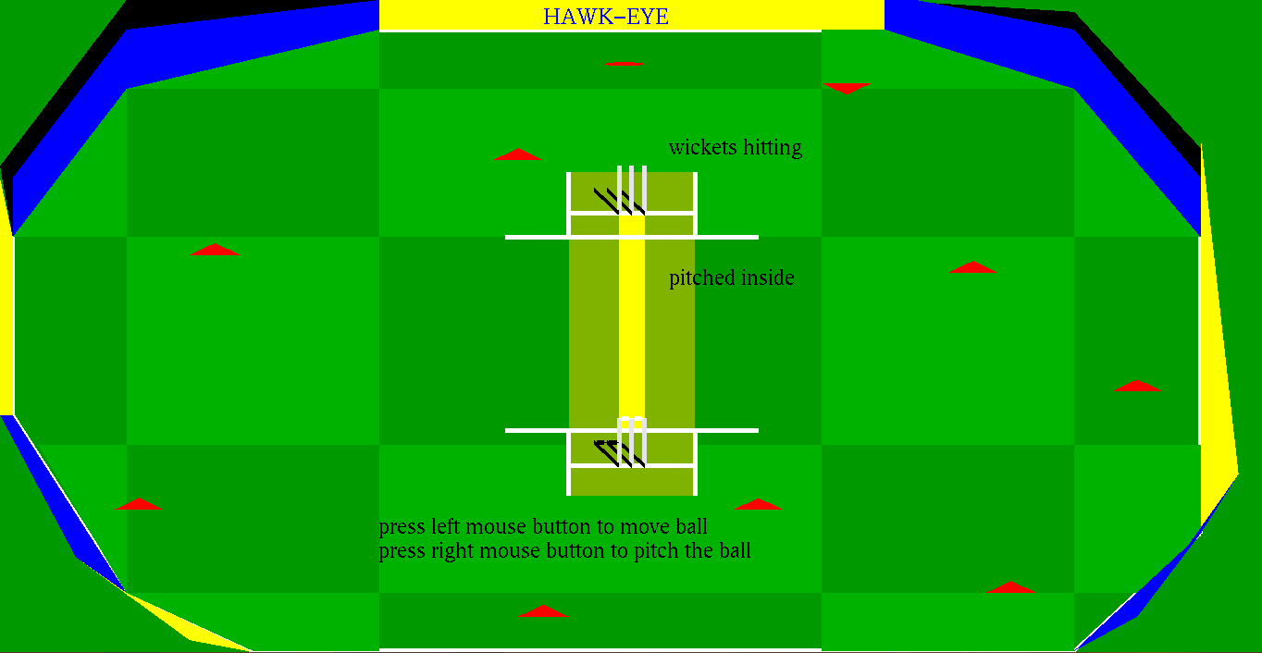

Fig. 5.5: Ball pitching inside and hitting the wickets

The above snap shot shows the ball pitching inside the LBW reference line and hitting the wickets and making the bails to disappear.

5.1: CONCLUSION
This project is to demonstrate the movement and pitching of the ball that helps in making the decision whether a batsman is out or not using OpenGL. This project provides good understanding of OpenGL prominent functions like moving and better mouse interactions. This project would improve the user's knowledge about computer graphics and OpenGL. HAWKEYE has been designed under the windows operating system using Visual C++ 6.0 using <GL/glut.h> library and built-in functions it makes easy to design good graphics package such as Animation.

5.2:BIBLIOGRAPHY
BOOKS
1) Interactive Computer Graphics, Edward Angel, 5th Edition PEARSON Education, 2008.
2) Computer Graphics Using OpenGL, F.S.Hill, Jr,2nd Edition PEARSON Education, 2001.
3) Computer Graphics, James D Foley, Andries Van Dam, Steven K Feiner, John F Hughes, Addison-Wesley,1997.
4) Computer Graphics-OpenGL Version, Donald Hearn and Paulin Baker, 2nd Edition, PEARSON Education, 2003.

LINKS
- www.google.com.
- Wkipedia.org
- www.opengl.org
- www.glprograming.com

5.3:APPENDIX
5.3.1 glColor3f ( )
1. Purpose: Using glColor3f function it is possible to color vertices of 3dimensional with OpenGL parameters we will use the function glColor3f which takes the R, G and B...
2. Prototype: glColor3f (r, g, b);
3. Description: We can use a different color for each vertex.
5.3.2 glBegin ( )
1. Purpose: the glBegin () function which takes as one parameter the “mode” or type of object you want to draw. ...
2. Prototype: glBegin ();
3. Description: All the vertices defined between these two functions will be drawn using the rules given in the glBegin function.
5.3.3 glEnd ( )
1. Purpose: The glBegin and glend functions delimit the vertices of a primitive or a group ... You can use only a subset of OpenGL functions between glBegin and glEnd. ...
2. Prototype: glEnd ( );
3. Description: glVertex is not constrained to be the only function you can use inside glBegin and glEnd. Here is the full listing of all functions you can use inside...
5.3.4 glLoadIdentity ( )
1. Purpose: glLoadIdentity (); This is used in conjunction with 2 other functions called glMatrixMode (GL_PROJECTION) and glMatrixMode (GL_MODELVIEW). ...
2. Prototype: glLoadIdentity ( );
3. Description: glLoadIdentity () happens to be used to clear the rotation of the 'model'. ... Let's call this function again anyway, just before we call glRotatef ()...
5.3.5 glTranslatef ( )
1. Purpose :Multiplies the current matrix by a translation matrix.
2. Prototype : glTranslatef ((frand () - 0.5) * seedsize, (frand () - 0.5) * seedsize, 0.0);
3. Description :This function multiplies the current matrix by a translation matrix.
5.3.6 glVertex2f ( )
1. Purpose: Specifies the 2D coordinates of a vertex.
2. Prototype: void glVertex2f (frand () - 0.5) * seedsize, (frand () - 0.5) * seedsize);
3. Description: This function is used to specify the vertex coordinates of points, lines and polygons.

5.4: glutFunctions()
5.4.1 glutCreateWindow ( )
1. Purpose :Creates an OpenGL enabled window
2. Prototype void glutCreateWindow(char *name);
3. Description :This function creates a top level window in GLUT. This is considered the current window.
5.4.2 glutDisplayFunc ( )
1. Purpose :Sets the display callback function for the current window.
2. Prototype void glutDisplayFunc(void (*func) (void));
3. Description :This function tells GLUT which function to call whenever the windows contents must be drawn.
5.4.3 glutInit( )
1. Purpose :Is used to initialize the GLUT library.
2. Prototype void glutInit(int *argcp, char **argv
3. Description : Will initialize the GLUT library and negotiate a session with the window system.
5.4.4 glutInitDisplayMode( )
1. Purpose :Initializes the display mode of the GLUT library OpenGL window.
2. Prototype void glutInitDisplayMode(unsigned int mode);
3. Description :This is the _rst function that must be called by a GLUT based program to set up the OpenGL window.This function sets the characteristics of the window that OpenGL will use for drawing operations.
5.4.5 glutIdleFunc ( )
1. Purpose :Sets the global idle callback..
2. Prototype void glutIdleFunc(void (*func)(void));
3. Description :Sets the global idle callback to be func so a GLUT program can perform background processing tasks or continuous animation when window system events are not being received.
5.4.6 glutInitWindowSize ( )
1. Purpose :Set the initialwindow size.
2. Prototype void glutInitWindowSize(int width, int height)
3. Description : Windows created by glutCreateWindow will be requested to be created with the current initial window size..
5.4.7 glutMouseFunc (mouse)
1. Purpose: Sets the mouse call-back function for the current window.
2. Prototype: void glutMouseFunc (mouse);
3. Description: This function establishes a call back function called by GLUT whenever one of the ASCII generating keys is pressed..
5.4.8 glutMainLoop ( )
1. Purpose :Starts the main GLUT processing loop
2. Prototype void glutMainLoop(void);
3. Description : This function begins the main GLUT event handling loop. The event loop is where all keyboard, mouse, timer, redraw, and other window messages are handled..

