**[How to Electronically Sign PDF Documents Without Printing and Scanning Them](https://www.howtogeek.com/164668/how-to-electronically-sign-documents-without-printing-and-scanning-them/)**



You’ve been emailed a document, and you have to sign it and send it back. You could print out the document, sign it, and then scan it back in and email it. But there’s a better, faster way.

We’ll show you how to quickly add your signature to any PDF document, saving it as a standard PDF file that can be read anywhere. You can do this on Windows, Mac, iPad, iPhone, Android.

**Windows: Use Adobe Reader**

While Adobe Reader [isn’t the most lightweight PDF viewer](https://www.howtogeek.com/282937/the-best-pdf-readers-for-windows/), it is one of the most feature-packed, and actually has excellent support for signing PDF documents. Other third-party PDF readers may offer this feature, but they generally require you purchase a paid version before using their signature features.

To sign a document using Adobe Reader, first open the PDF document in the [Adobe Acrobat Reader DC](https://clk.tradedoubler.com/click?p(264355)a(2868739)g(22804962)epi(content)epi2(164668)url(https://get.adobe.com/reader/)) application. Click the “Fill & Sign” button in the right pane.

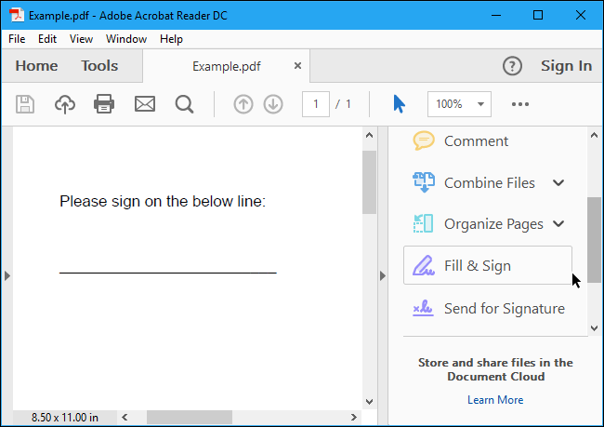

Click the “Sign” button on the toolbar and select “Add Signature” to add your signature to Adobe Acrobat Reader DC.

If you need to add other information to the document, you can use the other buttons on the toolbar to do so. For example, you can type text or add checkmarks to fill in forms using buttons on the Fill & Sign toolbar.

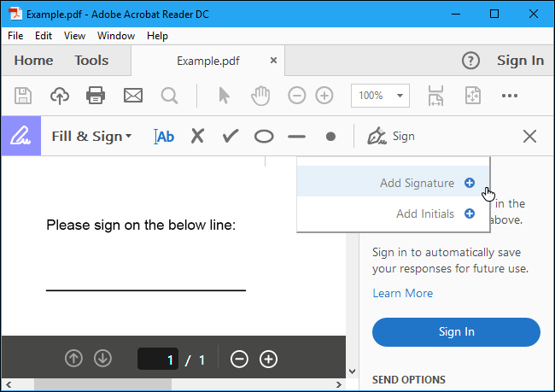

You can create a signature in one of three ways. By default, Adobe Reader selects “Type” so you can type your name and have it converted to a signature. This won’t look like your real signature, so it probably isn’t ideal.

Instead, you’ll probably want to select “Draw” and then draw your signature using your mouse or a touch screen. You can also select “Image” if you’d like to sign a piece of paper, scan it with a scanner, and then add your written signature to Adobe Reader. (Yes, this requires scanning, but you only have to do this once, after which you can use that signature on any documents you electronically sign in the future.)

After creating a signature, click “Apply” to apply it to the document. Leave “Save Signature” checked and you can quickly add this signature in the future.

Position your signature where you want it with your mouse and click to apply it. If you chose to save your signature, you’ll find it easily accessible in the “Sign” menu in the future.

To save your signed PDF document, click File > Save and select a location for the file.

**Mac: Use Preview**

Mac users are luckier than Windows users. The Preview application included with macOS has [integrated document-signing features](https://www.howtogeek.com/201519/use-your-mac%E2%80%99s-preview-app-to-merge-split-mark-up-and-sign-pdfs/). Thanks to the excellent trackpads built into MacBooks, you can actually draw your signature on the trackpad with one of your fingers to enter it into Preview. On a new MacBook with a “Force Touch” trackpad, this is even pressure sensitive, allowing for even more accurate signatures.

You could also just sign a piece of paper and “scan” it with your webcam, if you prefer creating your signature the old-fashioned way (or if you have an iMac with no trackpad).

To sign a document, open a PDF document in Preview (this should be the default app that opens when you double-click on a PDF file, unless you’ve changed it). Click the toolbox-shaped “Show Markup Toolbar” button, and then click the “Sign” button on the toolbar that appears.

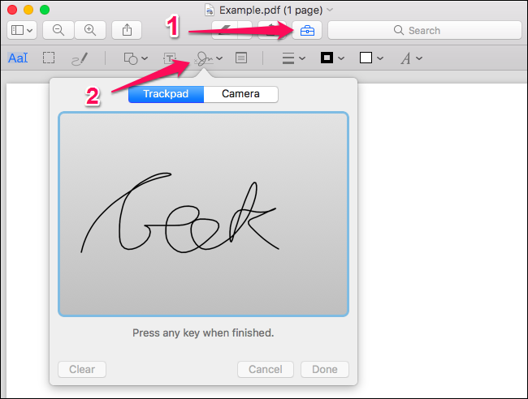

You’ll be prompted to either create a signature by dragging your finger over the trackpad, or by signing a piece of paper and scanning it with your webcam. Capture your signature once and Preview will remember it for the future.

Once you’ve captured a signature, you can select it in the menu that appears after you click the “Sign” button. Your signature is applied as an image that can be dragged around and resized to fit the document.

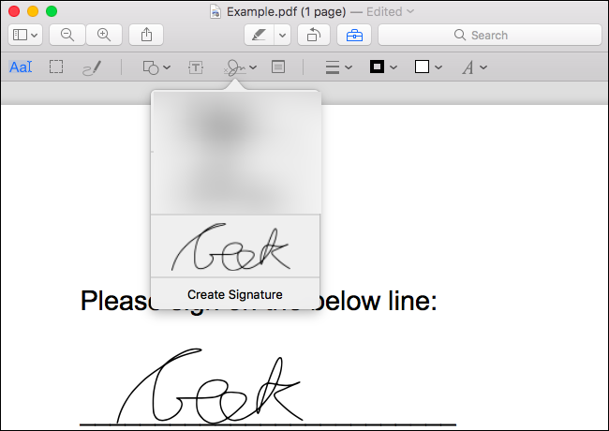

The other options on the toolbar allow you to type text and draw shapes on the document, allowing you to fill in forms, if necessary.

When you’re done, click File > Save to save the PDF, applying your signature to the file. You can also click File > Duplicate instead to create a copy of the PDF and save your changes into a new copy of the file without modifying the original.

If you don’t like Preview for whatever reason, you can also use [Adobe Reader DC](https://clk.tradedoubler.com/click?p(264355)a(2868739)g(22804962)epi(content)epi2(164668)url(https://get.adobe.com/reader/)) on a Mac. It’ll work just like signing a document on Windows, so see the instructions in the Windows section for information on that.

**iPhone and iPad: Use Mail or Adobe Fill & Sign**

On an iPhone or iPad, you can [sign documents using the markup feature in the iOS Mail app](https://www.howtogeek.com/259749/how-to-sign-documents-and-mark-up-attachments-in-ios-mail/). If you have a Mac and use Preview to sign documents, your signature will actually synchronize from your Mac to your iPhone or iPad so you don’t have to create it a second time.

This feature is convenient, but it only works if you want to sign documents in the Mail app. For example, you may be emailed a PDF document and you may need to sign it and email it right back.

To do this, you’ll need to receive an email with a PDF file attached, tap the PDF attachment, and click the toolbox-shaped “Markup and Reply” icon at the bottom right corner of the screen while viewing the PDF.

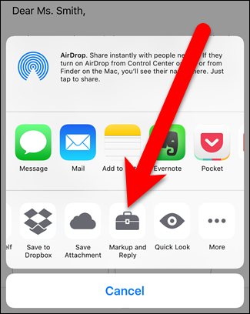

You’ll then be able to add a signature by tapping the signature button at the bottom right corner of your screen. You can also type text and draw on the document, if you like.

When you tap “Done”, the Mail app will automatically create a reply to the email with your signed document attached. You can type an email message and then send the signed document.

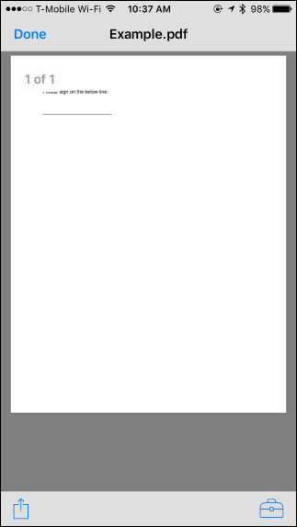 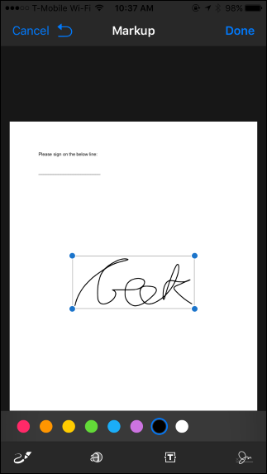

While this is convenient, it only works in the Mail app, so it is very limited. If you want to do this from any other app, you’ll need a third-party signing app.

There are quite a few options here, but we like Adobe’s [Adobe Fill & Sign](https://geo.itunes.apple.com/us/app/adobe-fill-sign-easy-pdf-form/id950099951?mt=8&at=1010loXs&ct=164668) app, which allows you to sign an unlimited number of documents for free. It can even capture pictures of paper documents with your camera, so you can create digital copies of paper forms. You can sign a document by writing on your touch screen with a finger or stylus, and they also allow you to type text into PDF documents to fill them in.

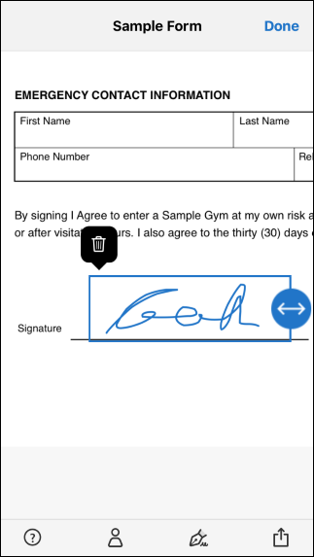 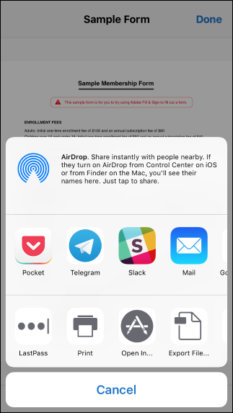

If you’re a business looking for a more full-featured tool, or if you just don’t like Adobe Sign & Fill, we also particularly like [SignNow](https://geo.itunes.apple.com/us/app/signnow-sign-fill-pdf-word/id489262811?mt=8&at=1010loXs&ct=164668). It works very well and allows you to sign documents with your finger. You can sign up to five document a month for free, but after that it requires a monthly subscription fee. It’s a good alternative, though.

**Android: Use Adobe Fill & Sign**

Android doesn’t come with a built-in app that can do this. Instead, you’ll need to use a third-party app. Just like on the iPhone and iPad, we like [Adobe Fill & Sign](https://play.google.com/store/apps/details?id=com.adobe.fas&hl=en), which allows you to sign an unlimited number of documents a month for free. It can also capture pictures of paper documents with your camera so you can sign them electronically.

After installing the app, you can open PDF documents in the app and tap the signature button to sign them. You can then share the signed document with another app by tapping the “Share” button.

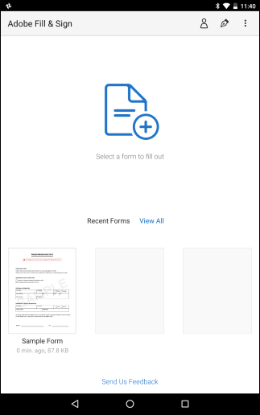 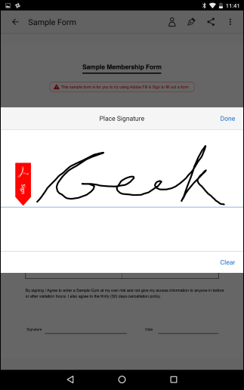

 Just like on iOS, we also recommend [SignNow](https://play.google.com/store/apps/details?id=com.signnow.android&hl=en) if you want something a bit more feature-filled and are willing to pay (since it only offers up to five signatures a month for free).