**Global Quest Technologies**

**PROJECTREPORT ON**

**“Resume”**

**Using Front-End Technologies**

Submitted by

Sripuram Ramya

(GQT-S0166)

Under the esteemed guidance of

Keshav

(Front-End Trainer at GQT)

________________ ___________________

Signature of Trainer Signature of CEO(GQT)

Keshav Murthy NARENDRA REDDY

Date: Date:

**INTRODUCTION**

**Resume**

**Scope of the document:-**

Creating a resume website using HTML and CSS is a modern approach to personal branding and professional self-presentation. This endeavor involves the utilization of fundamental web development technologies to craft a personalized online portfolio. The process begins with careful content planning, including sections for introductions, resumes, portfolios, and potentially blogs or testimonials. The website's visual and structural elements are determined through HTML, while CSS is employed to style and layout the content. Responsive design is a key consideration to ensure the site's accessibility across various devices. Additionally, aspects such as domain registration, hosting, SEO optimization, and regular updates are fundamental components of this project. Crafting a resume website serves as a powerful tool for showcasing one's skills, experiences, and accomplishments in an interactive and accessible manner.

**HISTORY OF HTML:**

**HTML** stands for **Hyper Text Markup Language**.

* It is used to share the information over the internet.
* HTML id developed by Tim Berner’s Lee in 1991.But officially in 1993.
* The First version of HTML consists of “18 tags”
* HTML follows certain rules and regulations setup by “**ISO**”.
* International Organization for standardization is set of rules and regulation are present in ‘**SGML**’ document.

**Versions of HTML**

* **HTML-1** version in the year 1993.
* **Html-2** version in the year 1995.
* **HTML-3.02** version in the year 1997.
* **HTML-4.1** version in the year 1999.
* **HTML-5** version in the year 2014.

**Features of HTML**

* It is easy to Learn.
* It is a tag based language.
* HTML is supported by multiple browsers.
* First web browser is Netscape navigation which was developed by the “Mosiac”.
* It is a portable language.
* **WORA** stands for ‘write once run anywhere’

**Limitation of HTML**

* HTML has less designing capabilities.
* It is dependent on other technology such as CSS in order to develop well designed Webpages.
* HTML has no programming capabilities.
* Using HTML and CSS we can develop only static Web page.
* In order to write the HTML code required an editor such as VS Code, Notepad, Eclipse.
* In order to execute the HTML code we required Web browsers.Like Chrome, Firefox, edge, Opera Safari .

**CSS**

* **CSS** stands for Cascading Style Sheets.
* It was developed by W3C to add stylings to the HTML elements.
* W3C stands for World Wide Web.com

**Versions of CSS:**

* **CSS-1** (level-1) in the year 1996.
* **CSS-2** (level-2) in the year 1998.
* **CSS-3** (level-3) in the year 1999.

**Why do we required CSS ?**

* Since HTML has less designing capabilities we cannot create well designed or most appealing Websites.
* Using HTML we cannot add style, animation and transitions to the Webpage.
* Therefore we require CSS to create well designed Webpages.

**Advantages of CSS**

* It allows to add styles, animation and variouses effects to the Webpage.
* It allows us to develop the Webpage rapidly. It is also know as RAD ( rapid application Developer).
* It allows us to separate from formatting develop page to the presentation of Webpage.
* It allows to create well designed Websites.

**Limitations of CSS**

* Using CSS we can perform static styles for the Webpages.
* In order to create dynamic styling for the Websites. We must make use of scripting language such as JavaScript and Libraries of JavaScript.

**Types of CSS:**

1. Inline CSS
2. Internal CSS
3. External CSS
4. Default Browser CSS

**Inline CSS:**

Defining all the CSS properties within the style attribute inside the opening of the tag is referred to as Inline CSS.

**Internal CSS:**

Defining all the CSS properties within <style> inside the HTML document is referred to as Internal CSS.

**External CSS:**

Defining all the CSS properties within as external Script or File with an extension CSS is referred to as External CSS.

* In order to link external CSS file within the HTML document we must use of <link>.
* The value for the ‘ref’ attribute should be ‘stylesheet’.

**Root Structure:**

**RESUME**

→**CODE**

→**HTML_Files**

→Resume.html

→**CSS_Files**

→Resume.css

**PROJECT REPORT**

→FRONT END PROJECT 1 RESUME.DOC

**SCREENSHOTS**

→ALL THE CORRESPONDING SCREENSHOTS OF PAGES.

**Our Project**

**Resume2.html**

**Source Code:-**

<!DOCTYPE html>

<html lang="en">

<head>

    <meta charset="UTF-8">

    <meta name="viewport" content="width=device-width, initial-scale=1.0">

    <title>Document</title>

    <link rel="stylesheet" href="Resume2.css">

</head>

<body>

    <div class="container">

        <div class="header">

            <div id="corner"></div>

            <h1 id="name">SRIPURAM RAMYA</h1>

            <p id="name2">FULLSTACK DEVELOPER</p>

            <p id="obj">I am currently looking for a job where I can hone my skills and enjoy my work with problem solving skills and interacting with people who help me to bolster my career choice. I am open to learning new and diversified technologies without boundaries to enhance my professional skills.</p>

         </div>

        <div class="body1">

           <div style="padding-top: 1px;"> <h3 class="inHead">Internship</h3></div>

                <div class="ins">

                     <p>Oct 2021- Dec 2021</p>

                     <h4 class="com">AICTE </h4>

                     <p>Cyber Security Virtual Internship</p>

                     <p class="dis">Learned about introduction to Cyber Security, Fundamentals of network

                        security and Fundamentals of cloud security</p>

                      <p class="dur">Jun 2022-Sep 2022</p>

                      <h4 class="com">SMARTINTERNZ </h4>

                      <p > Salesforce Virtual Internship</p>

                      <p>It is an Internship of 8 weeks where java programming is used

                         Learned about basic salesforce concepts</p>

                      <p>April 2022 - July 2022</p>

                      <h4 class="com">GOOGLE </h4>

                      <p > Google Cloud Ready Facilitator</p>

                      <p></p>Worked on hands-on-labs in google cloud platform

                        Learned about Cloud Computing Concepts</p>

                </div>

                <div style="margin-top: -45px;"><h3 class="inHead">Projects</h3></div>

                    <div class="Edu1">

                        <h4>Detecting Phishing Websites | ML based Project </h4>

                        <ul class="list-item1">

                          <li>Designed a website forfake website detection</li>

                          <li>Obtained an accuracy of 97 percent using logistic regression algorithm</li>

                          <li>TeckStack:HTML,CSS,JAVASCRIPT,Python</li>

                        </ul>

                        <h4 >Credit Card Fraud Detection | ML based Project </h4>

                        <ul class="list-item1">

                          <li>Developed a simple website that detects the credit card fraud using machine

                            learning algorithm</li>

                          <li>TeckStack:HTML,CSS,JAVASCRIPT,Python</li>

                        </ul>

                    </div>

                    <div><h3 class="inHead">CERTIFICATIONS</h3></div>

                    <div class="Edu1">

                        <ul class="list-item1">

                         <li>Pursuing Java Full stack and Software Testing Full stack course</li>

                         <li>TCS IONCareer Edge-Young Professional</li>

                         <li>Newindia Learnathon 2021 By ICT Academy</li>

                         <li>WEB Design and Development foundation training</li>

                         <li>Architecting with google compute engine by coursera</li>

                         <li>Published a paper in ICISMRSS 2022</li>

                        </ul>

                    </div>

        </div>

        <div class="side">

            <img src="PHOTO.jpg" alt="img" width="75%" height="220px" id="img1">

            <h3 class="cnt">Education</h3>

            <div class="Edu">

                 <p class="year">2020-2023</p>

                 <h4 class="Branch">B.Tech in Computer Science </h4>

                 <p class="clg"> Sree Vidyanikethan Engineering College,Tirupati</p>

                 <p class="per">Cum. GPA: 8.95 / 10.0</p>

                 <p class="year1">2017-2020</p>

                 <h4 class="Branch">Diploma in CSE</h4>

                 <p class="clg">Sri Venkateswara Government Polytechnic , Tirupati</p>

                 <p class="per">Percentage: 86.44 / 100</p>

            </div>

            <div class="skills">

              <h3 class="cnt">Skills</h3>

                <ul class="list-item">

                   <li>Core Java / Advanced Java</li>

                   <li>Core Python/ Advanced Python</li>

                   <li>Manual Testing</li>

                   <li>Automation Testing</li>

                   <li>HTML5 & CSS3 ,&nbsp;Bootstrap

                    JavaScript ,ES6</li>

                   <li>SQL</li>

                   <li>Git & GitHub<code>(Beginner)</code></li>

                </ul>

          </div>

          <div class="skills">

            <h3 class="cnt">Achievements</h3>

            <ul class="list-item">

                 <li>Java In Hackerrank ⭐⭐⭐⭐⭐</li>

                 <li>MySQL in Hackerrank ⭐⭐⭐⭐</li>

              </ul>

        </div>

            <div class="skills">

                <h3 class="cnt">Strengths</h3>

                <ul class="list-item">

                     <li>Communication Skills</li>

                     <li>Quick Learner</li>

                     <li>Adaptability</li>

                     <li>Team Player</li>

                  </ul>

            </div>

            <div class="skills">

                <h3 class="cnt">Languages</h3>

                <ul class="list-item">

                     <li>Telugu</li>

                     <li>English</li>

                     <li>Kannada</li>

                  </ul>

            </div>

            <div class="Contact-Info" >

              <h3 class="cnt">Contact</h1>

                <ol>

                  <li class="CnInfo">Tirupati, Andhra Pradhesh</li>

                  <li class="CnInfo">+91 &nbsp;6305521095</li>

                  <li class="CnInfo">Sripuramramya275@gmail.com</li>

                  <a href="https://www.linkedin.com/in/sripuram-ramya-385662214" target="_blank">sripuram-ramya-385662214</a>

                </ol>

          </div>

        </div>

    </div>

</body>

</html>

**Resume2.css:**

body{

    margin: 0px;

    padding: 0px;

    font-family:sans-serif;

}

.container{

    border: 1px solid gray;

    width: 75%;

    height: 1479px;

    margin-left: 13%;

    margin-top: 3%;

    border-radius: 14px;

    margin-bottom: 3%;;

}

.header{

    height: 280px;

    background-color: skyblue;

    border-top-left-radius: 14px;

    border-top-right-radius: 14px;

}

#corner{

    width: 25%;

    height: 40px;

    border: 1px solid rgb(24, 23, 23);

    background-color: rgb(24, 23, 23);

    float: right;

    border-top-right-radius: 14px;

    border-bottom-left-radius: 50px;

}

#name{

    float: right;

    margin-top: 70px;

    margin-right: 66px;

}

#name2{

    float: right;

    margin-top: 110px;

    margin-right: -195px;

}

#obj{

    float:right;

    width: 55%;

    height: 75px;

    margin-right: 57px;

    margin-top: 12px;

}

#img1{

    margin-left: 34px;

    border-radius: 50%;

    margin-top: 25px;

}

.body1{

    height: 1165px;

    background-color: white;

    border-bottom-left-radius: 14px;

    border-bottom-right-radius: 14px;

}

.ins{

    padding-bottom: 30px;

    width: 50%;

    margin-left: 329px;

    padding-left: 46px;

    height: 450px;

}

.inHead{

    text-transform: uppercase;

    color:white;

    border: 2px solid rgb(24, 23, 23);

    background-color: rgb(24, 23, 23);

    border-top-right-radius: 25px;

    border-bottom-right-radius: 25px;

    width: 35%;

    padding-left: 20px;

    min-height: 30px;

    line-height: 30px;

    margin-left: 350px;

}

.com{

    line-height: 2px;

}

.Edu1{

    padding-left: 380px;

}

.side{

   width: 30%;

   height: 1460px;

   border: 2px solid rgb(49, 48, 48);

   background-color: rgb(49, 48, 48);

   margin-top: -1430px;

   margin-left: 50px;

   border-top-right-radius: 150px;

   border-top-left-radius: 150px;

}

.Contact-Info{

    margin-top: 20px;

}

.cnt{

    text-transform: uppercase;

    color: black;

    border: 2px solid skyblue;

    background-color:skyblue;

    border-top-right-radius: 25px;

    border-bottom-right-radius: 25px;

    min-height: 30px;

    line-height: 30px;

    padding-left: 30px;

    width: 50%;

    margin-left: -2px;

}

.CnInfo{

    color: aliceblue;

    list-style-type: none;

    line-height: 25px;

    margin-top: -3px;

}

a{

    text-decoration: none;

    color: white;

}

.Edu{

    margin-left: 36px;

}

.year{

    color: white;

}

.year1{

    color: white;

    margin-top: 29px;

}

.Branch{

    color: white;

    line-height: 9px;

    margin-top: -6px;

}

.clg{

    color: white;

    margin-top: -6px;

}

.per{

    margin-top: -6px;

    color: white;

}

.list-item{

    margin-top: -4px;

    color: white;

    padding-left: 50px;

    line-height: 25px;

}

.list-item1{

    color: Black;

    padding-left: 50px;

    line-height: 25px;

}

Output:

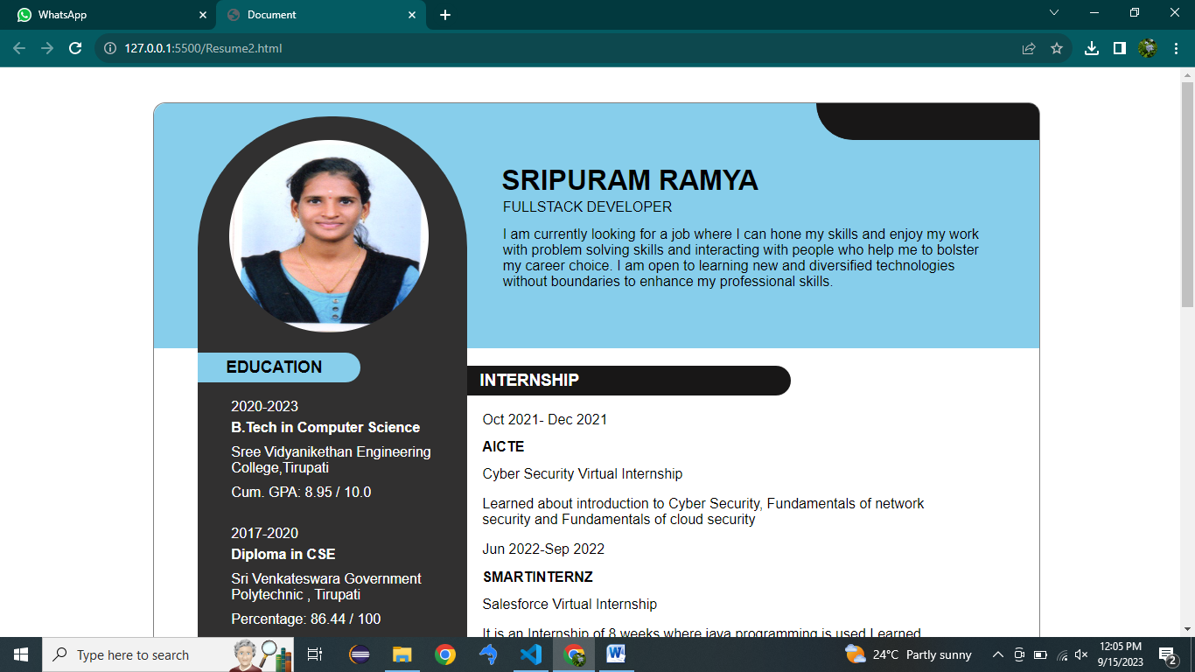

Fig1.1

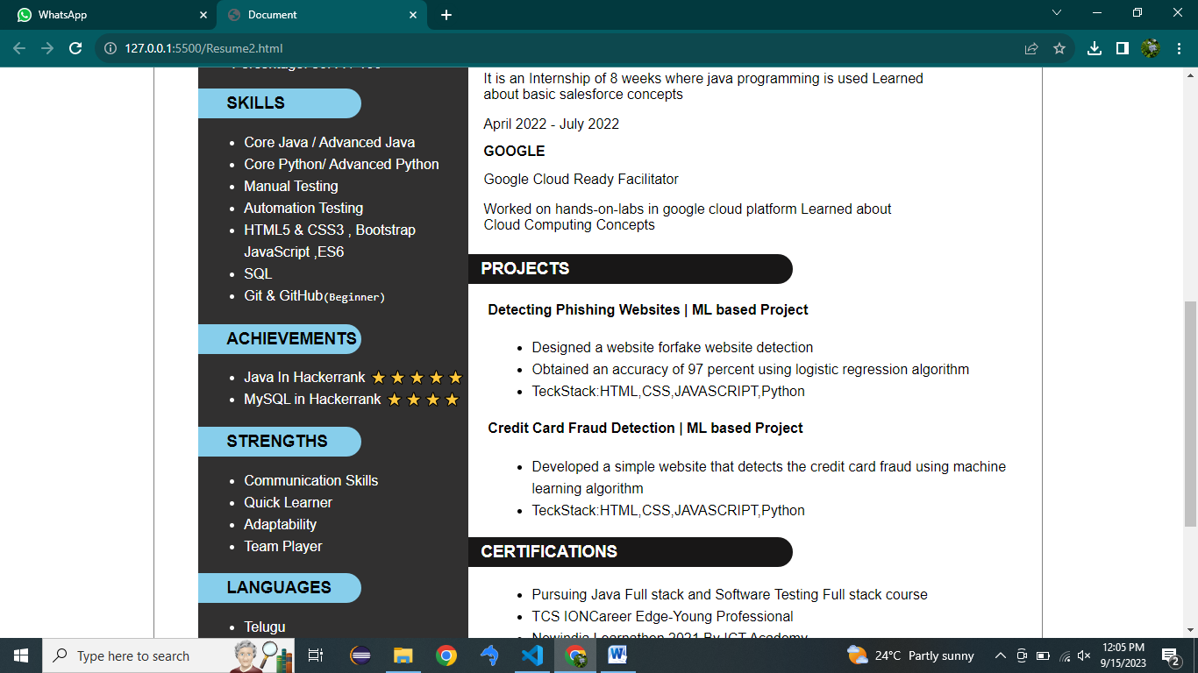

Fig:1.2

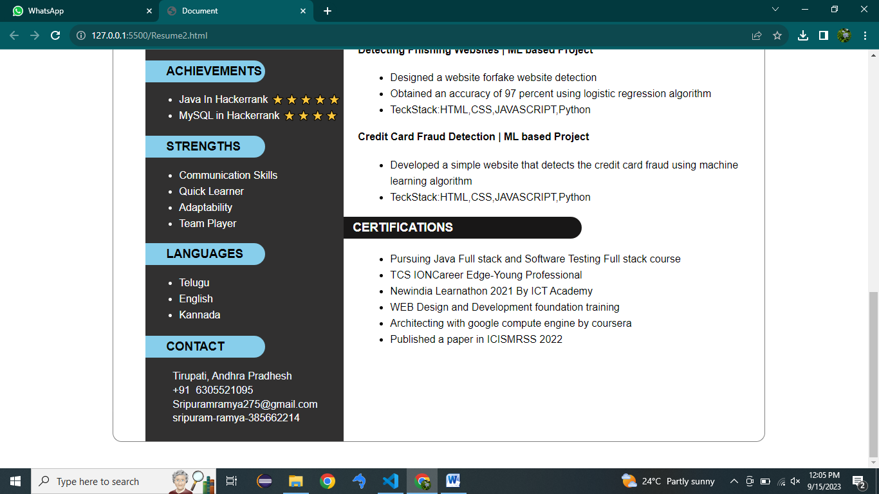

Fig:1.3

**Conclusion**

In conclusion, the creation of a resume website using HTML and CSS offers an innovative means to elevate one's online presence and professional image. This undertaking, encompassing content planning, web development, and continuous maintenance, empowers individuals to present themselves effectively to potential employers or audiences. The fusion of HTML for content structuring and CSS for visual styling results in a personalized and responsive web platform. Beyond the technical aspects, this project facilitates domain and hosting management, search engine optimization, and the opportunity for periodic updates to reflect evolving experiences and achievements. Ultimately, a well-crafted resume website stands as a dynamic testament to an individual's skills and qualifications in the digital age, enhancing opportunities for career growth and personal branding.