**Global Quest Technologies**

**PROJECTREPORT ON**

**“SR Technologies(Own project)”**

**Using Front-End Technologies**

Submitted by

Sripuram Ramya

(GQT-S0166)

Under the esteemed guidance of

Keshav Murthy

(Front-End Trainer at GQT)

________________ ___________________

Signature of Trainer Signature of CEO(GQT)

Keshav Murthy NARENDRA REDDY

Date: Date:

**INTRODUCTION**

**HISTORY OF HTML:**

**HTML** stands for **Hyper Text Markup Language**.

* It is used to share the information over the internet.
* HTML id developed by Tim Berner’s Lee in 1991.But officially in 1993.
* The First version of HTML consists of “18 tags”
* HTML follows certain rules and regulations setup by “**ISO**”.
* International Organization for standardization is set of rules and regulation are present in ‘**SGML**’ document.

**Versions of HTML**

* **HTML-1** version in the year 1993.
* **Html-2** version in the year 1995.
* **HTML-3.02** version in the year 1997.
* **HTML-4.1** version in the year 1999.
* **HTML-5** version in the year 2014.

**Features of HTML**

* It is easy to Learn.
* It is a tag based language.
* HTML is supported by multiple browsers.
* First web browser is Netscape navigation which was developed by the “Mosiac”.
* It is a portable language.
* **WORA** stands for ‘write once run anywhere’

**Limitation of HTML**

* HTML has less designing capabilities.
* It is dependent on other technology such as CSS in order to develop well designed Webpages.
* HTML has no programming capabilities.
* Using HTML and CSS we can develop only static Web page.
* In order to write the HTML code required an editor such as VS Code, Notepad, Eclipse.
* In order to execute the HTML code we required Web browsers.Like Chrome, Firefox, edge, Opera Safari .

**CSS**

* **CSS** stands for **Cascading Style Sheets**.
* It was developed by W3C to add stylings to the HTML elements.
* W3C stands for World Wide Web.com

**Versions of CSS:**

* CSS-1 (level-1) in the year 1996.
* CSS-2 (level-2) in the year 1998.
* CSS-3 (level-3) in the year 1999.

**Why do we required CSS ?**

* Since HTML has less designing capabilities we cannot create well designed or most appealing Websites.
* Using HTML we cannot add style, animation and transitions to the Webpage.
* Therefore we require CSS to create well designed Webpages.

**Advantages of CSS**

* It allows to add styles, animation and variouses effects to the Webpage.
* It allows us to develop the Webpage rapidly. It is also know as RAD ( rapid application Developer).
* It allows us to separate from formatting develop page to the presentation of Webpage.
* It allows to create well designed Websites.

**Limitations of CSS**

* Using CSS we can perform static styles for the Webpages.
* In order to create dynamic styling for the Websites. We must make use of scripting language such as JavaScript and Libraries of JavaScript.

**Types of CSS:**

1. Inline CSS
2. Internal CSS
3. External CSS
4. Default Browser CSS

**Inline CSS:**

Defining all the CSS properties within the style attribute inside the opening of the tag is referred to as Inline CSS.

**Internal CSS:**

Defining all the CSS properties within <style> inside the HTML document is referred to as Internal CSS.

**External CSS:**

Defining all the CSS properties within as external Script or File with an extension CSS is referred to as External CSS.

* In order to link external CSS file within the HTML document we must use of <link>.
* The value for the ‘ref’ attribute should be ‘stylesheet’.

**SR Technologies**

**Scope of the document**

This project report outlines the development and implementation of the SR Technologies website, a platform designed to offer both internship opportunities and a wide range of online courses. The SR Technologies website aims to connect aspiring interns with meaningful internships and provide a diverse selection of courses to enhance their skills and knowledge.

The SR Technologies website project represents a dynamic and innovative endeavor aimed at bridging the gap between education and career development. This project seeks to create a comprehensive online platform that seamlessly integrates both internship opportunities and a wide range of educational courses. SR Technologies envisions this platform as a powerful resource for individuals seeking to enhance their skills, knowledge, and career prospects. By providing a single, user-friendly portal for internships and courses, we aim to simplify and enrich the learning and career development experience for our users.

**Technologies Used**

* HTML5
* CSS3

**Our Project**

**Source Code:-**

own.html:

<!DOCTYPE html>

<html lang="en">

<head>

<meta charset="UTF-8">

<meta name="viewport" content="width=device-width, initial-scale=1.0">

<title>Document</title>

<link rel="stylesheet" href="own.css">

<link rel="stylesheet" href="https://cdnjs.cloudflare.com/ajax/libs/font-awesome/4.7.0/css/font-awesome.min.css">

</head>

<body>

<nav>

<h2>SR Technologies</h2>

<a href="own.html" class="sty1"><li class="li2">Home</li></a>

<a href="#internships" class="sty1" style="width: 8%; "><li class="li2">Internships</li></a>

<a href="#coursess" class="sty1" style="width: 6%;"><li class="li2">Courses</li></a>

<a href="#contact" class="sty1" style="width: 9%;"> <Li class="li2">Contact Us</Li></a>

<div class="search2">

<input type="search" id="search1" placeholder="search">

<a href=""><i class="fa fa-search"></i></a>

</div>

<form action="">

<button type="submit" class="button1"> <a href="login.html" target="_blank" class="a1">Login </a></button>

<button type="submit"class="button1"> <a href="Register.html" target="_blank"  class="a1">Register </a></button>

</form>

</nav>

<hr>

<div class="body2">

<h1 id="head1">We Empower you to find the right career path</h1>

<p id="para1">Join the Virtual Internship Program in emerging technologies with SR Technologies</p>

<div style="margin-top: 10px;">

<form action="">

<button type="submit" id="now"> <a href="apply.html" target="_blank" class="a1">Apply Now</a></button>

</form>

</div>

</div>

<div style="margin-top: 50px;">

<h2 id="head2">Trending Internship</h2>

</div>

<div class="cls">

<div class="course1">

<div class="cousre-details">

<h2>Web Development <br> Internship</h2>

<p>Duration: 1 Month</p>

<p><i class="fa fa-rupee"></i> 23345/-</p>

<form action="">

<button type="submit" id="Apply"> <a href="apply.html" target="_blank" class="a1">Apply Now</a></button>

</form>

</div>

</div>

<div class="course1 course2">

<div class="cousre-details">

<h2>Cloud Computing Internship</h2>

<p id="dur">Duration: 1 Month</p>

<p><i class="fa fa-rupee"></i> 23345/-</p>

<form action="">

<button type="submit" id="Apply"> <a href="apply.html" target="_blank" class="a1">Apply Now</a></button>

</form>

</div>

</div>

<div class="course1 course3">

<div class="cousre-details">

<h2>Java Programming Internship</h2>

<p id="dur">Duration: 1 Month</p>

<p><i class="fa fa-rupee"></i> 23345/-</p>

<form action="">

<button type="submit" id="Apply"> <a href="apply.html" target="_blank" class="a1">Apply Now</a></button>

</form>

</div>

</div>

</div>

<div style="margin-top: 50px;">

<a name="coursess"></a>

<h2 id="head2">Our Courses</h2>

</div>

<div class="Services1">

<div class="srv1">

</div>

<div class="srv2">

<h2 style="color: blue;margin-bottom: 10px;">Website Development</h2>

<p style="line-height: 22px; word-spacing: 2px;font-size: 15px;">Our Website Developers Provide Expert Web Application Development And Web Design Services To Our Clients. SR Technologies Offers A Variety Of Website Design And Development Services, We Specialize In Developing Interactive, Scalable, Brand-Oriented, And Business-Ready Custom Web Solutions. Our Aim Is To Build Profitable Digital Products Engineered To Spark Creativity And Boost.</p>

<form action="">

<button type="submit" id="Apply"> <a href="apply.html" target="_blank" class="a1">Apply Now</a></button>

</form>

</div>

</div>

<div class="Services1">

<div class="srv2">

<h2 style="color: blue;margin-bottom: 10px;">Cloud Computing</h2>

<p style="line-height: 22px; word-spacing: 2px;font-size: 15px;">Whatever Type Of Cloud Computing Services You Use, One Thing Is Certain: Large Quantities Of Data Will Move Back And Forth Between Your End Users And The Cloud Provider's Data Centers, Over The Internet. That's Why Whatever Type Of Cloud Services You Use, SR Technologies Can Help Your Organization Have A Better Cloud Experience And Reap Greater Benefits From Your Cloud Services Investment.</p>

<form action="">

<button type="submit" id="Apply"> <a href="apply.html" target="_blank" class="a1">Apply Now</a></button>

</form>

</div>

<div class="srv1 srev2">

</div>

</div>

<div class="Services1">

<div class="srv1 srev3">

</div>

<div class="srv2">

<h2 style="color: blue;margin-bottom: 10px;">Graphic Design</h2>

<p style="line-height: 22px; word-spacing: 2px;font-size: 15px;">Our Creative Designers Offer Outstanding And Attention-Grabbing Visuals For Brochures, Banners, Flyers, Logos, Business Cards, E-Books, And Many More. Our Graphic Designs Can Develop A Great Impression On Your Prospect’s Mind. With A Complete Mixture Of Professionalism And Stunning Creativity Skills, Our Expert Designers Can Establish A Bright Profile For Your Business In The Online World.</p>

<form action="">

<button type="submit" id="Apply"> <a href="apply.html" target="_blank" class="a1">Apply Now</a></button>

</form>

</div>

</div>

<div class="Services1">

<div class="srv2">

<h2 style="color: blue;margin-bottom: 10px;">Animation Design</h2>

<p style="line-height: 22px; word-spacing: 2px;font-size: 15px;">Animations Make Your Brand More Engaging And Interactive. This Makes Them Great Assets To Share On Social Media, Distribute Through Email, Feature Internally And Host On Your Website—They’re That Versatile. Our Passionate Team Of Motion Graphics Designers Empower You To Tell Great Stories For Your Business. We Believe It's Only When You Tell Great Stories You Become One.</p>

<form action="">

<button type="submit" id="Apply"> <a href="apply.html" target="_blank" class="a1">Apply Now</a></button>

</form>

</div>

<div class="srv1 srev4">

</div>

</div>

<div class="Services1">

<div class="srv1 srev5">

</div>

<div class="srv2">

<h2 style="color: blue;margin-bottom: 10px;">Database Management</h2>

<p style="line-height: 22px; word-spacing: 2px;font-size: 15px;">Your Databases Are At The Core Of Your Business. Whether You’re Operating On-Premises Or In The Cloud, Using A Traditional Or Open-Source Platform, Our Global Experts Are Available Around The Clock To Help You Turn Your Databases Into A Business Differentiator. We Offer A Full Range Of Solutions To Support Your Needs—From Assuming Total Ownership Of Your Database Environment To Augmenting Your Internal Team To Helping You Refactor For The Cloud.</p>

<form action="">

<button type="submit" id="Apply"> <a href="apply.html" target="_blank" class="a1">Apply Now</a></button>

</form>

</div>

</div>

<div class="Services1">

<div class="srv2">

<h2 style="color: blue;margin-bottom: 10px;">Machine Learning Solutions</h2>

<p style="line-height: 22px; word-spacing: 2px;font-size: 15px;">Artificial Intelligence & Machine Learning Offerings Help Organizations Build Highly-Customized Solutions Running On Advanced Machine Learning Algorithms. Our Machine Learning Services Offer Advanced Algorithms To Help Organizations In Solving Key Business Challenges, Enabling Data-Driven Decision Making And Creating Innovative Business Models.</p>

<form action="">

<button type="submit" id="Apply"> <a href="apply.html" target="_blank" class="a1">Apply Now</a></button>

</form>

</div>

<div class="srv1 srev6">

</div>

</div>

<div  class="Internship">

<a name="internships"></a>

<h2 id="head2">Our Internships</h2>

<div class="inter1">

<div class="int1">

<img src="Website designer.svg" width="50%" class="inter-img">

<h2 class="interns-head">Web Development Internship</h2>

<p class="interns-para">The Web Development Internship Offers Practical Work Experience And An Introduction To Creating And Improving Web-Based Systems. This Internship Will Involve Challenging Opportunities, Real World Projects. It’s A Fantastic Opportunity To Gain Hands-On Experience In The Web And/Or App Development Field With An Award-Winning Innovation Team.</p>

<form action="">

<button type="submit" class="Apply1" style="margin-top: 40px;"> <a href="apply.html" target="_blank"class="a2">Apply Now</a></button>

</form>

</div>

<div class="int1">

<img src="ui.svg" alt="" width="50%" class="inter-img">

<h2 class="interns-head">Graphic Design Internship</h2>

<p class="interns-para">With A Graphic Design Internship, You Will Be Involved In Projects That Focus On Nearly Every Aspect Of A Business’s Visual Design Strategies. Your Internship Tasks May Include Creating Graphic And Video Content, Template Design, Web Design Work, And Many More Exciting Tasks. Plus Our Graphic Design Internships Range In Industries, So We Work With You To Find One That Best Matches Your Career Goals.</p>

<form action="">

<button type="submit" class="Apply1"> <a href="apply.html" target="_blank" class="a2">Apply Now</a></button>

</form>

</div>

<div class="int1">

<img src="Coworking-rafiki (1).svg" alt="" width="50%" class="inter-img">

<h2 class="interns-head">Java Programming</h2>

<p class="interns-para">Master The Fundamentals Of Programming In Java From The Comfort Of Your Home And Get Certified To Apply For Great Job Opportunities. A With 4-Week Comprehensive Internship Program Where You Will Learn Right From Development To Deployment Of Web Applications Made Using Java. Get First-Hand Exposure To Working In The Real World, Build Your Professional Network, Integrate Classroom Knowledge.

</p>

<form action="">

<button type="submit" class="Apply1"> <a href="apply.html" target="_blank" class="a2">Apply Now</a></button>

</form>

</div>

</div>

<div class="inter1">

<div class="int1">

<img src="Website designer.svg" width="50%" class="inter-img">

<h2 class="interns-head">Android Development</h2>

<p class="interns-para">Android Is An Open Source Operating For Mobile Application Development.Now A Days People Continuously Shifting To Mobile Devices To Access Internet Application And Other Important Tasks.Which Is More Easy Than To Work On PC.It It Best Choice To Getting Started Your First App With SR Technologies.</p>

<form action="">

<button type="submit" class="Apply1" style="margin-top: 42px;"><a href="apply.html" target="_blank" class="a2">Apply Now</a></button>

</form>

</div>

<div class="int1">

<img src="ui.svg" alt="" width="50%" class="inter-img">

<h2 class="interns-head">Data Science Internships</h2>

<p class="interns-para">Remote Data Science Internships Are A Unique Chance To Gain Experience In The Midst Of The Virtual Workforce While Remaining Immersed In One Of The Top Organizations In The Field. Data Analysis Internships Are Some Of The Most Competitive And Popular Within The Broader Data Science Field.</p>

<form action="">

<button type="submit" class="Apply1" style="margin-top: 40px;"> <a href="apply.html" target="_blank"class="a2">Apply Now</a></button>

</form>

</div>

<div class="int1">

<img src="Coworking-rafiki (1).svg" alt="" width="50%" class="inter-img">

<h2 class="interns-head">Cloud Computing Internship</h2>

<p class="interns-para">We Offers, Cloud Computing Internship . Cloud Internship – Provides You An In-Depth Knowledge On Cloud Computing. This Cloud Computing Internship For Freshers , Enables The Students To Understand And Learn The Current Trend In The Job Market. Students Will Prefer Cloud Computing Training To Build Their Profile For Their Jobs And Also For Their Higher Studies.</p>

<form action="">

<button type="submit" class="Apply1"> <a href="apply.html" target="_blank" class="a2">Apply Now</a></button>

</form>

</div>

</div>

</div>

<hr style="margin-top: 40px;">

<div class="Rating">

<div class="rating1">

<h2 class="head4">300K+</h2>

<p class="para2">companies hiring</p>

</div>

<div class="rating1">

<h2 class="head4">10K+</h2>

<p class="para2">new openings everyday</p>

</div>

<div class="rating1">

<h2 class="head4">21Mn+</h2>

<p class="para2">active students</p>

</div>

<div class="rating1">

<h2 class="head4">600K+</h2>

<p class="para2">learners</p>

</div>

</div>

<div style="margin-top: 40px; display: flex;height: 350px; padding-left: 290px; background:linear-gradient(135deg,rgb(118, 157, 184),rgb(187, 85, 178)); border-radius: 30px;">

<ul class="ul1">

<h3 class="list">Quick Links</h3> <br>

<li class="list1"><a href="own.html" class="a1">Home</a></li>

<li class="list1"><a href="#internships"class="a1">Internships</a></li>

<li class="list1"><a href="#coursess" class="a1">Courses</a></li>

<li class="list1"><a name="contact" class="a1">Contact Us</a></li>

</ul>

<ul class="ul1">

<h3 class="list">Follow Us</h3> <br>

<li class="list1"><a href="https://www.facebook.com/" target="_blank" class="a1"><i class="fa fa-facebook-square a1" style="padding-right:10px;"></i>Facebook</a></li>

<li class="list1"><a href="https://www.instagram.com/" target="_blank" class="a1"><i class="fa fa-instagram a1"style="padding-right:10px;"></i>Instagram</a></li>

<li class="list1"><a href="https://www.LinedIn.com/" target="_blank" class="a1"><i class="fa fa-linkedin-square a1"style="padding-right:10px;"></i>LinedIn</a></li>

<li class="list1"><a href="https://www.twitter.com/" target="_blank" class="a1"><i class="fa fa-twitter a1"style="padding-right:10px;"></i>Twitter</a></li>

</ul>

<ul class="ul1">

<h3 class="list">Contact Info</h3> <br>

<li class="list1"><a href="https://.google.com/"  class="a1"><i class="fa fa-envelope"style="padding-right:10px;"></i>contact@srtech.in</a></li>

<li class="list1"><a href="" class="a1"><i class="fa fa-envelope"style="padding-right:10px;"></i>Services.srtech@gmail.com</a></li>

<li class="list1"><a href="https://www.google.com/maps" class="a1"><i class="fa fa-map-marker" style="font-size:24px;padding-right:10px;"></i>Tirupati,Andhra Pradesh ,india - 517505</a></li>

</ul>

</div>

<div style="border-top: 2px solid rgb(85, 82, 82); margin-top: -60px;">

<p style="text-align: center; margin-top: 20px;">copyrights <i class="fa fa-copyright a1"style="padding-right:10px;"></i> 2023 SR Technologies</p>

</div>

</div>

</body>

</html>

Own.css:

*{

    box-sizing: border-box;

    margin: 0px;

    padding: 0px;

    font-family: sans-serif;

}

nav{

    margin: 0px;

    width: 100%;

    display: flex;

    align-items: center;

    min-height: 60px;

    min-height: 60px;

    position: fixed;

    background-color: white;

}

.sty1{

    color: black;

    width: 5%;

     margin-left: 20px;

}

a{

    font-weight: 400;

    text-decoration: none;

}

.sty1:hover{

    color: white;

    background-color: blue;

}

li{

    margin-left: 6px;

    list-style-type: none;

    min-height: 40px;

    line-height: 40px;

    font-size: 17px;

}

.li2{

    margin-left: 6px;

}

#search1{

    background: transparent;

    width: 85%;

    border: 0px;

    outline: 0px;

}

.search2{

    margin-left: 240px;

    width:15%;

    border: 2px solid;

    min-height: 30px;

    border-radius: 50px;

    padding:08px;

}

 .button1[type="submit"]{

    width: 100px;

    height: 40px;

    border: 1px solid  #2691d9;

    background-color: white;

    font-size: 15px;

    color: blue;

    outline: none;

    cursor: pointer;

    margin-left: 20px;

    border-radius: 30px;

    background-color: #2691d9;

}

button[type="submit"]{

    width: 100px;

    height: 40px;

    border: 1px solid  #2691d9;

    background-color: rgb(255, 172, 17);

    font-size: 15px;

    color: blue;

    outline: none;

    cursor: pointer;

    margin-left: 20px;

}

.a1{

    color: black;

}

#now[type="submit"]{

    margin-left: 640px;

    border-radius: 10px;

    width: 10%;

}

.body2{

    margin-top: 58px;

    height: 300px;

    background-color: #2691d9;

}

#head1{

    padding-top: 60px;

    padding-bottom: 10px;

    text-align: center;

    color: white;

    font-size: 40px;

}

#para1{

    color: white;

    text-align: center;

    font-size: 20px;

}

#head2{

    text-align: center;

    font-size: 36px;

}

.cls{

    display: flex;

    margin-left: 50px;

}

.course1{

    margin-top: 30px;

    height: 250px;

    width: 28%;

    margin-left: 40px;

    background-image: url(https://img.freepik.com/free-photo/front-view-male-student-wearing-black-backpack-holding-copybooks-smiling-blue-wall_140725-42653.jpg?w=740&t=st=1693726330~exp=1693726930~hmac=05f5acb3180d9e4f162fdf4ed792c5f61d12895b4c9efca01de6867a81e0039e);

    background-repeat: no-repeat;

    background-size: cover;

}

.course2{

    background-image: url(https://img.freepik.com/free-photo/front-view-female-student-white-shirt-black-jacket-wearing-backpack-holding-files-with-copybooks-blue-wall-college-university-lessons_140725-43393.jpg?w=740&t=st=1693744009~exp=1693744609~hmac=3ef140e2818fb252ac19b4907fc896042775176e0ec4b4a10d9c7fb1efb72f2c);

}

.course3{

    background-image: url(https://img.freepik.com/free-photo/front-view-female-student-white-shirt-holding-pen-copybook-blue-desk_140725-38454.jpg?w=740&t=st=1693744167~exp=1693744767~hmac=172206d96ce66d290989bf8620a3233bb2704f642158d893f0d09ffd8e9fcc1b);

}

.cousre-details{

    color: white;

    margin-top:30px;

    width: 60%;

    margin: 10px;

    overflow: scroll;

    overflow-y: hidden;

    overflow-x: hidden;

}

#Apply[type="submit"]{

    margin-top: 40px;

    border-radius: 10px;

    width: 40%;

    border: gainsboro;

    background-color: orange;

}

.Services1{

    display: flex;

    margin: 40px;

}

.srv1{

    width: 30%;

    height: 300px;

    background-image: url(wbd.svg);

    background-repeat: no-repeat;

    background-size: cover;

    margin-left: 140px;

}

.srev2{

    background-image: url(cloud.svg);

}

.srev3{

   background-image: url(graphs.svg);

}

.srev4{

    background-image: url(ani.svg);

}

.srev5{

  background-image: url(dbms.svg);

}

.srev6{

    background-image: url(ml.svg);

}

.srv2{

    width: 41%;

    height: 300px;

    margin-left: 180px;

}

.Internship{

    margin-top:100px;

}

.int1{

    border: 1px solid rgb(228, 218, 218);

    background-color: rgb(235, 232, 232);

    box-shadow: 2px 0 5px;

    width: 29%;

    height: 500px;

    margin-left:45px;

}

.inter1{

    display: flex;

    margin-left: 30px;

    margin-top: 60px;

}

.inter-img{

  margin-left: 25%;

}

.interns-head{

    margin-top: 5px;

    text-align: center;

}

.interns-para{

    font-size: 14px;

    line-height: 21px;

    word-spacing: 3px;

    margin-top: 10px;

    padding: 0px 15px 0px 15px;

    text-indent: 15px;

    color: rgb(44, 43, 43);

}

.Rating{

    margin-top: 60px;

    display: flex;

    margin-left: 50px;

}

.rating1{

    border-right: 2px solid gainsboro;

    width: 20%;

    height: 150px;

    margin-left: 50px;

}

.head4{

    text-align: center;

    color: blue;

    font-size: 35px;

}

.para2{

    text-align: center;

    font-size: 20px;

}

.Apply1[type="submit"]{

    margin-top: 20px;

    color: white;

    border-radius: 10px;

    width: 40%;

    margin-left:110px;

    background-color: #2691d9;

}

.a2{

    color: white;

}

.list{

    color: white;

    border-bottom: 1px solid;

    padding-right: 10px;

    font-size: 24px;

}

.list1{

    line-height: 30px;

}

.ul1{

    margin-top: 70px;

    padding-right: 70px;

Output:

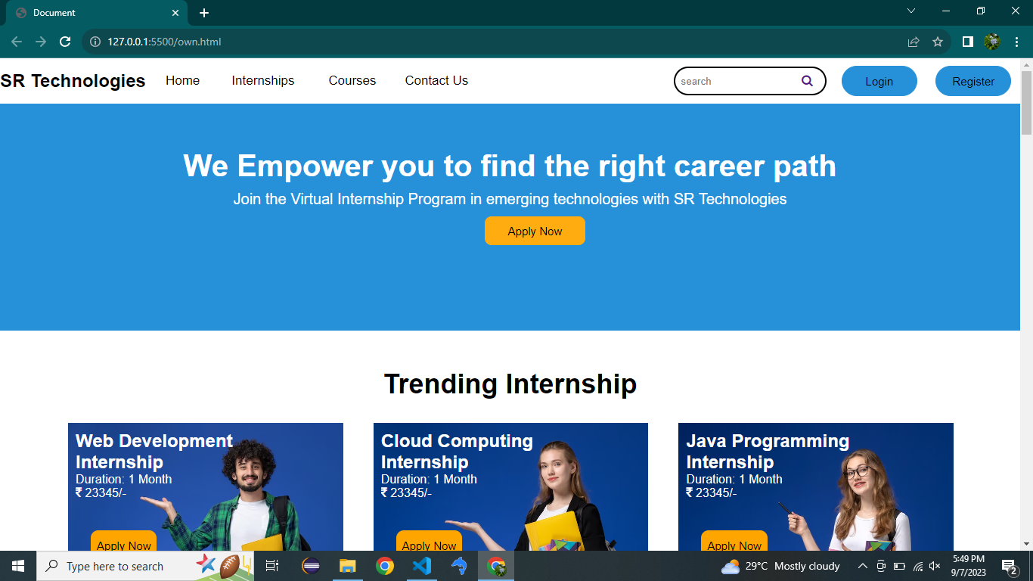

Fig:1.0

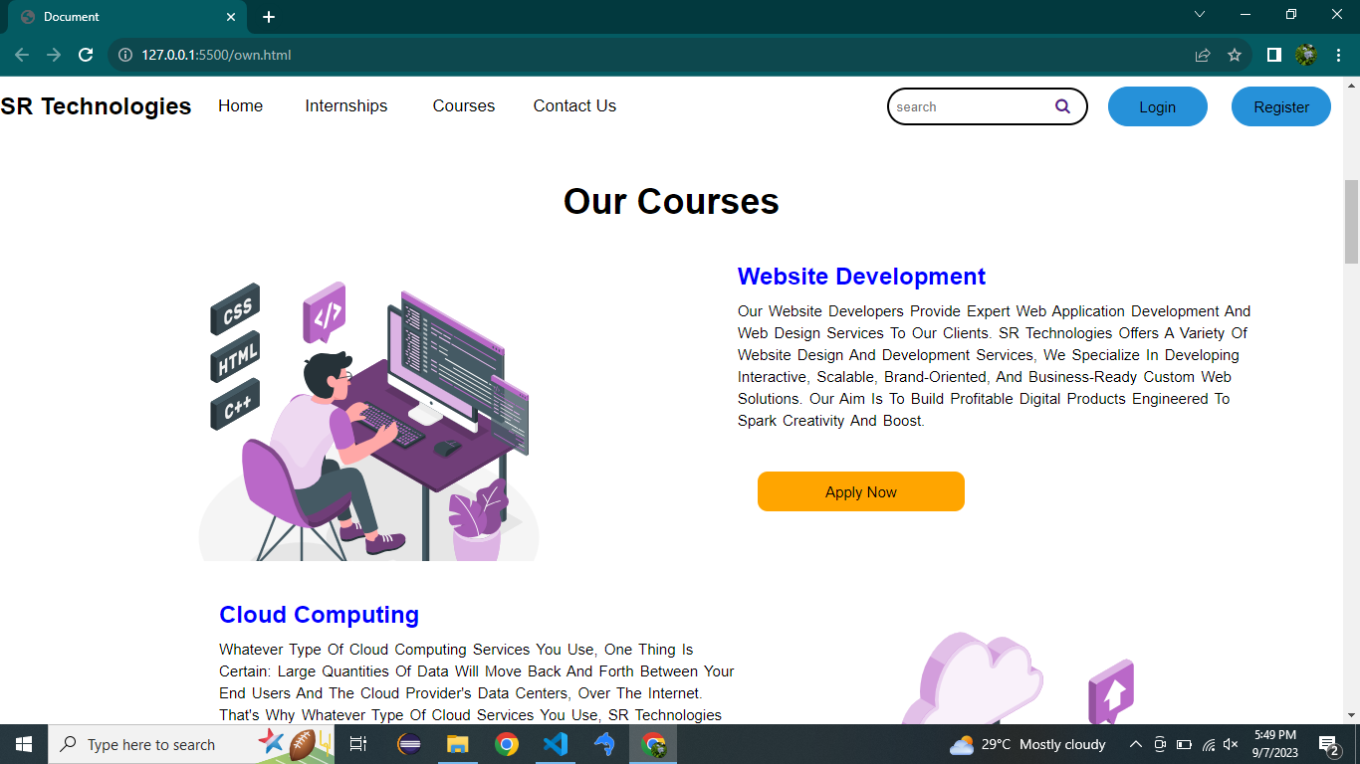

Fig:1.1

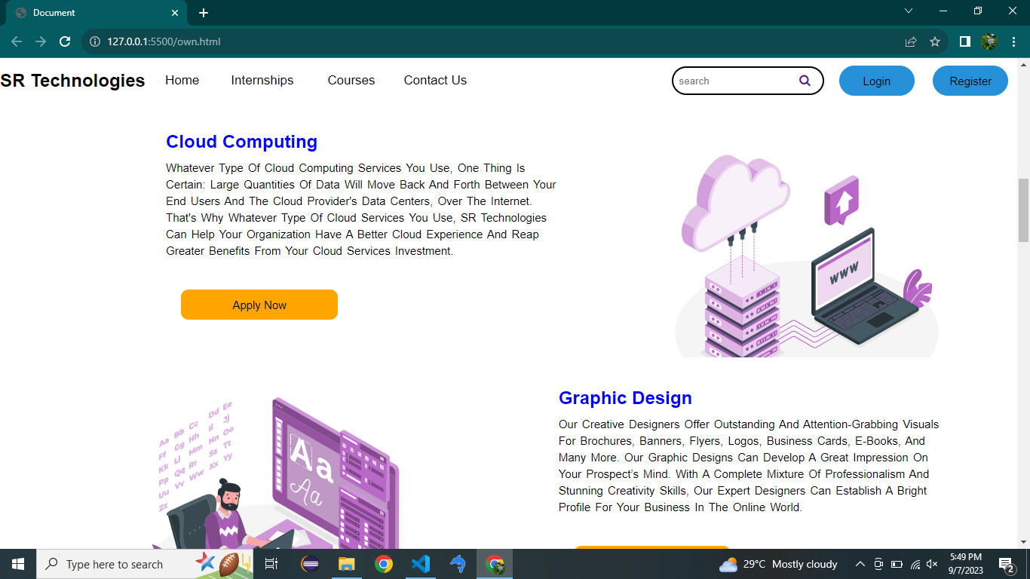

Fig:1.2

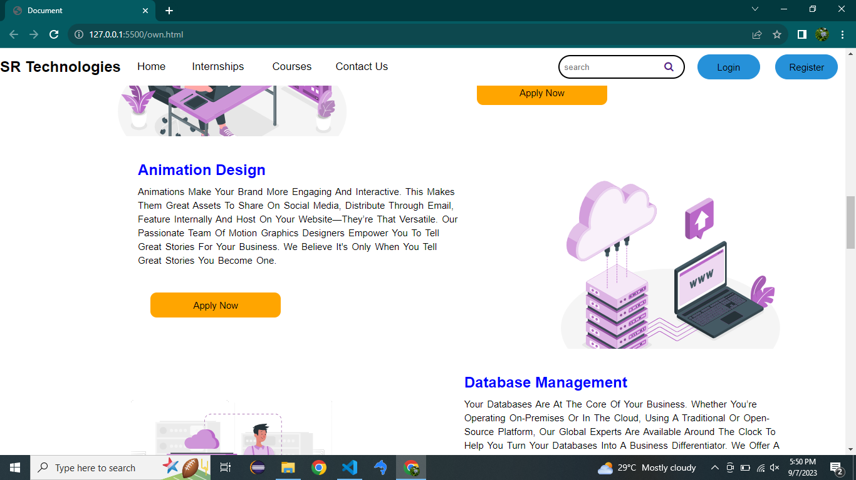

Fig:1.3

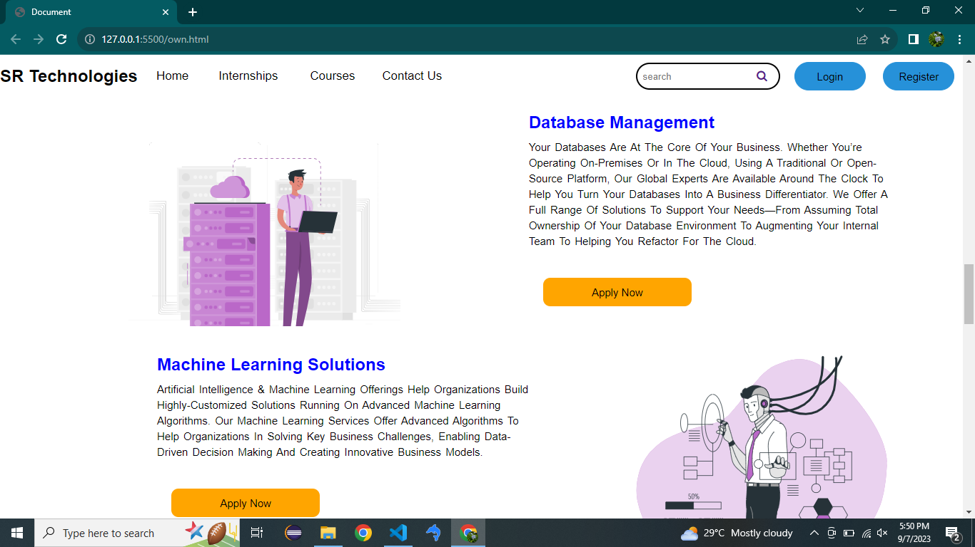

Fig:1.4

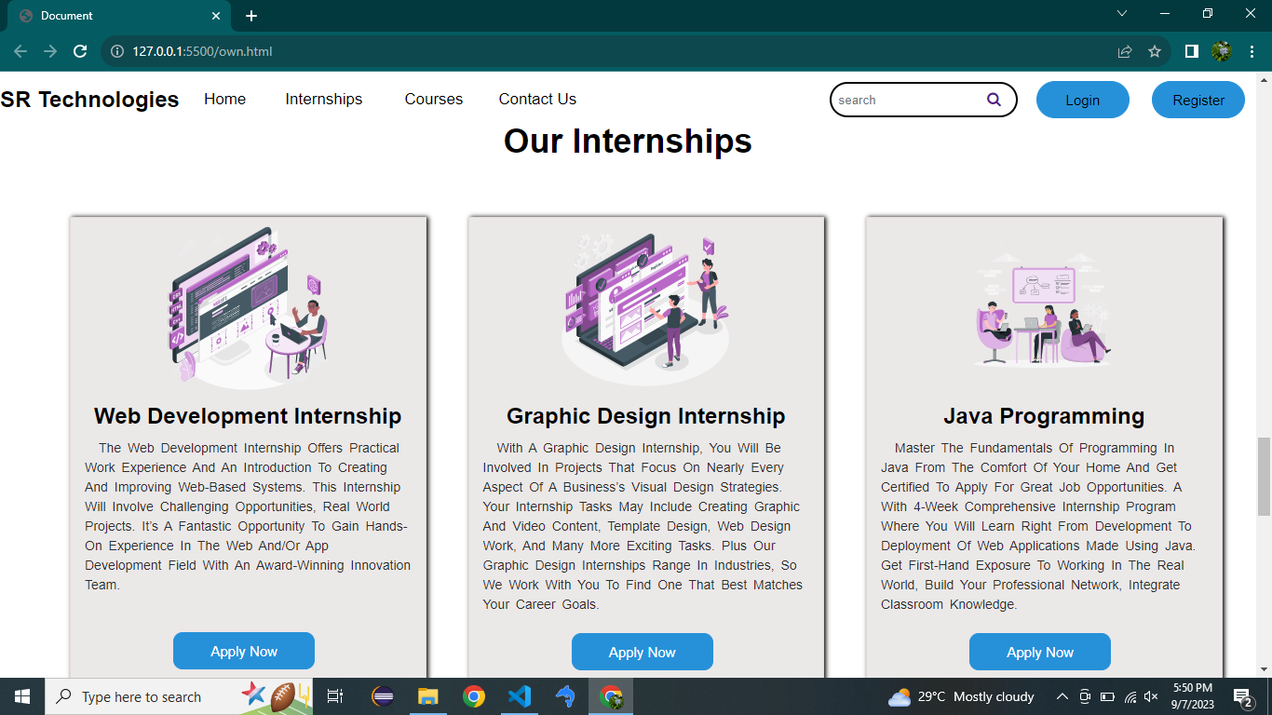

Fig:1.5

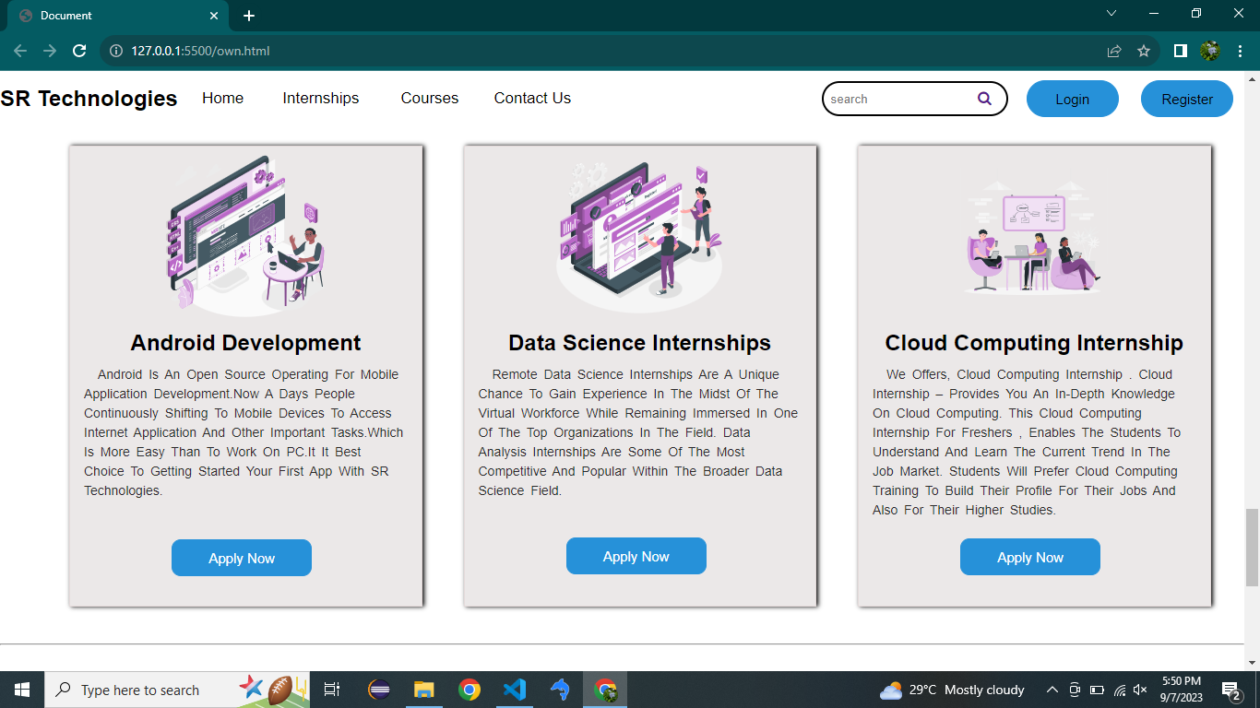

Fig:1.6

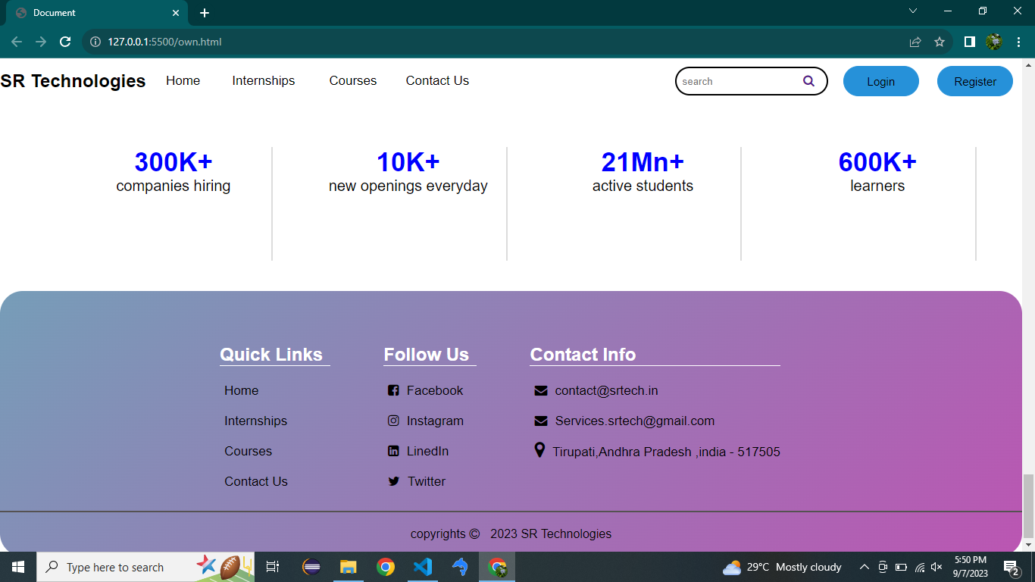

Fig:1.7

Login.html:

<!DOCTYPE html>

<html lang="en">

<head>

    <meta charset="UTF-8">

    <meta name="viewport" content="width=device-width, initial-scale=1.0">

    <title>Document</title>

    <link rel="stylesheet" href="login.css">

</head>

<body>

    <div class="Center">

        <h1>Login</h1>

        <form method="" action="own.html">

            <div class="text_field">

                <input type="text" required>

                <span></span>

                <label for="">Username</label>

            </div>

            <div class="text_field">

                <input type="text" required>

                <span></span>

                <label for="">Password</label>

            </div>

            <div class="pass"> Forgot Password?</div>

            <button type="submit"><a href="own.html" target="_blank"> Login</a></button>

            <div class="signup_link">

                Not a Member? <a href="Register.html">Signup</a>

            </div>

        </form>

    </div>

</body>

</html>

**Login.css:**

body{

    margin: 0;

    padding: 0;

    font-family: montserrat;

    background: linear-gradient(120deg, #2980b9,#8e44ad);

    height: 100vh;

    overflow: hidden;

}

.Center{

    position: absolute;

    top: 50%;

    left: 50%;

    transform: translate(-50%,-50%);

    width: 400px;

    background: white;

    border-radius: 10px;

}

.Center h1{

    text-align: center;

    padding: 0 0 20px 0;

    border-bottom: 1px solid silver;

}

.Center form{

    padding: 0 40px;

    box-sizing: border-box;

}

form .text_field{

    position: relative;

    border-bottom: 2px solid #adadad;

    margin: 30px 0;

}

.text_field input{

    width: 100%;

    padding: 0 5px;

    height: 40px;

    font-size: 16px;

    border: none;

    background: none;

    outline: none;

    font-size: 16px;

}

.text_field label{

    position:absolute;

    top: 50%;

    left: 5px;

    color: #adadad;

    transform: translateY(-50%);

    font-size: 16px;

    pointer-events: none;

}

.text_field span ::before{

content: ' ';

position: absolute;

top: 40px;

left: 0;

width: 0%;

height: 2px;

background: #2691d9;

transition: .5s;

}

.text_field input:focus ~ label,

.text_field input:valid ~ label{

    top: -5px;

    color:#2691d9;

}

.text_field input:focus ~ span::before,

.text_field input:valid ~ span::before{

    width: 100%;

}

.pass{

    margin: -5px 0 20px 5px;

    color: #a6a6a6;

    cursor: pointer;

}

.pass:hover{

    text-decoration: underline;

}

button[type="submit"]{

    width: 100%;

    height: 50px;

    border: 1px solid;

    background: #2691d9;

    border-radius: 25px;

    font-size: 18px;

    color:#e9f4fb;

    font-weight: 700;

    cursor: pointer;

    outline: none;

}

button[type="submit"]:hover{

    border-color: #2691d9;

    transition: .5s;

}

a{

    color: white;

    text-decoration: none;

}

.signup_link{

    margin: 30px 0;

    text-align: center;

    font-size: 16px;

    color: #666666;

}

.signup_link a{

    color: #2691d9;

    text-decoration: none;

}

.signup_link a:hover{

    text-decoration: underline;

}

Output:

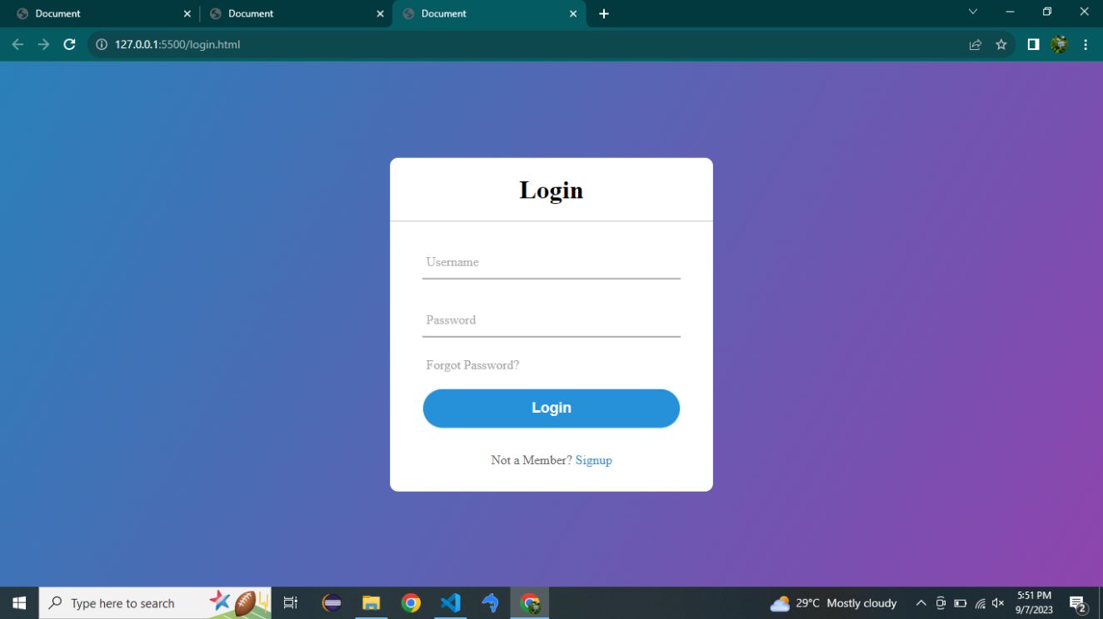

Fig:2.0

Register.html:

<!DOCTYPE html>

<html lang="en">

<head>

    <meta charset="UTF-8">

    <meta name="viewport" content="width=device-width, initial-scale=1.0">

    <title>Document</title>

    <link rel="stylesheet" href="Register.css">

</head>

<body>

    <div class="container">

    <div class="title">Registration</div>

    <form action="">

        <div class="user-details">

            <div class="input-box">

                <span class="details">Full Name</span>

                <input type="text" name="" id="" placeholder="Enter you name" required>

            </div>

            <div class="input-box">

                <span class="details">User Name</span>

                <input type="text" name="" id="" placeholder="Enter you Username" required>

            </div>

            <div class="input-box">

                <span class="details">Email</span>

                <input type="email" name="" id="" placeholder="Enter you email" required>

            </div>

            <div class="input-box">

                <span class="details">Phone Number</span>

                <input type="text" name="" id="" placeholder="Enter you number" required>

            </div>

            <div class="input-box">

                <span class="details">Password</span>

                <input type="password" name="" id="" placeholder="Enter you password" required>

            </div>

            <div class="input-box">

                <span class="details"> Confirm Password</span>

                <input type="password" name="" id="" placeholder="Confirm your password" required>

            </div>

        </div>

        <div class="gender-details">

        <input type="radio" name="gender" id="dot-1">

        <input type="radio" name="gender" id="dot-2">

        <input type="radio" name="gender" id="dot-3">

        <span class="gender-title">Gender</span>

          <div class="category">

            <label for="dot-1">

                <span class="dot one"></span>

                <span class="gender">Male</span>

            </label>

            <label for="dot-2">

                <span class="dot two"></span>

                <span class="gender">Female</span>

            </label>

            <label for="dot-3">

                <span class="dot three"></span>

                <span class="gender">Prefer not to say</span>

            </label>

          </div>

        </div>

        <div class="button">

            <button type="submit"><a href="login.html">Register</a></button>

        </div>

    </form>

   </div>

</body>

</html>

Register.css:

*{

    margin: 0;

    padding: 0;

    box-sizing: border-box;

    font-family: 'Poppins', sans-serif;

}

body{

    display: flex;

    height: 100vh;

    justify-content: center;

    align-items: center;

    background: linear-gradient(134deg,#71b7e6,#9b59b6);

}

.container{

    max-width: 700px;

    width: 100%;

    background: #fff;

    padding: 25px 30px;

    border-radius: 5px;

}

.container .title{

    font-size: 25px;

    font-weight: 500;

    position: relative;

}

.container .title::before{

    content:'';

    position: absolute;

    left: 0;

    height: 3px;

    width: 30px;

    bottom: 0;

    background: linear-gradient(135deg,#71b7e6,#9b59b6);

}

.container form .user-details{

    display: flex;

    flex-wrap: wrap;

    justify-content: space-between;

}

form .user-details .input-box{

    margin:20px 0 12px 0;

    width: calc(100%/2 - 20px);

}

.user-details .input-box .details{

    display: block;

    font-weight: 500;

    margin-bottom: 5px;

}

.user-details .input-box input{

    height: 45px;

    width: 100%;

    outline: none;

    border-radius: 5px;

    border: 1px solid #ccc;

    padding-left: 15px;

    font-size: 16px;

}

.user-details .input-box input:focus,

.user-details .input-box input:valid{

    border-color: #9b59b6;

}

form .gender-details .gender-title{

    font-size: 20px;

    font-weight: 500;

}

form .gender-details .category{

    display: flex;

    width: 80%;

    margin: 14px 0;

    justify-content: space-between;

}

.gender-details .category label{

    display: flex;

}

.gender-details .category .dot{

    height: 18px;

    width: 18px;

    background: #d9d9d9;

    border-radius: 50%;

    margin-right: 10px;

    border: 5px solid transparent;

}

#dot-1:checked ~ .category label .one,

#dot-2:checked ~ .category label .two,

#dot-3:checked ~ .category label .three{

    border-color: #d9d9d9;

    background: #9b59b6;

}

form input[type="radio"]{

    display: none;

}

form button{

    height: 45px;

   margin: 45px 0;

}

form .button button{

    font-size: 18px;

    font-weight: 500;

    border-radius: 5px;

    letter-spacing: 1px;

    height: 50px;

    width: 100%;

    outline: none;

    color: #fff;

    border: none;

    background: linear-gradient(135deg,#71b7e6,#9b59b6);

    cursor: pointer;

}

a{

    color: white;

    text-decoration: none;

}

Output:

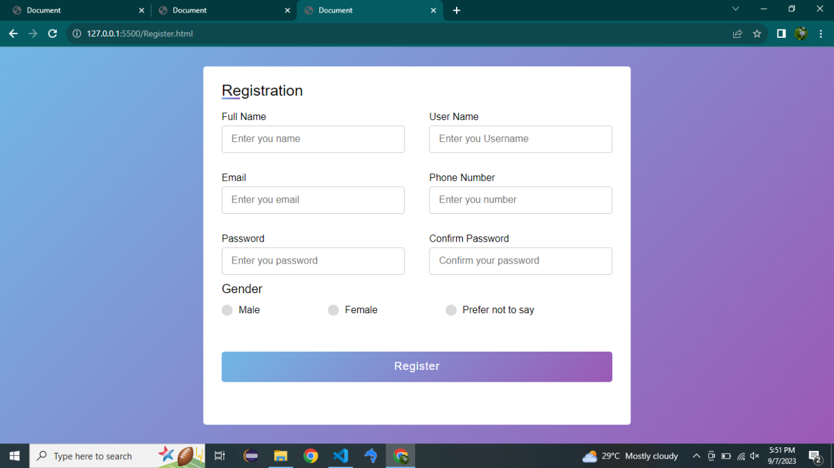

Fig:3.0

Apply.html:

<!DOCTYPE html>

<html lang="en">

<head>

    <meta charset="UTF-8">

    <meta name="viewport" content="width=device-width, initial-scale=1.0">

    <title>Document</title>

    <link rel="stylesheet" href="apply.css">

</head>

<body>

    <div class="container">

    <div class="title">Application Form</div>

    <form action="#">

        <div class="user-details">

            <div class="input-box">

                <span class="details">Full Name</span>

                <input type="text" name="" id="" placeholder="Enter you name" required>

            </div>

            <div class="input-box">

                <span class="details">College Name</span>

                <input type="text" name="" id="" placeholder="Enter you College name" required>

            </div>

            <div class="input-box">

                <span class="details">Email</span>

                <input type="email" name="" id="" placeholder="Enter you email" required>

            </div>

            <div class="input-box">

                <span class="details">Phone Number</span>

                <input type="text" name="" id="" placeholder="Enter you number" required>

            </div>

            <div class="input-box">

                <span class="details">Highest Degree</span>

                <input type="text" name="" id="" placeholder=" Enter your highest Degree" required>

            </div>

            <div class="input-box">

                <span class="details"> Course Name</span>

                <input type="password" name="" id="" placeholder="Enter you Course Name" required>

            </div>

        </div>

        <div class="gender-details">

        <input type="radio" name="gender" id="dot-1">

        <input type="radio" name="gender" id="dot-2">

        <input type="radio" name="gender" id="dot-3">

        <span class="gender-title">Gender</span>

          <div class="category">

            <label for="dot-1">

                <span class="dot one"></span>

                <span class="gender">Male</span>

            </label>

            <label for="dot-2">

                <span class="dot two"></span>

                <span class="gender">Female</span>

            </label>

            <label for="dot-3">

                <span class="dot three"></span>

                <span class="gender">Prefer not to say</span>

            </label>

          </div>

        </div>

        <div class="resume">

            <span class="details">Resume Upload:</span><br>

        <input type="file" value="resume" id="resume1">

        </div>

        <div class="button">

            <button type="submit"><a href="own.html">Apply</a></button>

        </div>

    </form>

   </div>

</body>

</html>

Apply.css:

*{

    margin: 0;

    padding: 0;

    box-sizing: border-box;

    font-family: 'Poppins', sans-serif;

}

body{

    display: flex;

    height: 100vh;

    justify-content: center;

    align-items: center;

    background: linear-gradient(134deg,#71b7e6,#9b59b6);

}

.container{

    max-width: 700px;

    width: 100%;

    background: #fff;

    padding: 25px 30px;

    border-radius: 5px;

}

.container .title{

    font-size: 25px;

    font-weight: 500;

    position: relative;

}

.container .title::before{

    content:'';

    position: absolute;

    left: 0;

    height: 3px;

    width: 30px;

    bottom: 0;

    background: linear-gradient(135deg,#71b7e6,#9b59b6);

}

.container form .user-details{

    display: flex;

    flex-wrap: wrap;

    justify-content: space-between;

}

form .user-details .input-box{

    margin:20px 0 12px 0;

    width: calc(100%/2 - 20px);

}

.user-details .input-box .details{

    display: block;

    font-weight: 500;

    margin-bottom: 5px;

}

.user-details .input-box input{

    height: 45px;

    width: 100%;

    outline: none;

    border-radius: 5px;

    border: 1px solid #ccc;

    padding-left: 15px;

    font-size: 16px;

}

.user-details .input-box input:focus,

.user-details .input-box input:valid{

    border-color: #9b59b6;

}

form .gender-details .gender-title{

    font-size: 20px;

    font-weight: 500;

}

form .gender-details .category{

    display: flex;

    width: 80%;

    margin: 14px 0;

    justify-content: space-between;

}

.gender-details .category label{

    display: flex;

}

.gender-details .category .dot{

    height: 18px;

    width: 18px;

    background: #d9d9d9;

    border-radius: 50%;

    margin-right: 10px;

    border: 5px solid transparent;

}

#dot-1:checked ~ .category label .one,

#dot-2:checked ~ .category label .two,

#dot-3:checked ~ .category label .three{

    border-color: #d9d9d9;

    background: #9b59b6;

}

form input[type="radio"]{

    display: none;

}

form button{

    height: 45px;

   margin: 45px 0;

}

form .button button{

    font-size: 18px;

    font-weight: 500;

    border-radius: 5px;

    letter-spacing: 1px;

    height: 50px;

    width: 100%;

    outline: none;

    color: #fff;

    border: none;

    background: linear-gradient(135deg,#71b7e6,#9b59b6);

    cursor: pointer;

}

a{

    color: white;

    text-decoration: none;

}

#resume1{

    font-size: 16px;

    background-color: rgb(223, 218, 218);

    border-radius: 50px;

    box-shadow:2px 2px rgb(128, 127, 127);

    width: 300px;

    outline: none;

    margin-top: 10px;

}

::-webkit-file-upload-button{

    color: white;

    background: linear-gradient(135deg,#71b7e6,#9b59b6);

    padding: 13px;

    border: none;

    border-radius: 50px;

    box-shadow: 1px 0 1px 1px #9b59b6;

    outline: none;

}

Output:

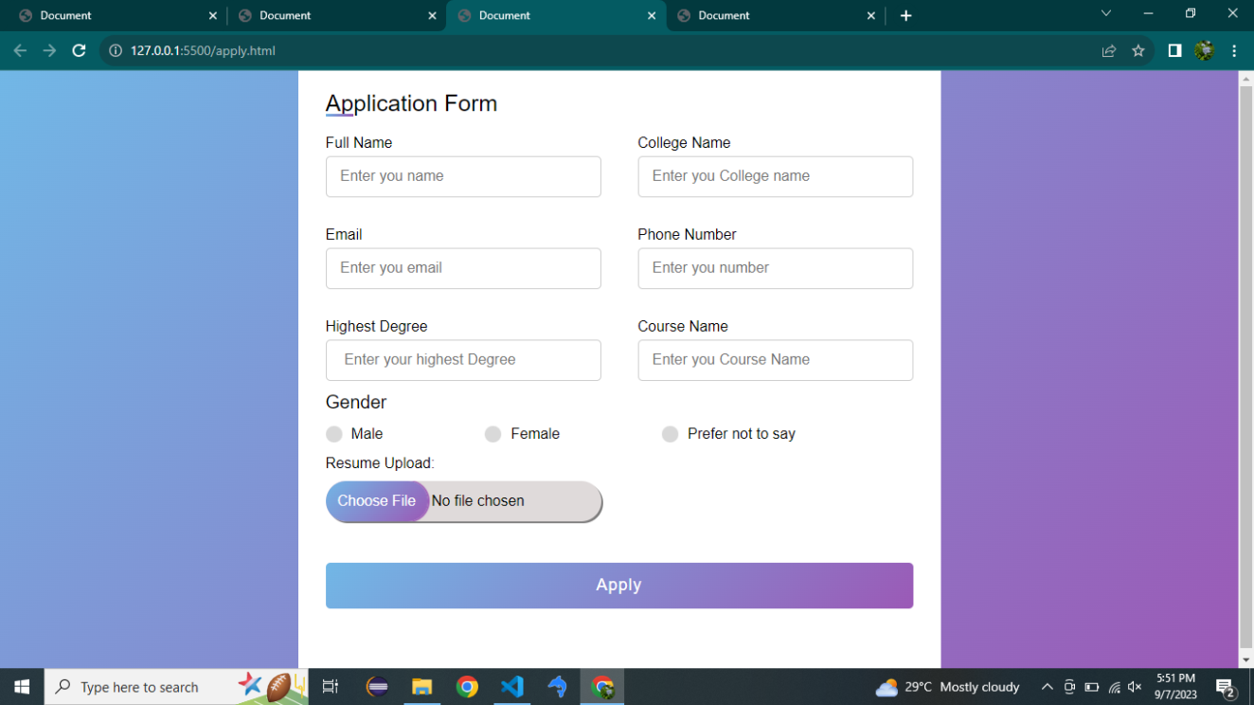

Fig:4.0

**Conclusion:**

The development and implementation of the SR Technologies website, focusing on internships and courses, have been a significant accomplishment. The platform offers valuable opportunities to both interns and learners, creating a bridge between education and career development. We believe that this website will serve as a powerful resource for years to come.

In summary, the SR Technologies website, integrating internships and courses, has successfully created a user-centric platform. It provides a seamless experience for both interns and learners, offering diverse opportunities and secure transactions. Challenges have been valuable lessons, reinforcing our commitment to improvement. As we move forward, we are dedicated to maintaining the platform's relevance and security. The SR Technologies website is not just a project but an ongoing journey empowering individuals in their pursuit of excellence.