**Constraint System:**

**By Ramya Balaraman**

1. Every property (integer) of every class can be constrained. Every such property is represented by a corresponding instance of the ‘Variable’ class.
2. Variable holds the value of the property, the list of variables it depends on and the list of variables which depend on it. It also has a flag to indicate if the value is up-to-date or out-of-date.
3. To express your constraint, create a class which implements interface Solvable and provides the evaluate() method implementation.

public int evaluate(ArrayList<Variable> params, GraphicalObject parent);

params is the list of variables the property depends on & parent is the Graphical Object the constrained property belongs to.

1. A few examples are provided in TestHomework4.java with comments.
2. Call ConstraintSolver.evaluate() before calling redraw() to evaluate all existing constraints on all variables.

**Note and Edge Editor:** (Only partially done)

1. Test using TestNoteEdgeEditor from main screen
2. Create multiple nodes using rectangle tool on the palette. Create edges between nodes using line tool on the palette.

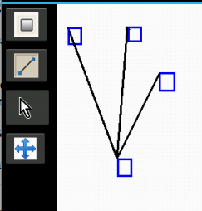

1. All edges associated with a node move when the node is moved. However sometimes edges leave specks while moving.
2. The system does not allow multiple edges between the same nodes. However instead of canceling the event the program currently throws an exception and exits.
3. Edges cannot be moved by clicking and dragging them directly. (Bug: However they sometimes randomly move when the corresponding node is clicked)