**CLI app using Sketch library (synchronous way)**

**To add Key value pair into json file**

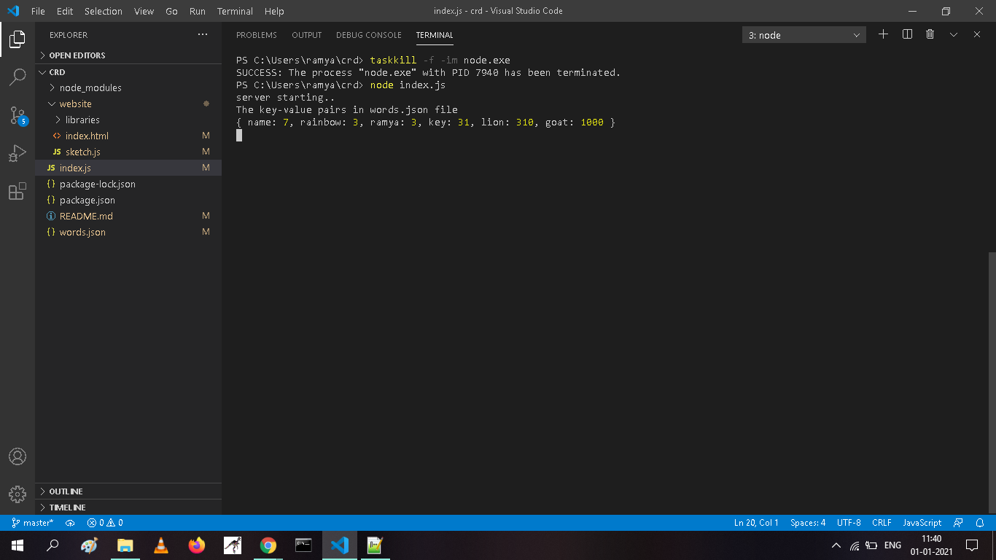

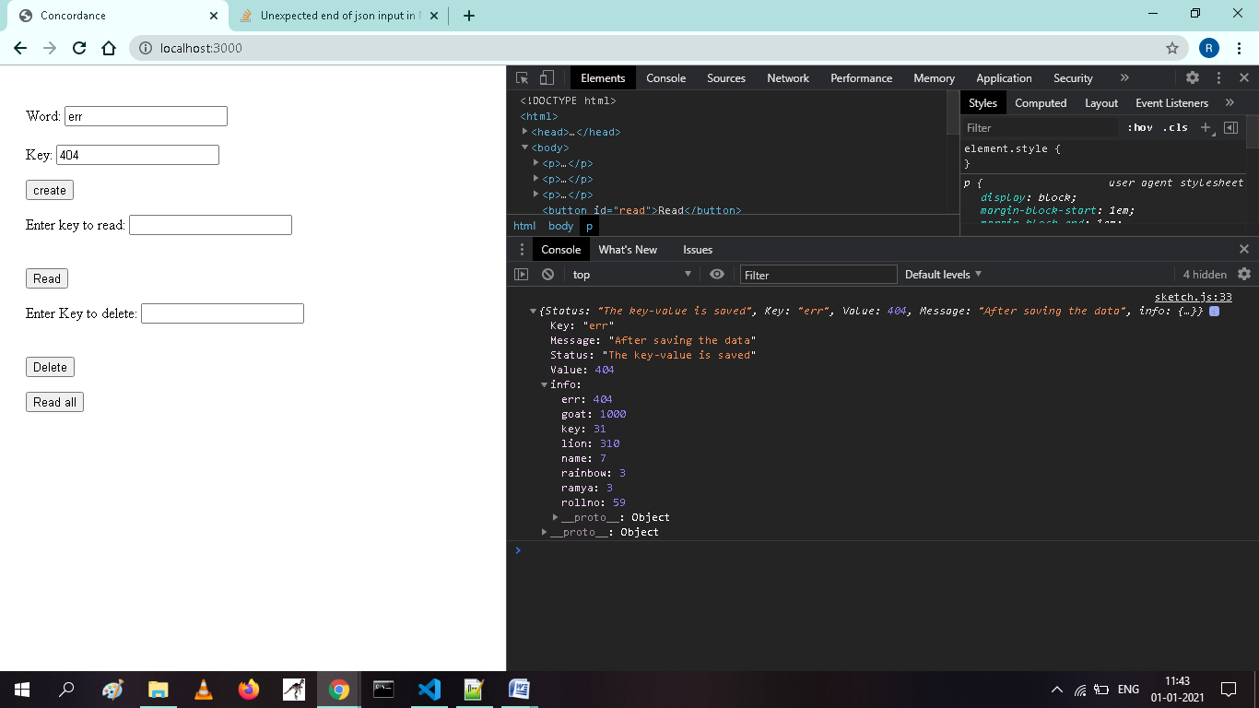

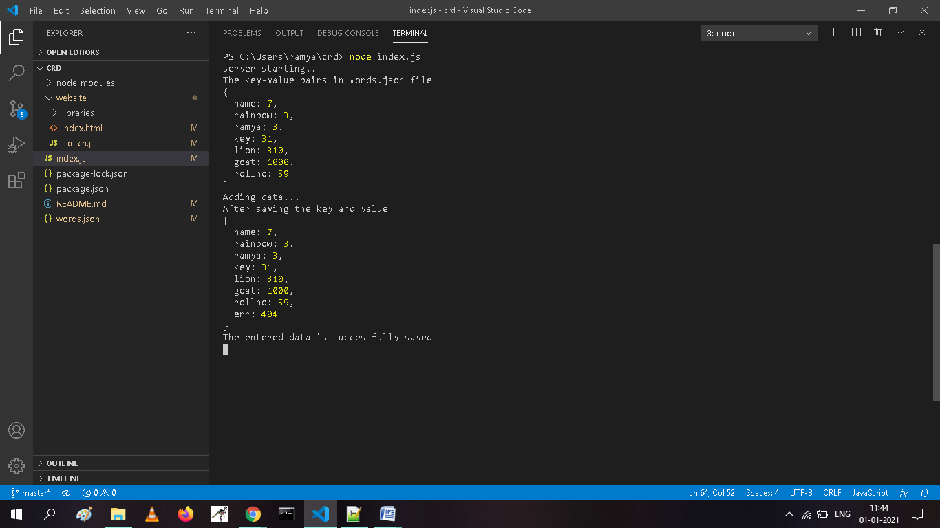

**To check already exists data:**

It checks whether the key is already exists or not if it exists then it shows Enter valid data,otherwise it saves the key value pair into the JSON file name “words.json”.

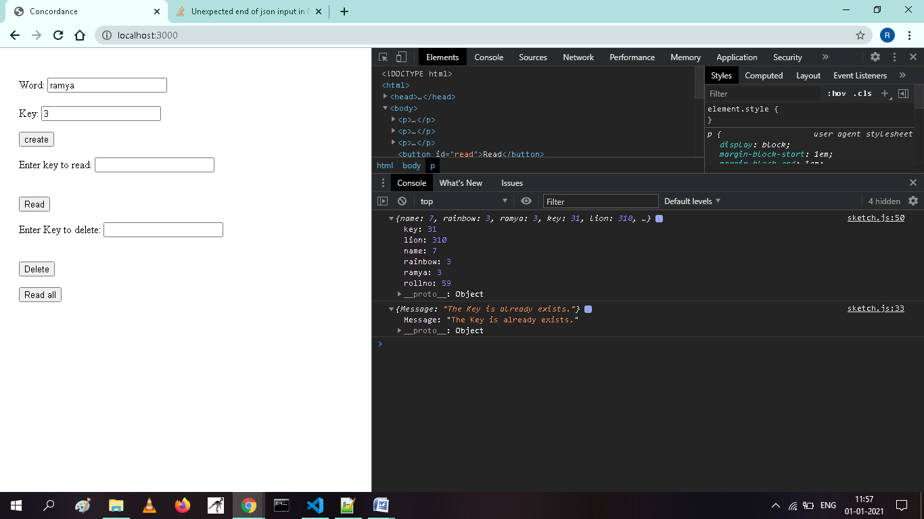

**To check key length:**

It check whether the enter key has the length less than 32 or not.if the length of the key is greater thsn 32 it shows “Enter valid data”,otherwise it saves the key value pair into “words.json” file.

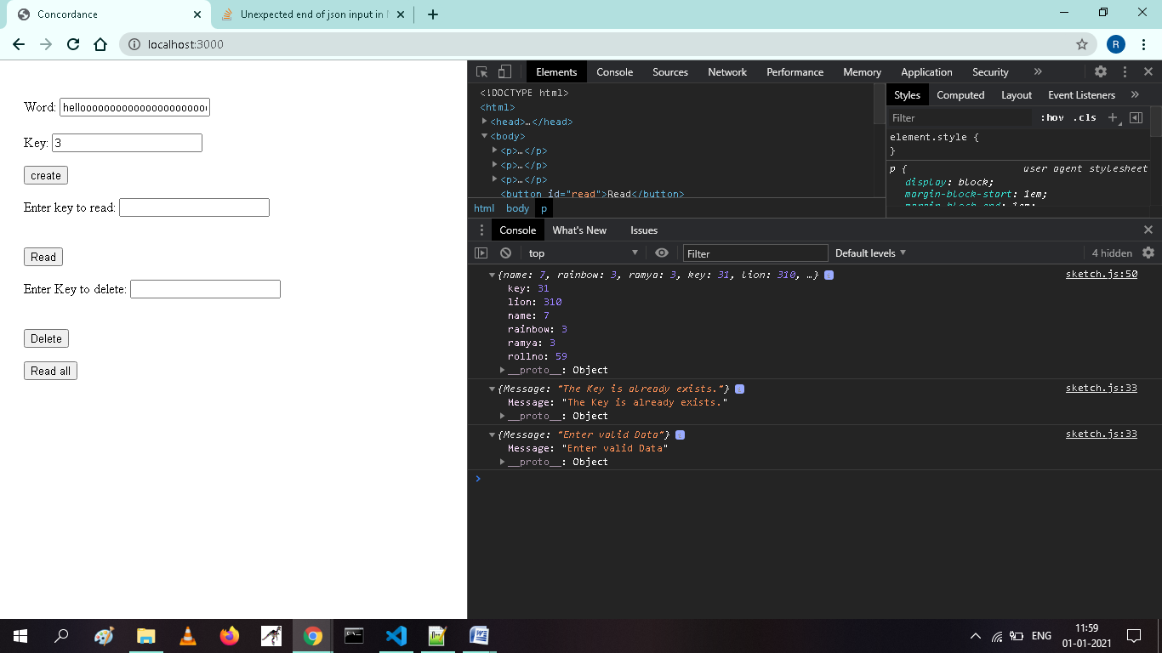

**To read a particular key:**

It reads the key value pair from the “words.json” file by using the user entered key value.

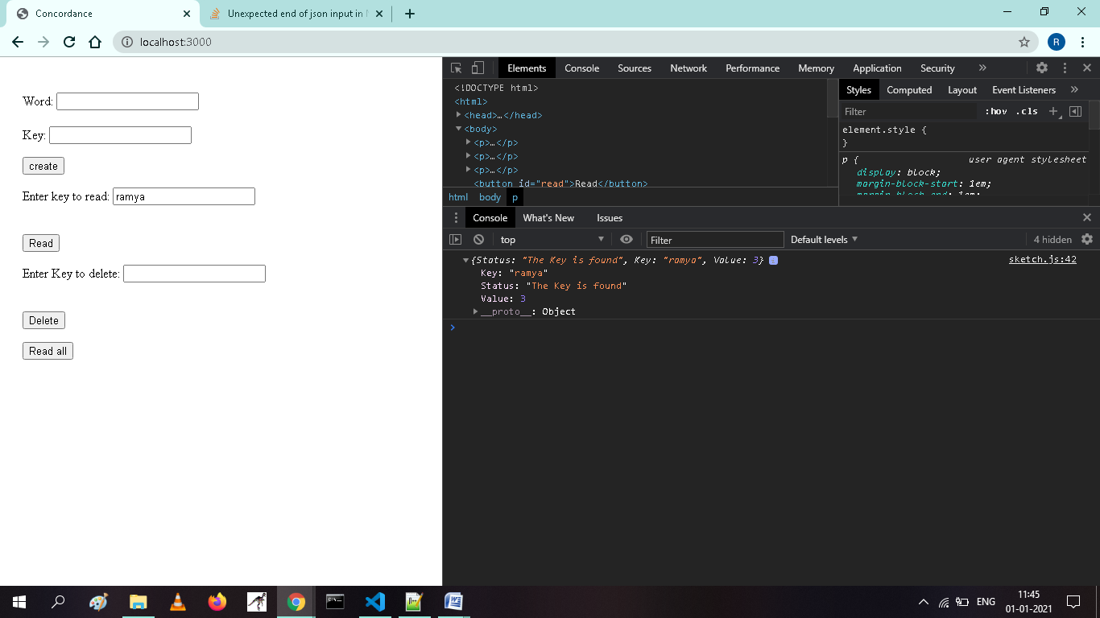

**To Delete a particular key:**

It deletes the the key entered by the user .If it does not contains the user entered key then it shows the error.

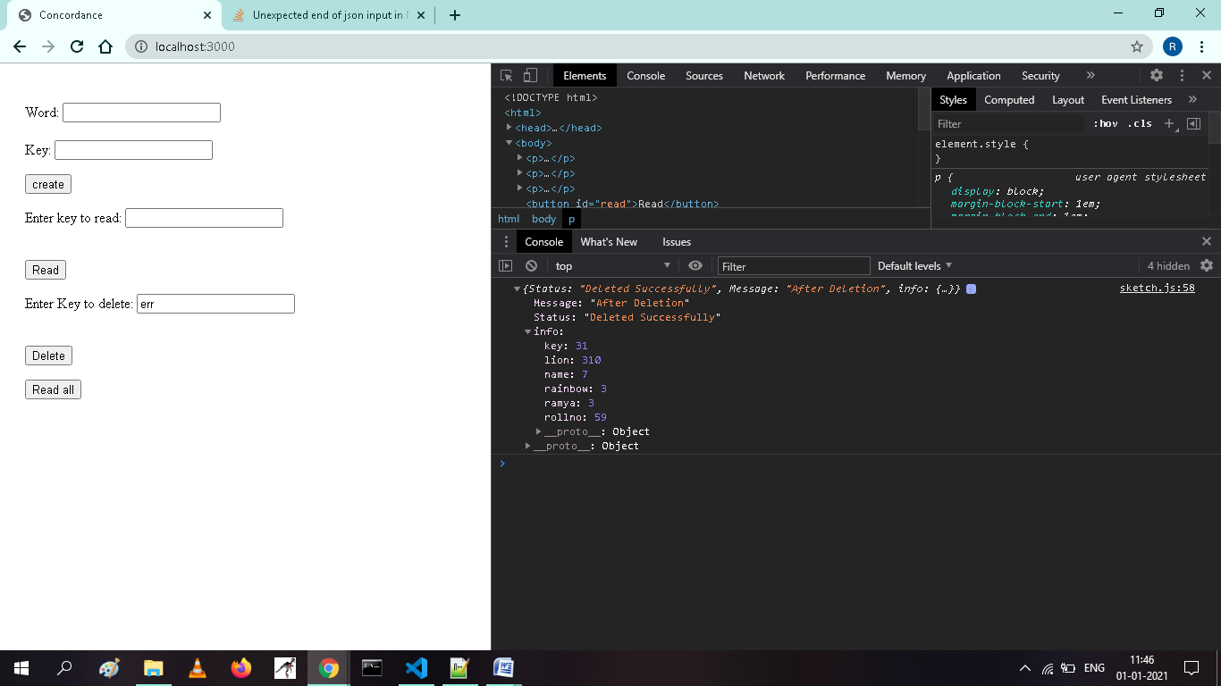

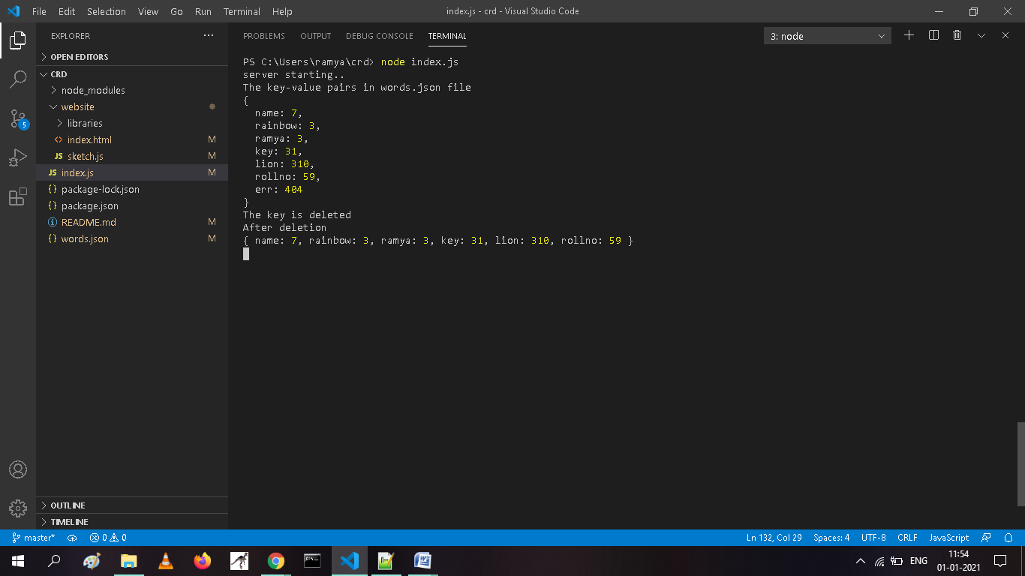

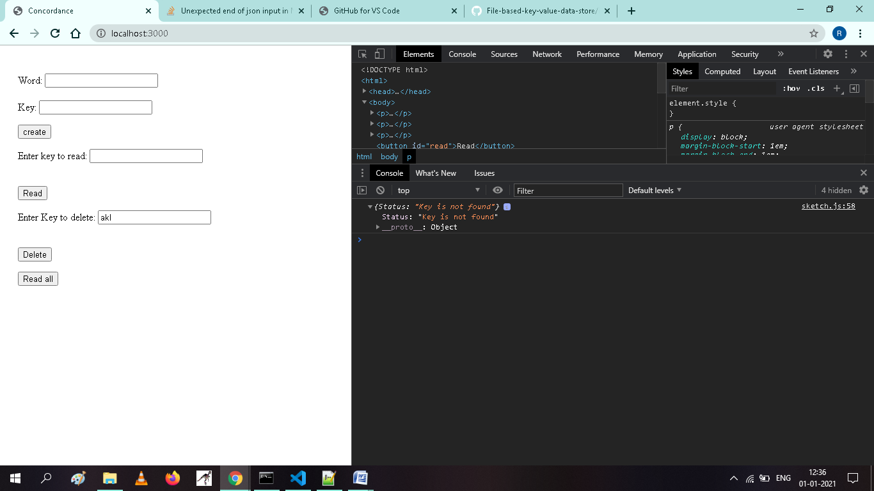

**Read all data:**

It prints the all key value pairs in “words.json” file.

