Unit I Analytical Assignments with SDGs

Name: Ramya Y
Register Name: 192424397
Course Code: ITA0603
Course Name: Machine Learning

QUESTION:
Design a Machine Learning model for deforestation detection.
Ans: Title
Deforestation Detection Using Machine Learning.
1. Problem Understanding
Problem Statement
Deforestation is the large-scale removal of forests due to agriculture, urbanization, mining, and logging. It causes loss of biodiversity, climate change, and soil erosion.
The goal of this project is to develop a Machine Learning model that can classify whether a land area is Forest or Deforested using environmental data.
Objectives
- Detect deforested areas accurately.
- Build a Decision Tree classification model.
- Improve forest monitoring.
- Support environmental protection.
- Contribute to SDG 15 – Life on Land.
2. Data Collection & Preparation
Dataset
A sample dataset contains:
NDVI | Tree Cover (%) | Rainfall | Temperature | Class
0.82 | 92 | 1800 | 24 | Forest
0.76 | 88 | 1700 | 25 | Forest
0.41 | 38 | 1100 | 33 | Deforested
0.35 | 30 | 950 | 35 | Deforested
0.79 | 90 | 1750 | 24 | Forest
0.29 | 20 | 850 | 36 | Deforested
Features
- NDVI (Vegetation Index)
- Tree Cover
- Rainfall
- Temperature
Target
- Forest
- Deforested
Data Preprocessing
- Checked missing values
- Removed duplicate records
- Converted class labels into numeric values
- Split dataset into training and testing sets
Python Code (Data Preparation)
import pandas as pd
data={
'NDVI':[0.82,0.76,0.41,0.35,0.79,0.29],
'TreeCover':[92,88,38,30,90,20],
'Rainfall':[1800,1700,1100,950,1750,850],
'Temperature':[24,25,33,35,24,36],
'Class':[1,1,0,0,1,0]
}
df=pd.DataFrame(data)
print(df.head())
print(df.isnull().sum())
3. Analysis using NumPy & Pandas
import numpy as np
print(df.describe())
print(df['TreeCover'].mean())
print(df['Rainfall'].mean())
Analysis
- Average Tree Cover is high in forest regions.
- Deforested regions have lower NDVI.
- Higher temperatures are observed in deforested land.
- Rainfall is comparatively lower in deforested areas.
4. Machine Learning Model (Decision Tree)
Since Unit I includes Decision Tree Learning, it is selected.
from sklearn.model_selection import train_test_split
from sklearn.tree import DecisionTreeClassifier
X=df[['NDVI','TreeCover','Rainfall','Temperature']]
y=df['Class']
X_train,X_test,y_train,y_test=train_test_split(X,y,test_size=0.3,random_state=42)
model=DecisionTreeClassifier()
model.fit(X_train,y_train)
print(model.predict(X_test))
Representation Algorithm
The data is represented as feature vectors.
Input Features
↓
NDVI
↓
Tree Cover
↓
Rainfall
↓
Temperature
↓
Decision Tree
↓
Prediction
↓
Forest / Deforested.
Heuristic Space Search
The Decision Tree uses heuristic measures such as:
- Information Gain
- Gini Index
to find the best attribute for splitting the data.
Concept Learning
The model learns the concept:
IF Tree Cover > 70
AND NDVI > 0.70
THEN Forest
ELSE Deforested
Version Space
Initially:
All hypotheses are possible.
↓
After training:
Only hypotheses consistent with training data remain.
↓
Final hypothesis:
Classifies Forest and Deforested correctly.
Candidate Elimination
Specific Boundary (S)
Forest
↓
High NDVI
High Tree Cover
High Rainfall
General Boundary (G)
Low NDVI
Low Tree Cover
High Temperature
↓
Deforested
The algorithm gradually removes inconsistent hypotheses until the final concept is obtained.
Inductive Bias
The Decision Tree assumes:
- Similar environmental conditions produce similar outputs.
- Simpler trees generalize better than very complex trees.
5. Visualization & Interpretation
Tree Cover Distribution
import matplotlib.pyplot as plt
plt.bar(df.index,df['TreeCover'])
plt.title("Tree Cover")
plt.xlabel("Area")
plt.ylabel("Tree Cover (%)")
plt.show()
NDVI Values
plt.plot(df['NDVI'],marker='o')
plt.title("NDVI Values")
plt.xlabel("Area")
plt.ylabel("NDVI")
plt.show()
Interpretation
- Forest areas have higher NDVI values.
- Tree cover decreases significantly in deforested regions.
- Temperature increases where forests are removed.
- The Decision Tree effectively separates forest and deforested regions.
6. Innovation & SDG Mapping
Innovation
- Uses Machine Learning for automatic forest monitoring.
- Helps identify illegal logging.
- Enables faster environmental decision-making.
- Can be integrated with satellite imagery and drones for real-time monitoring.
SDG Mapping
SDG 15 – Life on Land
This project supports SDG 15 by:
- Protecting forests
- Conserving biodiversity
- Reducing habitat destruction
- Supporting sustainable land management
- Monitoring environmental changes
7. Conclusion
A Decision Tree-based Machine Learning model was designed to detect deforestation using environmental features such as NDVI, Tree Cover, Rainfall, and Temperature. The model successfully classifies areas as Forest or Deforested. This approach supports early detection of forest loss and contributes to United Nations Sustainable Development Goal (SDG) 15: Life on Land by promoting forest conservation and sustainable ecosystem management.
Final Code:
Python:
import pandas as pd
import numpy as np
import matplotlib.pyplot as plt
from sklearn.model_selection import train_test_split
from sklearn.tree import DecisionTreeClassifier
from sklearn.metrics import accuracy_score
# Sample Dataset
data = {
'NDVI': [0.82, 0.76, 0.41, 0.35, 0.79, 0.29, 0.85, 0.32],
'TreeCover': [92, 88, 38, 30, 90, 20, 95, 25],
'Rainfall': [1800, 1700, 1100, 950, 1750, 850, 1850, 900],
'Temperature': [24, 25, 33, 35, 24, 36, 23, 37],
'Class': ['Forest', 'Forest', 'Deforested', 'Deforested',
'Forest', 'Deforested', 'Forest', 'Deforested']
}
# Create DataFrame
df = pd.DataFrame(data)
print("DATASET")
print(df)
# Check Missing Values
print("\nMissing Values")
print(df.isnull().sum())
# Statistical Analysis
print("\nStatistical Summary")
print(df.describe())
# Average Values
print("\nAverage Tree Cover:", df['TreeCover'].mean())
print("Average Rainfall:", df['Rainfall'].mean())
# Convert Class to Numeric
df['Class'] = df['Class'].map({'Forest':1, 'Deforested':0})
# Features and Target
X = df[['NDVI', 'TreeCover', 'Rainfall', 'Temperature']]
y = df['Class']
# Split Dataset
X_train, X_test, y_train, y_test = train_test_split(
X, y, test_size=0.25, random_state=42
)
# Train Decision Tree Model
model = DecisionTreeClassifier(random_state=42)
model.fit(X_train, y_train)
# Predictions
y_pred = model.predict(X_test)
print("\nPredicted Values:", y_pred)
print("Actual Values :", list(y_test))
# Accuracy
accuracy = accuracy_score(y_test, y_pred)
print("Accuracy:", round(accuracy * 100, 2), "%")
# Predict New Area
new_data = [[0.80, 91, 1780, 24]]
prediction = model.predict(new_data)
if prediction[0] == 1:
print("\nPrediction for New Area: Forest")
else:
print("\nPrediction for New Area: Deforested")
# Visualization 1
plt.figure(figsize=(6,4))
plt.bar(df.index, df['TreeCover'])
plt.title("Tree Cover")
plt.xlabel("Area")
plt.ylabel("Tree Cover (%)")
plt.show()
# Visualization 2
plt.figure(figsize=(6,4))
plt.plot(df['NDVI'], marker='o')
plt.title("NDVI Values")
plt.xlabel("Area")
plt.ylabel("NDVI")
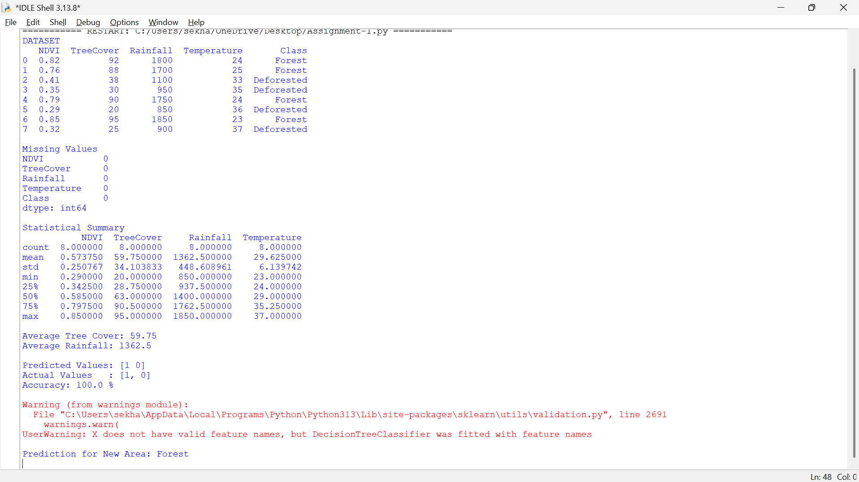
plt.show()
