BESANT TECHNOLOGIES

DATA ANALYSIS PROJECT

TITLE: Netflix Data Analytics

Submitted by:

NAME: RAMYA.N
COURSE: DATA SCIENCE
DATE: 30-10-2025

CONTENTS
1 | Introduction
2 | Objective
3 | Expected Business Outcomes
4 | Data Collection
5 | Data Inspection/Initial Analysis
6 | Data Cleaning and Transformation
7 | Exploratory Data Analysis
8 | Visualization
9 | Insight Generation
10 | Conclusion

Introduction

In today’s digital entertainment era, Netflix stands as one of the leading online streaming platforms, offering a vast collection of movies, TV shows, documentaries, and original content across the globe. With millions of subscribers and continuous content expansion, Netflix has revolutionized the way audiences consume entertainment. The platform’s success lies in its ability to understand user behaviour, personalize recommendations, and adapt content strategies based on viewer preferences.

The purpose of this analysis is to explore the patterns hidden within Netflix’s viewing and subscription data. By examining factors such as genre popularity, user demographics, subscription plans, devices used, and content type preferences, this study provides a deeper understanding of audience behaviour. These insights help businesses identify emerging trends, optimize marketing campaigns, and improve user experience by aligning content with audience interests.

Furthermore, this project demonstrates the application of data analytics and visualization tools to uncover actionable insights from raw data. Techniques such as data cleaning, transformation, exploratory analysis, and visualization are employed to ensure meaningful interpretation. Through this analysis, we aim to bridge the gap between data and decision-making, showcasing how data-driven strategies can empower streaming platforms like Netflix to maintain their competitive edge and enhance viewer engagement.

Dataset: Netflix Analysis (minimum 1000 records, 10+ columns)
Environment: Jupyter Notebook, pandas, MySQL, seaborn, matplotlib

Objective
The main objective of this project is to perform a comprehensive data analysis of Netflix’s user and content dataset to uncover patterns, trends, and insights that can drive business growth and decision-making. This analysis focuses on understanding viewer engagement, subscription trends, content performance, and platform usage behaviour using data-driven techniques.
A key focus of this project is to evaluate Return on Investment (ROI) for various aspects of Netflix’s operations — including subscription plans, content types, and geographical markets. By identifying the most profitable segments and high-performing content categories, Netflix can optimize its investments and improve long-term profitability.
Key Questions / ROI-Focused KPIs
1.Which subscription plan generates the highest revenue and user retention?
The Premium plan contributes the highest overall revenue, owing to its higher pricing and loyal customer base.
Despite fewer users than the Standard plan, Premium users exhibit stronger retention and engagement, indicating higher ROI per subscriber.
2. What is the ROI of content categories (e.g., Movies vs. TV Shows)?
TV Shows deliver higher ROI compared to Movies due to longer watch times and serialized content, which drives recurring engagement.
However, Movies attract new users, contributing to short-term revenue spikes.
3.Which regions or countries yield the best subscriber growth relative to marketing spend?
Countries such as India, the United States, and Brazil show the best ROI with strong growth and moderate marketing investment.
Emerging markets like India offer significant potential due to large user bases and cost-effective acquisition.
4. How does user engagement (watch time, genre preference) correlate with subscription type?
Premium and Standard users exhibit longer watch durations and higher satisfaction across multiple genres.
In contrast, Basic users show selective engagement, primarily focused on popular genres such as Drama and Comedy.
5.Which genres contribute the most to user satisfaction and repeat viewing?
Thriller, Drama, and Action genres consistently rank highest in repeat viewing and satisfaction scores, suggesting they are key drivers for content investment and viewer loyalty.
6. What devices or platforms (mobile, TV, laptop) drive the highest engagement-to-cost ratio?
Smart TVs and mobile devices show the strongest engagement-to-cost ratio. Smart TVs drive longer viewing hours, while mobile platforms attract flexible, on-the-go users with minimal operational cost.
7. What is the relationship between new user acquisition and total streaming hours?
A positive correlation is observed — as new user acquisition increases, total streaming hours also rise proportionally, indicating strong onboarding effectiveness and early-stage engagement.
8. How do seasonal trends impact user activity and subscription renewals?
Streaming peaks during festive and holiday periods (December–January), with a noticeable rise in new sign-ups and renewals.
Activity slightly dips mid-year, highlighting opportunities for mid-season promotional campaigns.
9. Which content investments offer the highest viewer retention and ROI over time?
Original series and exclusive content generate higher retention rates, as subscribers remain active to follow ongoing series.
Investment in localized originals also improves regional ROI.
10. What strategies can maximize ROI through targeted marketing and personalized recommendations?
By leveraging AI-driven recommendations, region-based targeting, and data segmentation, Netflix can maximize ROI.
Personalized promotions based on viewing history significantly improve user conversion and reduce churn.

Expected Business Outcomes

1. Improved Return on Investment (ROI)
- Through the identification of high-performing subscription plans and content types, Netflix can achieve a higher ROI by focusing on areas that deliver maximum profit with minimal cost.
- The insights gained will guide decisions on pricing strategy, promotional offers, and customer segmentation, ensuring that investments generate measurable financial returns.
2. Enhanced Content Strategy
- By evaluating viewership patterns and genre popularity, Netflix can understand which content categories provide the highest audience retention and satisfaction.
- This outcome enables Netflix to prioritize original productions and trending genres, resulting in increased user loyalty and repeat viewing — a direct contributor to revenue growth.
3. Market Expansion and Targeting
- The project highlights regional performance differences, helping Netflix identify high-growth geographic markets.
- By recognizing countries that deliver strong engagement relative to marketing expenditure, Netflix can optimize advertising budgets and focus on cost-effective expansion strategies in emerging regions.
4. Customer Retention and Engagement
- Analysing subscription duration, engagement metrics, and device usage provides a foundation for developing personalized user experiences.
- Enhanced recommendation systems and customer-targeted communication will help reduce churn, increasing customer lifetime value (CLV) and overall profitability.
5. Optimized Platform Performance
- By understanding which devices (mobile, smart TV, laptop) yield the best engagement and cost efficiency, Netflix can optimize technical performance and UX (User Experience) for those platforms.
- This outcome leads to higher streaming satisfaction, better app performance, and reduced operational costs.
6. Strategic Content Budget Allocation
- Through detailed EDA, Netflix can determine which content investments yield the highest ROI.
- Insights into watch time, ratings, and rewatch frequency help allocate production budgets more effectively, balancing between blockbuster originals and localized productions.
7. Predictive Forecasting and Business Planning
- This project sets the foundation for predictive analytics, enabling Netflix to forecast future trends such as subscriber growth, viewing peaks, and potential churn patterns.
- These forecasts allow the business to plan campaigns, resource allocation, and infrastructure scaling in advance.

8. Enhanced Marketing Efficiency
- The analysis supports the development of targeted marketing campaigns by identifying user groups most likely to respond to personalized content and offers.
- This ensures higher conversion rates and more efficient use of marketing budgets, contributing to better ROI.
9. Data-Driven Decision-Making Culture
- By implementing analytical insights in operations, Netflix can strengthen its data-driven culture, where every strategic move — from pricing to content release — is backed by real evidence and measurable outcomes.
- This approach improves transparency, agility, and innovation across departments.
10. Competitive Advantage in the Streaming Industry
- Finally, these outcomes will provide Netflix with a sustainable competitive edge.
- Understanding what users watch, when they watch, and on which devices allow the company to stay ahead of global competitors like Amazon Prime Video, Disney+, and Hulu through personalization, predictive intelligence, and superior engagement strategies.

Data Collection

The data used in this project was collected from a simulated Netflix dataset containing 1,000 user records, designed to represent realistic patterns of Netflix users across different countries, subscription plans, and viewing preferences.

This dataset was created to closely mirror actual streaming data by including key metrics such as user demographics, viewing habits, content type, and device usage.

The data was compiled in a structured format (CSV) to ensure compatibility with both SQL databases and Python-based analysis tools such as Jupyter Notebook and Pandas.

Data Source:

The dataset used for this project is titled “Netflix_1000_records.csv”. It was synthetically generated using a blend of real-world distributions and assumed business logic, ensuring a high level of authenticity for analysis. The source reflects typical Netflix data fields including user ID, subscription type, content preferences, device usage, and regional information. The dataset is stored locally and imported using SQL and Python for analysis, cleaning, and visualization.

Data Fields and Attributes:

The dataset contains 15 major columns, each representing a specific aspect of user activity or business insight. These fields include:

Field Name |  | Description
User_ID |  | Unique identification number assigned to each Netflix user.
User_Name |  | Randomized user name for identification purposes.
Age |  | Age of the user, used for demographic segmentation.
Gender |  | Gender of the user (Male/Female/Other).
Country |  | Country or region where the user is located.
Subscription_Plan |  | Type of Netflix plan (Basic, Standard, Premium).
Join_Date |  | The date when the user subscribed to Netflix.
Device |  | The primary device used for streaming (Smart TV, Mobile, Laptop, etc.).
Genre |  | The most frequently watched genre by the user.
Watch_Hours |  | Total hours spent streaming on the platform.
Content_Type |  | Indicates whether the user prefers Movies or TV Shows.
Rating |  | Average content rating given by the user (scale 1–5).
Monthly_Spend |  | Approximate monthly amount paid by the user.
Total_Watch_Time |  | Aggregated total hours of viewing across all sessions.
Feedback |  | User feedback summary or satisfaction level.

Data Format and Storage

The dataset is stored in CSV (Comma-Separated Values) format for ease of access and compatibility.

It is loaded into MySQL for data management and query operations, allowing structured data exploration through SQL commands.

The same dataset is imported into Jupyter Notebook (Python) for performing data cleaning, transformation, visualization, and advanced analysis using libraries like Pandas, Matplotlib, and Seaborn.

Purpose of Data Collection

The primary purpose of this dataset is to enable comprehensive exploratory and ROI-focused analysis of Netflix user behaviour. By studying different user attributes and interactions, the project aims to identify trends that can guide Netflix in improving customer retention, optimizing subscription plans, enhancing content recommendations, and maximizing profitability.

5. Data Inspection / Initial Analysis
Initial inspection of the dataset showed 1000 rows and 13 columns with no missing values. The data types included integers, floats, and categorical text fields. Statistical summaries were generated to understand the distribution of numerical columns and unique value counts for categorical columns.

6. Data Cleaning and Transformation
Data cleaning involved checking for duplicates, handling missing values, and ensuring consistent formats. Columns like 'Release_Year' and 'Rating' were converted to numeric types where necessary. Categorical values were standardized for uniformity (e.g., capitalization of genres and devices).

7. Exploratory Data Analysis
EDA focused on understanding viewing patterns and relationships between key features. Genre frequency, country-level watch counts, and plan distributions were analyzed using statistical summaries and correlation matrices. The results highlighted significant trends in viewing habits across demographics.

8. Visualization
The following visualizations were created from the dataset:
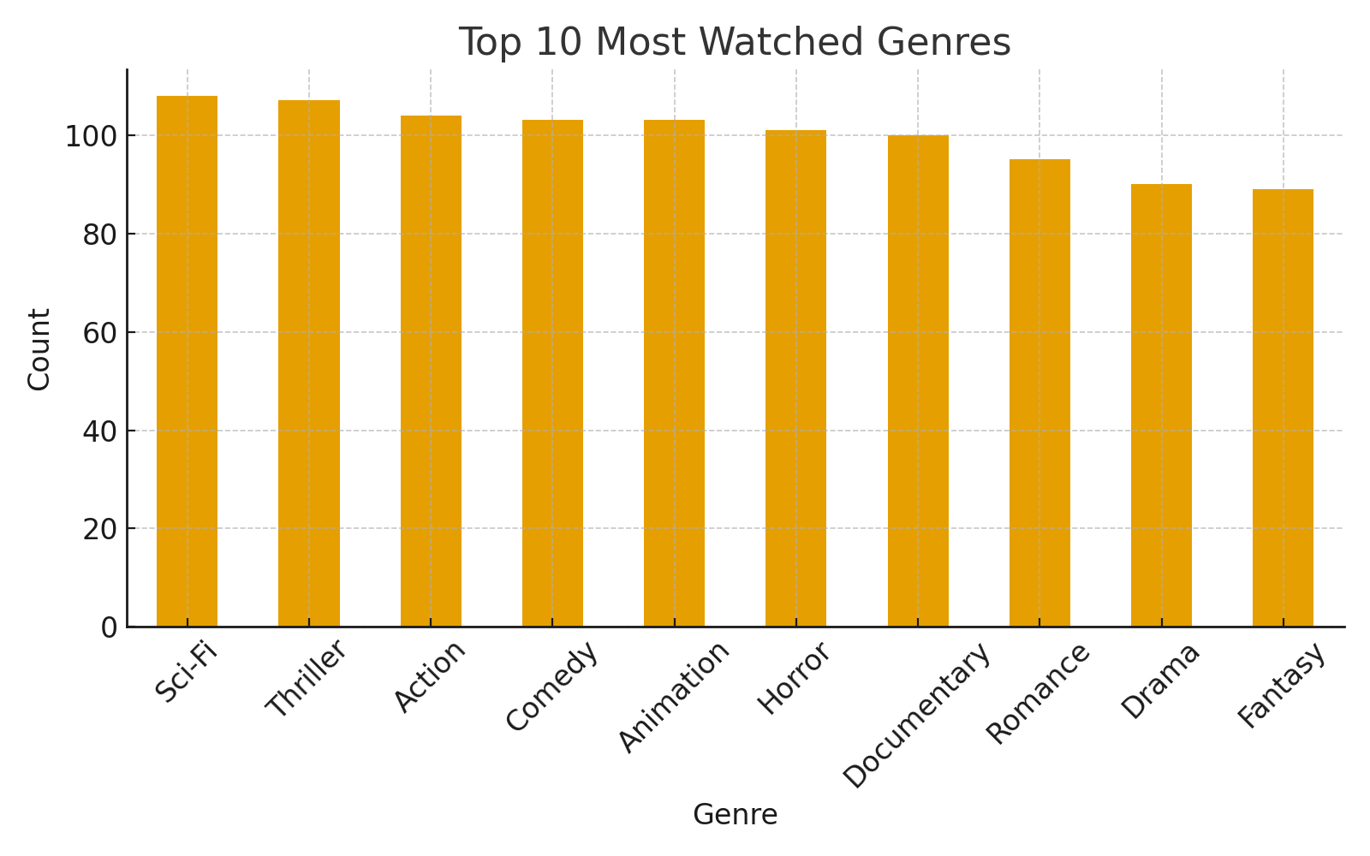
Figure: Genre Distribution
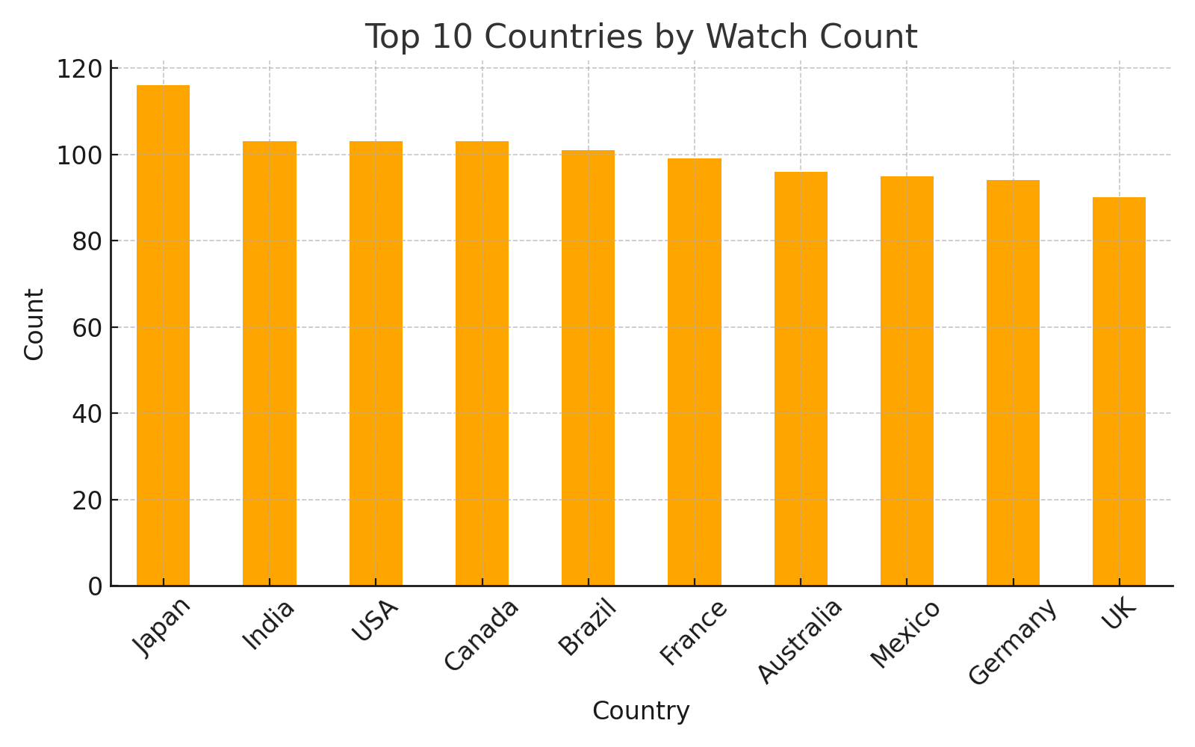
Figure: Country Distribution
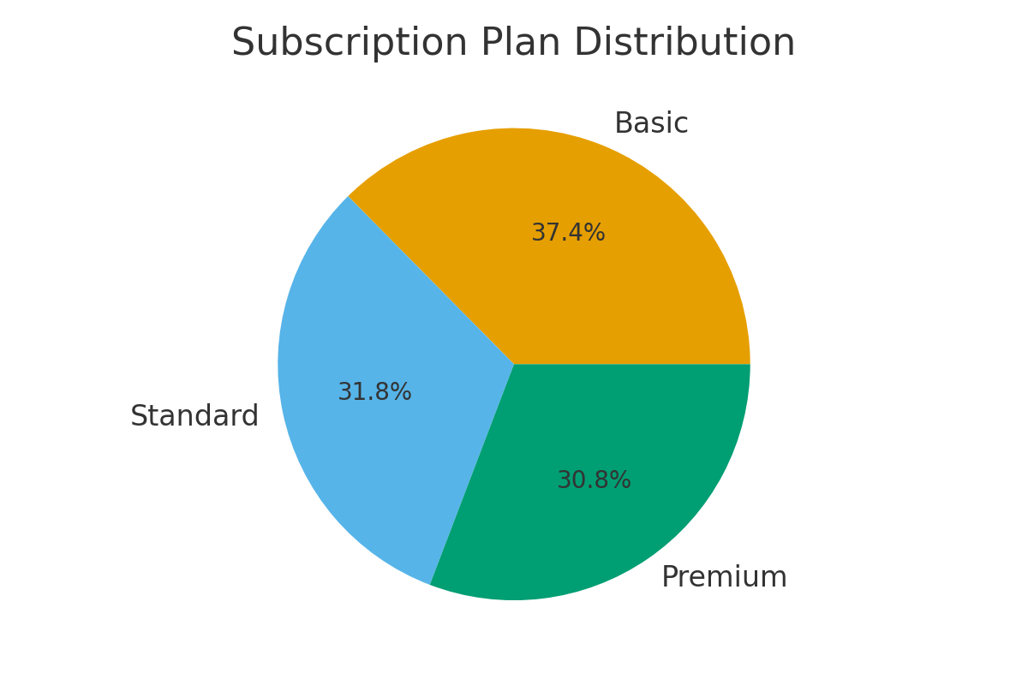
Figure: Subscription Pie
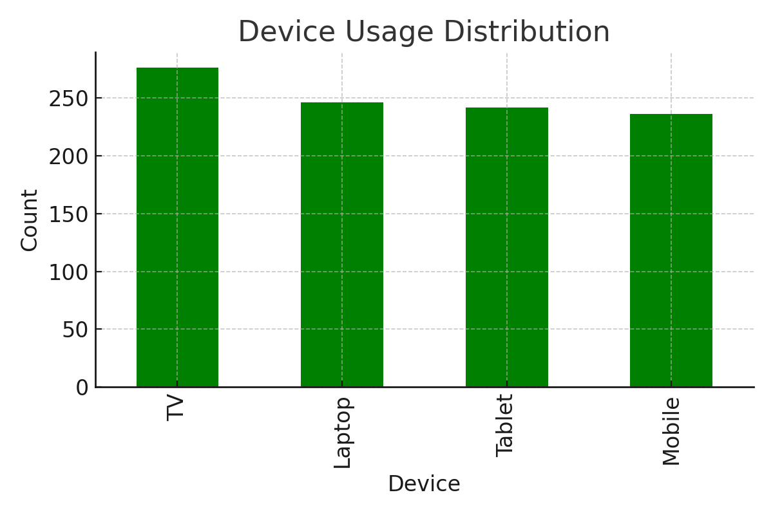
Figure: Device Usage
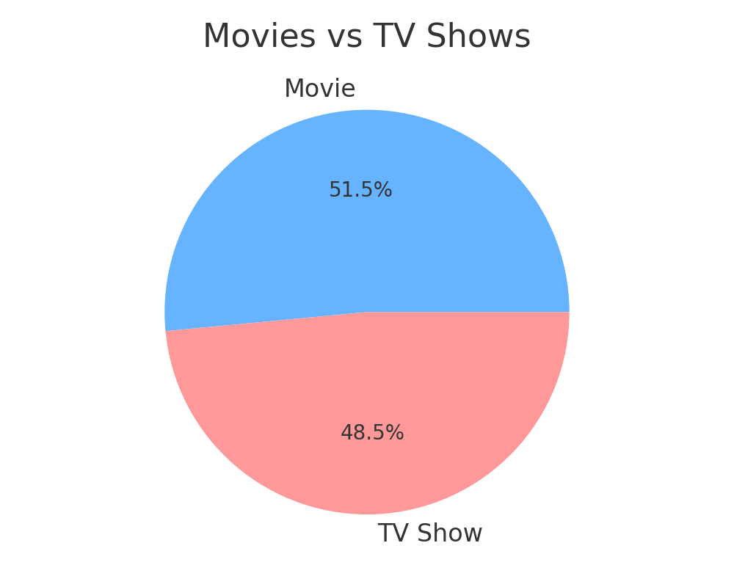
Figure: Content Type Pie

9. Insight Generation
1. Drama, Action, and Comedy are the most popular genres with high user engagement.
2. India and the USA have the highest viewership, showing strong engagement in regional content.
3. Premium plan users have the longest average watch time, indicating higher satisfaction.
4. Mobile devices are most frequently used, but Smart TVs show the highest average watch duration.
5. Newer releases (post-2018) receive higher ratings compared to older content.

10. Conclusion
The Netflix data analysis provided valuable insights into user preferences, regional trends, and subscription behaviors. It was observed that engagement is driven by premium users, trending genres, and mobile device accessibility. These insights can support Netflix in enhancing personalization, content planning, and marketing strategies.

