**CS 697 Digital Image Processing – Independent Study**

Assignment 2 UIN: 01161389

a) Separate RGB layers of a RAW image: Read a colored image. Then separate and display the three layers (Red, green, and Blue)

Initial Image:

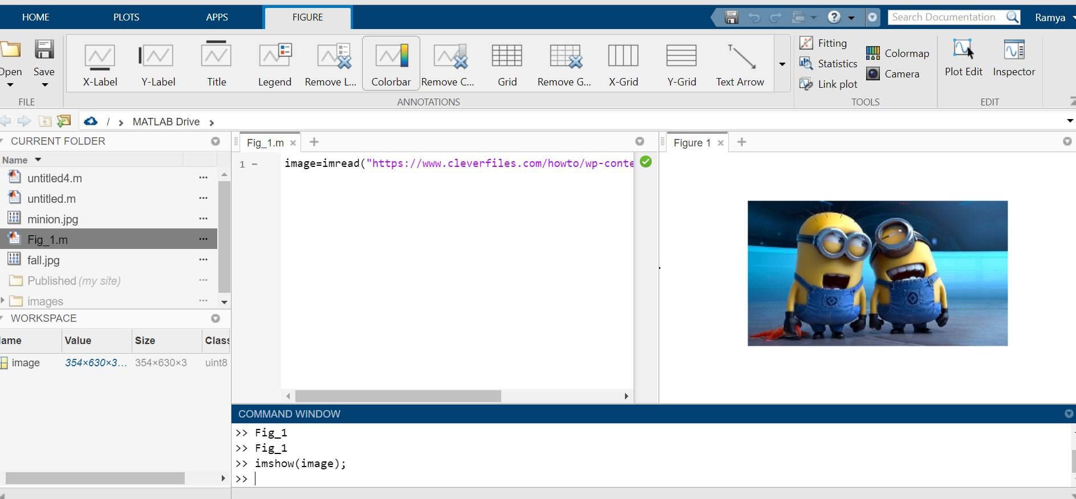

Red Color layer image:

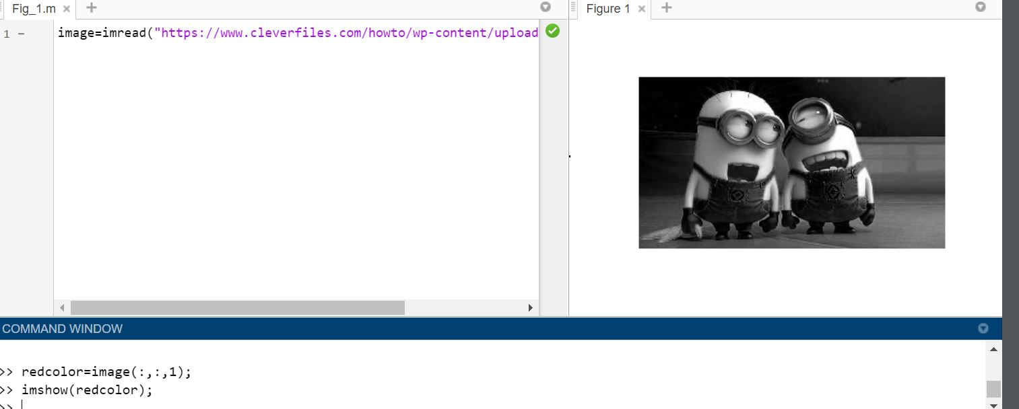

Green Color layer image:

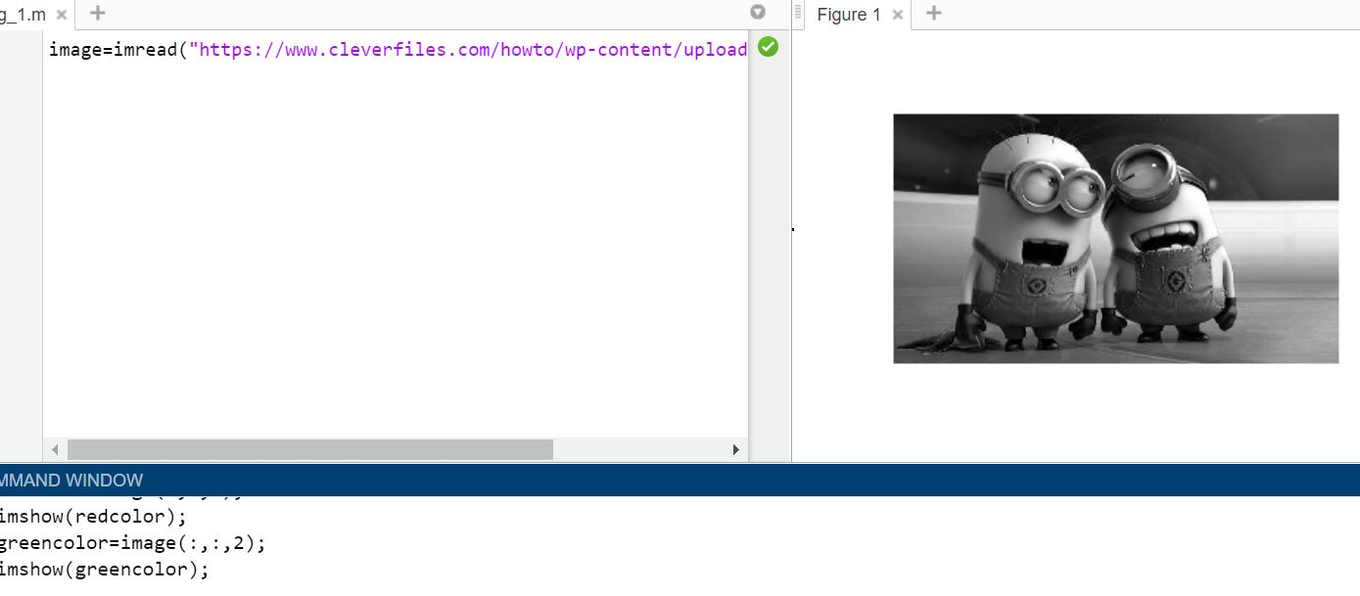

Blue Color layer image:

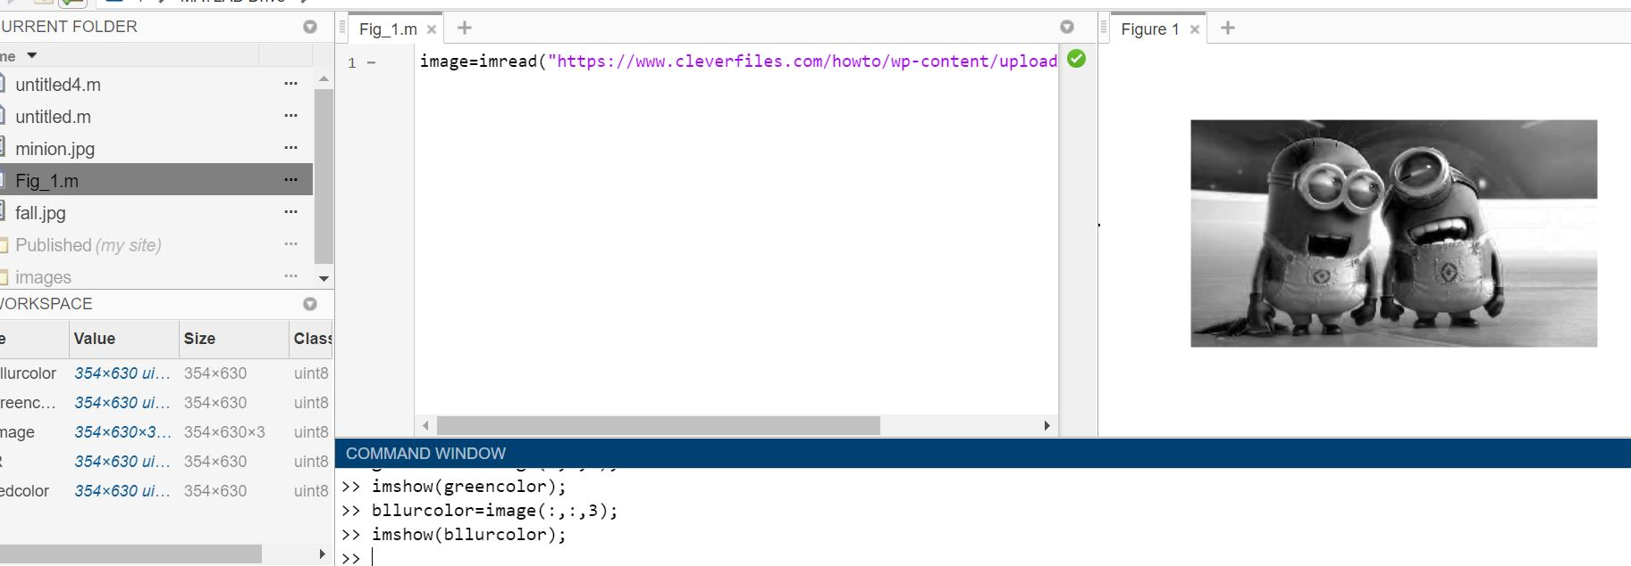

In order to verify the results I have added all the layer values and displayed it.

Verified Result:

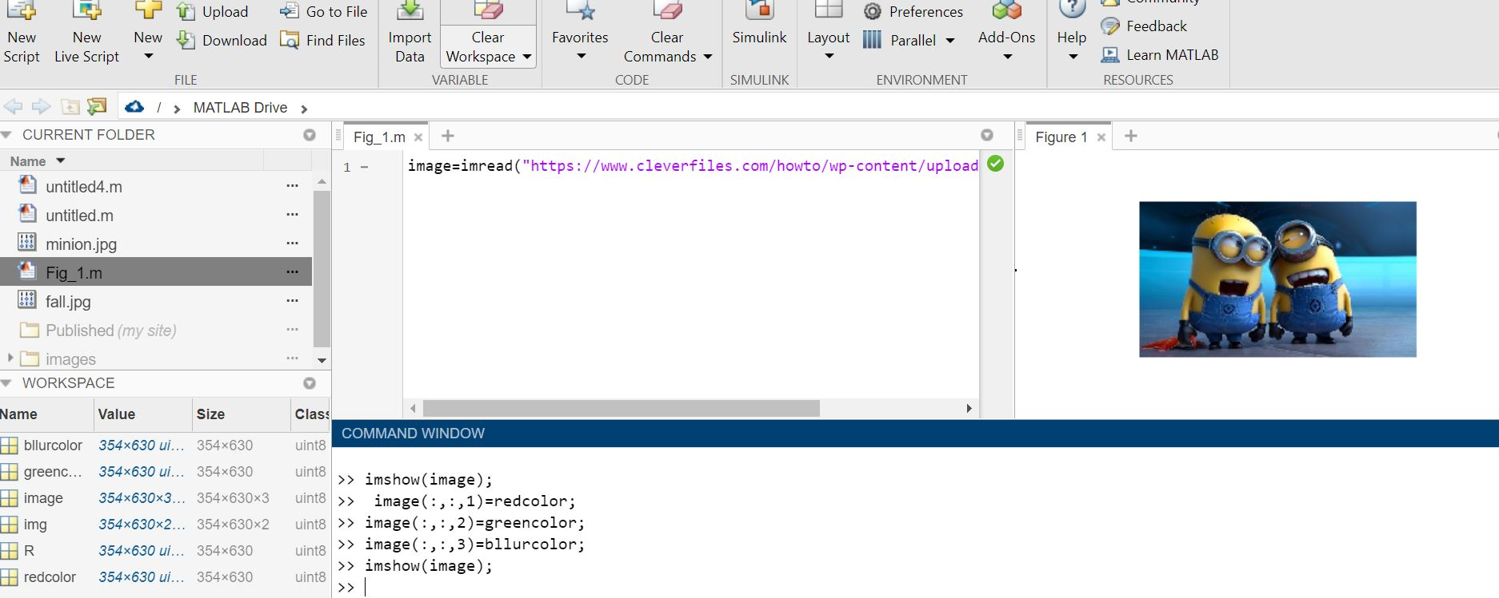

b) Histogram of Image Data: Read a gray scale image and display the histogram of the image

Gray Scale Image:Command used here is rgb2gray

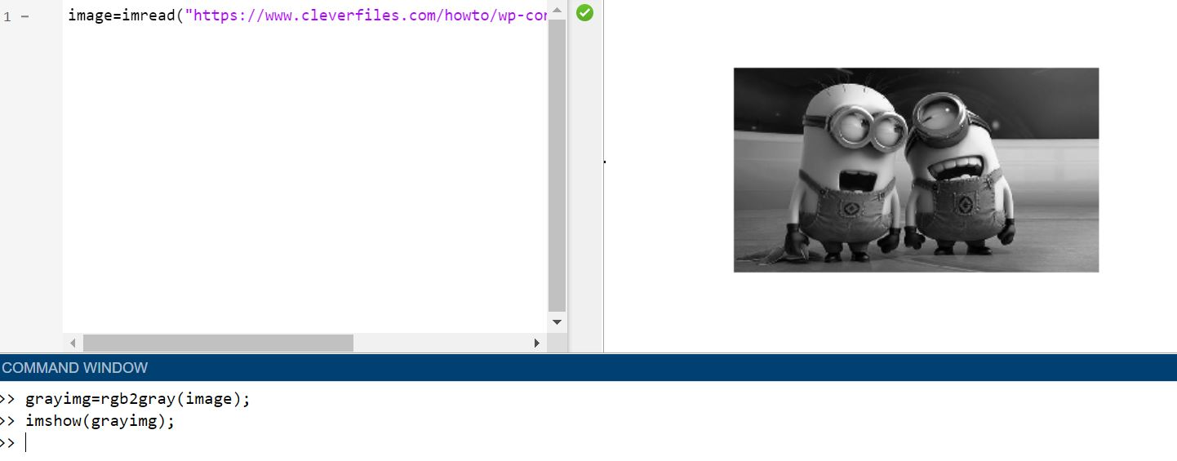

Histogram of Image: command used here is imhist ()

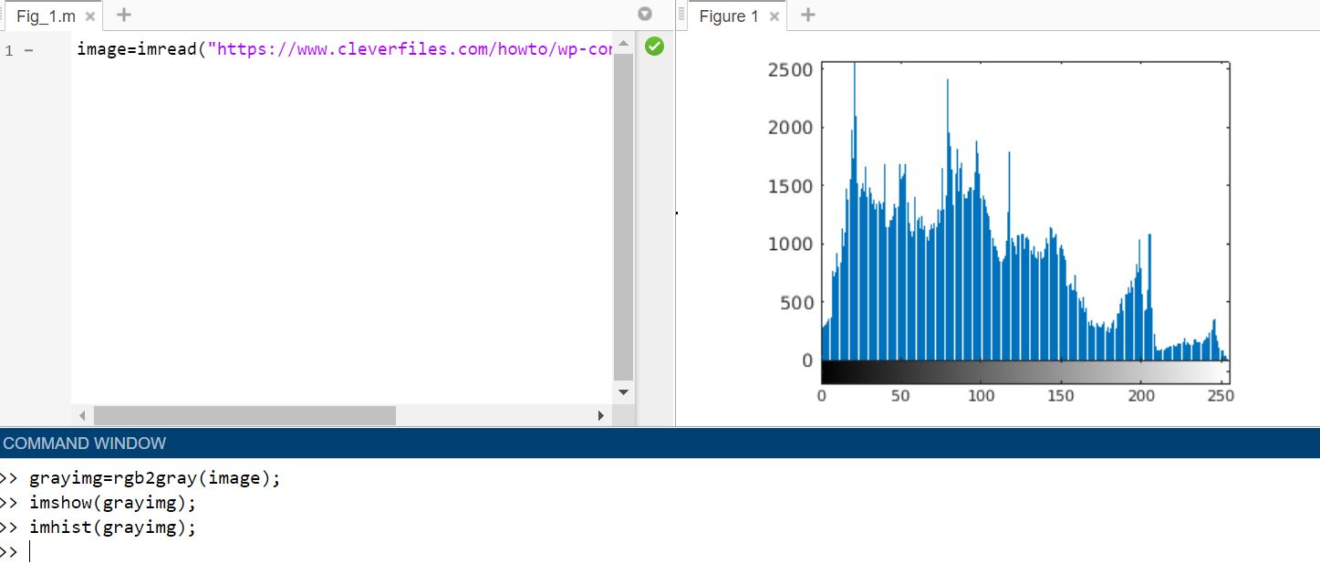

c) Histogram Equalization: Apply histogram equalization to a gray scale image to increase the contrast for the image. Display the output image and its histogram.

Before Histogram Equalization:

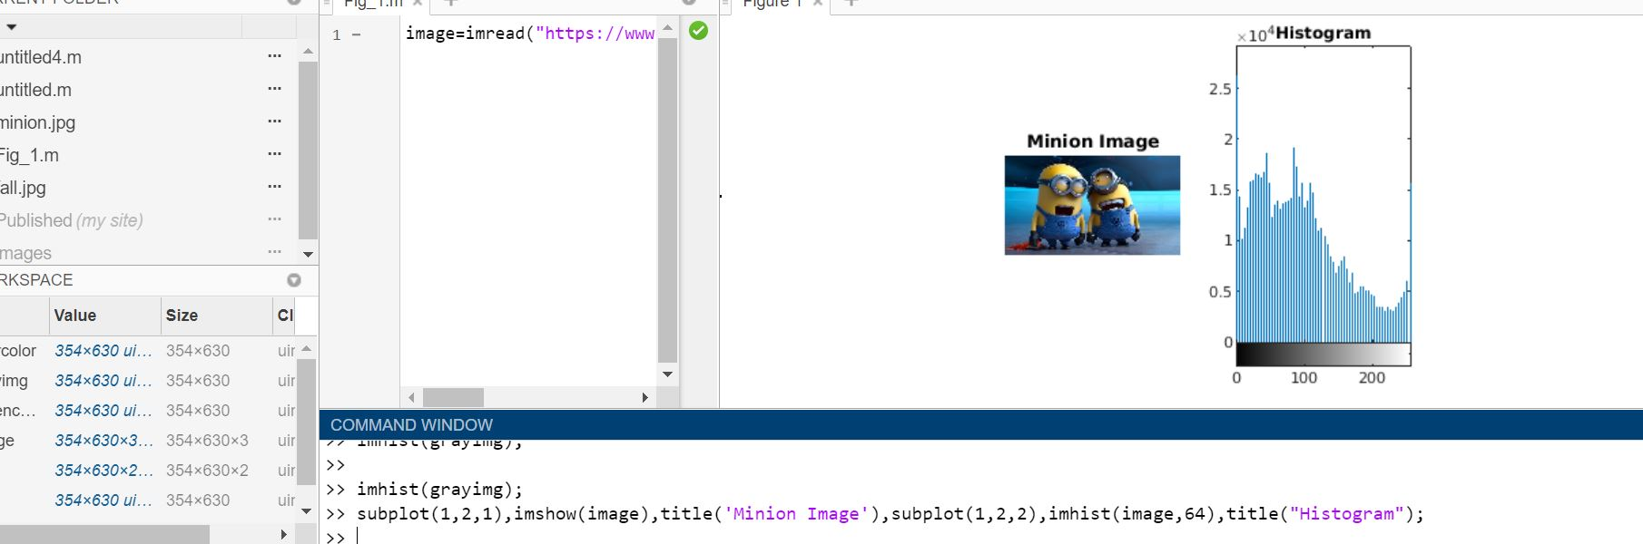

After Histogram Equalization: command used here is histeq () and subplot is used to display image and histogram.

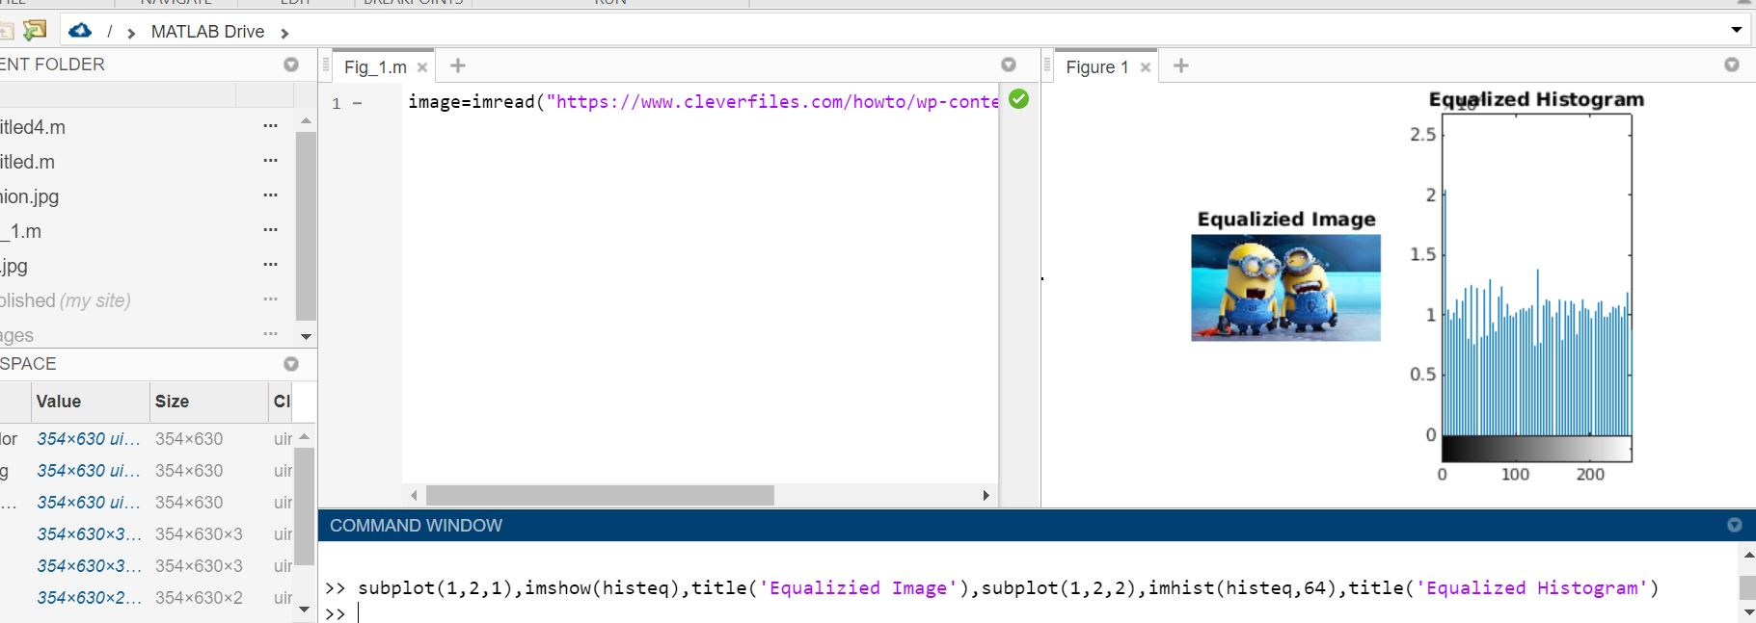

d)Histogram Matching: Use the Matlab function imhistmatch() to match the histogram of an image to e reference image. Display the following:

i. the input image,

ii. the reference image,

iii. the output image,

iv. the histogram of the input image,

v. the histogram of the reference image

vi. the histogram of the output image.

1. 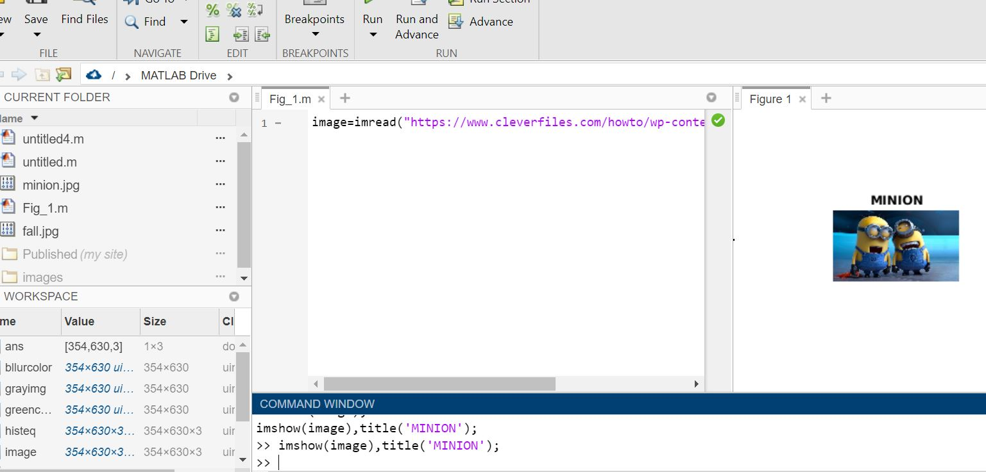Input image:
2. 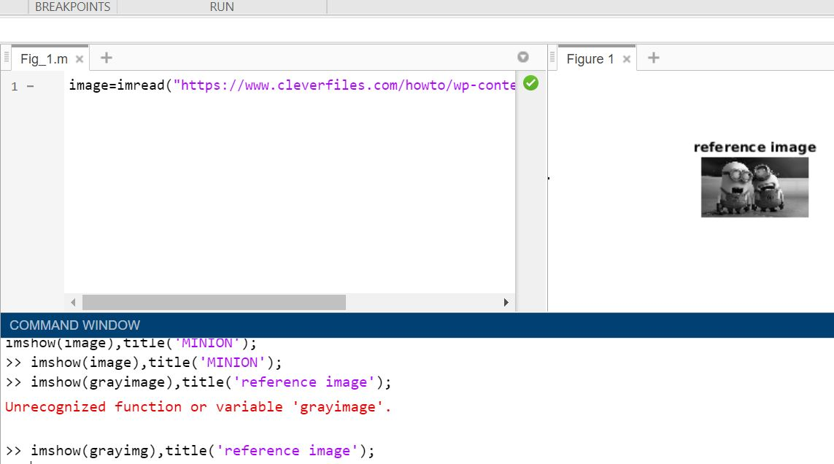Reference image: It is a gray scale image, command used here is rgb2gray ()
3. Output image: after histogram matching, command used is imhistmatch ()

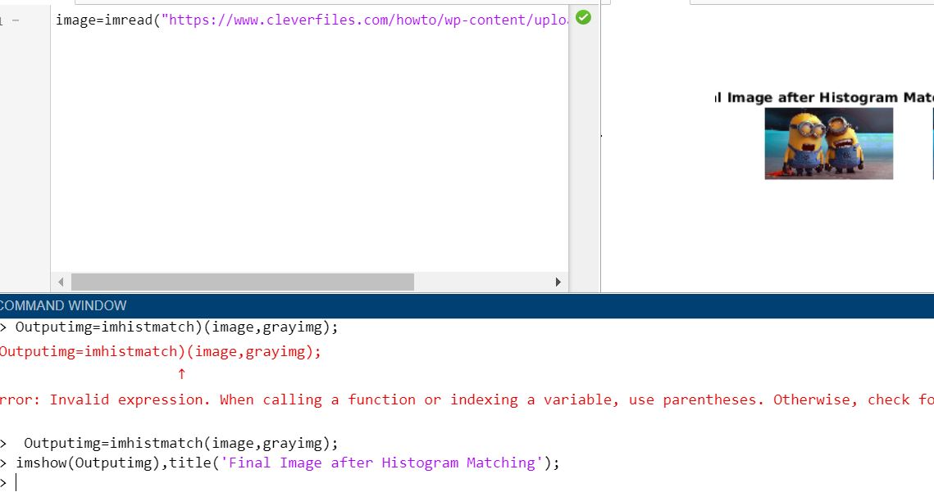

1. 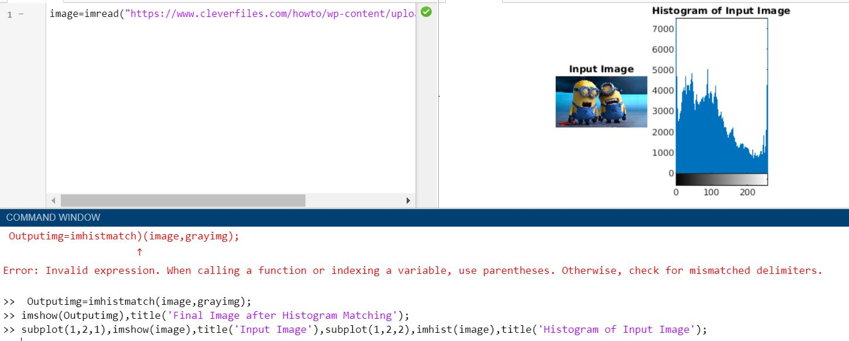Histogram of the input image
2. 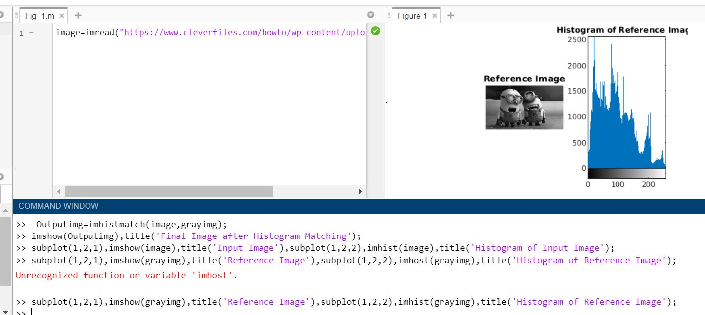Histogram of the reference image
3. 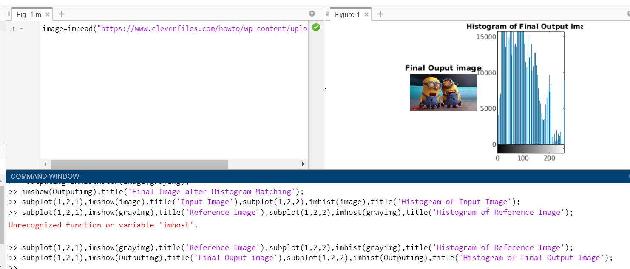Histogram of the output image: