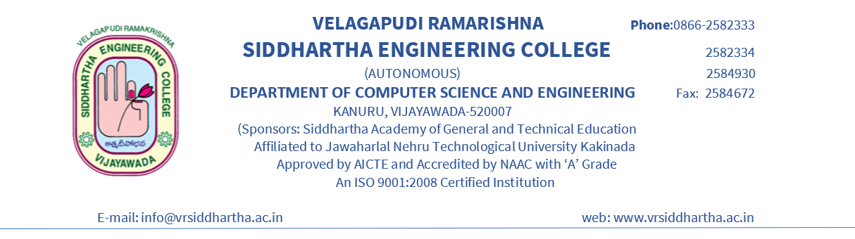

**LETTER OF RECOMMENDATION**

As the Senior Professor of CSE Department in V.R.Siddhartha engineering college, I am glad to pen a few lines about Bondalapati Bindu Priya, who is known to me for the past four years during which I had an ample opportunity to judge her capabilities and integrity personally as well as academically.

Having a handful of communication and interaction with her, I undoubtedly found her a devoted and diligent student. She has impressed me a lot with her acumen and systematic approach to problem-solving. Her aptitude for research is exemplary and laudable.

Her assiduous nature, motivation, and prodigiously inquisitive posture can be an asset to any research team. Her attitude has always been thought infuriated, and her self-confidence pays her academic dividends. Her muffled temperament, pleasant manners, and affable nature make her highly suitable for teamwork.

She performs any job assigned to her with all her willingness. Her amiability with others and readiness to work in a group are notable. Her leadership qualities with amenable, subtle, and impeccable manners make her very much suitable for teamwork. She has excellent communication skills, both oral and written. Her perseverance, potential for professional growth, and career advancement are praiseworthy.

Her consistent top-grade performances prove her solid grounding in subjects' fundamentals, unwavering focus, and perseverance. Her meticulous approach to problem-solving and willingness to learn to make her an ideal person for research. Considering her burning zeal for excellence and inborn drive for achieving the best, I strongly recommend her for the Master's Degree program at your esteemed University with a maximum possible assistantship, which she richly deserves.

I assure you that she would exceptionally do well at your University.

**DR.S.Vasavi, MS, Ph.D.**

**Professor & Program Co-Ordinator (PG),**

**Department of Computer Science and Engineering,**

**VR Siddhartha Engineering College.**

**Place:Vijayawada**

**Email:** **vasavi_movva@vrsiddhartha.ac.in**

**Phone: College Phone Number (308)**