1.Explain OOPS Concepts?What are the benfits of oops concept?
Ans:
OOPS concepts are
1.Polymorphisam
2.Abstraction
3.Inheritance
4.Encapsulation
Polymorphisam means we can use one thing in multiple forms.
Abstraction means we can bind the things into one single unit.
Inheritance means we can extract the properites of parent class to child class.
Encapsulation means whatever the required data thats only we will give,unneccesary data we will hilde.that means data hilding.

Benfits of oops concept reusability is here.
We can define a method in class,and we can declare variables and methods with in the class itself.

2.Ans
Ans:
/////////shallow copy

#include<iostream>
using namespace std;

class shallowcopy
{
int a,b;
public:

void setdata(int x, int y)
{
a=x;
b=y;
}

void showdata()
{
cout << "data1="<<a<<"\ndata2="<<b<<"\n";
}

};
int main()
{
shallowcopy obj;
obj.setdata(10,20);
obj.showdata();
shallowcopy obj1;
obj1=obj;
obj1.showdata();

return 0;
}
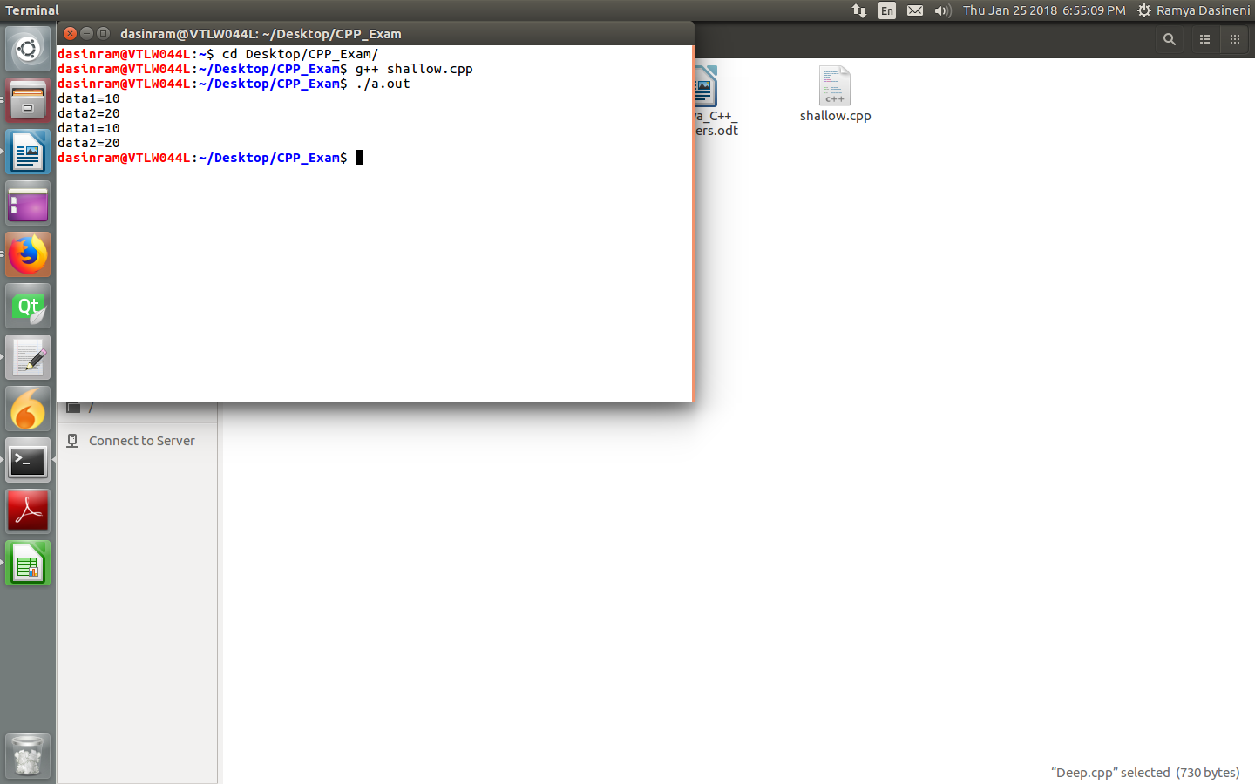
///////Deep Copy

#include<iostream>
using namespace std;

class deep_copy
{
int data1,data2,*ptr;
public:

deep_copy()
{
ptr=new int ;
}
void setdata(int value1, int value2,int value3)
{
data1=value1;
data2=value2;
*ptr=value3;
}
void showdata()
{
cout << "data1="<<data1<<"\ndata2="<<data2<<"\nptr="<<*ptr<<"\n";
}
deep_copy(deep_copy &ref)
{
this->data1=ref.data1;
this->data2=ref.data2;
this->ptr=new int;
*ptr=*(ref.ptr);
}
~deep_copy()
{
delete ptr;
}
};

int main()
{
deep_copy obj1;
obj1.setdata(10,20,30);
deep_copy obj2=obj1;
obj1.showdata();
obj2.setdata(1,2,3);
cout<<"After setting Obj2 it will not effecting on obj1"<<endl;
obj1.showdata();
cout<<endl;
obj2.showdata();
return 0;
}

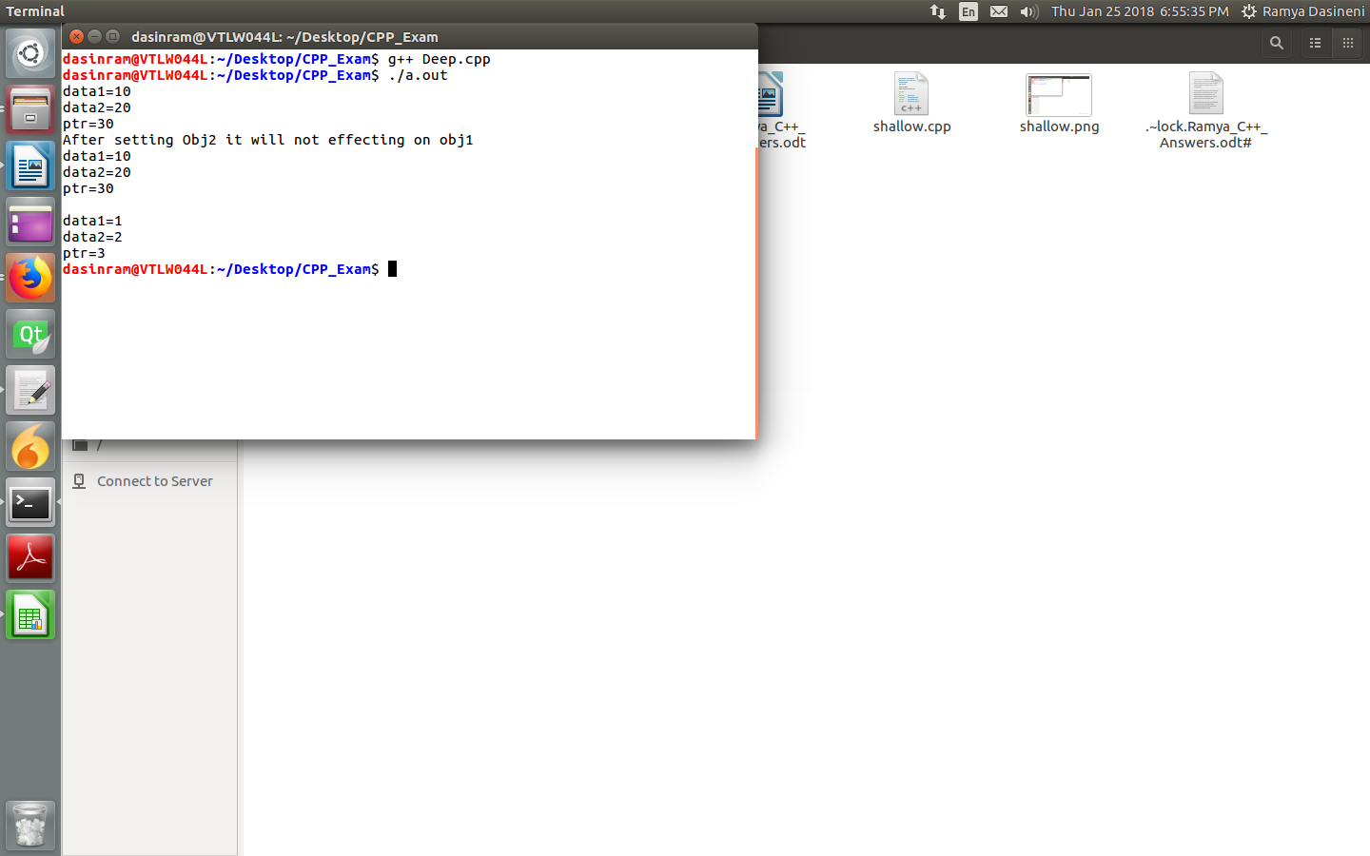

3.Ans
Ans:
- Inheritance means extracting the properties from parent class to class child class.
- Multiple inheritance means if one child class extracting the properties from two or more parents classes the it will be called as multiple inheritance.
- Virtual functions means if we are defining a function in parent class and if we want to extend that function in child class then we can override that function in child class.But whenever we are calling that function with object bydefault it will call the base class function,so to avoid that we are declaring the parent class function as a virtual function.Then it will call the child class object.
- Vtable means Virtual table.Virtual table contains all the data about virtual functions and its addresses.

4.Ans
STL Means Standard template library.This STL’s are used for to implement generic functions.
#include <iostream>
#include <vector>
#include <list>
#include <set>
#include <map>
#include <string>
#include <algorithm>
#include <iterator>
#include <functional>
#include <numeric>

template <class T>
inline void print (const T& a, const char* x="")
{
typename T::const_iterator pos;

std::cout << x;
for (pos=a.begin(); pos!=a.end(); ++pos) {
std::cout << *pos << ' ';
}
std::cout << std::endl;
}

template <class T>
inline void insert (T& a, int first, int last)
{
for (int i=first; i<=last; ++i) {
a.insert(a.end(),i);
}
}

using namespace std;

int main()
{
vector<int> a;

insert(a,1,9);

print(a,"elements:");




