1.
#include<stdio.h>
//rotate.c
int rightrotaions(int num,int rot)
{
int n=0,rem,res;
while(n<rot)
{
rem = num%10;
num = num/10;
num = rem*100+num;
n++;
}
return num;
}

int main()
{
int num,rotations;
printf("enter number and rotations:");
scanf("%d %d",&num,&rotations);
int res = rightrotaions(num,rotations);
printf("rotated number:%d\n",res);
}
Output:
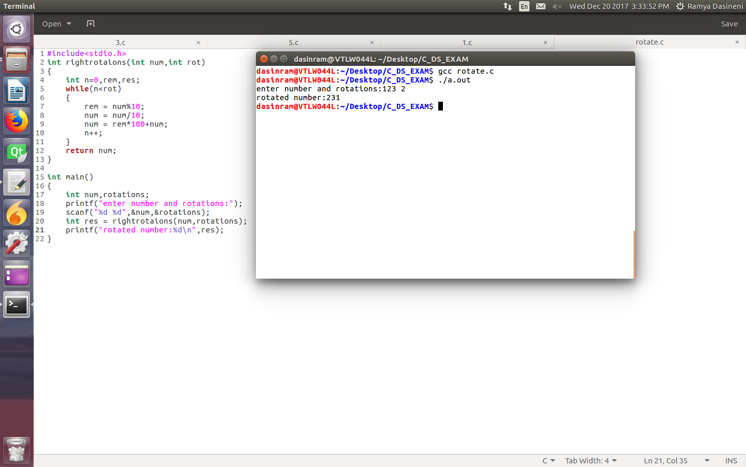

2.
#include<stdio.h>
//array_subset.c
int main()
{
int arr1[100],arr2[100],i=0,j=0,len1,len2,cnt=0;
while(1)
{
printf("enter array1 length:");
scanf("%d",&len1);
printf("enter array2 length:");
scanf("%d",&len2);
printf("enter array1 elements:");
for(i=0;i<len1;i++)
scanf("%d",&arr1[i]);
printf("enter array2 elements:");
for(j=0;j<len2;j++)
scanf("%d",&arr2[j]);

for(i=0;i<len1;i++)
{
for(j=0;j<len2;j++)
{
if(arr1[i]==arr2[j])
cnt++;

}
}
if(cnt == len2)
printf("arr2[] is subset of arr1[]\n");
else
printf("arr2[] is not subset of arr1[]\n");
}
}
Output:
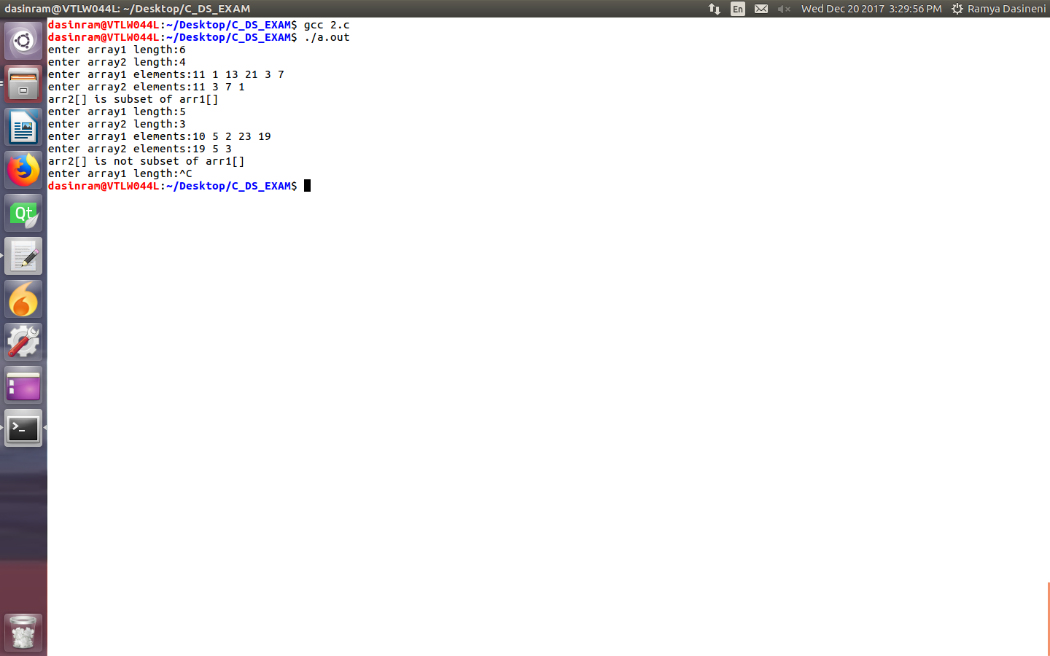

3.
#include<stdio.h>
int main()
{
int arr[10],res[10],ind1,ind2,cnt=0;
puts("enter values into array:");
for(ind1=0;ind1<10;ind1++)
scanf("%d",&arr[ind1]);
for(ind1=0;ind1<10;ind1++)
{
for(ind2=0;ind2<10;ind2++)
{
if((arr[ind1]==arr[ind2])&&(ind1!=ind2))
break;
}
if(ind2==10)
res[cnt++]=arr[ind1];
}
puts("resultant arr is:");
for(ind1=0;ind1<cnt;ind1++)
printf("%d ",res[ind1]);
printf("\n");
}
Output:
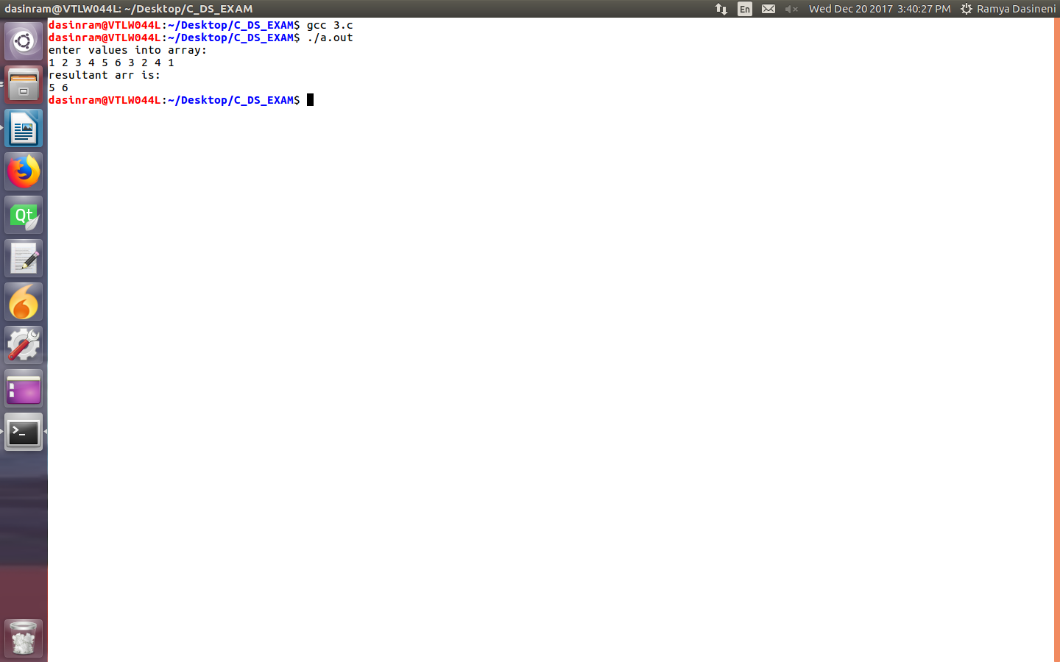

4.
#include<stdio.h>
//function_pointer.c

void add(int a,int b)
{
printf("addition=%d\n",a+b);
}
void sub(int a,int b)
{
printf("subtraction=%d\n",a-b);
}
void mul(int a,int b)
{
printf("multipication=%d\n",a*b);
}
void div(int a,int b)
{
printf("division=%d\n",a/b);
}
int main()
{
int num1,num2;
printf("enter num1,num2:");
scanf("%d %d",&num1,&num2);
void (*fp)(int,int);
fp = &add;
(*fp)(num1,num2);
fp = &sub;
(*fp)(num1,num2);
fp = &mul;
(*fp)(num1,num2);
fp = &div;
(*fp)(num1,num2);
}

Output:

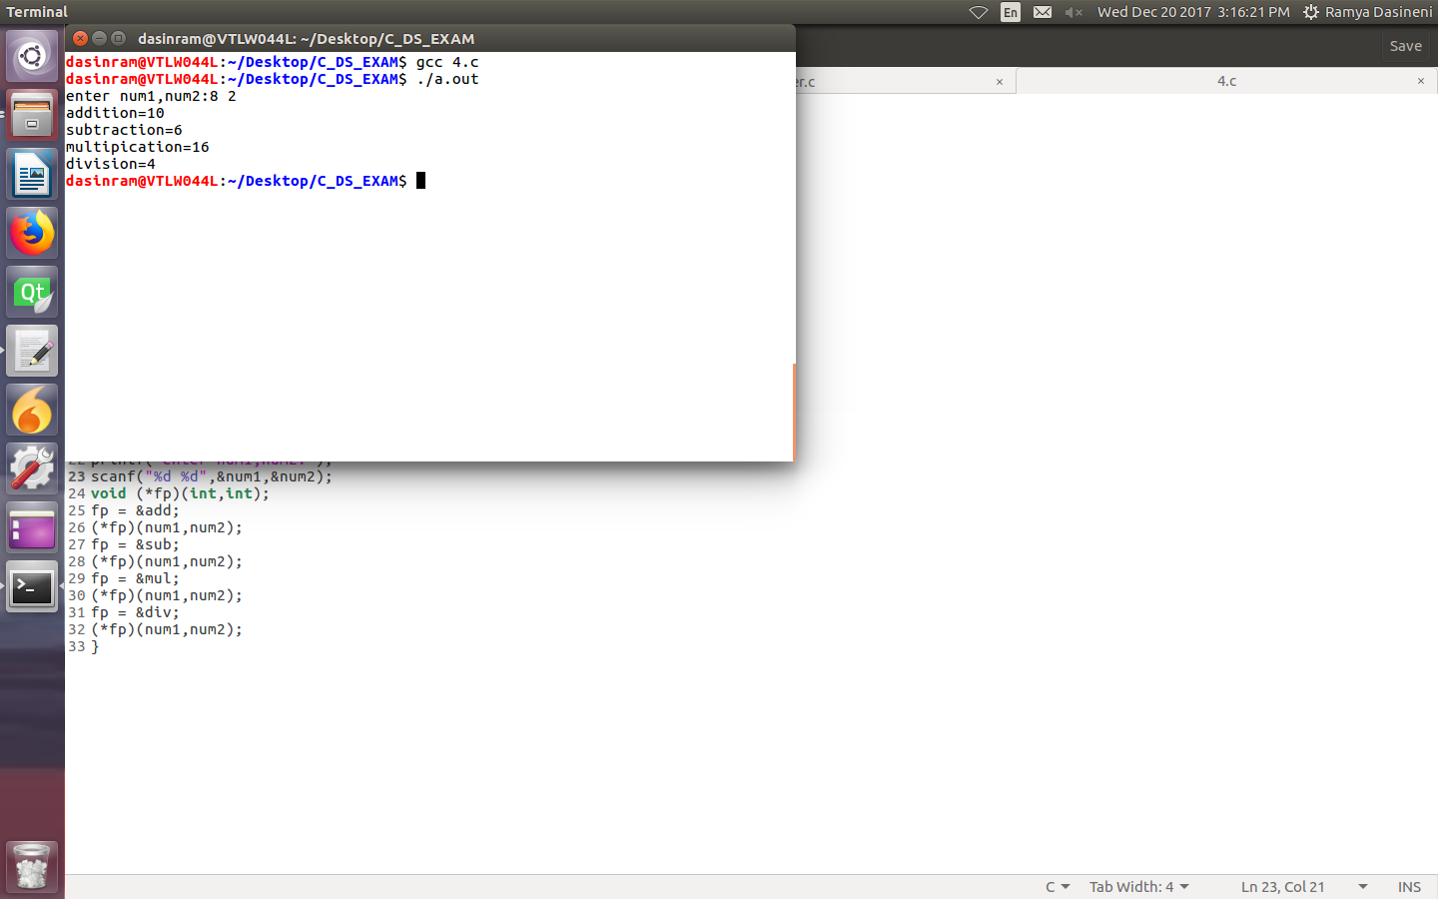
5.#include<stdio.h>
#include<stdlib.h>
struct bst
{
int val;
struct bst *left,*right;
};
void insert(struct bst**node,int data)
{
struct bst *nu;
if(*node==NULL)
{
nu=malloc(sizeof(struct bst));
nu->val=data;
nu->left=NULL;
nu->right=NULL;
*node=nu;
}
else if(data<(*node)->val)
insert(&((*node)->left),data);
else if(data >(*node)->val)
insert(&((*node)->right),data);
else
printf("duplicates are not allowed\n");
}
void printin(struct bst *node)
{
if(node)
{
printin(node->left);
printf("%d-->",node->val);
printin(node->right);
}

}
void printpre(struct bst *node)
{
if(node)
{
printf("%d-->",node->val);
printpre(node->left);
printpre(node->right);
}

}
void printpost(struct bst *node)
{
if(node)
{
printpost(node->left);
printpost(node->right);
printf("%d-->",node->val);
}

}
int main()
{
int choice;
int data;
struct bst *root=NULL,*ptr=NULL;
insert(&root,8);
insert(&root,4);
insert(&root,12);
insert(&root,2);
insert(&root,5);
insert(&root,9);
insert(&root,14);
insert(&root,3);
insert(&root,7);
insert(&root,10);

while(1)
{
printf("\n1:printin 2:printpre 3:printpost 4:quit\n");
printf("enter ur choice");
scanf("%d",&choice);

switch(choice)
{

case 1:printin(root);
break;
case 2:printpre(root);
break;
case 3:printpost(root);
break;
case 4:return 0;

default:printf("invalid choice\n");
}
}
return 0;
}

Output:

