Question1:

#include<stdio.h>
int main()
{
int num,i,j,flag=0,count =0;
printf("enter which position prime number you want:");
scanf("%d",&num);
for(i=2;;i++)
{
flag =0;
for(j=2;j<=i/2;j++)
{
if(i%j == 0)
{
flag = 1;
break;
}
}
if(flag == 0)
count ++;
if(count == num)
break;
}
printf("prime number in position %d is: %d\n",num,i);
}

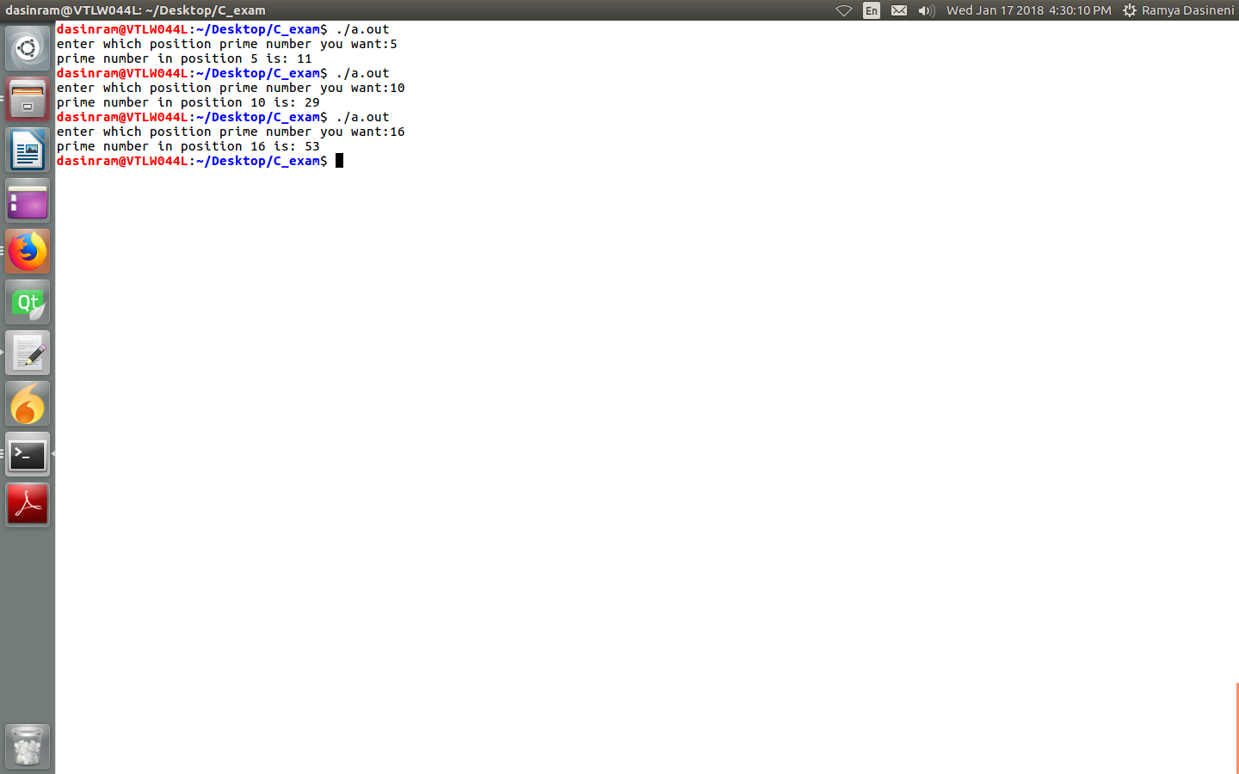

Question3

#include<stdio.h>
int main()
{
int num,a=0,b=1,c=0,flag =0;
printf("enter a number:");
scanf("%d",&num);
while(c<num)
{
c=a+b;
a=b;
b=c;
if(c == num)
{
for(int i=2;i<=num/2;i++)
{
if(num%i == 0)
{
flag = 1;
break;
}
}
}
if(c>num)
{
flag = 1;
break;
}

}
if(flag == 0)
printf("Number %d is fibnocci prime\n",num);
else
printf("Number %d is not fibnocci prime\n",num);
}
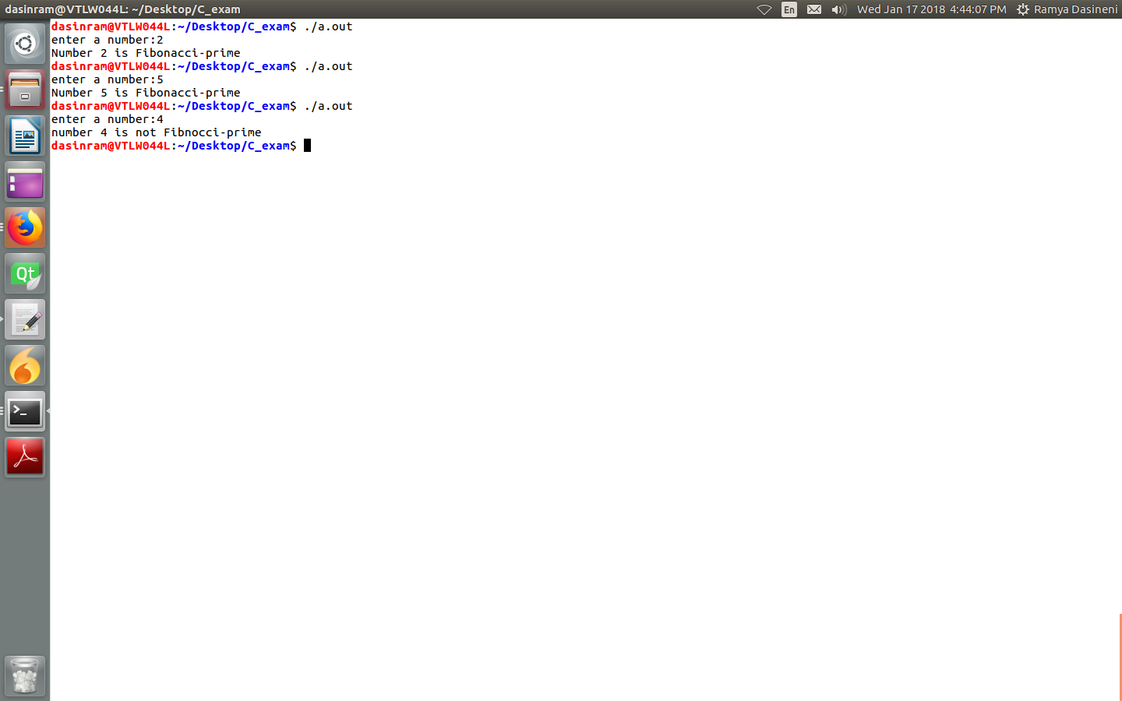

Question4:

#include<stdio.h>
#include<stdlib.h>
int main()
{
char string[20];
int index1,index2;
printf("enter a string:");
scanf("%s",&string[0]);
for(index1=0;string[index1];index1++)
{
for(index2=0;string[index2];index2++)
if((string[index1]==string[index2])&&(index1!=index2))
break;
if(string[index2]=='\0')
{
printf("First non repeating char in string %s is:%c\n",string,string[index1]);
return 0;
}
}
printf("first non repeating char in string %s is:-1\n",string);

}

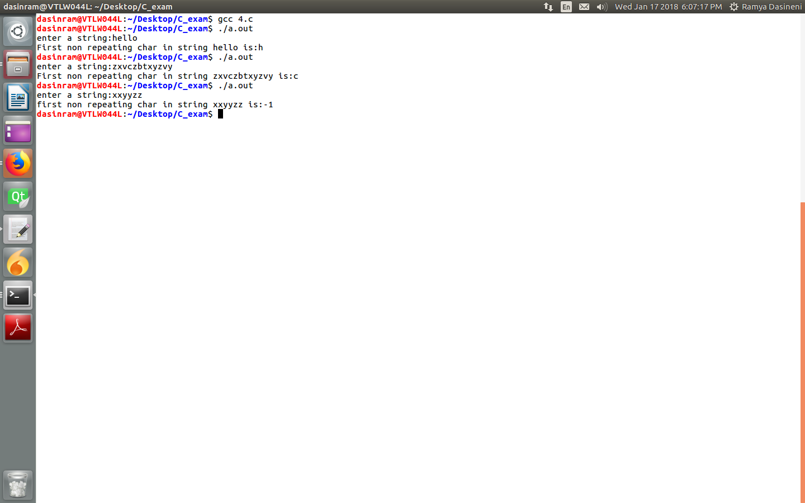

Question5:

#include<stdio.h>
#include<stdlib.h>
typedef struct sll
{
int data;
struct sll *next;

}NODE;
void insert(NODE **head)
{

NODE *nu,*temp;
nu=malloc(sizeof(NODE));
printf("enter data:");
scanf("%d",&(nu->data));
nu->next=NULL;
if(*head==NULL)
{
*head=nu;
}
else
{
temp=*head;
while(temp->next)
temp=temp->next;
temp->next=nu;
}
}
void print(NODE *head)
{
if(head!=NULL)
while(head)
{
printf("%d ",head->data);
head=head->next;
}
else
puts("Empty");

}
void merge(NODE **head1,NODE **head2)
{
NODE *temp1,*prev1,*temp2,*prev2,*nu;
temp1=*head1;
temp2=*head2;
prev1=*head1;
while((prev1->next)&&(prev2->next))
{
prev1=temp1->next;
nu=malloc(sizeof(NODE));
nu->data=temp2->data;
temp1->next=nu;
nu->next=prev1;
prev2=temp2->next;
*head2=prev2;
free(temp2);
temp2=NULL;
temp2=prev2;
temp1=prev1;

}
if(prev1->next==NULL)
{
nu=malloc(sizeof(NODE));
nu->data=temp2->data;
nu->next=NULL;
prev1->next=nu;
prev2=temp2->next;
*head2=prev2;
free(temp2);
temp2=NULL;

}

}
int main()
{
int n1,n2;
printf("enter no.of elements in list1,list2:");
scanf("%d%d",&n1,&n2);
NODE *head1=NULL,*head2=NULL;
printf("insert elements into head1:\n");
while(n1>0)
{
insert(&head1);
n1--;
}
printf("insert elements into head2:\n");
while(n2>0)
{
insert(&head2);
n2--;
}
merge(&head1,&head2);
printf("head1:");
print(head1);
printf("\n");
printf("head2:");
print(head2);
printf("\n");

}
