C Theory Test
1.Copy n no of bytes from source to destinantion without using c library functions?
Ans:
void myMemCpy(void *dest, void *src, int n)
{
char *msrc = (char *)src;
char *mdest = (char *)dest;
for (int i=0; i<n; i++)
mdest[i] = msrc[i];
}
2.What is Re-entrant code?
Ans:A function is said to be reentrant if there is a provision to interrupt the function in the course of execution, service the interrupt service routine and then resume the earlier going on function, without hampering its earlier course of action. Reentrant functions are used in applications like hardware interrupt handling, recursion, etc.

EX:int fun1(int i)
{
return i * 5;
}
int fun2(int i)
{
return fun1() * 5;
}

5.Given a pointer to node in a doubly linked list.Write a piece of code to delete the node?
Ans:
struct Node
{
int data;
struct Node *next;
struct Node *prev;
};

void deleteNode(struct Node **head_ref, struct Node *del)
{
if(*head_ref == NULL || del == NULL)
return;

if(*head_ref == del)
*head_ref = del->next;

if(del->next != NULL)
del->next->prev = del->prev;

if(del->prev != NULL)
del->prev->next = del->next;

free(del);
return;
}

C Coding Test

1.Middle position element in stack
Ans:
#include<stdio.h>
#define MAX 5
int top=-1;
int cnt=0;
int push(int a[],int data)
{
top++;
if(top<MAX)
a[top]=data;
else
{
printf("stack overflow\n");
top--;
}
cnt++;
return cnt;
}
void display(int a[])
{
int i;
i=top;
while(i!=-1)
{
printf("%d ",a[i]);
i--;
}

}
void middlenode(int a[])
{
int i;
i=top;
while(i!=-1)
{
if(i == cnt/2)
{
printf("%d\n",a[i]);
break;
}
i--;
}
}

int main()
{
int n,choice,data;
int arr[MAX];
push(arr,1);
push(arr,2);
push(arr,3);
push(arr,4);
push(arr,5);
printf("stack elements are:");
display(arr);
printf("\nmiddle node data is:");
middlenode(arr);
}

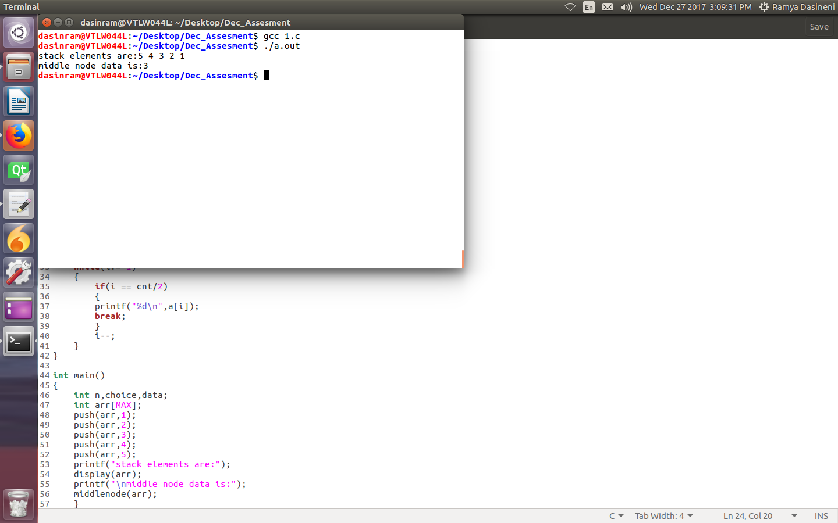
3.Invert function

Ans:
#include<stdio.h>
int invert(int x,int p,int n)
{
int i,num=x;
int cnt=0;
for(i=0;i<=31;i++)
{
if(i==p)
{
for(int j=i;j<=31;j++)
{
num = (num^(1<<j));
cnt++;
if(cnt == n)
break;
}
}

}
return num;
}
int main()
{
int num,pos,bits;
printf("enter number,position,bits:");
scanf("%d %d %d",&num,&pos,&bits);
int res = invert(num,pos,bits);
printf("resultant number is %d\n",res);
}
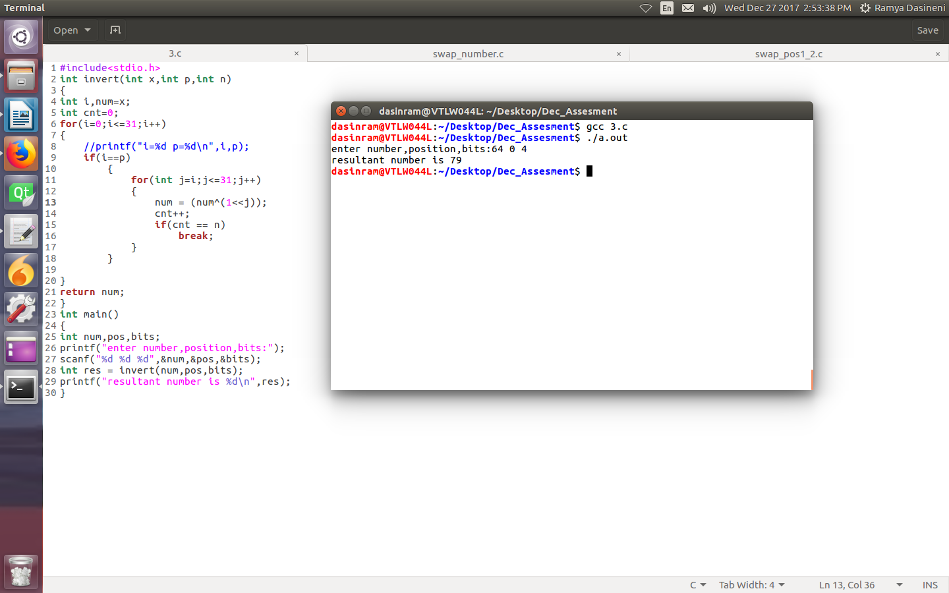
6.Subset of Array:
Ans:
#include<stdio.h>
int main()
{
int size1,size2;
while(1)
{
printf("enter size of arr1:");
scanf("%d",&size1);
printf("enter size of arr2:");
scanf("%d",&size2);
int arr1[size1],arr2[size2];
int ind1,ind2,cnt=0;
printf("enter values of arr1:");
for(ind1=0;ind1<size1;ind1++)
scanf("%d",&arr1[ind1]);
printf("enter values of arr2:");
for(ind1=0;ind1<size2;ind1++)
scanf("%d",&arr2[ind1]);
for(ind1=0;ind1<size2;ind1++)
{
for(ind2=0;ind2<size1;ind2++)
{
if(arr2[ind1]==arr1[ind2])
break;
}
if(ind2==size1)
{
printf("arr2 is not a subset of arr1\n");
return 0;
}
}
printf("arr2[] is subset of arr1[]\n");
}
return 0;
}
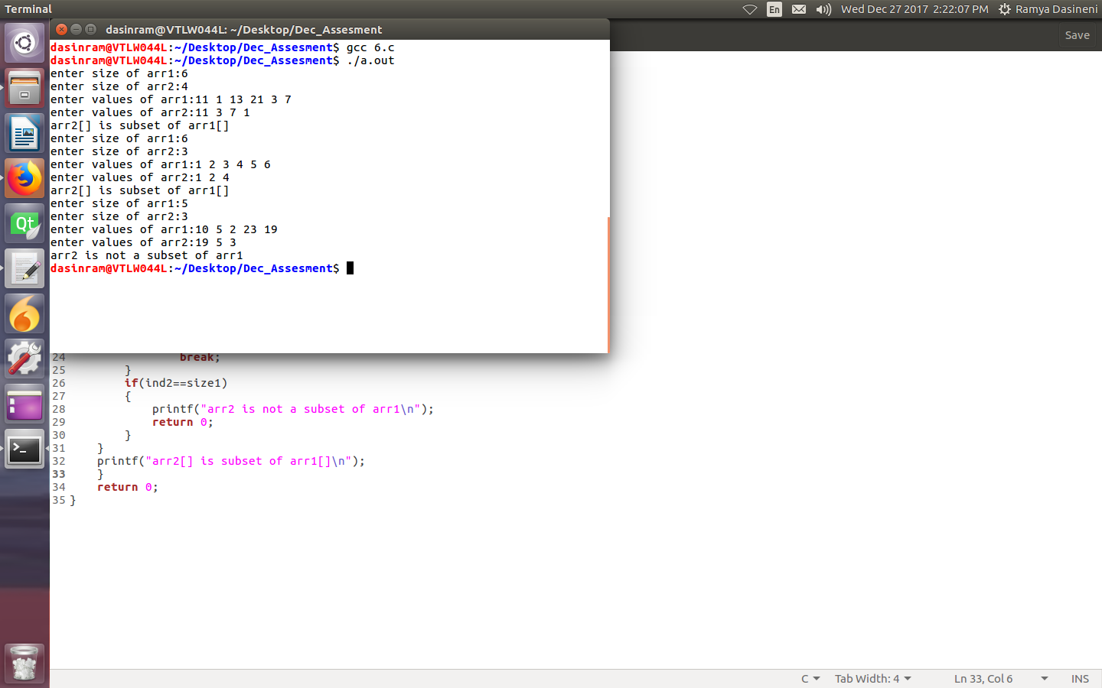

Linux Kernel
1.Explain Booting process of any Soc?Explain each stage of booting process?
Ans:
1.Power up device.
2.BIOS
3.Primary Boot loader(MBR)
4.Secondary boot loader(GRUB)
5.Kernel
6.Init
7.Runlevel.
BIOS means basic input output system.
In this stage it will power up the device and initiate peripherals of the device.
Then it will load the primary boot loader address.
Primary boot loader will read the secondary boot loader adress and it will load that secondary boot loader address from the RAM.
Secondary boot loader will load the kernel image.
Kernel will be loaded and it will call init.rd etc files.
In run level it will decide that it is multiuser or single user like that configurations will be done in that runlevel.

2.What is Boot loader?What are the functions of boot loader?
a)What is the difference between primary boot loader and secondary boot loader?
b)How does boot loader passes the parameters to the kernel?
Ans: A boot loader primarily manages and executes the boot sequence of a computer system. A boot loader program is typically started after the computer or the BIOS have finished performing the initial power and hardware device checks and tests. It fetches the OS kernel from the hard disk or any specified boot device within the boot sequence, into the main memory. A boot loader is associated with only a single operating system. An operating system can also have multiple boot loader programs classified as primary and secondary boot loaders, where a secondary boot loader might be larger and more capable than the primary boot loader.
c)What is u-boot?
Ans:
U-boot is
- Monolithic code image
- Runs processor in physical or a single address space
- Enables clocking, sets up some of the pin mux settings
- Reads in Kernel image (uImage)
- Jumps to load address pointed to in uImage header
- Passes Kernel Command Line to Kernel
d)What is Yocto linux?
Ans:
- Yocto is a distribution to build customized linux kernel images.
- It uses Open embedded ,poky to build that images.
- By using this Yocto we can add packages and driver modules dynamically.
6.Memory layout of a process based on Data,BSS,HEAP and STACK?
Ans:
stack
Heap
Uninitialized Data Segment
Intialized Data Segemnt
Text Segment

Text Segment:
A text segment , also known as a code segment which contains executable instructions.
Initialized Data Segment:
A data segment is a portion of virtual address space of a program, which contains the global variables and static variables that are initialized by the programmer.
Uninitialized Data Segment:
Uninitialized data segment, often called the “bss” segment,uninitialized data starts at the end of the data segment and contains all global variables and static variables that are initialized to zero or do not have explicit initialization in source code.

Stack:
Stack, where automatic variables are stored, along with information that is saved each time a function is called. Each time a function is called, the address of where to return to and certain information about the caller’s environment, such as some of the machine registers, are saved on the stack
Heap:
Heap is the segment where dynamic memory allocation usually takes place.

8.What are the differences between Mutex vs semaphore ?Explain difference between binary semaphore and mutex?
Ans:
Mutex provides one person to access a single resource at a time, others must wait in a queue. Once this person is done, the guy next in the queue acquire the resource.
So access is serial, one guy after other.
Semaphore are useful if multiple instances of a resource is to be shared among a set of users. As soon as all N resources are acquired, any new requester has to wait. Since there is no single lock to hold, there is as such no ownership of a semaphore.
9.What is Priority inversion and how to overcome it?
Ans:Priority Inversion means when one task is executing at that time one interupt comes and it has high priority ,so the current process will saved some where and it will excute that particular interupt.At that time one low priority task will come ,It is taking that particular resource and it is executing.This is called Priority inversion,It will be overcome by Priority Inheritance.
10.Difference between Multithreading and multitasking?
Ans:Multitasking let CPU to execute multiple tasks at the same time.
Multithreading means when we want to run multiple tasks with in a same process then we will use multithreading.
11.What is Paging and how it is different from segmentation?
Ans: Paging means the segments in virtual memory is called pages.Whenever the program wants some which is not present in cache then it will take from virtual memory.This is called page-in.If cache memory is full then it will remove some pages from cache memory.this is called page-out.This concept is called paging.
14.What is use of ioctl?
Ans:
Ioctl is used to communicate from user space to kernel space.

