C ANSWERS

2.Ans

#include<stdio.h>
#include<stdlib.h>
#include<unistd.h>
int fun(int arr[],int n)
{
int i,j,sum=0,res=0;
for(i=0;i<n;i++)
{
for(j=i+1;j<n;j++)
{
res = arr[i]^arr[j];
sum = sum+res;
}
}
return sum;
}

int main()
{
int arr[100],n,tc=0,i;
int r[100];
printf("enter number of test cases:");
scanf("%d",&tc);
int temp = tc;
while(tc)
{
n=0;
printf("number of elements:");
scanf("%d",&n);
printf("enter elements:");
for(i=0;i<n;i++)
scanf("%d",&arr[i]);
int s = fun(arr,n);
for(i=0;i<tc;i++)
r[i]=s;
tc--;
}
for(i=(temp-1);i>=0;i--)
printf("%d\n",r[i]);
}

Output:
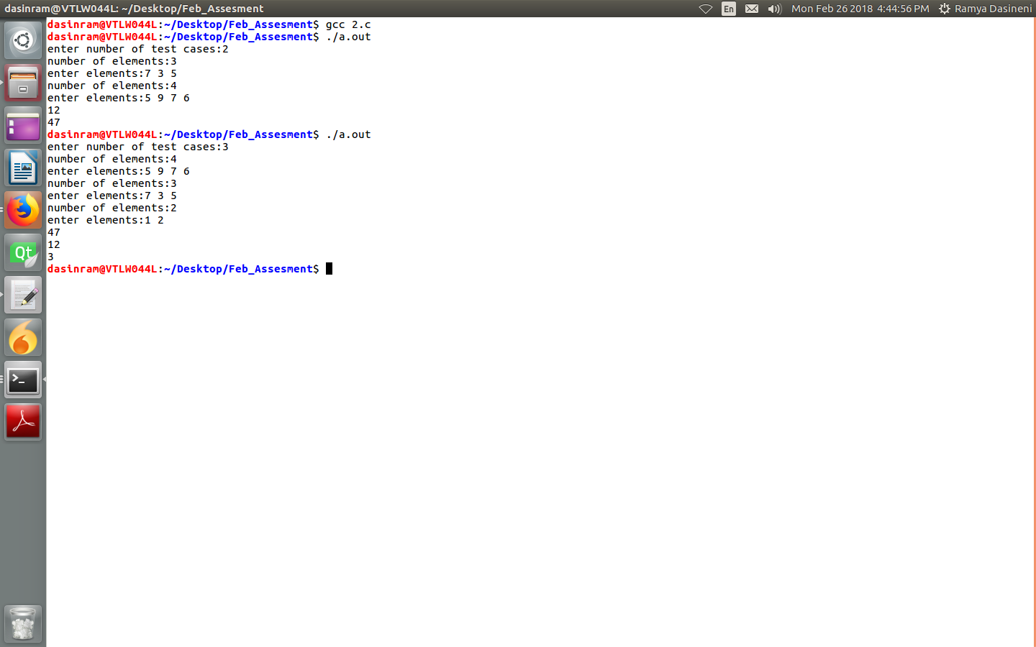

1.Ans:
#include<stdio.h>
#include<stdlib.h>
typedef struct ll
{
int data;
struct ll *next;

}NODE;
void insert(NODE **head)
{

NODE *nu,*temp;
nu=malloc(sizeof(NODE));
printf("enter data:");
scanf("%d",&(nu->data));
nu->next=NULL;
if(*head==NULL)
{
*head=nu;
}
else
{
temp=*head;
while(temp->next)
temp=temp->next;
temp->next=nu;
}
}
void print(NODE *head)
{
if(head!=NULL)
while(head)
{
printf("%d ",head->data);
head=head->next;
}
else
puts("Empty");

}
void movefront(NODE *head)
{
NODE *sel_data = NULL;
NODE *search = head;
while(search->next != NULL)
{
sel_data = search;
search = search->next;
}
sel_data->next = NULL;
head = search;
}

int search(NODE *head,int data)
{
int count =1;
while(head != NULL && head->next != NULL)
{
if(head->data == data)
{
movefront(head);
return count;

}

head=head->next;
count ++;
}
}

int main()
{
int n1,search_data;
printf("enter no.of elements in list:");
scanf("%d",&n1);
NODE *head1=NULL;
printf("insert elements into head1:\n");
while(n1>0)
{
insert(&head1);
n1--;
}
print(head1);
printf("\n");
printf("enter search data:");
scanf("%d",&search_data);
int res = search(head1,search_data);
if(res)
printf("%d found at %d index\n",search_data,res);
else
printf("not found\n");
print(head1);
printf("\n");

}

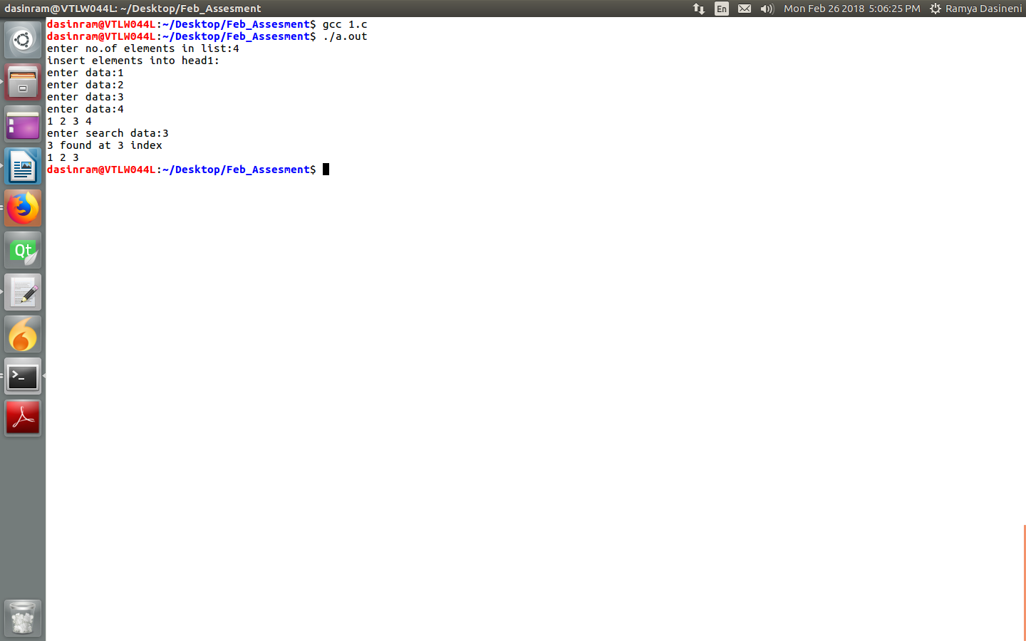

LINUX ANSWERS

1.Linux Booting Process:
Stages of Linux booting process:
1.BIOS
2.Bootloader1(MBR)
3.Secondary boot loader(GRUB)
4.Kernel
5.Init
6.Runlevel

BIOS:BIOS means basic input output system.The first task for the BIOS is to perform a Power On Self Test, which examines various piece of hardware connected to the computer to ensure that they are working properly or not.
BootLoader1(MBR):The MBR contains the boot loader program as well as partion table and a magic number.
The partition table contains the location on disk of active partitions where bootable
operating system can be found.
The MBR is of 512 bytes in length.
The first part of MBR consist of 446 bytes that contain part of the bootloader program.
For Linux OS two commanly used bootloaders 1] GRUB (Grand Unifield Bootloader)
Secondary Bootloader(GRUB):
GRUB which can be use to load multiple types of operating system .
GRUB stage 2 loads the default configuration file in order to present to the user a
seletion of kernel to select between.
Kernel:
The linux kernel is stored as a partially compressed image.
What is loaded into memory is not entirely executable.
The first portion of the kernel image is executable and it contain two parts, a 512-bytes
boot sector and a kernel setup program.
As the kernel setup portion runs, it perform some basic initial hardware setup.
Init:
It will intialize the kernel it runs the OS first file init.rd.
RunLevel:
In run level selection of users,i.e,single user,multiple users it will happen in this level.

2.Stack Overflow:
Stack oveflow means whenever we are trying to access allocated size of stack then it will cause to stackoverflow.If Stack overflow comes we are writing the values into some others memory ,it will leads to data corruption.At that if we are trying to access data then it will give unexpected results.
Ex:
if we are calling a function recursively,if we are calling nested functions without ending then it will leads to stack overflow plroblem.
fun()
{
fun1()
{
fun2()
{
fun3()
{
fun4()
}
}
}
}
If we wre calling like this it will cause stack oveflow problem.

3.Memory Leak:
If we are allocating some memory dynamically ,but we forgot to free it.Then it is called as memory leak.By using valgrind tool we can find the memory leaks.
To make sure our program has no memory leak,we have to maintain a list of allocated memory and addresses of that memory.We have to maintain a wrapper code for that,i.e,when ever we are calling malloc or calloc function instead of calling that,we have to call our own malloc,whenever we are calling free,instead of that we have to call our own free function.
Every time we have to check that list,allocated memory ,and freed memory.Then we got know if any memory leaks are there in our program or not.
Finally as a developer manually we have to check memory leaks.

4.Mutex Vs Semaphore:
Mutex provides one person to access a single resource at a time, others must wait in a queue. Once this person is done, the next person in the queue acquire the resource.So access is serial, one person after other.
Semaphore is useful if multiple instances of a resource is to be shared among a set of users. As soon as if all resources are acquired, any new request has to wait. Since there is no single lock to hold, there is as such no ownership of a semaphore.
5.Coredump:
A core dump is a file containing a process's address space , when the process terminates unexpectedly. Core dumps may be produced on-demand such as by a debugger, or automatically upon termination. Core dumps are triggered by the kernel in response to program crashes, and may be passed to a helper program for further processing. A core dump is not typically used by an average user, but may be passed on to developers upon request where it can be invalid program's time of the crash.

6.Page Fault:
While executing a program, if the program references a page which is not available in the main memory , the processor treats this invalid memory reference as a page fault and transfers control from the program to the operating system to demand the page back into the memory.

7.DeadLock:
Dead lock means If one process is occupting one resource ,second process is occupying another resource ,then if process1 wants second resource,process 2 wants first resource then that situation will be called as DeadLock.
To avoid dead lock in linux we have to use synchronization techniques.

8.Static Library Vs Dynamic Library:
Ans:

Static Library | Dynamic Library
1.It will link to the program at the time of compilation only. | 1.This library will link to the program at run time.
2.Size of executable is more. | 2.Size of executable is less.
3.Program execution time is less. | 3.Program execution time is more.

9.Interupt Mechanism:
When any interupt raised by a device the current running process will be stored somewhere,and the interupt will be executed first.While executing interupts top-half,bottom-half will come into picture.If one interupt comes at a time,we will execute that interupt first and we will com back to our current running process.this is called context switching.
If multiple interupts comes at a time,to handle that interupts we can use top half and bottom half mechanisms.In top half it contains only interupt hanndlers.this interupts will be services in bottom half.In bottom half we tasklets,work queues will come.To handle that multiple interupts we can use this mechanisms.
Top Half : The interrupt handler is the top half . The top half is run immediately upon
receipt of the interrupt and perform only the work that is time-critical, such as acknowledging
receipt of the interrupt or reseting the hardware. The processing done in interrupt context is called
as Top half. It is actually respond to the interrupt i.e the one you register with request_irq.
Bottom Half: It is the routine that is scheduled by the top half to be executed later, art a
safer time. Work that can performed later is deferred until the bottom half. The bottom half runs in
the future, at a more convenient time, with all interrupt enabled.
The big difference between the top-half handler and bottom half is that all interrupts are
enabled during execution of the bottom half, thats why it runs at safer time.

10.Kernel Panic:
A kernel panic happen when the kernel detect an error from which it cant recover.The reason for a kernel panic can be a bug in the kernel or a hardware or software issue that cause an unexpected or unpredictable condition for the kernel.
By using kdmup or crash we can see the crash.

