Question1-Write a Caluculator program in BASH using Switch case to perform arithmetic operatiopns:
Ans:
#!/bin/bash
#calculator.sh
echo "enter numbers:"
read -p "number1-->:" number1
read -p "number2-->:" number2
echo "1.Add 2.sub 3.mul 4.division 5.modulus 6:quit"
while ((1))
do
#echo "enter choice"
read -p "choice-->" choice
case $choice in
1) echo "Addition= `expr $number1 + $number2`";;
2) echo "subtraction = `expr $number1 - $number2`";;
3) echo "Multiplication = `expr $number1 \* $number2`";;
4) echo "Division = `expr $number1 / $number2`";;
5) echo "Modulus = `expr $number1 % $number2`";;
6) break
esac
done
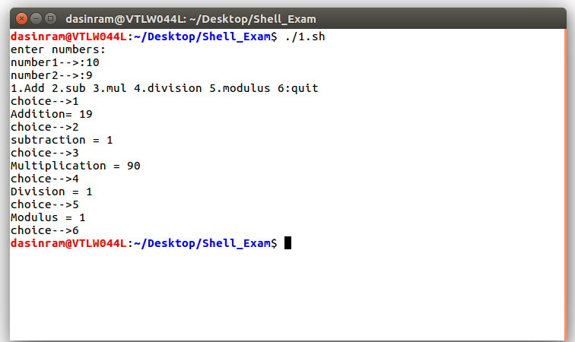

Question2:Write a Program to print from 1 to 10 using for loop?
Ans:
#!/bin/bash
#numbers.sh
for i in `seq 1 10`
do
echo $i
done

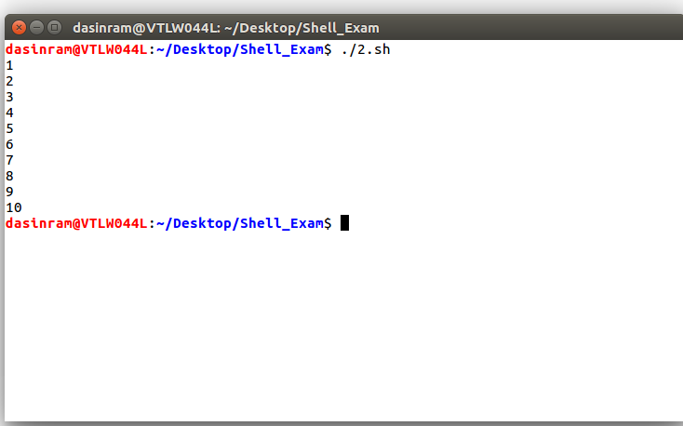

Question3:To print files and subdirectories?
Ans:
#!/bin/bash
#files.sh
file_c=0
dir_c=0
echo "Enter specific directory:"
read -p "Path=>" path
cd $path
eval pwd
for file in `ls`
do
if [[ -f $file ]]
then
file_c=`expr $file_c + 1`
fi
if [[ -d $file ]]
then
dir_c=`expr $dir_c + 1`
fi
done
echo "file count :"$file_c
echo "Directory count :"$dir_c

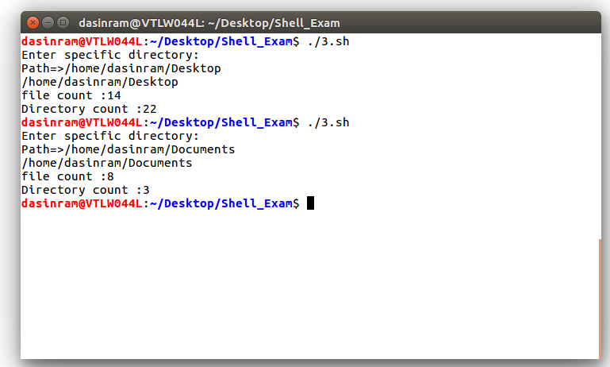

Quetion4:Fibnocci Series?
Ans:
#!/bin/bash
#4_fibnacc.sh
num1=0
num2=1
res=1
echo "numbers are:"
if [ "$#" -ne 0 ]
then
for((num=1;num<="$1";num++))
do
echo -n " $num2"
num1=$num2
num2=$res
res=`expr $num1 + $num2`
done
else
for((num=1;num<=5;num++))
do
echo -n " $num2"
num1=$num2
num2=$res
res=`expr $num1 + $num2`
done
fi
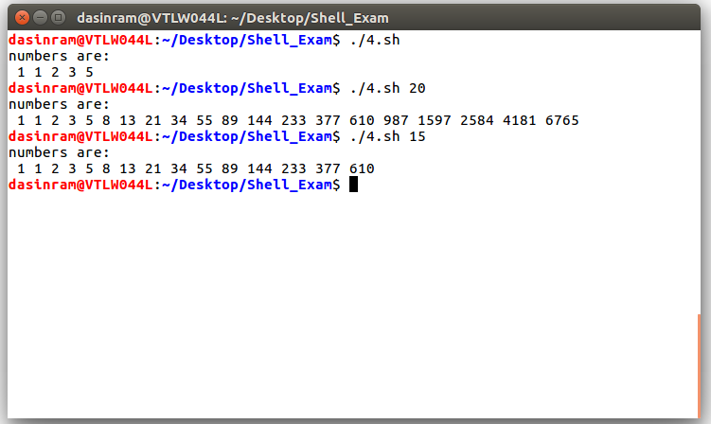
echo

Question5:Signals?
Ans:
#!/bin/bash
#5_sighand.sh
trap sigint INT
trap sigusr1 USR1
trap sigusr2 USR2
trap sigterm TERM
trap sigabrt ABRT
cnt=0
int=0
sigint()
{
echo "Recieved SIGINT"
int=`expr $int + 1`
echo $int
if [ $int -eq 2 ]
then
exit
fi
}
sigterm()
{
echo "Recieved SIGTERM"
exit
}
sigabrt()
{
echo "Recieved SIGABRT"
}
sigusr1()
{
#echo ""
echo "Recieved SIGUSR1"
}
sigusr2()
{
echo "Recieved SIGUSR2"
}
while :
do
ps -f
sleep 3
echo $cnt
cnt=`expr $cnt + 1`
clear
done

