Detail Design Document

MULTIMEDIA IMAGE PROCESSING Using OpenCV

Votary Softech Solutions Pvt. Ltd.
Plot No: 76, Lumbini layout,
Near Euro school,
Gachibowli-I (V), Hyderabad,
Telangana - 500032,
India.

Revision History

Version (x.y) | Date of Revision | Description of Change | Reason for Change | Affected Sections | Approved By

Approval History

Version (x.y) | Prepared By | Reviewed By/Date | Approved By/Date

Contents
1 Define 4
1.1 Overview 4
1.2 Assumptions 4
1.3 Limitations 4
1.4 Deliverables.....................................................................................................4
1.5 Glossary 4
2 Specify 4
2.1 Scope 4
2.2 Design Approach 5
2.3 Alternative Design Approaches Considered 5
2.4 Module Design 5
2.4.1 Module Name and Description 5
2.5 External Interfaces 6
2.6 Design Tools 6
3 Architecture 6
3.1 Block Diagrams 6
3.2 Activity Diagrams/ Flow Charts 6
3.3 Deployment diagrams 6
3.4 State Transition Diagram (Optional) 6
3.5 State Transition Table 7
4 Design 7
4.1 Class Diagrams 7
4.2 Sequence Diagrams 7
4.3 Database Design 7
4.4 Wireframes 7
5 Implementation 7
5.1 Directory Structure 7
5.2 Libraries and Framework 7
5.3 Error Handling 7
5.4 Status Codes and Description 7
6 Validate 8
7 Deploy 8
8 Maintain 8

1.Define

1.1 Overview
The purpose of this document is to do the high level design by
identifying the different modules and interfaces. The modules involved in the design for Image Recognition are image acquisition, image processing to identify image objects and image storage using Database.

1.2 Assumptions
Pre-configured data should be present in database for image processing.

1.3 Limitations
Process one image at a time.

1.4 Deliverable
- Gateway
- SQL Database
- Wrapper

1.5 Glossary
Term | Definition
OpenCV | Open Source Computer Vision.
SQL | standardized query language

2.Specify
All the modules are in the same network. Database and Gateway can be in a different Network.

2.1 Scope
The modules can be change throughout life cycle vgate process and updated with corresponding documents with specified changes. Estimations and budget are not applicable.

2.2 Design Approach
Image Acquisition system in the Gateway acquires raw data either from the Camera or from local storage or database .Image Acquisition system in the Gateway is implemented in python.

Image Processing System process data(captured image) to identify the things or Images or objects based on the pattern implemented by the Algorithm. Image Processing System in the Gateway is implemented in python.

Database to store the processed image and details from the image processing system which is implemented in python.

2.3 Alternative Design Approaches Considered
It can also be done using C++ and Matlab.

2.4 Module Desig

2.4.1 Module Name and Description
Image Acquisition system in the Gateway acquires raw data either from the Camera or from local storage or database.
Image Processing System process data(captured image) to identify the things or Images or objects based on the pattern implemented by using OpenCV Algorithms.
Database to store the processed image and details from the image processing system.
2.4.2 API in Module
Image Acquisition:
VITA_Cam()
VITA_local_browse()
VITA_database()
Image Processing:
VITA_face_detect()
NOTE:Arguments for each API is mentioned in Module functions
2.4.3Module Functions
Image Acquisition:
VITA_Cam():This API will capture images from the connected camera module.
cv2.VideoCapture()
VITA_local_browse(): This API will browse images from the local system.
tkFileDialog.askopenfilename()
Image Processing:
VITA_face_detect(arg):This API will detect face and eyes of persons ,it will draw rectangles on that image.
Argument for this API is filename of the image.

2.5 External Interfaces
External interfaces used in the project are camera module and third party library OpenCV is used.
< Contact Persons for specific tasks at
- Company Name xxxxxxx
- The customer organization
- Sub-contracted organization
- Other organizational entities that interact with the project. >
Organization | Liaison/ Interface

2.6 Design Tools
List of the design tools used:
- OpenCV
- Python
- SQL
- Git

3.Architecture
3.1.Block Diagram


Camera
Local browse
Database
Display Image details
Image Processing Environment
Image Acquisition
database

Input
Image
Output
OpenCV

Process the image using OpenCV

3.2 Activity Diagrams/ Flow Charts

Flow Chart:

Application Start
Image Acquisition
Compare Image With
Database Images
Match
Display
Details
Store image in
Database
With meta
data
Yes
No

3.3 Deployment diagrams
NA

3.4 State Transition Diagram (Optional)
NA

3.5 State Transition Table
NA

Design

Class Diagrams
NA

Sequence Diagrams
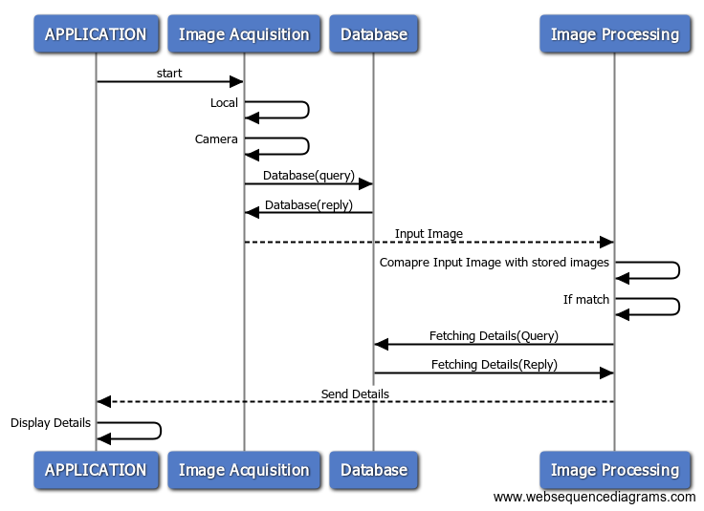
If Image is matched with any one of the database images.

If Image does not match with

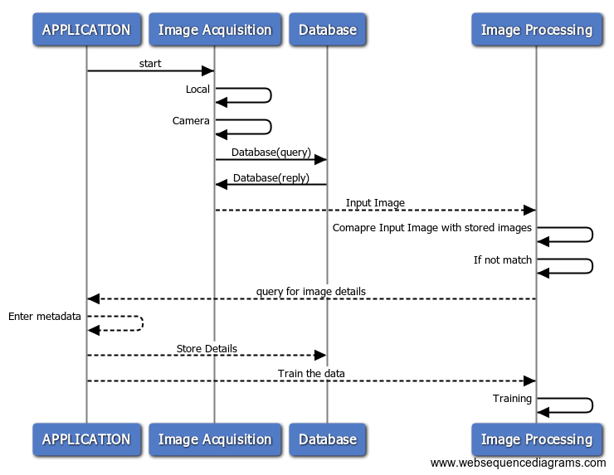

Wireframes
NA

Implementation
<Implementation details of the project.>

Directory Structure
Project Repository contains 2 directories,which are Docs and Source.
Docs contains Design Document,Requirement document and UAT document.
Source contains python script file and xml files which are required.

Libraries and Framework
<Give the details of Libraries, SDK or framework classes used from internal or 3rd parties to construct the project base. Packaging of libraries and their reference documentation>

Error Handling
<Applicable for Module services, Success, Retry count, Failure error codes, that will be sent as response to clients/modules using the service.>

Status Codes and Description
<List the Success/Warning/Failure Error codes that will be sent as response to clients/modules using the service and their description and severity.>

Validate
<References to Checklists, Checklists for Detail Design Document, Review defect logs, Approval Emails, Traceability >

Deploy
<Commit Base-lined Design Documents to SVN, Configure all the tools and raise Requests for Training, hardware, software and resources identified in the Plan>

Maintain
<Changes to Design with appropriate references to CRs, Enhancements etc,>

