1.Difference between spinlock,mutex and semaphore?

Ans:
Mutex provides one person to access a single resource at a time, others must wait in a queue. Once this person is done, the guy next in the queue acquire the resource.
So access is serial, one guy after other. Too aggressive.

Semaphore are useful if multiple instances (N) of a resource is to be shared among a set of users. As soon as all N resources are acquired, any new requester has to wait. Since there is no single lock to hold, there is as such no ownership of a semaphore.
Spinlock is an aggressive mutex. In mutex, if you find that resource is locked by someone else, you (the thread/process) switch the context and start to wait (non-blocking).
Whereas spinlocks do not switch context and keep spinning. As soon as resource is free, they go and grab it. In this process of spinning, they consume many CPU cycles. Also, on a uni-processor machine they are useless and perform very badly.

2.How to switch from kernel space to user space?
Ans:
From the operating system's perspective, user space is the execution of code from a process, and kernel space is the execution of code from the kernel. A transition from user space to kernel space is the entry into a system call, and a transition from kernel space to user space is the return from a system call.
Process Control
  - load
  - execute
  - end, abort
  - create process (for example, fork on Unix-like systems, or NtCreateProcess in the Windows NT Native API)
  - terminate process
  - get/set process attributes
  - wait for time, wait event, signal event
  - allocate, free memory
- File management
  - create file, delete file
  - open, close
  - read, write, reposition
  - get/set file attributes
- Device Management
  - request device, release device
  - read, write, reposition
  - get/set device attributes
  - logically attach or detach devices
- Information Maintenance
  - get/set time or date
  - get/set system data
  - get/set process, file, or device attributes
- Communication
  - create, delete communication connection
  - send, receive messages
  - transfer status information
  - attach or detach remote devices
3.Difference between modprobe and insmode?
Ans:
modprobe is an intelligent command, it looks for dependencies while loading a module. Suppose, if I loaded a module, which has symbols defined in some other module (this module path is given inside the main module). So, modprobe loads the main module and the dependent module.
But if insmod is used, it won't load the dependency, and hence it will give compilation errors like Unresolved symbols. In this case, we have to manually look for dependent module and need to load them in order to resolve the errors.

4.Implementation of sprintf()?
Ans:
#include <stdio.h>
#include <string.h>
#include <stdarg.h>

int sprintf(char * str, const char * format, ... )
{// Here you can redfine your input before continuing to compy with standard inputs
va_list args;
va_start(args, format);
vsprintf(str,format, args);// This still uses standaes formating
va_end(args);
return 0;// Before return you can redefine it back if you want...
}
int main (void)
{
char h[20];
sprintf(h,"hei %d ",10);
printf("t %s\n",h);
getchar();
return 0;
}
5.What is the difference between memory mappped i/o and io mapped i/o?
Ans:
I/O is any general-purpose port used by processor/controller to handle peripherals connected to it.
I/O mapped I/Os have a separate address space from the memory. So, total addressed capacity is the number of I/Os connected and memory connected. Separate I/O-related instructions are used to access I/Os. A separate signal is used for addressing an I/O device.
Memory-mapped I/Os share the memory space with external memory. So, total addressed capacity is memory connected only. This is underutilisation of resources if your processor supports I/O-mapped I/O. In this case instructions used to access I/Os are same as that used for memory.
Memory-mapped IO (MMIO):
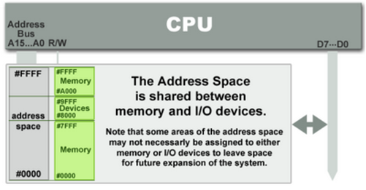
Port-mapped IO (PMIO or Isolated IO):
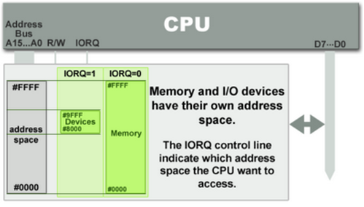
Comparison - Memory-mapped vs port-mapped
Memory-mapped IO:
1.Same address bus to address memory and I/O devices
2.Most widely used I/O method
3.Access to the I/O devices using regular instructions
Port-mapped IO:
1.Different address spaces for memory and I/O devices
2.Uses a special class of CPU instructions to access I/O devices
3.x86 Intel microprocessors - IN and OUT instructions

