Yocto

About Yocto

The Yocto Project is an open source collaboration project that provides templates,
tools and methods to help you create custom Linux-based systems for embedded products
regardless of the hardware architecture. It was founded in 2010 as a collaboration among
many hardware manufacturers, open-source operating systems vendors, and electronics
companies to bring some order to the chaos of embedded Linux development.
Why use the Yocto Project? It's a complete embedded Linux development environment
with tools, metadata, and documentation - everything you need. The free tools are easy to
get started with, powerful to work with (including emulation environments, debuggers, an
Application Toolkit Generator, etc.) and they allow projects to be carried forward over time
without causing you to lose optimizations and investments made during the project’s
prototype phase. The Yocto Project fosters community adoption of this open source
technology allowing its users to focus on their specific product features and development.
Yocto is Raspid, repeatable development of linux - based embedded systems. Every six
month it has stable release
Yocto open source has very good documentation.

Platform Yocto Supports:
1.DragonBoard-410c
2.RaspberryPi3
3.BeagleBone

Board Support Packages:
#MACHINE = “DragonBoard-410c”
#MACHINE = “beaglebone”
#MACHINE = “raspberrypi3”

Yocto Build Using Shell Script to select Board,Adding Packages dynamically:

- Whenever the script runs first it will ask for board selection.
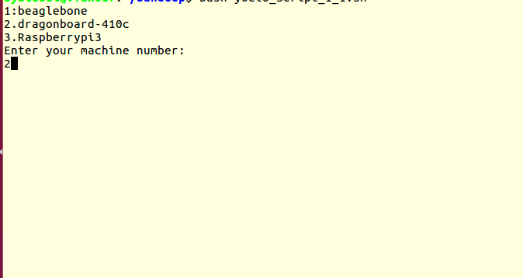

- After selecting the board it will ask for kerenl version.
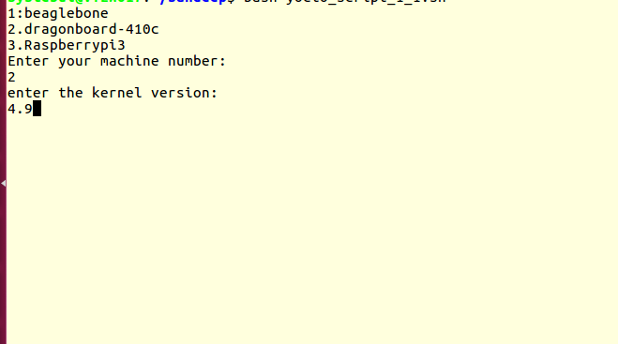

- After kernel version selection it will clone all the required source code for that particular machine ,poky,openembedded source codes.
- After this it will ask for packages selection.

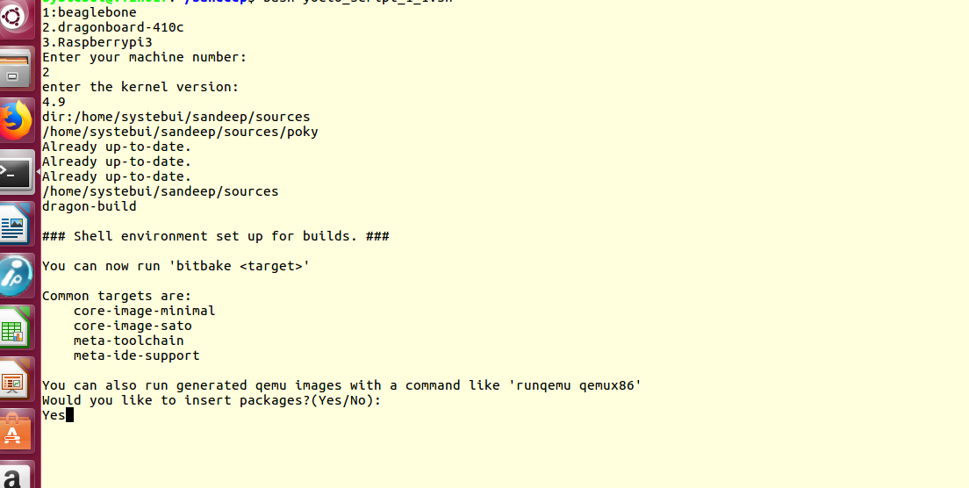

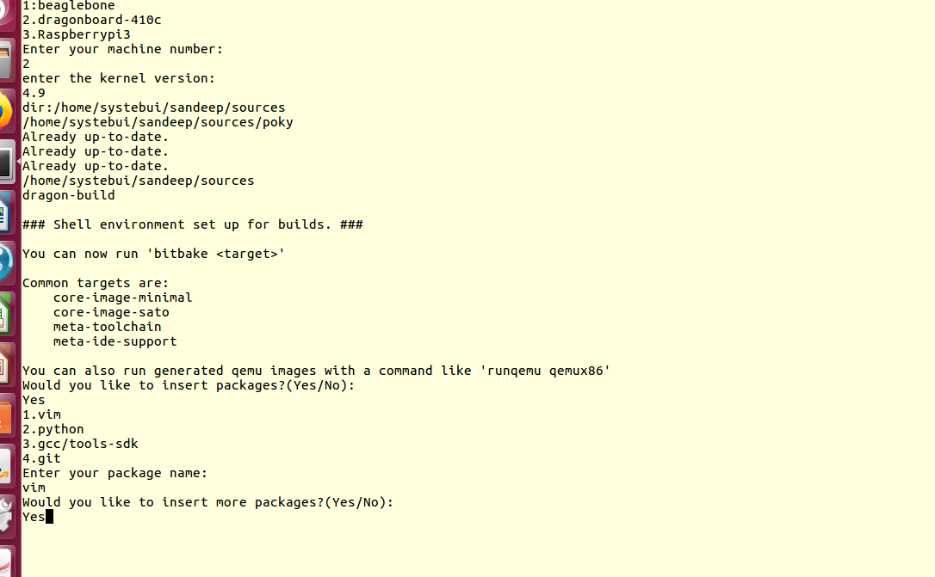

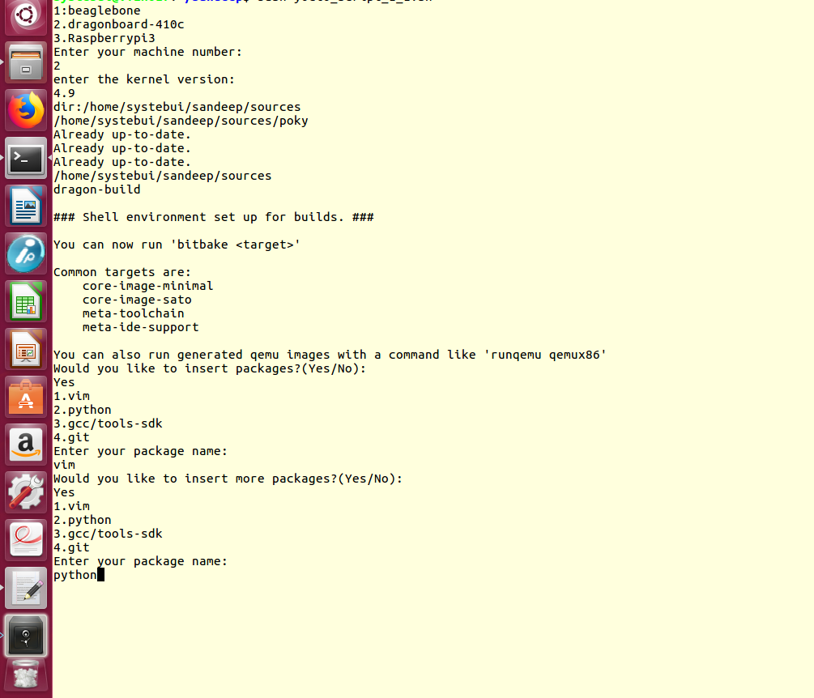

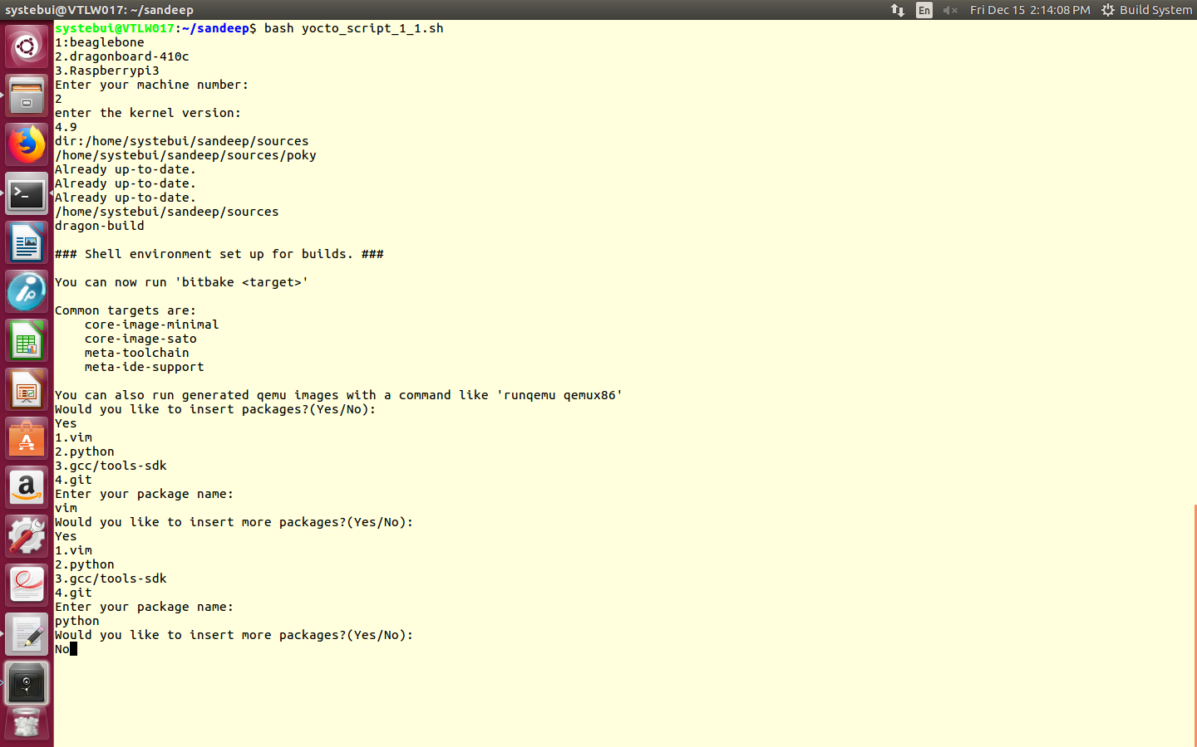
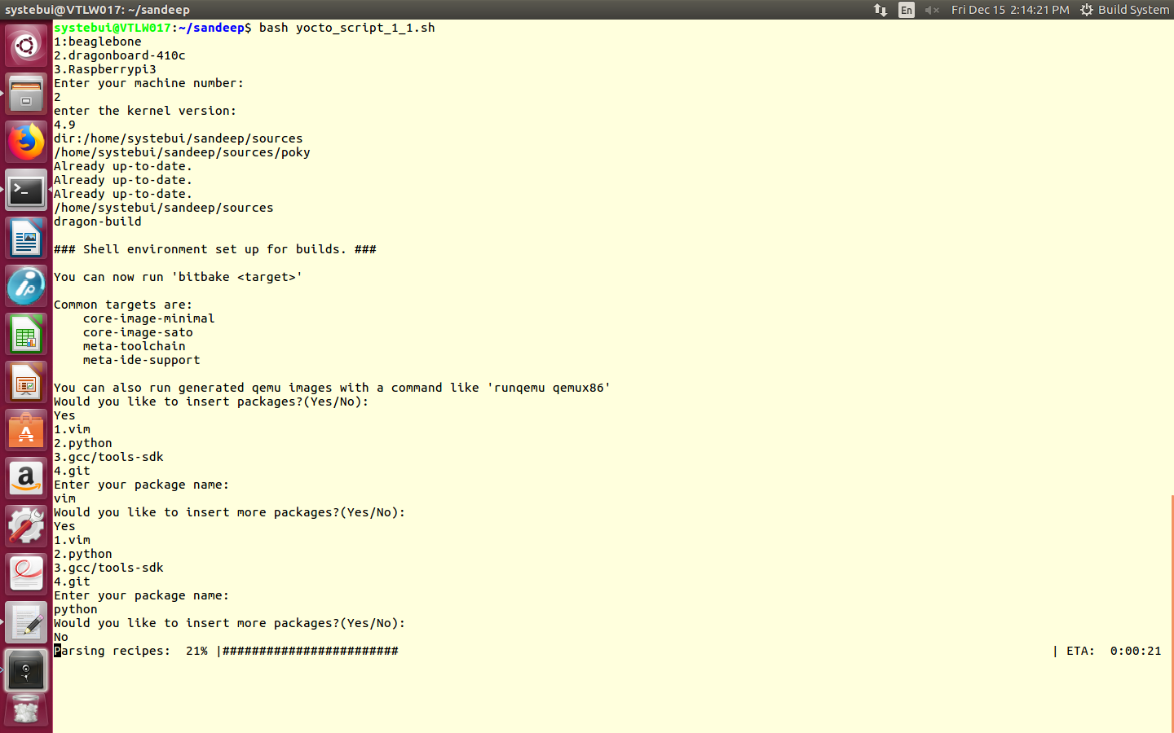
- If user selects any package we will add that package into local.conf file by using following line.
echo “CORE_IMAGE_EXTRA_INSTALL += \ ” Package\” “>>local.conf
or
echo “IMAGE_INSTALL_append += \“ package\” “>>local.conf
Ex: we added vim,apt,gcc,python,git by using following lines.
IMAGE_INSTALL_append = “ apt”
IMAGE_INSTALL_append = “ python”
IMAGE_INSTALL_append = “ vim”
CORE_IMAGE_EXTRA_INSTALL += “ tools-sdk”
CORE_IMAGE_EXTRA_INSTALL += “ git”

while we are adding any package for raspberry pi we have to give that particular path in bblayers.conf.

${BSPDIR}/sources/meta-openembedded/meta-python

