Jenkins installation in ubuntu

Basic Requirements:

There’s no complex requirement for Jenkins but you must have sufficient superuser privileges to perform some basic installation tasks on your operating system and your system should be properly updated with the latest packages. Furthermore, Jenkins requires to have any basic web server installed on it. So, let’s start the setup of Jenkins on Ubuntu 14.04 LTS operating system.
System Update

Run the following command to update your operating system before moving on to other packages installation.

root@ubuntu-14:~# apt-get update

Basic Web Server:

Jenkins requires the basic web server installed on your system, so if you don’t have any of your web server installed on your operating system, you can execute the following command to install the web server.

root@ubuntu-14:~# apt-get install nginx

This will be installing Nginx web server. If you are more comfortable with a different web server, you can also choose other web servers to be installed.

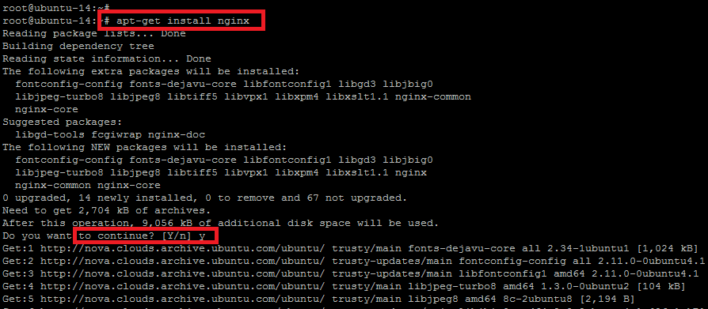
Once your Nginx web server is installed check the status of its services with the command below.

root@ubuntu-14:~# service nginx status

* nginx is running

It means `Nginx` is working fine, so let’s proceed to next step.

Java Installation

Now install the Java first through the `apt-get` package manager. For this purpose, you will need to install open source implementation of JAVA Version 7. This is quite easy to do so by executing the command below.

root@ubuntu-14:~# apt-get install openjdk-7-jdk

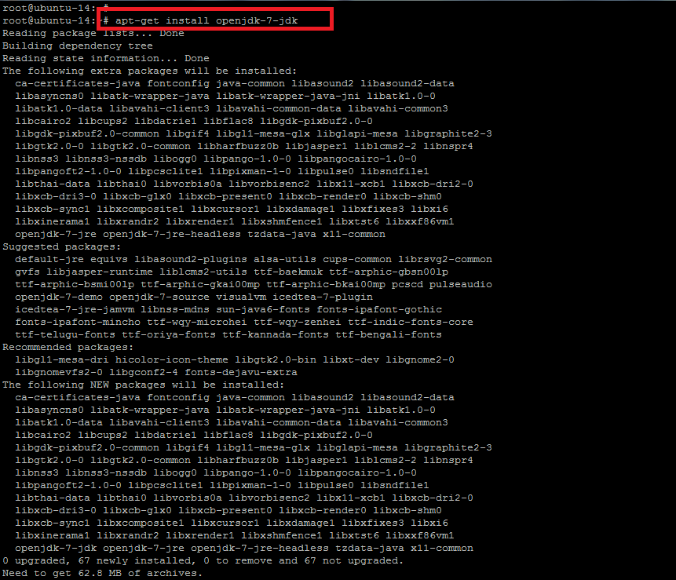
When you execute the above command, it shows you the list of other recommended and required packages to be installed with Java `openjdk`. To proceed with those packages, you have to press `Y` or type `N` to exit the installer.

It will take a few minutes to complete the Java installation. Once it is done, run the command below to check the installed version of Java on your system as shown.

root@ubuntu-14:~# java –version

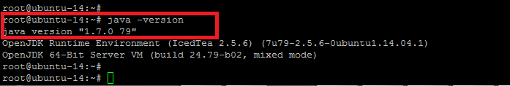
Jenkins Installation and Configuration

Now we are ready to install `Jenkins`. So before the package installation, we have to add the key and source list to apt for Jenkins. To do so, issue the following two commands in the terminal.

root@ubuntu-14:~# wget -q -O – https://pkg.jenkins-ci.org/debian/jenkins-ci.org.key | sudo apt-key add –

OK

You will get the `OK` status after you add the key. For the source list, here is the command to run.

root@ubuntu-14:~# sh -c 'echo deb http://pkg.jenkins-ci.org/debian binary/ > /etc/apt/sources.list.d/jenkins.list'

Now it needs to update `apt’s` cache before moving to Jenkins so that it can refresh the operating system’s repository for the latest packages.

root@ubuntu-14:~# apt-get update

Once your system is updated, execute the command below for the installation of Jenkins and type the `Y` key to proceed with the installation process.

root@ubuntu-14:~# apt-get install Jenkins

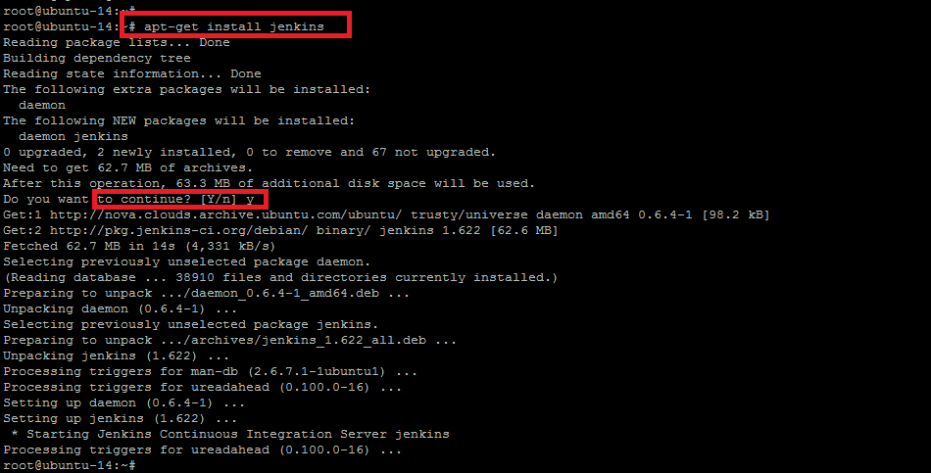
The installation process will end up with starting its daemon. To check the status of Jenkins service, the command below will show you its status with running process ID. Jenkins service run with its default user name `jenkin`.

root@ubuntu-14:~# service jenkins status

Jenkins Continuous Integration Server is running with the pid of some number.

If you need to update the configurations of Jenkins as per your requirements, then you can find its configuration file under the `/etc/default/` directory and can make the changes.

root@ubuntu-14:~# vim /etc/default/Jenkins

Jenkins runs on port 8080 by default for HTTP connector.

