Task 1: To Create Main Loop, Display Prompt, Read User Input, Handle Exit Conditions, Design Control Flow Diagram, Test Interactive Loop
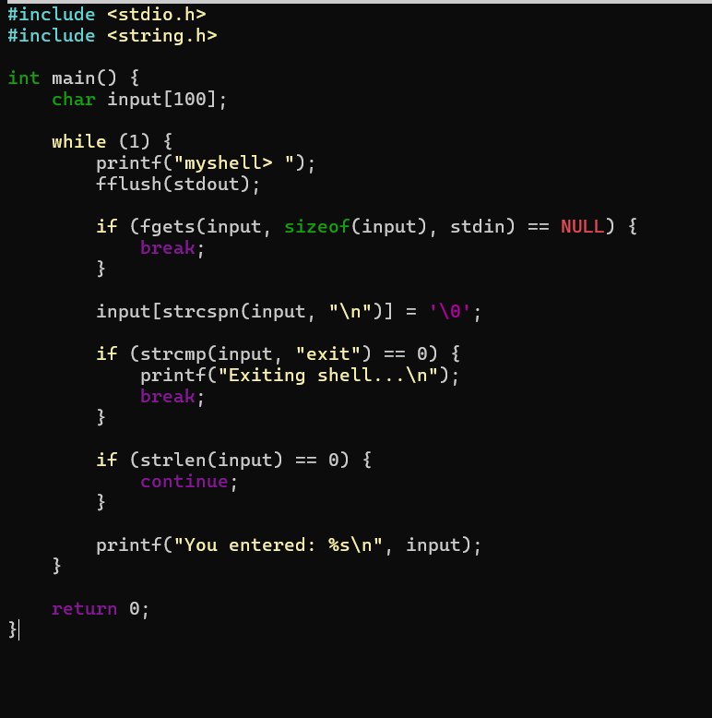
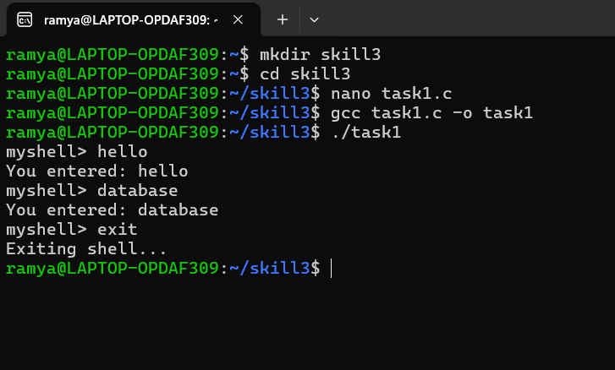
Task 2: Using the following system calls, copy the content from File1.txt to File2.txt.
- Open()
- Read()
- Write()
- Close()
open()
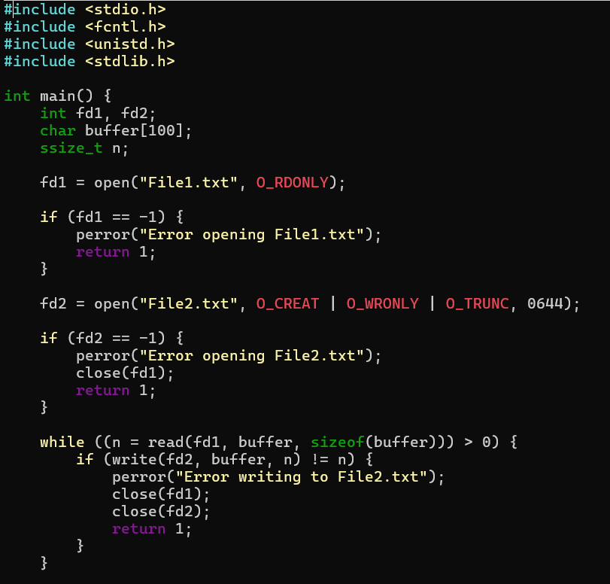
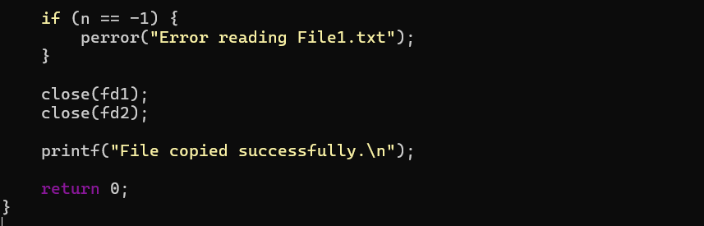
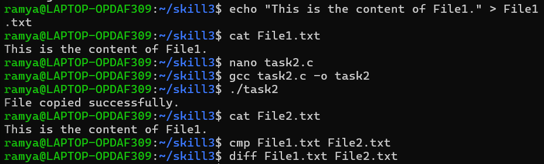

Task 3: To Capture Keyboard Input, Handle Backspace, Process Enter Key, Manage Input Buffer, Support Multi-Character Commands, Test User Interaction.

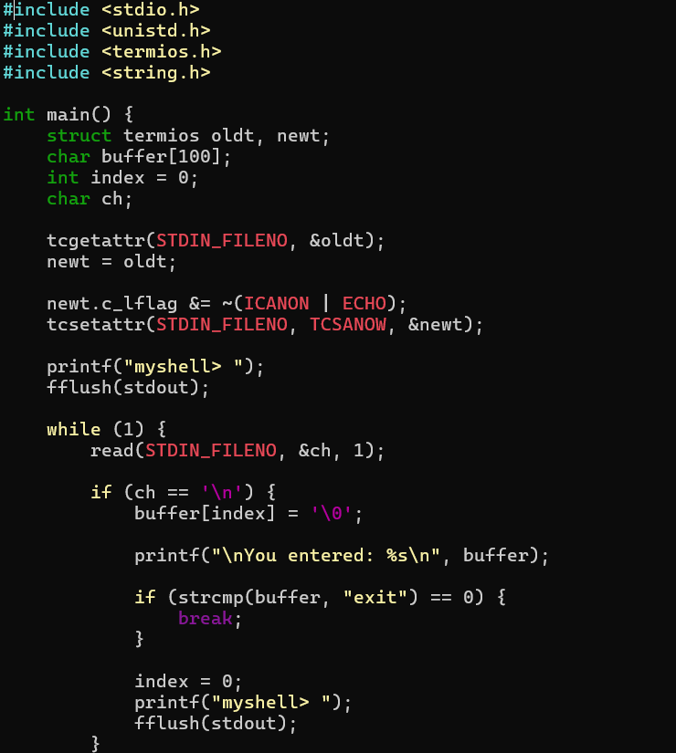
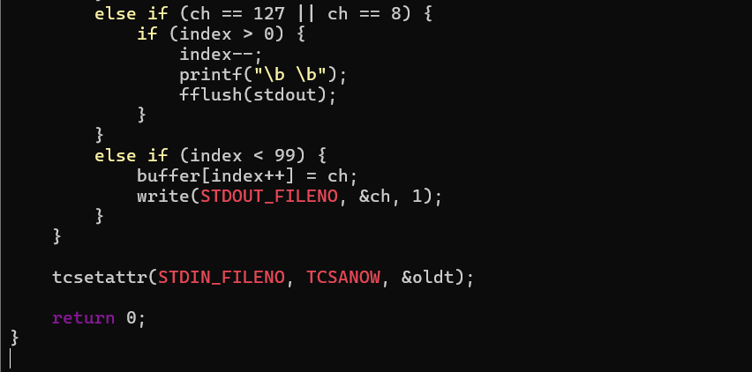
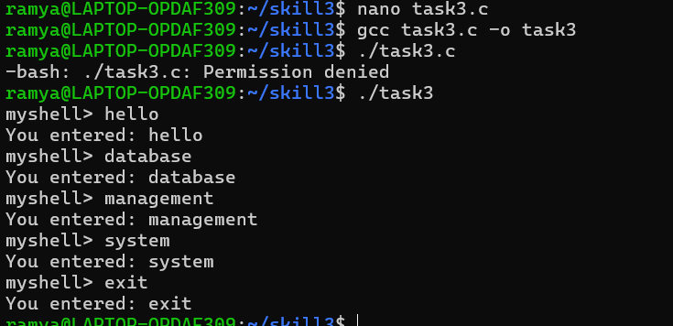

Task 4: To Apply Escape Sequences, Store Command History,
Navigate Previous Commands, Navigate Next Commands,
Update Input Buffer, Test Recall Functionality
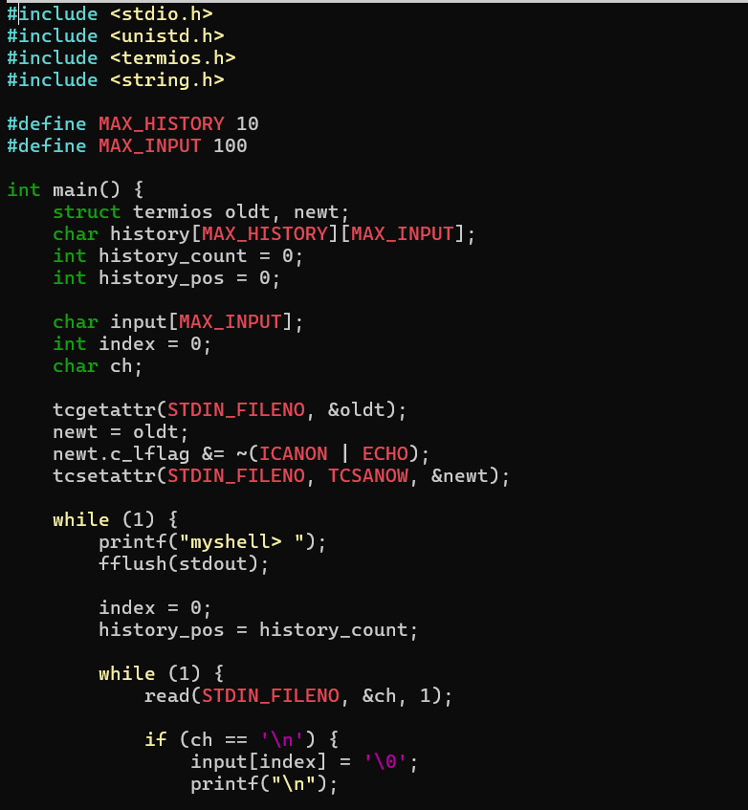
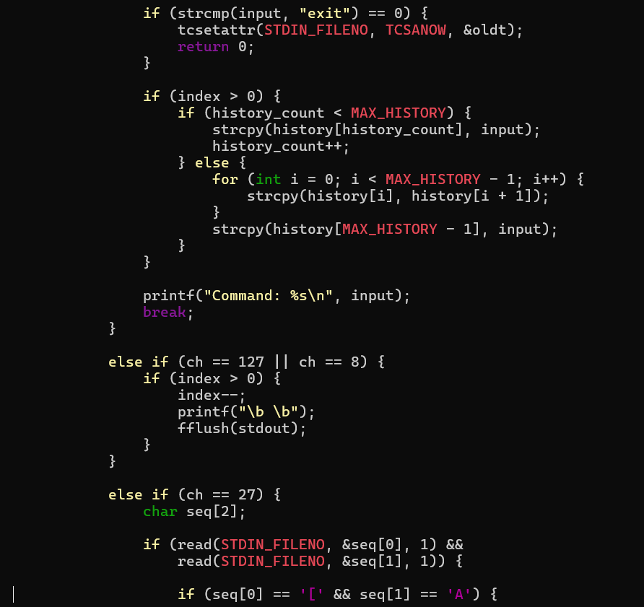
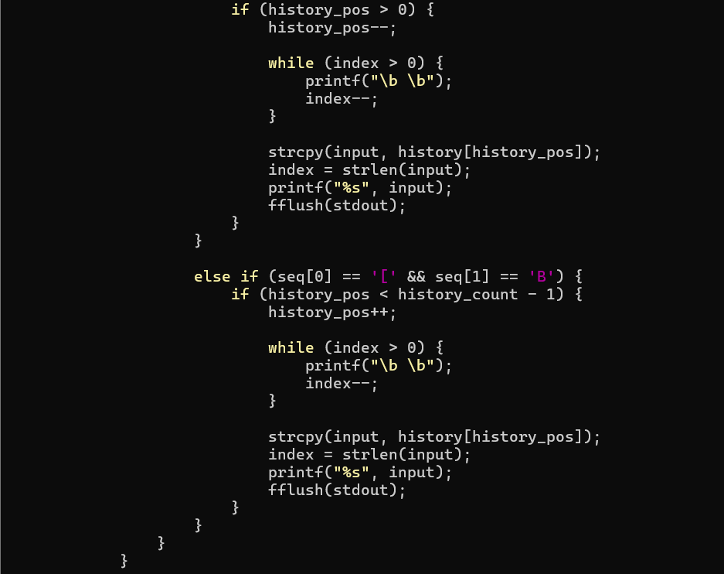
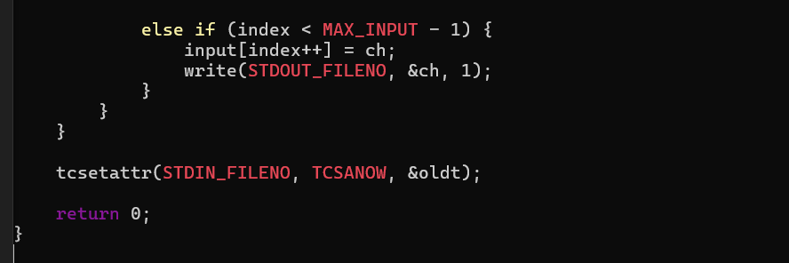
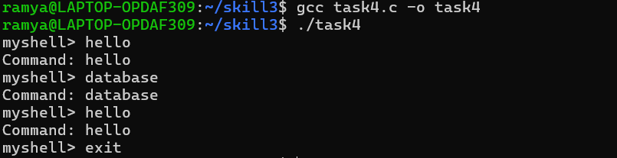

Task 5: To Allocate Buffers Dynamically, Resize Arrays, Prevent Buffer Overflow, Manage Linked Lists, Release Memory Correctly, Verify with Valgrind.
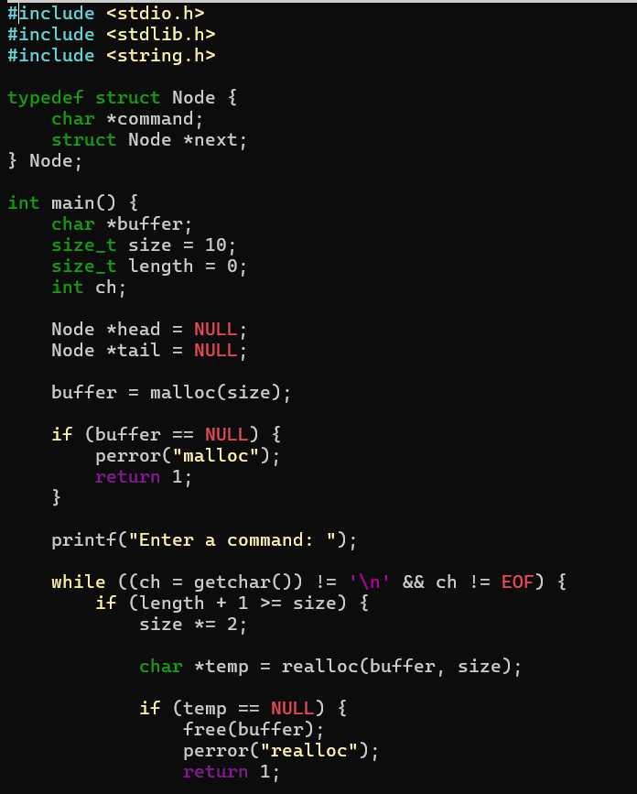
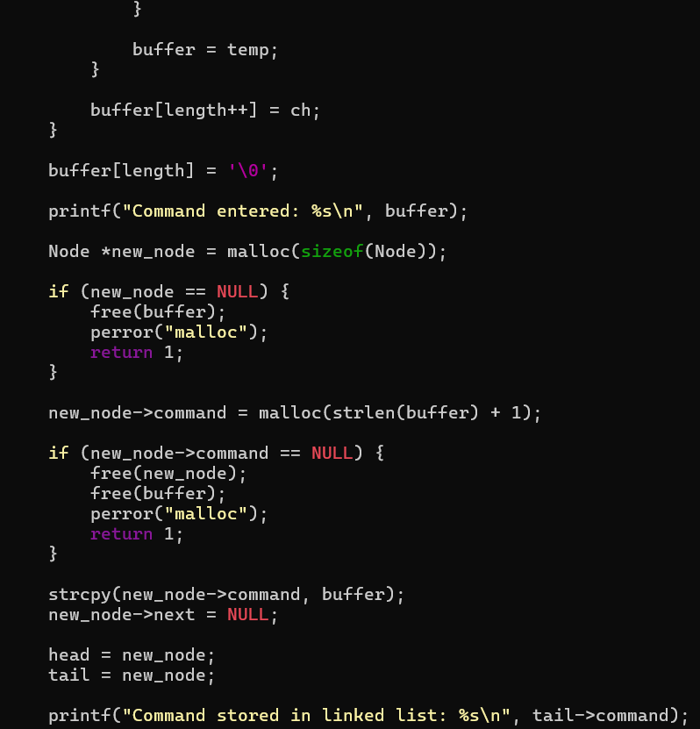
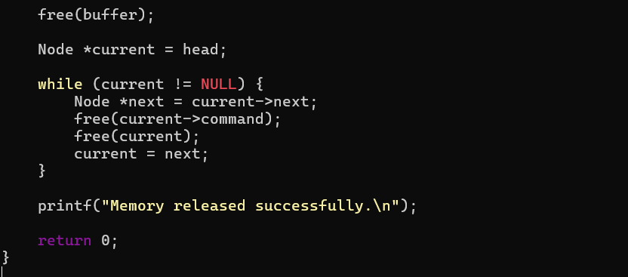
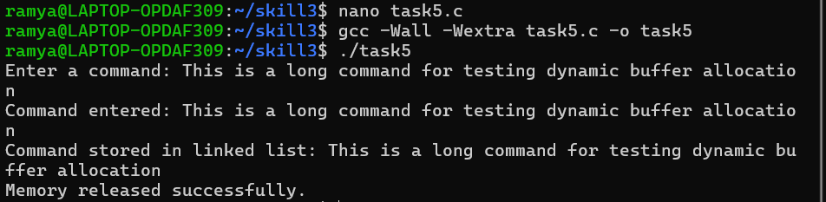

Verify Using Valgrind :
